Quiet Hour Rack Card Template

This template can be used to create a rack card for self-led sessions. It summarizes what Quiet Hour is and includes the main steps so people can do it on their own. You can use it as a starting point in this Word document or recreate it in your favorite graphics design software.
The layout comes with pre-written text and designated sections for you to personalize, such as adding your logo, location, and contact details.

Below is an example of the rack card that shows you where you can add specific custom information.

In blank areas 1 and 2, you can add details like your organization’s logo.

In blank area 3, if your organization hosts the Quiet Hour for Individuals Audio Program, add information on how people can access the program.

In blank area 4, if your organization offers Quiet Hour guided group sessions, add information where people can find when and where the sessions are held.

In blank area 5, you can add things like your organization’s contact information.

Next, print the cards double-sided on cardstock and offer them wherever your audience might see them, as in brochure holders or with other handouts. Or you could add the card’s information as part of a brochure your organization already gives out.

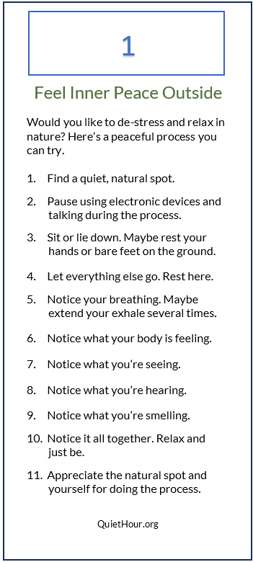
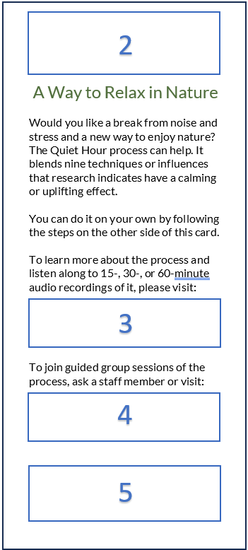

​
​
​
​

Would you like to de-stress and relax in nature? Here’s a peaceful process you can try.

- Find a quiet, natural spot.
- Pause using electronic devices and talking during the process.
- Sit or lie down. Maybe rest your hands or bare feet on the ground.
- Let everything else go. Rest here.
- Notice your breathing. Maybe extend your exhale several times.
- Notice what your body is feeling.
- Notice what you’re seeing.
- Notice what you’re hearing.
- Notice what you’re smelling.
- Notice it all together. Relax and just be.
- Appreciate the natural spot and yourself for doing the process.

QuietHour.org

Feel Inner Peace Outside
Would you like a break from noise and stress and a new way to enjoy nature? The Quiet Hour process can help. It blends nine techniques or influences that research indicates have a calming or uplifting effect. ​
​
You can do it on your own by following the steps on the other side of this card. ​
​
To learn more about the process and listen along to 15-, 30-, or 60-minute
audio recordings of it, please visit: ​

To join guided group sessions of the process, ask a staff member or visit:

A Way to Relax in Nature

​
​
​
​

