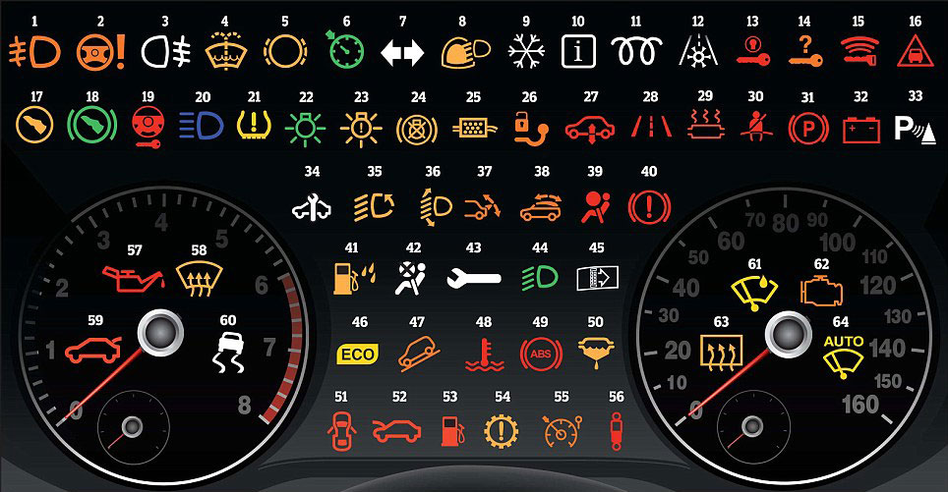
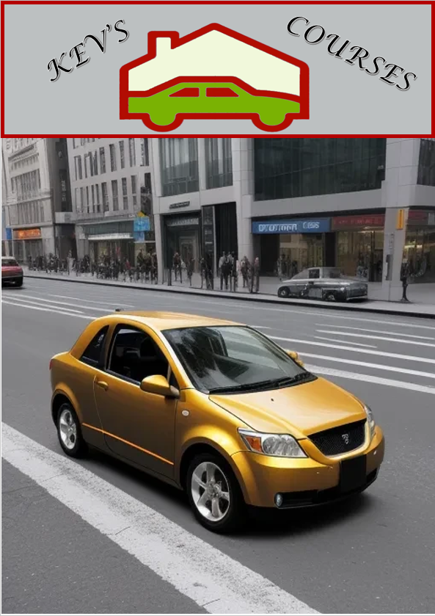
Dash Lights!
What Do They Mean?
Welcome to your Dashboard, no not the one on your computer the one in your car although with modern cars they have computers that run all sorts of systems to keep your vehicle running at optimal performance however when your vehicles computer finds a problem it will show a light on your dash to indicate that something might need looking at, now I say might because not all lights indicate a problem some are there just to notify you of a function that is turned on like your high beam lights so here we will go through what could be on your dash and what it means.
Not every vehicle will have every light it will depend on the vehicle and the added components within that vehicle for instance if your vehicle is petrol (Gas) driven and does not use Diesel it will not have a Glow Plug indicator
Below is a picture of most of the possible lights you may have, your vehicle will definitely NOT have all of them.

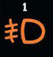
- Fog light (front)
The symbol for the front fog lights (if fitted) is an oval-shaped lamp with three diagonal lines intersected with a wavy vertical line to the left of it. The symbol for the rear fog lights is an oval-shaped lamp with three horizontal lines bisected by a wavy vertical line on its right.

This indicates that the Fog lights are turned on
This NOT a warning light

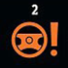
- Power steering warning light
If you're driving along and you notice your power steering light come on – which looks like a steering wheel with an exclamation mark next to it – you should park your car in a safe place as soon as you can, taking extra care as you'll be struggling a little with much heavier steering.

This is a Warning Light alerting you to a problem, most likely that the power steering fluid is low and needs filling, if the fluid is at the appropriate level there may be another problem and you should consult your trusted mechanic.
My course covers how to properly check and fill your power steering fluid.

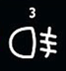
- Fog light (rear) an indicator that your rear fog lights are on if they are installed


- Washer fluid low
What Does an Illuminated Windshield Wiper Fluid Symbol Mean? It indicates a low windshield washer fluid level in the reservoir. The windshield wiper fluid symbol has a windshield sign with a dotted line representing the washer fluid jet.

This is a warning light and the washer fluid needs to be refilled, my course shows how to do this and the benefits of some additives.
It is not important to fill immediately, the next time you refill with fuel will be sufficient


- Brake pad warning
The universal symbol for worn brake pads is typically a circle inside dotted brackets. Certain manufacturers may use their own specific symbols or use the generic “exclamation mark inside a triangle” warning light, along with a message in the dashboard instrument display.
This is a warning light and if you are unable to change your brake pads yourself you will need to have them services by a licenced qualified and trusted mechanic.

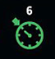
- Cruise control on
The cruise control system will often be a speedometer symbol with an arrow pointing to a set speed. It will light up green when it has been successfully set, and an amber or yellow light can indicate that cruise control is enabled but not set, or that there is a problem with the system.
This is NOT a warning light but simply and indicator that the system is currently in use.

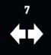
- Direction indicators
Also known as your blinkers, these are just an indicator that your blinker is turned on, these are usually green in colour.
There are certain aspects of faulty blinkers where the light may flash more quickly this sometimes mean there is a blown bulb that needs changing, my course goes through the steps to help you learn how to easily change all of the bulbs in your car

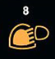
- Rain and light sensor.
Indicator light means there is an issue with the sensor system. The wipers and lights will not function automatically.

This IS a warning light and needs to be looked at by your mechanic

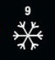
- Winter mode
Winter mode is a feature of automatic vehicles. It takes the first gear out of use. In some cases, it takes the lowest two or three gears out depending on the design of the gearbox.

When you start in first gear, you have a lot of torque. Usually, this is good for getting started, but if there are snow and ice on the ground, this can cause your wheels to spin. Beginning in a higher gear will get you off and moving.
When Should You Use It?
You may want to turn winter mode on as soon as you notice either snow or ice on the road. The other indication is if you try to start moving, but your wheels spin.
When You Might Want To Turn It Off.
While driving with winter mode on, you might find it more difficult to drive up hills. Without your lowest gear, you may struggle. If you find this to be an issue, you can easily turn off winter mode temporarily then turn it back on once you are safely up the hill.
What A Flashing Light Means.
In most cars, there’s a light on the dashboard to indicate that winter mode is on. It’s usually marked with either a ‘W’ or a snowflake symbol. When it’s working correctly, the light will illuminate when you turn it on and go out when you turn it off.
If the winter mode light is blinking, then it means that there’s a problem with winter mode. Even if you turn it on, it won’t be active. This could be an issue with the CPU or with the gearbox its self. If you see this flashing light, you’ll want to get it checked as it can be an early warning that there might be a problem with your automatic transmission.
Reference: https://milta.co/2020/10/30/winter-mode-in-your-vehicle-explained/
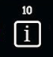
- Information indicator.

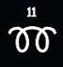
- Glow plug/diesel pre-heat warning
If you see a diesel engine pre-glow warning light come on steady at startup, it simply means that your engine is in the process of warming up and you will be able to start your car or truck momentarily, you will normally need to wait for the light to turn off before starting your vehicle

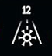
- Frost warning
What does the frost warning indicator light mean? First turns on when the outside air starts to reach freezing temperatures, around 35° F. Even though water usually starts freezing at around 32° F, this frost warning dictator light will turn on before that point to warn the driver that ice may start forming.

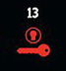
- Ignition switch warning
This light warns you about a malfunction in the ignition system that allows you to turn the engine on and off. ...

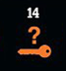
- Key not in vehicle
Usually, a blinking red key not in vehicle warning light indicates an undetected key fob. The car's keyless system cannot pick up the radio signal that the fob generates

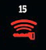
- Key fob battery low
This indicates that the battery inside the key fob is in need of being replaced. You just need to separate the key fob and check to see what the battery number is and buy one to replace it. The computer will see the higher voltage in the key fob and the message will go away

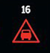
- Distance warning
The distance warning1 function can assist the driver to notice that the time interval to the vehicle ahead may be too short. This requires the car to be equipped with a head-up display* to be able to display Distance Warning.

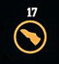
- Press clutch pedal
The press clutch and press brake pedal lights remind you to press on the brake or clutch before starting the engine or while in park mode.

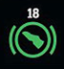
- Press brake pedal

If your vehicle is fitted with an automatic transmission then you may experience this press brake pedal information light. It is indicating that you should press the brake pedal whilst moving the gear lever out of park

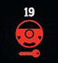
- Steering lock warning

Usually, an amber steering lock symbol will indicate that the car's steering lock needs to be released before the engine can be started. But if it remains red after starting the motor, it suggests there is a malfunction with the mechanism.


- Main beam headlights

The main beam light symbol shows a bulb with horizontal lines coming from it to represent the light projecting from the headlight.

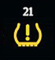
- Tyre pressure low

WHAT IT MEANS & WHAT YOU NEED TO DO. The purpose of the TPMS (Tire Pressure Monitoring System) is to alert you when tire pressure is too low and could create unsafe driving conditions. If the light is illuminated, it means your tires could be underinflated, which can lead to undue tire wear and possible tire failure.

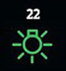
- Sidelight information

Meaning: Indicates the status of the vehicle's sidelights. Explanation: Sidelights, also known as parking lights, enhance vehicle visibility in low-light conditions.

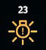
- Exterior light fault

Indicator light means any exterior light on your car isn't working.

- Brake lights warning

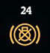
What does it mean if your brake warning light is on? Typically, your brake system warning light being on means your parking brake is engaged, but if you're still seeing the red (or orange) warning on your dash while the parking brake is disengaged, you will need to get your brakes inspected as soon as possible.

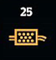
- Diesel particulate filter warning

The experts at Ace Supply explain why ignoring it is never a good idea. When the diesel particulate filter warning light turns on it means that the soot level from the diesel exhaust is high and your vehicle is likely to go into limp mode.

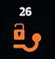
- Trailer tow hitch warning

Indicator lights mean that the tow hitch is unlocked or that there's an issue with the lighting system.

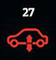
- Air suspension warning

Indicator light means that there is a problem with the air suspension bags, likely due to a leak or inflation issue

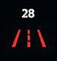
- Lane departure warning

There are four types of systems:

- Lane departure warning (LDW): Systems which warn the driver if the vehicle is leaving its lane with visual, audible, and/or vibration warnings
- Lane keeping assist (LKA/LKS): Systems which warn the driver and, with no response, automatically take steps to ensure the vehicle stays in its lane
- Lane centering assist (LCA): Systems which assist in oversteering, keeping the car centered in the lane, and asking the driver to take over in challenging situations
- Automated lane keeping systems (ALKS): Designed to follow lane markings with no human driver.
Another system is the emergency lane keeping (ELK). The emergency lane keeping applies correction to a vehicle which drifts beyond a solid lane marking.^{[3]}

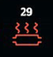
- Catalytic converter warning

Indicator light means the catalytic converter is either overheating or not operating as intended.

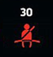
- Seat belt not on

The warning system alerts you if the seatbelts are not fastened when the car is started. Relevant symbols appear on the multifunction display for 30 seconds after the ignition is turned on. A light indicates a passenger has fastened their seatbelt properly, while an empty seat shows the seatbelt is still to be secured.

- Parking brake light

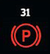
Typically, your brake system warning light being on means your parking brake is engaged, but if you're still seeing the red (or orange) warning on your dash while the parking brake is disengaged, you will need to get your brakes inspected as soon as possible

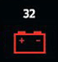
- Battery/alternator warning

Basically, the light indicates a battery charging problem. If the light comes on and stays on while driving, this means that your alternator is running solely on energy stored in the battery. If you continue driving, your battery will eventually drain and your vehicle will stop working.

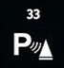
- Parking assist

If the symbol emits green light, it usually means the park assist works as intended. However, if the light emitted by the park assist system indicator symbol turns amber or yellow, something has likely gone wrong. The indicator symbol might add an exclamation mark to the end.

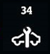
- Service required

The service required warning symbol informs a vehicle's owner that a service or preventative maintenance is required. Quite often this symbol is a courtesy reminder for scheduled regular maintenance, but other times it could be indicating that a more important or serious problem needs to be diagnosed and repair.

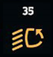
- Adaptive lighting

The adaptive lighting warning light means there is an issue with the automatic function for the front car headlights, which could be caused by dirt
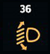
- Headlight range control

An amber headlight range control light means that action is required. There is a fault in the headlight range control system. Please contact an authorised repairer.

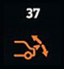
- Rear spoiler warning

What the rear spoiler warning light means. The rear spoiler warning light indicates that a fault has been detected with the spoiler system. The system will be temporarily deactivated to prevent any damage from occurring.

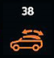
- Convertible roof warning

This lamp will be lit while the roof is either opening or closing. When the roof is fully opened or closed the lamp goes out. If the lamp is lit continuously the roof is not fully opened, or there is a fault in the system

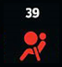
- Airbag warning

The airbag light is an indicator that there is a problem with the vehicle's Supplemental Restraint System. This system includes various crash sensors and the airbags themselves

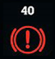
- Handbrake warning

The handbrake warning light illuminates when you have the handbrake on. Don't start driving until this light is off – you may have left the handbrake on slightly, and that means the brake shoes could be rubbing and they will overheat.

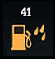
- Water in filter

If water accumulates in the fuel filter, the warning light comes on when the ignition switch is in the ON position. If this warning light illuminates, take your car to a professional workshop and have drain the water and check the system.

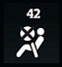
- Airbag deactivated

When this light is on, that means your airbags are deactivated. It means they will not deploy properly if you get into an accident. Needless to say, this is a serious issue that you will want to get rectified quickly for your safety and the safety of your passengers

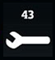
- Fault problem Service Vehicle Soon

Indicator light turns on when there is a fault condition in an area of the vehicle chassis systems such as—the anti-lock (ABS) brake system, the traction control (TCS) system, the electronic suspension system, or the brake hydraulic system.

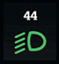
- Dipped beam headlights

You'll see a dome-like shape with lines directing downwards on the stalk to indicate low-beam headlights are on. This should also show a matching green or yellow symbol within your instrument cluster. If this shows as blue with the lines pointing straight on, this means your high beam headlights are on.

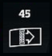
- Dirty air filter

This light means that your engine air filter may be obstructed or dirty. A common fix is resetting the button as well as getting the filter replaced.


- Eco driving indicator

During Eco-friendly acceleration (Eco driving), the Eco Driving Indicator Light will turn on. If acceleration exceeds the Zone of Eco Driving or the vehicle is stopped, the light turns off. The Eco Driving Indicator is designed to increase fuel economy and can be activated or deactivated

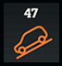
- Hill descent control

Hill descent control switch turned ON. If the hill descent control indicator light is ON steadily, the system is ON and engaged, controlling vehicle speed. If the hill descent control indicator light is blinking, the system is ON, but not engaged, not controlling vehicle speed.

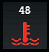
- Temperature warning
If this light turns on, it means that your vehicle has detected that the coolant temperature is too high. This indicates that your engine is likely overheating. If your engine is overheating, it is recommended to pull your vehicle over to a safe place and turn off the engine for at least 20 minutes.

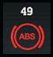
- ABS warning

Anti-lock Braking System
The ABS warning light is an icon on a vehicle's dashboard that alerts the driver to a potential problem with the ABS (Anti-lock Braking System). The ABS on a car, truck, or SUV prevents the wheels from locking up when a driver slams on the brake pedal in an emergency situation or on a wet or slippery surface.


- Fuel filter warning

Driving with a fuel filter warning light on is a bit like tightrope walking without a safety net. Yes, you can continue to drive, but that doesn't mean you should. When this particular light illuminates, it's indicating that there might be a clog or other issue in your fuel system.

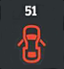
- Door open

The door open symbol on your dashboard is more than just an image; it's a vital alert that one or more doors are ajar. The ability to recognize this symbol ensures safety, preventing accidents that can occur if doors are inadvertently left open.

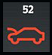
- Bonnet open

This might be because you have opened it on purpose to check something in the engine, top-up fluids, or if the car is in the garage to be fixed. If you see it when you are driving, however, it usually means that the bonnet has not been closed correctly

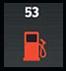
- Low fuel

In most new and used models, the “Low Fuel” light signal is either designated by flashing text or a symbol of a gas pump. There are sensors in your tank that let your electronics know when you're running out of gas, and the light will start flashing when you're down to either a gallon or 1.5 gallons of fuel left.

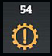
- Automatic gearbox warning

The transmission warning light (or message) indicates there's a problem with your car's automatic transmission or associated components. Some of the most common triggers of a transmission warning light are low transmission fluid levels, overheating, and internal transmission failure

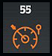
- Speed limiter

The speed limiter function helps you stay within the driving speed limit that you choose, known as the limit speed. Controls When this green light is displayed, it means your speed limiter is on and your car will not exceed the maximum speed you have set.

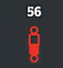
- Suspension dampers

The indicator likely either shows you what setting you are using, or alerts you to a fault in the system.

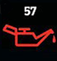
- Oil pressure low

When the oil light on your dashboard comes on, it might mean your vehicle has low oil pressure. This drop in oil pressure could be a sign of a few things: you are low on oil, your oil is dirty, or you have an oil leak.


- Windscreen defrost

What the defrost indicator light means. Whenever the light is illuminated, the defroster is turned on. The symbol for the front is a curved window, while the rear is rectangular. While you are defogging the windshield, you may not be able to get air out of the normal vents

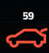
- Boot/trunk open

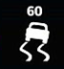

- Stability control off

ESC OFF indicator light (ESC OFF ) will illuminate and ESC OFF warning chime will sound. At this state, the engine control function and brake control function do not operate. It means the car stability control function does not operate any more.

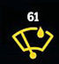
- Rain sensor

Automatic lights and windscreen wipers are becoming increasingly common on new cars. If this warning light appears, it's telling you there's a problem with one of them

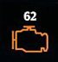
- Engine/emissions warning

Some common causes for the emission light on car illuminating are: Emission system fault – This is when the engine is burning too much fuel, increasing your carbon footprint. The emission light on car could also be on because the system is not burning enough fuel, or if the sensor is broken

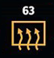
- Rear window defrost

What the defrost indicator light means. Whenever the light is illuminated, the defroster is turned on. The symbol for the front is a curved window, while the rear is rectangular. While you are defogging the windshield, you may not be able to get air out of the normal vents.

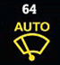
- Auto windscreen wiping

Autowipers uses a rain sensor in the area around the interior mirror. The wipers operate when the rain sensor detects water on the windshield in front of it. The rain sensor continues to monitor the amount of water and adjusts the speed of the wipers. You can switch autowipers on or off in the information display.

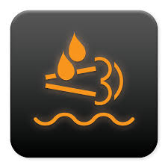
DEF This one was not on our original picture but it is called the Diesel Exhaust Fluid more commonly called Ad Blue.
If this light is on it means you are out of or getting low od Exhaust Fluid and need to top up at your next refuelling, some vehicles will not run if this runs out

Stay safe on the roads and catch any issues as soon as possible, if you are unsure it's always safer to ask a professional.
How do I reset my dashboard warning lights?
While DIY engine code scanners are available, simply removing persistent dashboard warning lights only treats the symptom and not the cause.
Your car has been built with sensors to identify faults that range from mild to potentially catastrophic, so if you find a dashboard warning light keeps returning, it is likely indicative of a larger problem.

