

FUEL SAVING TIPS FOR YOU TO SAVE MONEY
How to save fuel
One of the biggest gripes in the economy today is the price of fuel yet it is a necessary evil as we need fuel to go to work so we can earn enough money to pay for the fuel we need to be able to get to work. So how can we optimise our vehicles to make them as fuel efficient as possible.
First we have to have a look at just what causes our cars to use more fuel than it should.

Incorrect fuel:-
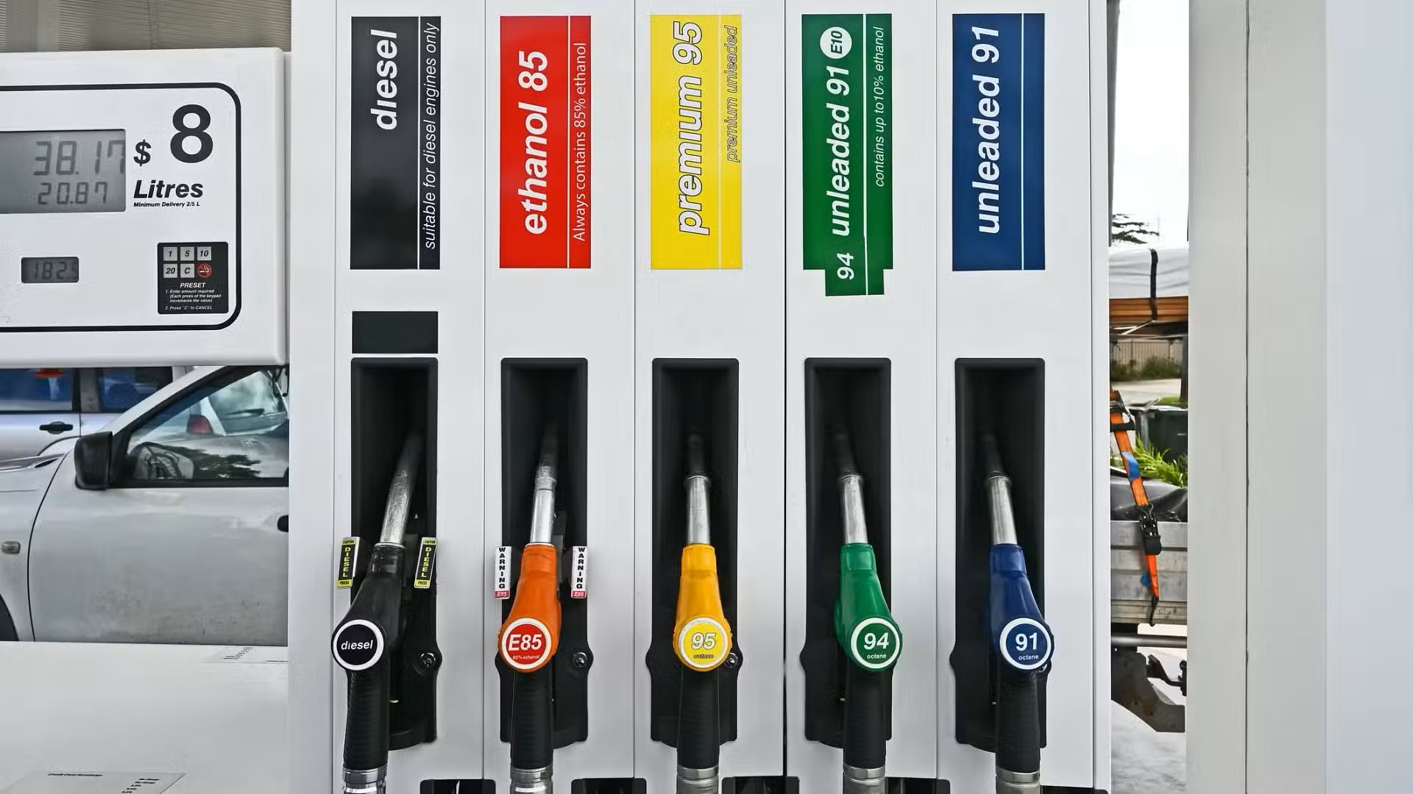

There is a lot of speculation about what fuel to use which depends on the amount of OCTANE used in the fuel.
There is a number of different fuels to consider regular unleaded 91, Premium Unleaded 95 & 98, E85, E10. Diesel, Liquid Petroleum Gas (LPG)
Regular Unleaded 91
Generally the most readily available type of fuel in Australia, regular unleaded petrol has an octane rating of 91. While it doesn’t have the octane rating of premium unleaded fuels, regular unleaded is cheaper at the bowser, making it suitable for petrol-run cars that don’t have high-performance requirements.
Premium unleaded petrol (95 and 98)
Available in octane ratings of 95 and 98, premium unleaded is suited to high-performance cars and is significantly more expensive per litre than regular unleaded. While they can be used in cars that commonly run regular unleaded, the difference in performance might not be worth the extra cost.

E10
An alternative to regular unleaded petrol, E10 is a fuel that includes a 10% blend of ethanol with 90% ULP. Ethanol generally has a higher octane rating than petrol, which means that adding it to ULP increases its overall rating to 94.
Depending on where you live, E10 may be cheaper at the bowser than ULP. However, it generally isn’t as fuel efficient as regular unleaded, as your car’s petrol consumption may increase by around three per cent when using E10.²
E85
Also known as ‘Flex Fuel’, E85 blends 85% ethanol with 15% unleaded and is generally used in professional racing due to its high-octane rating of 105. In fact, as of the 2009 season, all V8 Supercars have converted to the ethanol blend.³
While it’s more environmentally friendly and may be cheaper than 98 petrol at the pump, E85 is only available at select service stations. Also, older engines might have to be converted to be compatible with E85.
Diesel
Diesel is a common fuel for SUVs and work utes, and is becoming increasingly popular for luxury European brands as well. Traditionally, diesel engines have been more robust than petrol engines, and advances in technology have also made them a more environmentally friendly option than many petrol powered vehicles.
There are also biodiesel and premium diesel fuels available on the market. As such, make sure you read the manufacturer’s guidelines for your vehicle. Also, it’s a good idea to check what’s in the premium/bio-diesel as your engine may not be designed to work with some of the premium additives and ethanol mixes on the market.
Liquefied petroleum gas (LPG)
LPG, also known as Autogas, is a mixture of propane and butane and is generally considered one of the more eco-friendly fuel types. Most standard combustion engines can be converted to LPG with conversions costing a few thousand dollars.

How do I know what fuel my car takes?
Your car’s owner’s manual should outline the recommended fuel for your vehicle. This information can also often be found on the inside of the fuel cap.
So, if the label on the cap says ‘unleaded petrol only’, it can run on regular unleaded petrol or higher octane fuels. Conversely, ‘premium unleaded fuel only’ signifies that your car should only be filled with fuel above 95.
Reference https://www.comparethemarket.com.au/fuel/best-fuel-for-your-car/
It can be beneficial to test the efficiency of your car with different fuels and make comparisons to usage and cost, for instance fill your vehicle with the desired fuel and drive until you have used most of that fuel push the trip metre so you can see the distance travelled, refuel with the next type of fuel and continue with the test (Driving conditions should be the same for each test eg highway driving) for instance you could start with 91 then try 95 then 98 and then E10 (providing your vehicle is capable of using that fuel eg a vehicle that the manufacturer suggests using 98 will probably not be able to use E10)
Working out your efficiency for each type is fairly simple.
Distance travelled 540km and using 54ltrs means you have an efficiency of 10ltrs per 100km (54 divided by 540 times by 100 = 10 )
If the next fuel used gives you 580km using 52ltrs gives you a fuel use of 52 divided by 580 times by 100 = 8.9 ltrs per 100km
You then need to consider the cost of the fuel as well

So if 91 gave you 540km with 54Ltrs and cost $1.91 per Ltr the cost of fuel was $103.14 = $0.0524 per km (540 divided by $103.14)
If 98 gave you 580km with 52Ltrs and cost $2.13 per Ltr the cost of fuel was $110.76 = $0.0523 per km

Tyres:-
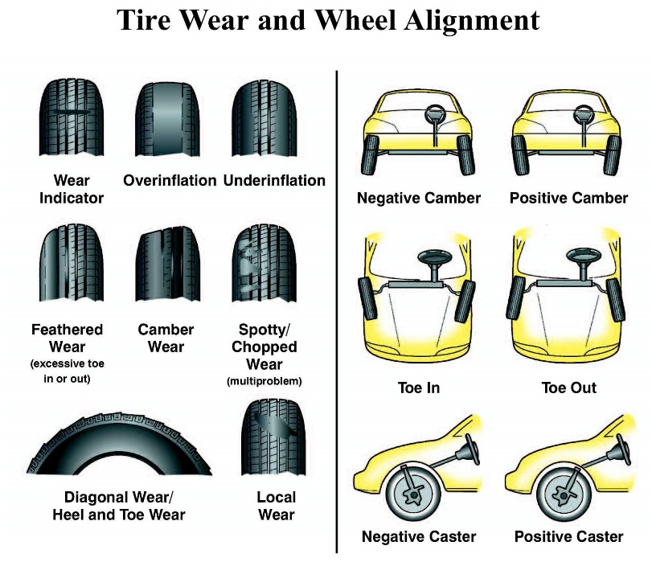

We often consider whether or not our tyres are worn out but there are a few other things to consider when we are talking about fuel efficiency.
Do you have the correct tyres for your car? Your owners manual will outline the correct tyre size and inflation level for your car, there should also be a label inside the front door jamb of your car which outlines the correct tyre inflation level for your car. If you have the tyres that are oversize or undersize for your car it could change the efficiency of the car as well as make your odometer read incorrectly meaning you could be driving faster than you think and risk the possibility of a speeding ticket.
Under inflated tyres can cause more drag making the car work harder to maintain the same speed and in turn make the car less fuel efficient. (under or over inflated tyres can cause uneven wear on your tyres causing damage and needing replacement prematurely and costing money for virtually no reason)
While looking at tyres and uneven wear if your wheel alignment is not correct it will not only wear your tyres prematurely costing more money but also mean your car is again working harder than it needs to and cause more fuel use.

Wind Resistance:-


Do you ever consider the condition of your car could be causing more fuel use?
It may not seem like it will not cause too much problems and although correct to an extent dirty cars don’t cause too many problems however the dirt on your car can cause drag and in affect cause less fuel efficiency so just by cleaning your car can help you save on fuel.

Accessories:-
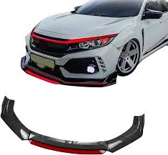
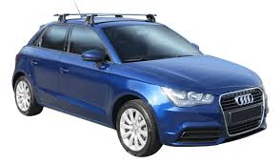

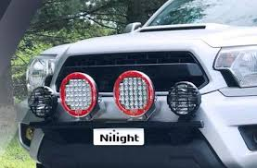

Some people like to upgrade their car with accessories like spoilers and although there is some evidence that a real spoiler can possibly help with fuel efficiency and handling the cost of installing these can far outweigh the saving in fuel and a lot depends on the type of car as well as many other factors.
Front lower spoilers will definitely cause an impact as well as side guards wider tyres.
Spot lights, roof racks all cause extra wind resistance as well.

WEIGHT :-
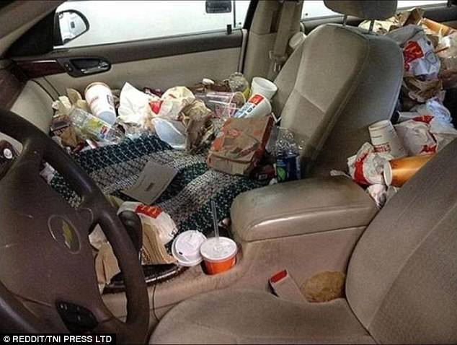

This may be extreme but I have seen worse
Anything in your car that doesn’t need to be there will cause less fuel efficiency, your boot full of toys, games, beach gear, camping gear and unnecessary tools add weight to your car, inside, water bottles packages, computers etc all add up.

OIL :-
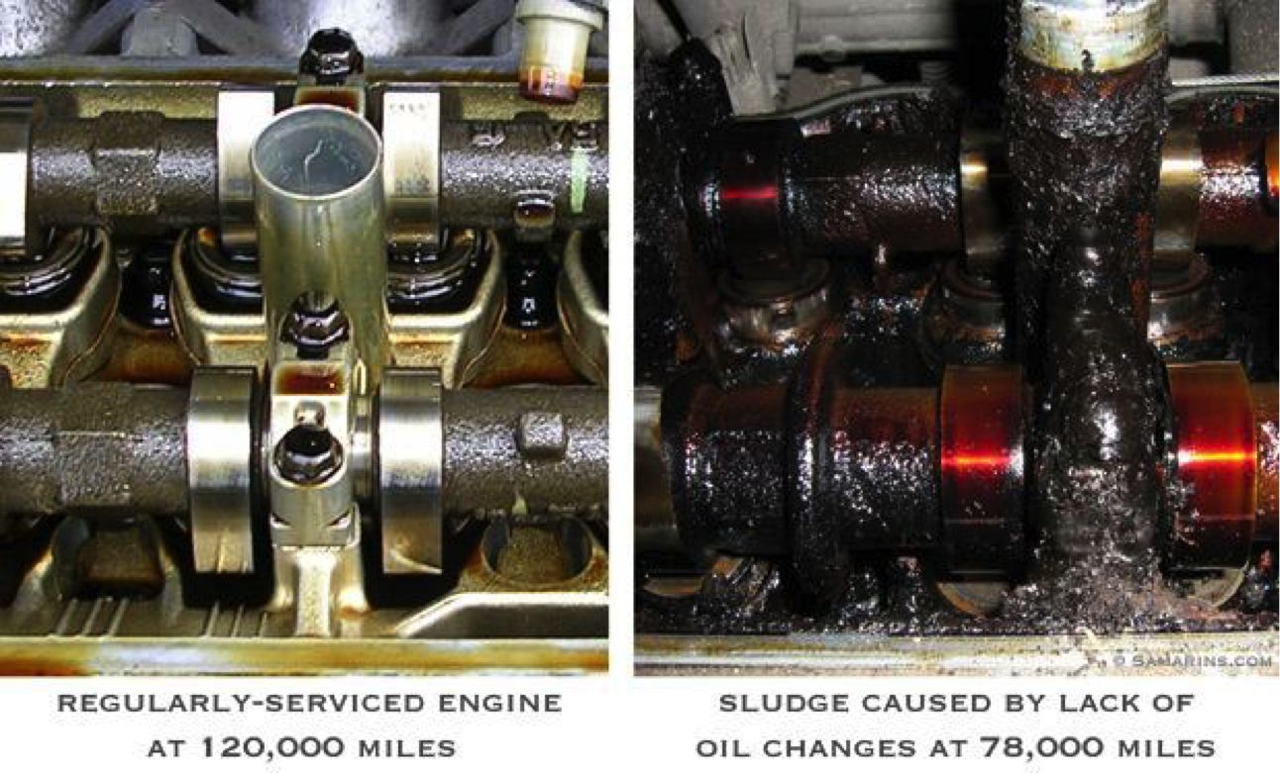

Your cars engine has been designed by the manufacturer to run at its’ optimum level with the correct oil (check your owners manual) You can’t just put any old oil in your car (enrol in our course and what all those numbers on the oil bottle means and also how to change your own oil)
If you don’t change your oil as often as you should (approximately every 10,000 km) the dirt and grunge in the oil can make your engine lose its efficiency and also cause premature wear costing extra money. The engine will now be working harder and cause you to use more fuel.

Engine components:-
All of the components that go into your engine are designed to make that engine run as smooth and as fuel efficient as possible so it makes sense that as the parts wear over time the engine will become less efficient so it is important to make sure that you maintain your vehicle and change out parts when needed.
Some of the most important parts that will need attention.
- Spark plugs – these wear over time and different plugs have different wear times, some can last as much as 100,000 km but you will need to check with the manufacturer as to what your vehicle takes and how often they should be changed.
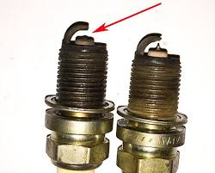
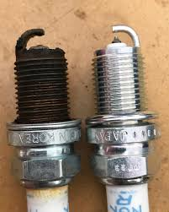

- Air Filter – Something that should be checked at least weekly, when dust builds up in the air filter it makes the engine work harder to get enough air, air filters can be cleaned out with a compressor and air nozzle however even if you clean it, it will still need to be replaced now and then.
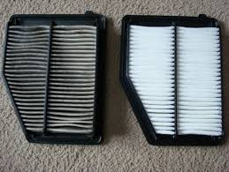

- Vacuum leaks – The engine uses a system where it uses suction to get the correct amount of air into the system to function correctly this is call the “air fuel mixture” if the mix is incorrect the engine can use substantially more fuel and cause a hole in your hip pocket. There are tools you can buy to check a vacuum leak but it may be better to take your vehicle to a trusted mechanic to test. If your vehicle has a vacuum leak one of the most common things to see is a black or sooty exhaust which generally means your vehicle is running too rich.
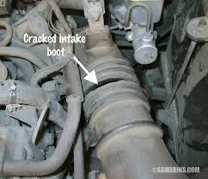

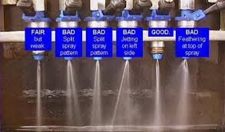
- Defective fuel injectors can get clogged they do not spray the fuel correctly and could cause more fuel use, I don’t know of any additives that work but you can google and find some information the other option is to get your mechanic to run a clean on your engines fuel injection system.

Excessive Idling
- Idling for too long – more than 30 seconds at a time – has a severe impact on how much fuel your car uses. Ideally turn your car off or put it in neutral to save fuel and, of course, money.

Driving in Wrong Gear
- Every gear has a speed limit, and this must be observed cautiously. If you are driving at higher speeds in lower gears, the RPM will be higher, and the engine will consume more fuel. Also, do not accelerate your car harder than it is necessary to change gears or to propel it from a standstill. Moreover, letting your car struggle in a higher gear in corners or in the hilly areas is also wasteful on the fuel.

Over speeding, Overloading, and Air Conditioning
Over speeding always puts a strain on the engine as it has to work hard. This results in more fuel consumption than driving at normal speeds. Generally, in normal cars, speeds above 120 km/h result in fuel wastage. Similarly, overloading also puts undue pressure on the engine. In order to propel the added weight, the engine must work harder to produce more power; therefore, using more fuel in the process.
If you are driving with air conditioning turned on, the engine surely consumes more fuel. However, if you are driving at higher speeds, turning on the air conditioning might result in better fuel economy compared to opening up the window. This is because the latter creates aerodynamic drag, which reduces fuel efficiency.
Moreover, when your car is standing, in the sun and the interior is hotter compared to the outside temperature, open the sunroof and the windows to help the interior cool down naturally. This will put less of a strain on the engine when air conditioning is turned on.

Erratic Driving Style/Habits
If you drive your car at a higher rpm range, you will definitely consume more fuel. Also, if you shift gears often, your engine goes through fluctuation of torque output which causes it to consume more fuel. Hitting the pedal to the metal doesn’t make any sense. Be slow and steady when you start accelerating. Same is the case with braking. Keep a careful check on the road. Repetitive braking and sudden acceleration cause low fuel mileage on your car so try avoiding that on a busy road.
Conclusion:-
It is supremely important to keep your vehicle in tip top condition, keep it maintained and look out for tell tale signs that it is not quite running correctly.
Make sure your tyres are inflated correctly and the wheel alignment is also correct.
Make sure your air filter is clean
Our Vehicle maintenance Course can show you how to take care of your vehicle and save thousands of dollars over the life of a vehicle.

