Kev’s Courses


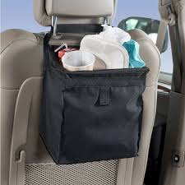
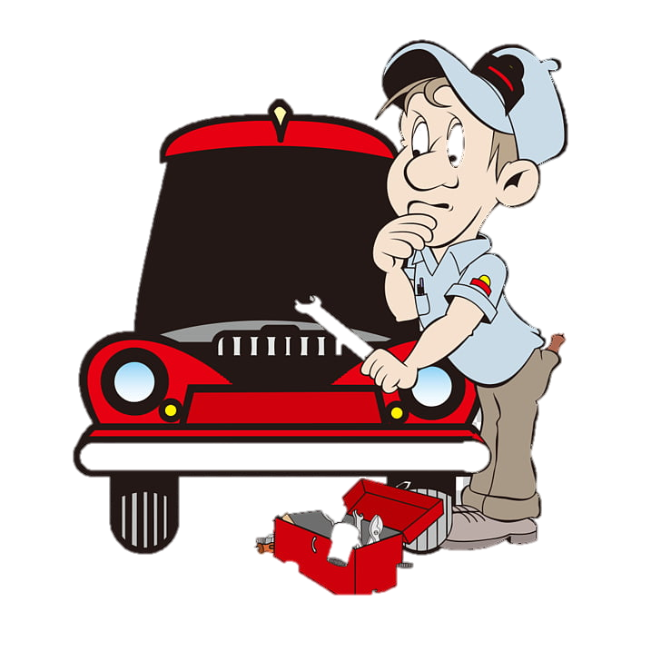
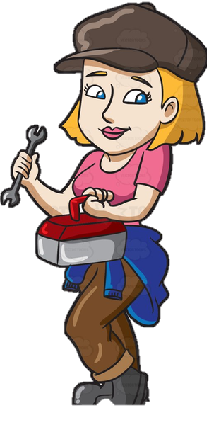
Aarrrggghhh What’s that noise?
Diagnostics for noises coming from your car!
Disclaimer: The information here is for information only with no liability either real or implied by the author.
Note:- You are responsible for yourself and your own safety if you decide to embark on any of the diagnostic suggestions within.
Rattles, Thumps and Bumps:-
The fundamentals of finding a rattle is to make sure it is not simply 2 items you have placed in the car yourself rubbing together. I have seen people take cars to a mechanic because every time they braked there was a thump noise only to find out it was a water bottle under rolling around under the seat. More often than not a rattle comes from a couple of coins or other metal object rubbing together when driving. It’s possible that it is a couple of coins under an empty can of drink in a cup holder or in the glove box.
The first thing to do in the attempt to diagnose a noise in your car is to clean it out, making sure to remove any coins and or metal objects from pockets, glove boxes, storage areas, drink holders, under seats and any sections in the rear of the car including in the spare wheel well.
If after you have cleaned the car and the noise has not disappeared then it is time to track it down before it drives you mad.
It helps to have friends or family members sit in the passenger seats while you drive. This will help determine the direction in which the noise is coming from as these noises can echo and seem like they are coming from different places.
Now the question is what does the noise sound like?
Is the noise only there after driving at certain speeds?
Does it sound like it is coming from inside or outside of the car?
Is it above or below or front or back of the car?
Now that you have established the approximate location and sound of the noise you can start to dial into the cause.
Here is a list of possible noises and causes. This is not a definitive list as there can be hundreds of different noises and causes but these are the more common ones.

Humming:-
1). There are several types of humming noises and one of the most common is a bad wheel bearing – this is usually a low droning sound that usually appears after you reach approximately 60kmh (35mph) and can get louder and higher in pitch the faster you go.
The reason for this is the bearing which is located in the wheel hubs has either come to the end of its’ life or something has happened for it to become warn sooner than it should, for instance, maybe a dust cover has come off allowing grit to get into the bearing and wearing it out.
Bearings are not any easy job to replace for a novice and would best to take your vehicle to a mechanic for further diagnosis and repair depending on recommendations from the mechanic.

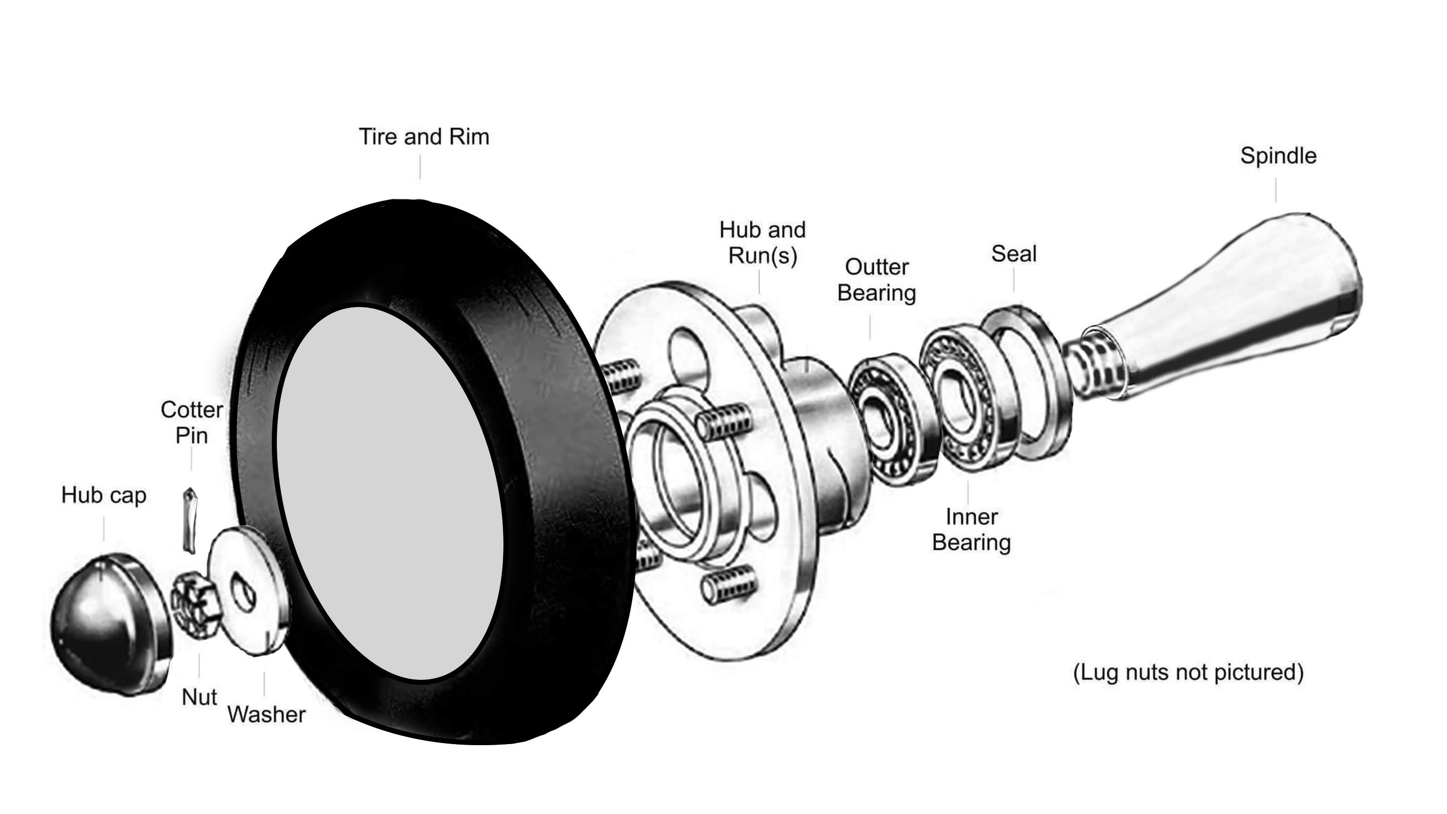

2). The next option could be the gearbox or transmission, in this case it can still be a worn bearing inside the box or worn gears rubbing against each other due to insufficient maintenance or again just the age of the car.

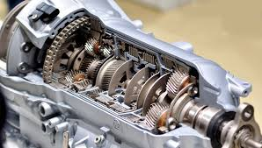
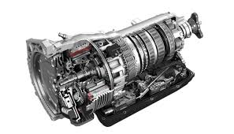

3)Another option is a differential (the Diff) and depending on your car if it is rear wheel drive it will have a Diff in the rear or if it is a 4X4 there will be one in the rear and another in the front of the vehicle. The Diffs again have bearings and gears that could be worn and making a noise.
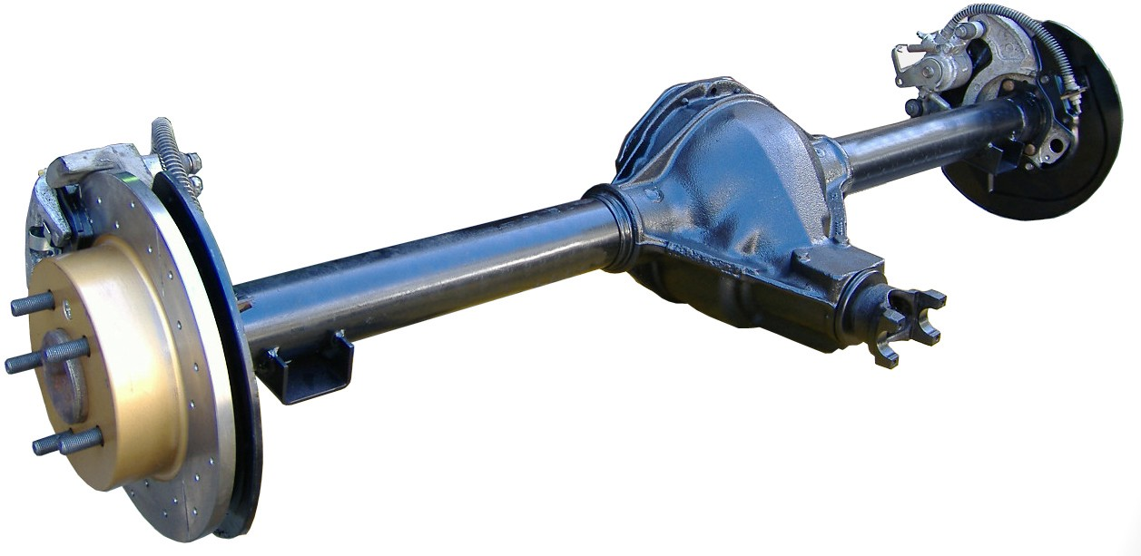

All these parts need to be serviced regularly and if needing replacement this should be done by a licenced and competent mechanic.

Whistling:-
Whistling usually happens when wind is passing by a hollow tube or could be rushing passed leaves or other debris trapped in and around the gaps in the bonnet or other gaps in door panels or around the grill or other parts around the front of the car.

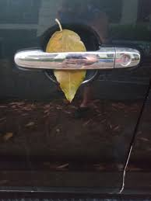

Look for any open holes in bull bars or roof racks. Roof racks usually have rubber stoppers in the ends and if one comes off it leaves a tube that the wind can echo around inside the tube and make a whistling sound. Leaves can vibrate and whistle under the right circumstances if they are jammed near and opening.

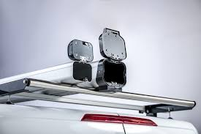

Metal on Metal Grinding:-
The most common cause here is worn brake pads where the pad has worn off all of the braking material off the pad leaving only metal to grind against the brake rotor.
If this is the case then both the pads and rotors will need replacing, however, if you have followed my course you should have changed your brake pads well before this situation arises. If not this is going to be an expensive fix.


This is the worst case scenario. If your brake pads and rotors look like this you are most welcome to say Oh Crap!

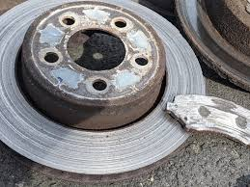

Clunk when Driving:-
This one can be difficult to find but it will most likely be under the car in the steering or suspension and we will discuss variations in the next couple of paragraphs.
If the noise occurs when you are turning corners and or steering left to right or right to left, it is most likely going to be a Tie Rod End or Ball Joint that has worn and needs replacing.
Finding these can be fairly simple but you will need to get it checked out under the car either by yourself or by a competent mechanic to confirm the problem.
If you decide to do this yourself, make sure the car is parked with the selector in park or if a manual car in first gear and the handbrake on and the keys removed from the ignition, you may also put a note on your steering wheel to prevent anyone else starting the car and driving off while you are underneath, also put some wheel chocks under the wheels to prevent the car from moving, remember to make sure everything is safe before climbing under any car.
You are going to be looking at the front steering of the car and so it is most likely it will be easier to climb under the car from the front.
Use a torch (flash light) to look around under the car. You are looking for the attachment points from the steering to the wheels. Put on some disposable gloves to avoid getting grease on you and hold the connecting rod and see if you can move it by twisting it. If you can and it is loose, you might be able to see the joint at the end of the rod.
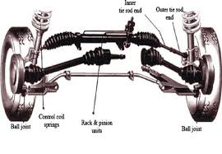
Obviously if you find loose or worn parts you will need to have them repaired or replaced to make the car safe and roadworthy again.

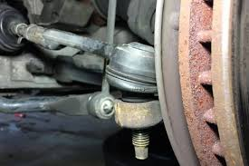

Clunk when going over Bumps:-
This one will most likely be from part of your suspension system and similar to the Tie Rod or Ball Joint there could be loose joints in both the front and bac k of the car, a thorough search with your torch should be able to find the worn parts.
The other thing you will be looking for are worn bushings (Rubber Mounting Points) this can be cracked, broken or even missing from shock absorbers, suspension parts, and steering points.
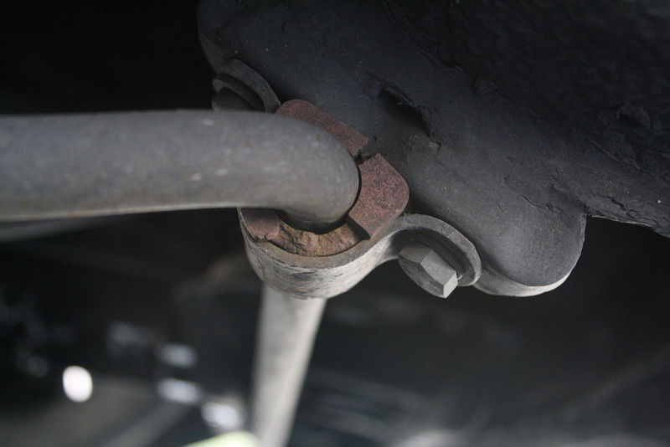
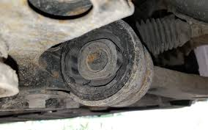
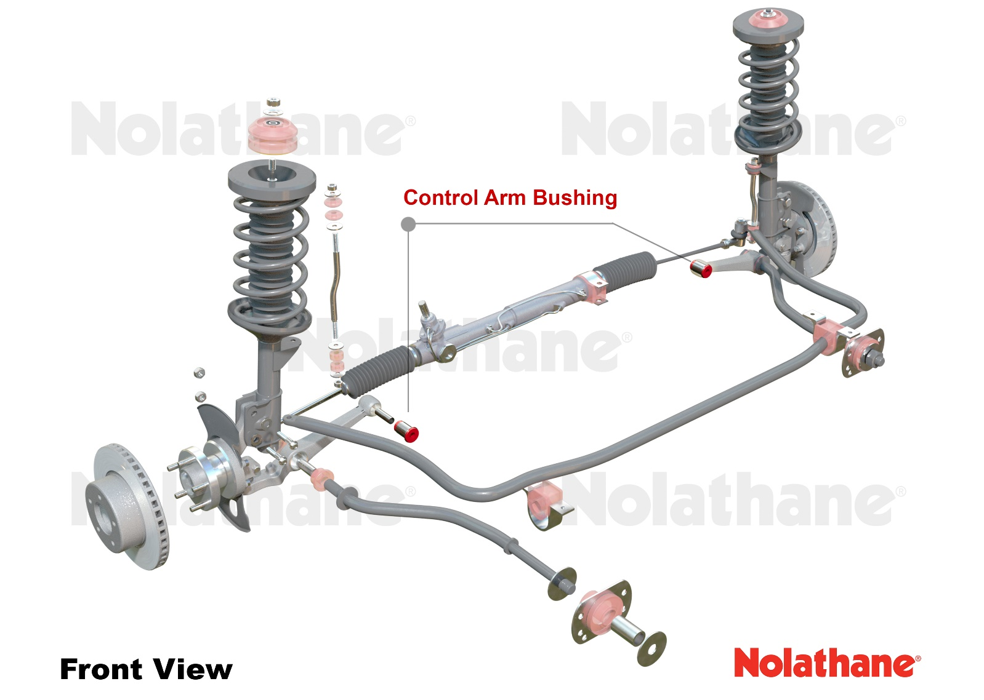
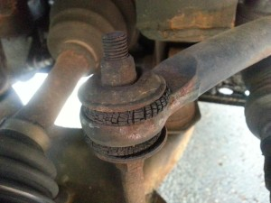
Clunk when putting into drive or Reverse:-
If you are putting the car in Drive or Reverse and there is a clunking sound there a few possibilities below but not limited to:
1). There could be a loose bolt within the drive train, that is it can be anywhere from front to back, suspension connections, broken engine mount or loose engine mount bolts, gearbox cross member bolts or mounting bolts, rear suspension mounting bolts.
2). There could be a problem with the Gearbox or Transmission itself.
3). A problem with the universal joints on the drive shaft.
4). A problem with the rear Diff
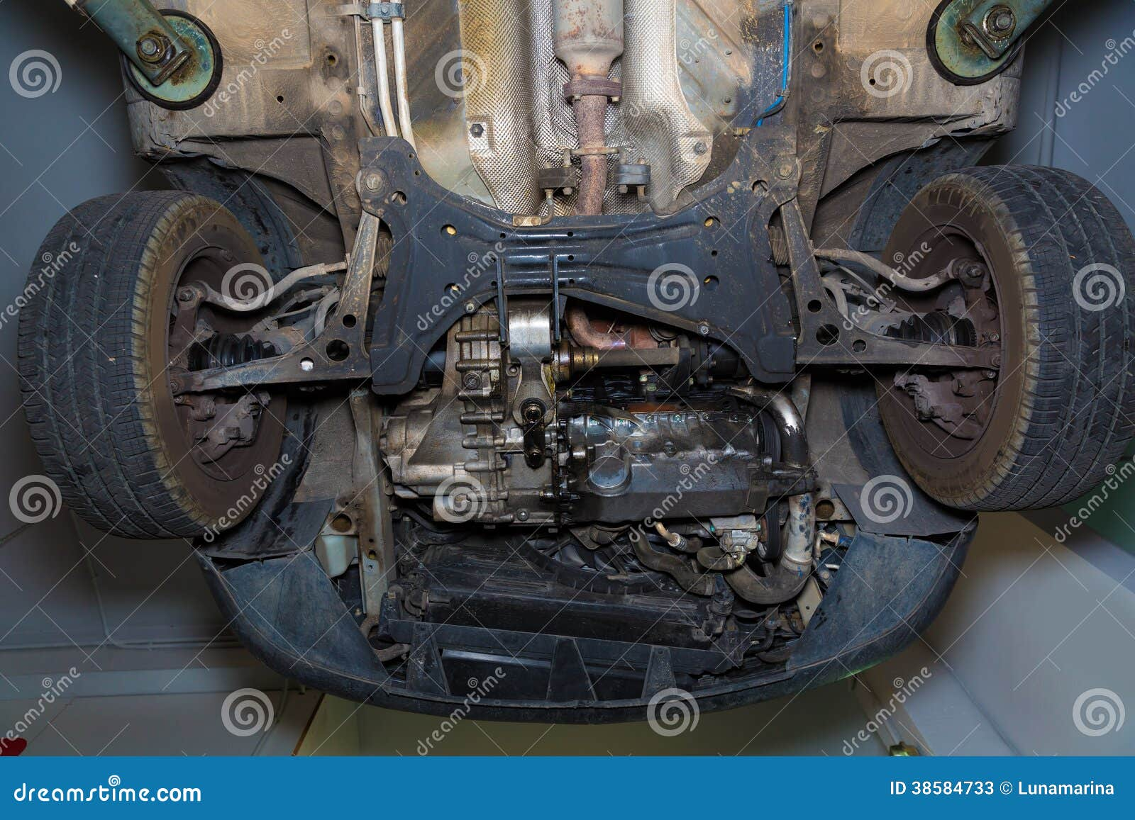
By getting under the car (only when it is safe to do so as mentioned before) and looking at all the connection points with a torch you may be able to see a loose connection, however, my suggestion is to get a trusted mechanic to check your vehicle.

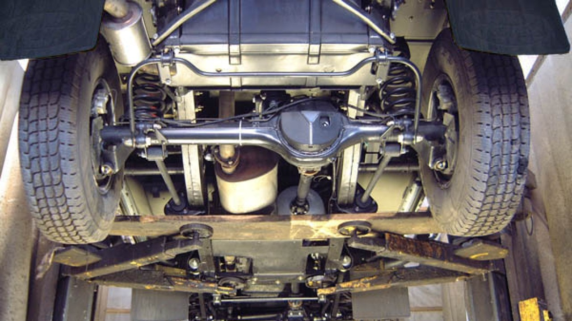

Squeaks:-
Squeaky noises are generally coming from 2 items rubbing together, (there is nothing worse than polystyrene rubbing against something) so after you have cleaned out your car and there is still a noise, it becomes more difficult to track down. Time and patience should prevail. It can be as simple as an internal door panel rubbing on the door frame. This can be fixed by possibly spraying some WD 40 or even a silicon spray on the affected item creating some lubrication.

Vibration when Driving:-
There a few things that can cause a vibration while driving.
1). The most common reason is an unbalanced wheel, this can happen if the wheel was not balanced correctly to start with or a wheel weight has fallen off the wheel over time, take the car to a tyre shop and have them rebalance the wheels.

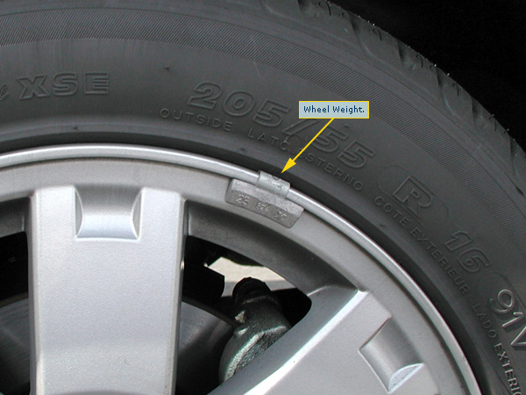

2). If there is a problem within the braking system this can also cause a vibration.
3). A worn connection in the suspension system. This could be a bolt or bushing.
All of these should be checked by a competent mechanic for diagnosis and repair.

Whining:-
Whining is usually a worn bearing but unlike wheel bearings this will generally be a higher pitch sound and most likely coming from the front of the car.
There are quite a few bearings being used in the front of the engine and so can be difficult to diagnose exactly which one it is.
Culprits can be the alternator, power steering, air conditioning compressor, water pump, radiator fans or anything that has a pully attached.

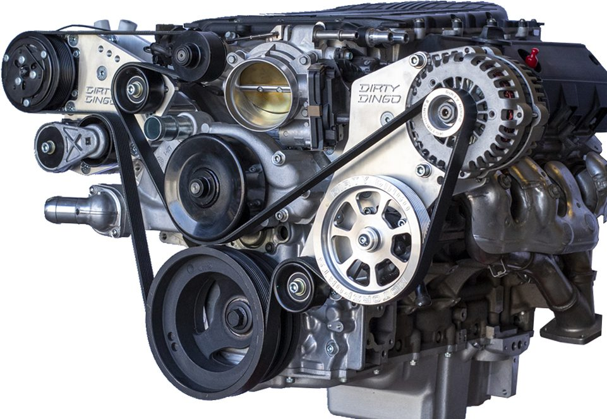
Air Conditioning Compressor
Idler Pulleys
Alternator
Harmonic Balance Pulley

Grinding:-
If not the Brakes then it is a moving part coming into contact with another part, seems logical right? Grinding is metal on metal contact under pressure. You need to distinguish when this is happening so if it is only happening when you are turning left or right then it is most likely that it is the wheel coming into contact but if it is when driving straight it can be a lot more difficult to find. It could be an internal engine and/or gearbox problem.
Scraping:-
Scraping is a much lighter sound that grinding and can be as simple as a plastic inner guard scraping against the wheel, sometimes a rock can get caught between the brake rotor and the cover plate. Again, listening to where the sound is coming from will greatly help in finding the cause.

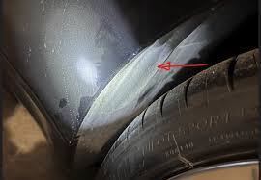

Back Firing Popping:-
This is more likely to be on an older vehicle with a carburettor and is caused by improper timing e.g. when the spark-plug fires in relation to when the valves are opening and closing. You will need a competent mechanic to help adjust the timing in your vehicle.

Tick Tick Tick Tick:-
This can be a particularly bad noise to hear and will most likely be coming from one of two places
1). the CV joints in your front wheel drive car especially when you are turning slowly around a corner.
These can get damaged because the grease boot can crack and allow grit into the grease and become like liquid sandpaper and wear the join prematurely.
This is a difficult job to replace the CV Joint with the need of specialised tools and experience.
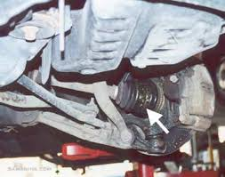
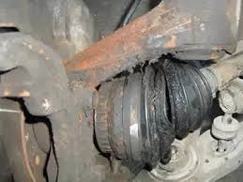
2). The second place is in the motor itself, if you are low on oil it could make the tappets or lifters a dry and cause a ticking sound. It may be as simple as topping up your oil.

These are the most common reasons for that noise but there are lots of other reasons that it could be as well.

If you have joined my course, I go through how to check, change and top up your oil as well as 22 other topics on maintenance and repair

