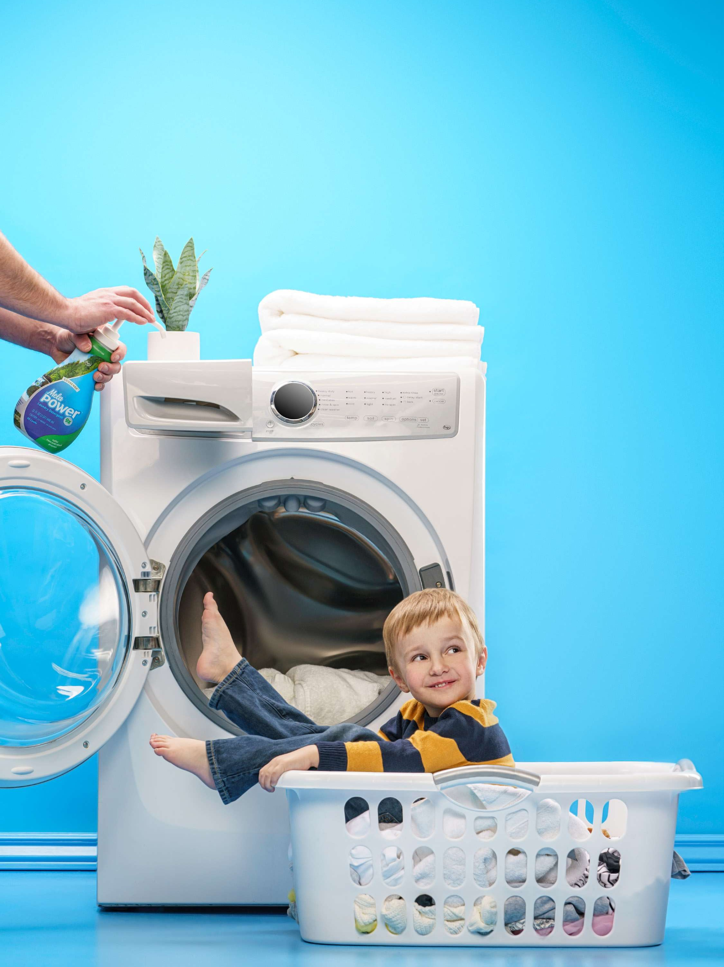

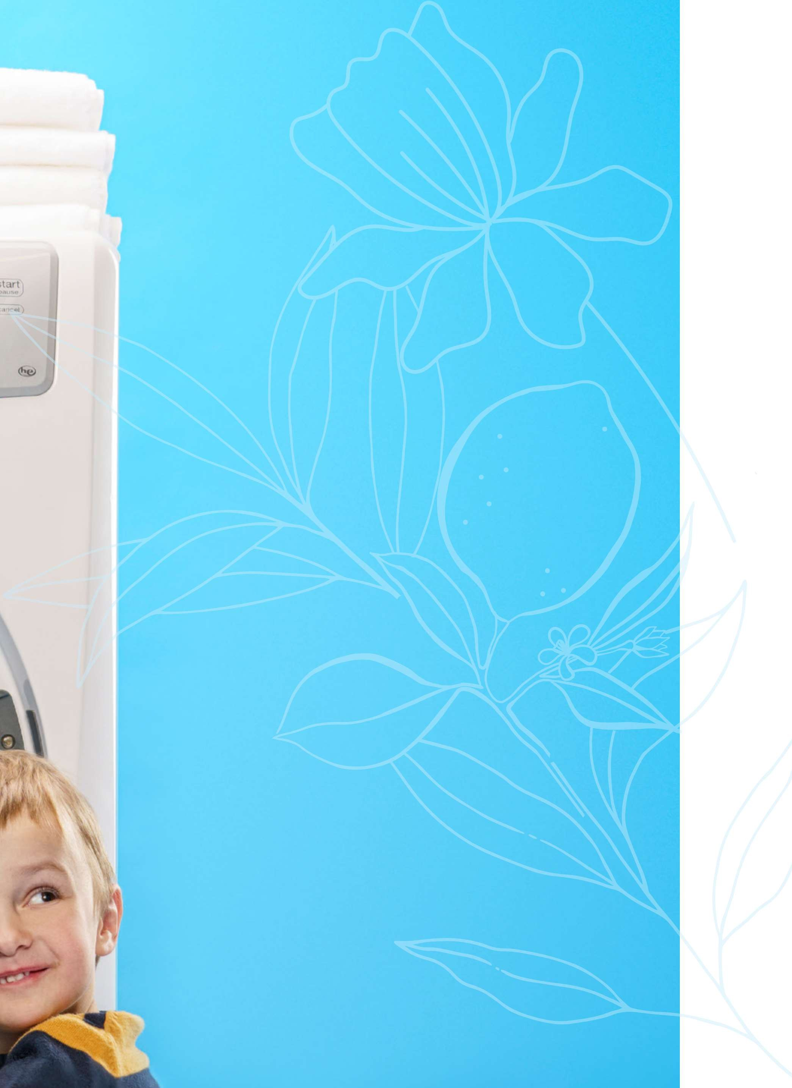







SunshineLivin.com

SunshineLivin

Contents

Introduction O3
Clean without Compromise 0\
CLEANERS 05
Surface Guide 06
Appliance Guide 7
Stain Guide 10
Concentration 1O1 15
Tough & Tender"
All-Purpose Cleaner 16
Clear Power* Glass Cleaner 16
Tub & Tile"“ Bathroom Cleaner 17
No Work" Daily Shower Cleaner 17
Vol-U-Mel Stain Remover 18
Sol-U-Guard Botanical" Disinfeetant i8 Clean &
MelaPower"’ Laundry Detergent 27
MegaBrite"' Plus Oxi z8
MedaBrite Color Booster s8
MetaBoost” Laundry
-ragrance Booster 29
MelaSoft" Liquid Fabric Softener
Dryer 29
DISH GUIDE ]0
Diamond Brite" Automatic
D Detergent 33
EcoSense* Rinse Aid Dishwasher Rinse and Drying Agent
Lemon Brite% Hand Dishwashing Liquid
ORGANIZATION 35

SunshineLivin
Room-by-Room Guides
PreSpot’“ Laundry Stain Remover 87
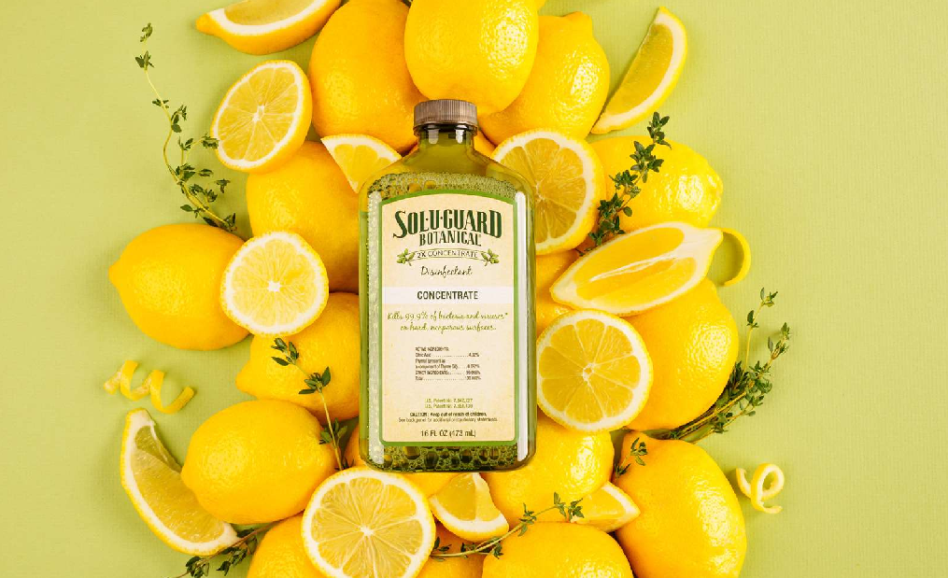

ECOS ENS E CLEA NING HAND BOOK | 2

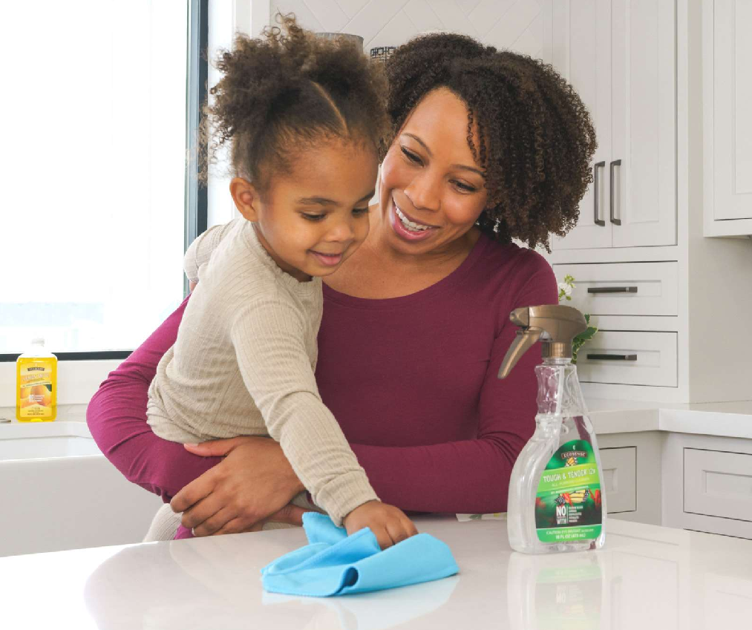








SunshineLivin

C HO R ES. The word itself just feels like a draaaag. We get it. But since cleaning is a necessary—and even fulfilling—part of a healthy life, we thought we'd make things easier by changing your relationship with cleaning. Cleaning and what we clean with have a direct impact on our wellness. Cleaning is how we take care of our fam- ily, our environment, and ourselves. And what we choose to bring into our homes and put on the surfaces our families touch every day makes a big difference.

Lite is full of spills from family meals, grass stains, the clutter of party
decorations, and paint splatters from your latest DIY—and that's beautiful! ñcosense makes cleaning products for people who aren't afraid to get dirty. We celebrate those who may not have the time or energy to keep their home immaculate but who still appreciate the sense of calm that a clean space can inspire.

In this guide, you'll find simple solutions to any mess you may encounter. We hope it takes some pressure off your routine and encourages you to see cleaning as less as a chore and more of an act of love, service, and self-care.

Clean without
CLEANING WITH ECOSENSE IS
NORE THAN HONE CARE. IT'S CARING FOR EVERYONE IN YOUR HONE.

Here at Melaleuca, family means everything. It's what has inspired us to develop ñco5ense cleaning products using ingredients that are safer for your home and exceptional at what they
do! We take great care to develop our products in a way that minimizes our impact on the earth and your wallet.
Most cleaners use unsafe chemicals, i i

Compromise
phthalates, parabens, which that can damage your lungs or irritate your skin. Others may use nontoxic ingredients but don't clean effectively.

You shouldn't have to choose between a clean home and your family's wellness. EcoSense products are formulated with safer ingredients that are just as or even more effective than brands that rely on harsh chemicals. We offer all of our innovative formulas at highly competitive, reasonable prices. That's clean without compromise.

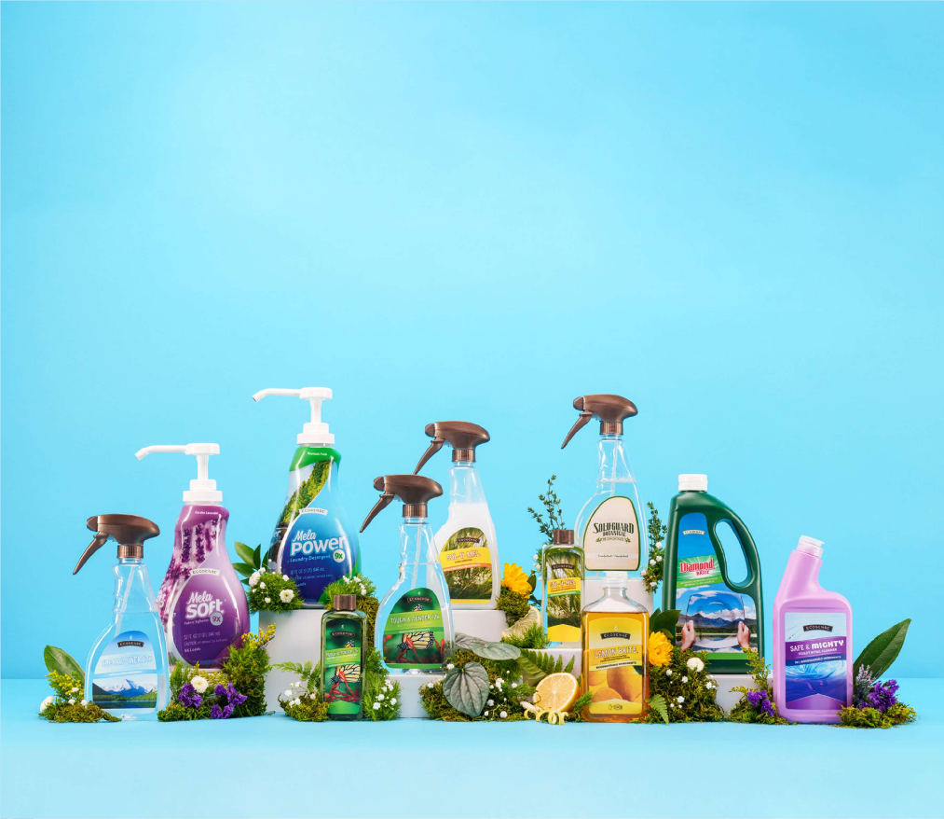

SunshineLivin

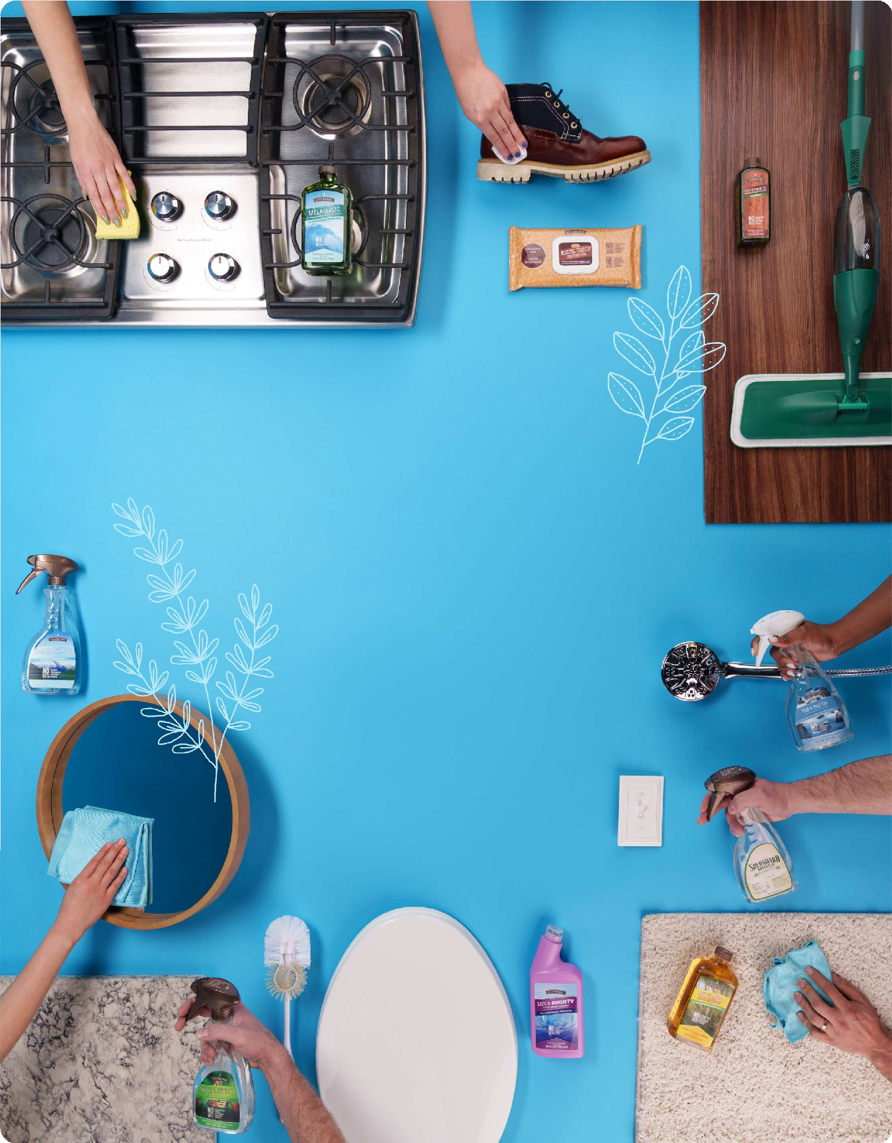




SunshineLivin

Surface Guide

Aluminum and Chrome Appliances and Stainless Steel

Cabinets

Sealed Natural Narble, Granite, and Other Stone

Glass and Nirrors
Clear Power" Glass Cleaner

Clear Power Glass Cleaner
E

So/-V-Ne/"Stain Remover
Tough & Tender”'All-Purpose Cleaner Rustic Touch"’ Furniture Polish
R
Tough & Tender All-Purpose Cleaner f4elaf4agic”Heavy-Duty Cleaner
S
Clear Power Glass Cleaner
Tub & Tile” Bathroom Cleaner
(hard water spots on shower windows and doors)


SunshineLivin

Range Tops and Barbecues

Artificial Plants

Carpets

Flooring (including sealed hardwood, linoleum, tile, and concrete)

Grout

Upholstered Furniture

Clothing, Linens, and Fabrics
Nlelai4agic Heavy-Duty Cleaner Tough & Tender All-Purpose C/eases Sol-U-f4eIStain Remover
Clean & Gleam”Floor Cleaner (excluding unsealed natural wood)
Clean & Gleam Floor Polish f4elallagic Heavy-Duty Cleaner
(excluding unsealed natural wood)
Sol-U-f4eIStain Remover (excluding natural wood)

Noncolored grout: Tub & Tile Bathroom Cleaner
Colored grout: Tough & Tender All-Purpose C/eases
So/-L/-be/ Stain Remover Revive”Fabric Freshener
So/-V-be/ Stain Remover

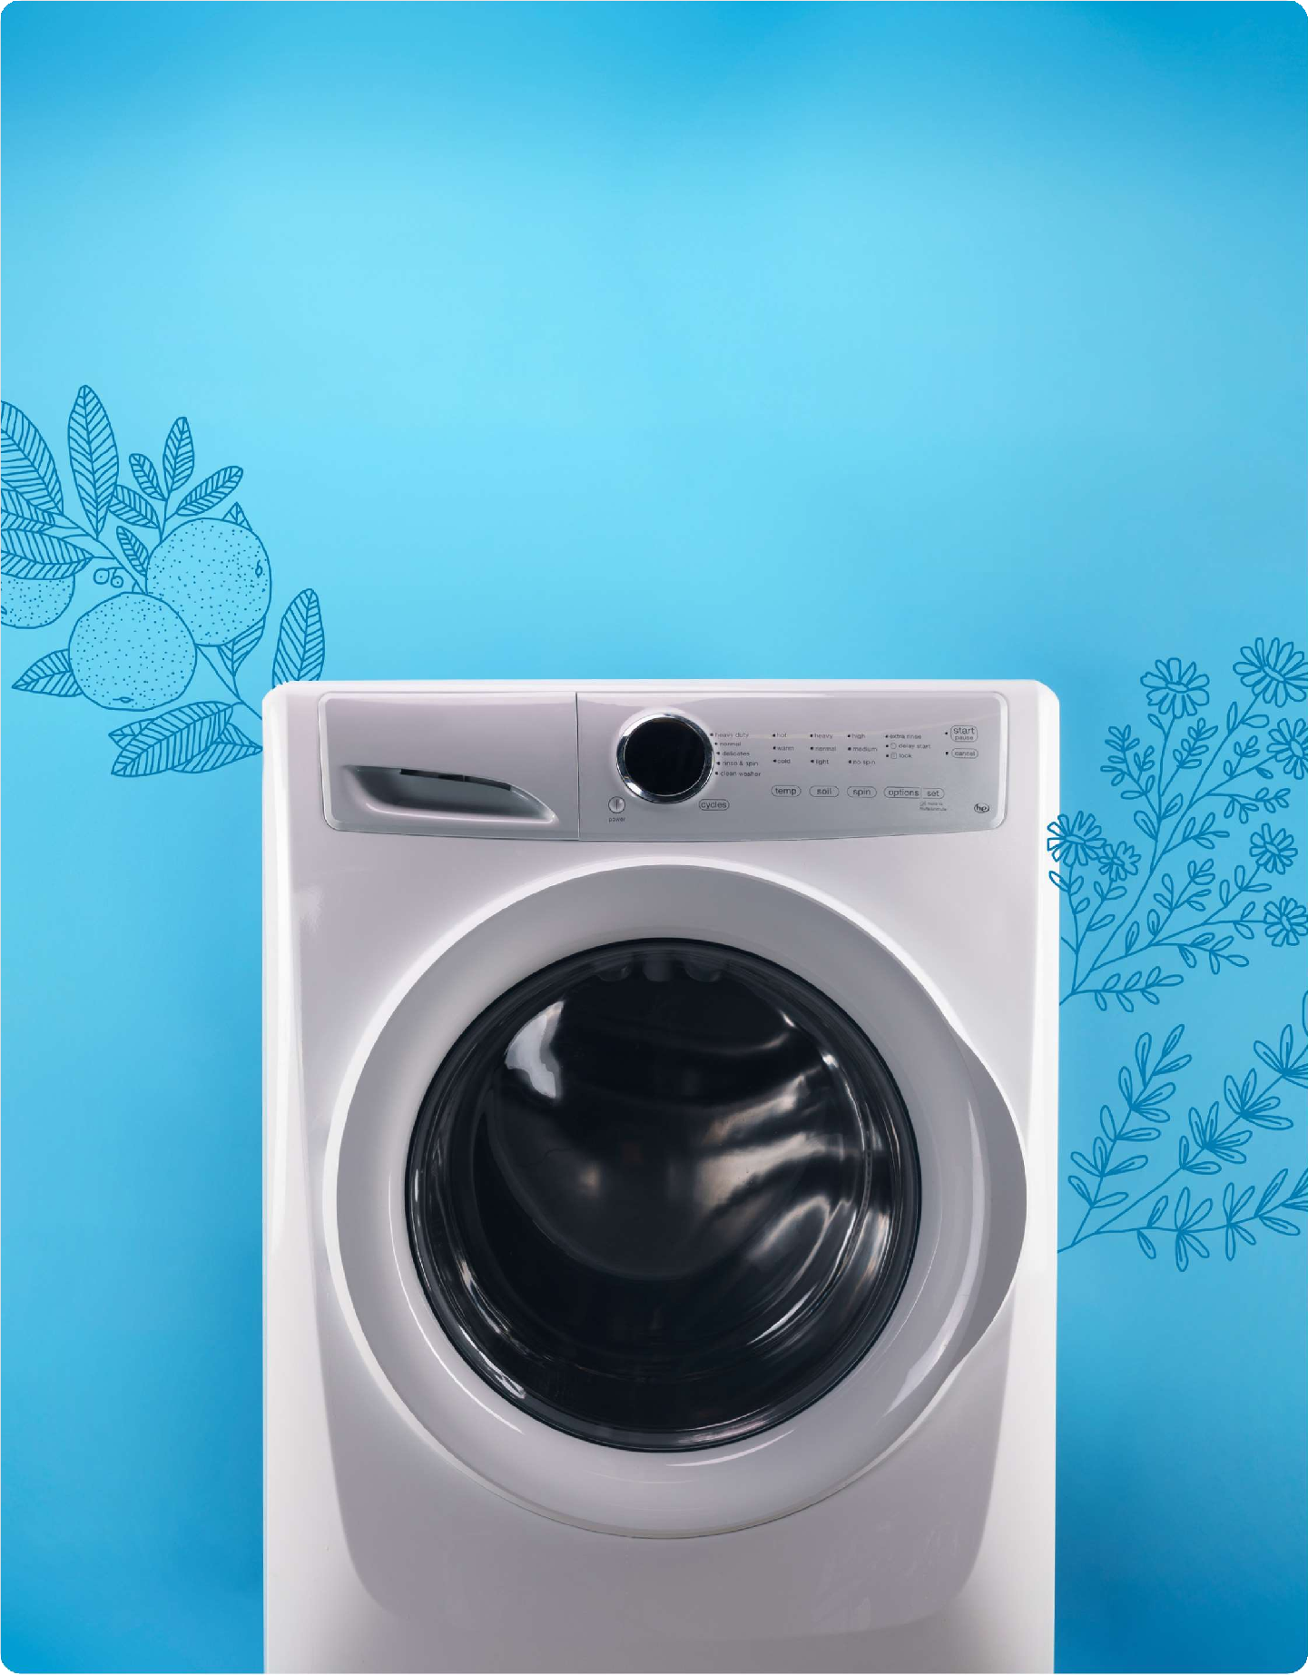





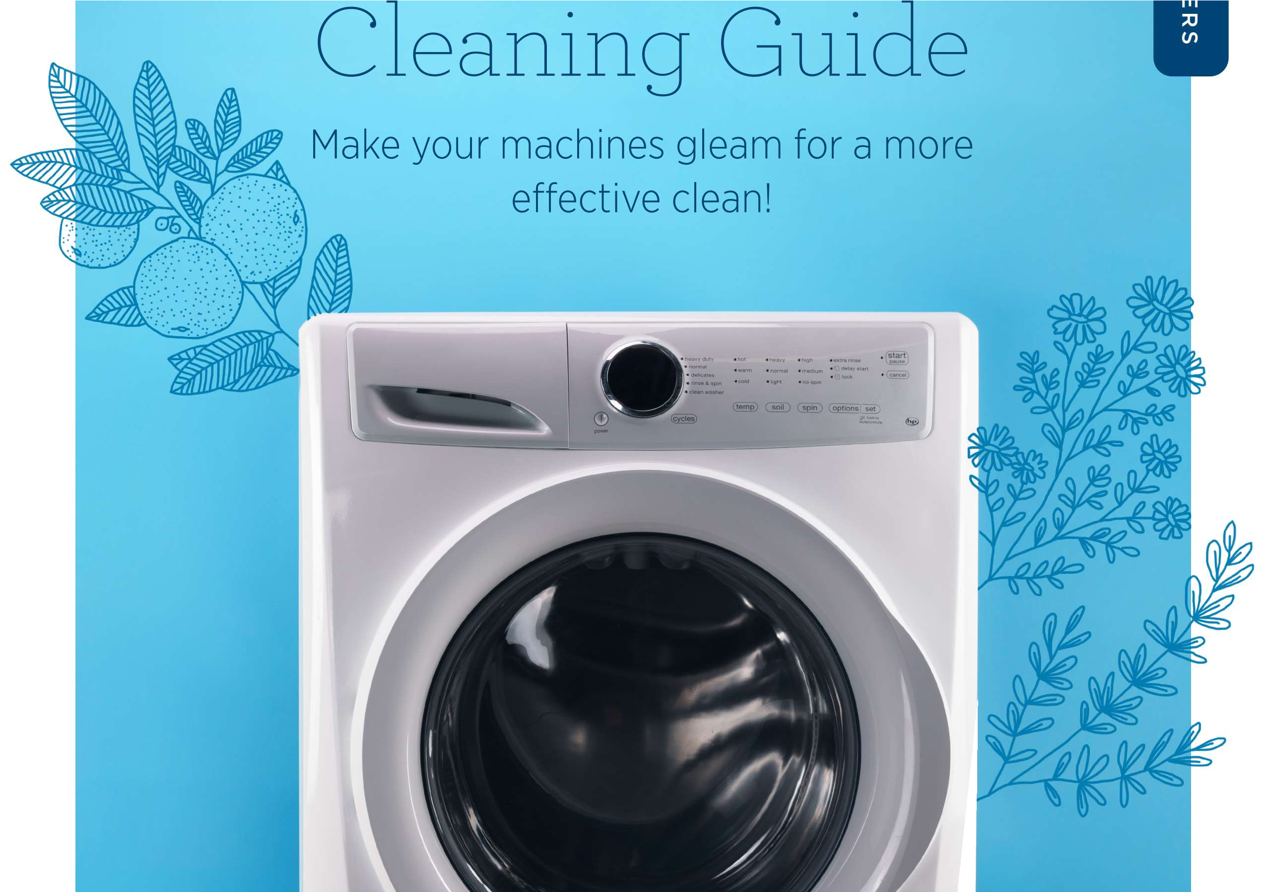

SunshineLivin

STOVE TOP

TO CLEAN

STEP 1
Appliance exteriors can be cleaned with Tough & Tended'.
For stuck-on messes, use
C
f4e/af4agic'”.
For stainless steel appliances, clean with C/ear Power'.

Remove any food blockage from filter.

STEP l

STEP 2

STEP 3

STEP 4
Add f4elaNiagic to sink full of water. Use /2 fl. oz. of MelaNiagic per 1 gallon
of water.
L

Remove burner rings and drip trays (if applicable) and let them soak in mixture of
i telaMagic and water (minimum 3-5 minutes).

After soaking, scrub rings and drip trays clean.

Rinse with water and dry.

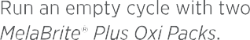
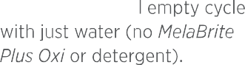
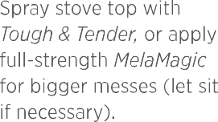
SunshineLivin
Wipe edges and seals clean

STEP 4
OVEN

STEP 1

STEP 2

STEP 3

STEP 4
with Tough & Tender after cycle has completed.

Run the self-clean cycle on your oven. Once complete, let it cool.

Apply full-strength Nelaf4agic with sponge or cloth and let sit for 5 minutes.

Scrub oven.

Wipe off excess be/aNag/c with water and cloth.
STEP 6

GLASS
Wipe off excess NelaNiagic
with water and a cloth.

Polish glass stove tops with
Clear Power.

L1ORE APPLIANCES 6

REFRIGERATOR/FREEZER
MICROWAVE

STEP 1
STEP 2

STEP 3

STEP 4

STEP 5
Empty appliance.

Discard old and expired food.

Clean contents and wipe the bottoms and the sides of items to prevent more messes.

Add 1—2 squirts of 1emon
Brite' to sink full of hot water.

Remove shelves and drawers and add them to the sink full of soapy water. Let soak.

While shelves and drawers
STEP 1
STEP 2
STEP 3

STEP 4

STEP 5
Fill a microwave-safe bowl halfway with water.
Add the juice of one lemon. Microwave for 5-5 minutes. Let it sit and steam for
A
N
E
another 5 minutes. Open door
and carefully remove bowl (bowl will be hot).
R

Remove turntable and wipe clean with Tough & Tender. For bigger messes, scrub turntable in sink with Lemon
S



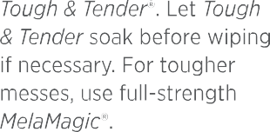
SunshineLivin

Scrub shelves and

STEP 7

STEP 8

STEP 9
drawers with soapy water, rinse, then dry.

Return shelves and drawers.

Return food to fridge and freezer, organizing and grouping similar items.
STEP 1

STEP 2

STEP 3

Clean from the top level to the bottom so you don't have anything fall into your already-cleaned areas.

STEP 4
Scrub door seal with
Tough & Tender.

Remove hard water stains from washing machine door with Tub & Tile. Let sit for a few minutes, then wipe clean.

Sanitize the drum by spraying the inside with Sol-U-Guard Botanical' Disinfectant. Let
sit for 10 minutes and wipe clean.

Place two NelaBrite' Plus Oxi Packs in your empty washer and run it on hot.

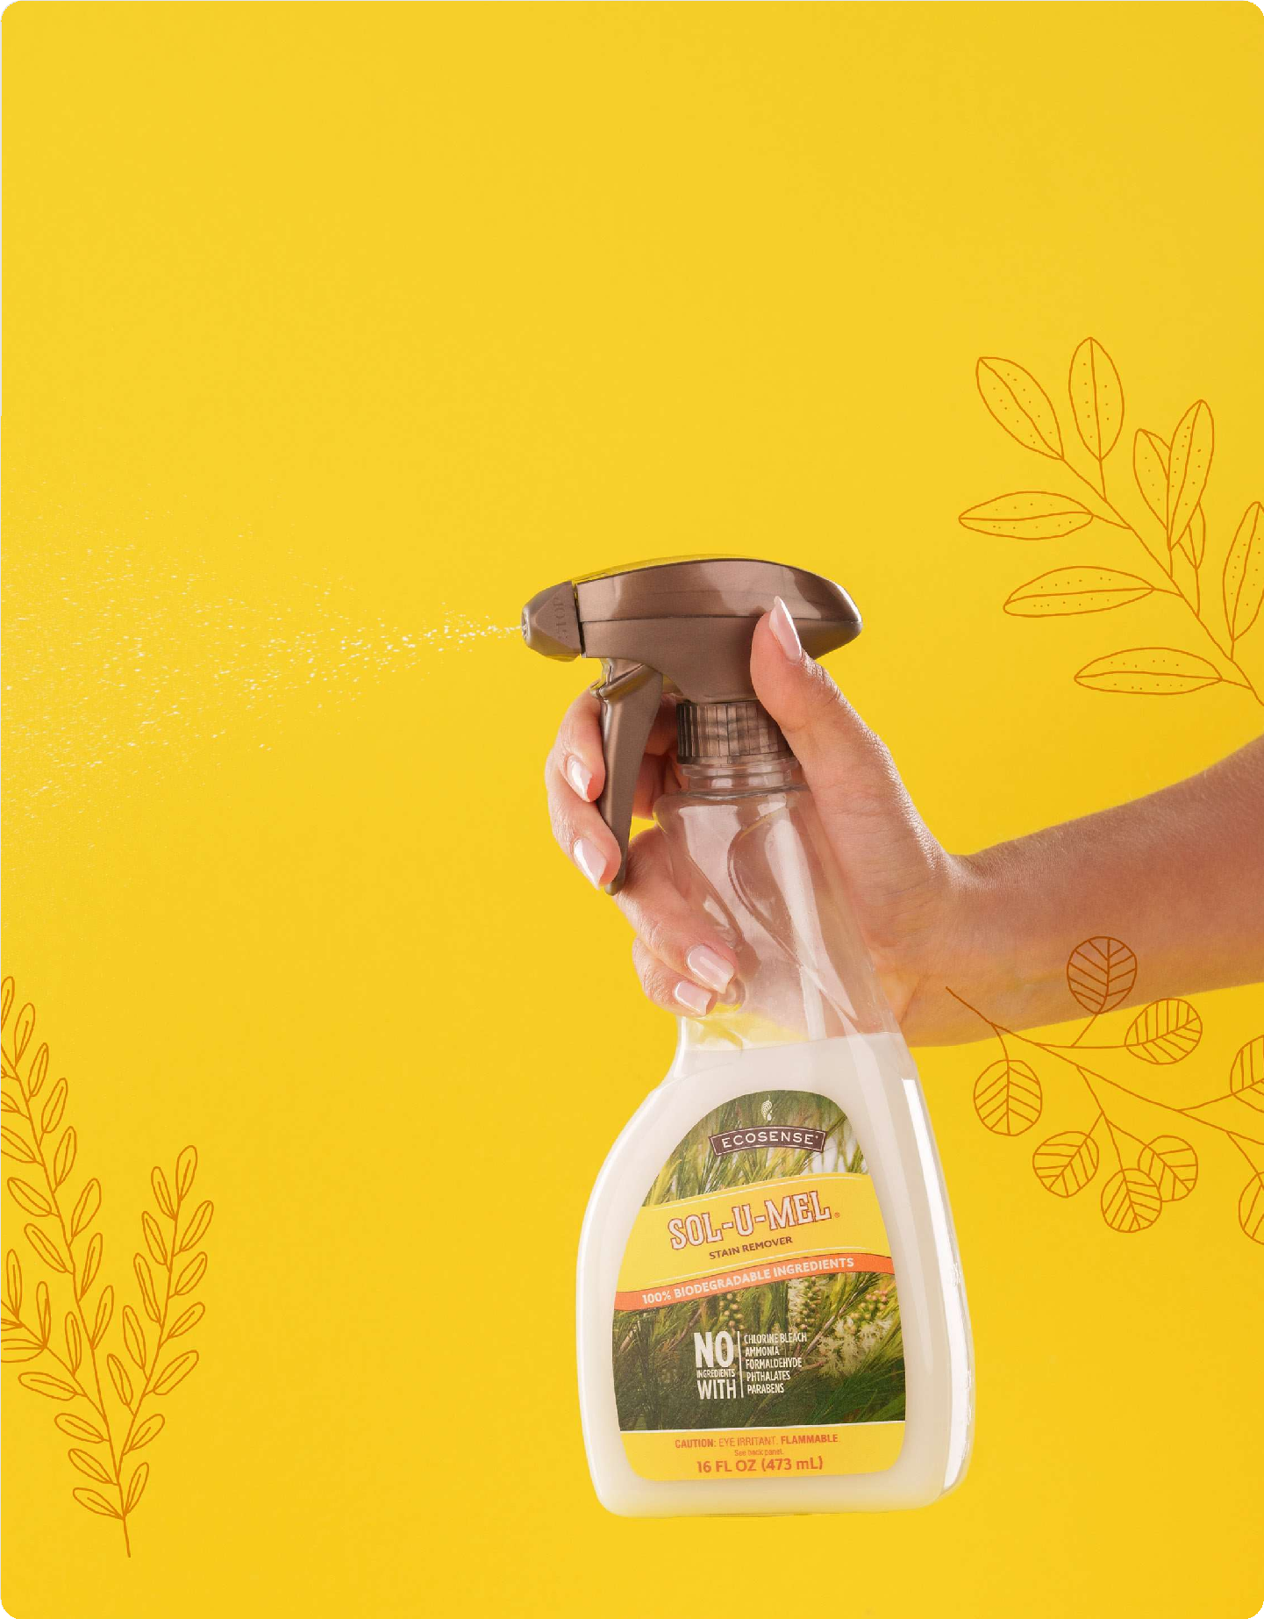


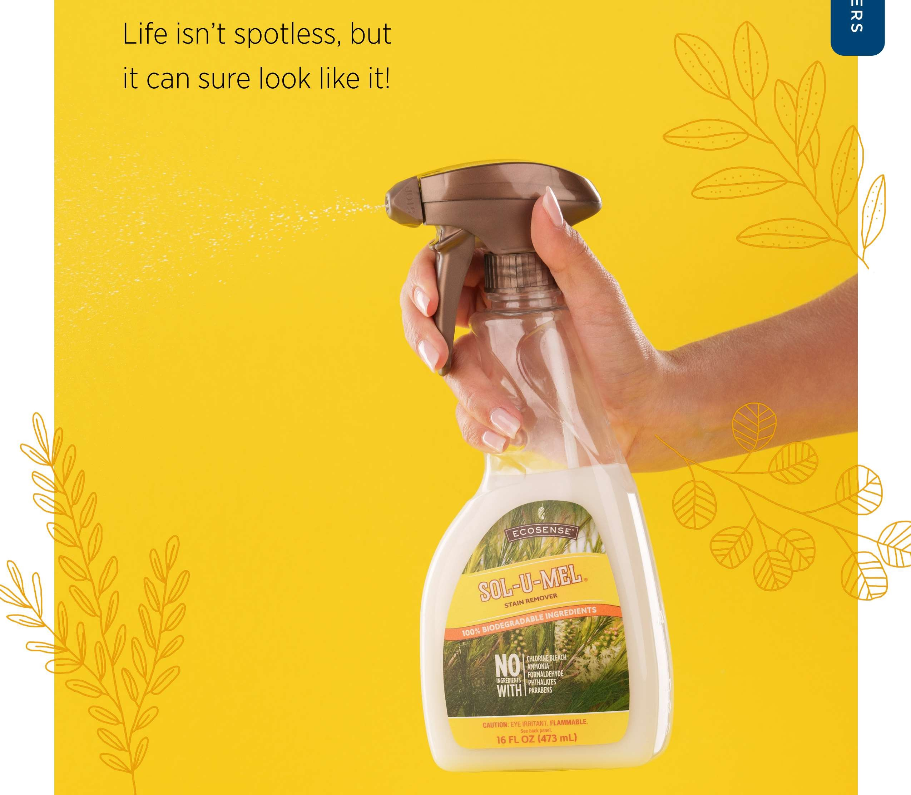

SunshineLivin

Solve It All with Sol-U-Mel"
C
We encounter hundreds of tough messes in would come out). Read on to discover our
our lives! Pet stains, dirt, oil, gum, permanent proven tips for removing stubborn stains and marker—the list is endless. odors using Sol-U-Mel!
L

So what's a person to do? Drab the Sol-U-Mel NOTE: While Sol-U-Mel is safe to use on almost all
of course! We love how effective it is against all surfaces, it's alwaYs a good idea to test the formula on
kinds of stains {even those we never thought a sftsall section of whatever you're cleaning to make sure
it doesn't alter the material.

Diluted vs Full- Strength Sol-U-Mel

FULL STRENGTH

SunshineLivin
DILUTED
- Deodorizing garbage cans
- Removing mildew odors on carpets and other surfaces
  - Deodorizing odors like smoke, mildew, or pet stains from air or furniture
- Removing stains and sticky messes from walls and other hard surfaces
- Tree sap
- Permanent marker
  - Paint
  - Grease
- Gum in hair or carpet
  - Candle wax
  - Any other stubborn stains on carpet, furniture, or other surfaces

STEP 1

It's important to be aware of the surface you're working with. Plastics
GUN
and clothing can be easily damaged and aren't as durable as surfaces like glass. Too much scrubbing can cause damage to some surfaces, and using full-strength Sol-Li-Mel% can remove paints. Always remember to test an inconspicuous spot
before cleaning.
IN HAIR

Saturate the area of hair with full-strength Sof-U-wet and rub the formula as close to the problem area as possible. Let sit for at least 2
minutes. Using fingers or a comb, gently remove the gum from the hair. Wash hair after gum is removed. Avoid contact with eyes!
ADHESIVES
(STICKERS, TAPE, AND GLUE)

ON CARPET

Work full-strength Sol-U-f4eI into gum stain.

Let sit for at least 2 minutes. Carefully blot and scrape the gum using a scraping tool that will not damage your carpet; we recommend a spatula or a spoon. Scrape in the same direction each time to
avoid causing damage to the carpet fibers. Repeat

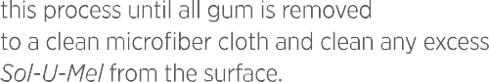
SunshineLivin
LEANERS

STEP 2

STEP 3
Before cleaning, remove as much of the adhesive or glue as possible. This can be done by taking a plastic scraper
or razor blade and scraping away gently so that you don't damage the surface.

Dampen a microfiber cloth with Sol-U-Net. Dab it on the residue generously, allowing it to soak and soften the adhesive or glue until stains are removed. You may need to let the Sol-U-i4el sit on the adhesive for a few minutes to soften any dried-on residue.

STEP 4
Add water to a clean microfiber cloth and clean any excess Sol-U-NIeI from the surface.

MORE SURFACES6

Determine the type of fabric you'll be cleaning. So/-L/-be/% is water based and can be
STEP 1 used diluted on furniture (see
right) with the W or W/S code and full strength on W/S (see codes to the right).

Apply Sol-U-i eI to a microfiber cloth and dab the cloth on the spot from the outside in. As you remove the stain, blot with a clean
HOW TO DETERMINE

Furniture Fabric Type
UPHOLSTERED FURNITURE
Like clothing, upholstered furnishings come with a cleaning tag. These tags contain cleaning codes that suggest the best cleaning methods for the material. Below is a list of the dfferent codes and what they mean:
W: A water-based cleaner may be used (we recommend using distilled water because tap water contains minerals that may cause rings or fading).

STEP 2
section of cloth. Keep blotting until the stain is gone. To avoid rings, clean the entire section where soil

S: Use a solvent-based cleaner (do not use water). This means that fabric must be cleaned with an upholstery dry-cleaning solution intended

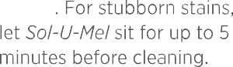
SunshineLivin
CLEANERS
the surface.
DEODORIZING

Before cleaning with
STEP J So/-L/-be/, test a small,
hidden area.

Spray diluted So/-L/-be/
STEP 2 onto surface. For tough
stains, let sit.

STEP 3 Wipe clean.

Use Tough & Tender’" to
STEP 4 clean any excess Sol-U-NeI
from the surface.
ELININATE ODORS FRON

Pets Smoke Garbage Mold
HOW TO USE
HARD SURFACES
tCOUNTERTOPS, TABLES, AND NORE}

To eliminate lingering smells, spray diluted So/-L/-be/ into the air and small spaces (such as trash cans and closets) or onto carpet, upholstery, rugs, and more.

MORE SURFACES 6

REMOVING WAX FROIH CARPET
WALLS

STEP l

STEP 2

STEP 3
Allow wax to harden by either letting it dry naturally or placing ice cubes directly onto the wax.

Gently scrape away hardened wax. Use a vacuum to suck up any loose wax.
For any remaining wax, place a paper towel or a terry cloth towel over the wax.
Turn your clothing iron on low heat with no steam. If
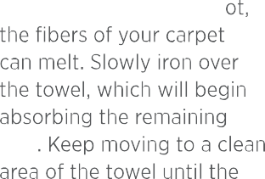
the tern rature is too h

STEP1

STEP 2

STEP 3

STEP 4
Before cleaning with
Sol-U-Me% , test a small, hidden area.

Spray diluted Sol-U-I4el onto microfiber cloth.

Lightly wipe the stain until the stain is gone.

Add water to a clean microfiber cloth and clean any excess So/-L/-be/ from the surface.

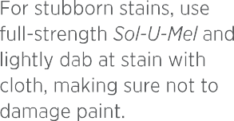
SunshineLivin

STEP 5

STEP 6
To remove remaining residue or stains, pour full-strength Sol-U-f4eI onto microfiber cloth and blot until the stains are gone. Remember to test on an inconspicuous spot.

Add water to a clean microfiber cloth and clean any excess Sol-U-NeI from the surface.

HOW TO USE

Our Concentrated Products

WHAT DO ECOSENSE CONCENTRATIONS, LIKE 2X AND 12X, REALLY NEAN?
EcoSense products are highly concentrated. That means that we use powerful cleaning ingredients without all the added water!
For example, one bottle of Tough & Tender"’
includes enough concentrate to fill six
16 fl. oz. spray bottles. This conserves water, reduces plastic waste, and keeps costs low— so we can pass those savings on to you!
Our concentrated cleaners can be diluted at horse in reusable spray bottles by sirriply
adding water from your tap. The level of concentration in each product (an here from 2x to ixx) will tell you how much water each product needs for proper dilution.

fico5ense conce otrates are meant to be used with the mat ching reusable mixing spray bottle. Once the spray bottle is empty, simply refill with concentrate (there’s a line on the side of each bottle that tells you how much concentrate to add), top off with water, and reuse it!

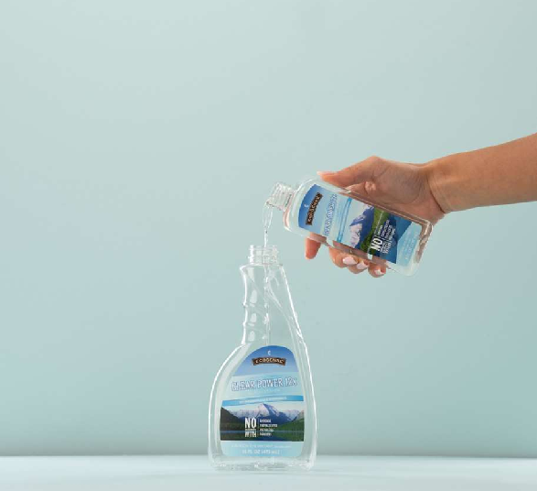
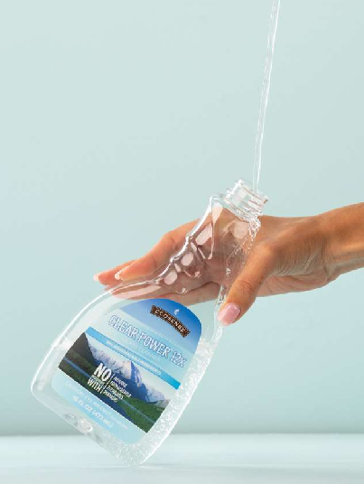
DIRECTIONS

SunshineLivin

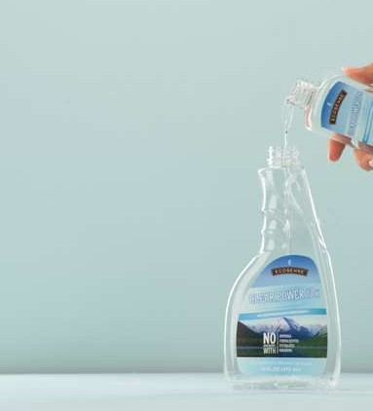
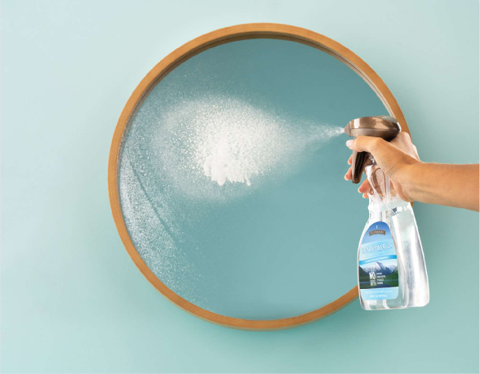

Step 1: Fill the spray bottle with concentrate to the directed concentrate line.

Step 2: Tilt the bottle and slowly add cold water into the spray bottle to the “Fill” line to avoid excess foam.

Step 3: Spray the diluted cleaner onto the appropriate surface. When the cleaning solution is gone, simply repeat these steps.

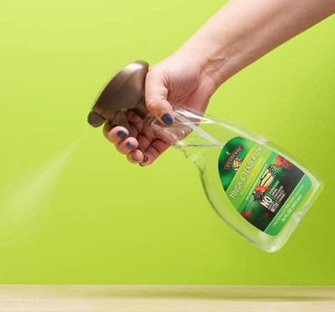
TOUGH & TENDER°

TOUGH & TENDER 12X ALL-PURPOSE CLEANER
This all-purpose cleaner is effective on virtually every surface in your home. Cleans spills, splatters, crumbs, and even grease!

USE O N Tables, counters, stovetops, cabinets, light fixtures, appliances, walls, artificial plants, car interiors, natural marble, granite, stone, and more.


THE ECOSENSE ADVANTAGE

Tough & Tender All-Purpose Cleaner features plant-derived
biodegradable ingredients that are
DIRECTIONS
STEP 1 Spray entire surface.
STEP 2 Wipe clean.

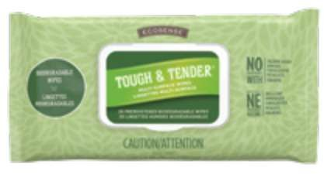
Also available in Tough & Tender Wipes!





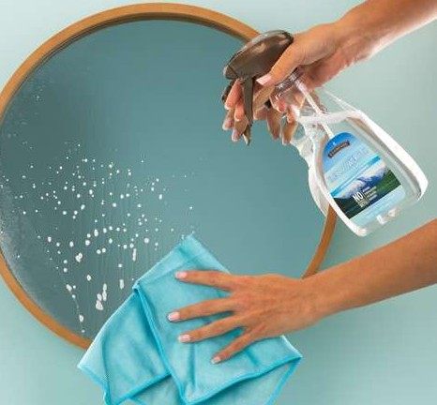
SunshineLivin

Tough & Tender Wiper can be used to clean electronics like keyboards, phones, tablets, and more!

CLEAR POWER 12X GLASS CLEANER
This concentrated glass cleaner leaves mirrors, windows, and stainless steel spotless. Best when used with a microfiber cleaning cloth.

USE O N Class, windows, mirrors, stainless steel, aluminum, chrome, and appliances.

DIRECTIONS
THE ECOSENSE ADVANTAGE

Clear Power uses plant-derived and biodegradable cleaning agents instead of ammonia like many other glass cleaners.
STEP 1 Spray entire surface.
STEP 2 Wipe surface with a microfiber cloth for a streak-free shine.

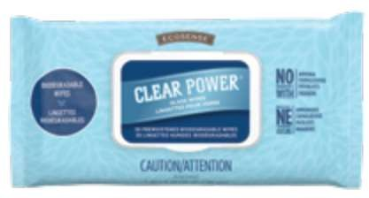
Also available in Clear Power Wipes!

TUB & TILET°
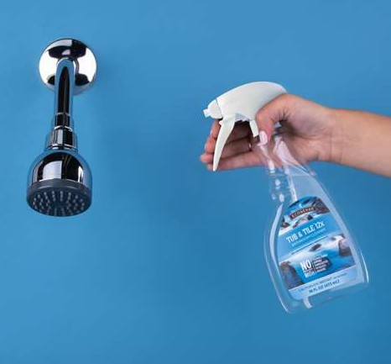
THE ECOSENSE

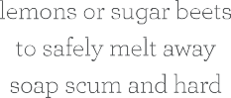
ADVANTAGE

Rather than resorting to harsh chemicals or abrasives, Tub & Tile relies on the natural cleaning power of

TUB & TILE 12X BATHROOM! CLEANER
This concentrated foaming bathroom cleaner quickly dissolves dirt, hard water stains, soap scum, and lime deposits with minimal scrubbing.

USE O N Tubs, showers, sinks, toilets, bathroom fixtures, and hard water stains on windows and shower doors.
NOTE: Do not use on natural marble, stone, colored grout, or antique, brass, or acrylic surfaces.

DIRECTIONS
STEP 1 Spray onto bathroom surfaces where hard water and soap scum accumulate. Let sit for s minutes.
STEP 2 Wipe away residue with a cloth or sponge.






SunshineLivin
stains that have already formed.
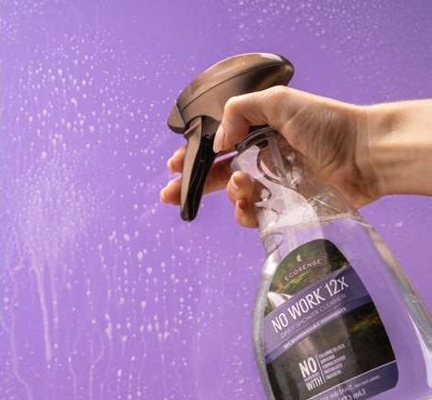
NO WORK°

NO WORK 12X DAILY SHOWER CLEANER
This daily shower cleaner prevents hard water stains, soap scum buildup, and spotting. Our No Work formula even forms a protective barrier so that your shower will stay cleaner longer!

USE ON Inside of tub as well as shower walls, doors, and curtains. NOTE: Do not use on natural marble, stone, or brass surfaces.
DIRECTIONS
After showering, spray any part of the shower where water droplets remain. No need to wipe down the shower—just spray and walk away!
For best resume, start with a clean shower.

SOL-U-NEL°
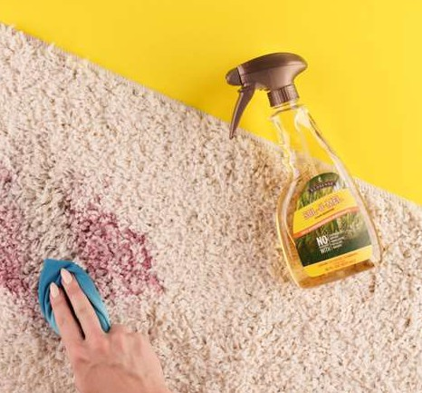
THE ECOSENSE ADVANTAGE

MELALEUCA OIL
Vol—V—Set is a ioo% natural formula that uses Melaleuca Oil to penetrate, dissolve, and

SOL-U-PIEL STAIN REPIOVER & DEODORIZER
This multipurpose formula removes stains, eliminates odors, and works as a general daily cleaner.

USE O N Upholstered furniture, clothing, linen, fabrics, cabinets, counters, hardwood floors, carpet, and more!

REPROVES STAINS SUCH AS Pet accidents, juice, ink, crayon, permanent marker, paints, gum, grease, mold, glues, residues, tree sap, road tar, and so much more. For more information, go to the Sol-U-Mel Stain Ciuide on page 10.
DIRECTIONS
FOR STAl N REMOVAL
STEP 1 Spray on soiled area and let sit for 5 minutes.
STEP 2 Scrub with brush, then blot with damp cloth. Repeat if necessary.

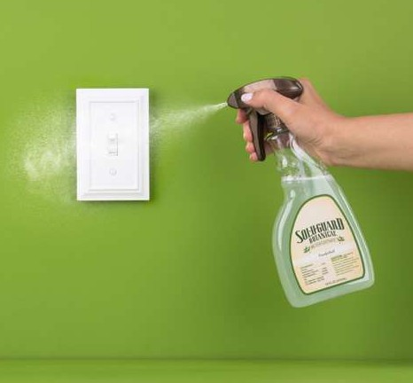










SunshineLivin
SOL-U-GUARD BOTANICAL 2X DISINFECTANT
Powered by thyme oil and citric acid, this EPA-registered botanical disinfectant kills over 99 9% of household germs.

USE O N Hard nonporous surfaces, kitchen counters, kitchen faucets, kitchen drains, light switches, doorknobs, computer keyboards and mice, and remote controls.
i4OTE: Do not use on natural marble, granite, or stone.
THE ECOSENSE
ADVANTAGE
NO BLEACH
No problem!
Sol-U-Guard Botanical Disinfectant kills germs naturally. It was the first EPA-registered botanical household disinfectant!
DIRECTIONS
TO CLEAN
Spray diluted product on area to be cleaned until thoroughly wet and wipe or rinse away.
TO SANITIZE (KILL BACTERIA)
Spray diluted product on surface until thoroughly wet. Let stand 1 minute. Wipe and let air dry. No rinsing necessary.
TO DISINFECT (KILL BACTERIA AND VIRUSES)
Preclean surface with Tough & Tender°’ before disinfection and deodorization. Spray diluted product on surface until thoroughly wet. Let stand lo minutes before wiping. No rinsing necessary!

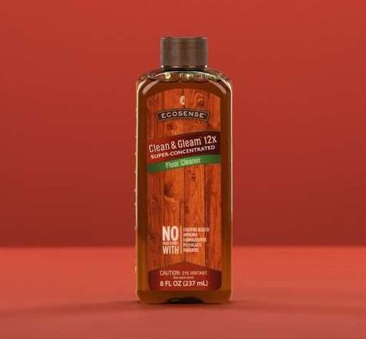
CLEAN & GLEAN"

CLEAN & GLEAI3 12X FLOOR CLEANER
This concentrated formula gently and effectively cleans dirt and grime mom your floors.
USE O N Finished or sealed wood, tile, linoleum, and sealed concrete (safe on finished or sealed floors).

DIRECTIONS
STEP 1 Sweep floor using the Clean & U/eom

To use Cleon & Gleam Floor Cheerier with a bucket mop, add 2/3 cup of Clean & G/enm to a gallon of water.
Mop and Dusting Pad.
STEP 2 Add concentrate to spray mop reservoir (up to “12X” line).
STEP 3 Add water to top fill line.
STEP 4 Spray floor cleaner as you mop.
Fill mop cleaner

this point.
—

Concentrate

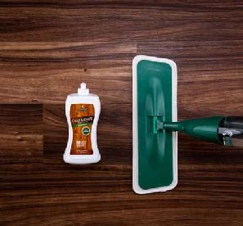
CLEAN & GLEAN READY-TO-USE FLOOR POLISH
CLEANE

SunshineLivin
er.
STEP 2 Apply polish directly to floor in small S-like pattern.
STEP 3 Spread evenly on floor surface with polish pad.
STEP 4 A1Iow to d for s-to minutes.
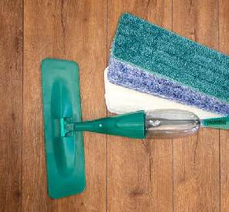
NOTE: If additional coats are desired, wait until polish is dry before applying another coat (up to 3 applications in 24 hours).

CLEAN & GLEAN SPRAY NOP AND REUSABLE PIOP PADS
This ergonomic spray mop features a refillable fluid reservoir and powerful hand spray trigger. Microfiber pads provide dust-free, lint-free results.

USE O N Wood, tile, linoleum, and sealed concrete.

DIRECTIONS
Squeeze trigger to spray Cleon & C/eom Floor Cleaner as you mop floor.
MOP WITH BOTH HANDS
As you mop, hold the middle of the rod with your nondominant hand for added stability.
DUSTIf4G PAD (BLUE) Feathery fibers collect and cling to dirt. Use on dry floors.
CLEANING PAD (GREEN) High-count absorbent fibers clean thoroughly. Use
w'ith Cleari & Glearn Floor Cleaver.
POLISHING PAD (WHITE) Soft texture smooths polish on evenly. Use with
Clean & Gleam Floor Polish.

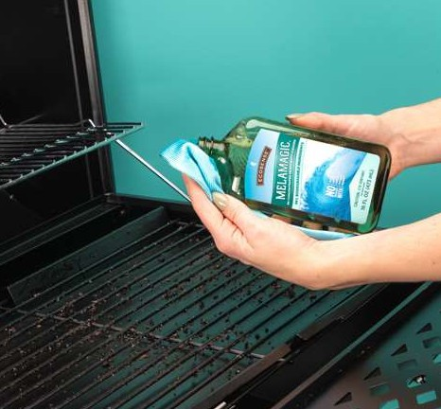
NELANAGIC°

IHELANAGIC HEAVY-DUTY CLEANER
Clean surfaces like magic! This heavy-duty all-purpose cleaner was made to tackle the greasiest, grimiest messes both indoors and out.

DIRECTIONS
For greasy messes:
USE ON Range tops, ovens, garage messes, mechanical parts, decks, outdoor furniture, linoleum or tile floors, concrete, barbecue grills, and anywhere else a greasy stain strikes.
NOTE: Not recommended for wood surfaces or carpet.
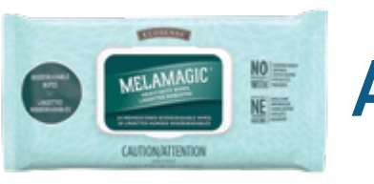
Also available in NelaNagic Wipes!

For baked-on messes:

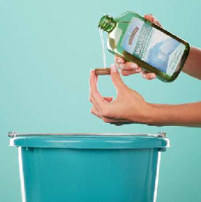
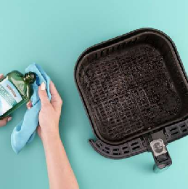
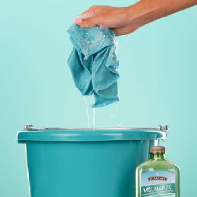
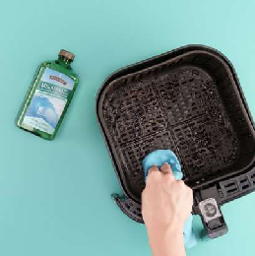
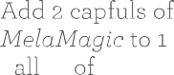


SunshineLivin
g on water. minutes.

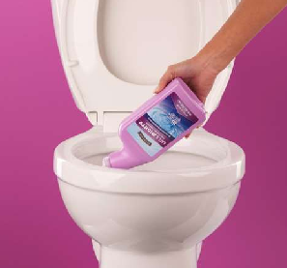
SAFE & NIGHTY”
THE ECOSENSE
ADVANTAGE

INSPIRED BY NATURE
Safe & Mighty uses the power of citric acid and thyme oil to remove grime, stains, and buildup—all while
leaving your bowl with a fresh, clean fragrance that no chemical formula can match.

SAFE & NIGHTY TOILET BOWL CLEANER
This safe and effective cleaner leaves your toilet bowl looking clean and smelling fresh.
DIRECTIONS
STEP 1 Flush toilet before cleaning.
STEP 2 Squirt under and around toilet bowl rirri.
STEP 3 Scrub the bowl with a toilet brush and
then flush.
For stubborn stains: Let sit for a few minutes after scrubbing and before flushing.

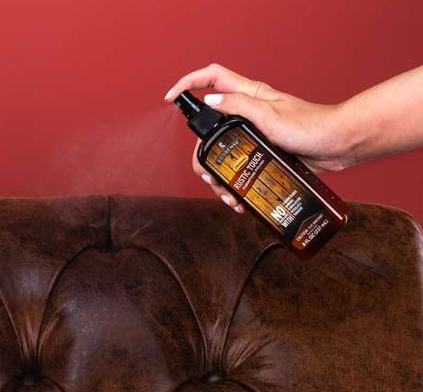
RUSTIC TOUCH%

RUSTIC TOUCH FURNITURE POLISH
This highly elective formula cleans, conditions, and protects your wood, leather, and vinyl surfaces against nicks and scratches.

USE ON Wood, leather, laminated surfaces, vinyl, and baseboards.

DIRECTIONS
STEP 1 Spray surface.
STEP 2 Gently wipe with a soft, clean cloth to get a deep, rich shine.

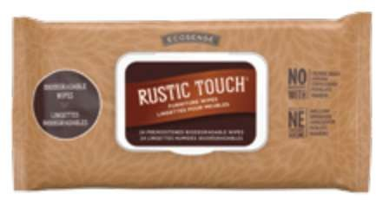 Also available in Rustic Touch Wipes.

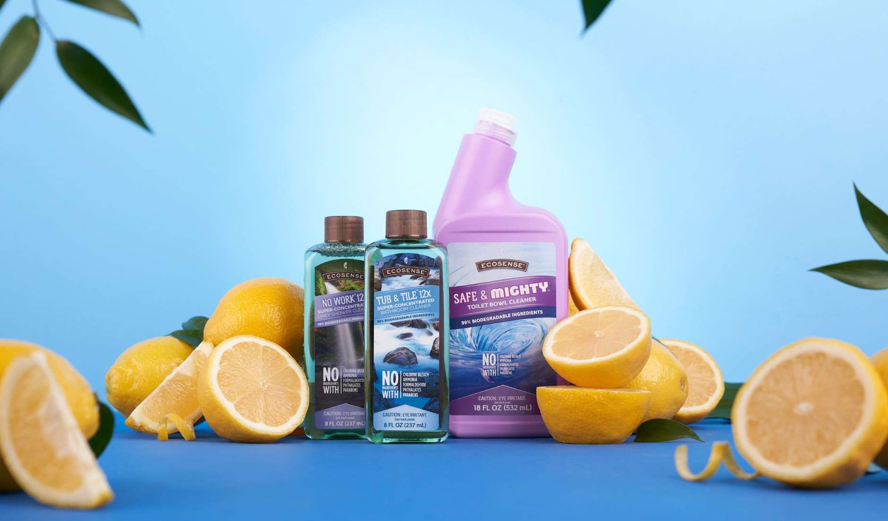
THE ECOSENSE ADVANTAGE

SunshineLivin

Unlike many national brand cleaners—like those that use ammonia an bleach, which can create extremely caustic fumes, especially when used together—£coSense* cleaners are designed to be used together to produce synergistic results.

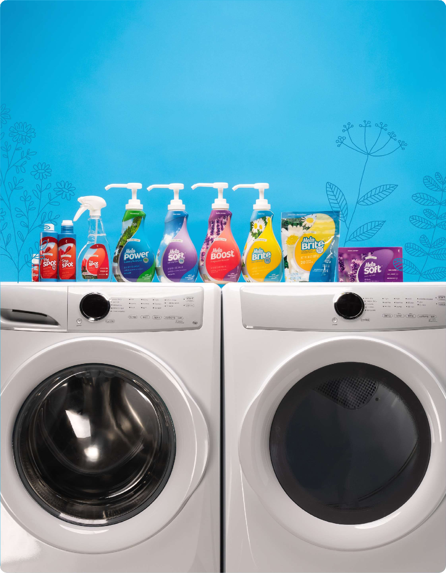



SunshineLivin

HOW TO EXTEND THE

Life of Your Clothing
It's not your imagination—clothes really do wear out more quicHy these days. So here are some tips to help your clothes withstand all that you do.

- Pay attention to fabric care and content.

- Wash in cold water (reduces energy costs and prevents colored fabrics from fading).

- Avoid chlorine bleach.

- Pamper your laundry with NelaSoft', Ie/a6rte', NelaBrite hIus Oxi, and he/a6oost'.
- Wash less often.
How often to wash certain articles/fabrics:
  - Towels After 2—5 uses
  - Denim After 5-5 wears
  - Bedding Once a week

NOTE: It's better to use less heat when drying your clothes because high heat in drying causes clothes to age faster! Try the “air dry” or “fluff dry” setting instead. This tip works well with fiber blends.








aun erg s ener same dispenser can negate the potency of both products.
LAUNDRY
SunshineLivin

    - Using too much laundry detergent can sometimes CREATE stains on your clothes.

    - Putting stained items in the washer and dryer without pretreating them can permanently set stains into fabric.

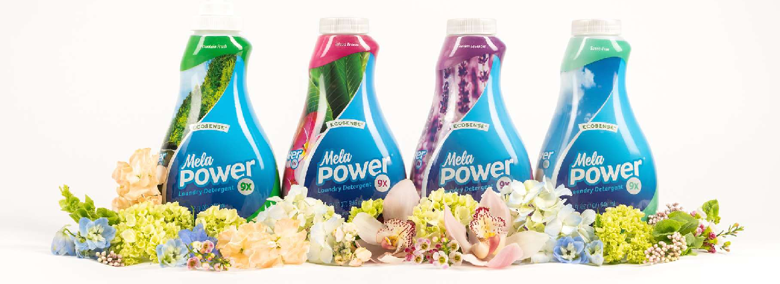

Turn out your pockets, close your zippers to prevent snagging, fasten hooks, and unbutton all buttons (keeping these fastened can cause stress on the buttons and buttonholes).
Examples of sorted laundry groupings:
Everyday laundry (cotton shirts, underwear, socks) • Denim • Bedding • Towels • Athletic Wear • Delicates

Check the care labels on your clothing. These will tell you how to properly wash and dry clothing to maximize the lifetime of your fabrics. To easily determine how to take care of your clothing, use our laundry symbol guide on page 26.


      - Half full, select “Medium.”
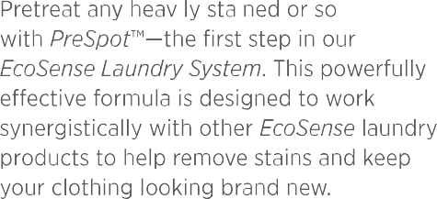
      - Three-quarters full, select “Large.”

WHAT IF NY
Fabric Is Blended?
When sorting blended fabric, separate based on fabric with the highest-percentage type—cotton, silk, polyester, etc.
SunshineLivin
      - At full capacity, select “Extra Large.”

Separate items based on color
- To avoid damaging clothing, sort laundry according to color by grouping dark, medium, and light colors separately.
- Separate multicolored/patterned clothes by dominant color.
Separate heavier items from lighter items:
- Heavier items can be abrasive and damage lighter, finer fabrics.
Heavier items also take longer to dry, which turns into overdrying lighter items (stressing this delicate fabric).
Separate based on fabric types indicated on the label:
Remove items that are dry clean or hand-
wash only.



Only one pump (10 mL) of he/aPorrer' is needed per load. For heavily soiled loads, use two pumps.
- Excess detergent clogs your washing machine with a buildup of soap, which can lead to stinky clothing and towels.
- Excess detergent causes clothes to look dingy and lose their vibrancy.

Everything moves in cycles. Choose the right one for your laundry load (but only after reading care labels and sorting fabric to make sure you get the most out of your clothes, towels, and bedding).
BEDDING
Purpose  When to Use | Washing linens or large items and preventing items from tangling and wadding up into a ball. If you do not have this setting, you can use the heavy-duty or bulky cycle.  When washing sheets, blankets, comforters, and rugs.
QUICK/SPEED

Purpose
NORNAL/REGULAR CYCLE
Purpose  When to Use | Removing stains and dirt on everyday laundry items.  When washing cottons, linens, sheets, and mixed-garment loads.

Quickly washing a small amount of lightly soiled clothing.

When washing 2-4 lightly

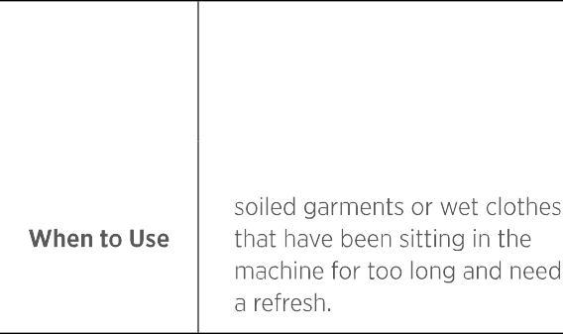
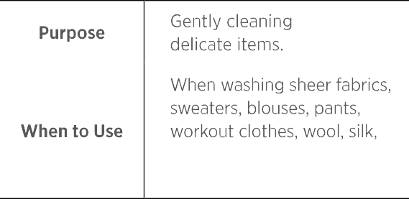
SunshineLivin

or anything recommending a gentle cycle on the tag.
Purpose

When to Use
PERMANENT PRESS
Purpose  When to Use | Washing clothes that wrinkle easily.  When washing jeans, noncotton items, and synthetic fibers, such as rayon, knit, and polyester.
BULKY/HEAVY
Purpose  When to Use | Cleaning sturdy, extra-dirty loads.  When washing towels, jeans, and colorfast fabrics.

Killing bacteria with extra-hot water.

Clothes, bedding, towels, baby clothes, and any other items that need sanitization. Check the care label to ensure the item can handle high- temperature water.

This is the moment when it's especially important to pay attention to care labels! Nany of us have lost a favorite sweater (or two) after accidentally drying shrinkable fabric. Use NelaSof% dryer sheets to prevent static and add softness.


yC O S E N y y--

Laundry Symbol Guide
Want to know how to read the tags on your laundry?

WASH
WATER
TEMP.
DRYER
DRYER TEMP.
AIR DRY BLEACH IRON



Normal 8o°F/3O°C Machine
Dry
Low Heat
Drip Dry Any Bleach Iron Low Heat



SunshineLivin
LAUNDRY

Delicate izo°F/so°C Perm.
Press
High Heat
Dry Flat Do Not Iron Bleach High Heat



Hand-wash 1qo°F/6o°C Delieates No Heat
Dry In
Shade
IronAny
Temp



Do Not i6o°F/7O°C Do Not Wash Tumble
Dry


Do Not zoo‘F/95‘C Dry Clean Wring
Do Not Dry
Do Not Iron

Iron No Steam

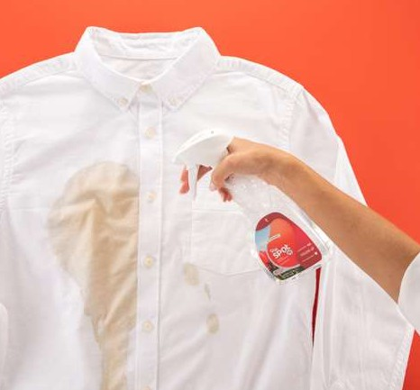
PRESPOT" 4X

THE ECOSENSE ADVANTAGE

PreSpot Laundry 5rnin Remover leverages the power of six natural enzymes to attack stubborn stains
PRESPOT 4X LAUNDRY STAIN RECOVER
This powerful laundry stain remover is optimized to work in cold water and easily lifts the toughest stains out of fabrics by using a foaming action to ensure better coverage and performance. PreSpot removes a variety of stains, including grass, blood, dirt, coffee, milk, gravy, tomato sauce, chocolate, salad dressing, makeup, and cooking oil. While PreSpor is tough on all stains in any water temperature, be sure to always wash blood stains in cold water.
Dl RECTIONS
STEP 1 Spray on stain and rub in. STEP 2 Let sit for at least s minutes.
STEP 3 Wash as usual. For best results, treat stains as soon as possible.
STEP 4 Inspect stain before drying laundry because drying can set stains in. Extremely tough stairs may require a second treatment before going into the dryer.





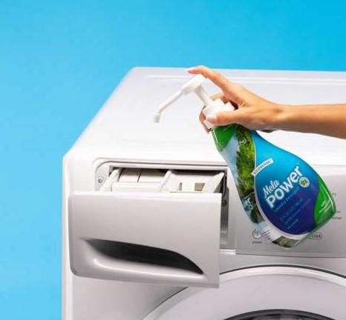
SunshineLiviner!
LAUNDRY

NELAPOWER 9X LAUNDRY DETERGENT
This laundry detergent is designed to lift out dirt and prevent it from resettling, giving you cleaner, fresher clothes wash after wash. A little goes a long way!
Me/oPower is gx concentrated, so only one pump is needed to clean most loads.
Dl RECTIONS
STEP 1 Add one pump (10 mL) of MeloPower to detergent dispenser.
For heavily soiled loads, use two pumps.
THE ECOSENSE ADVANTAGE

MelaPower Laundry Detergent breaks down even the toughest stains using safer ingredients— including a proprietary blend of natural enzymes.
STEP 2 Wash as usual. MeloPower is formulated to work in all water temperatures, including cold water.
HIGH EFFICIENCY OR REGULAR?
MelaPower has formulas for high efficiency (HE) and regular washers. Be sure to choose the correct formula for your machine.

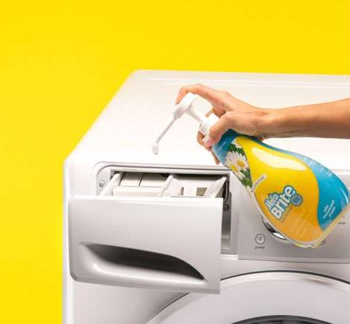
NELABRITE* 9X

NELABRITE 9X COLOR BOOSTER
This color-safe brightener keeps colors bright without fading or buzzing. Our pH-neutral formula uses safer ingredients to help clothes look new longer.


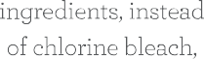

THE ECOSENSE ADVANTAGE

Chlorine bleach is commonly used in laundry whiteners to whiten whites, but this comes at a
Dl RECTIONS
STEP 1 Add one pump (10 mL) oi MelaBrite to the detergent dispenser.
STEP 2 Add colors and wash as usual. MelaBrite is formulated to work in all water temperatures, including cold water.

WHICH NELABRITE SHOULD I USE?
MelaBrite gx and MelaBrite Plus Ovi are laundry additives designed to do different things. MelaBrite brightens and protects colors, while MelaBrite Plus Ovi brightens whites and deodorizes.
They usually don't need to be used together, unless your goal
is to deodorize an especially smelly load of colors. Use with

SunshineLivin
LAUNDRY

NELABRITE"
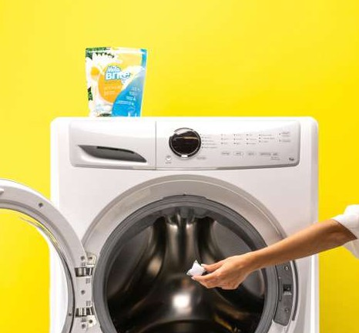

PLUS OXI
NELABRITE PLUS OXI COLOR-SAFE WHITENER
This color-safe formula whitens, removes stains, and battles dinginess—all in a small, dissolvable, toss-in pack. The same whitening technology also deodorizes, giving you a laundry additive to battle odors like sweaty gym clothes and musty washing machines.
01RECTIONS
STEP 1 Toss one MeloBrite Plus Ovi pack into empty washer (use two packs for heavy loads). DO NOT place in bleach cup.
DEODORIZING
To deodorize washing machine, add two packs to empty machine and run a cycle.
STEP 2 Load laundry on top of pack(s).
STEP 3 Run cycle.

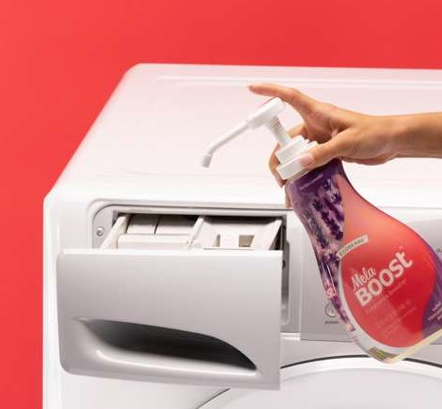
NELABOOST”

NELABOOST LAUNDRY FRAGRANCE BOOSTER
Used in combination with MelaPoweS, this long-lasting, in-wash scent enhancer adds a fantastic, fragrance-bursting experience to any fabric. All EcoSense products use our Safe Scent" standard to ensure you get a fragrant experience without compromise!
DIRECTIONS
Put a little or a lot directly into the washer with MelaPower, depending on your personal preference. We recommend using three pumps (3s b) For a more pronounced scent, add up to nine pumps or capfuls.

NELASOFT° 9X

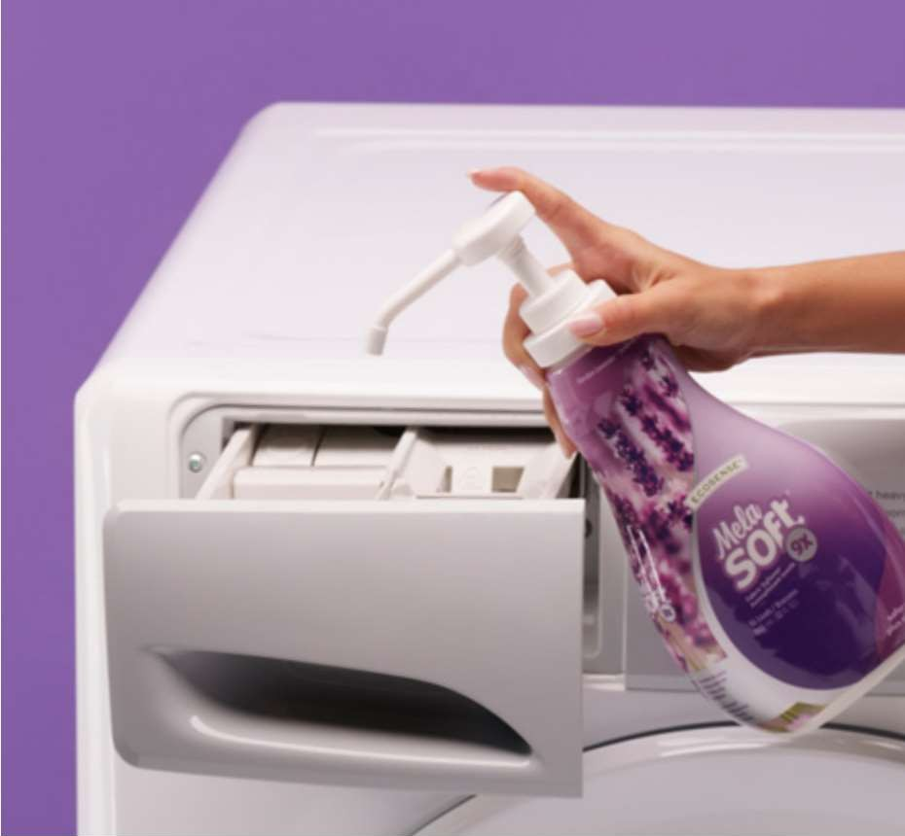
MELASOFT 9X LIOUI D FABRIC SOFTENER
This fabric soitener leaves clothes, linens, and towels naturally softer, fresher-

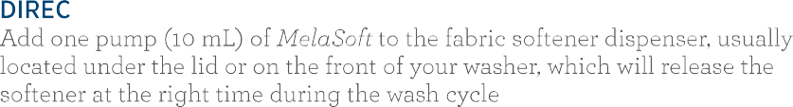
SunshineLivin
LAUNDRY

ADVANTAGE
MelaSott is formulated with natural ingredients, like formaldehyde-tree scent capsules that release scent over time.
washer during the final rinse cycle.

Avoid using MelaSoLt on workout clothes, microfiber, flame- resistant items, and water-repellent clothing. To keep towels both soft and absorbant, we suggest using it every other wash cycle.

NELASOFT DRYER SHEETS

NELASOFT DRYER SHEETS
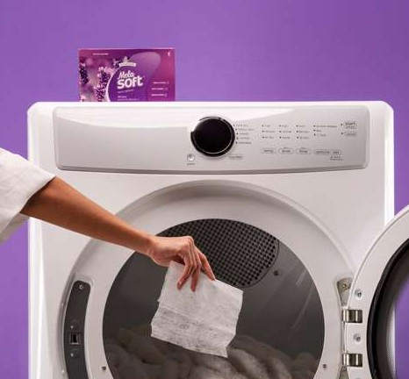
These dryer sheets leave clothes, linens, and towels naturally softer and smelling fresher while also reducing static cling.
DIRECTIONS
Place one dryer sheet in the dryer with laundry before starting cycle. Add an extra sheet for large loads or for extra softness.

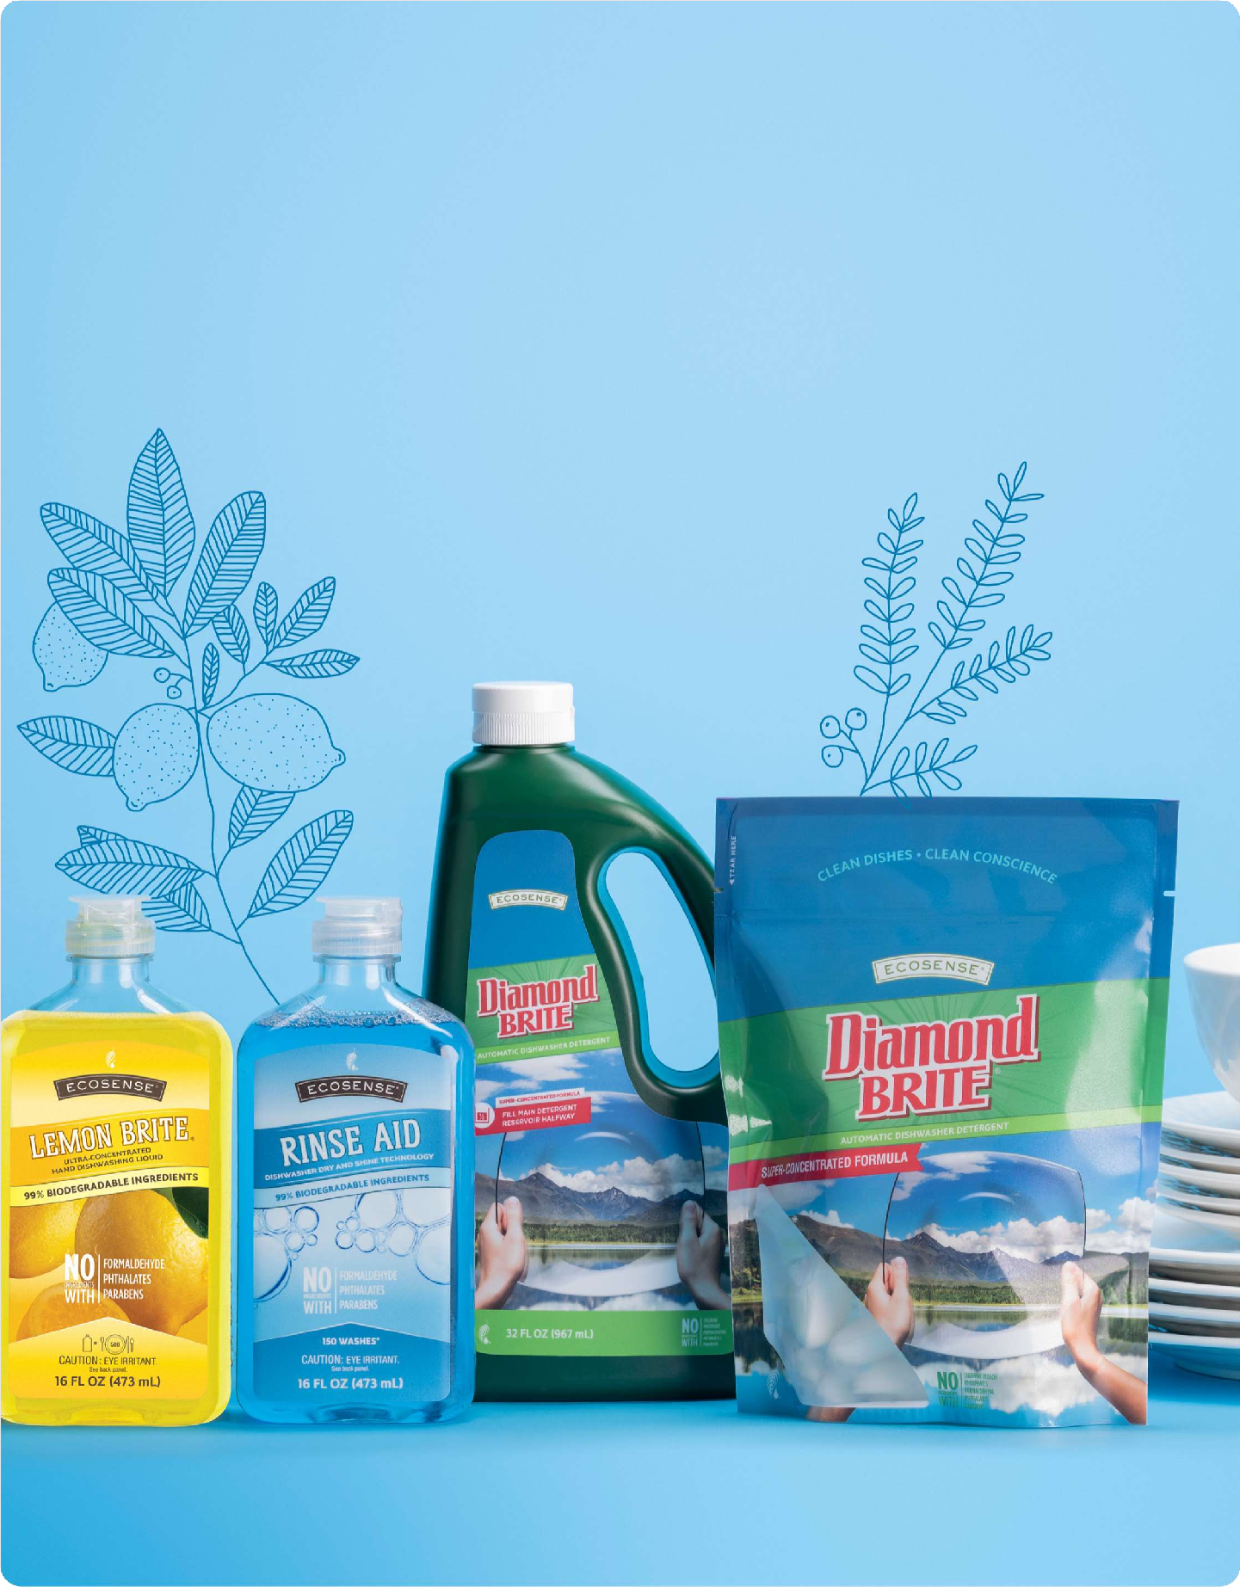




SunshineLivin


HOW TO
p
Load Your Dishwasher

Even the best dishwashers won't get your dishes clean if they're loaded improperly. We've put together some of our recommendations on how to load your dishwasher to get sparkling-clean dishes every time.
S
- Top rack

Place cups, glasses, small bowls, dishwasher-safe plastics, and lids on the top rack. Place cups and bowls face down or at an angle.

Lay long utensils flat, such as spatulas, to ensure they don't slip through the rack.
- Bottom rack
Place plates, serving bowls, pots, and pans on the bottom rack. Place pots, pans, and baking dishes along the sides or front of
Avoid placing large items in front of dishwasher door; this can block detergent from reaching the other dishes.

- Silverware
H
E
Place forks and spoons with handles facing down. Knife handles po up. lix spoons,
S
forks, and knives.

DO NOT WASH: Sharp knives (running knives through
the dishwasher will dull them), wooden items (cutting boards or utensils), nonstick pans, cast iron, metal

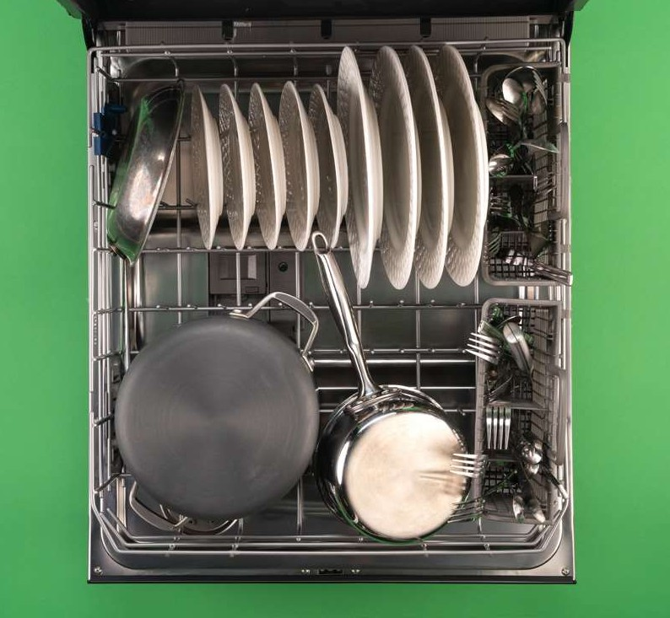
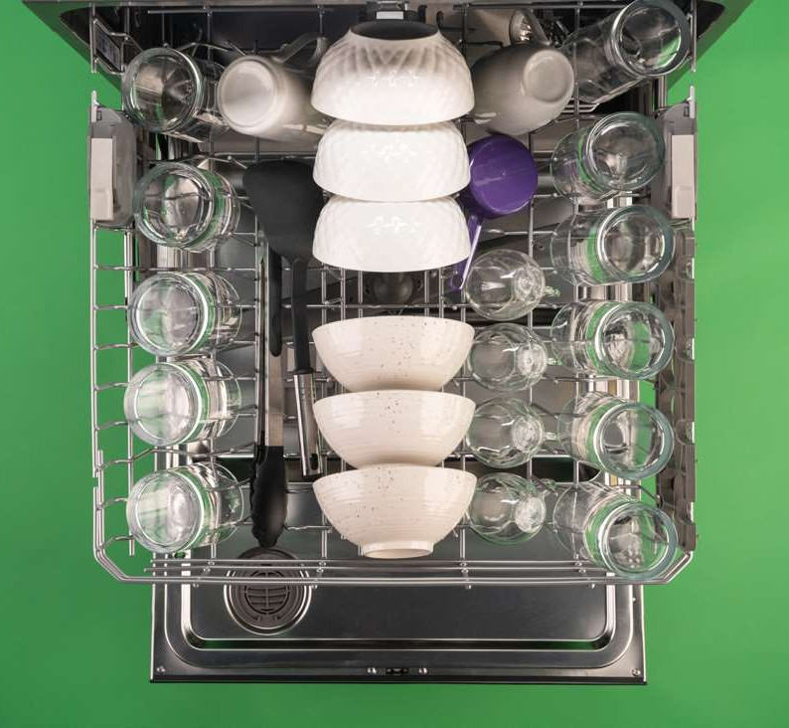
SunshineLivin

Have a Loading
Strategy
TOP RACK
- Face everything toward the sprayer
- Load from back to front
- Unload from bottom to top

BOTTOM RACK

MORE TIPS6

AVOl D THESE COM PiON
Mistakes
- Using too much dish detergent (with Diamond Brite°’, you only need to fil1 main detergent
reservoir half full).
a breeding ground for germs,
unpleasant odors, and a less efficient cleaning cycle.
- Not cleaning your dishwasher regularly. Built-up food in your
dishwasher's filter results in
- Using old accessories (sponges or dish rags can hold a lot of bacteria,
so replace them often).



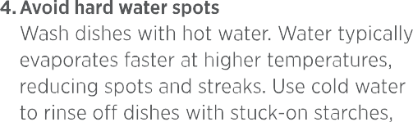
HOW TO NAKE
D
I
S
H

Hand-Washing Dishes Easy
E

  - Clean as you go
Keeping up is much easier than catching up. Cleaning as you cook, or immediately after, makes the cleaning process more
foods, presoaking for a few minutes while you wash other dishes saves time and energy. wARNING: NEVER SOAK CAST IRON!
SOAKING IT IN WATER WILL CAUSE CAST IRON
S

SunshineLivin

order: glassware, cutlery, plates and bowls, then pots and pans.

3. Allow to soak
While it's wise to wash some dishes immediately, for dishes with burnt-on
like pasta and rice, and dairy because starches and dairy can swell up and get sticky in hot water. Drying dishes with a clean towel can help avoid spotting or film being left on dishes. Always use a clean towel to avoid spreading bacteria to your clean dishes.

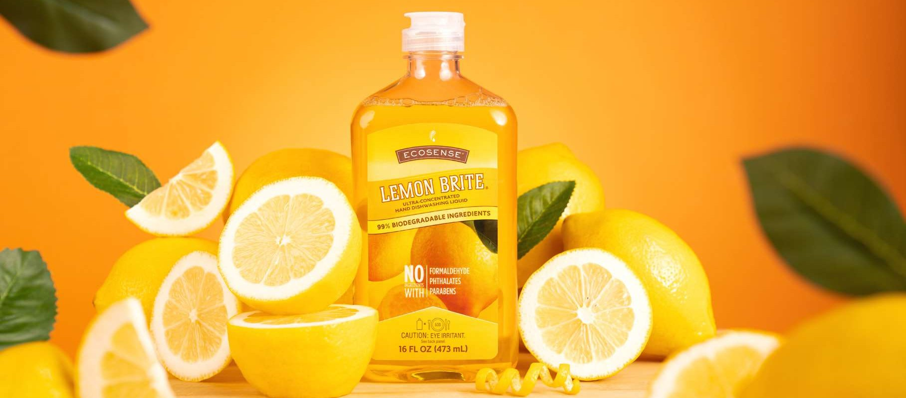

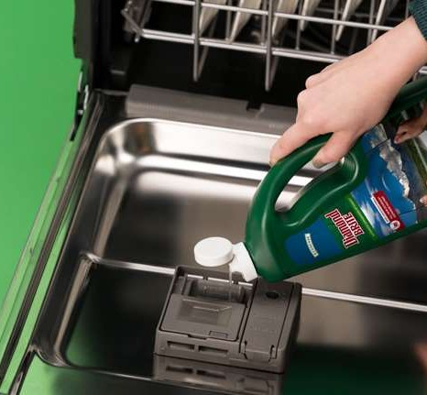
DIANOND BRITE° GEL

°_

DIAMOND BRITE AUTOMATIC DISHWASHER DETERGENT GEL
This pH-neutral automatic dishwasher detergent leaves dishes, glasses, and
silverware spotlessly clean without harsh fumes or residues.
S

Dl RECTIONS
STEP 1 No need to prerinse dishes; simply remove large food particles.
H
STEP 2 A little goes a long way! Fill your main detergent dispenser halfway.
E
NEED NORE SHINE?
For best results, use in combination with EcoSense°’ Rinse Aid.

DIANOND BRITE PACKS
S

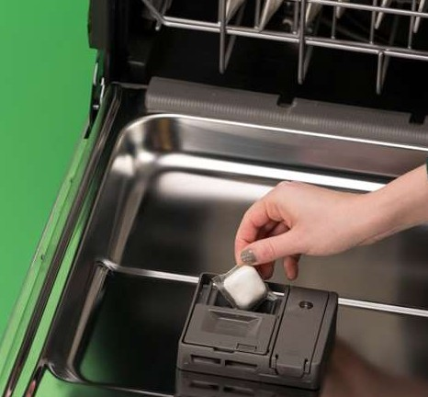
SunshineLivin
Dl RECTIONS
STEP 1 No need to prerinse dishes; simply remove large food particles.
STEP 2 Add one pack to main detergent cup (leave dispenser door open if necessary).
THE ECOSENSE
ADVANTAGE
PHOSPHATE-FREE
Diamond Brite was the world's first effective phosphate- free automatic dishwashing detergent.
PACK NOT FULLY DISSOLVING?
Try placing a Diamond Brite Pacts on the floor of your dishwasher rather than in the detergent dispenser.

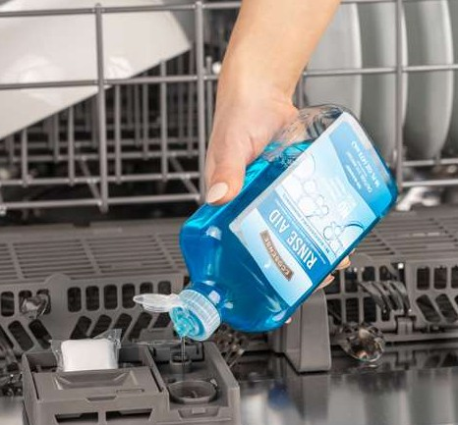
ECOSENSE° RINSE AID

°_

ECOSENSE RINSE AID DISHWASHER RINSE AND DRYING AGENT
Naturally derived citric and glycolic acids—like those found in lemons and sugar beets—help soften the water and prevent hard water spots, while natural cleaners reduce the surface tension of the water so that it quickly and easily slides off, with no streaks and no droplets!
S
H

DIRECTIONS
Fill the rinse aid dispenser in your dishwasher. Refill your dishwasher's rinse aid dispenser every month or so as needed.
E

LENON BRITE%
S

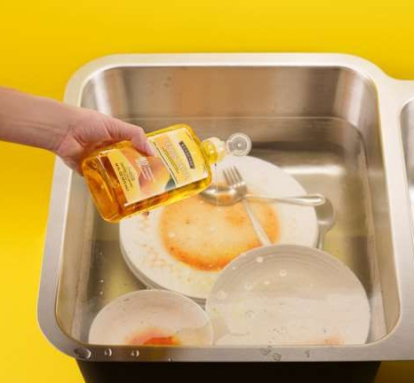
LEMON BRITE HAND DISHWASHING LIOUID
This hand dishwashing liquid quickly breaks down food to save you

SunshineLivin
ADVANTAGE

One bottle of concentrated Lemon Brite is enough to clean over soo dishes!
All with gentler,
naturally derived, biodegradable cleaning agents.




SunshineLivin

Tackle one room or space at a time to avoid
getting overwhelmed.

Start small (like cabinets and drawers). Quick wins create a snowball effect that helps you build motivation faster!
- Place similar colors together.




- Color coordinating makes your items look neater and more visually appealing.
- Examples: closet, books, clothes, crafting supplies.
- Follow ROYGBIV (red, orange, yellow, green, blue, indigo, and violet).


  - Imagine you're a guest entering your home for the first time.



SunshineLivin

mo ru oss or on

- Designate a hidden home for clutter (such as a junk drawer or all-purpose closet).
Arrange items according to how frequently
they're used.
- Keep similar items together.
- Create a system that makes it easier to put things away (for example, if you're stacking boxes on top of each other, place the boxes that hold things you use most often on top).
Routine
Maintenance
Take care of clutter daily.

Don't put it down—put it away!

Everything should have a designated spot in your home. Once you're done using something, immediately put it back where it belongs.

Pay attention to your habits and work to mitigate messes.

Clear flat surfaces of clutter.


POWER THROUGH

Your Pantry

- Discard old and expired foods. 5. Put heavy items on bottom shelves or floor.

- Divide your pantry into zones to keep food organized and easy to find.

- Put items you use less frequently on the higher shelves.

- Put daily-use items on middle shelves where they're easiest to see and access.
- Take items out of original packaging for more space and a cleaner, simpler look. Use bins, baskets, or clear containers for storage and to make pantry items more visible.

- If your pantry features deep shelves, place taller items at the back. Keep smaller items in a line (instead of stacking them) so you know what's at the back of the shelf.

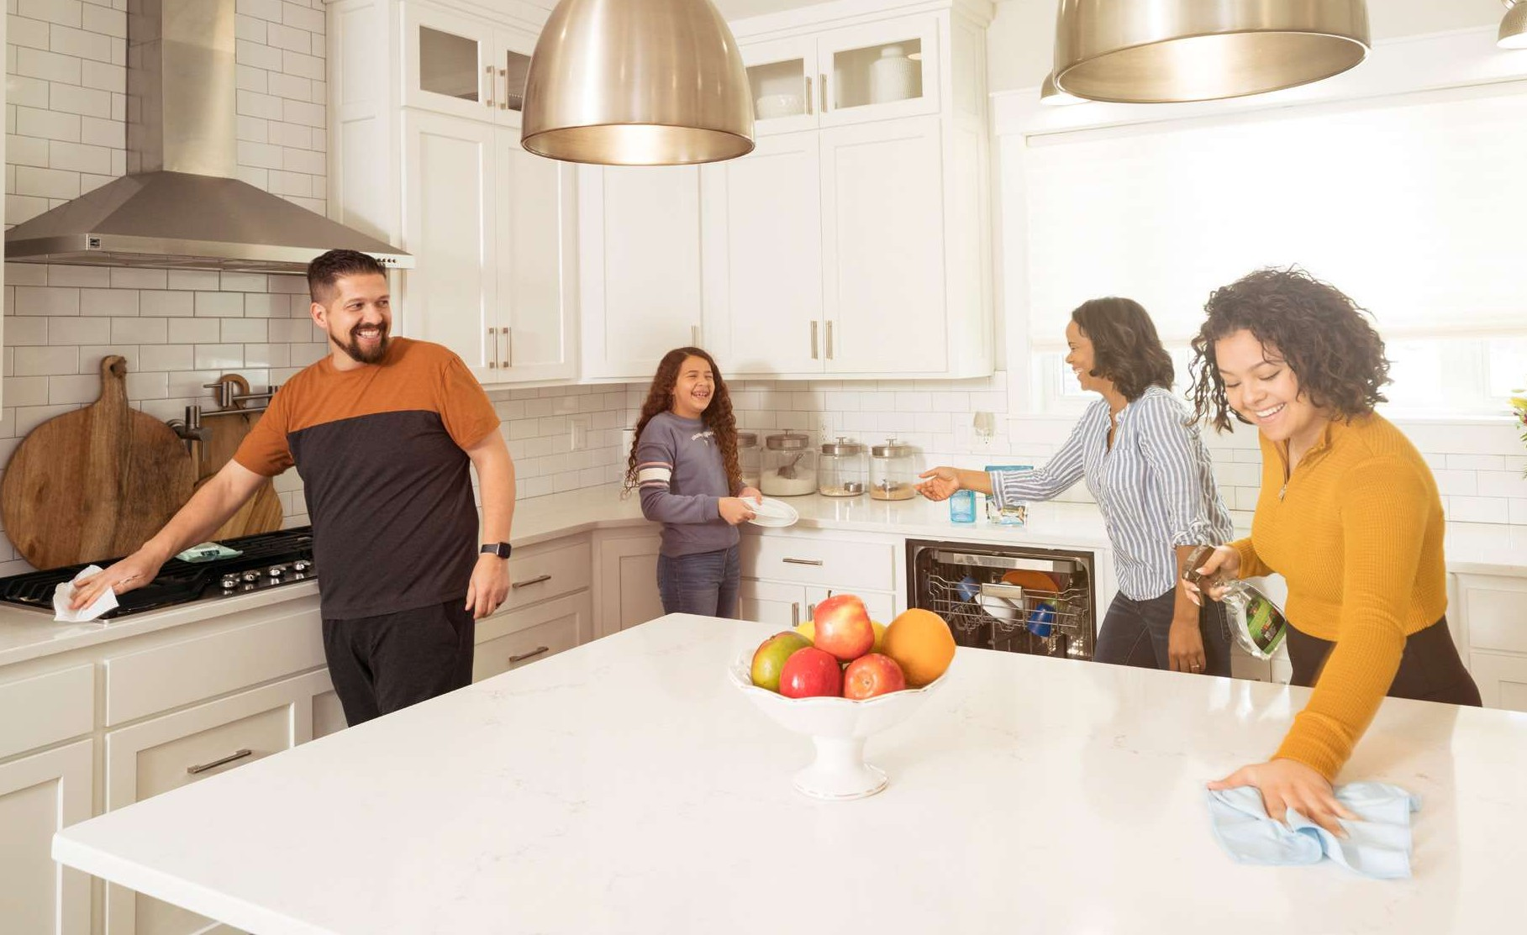
SunshineLivin

Clean space, clear head.
Keeping your home and your work area organized boosts productivity by focusing your mind. It also contributes to a more stress-free life!

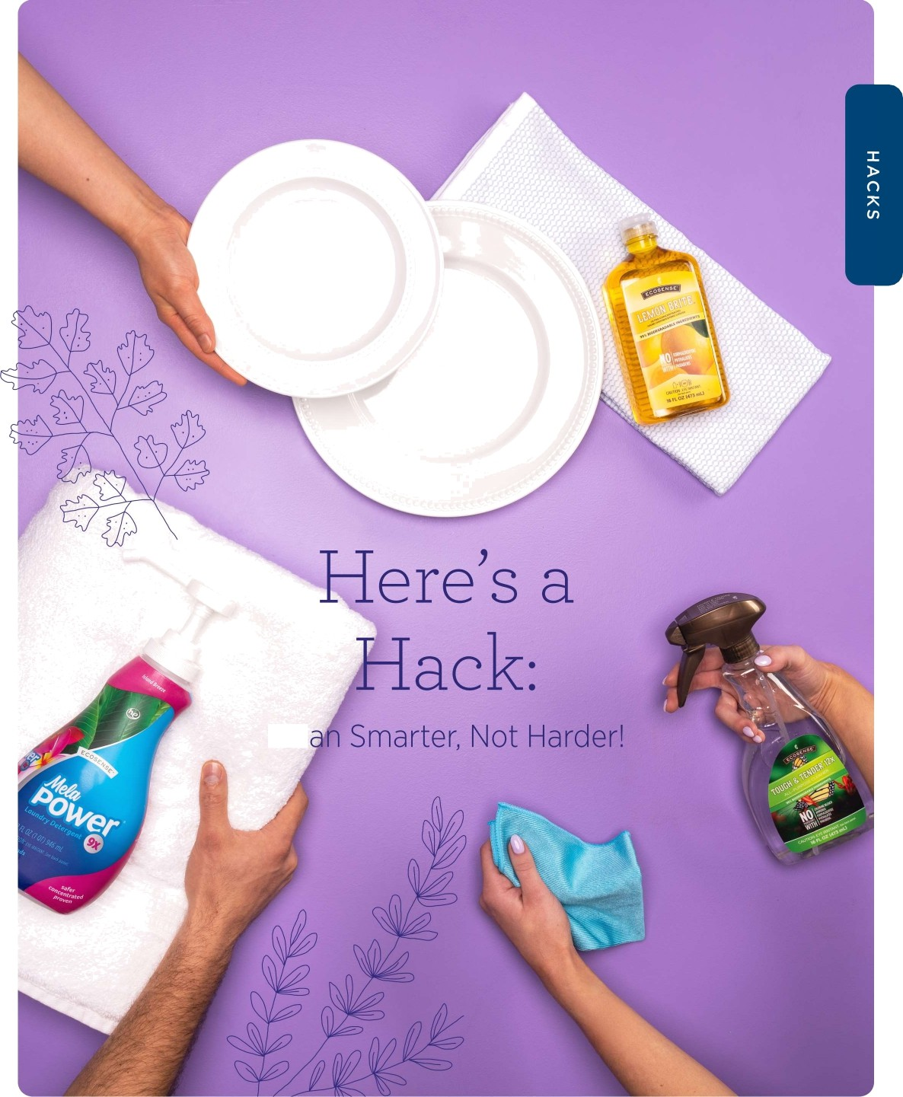

SunshineLivin

C e

ECOS ENSE CLEANING HANDBOOK | 38


USE ECOSENSE
To Solve Problems

RENOVE SWEAT STAINS
Use diluted Tub & Ti/e^{T}" to remove underarm stains caused by antiperspirant.
WASH THE OUTSIDE OF YOUR CAR
MeloMo9ic‘ is great for washing the outside of your car.
CLEAN OUTDOOR WINDOWS
Use diluted Tub & Tile on the outside of windows to remove hard water stains.
REMOVE GREASE STAINS
Add one capful of full-strength Me/nMog/c or Sol-U-Mel " to your laundry detergent dispenser along with MelaPower to remove grease stains.
DIRTY BLENDER
Fill halfway with hot water, add a squirt of Lemon Brite, blend for a few seconds, then rinse with clean water!

SunshineLivin

shoes, cars, folded sheets, and more.

REMOVE HARD WATER
Minerals on your fixtures? Secure a plastic bag filled with diluted Tub & Tile to remove difficult mineral buildup from shower heads, faucets, and more.
grease and oil stains! Pour one capful into your laundry detergent dispenser along with your laundry detergent and let
Sol- V-Set work its magic.

DEODORIZE APPLIANCES
Use MeloBrite® Plus Oxi to deodorize your dishwasher or washing machine.

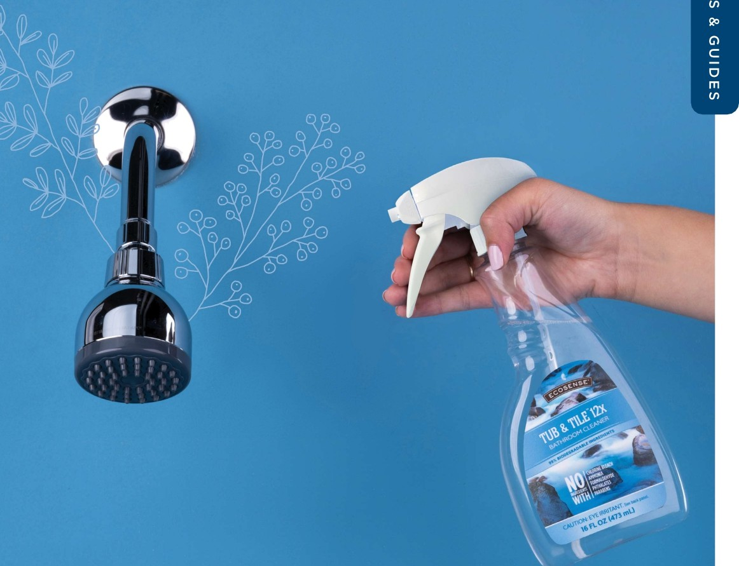
SunshineLivin


Solutions for every space!
Sui faces and matei ial may vary. Ensure you are using th°. '.err°..I clean°.r.

TASKS
WEEKLY TASKS








Does cleaning feel overwhelming? We get it! If the amount of work in front of you seems too large, it can be difficult to start. That's why the first principle of our EcoSense"' cleaning method is tackling small tasks daily to keep chores from snowballing into an unmanageable monster.
DAILY TASKS

Make beds Declutter

Plonday

Tuesday
ORGANIZE: This is a bigger decluttering. Check the flat surfaces that collect items when you are busy. Every item should have a home that it wants to return to. Wipe counters and dust tables as you tidy up. Sort the mail that has piled up and make a plan of action for dealing with it this week.

BATHROONS: Scrub toilets, surfaces, shower/tub,
S
T
S
&
and floors.
G

Wipe counters

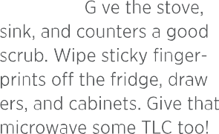
SunshineLivin
U
I
D
FLOORS: flop any hard


Dishes (load and run the dish- washer at the end of every day so dishes don't pile up)

Trash (check your main trash

cans daily—here's a rule of thumb: if it will stink by tomorrow, take it out tonight)


Have a plan. Clean the way that works best for you! Lists like this one make it easy to track your tasks and keep your living space clean and inviting.
CLEAR LIST
Thursday

Friday

Saturday
floors and vacuum carpets and stairs.

PLAY CATCHUP: If you
E
S
were too busy to tackle something on a previous day, this is your chance to take care of it. If you have a light day, choose from your monthly tasks and knock one off the list.

LAUNDRY: Get caught up on any clothes, bedding, and towels that need to be washed, ironed, or folded.

Bathrooms
SUPPLIES
Safe 8 Nlighty™ Tub & Tile™ Broom/N!op Tough & Tender
Botanica"
SohU-Guard
Clean & Gleam” telaMagic' Revive™ Air Care Sol-U-Mel" Rustic Touch™
Clear Power"
Laundry Line
EcoSense'


Clear clutter and return items to their proper places.

 Clean mirrors and windows with C/ear Power.


Wash towels and bath mats with f4elaPower“,

or spot clean with Sol-U-Mel if not washable.

 Wash shower curtains with MelaPower.

 Dust above cabinets.

Clean glass light fixtures with Clear Power. For nonglass light fixtures, use Tough & Tender.

Use a dry microfiber cloth to dust, then clean doors, door frames, and baseboards with Tough 8 Tender. If any of these are woodwork, use Pvst/c Touch.

Wipe exteriors of cabinetry with


 Tough & Tender. If cabinetry is woodwork, use Avst/c Touch.

Clean and disinfect cabinet handles with Tough & Tender and Sol-U-Guard Botanical.

Clean inside cabinets and drawers with

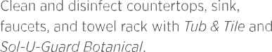
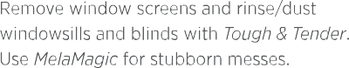






SunshineLivin

Thoroughly clean toilet with Safe & Mighty



Clean toilet with Safe 8 Mighty.

After cleaning your toilet, place the brush under the toilet seat. It will hold the brush in place to allow it to drip-dry. Spray the brush with Sol-U-Guard Botanical before placing back in the holder.

 Disinfect toilet with Sol-U-Guard Botanical.

Clean and disinfect shower/tub with Tub & Tile and Sol-U-Guard (use to Work after every shower or bath).

 Empty trash.

 Sweep, then mop floors with Clean & Gleam.

Freshen area with your favorite Revive Candle




or Room Spray.

Clear clutter and return items to their proper  places. Sort items into three categories: keep,



toss, and donate.

Tidy storage areas.
and Tough & Tender. Disinfect toilet with
Sol-U-Guard Botanical.

After emptying, clean and disinfect trash can with Tough & Tender and Sol-U-Guard Botanical.

Deodorize trash can with So/-L/-be/. Clean vents with Tough & Tender Wipes.
Scrub grout with Tub & Tile, use
Tough & Tender on colored grout.

Freshen area with your favorite /?ex/ e Candle
or Room Spray.

Entryway, Hallways & Stairs

Clear clutter and return items to their proper  places. Sort items into three categories: keep,
toss, or donate.
I

 Organize backpacks, jackets, and shoes.  Tidy coat closet.


 Spot clean walls with Tough 8 Tender Wipes.
SUPPLIES
Vacuum/Broom/ Mop
telaMagic' Clear Power"’ Tough & Tender'
Tub & Tile™ Clean & Gleam™ Microfiber Cloth
EcoSense' Laundry Line
Sol-U-Guard
Botanical'
D
E
S

Clean glass light fixtures with Clear Power. For nonglass light fixtures, use Tough & Tender.

Clean mirrors, windows, and glass with Clear Power.

 Clean vents with Tough & Tender Wipes.

SunshineLivin
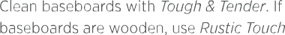






aren't washable.

 Tidy coat closet.


Dust hard surfaces with a feather duster, or wet-dust with Rustic Touch.

 Clean mirrors and windows with Clear Power.


Clean and disinfect handrail, doorknobs, and light switches with Tough & Tender and Sol-U-Guard Botanical.

Vacuum/sweep floors and stairs.

Mop hard floors and hard stairs with
Clean & Gleam.

 Vacuum/sweep floors and stairs.

 Mop floors and stairs with Clean & Gleam.
CLEAR LIST











Kitchen
SUPPLIES
Vacuum/Broom/Mop Tough & Tender"
Concentrate
telaMagic'
and Wipes
Botanical'
Sol-U-Guard
Clear Power' Tub & Tile™ Clean & Gleam™
Dish Line
EcoSense
Rustic Touch"
& Pantry
Clean any spills inside fridge with


Tough & Tender.
S
T

Clean countertops and kitchen appliances with Tough & Tender. For stainless steel appliances, use Clear Power.

 Clean windows with Clear Pow'er.  Empty trash.
 Sweep floor and mop with Clean 8 Gleam.
S
&

Freshen area with your favorite /?ev/ e™

Candle or Room Spray.
G
U

SunshineLivin

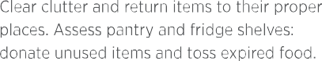



Wash dishes with EcoSense dish line.
I
D


Clean and disinfect counter with Tough & Tender and Sol-U-Guard Botanical. NOTE: Do not use Sol-U-Guard Botanical on natural stone.

Clean and disinfect sink and faucets with
Tough & Tender and Sol-U-Guard Botanical.


Spot clean cupboards and cabinets with Tough 8 Tender. If cabinetry is woodwork, use Push/c Touch.

Spot clean exteriors of all appliances with
Tough & Tender.


Clean microwave interior with Tough & Tender.

Clean stovetop with MelaMagic Wipes.

Spot clean oven interior with f4elaf4agic.
 Organize cabinets and drawers.

Clean glass light fixtures with Clear Power. For nonglass light fixtures, use Tough & Tender.

Clean windows with Clear Power. Remove window screens and rinse/dust windowsills with Tough B Tender. Use MelaMagic for stubborn messes.

Clean microwave interior and exterior (refer to app|iance guide on pape 7).

 Clean range hood with NelaMagic.

Clean stovetop (refer to appliance guide on page 7).

Clean oven interior and exterior (refer to appliance guide on page 7).

CLEAR LIST

CONTINUED 6


Clean dishwasher interior and exterior (refer to appliance guide on page 7).


Clean oven interior and exterior (refer to appliance guide on page 7).


Clean dishwasher interior and exterior (refer to appliance guide on page 7).

Clean fridge and freezer interior and exterior (refer to appliance puide on page 7).
Disinfect all appliance handles, door knobs,
and light switches with Sol-U-Guard Botanical'.

Clean cabinet and drawer exterior with
 Tough 8 Tender". If cabinetry is wooden, use Rustic Touch".


Scrub sink with Tub & Tile™.
 Spot clean walls with Tough & Tender Wipes.

 Dust baseboards with dry microfiber cloth.

Clean baseboards with Tough & Tender. If baseboards are wooden, use Rustic Touch.

 Sweep, then mop floor with Clean & Gleam™.

Freshen area with your favorite /?ev/ve™


Candle or Room Spray.
LI
ST
S
CLEAR LIST

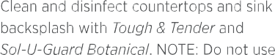



SunshineLivin
&
G
U
I

Sol-U-Guârd Botanical on natural stone.
D
E

After emptying, clean and disinfect trash can with Tough & Tender and Sol-U-Guard Botanical.

Deodorize trash can with Sol-U-Mel.

 Spot clean window curtains with Sol-U-feel.

Dust blinds with a microfiber cloth, then wipe down with Tough & Tender Wipes. Use

telaMagic Wipes for stubborn messes.

 Clean vents with Tough & Tender.

Wash kitchen mat with f4elaPoweñ. Spot clean with So/-L/-be/ if mat isn't washable.

ECOS ENS E CLEAN ING H ANDB OOK | €5

Dining Room
SUPPLIES
Paper Towels
mop
Vacuum/Broom/
Tough & Tender"
Botanical"
Sol-U-Guard
Clear Power"
Clean & Gleam” telaMagic'
Sol-U-N!eI”
Rustic Touch™
EcoSense' Laundry Line
Microfiber Cloth


Clear clutter and return items to their proper places.

Clear clutter and return items to their proper  places. Sort items into three categories: keep,

toss, or donate.
LI
S
T

Clean glass light fixtures with Clear Power. For nonglass light fixtures, use Tough & Tender.

Clean windows with Clear Power. Remove window screens and rinse/dust windowsills and blinds with Tough 8 Tender. Use MelaMagic for stubborn messes.

 Clean mirrors and plass with Clear Power.

Wipe down doors, door frames, and
 baseboards with Tough 8 Tender. For any woodwork, use Rustic Touch.
S
&

Clean and disinfect doorknobs and li ht

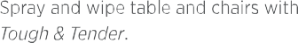
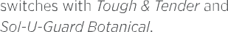
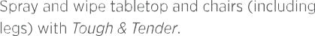





SunshineLivin
G
U
I

 Sweep/vacuum floor and area rugs.  Mop with Clean & Gleam on hard floors.  Polish furniture with Rustic Touch.

Freshen area with your favorite /?ev/ e” Candle or Poom Spray.

Dust blinds with a microfiber cloth, then wipe down with Tough & Tender Wipes. Use telaMagic Wipes lot stubborn messes.
D
E

 Clean vents with Tough & Tender Wipes.  Polish wooden furniture with Pustic Touch.  Dust baseboards with dry microfiber cloth.


Clean baseboards with Tough & Tender. If baseboards are wooden, use Rustic Touch.
S

Vacuum and wash area rups with EcoSense laundry line. Spot clean with Sol-U-Mel il rugs aren't washable.

 Sweep, then mop floor with Clean & Gleam.

Freshen area with your favorite Revive Candle or Room Spray.

CLEAR LIST

Livinq Room
SUPPLIES
MVaocpuum/Broom/
MelaNagic' Clear Power' Tough & Tender'
Botanical
SolU-Guard
Rustic Touch' Clean & Gleam™
Sol-U-Mel'

Clear clutter and return items to their proper places.


Dust hard surfaces with a feather duster or wet-dust with Pustic Touch.




 Clean remotes with Tough 8 Tender Wipes.

Clean plass light fixtures with Clear Power. For nonglass light fixtures, use Tough & Tender.

Dust blinds with a microfiber cloth, then wipe down with Tough 8 Tender Wipes. Use f4elaMagic Wipes for stubborn messes.

Clean windows with Clear Power. Remove window screens and rinse/dust windowsills with Tough & Tender. Use Ne/a/'Yag/c for stubborn messes.

Clean mirrors and glass with Clear Power.

 Clean ceiling fan with Tough 8 Tender.

Wipe down doors, door frames, and baseboards with Tough & Tender. If doors, door frames, and baseboards are woodwork,

use Rustic Touch.

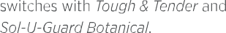





SunshineLivin


pe own rn re ou
and spot clean fabric with Sol-U-Mel.


Fold blankets and fluff pillows, freshen with Pevive” Fabric Freshener.


Sweep and vacuum floor. For hard floors, mop with Clean 8 Gleam.


Freshen area with your favorite dev/ve
Candle or /?oom Spray.


Clear clutter and return items to their proper places. Sort items into three categories: keep, toss, or donate.
 Wash blankets with NelaPoweé.


Dust and clean electronics with
Tough & Tender w‘/pes and Rustic Touch Wipes.
CLEAR LIST
Clean surfaces such as coffee tables with




Tough & Tender.

Remove cushions and vacuum couch/ armchairs. Freshen throw pillows with Pevive Fabric Freshener.

 Spot-clean curtains with Sol-U-feel.

 Clean vents with Tough & Tender Wipes.

Vacuum/wash area rugs with EcoSense laundry line. Spot clean with Sol-U-Mel if rups aren't washable.

Vacuum or sweep floors. For hard floors, follow with Clean 8 Gleam.

 Polish wooden furniture with Rustic Touch.

Freshen area with your favorite Revive Candle or Poom Spray.

Bedrooms
SUPPLIES
Vacuum/Broom/
Clear Power' Tough & Tender'
°p
Sol-U-Mel’
Rs.tic Touch'
Clean & Gleam”
Sol-U-Guard
Botanical"


Clear clutter and return items to their proper places.
QUICK CLEAN

Dust hard surfaces with a feather duster or wet-dust with Rustic Touch.
Clean glass light fixtures, lamps, and ceiling  fans with Clear Power. For nonglass light




fixtures, use Tough & Tender.
LI
S
T

Dust blinds with a microfiber cloth, then wipe down with Tough & Tender Wipes. Use telaMagic Wipes for stubborn messes.

Clean windows with C/ear Power. Remove window screens and rinse/dust windowsills and blinds with Tough & Tender. Use Nelaf4agic for stubborn messes.

 Clean mirrors and plass with Clear Power.

Wipe down doors, door frames, and baseboards with Tough & Tender. If doors, door frames, and baseboards are woodwork, use Rustic Touch.

Clean and disinfect doorknobs and light switches with Tough & Tender and







SunshineLivin


Clean dresser, bedside tables, and drawers with Tough & Tender.


Sweep/vacuum floor. For hard floors, mop with Clean 8 Gleam.


Freshen area with your favorite Per/ce™
Candle or /?oom Spray.
DEEP CLEAN



Clear clutter and return items to their proper places. Sort items into three categories: keep, toss, or donate.


Wash pillowcases with NelaPower and/or freshen with Revive Fabric Freshener.


 Wash bedding with fJelaPower.


Dust hard surfaces with a feather duster or wet-dust with Rustic Touch.
CLEAR LIST
with Sol-U-Mel.

 Make beds.

 Spot clean walls with Tough & Tender Wipes.

 Spot clean curtains with Sol-U-Mel.

 Clean vents with Tough 8 Tender.

Vacuum and wash area rugs with NelaPower. Spot clean with Sol-U-Mel if rugs aren't washable.

After vacuuming or sweeping, mop hard floors with Clean 8 Gleam.

 Polish furniture with Rustic Touch.

Freshen area with your favorite Revive Condle or /2oom Spray.

Closets
SUPPLIES
Vacuum/Broom/
MelaMagiC
Clear Power'
Tough & Tender'
°p
Sol-U-Mel’ Tab & Tile™ Rustic Touch’
Clean8 Gleam”
Sol-U-Guard
Botanical"







Clear clutter and return items to their proper places.
S

 Remove all items from closet/storage space.

Assess items and sort into three categories: keep, toss, or donate.

Dust hard surfaces with a feather duster or wet-dust with Pustic Touch.

 Wipe down surfaces with Tough & Tender.

Clean glass light fixtures with Clear Power. For nonglass light fixtures, use Tough & Tender.

Wipe down doors, door frames, and baseboards with Tough & Tender. If doors, door frames, and baseboards are wooden, use Rustic Touch.



SunshineLivin
LI
S
T




with Clean & Gleam.

 Organize and return items to closet.
CLEAR LIST




Laundry Room
SUPPLIES
Mop
Vacuum/Broom/
Botanical'
Sol-U-Guard
Paper Towels telaMagic"
Sol-U-Mel" Tub & Tile™
Clear Power" Rustic Touch' Tough & Tender' Clean & Gleam™




Clear clutter and return items to their proper places.
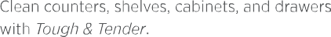
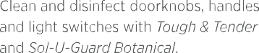




Dust hard surfaces with a feather duster,

Clear clutter and return items to their proper places. Sort items into three categories: keep, toss, or donate.

Clean shelves, drawers, and cabinets with Tough & Tender.

Dust hard surfaces with a feather duster or wet-dust with Pustic Touch.

Clean glass light fixtures with Clear Power. For nonglass light fixtures, use Tough & Tender.

Wipe down doors, door frames, and baseboards with Tough & Tender. If doors, door frames, and baseboards are wooden, use PL/st/c Touch.

Spot clean walls with Tough & Tender Wipes.





Clean any faucets and fixtures with Tub & Tile.
SunshineLivin

 Clean sink and faucets with Tub & Tile.

 Clean appliance fronts with Tough & Tender.

 Clean dryer lint trap.
Clean windows with Clear Power.
 Empty trash.

Sweep or vacuum floors. For hard floors, mop with Clean & Gleam.


Clean washing machine (refer to appliance guide on page 7).

 Clean dryer and clear lint trap.

 Clean appliance fronts with Tough & Tender.  Vacuum underneath and behind machines.  Empty trash.

 Clean vents with Tough & Tender.

After sweeping or vacuuming, mop hard floors with Clean 8 Gleam.

CLEAR LIST

Office
SUPPLIES
Mop
Vacuum/Broom/
Botanical'
Sol-U-Guard
telaMagic" Clear Power" Tough & Tender'
Sol-U-Mel" Rustic Touch" Clean & Gleam™


Clear clutter and return items to their proper places.

 Organize paperwork and office supplies.

 Clean desk and drawers with Tough & Tender.

Clean glass light fixtures with Clear Power. For nonglass light fixtures, use Tough 8 Tender.

Clean windows with Clear Power. Remove window screens and rinse/dust windowsills and blinds with Tough & Tender. Use telaMagic for stubborn messes.

Wipe down doors, door frames, and baseboards with TToUgh 8 Tender. If doors, door frames, and baseboards are wooden, use PUst/c Touch.

Clean and disinfect doorknobs and light


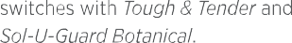
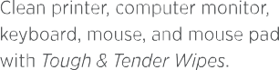













SunshineLivin
D
E
S

 Clean desk with Tough & Tender.


Dust and clean electronics (including computer monitor, keyboard, mouse, and mouse pad) with Tough 8 Tender Wipes.

 Clean windows with Clear Power.


Sweep/vacuum floor. For hard floors, mop with Clean & Gleam.


Freshen area with your favorite
/?e /ve™ Candle or Room Spray.
Wipe down chairs with Tough & Tender.

 Spot clean curtains with Sol-U-Mel.

Clean vents with Tough & Tender; change furnace filter if necessary.

Vacuum and wash area rugs with NelaPower. Spot clean with So/-U-Te/ if rugs aren't washable.

After vaCuuming or sweeping, mop hard floors with Clean & Gleam.

 Polish wooden furniture with Pustic Touch.

Freshen area with your favorite Pevive Candle or /?oom Spray.

CLEAR LIST

Basement
SUPPLIES
Mop
Vacuum/Broom
Botanical'
Sol-U-Guard
telaMagic" Clear Power" Tough & Tender'
Sol-U-Mel" Rustic Touch” Clean & Gleam™


Clear clutter and return items to their proper places.


Dust hard surfaces with a feather duster or wet-dust with Pustic Touch.

Remove window screens and rinse/dust  windowsills with Tough & Tender. Use
MelaMagic for stubborn messes.
LI
SI

 Spot clean curtains with Sol-U-Mel.

 Clean mirrors and glass with Clear Power.

Clean glass light fixtures with Clear Power. For nonglass light fixtures, use Tough & Tender.

Dust and clean electronics with

Tough & Tender Wipes.
T D

Wipe down doors and door frames with
 Tough & Tender. If doors and door frames are wooden, use Rustic Touch.
E

Clean and disinfect doorknob and light  switches with Tough & Tender and
Sol-U-Guard Botanical.












SunshineLivin

and spot-clean fabric with Sol-U-Mel.


Fold blankets and fluff pillows, freshen with Revive™ Fabric Freshener.


Sweep and vacuum floor. For hard floors, mop with Clean & Gleam.


Freshen area with your favorite Pevive™ Candle or Poom Spray.


Clear clutter and return items to their proper places. Sort items into three categories: keep, toss, or donate.


Dust hard surfaces with a feather duster, or wet dust with Pustic Touch.


Clean windows with Clear Power.
CLEAR LIST
Wipes for stubborn messes.

 Clean vents with Tough & Tender.

 Dust baseboards with dry microfiber cloth.

Clean baseboards with Tough & Tender. If baseboards are woodwork, use Rustic Touch.

 Vacuum/sweep floors.

Vacuum/wash area rugs with EcoSense”' laundry line. Spot-clean with So/-U-/ fed if rugs aren't washable.

 Clean floors with Clean & Gleam Floor Cleaner.

 Polish furniture with Pustic Touch.

Freshen area with your favorite Revive Condle or Poom Spray.

Garage


Clear clutter and return items to their proper places.






Dust hard surfaces with a feather duster or wet-dust with Rustic Touch.
G
Clean glass light fixtures with Clear Power. For nonglass light fixtures, use Tough & Tender.

 Clean windows with Clear Power.

Remove window screens and rinse/dust windowsills with Tough & Tender. Use Nelaf4agic for stubborn messes.

Wipe down doors and door frames with Tough & Tender. If doors and door frames are wooden, use Rustic Touch.

Clean and disinfect doorknobs, handles, and light switches.

Wash inside and outside of garage doors with telaMagic.

Clean and disinfect counters with






Tough & Tender and Sol-U-Guard Botanical.
SUPPLIES
Broom/Vaccum telaMagic' Clear Power" Tough & Tender'
Botanical'
Sol-U-Guard
Sol-U-Mel" Rustic Touch" Clean & Gleam™
LI
S
T
S
&

SunshineLivin




Empty trash.  Sweep floor.
U
I

 Remove items from parape.

Assess items and sort into three categories: keep, toss, or donate.


Dust hard surfaces with a feather duster or wet-dust with Rustic Touch.


Wipe down surfaces with Tough & Tender.
Use telaMagic for stubborn messes.


Return and organize tools, supplies, equipment, etc.
D
E

 Empty trash.

Clean trash can interior and exterior with f4elaf4agic.

Disinfect and deodorize trash cans


with Sol-U-Guard Botanical and Sol-U-f4eI.
S
CLEAR LIST

Outside
SUPPLIES
Push Broom
Paper Towels/Rags MelaMagic'
ClearPower'
Tough & Tender'
Sol-U-Guard Botanical'
SOI-U-Mel’
Tub & Tile™


 Pick up yard clutter (waste, toys, tools, etc.) Clean windows with Clear Power.
Use Tub 8 Tile for hard water stains.
Remove window screens; rinse/dust windowsills and clean out window wells with ToiJgh 8 Tender or Tub 8 t/ie for hard water stains.

 Clean windows with Clear Power.

Clean doors inside and out with Tough & Tender. If doors are wooden, use Rustic Touch.

Clean and disinfect doorknobs and doorbell with Tough & Tender and Sol-U-Guard Botanical.

 Clear gutters.

Hose down siding, shutters, and ledpes that might be dusty.

Clean patio furniture. Use telaMagic for heavier messes and Tough & Tender for lighter












SunshineLivin
D
E
S



messes. Spot clean fabric with Sol-U-Mel.

Spray and wipe tables, countertops, and chairs with Tough & Tender.

 Sweep walkway, decks, and porch.

Clear heavy yard waste (trash, branches, leaves, etc.)

 Organize tools and equipment.

Clean glass light fixtures with Clear Power. For nonglass light fixtures, use Tough & Tender.

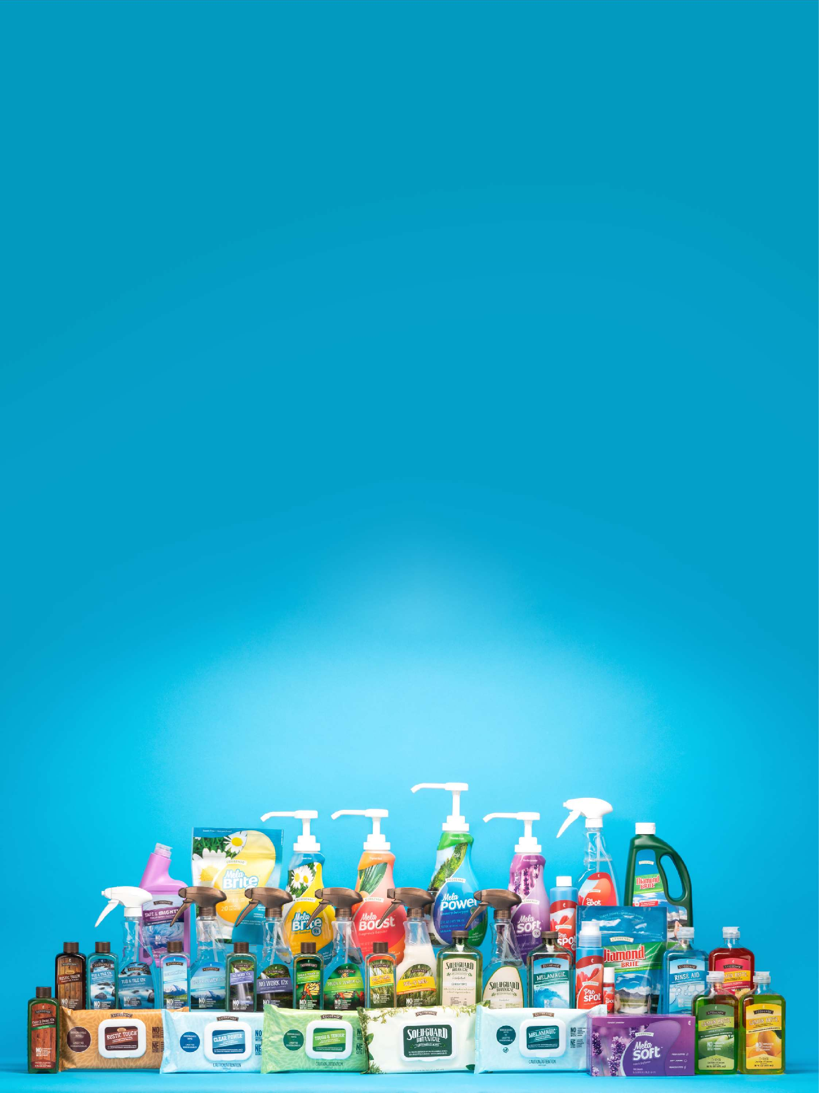

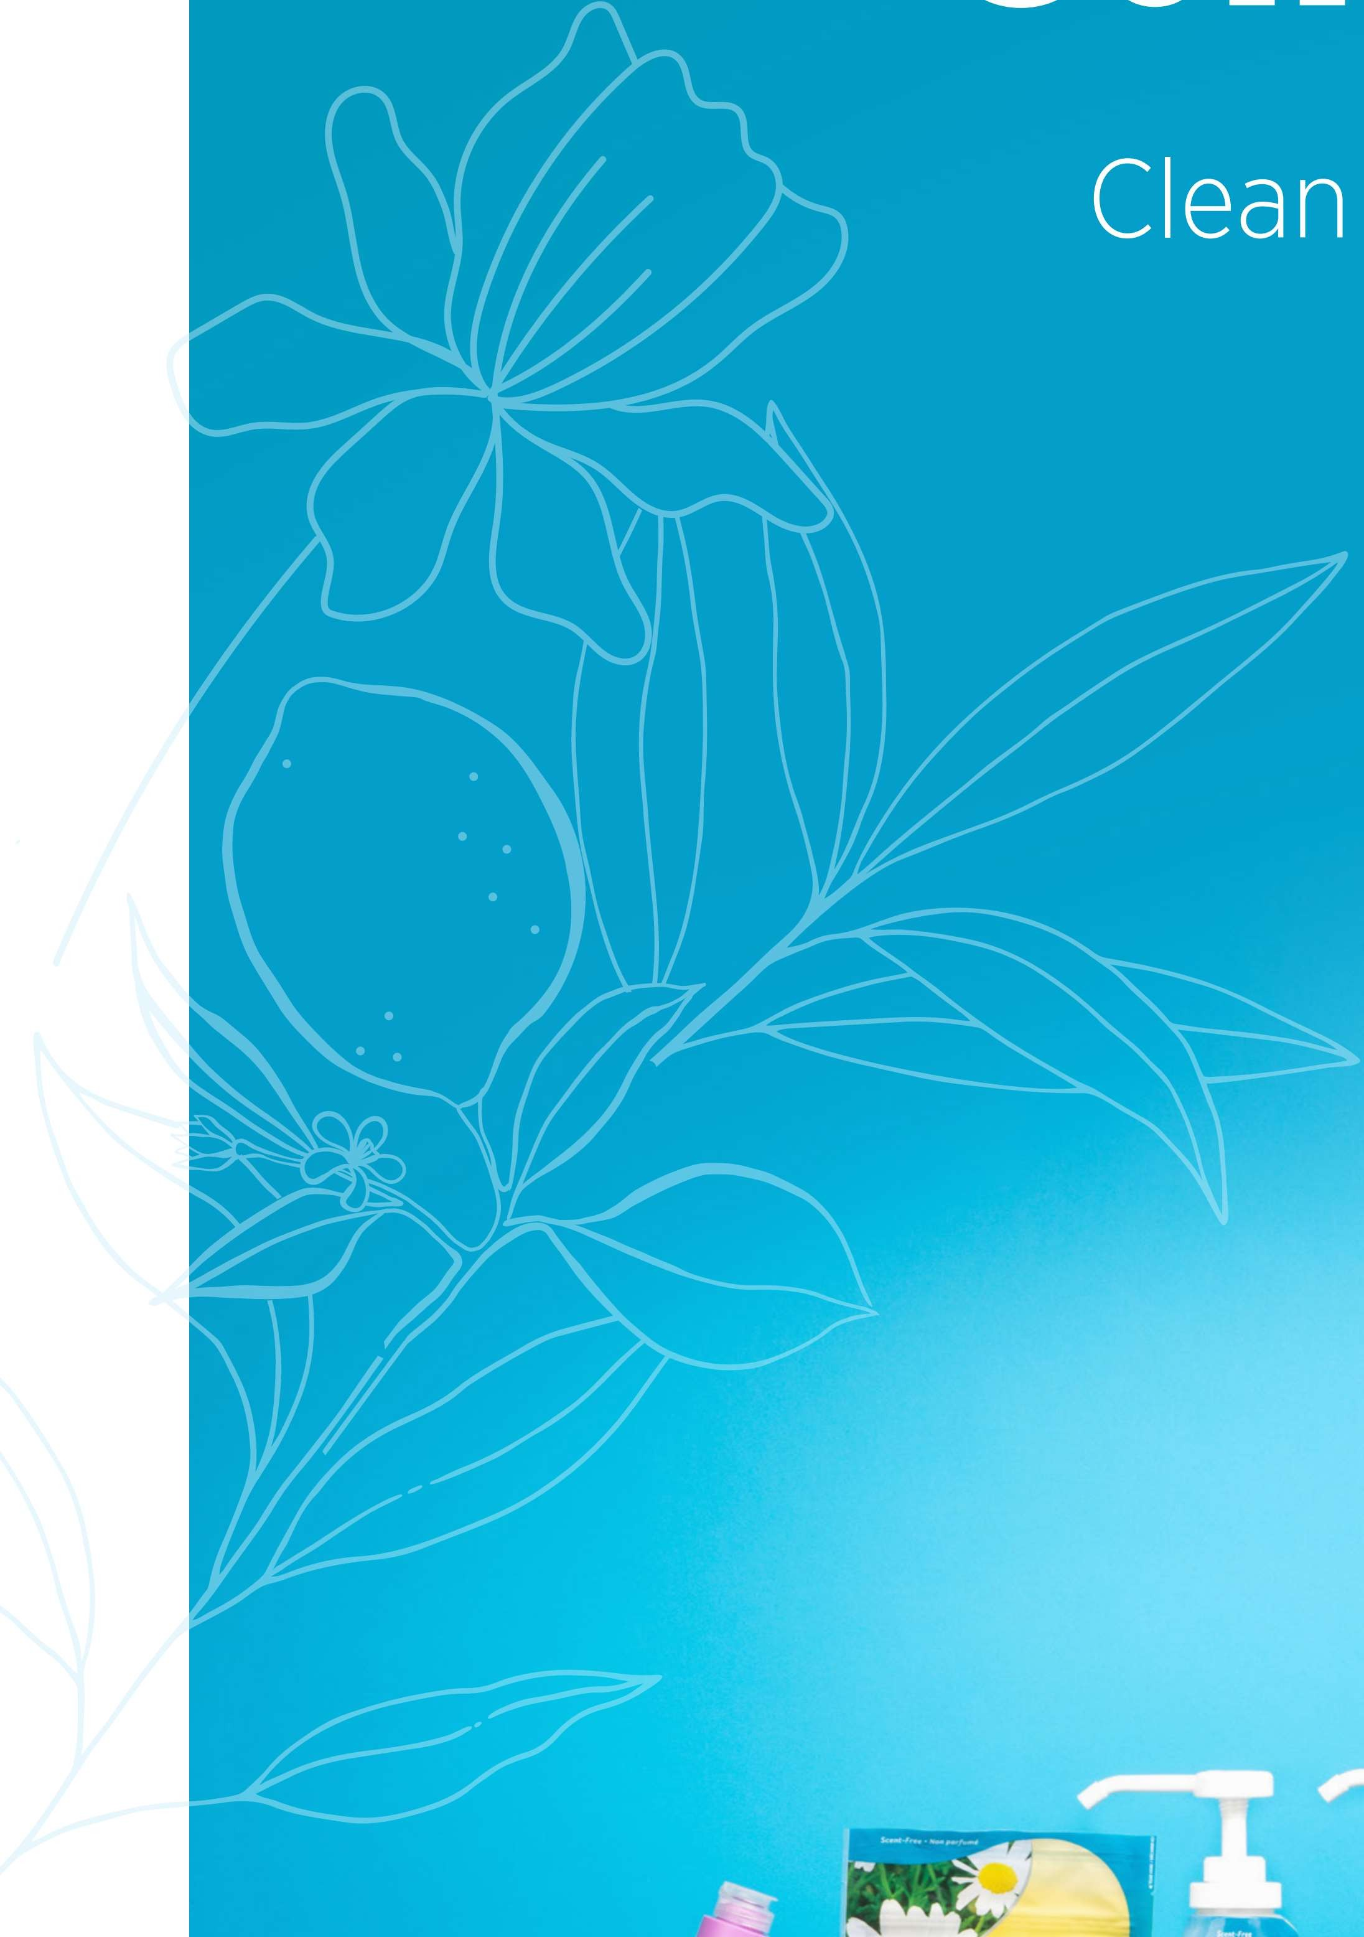

SunshineLivin

