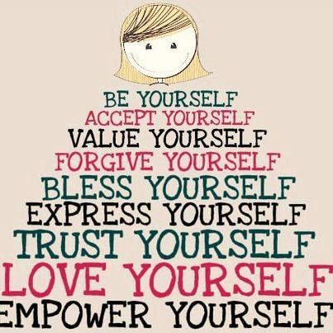

SUPER SELF ESTEEM
Change Your Mind and Change Your Mind
Zoilita Grant

FIVE LAWS OF SUCCESS
The first law is the Law of Attraction: the energy and actions that we put out into the world is the energy and actions that we receive back. That is really what Karma is about. Our thoughts, feelings, and actions attract to us what we receive in the world. Outer reality does indeed mirror what is inside of us.

The second law is the Law of Intention: setting intentions, clearly and definitely are essential in creating lives that we truly enjoy. The more clearly that intentions are set, the more easily we can create them.

The third law is the Law of Celebration and Gratitude: cultivating an attitude of gratitude and counting our blessings creates the heart space for more blessings to come into our lives/

The fourth law is the Law of Receptivity: our ability to have a joyous and abundant life is only limited by our capacity to receive. It is important we increase our ability to receive.

The fifth law is the Law of Involvement: our lives are our responsibility. We must do our own part. We must involve ourselves in the process of creating our businesses and our lives. We must remember it is our life!

SELF ESTEEM PROGRAM
Self Image is the picture that you have of yourself in your mind. In women this is about 70% body image , but also includes characteristics that you identify with yourself such as hard working or lazy. In men it is approximately 50% body image and 50% character traits. Self confidence is measured by the things you know you can do. The world reinforces you by giving you money, grades or pats on the back.
The third component is Innate Worth. This is an intrinsic sense of worth and value that comes from within yourself and is not dependent on externals.
Affirmations Which Support the Development of High Self Esteem
1. I believe that I am capable and competent.
2. I believe that I am worthwhile and valuable, and that my life is significant.
3. I believe I have the power to influence my life.
Do 3 sets of 10 each. Just like physical muscles, you build emotional muscles in sets.

Tips to Improve Self Esteem
Focus on Your Positives!
It’s easy to forget that you are a special person. Take some time to write a list of the attributes that you are proud of (i.e. intelligence, humor, athletic ability, etc.) Be specific, and keep your list handy to make additions or read it aloud when you are feeling down.
in the Mirror! Take a reflective moment to see you as others do. Are you taking care of your body, are you eating right, exercising, practicing good grooming? How you look on the outside is a reflection of how you feel on the inside.
Associate with Winners! Picking the right friends and associates helps you surround yourself with positive energy, enthusiasm, and a “can do” attitude. Be careful not to compare, be okay with who you are.
Manage your First Impressions! Many studies in human communication emphasizes the importance of a first impression. Look people in the eye, reach out with a handshake, and volunteer with your name first. Try to use the persons name in the conversation to aid in remembering. Using this technique gives a great first impression. Eye contact is vital in informing people how you feel about yourself and conveys sincerity.
Acknowledge Those Around You! Take the time to notice the little positives you see in others. Don’t be stingy with compliments and congratulations. By putting the positive energy out to others, you are bond to receive some back. Say “thank you” when you are the receiver of praise. Thank them twice and it will reinforce the compliment and spread the positive energy around.
Choose your Words Wisely! Everything that you say about yourself and others is carved into your memory. Negative self talk, along with put downs of other people, has a way of influencing the way you look at life.
Nine Things You Can Do to Increase Self Esteem
1. Increase the number of positive things you say to yourself, about yourself.
2. Decrease the number of negative things you say to yourself, about yourself.
3. Practice giving and receiving genuine compliments.
4. Develop a more realistic view of the world and your place in it.
Develop an appreciation of your own worth
Accept that you are not responsible for the emotional reaction of others
5. Accept your weaknesses and mistakes.
6. Learn to refrain from comparing yourself to others. Comparisons are deadly!
7. Work at reducing indecisiveness.
8. Limit the number of commitments you make. Balance your life.
9. Use your imagination spend time regularly recalling your successes.

SELF ESTEEM DEVELOPMENT SHEET

1. List three things you like about yourself.
(New things each week.)

2. List three successes you have achieved this week.
(New successes each week)

3. List one good habit you are working on.

4. List one challenge you are working on.

5. List a new positive attitude you have found for yourself.

6. List three rewards you have given yourself.
(Non-food or shopping rewards)

Make 6 copies, Do 1 a week for 6 week

