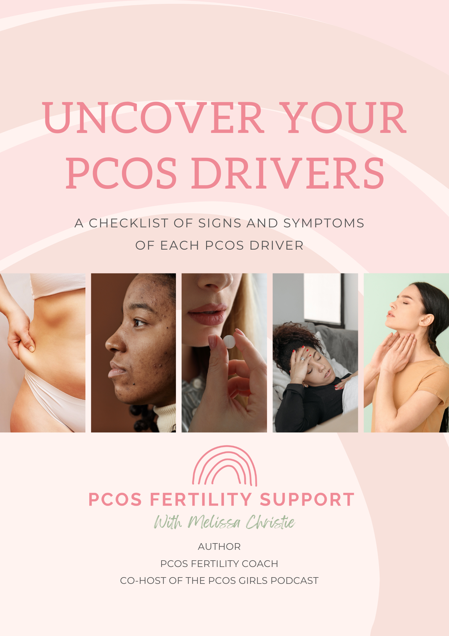

INTRODUCTION
A PCOS driver is defined as something that can cause your body to create too many androgens.
When it comes to PCOS, there are 6 drivers that could be pushing your androgens and other hormones out of balance, causing all your PCOS symptoms and making it difficult for your body to ovulate.
These drivers are also known as the root causes of your PCOS.
We need to know which of these 6 drivers are at play for you because healing these drivers is ultimately what will heal your PCOS, regulate your cycle and help you to get pregnant.
Because our drivers are responsible for pushing our hormones out of balance and causing all our PCOS symptoms – every single PCOS symptom can be caused by each driver. So here, I‘ve listed each driver and the signs and symptoms that are more unique to that driver.
If you find there’s a driver where you have more than a few symptoms – it’s worth exploring further with some testing (details below).
The most important thing to note here is that it’s really normal to have multiple drivers show up for you. It’s very common for people with PCOS to have more than one PCOS driver and to need to bring in a treatment protocol for each driver.

Mel xo

SYMPTOMS OF PCOS DRIVERS (select the symptoms you have)
Insulin Resistance

☐ | Extra weight around the middle
☐ | Carb cravings
☐ | An energy crash after eating
☐ | Afternoon fatigue
☐ | Skin tags
☐ | Dark patches on skin
☐ | Feeling ‘hangry’
☐ | Waking between 1 and 4am
☐ | Increased thirst
☐ | Increased urination
☐ | Blurred vision
☐ | Slow healing cuts and sores

How to confirm with testing: Hba1C, fasting insulin, fasting glucose, ALT and AST

Inflammation

☐ | Unexplained fatigue
☐ | IBS, Sibo or other gut issues
☐ | Autoimmune conditions like Hashimoto’s
☐ | Headaches
☐ | Water retention
☐ | Joint pain
☐ | Food sensitivities
☐ | Skin conditions like dermatitis, psoriasis, eczema or hives.
☐ | Unexplained weight loss

How to confirm with testing: CRP, ESR

Gut issues

☐ | Digestive issues like constipation, diarrhea, bloating, IBS, SIBO
☐ | Skin issues
☐ | Mental health issues
☐ | Inflammation
☐ | Insulin resistance
☐ | Fatigue
☐ | Brain fog
☐ | Frequent colds and flus
☐ | Allergies
☐ | Any autoimmune condition like Hashimoto’s

How to confirm with testing: GI Map, food intolerance testing (only through naturopath)
Stress

☐ | Extra Weight around the middle
☐ | Mental health issues
☐ | Difficulty handling stress
☐ | Moody and temperamental
☐ | Struggle to get out of bed in the morning
☐ | Struggling to sleep at night – TIRED BUT WIRED
☐ | Eye twitching (high cortisol causes muscle arousal)
☐ | Constant mental stimulation: racing thoughts, constant hustle, constant worry etc
☐ | Sugar and salt cravings
☐ | Bruise easily (Cortisol causes the breakdown of some skin proteins and weakens small blood vessels.)
☐ | Puffy Moon face (high cortisol can cause extra fat deposits and inflammation)

How to confirm with testing: DHEA-S, cortisol blood test (through doctor) or cortisol saliva test (through functional medicine testing)

Post-pill PCOS
There are no distinctive symptoms of post-pill PCOS, however there are a couple of signs..
☐ | No symptoms of PCOS before going on the pill
☐ | Symptoms of androgen-excess went away within 12 months of coming off the pill

There’s no way to confirm with testing but if you’ve come off the pill, I recommend testing zinc, Vit C, Vit E, magnesium, folate, B2, B6, B12 and selenium as the pill depletes these.

Thyroid issues

☐ | Fatigue
☐ | Weight management issues
☐ | Anxiety or Depression
☐ | Dry skin
☐ | Hair loss or course hair
☐ | Joint pain
☐ | Memory loss or brain fog
☐ | Muscle weakness
☐ | Cold sensitivity
☐ | Enlarged tongue
☐ | Pale, puffy face
☐ | Low libido

How to confirm with testing: TSH, Free T4, Free T3, reverse T3, Anti TPO, Anti TG, SHBG, iodine, selenium, vitamin D, zinc, iron and selenium.

