Your PC Safety Checklist
Your quick-reference guide to safer everyday computing
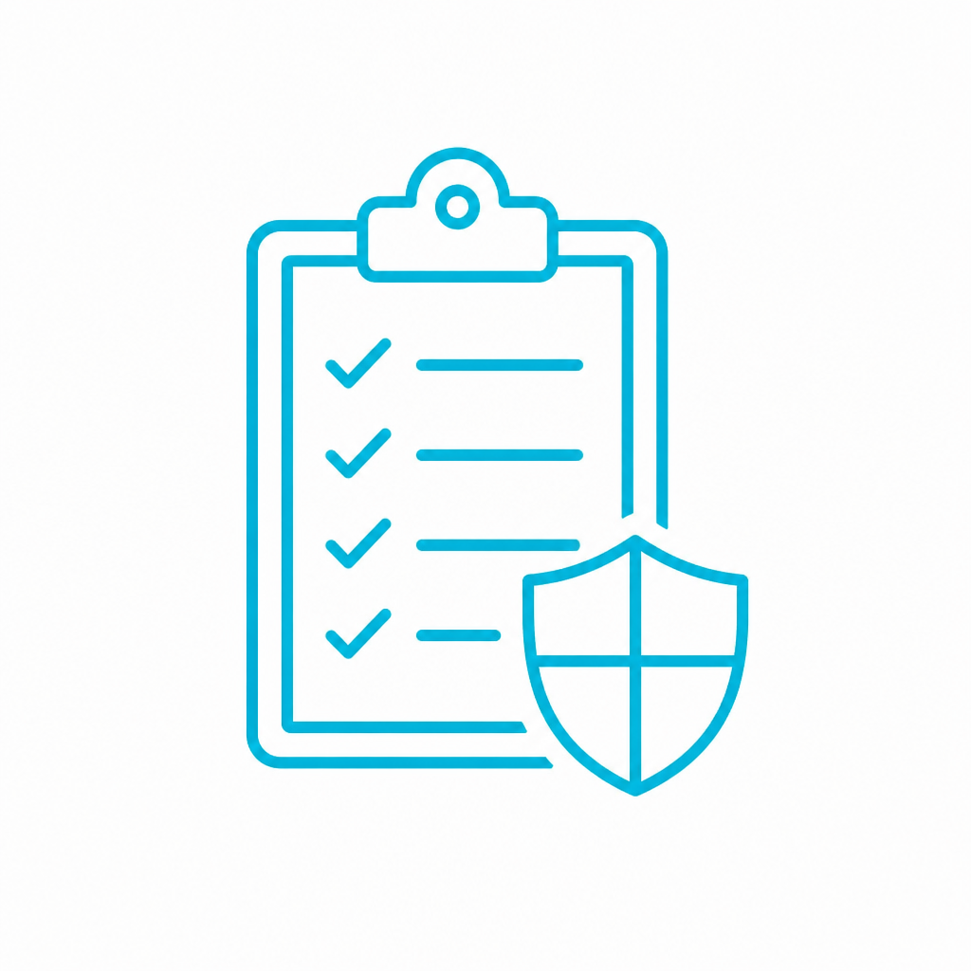
Staying safe online isn’t about avoiding technology—it’s about using it with awareness. With a few simple habits, you can use your computer confidently and safely.
🖥 Your Computer:
☐ Keep your system updated
☐ Make sure protection is active
🔐 Your Accounts:
☐ Use strong passwords
☐ Use a password manager
☐ Turn on 2FA
✉️Messages & Websites:
☐ Don’t click unexpected links
☐ Go directly to sites
☐ Watch for urgency or scams
📶 Your Network:
☐ Use secure Wi-Fi
☐ Be cautious on public networks
📁 Your Files:
☐ Back up important files
☐ Check backups
✓Everyday Use:
☐ Access accounts directly
☐ Verify before acting
☐ Don’t rush

When in doubt
* Don’t click
* Don’t respond
* Go to official sites
* Ask someone you trust

