THE SELF-LED
P.O.W.E.R. REFLECTION GUIDE™
A companion to From Pressure to P.O.W.E.R.

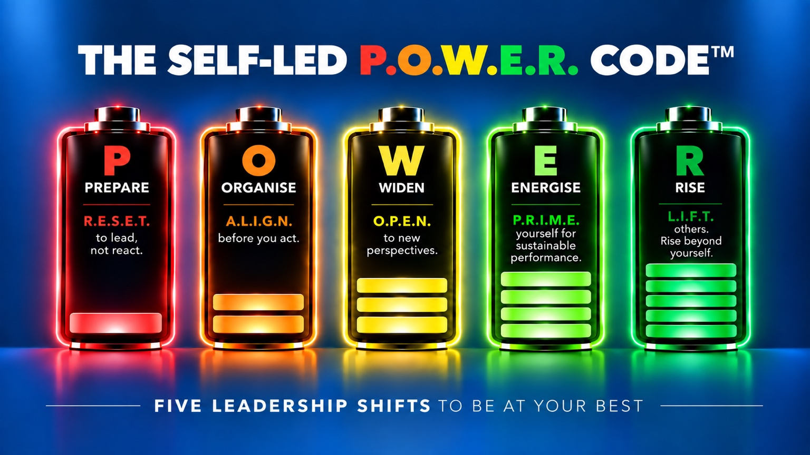

Antoine Catteau
Executive Coach • Mentor
Creator of The Self-Led P.O.W.E.R. Code™

“You can’t always choose the pressure you face.
But you can choose how you lead through it.”

Continue the conversation
Thank you for reading my chapter — and for choosing to take the reflection a little further.
This guide invites you to pause and look at how you are leading right now, particularly when pressure is high. You will revisit the five Leadership Shifts, notice where you are today and choose one small change to explore.
There are no right or wrong answers. Set aside around 15–20 minutes for a first pass. A few honest words or one real example are enough; you do not need to fill every line.

THE FIVE LEADERSHIP SHIFTS
PREPARE — From Autopilot to Awareness
ORGANISE — From Busyness to Purpose
WIDEN — From Limitations to Unseen Possibilities
ENERGISE — From Survival to Sustainable Energy
RISE — From Leading Yourself to Collective Impact

A SIMPLE WAY TO USE THIS GUIDE
For each shift, read the central question and give yourself a score from 0 to 10. Think about the last two weeks, including a moment when the stakes felt high. Then note what makes you give yourself that score.
0 = hardly at all • 10 = consistently, even under pressure
The optional prompt is there to help if you need a starting point. Your scores are a personal snapshot, not a diagnostic assessment or a comparison with anyone else.
At the end, choose one shift to move forward by one point. You do not need to work on all five at once.
The guide builds on the chapter without unpacking the full Signature Approaches behind the Code. Its purpose is to help you notice what matters for you now.
Antoine

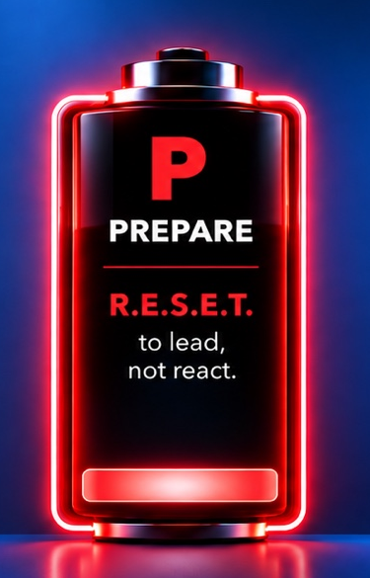

PREPARE
From Autopilot to Awareness

P.O.W.E.R. LAW
Pressure doesn’t create your leadership. It reveals it.

BACK TO THE CHAPTER
In the chapter, I invited you to think about a recent situation when you were under real pressure and notice what happened to one of your natural strengths. Did decisiveness become impatience? Analysis become overthinking? High standards become perfectionism? The question was not how to remove the pressure, but: What is pressure revealing about the way I lead?

YOUR REFLECTION
When pressure rises, how well are you creating space to choose your response?
Where am I today? Circle one number.
0 1 2 3 4 5 6 7 8 9 10
0 = hardly at all • 10 = consistently, even under pressure
What makes me give myself this score?
Optional starting point: Think of a recent moment when you reacted automatically — or managed to respond differently.
________________________________________________________________________
________________________________________________________________________
________________________________________________________________________

A THOUGHT FROM ANTOINE
Under pressure, speed can feel like leadership. But awareness often creates the space for a better choice. You do not need to judge the pattern before you can change it. First, learn to see it.



ORGANISE
From Busyness to Purpose

P.O.W.E.R. LAW
You can be successful and still be heading in the wrong direction.

BACK TO THE CHAPTER
In the chapter, Richard valued “Making a Difference”. His instinct was to step in and solve problems himself. Through reflection, he realised that the same value could be expressed more powerfully by helping others develop and find their own solutions. His value had not changed. His way of living it had.

YOUR REFLECTION
How well are you protecting your time and attention for what matters most?
Where am I today? Circle one number.
0 1 2 3 4 5 6 7 8 9 10
0 = hardly at all • 10 = consistently, even under pressure
What makes me give myself this score?
Optional starting point: Think about what keeps taking over your day — and what keeps getting pushed aside.
________________________________________________________________________
________________________________________________________________________
________________________________________________________________________

A THOUGHT FROM ANTOINE
Being busy can feel reassuring because activity is visible. Alignment is quieter. The useful question is not only “What am I getting done?” but “Is the way I am spending myself taking me towards what truly matters?”



WIDEN
From Limitations to Unseen Possibilities

P.O.W.E.R. LAW
When your perspective expands, your possibilities multiply.

BACK TO THE CHAPTER
In the chapter, an executive moved from a large transformation programme to a smaller project and immediately thought: “This is a step backwards.” The move was a fact. The conclusion was a story. When she explored other perspectives, the same role began to reveal access, freedom, development opportunities and a better fit with the leader she wanted to become.

YOUR REFLECTION
How well are you stepping back to see the bigger picture and the options available to you?
Where am I today? Circle one number.
0 1 2 3 4 5 6 7 8 9 10
0 = hardly at all • 10 = consistently, even under pressure
What makes me give myself this score?
Optional starting point: Think of a situation where you feel stuck, keep going round in circles or can see only one way forward.
________________________________________________________________________
________________________________________________________________________
________________________________________________________________________

A THOUGHT FROM ANTOINE
Your first interpretation may be perfectly reasonable. The danger begins when reasonable becomes unquestionable. Sometimes leadership expands the moment certainty loosens enough for another possibility to enter.



ENERGISE
From Survival to Sustainable Energy

P.O.W.E.R. LAW
Your leadership is only as sustainable as the system that protects it.

BACK TO THE CHAPTER
In the chapter, you tried the 2-Minute CEO Reset™: slowing your breathing and choosing one word for how you wanted to show up — perhaps Calm, Clarity, Confidence or Focus. It was one small example of protecting the state in which you enter a demanding situation. The wider question is whether the way you perform is sustainable.

YOUR REFLECTION
How well are you sustaining your energy through the demands of your life and leadership?
Where am I today? Circle one number.
0 1 2 3 4 5 6 7 8 9 10
0 = hardly at all • 10 = consistently, even under pressure
What makes me give myself this score?
Optional starting point: Think about whether your current pace leaves room to recover — or relies on you just keeping going.
________________________________________________________________________
________________________________________________________________________
________________________________________________________________________

A THOUGHT FROM ANTOINE
Sustainable performance is not about feeling energised all the time. Leadership will sometimes be exhausting. The question is whether your system helps you recover and return — or simply asks you to keep drawing from an increasingly empty account.

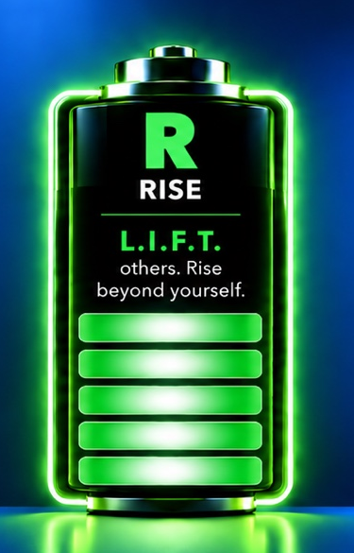

RISE
From Leading Yourself to Collective Impact

P.O.W.E.R. LAW
Your leadership becomes powerful when its impact no longer depends on you.

BACK TO THE CHAPTER
In the chapter, I invited you to look twelve months ahead — not first at what you had achieved, but at the people around you. Who had grown? What were they now doing without you? What had become normal because the way you led had changed?

YOUR REFLECTION
How well are you helping others grow, take ownership and succeed without relying on you?
Where am I today? Circle one number.
0 1 2 3 4 5 6 7 8 9 10
0 = hardly at all • 10 = consistently, even under pressure
What makes me give myself this score?
Optional starting point: Think about where your support builds confidence — and where things still depend on you stepping in.
________________________________________________________________________
________________________________________________________________________
________________________________________________________________________

A THOUGHT FROM ANTOINE
The strongest evidence of leadership is not always what happens while you are in the room. Sometimes it is what becomes possible when you are no longer needed in the same way.

Choose your next shift
Look back across your five scores and the examples you noted. Notice what connects them: a narrow perspective can drain energy; constant urgency can crowd out what matters; doing everything yourself can limit others’ growth.
Your lowest score is not automatically your best starting point. Choose the shift that could make the most useful difference now.

ONE SHIFT
Which shift, if you moved it forward by just one point, would make the biggest difference to how you lead?
________________________________________________________________________
________________________________________________________________________
________________________________________________________________________

ONE POINT
What would that one-point shift look like in a real situation over the next two weeks?
________________________________________________________________________
________________________________________________________________________
________________________________________________________________________
________________________________________________________________________

ONE SMALL CHANGE
What is one small change you will try?
________________________________________________________________________
________________________________________________________________________
________________________________________________________________________
Come back in two weeks. Notice what changed, what you learnt and what you want to keep practising.

Where do you go from here?
You may already have something you want to try. Start there, and notice what happens when the pressure rises again.

EXPERIENCE IT LIVE
Join one of my complimentary Self-Led P.O.W.E.R. masterclasses to explore the five Leadership Shifts more deeply and how to apply them when the stakes are high.
Each shift is supported by its own Signature Approach — R.E.S.E.T.™, A.L.I.G.N.™, O.P.E.N.™, P.R.I.M.E.™ and L.I.F.T.™ — with practical tools to help turn insight into lasting change.
Next masterclass: [DATE / REGISTRATION LINK]

CONTINUE THE CONVERSATION
If this reflection has brought up something you would value thinking through with an experienced thinking partner, you can also explore Executive Coaching or Business Mentoring with me.
Resources and masterclasses: [BOOK / RESOURCE PAGE]
LinkedIn: linkedin.com/in/antoine-catteau-executive-coach

ABOUT ANTOINE
Antoine Catteau is an Executive Coach, Mentor, award-winning speaker and former CFO and Board Member with over 30 years of international leadership experience across Europe and the United States.
His career has been anything but linear. During a two-year sabbatical, Antoine travelled the world, helped launch a start-up, volunteered in India, meditated with monks, climbed Kilimanjaro and even met a few penguins in Antarctica — before returning to corporate leadership.
Experiencing such different worlds reshaped his view of success: not simply how far you go, but whether you are consciously choosing the destination — and who you become along the way.
Today, Antoine helps senior leaders and entrepreneurs reconnect with themselves so they can lead at their best under pressure. Creator of The Self-Led P.O.W.E.R. Code™, he helps leaders turn pressure into a catalyst for growth, fulfilment and greater impact.
At the heart of his work is a simple belief: the most important life you will ever learn to lead is your own.
STAY AT YOUR BEST WHEN THE STAKES ARE HIGH
© 2026 Antoine Catteau. The Self-Led P.O.W.E.R. Code™, The Self-Led P.O.W.E.R. Reflection Guide™ and associated Signature Approaches. All rights reserved.

