

ICPKP – BKP PROTOCOL BALANCE RECORD

NAME: _________________________________________ DATE ____/____/____

Educate / Demonstrate / Empower
Discuss client history

Before Picture: Energy ______/10 Stress ______/10 Mood __________________
Pain / Tension _______ Site _________________ Details _____________________
Pain / Tension _______ Site _________________ Details _____________________
Stress / Issue _____________________________Details______________________
Stress / Issue _____________________________Details______________________

Set Up: Permission to test Clear circuit IM

Pre Checks: Switching Dehydration Thymus - Bal A/B/C & ____%
CV Integrity Ionisation Polarity
________________________________________________________________________
________________________________________________________________________
________________________________________________________________________
________________________________________________________________________

Goal Discussion –

- What is the result that if you left here today with it would have the biggest impact on your self /
life going forward?
- What specifically would you like to do, be or have that you perceive you are not now?
- What would you rather have?
________________________________________________________________________
________________________________________________________________________
________________________________________________________________________
________________________________________________________________________

Goal Statement ________________________________________________________________________
________________________________________________________________________
________________________________________________________________________

Issues Around Goal - (What tools / resources do they perceive they need to achieve the goal or what
traits etc do they perceive they need to take on to achieve the goal?) ________________________________________________________________________
________________________________________________________________________
________________________________________________________________________
________________________________________________________________________

Priority Issue ________________________________________________________________________
_______________________________________________________________________

Emotion ______________________________ Stress on Goal ______%
Life Energy on Goal ______ %

Pre-Tests: (Below are some examples as any finger mode can be a pre test)
Switching CV Ionisation Polarity Auriculars
Visuals Gaits Cross Crawl Hydration Other: ________________

Note Pre-Activities: (what the client can or cannot do because of issue, measure physical movement
and stress. Consider a postural evaluation as well)
________________________________________________________________________
________________________________________________________________________
________________________________________________________________________
________________________________________________________________________
________________________________________________________________________

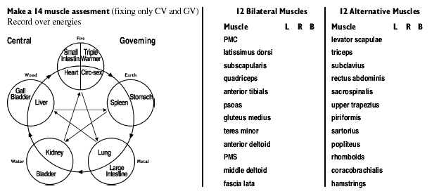

Over energies: ________________________________________  ________________________________________  ________________________________________  Meridian to balance in 5 Elements:  ________________________________________  Meridian to balance in Horary Clock:  ________________________________________  (Discuss the metaphor with the client. What does this mean in relation to their goal?) | 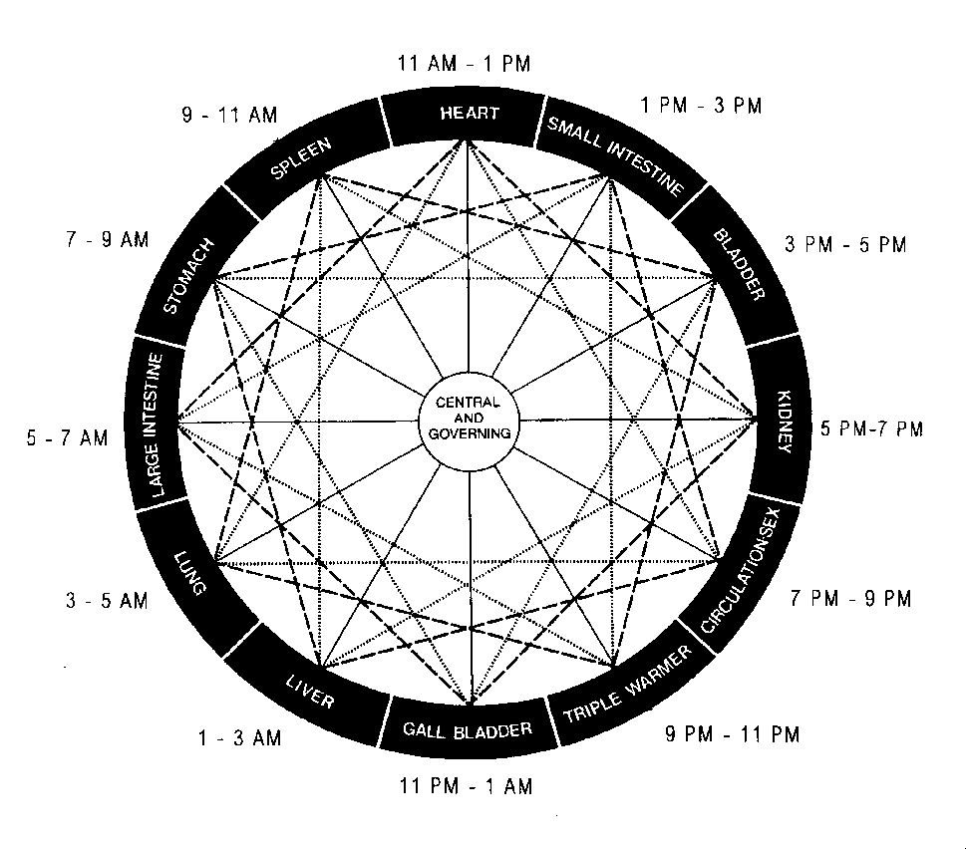
SUBCONSCIOUS CONGRUENCY WITH ACHIEVING THE GOAL

(Discuss subconscious mind with the client before testing)

[Life Areas – Physical, Emotional, Mental, Spiritual, Financial, Social, Other ___________]

(Clear using ESR / FO Holding then retest & DD if not cleared)

Willing to release need ____% | Priority Life Area _______________ | Emotion ______________________
Balance:

Willing to accept benefits ____% | Priority Life Area _______________ | Emotion ______________________
Balance:

Determined to implement ____% | Priority Life Area ________________ | Emotion ______________________
Balance:

If you balanced willingness or determination - Re-test: Goal / Stress / Emotion

Goal clear______ Emotion clear______ Stress ______% Life Energy ______%

THE BALANCE
Test - Y / N - “The finger modes will show the priority balance needed for correction”
If N – Correct 1 point found in assessemnt with réflex points
If Y – DD (as below)

- Note down - Finger modes, balance details, emotion, age recessions, awareness, etc
- Balance all modes in present time then ask if there are any other times. Repeat the balancing of all modes at each required time until all clear. Then return to present & rescan all modes.

CHECKING THE CHANGES
* Goal is clear? YES / NO Emotion is clear? YES / NO
* Stress on the goal reduced to _____% Life energy in relation to the goal now _____%
* Unlocking muscles (14 muscle assessment) now lock? YES / NO
* Over- Energies now clear? YES / NO
- Pre-tests and Pre-Activities re-evaluated – status: (Discuss how the changes relate to the clients achievement of the goal)

* Detail any home reinforcement required to support the balance?

* Ask client to say “I am 100% accepting and taking responsibility for the implementation and outworking of this balance”? YES / NO. If “No” – clear now using same process as willingness / determination:
- When is a follow-up balance needed?
- This session is now complete? YES / NO
- Discuss how they will now be different and then what their first step is going to be toward it.

FINISH OFF: ESR & consider future path - (Bring in as much sensory awareness as possible eg - what they will now hear, see, taste, touch smell in their achievement of this goal)

