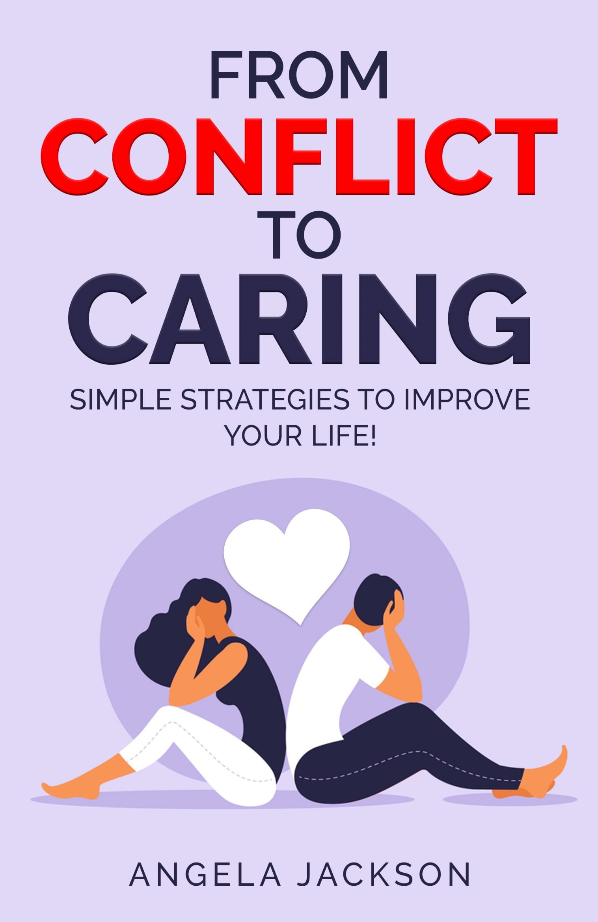
From Conflict to Caring

If you asked, most people would say we get into conflict around three subjects––Money, politics and religion. And of course, sex. So, if we avoid those topics––no conflict. Right?
But what about differences in values, in temperament, or taste? What about unmet needs or resentments over who left the toothpaste cap undone, or the towel lying on the floor? I could go on, but you get the point.
After working with couples and individuals for the past thirty years, I’ve concluded that conflict is conflict is conflict. We all have it, though many of us wish we didn’t. It’s part of being human. Maybe we’re conflicted about a decision we have to make. For example, you need to move into a new home and you’ve been looking for months and found a couple of possibilities but now you can’t make up your mind. Which should you choose? One is located in a nice neighbourhood with convenient shopping nearby, but it’s dark inside. The other is full of light but the neighbourhood is run down. You have only one day left to decide. Which one is best? You feel conflicted, but know you must choose.
Did you know that most conflicts come from within? It could be a simple one, like deciding what to wear. You have a grey outfit ready to put on but when you wear grey you feel dowdy. You’ve worn your blue outfit twice this week and you like it but don’t want to look as if you have nothing else in your cupboard, which is closer to the truth than you’d like to admit. Which should you pick? You feel conflicted.
Conflict can arise when having to make the simplest decisions, which some of us put off indefinitely. We hope the problem or challenge will go away. We want to ignore it and let the good times roll. In time a decision will be made on its own, right? Not exactly, because not making a decision is a decision, and if we keep procrastinating, we deplete our energy and end up walking around anxious or depressed, but we don’t realize its because we’ve put the decision on hold. Meanwhile the conflict continues…

Do I have to finish this report right now or can I take a walk? It’s a lovely day and I need the exercise. But the report is due. Can I take the time?
Or
This job pays well, but the work is boring. I’d like to do something more gratifying, like open a bicycle shop and tinker with bikes, but my partner says no, we have to have security. I’m torn between doing what I want and…
Or
I need to choose which high school my daughter will attend. One offers a rich cultural program, the other excels in athletics. She’s good at both and wants me to choose. I don’t want to make the wrong decision because it will affect the rest of her life. Which one should I pick?

Off course, conflict also comes from without. For example, you work with people who drive you nuts. They’re always looking over your shoulder and muttering at what you’re doing, and they pounce on any little error you make and criticize you. Your shoulders are hunched, you feel boxed in and you want to scream with frustration, but you’re a new hire. You have to prove your worth but you really don’t like coming to work. You think you might be developing an ulcer. The job pays well and you do like the money, but…
Or
Your relationship has been flagging for a while. You’ve gone through bad patches before but this feels different. You’re bored and dis-interested. You barely communicate with each other but at the same time, you’re comfortable and don’t like change. The question torments you. Should I stay or should I leave?

Most of us experience conflict within ourselves and with other people on a regular basis. Its easy to feel content around our pets, because they don’t talk back or insist on being right, but human beings do what I call, the ‘conflict dance.’ This dance starts out with wanting to be seen, heard and understood, something we all desire. In the beginning of a relationship, we’re attentive and good listeners, but as time goes by, things change. The trouble comes when the other person has the same need, but neither one wants to listen, to look and feel empathy. For example, one person feels out of sorts and snaps at the other. The other reacts. The conflict escalates. Soon they’re blasting out nasty words and feeling a sense of power, but its temporary, for later comes a feeling of regret or remorse. Sure, the make-up can be fun, but after a while, even that fades and both parties end up wounded.
Let’s take another scenario. In this story, one person dominates and the other withdraws and says nothing. A pattern becomes established, but sooner or later the withdrawer becomes fed up and leaves the relationship, or he/she snaps and all hell breaks loose. Either way, they’re doing the ‘conflict dance,’ repeating steps which have been learned together and practiced over time. The withdrawer holds frustration in, the dominator lets it out, but neither get what they really want.
For example. He does something that offends you. You feel angry and not considered. You stuff your feelings, but keep a list. The list grows. One day you share your list with him. He says you’re being oversensitive and emotional. You say that talking to him is like speaking to a brick wall. He swears and storms out of the room. You stand there and cry, feeling hopeless and dejected. Or you fume and chase after him, maybe throw something at him. Either way, nothing is solved.
Another example. She nags you, always coming at you with “the list,” –– do this, you forgot that, you did it wrong. You feel fed up and resentful. Why can’t she leave you alone? You love her, but even when you’re watching the sports channel and getting relief, she comes into the room and demands your attention. You’ve asked her to give you some space but she doesn’t seem to hear. What can you do?

These are a couple of simple examples. Yours might be more complicated, but the truth is, as long as we are alive, there will be conflict. My mother used to say as long as there is life, there is hope. I believe this to be true, and I also know that as long as there is life, there is conflict. (The alternative is the flat line.)

So how can we deal with conflict in a way that doesn’t cause damage to ourselves or hurt anyone else? That is the focus of this book. We’re going to take a look at some common habits and learn a few tricks to handle conflict in a positive manner, so we don’t feel depleted or stuck in reactions. Then we’ll be able to get on with our real purpose in life…to live freely and joyfully and express ourselves creatively.

Are you with me? Ready to take the leap? Then let’s begin.

Here are three profound strategies we’ll be working with.

- Take the time to dig deep
- Make a decision
- Co-operate with others

Dig Deep

How often have you said, in true Scarlett O’Hara fashion, I’ll think about it tomorrow? Or like
the rabbit in Alice in Wonderland, I’m late, I’m late for a very important date? How often have you rushed at the last minute because you’ve procrastinated, only to hand in shoddy work? Or not listened to what the other person is saying because you’re afraid you won’t be able to fulfil their needs?
Most conflict comes from lack of communication, which in turn comes from our inability to sit quietly and have a look at who we are and what we need. Fundamental truth. We can’t give to others what we don’t have ourselves. We need to take the time to dig deep and get to know ourselves in an honest way. So, starting today, I’d like you to make a commitment to do things differently.
Have a look at your day and choose fifteen minutes of uninterrupted time where you can be with yourself. Once you have blocked out that time and are ready to begin, return to this page and we’ll continue.

Exercise One - Take Time.

Sit on a comfortable chair, close your eyes and do a mental body scan, starting with your head and working your way through your body. How is body feeling right now? Is your jaw tight? If so, breathe into it, telling your jaw to relax. How about your shoulders? Any tightness there? Breathe into your neck and shoulders, telling them to let go and relax. Continue throughout your body, checking for stiffness or soreness and breathing into each body part. When you have finished, continue to sit quietly for the next five minutes and simply breathe in and out, following your breath. When this is done, ask yourself two questions.

- What have I been avoiding?
- How is it affecting me?

Sit with the questions. Don’t worry about the answers, they will come. Just roll the questions around in your mind. Practice the above routine every day if possible. Make the commitment to take time to be with yourself, to trust your deeper knowledge and gradually the answers will come. Once you have done this for a while, you’ll begin to treasure your alone time.

Make a decision.

As I said earlier, not making a decision robs us of energy. Either that, or we go squirrely trying to figure things out. Decisions require both right and left brain thinking, factual and creative, so let’s get at it.

Exercise Two - Examine Alternatives.

List the Pros and Cons of each scenario.
Get out a notebook and divide the page into two columns. Label one Pro’s and the other Con’s. Start with the Pro’s. Write them all down. Then move to the Con’s. See them in black and white on the same page. Which list is longer? Any idea why? Look at the Pro’s again. Which one’s appeal to you the most? Circle these. Then move to the Con’s. Which ones scare you the most? Underline them.
Now bring your intuition into play. Sit quietly for 5 minutes. You already know how to do this so it will be a breeze. Simply sit, noticing your thoughts, catching yourself thinking, then letting your thought go. Ask your intuition to guide you. Let it join your fact finding. Shake out your body and open your eyes. Go over your list of pros and cons. Notice how you feel when you consider them one by one. What is your intuition telling you? If you get an instant ‘hit,’ write it down. If you are new to listening to your intuition, ask it to appear and trust the process. Sit until you have a sense of what is truly best for you. Write this down. Then make a decision and go for it. What’s the worst that can happen? Can you live with it? Yes? No? Maybe? Write this out as well.
Even if you make a decision you later regret, so what. You’ve learned something. You have not been destroyed and guess what? You’ve become stronger in the process. This will take you a long way. You’re no longer stuck in your head and living in limbo land. You’re on a journey of discovery, one that will bring obstacles along the way, but now you know you can deal with them! By the way, we all make mistakes. It’s called learning. We’re not supposed to be perfect. We’re supposed to be ourselves. Give yourself a pat on the back, and let’s continue.

Co-operate with others.

This doesn’t necessarily mean you have to work with real people, although it can. What it means is that you need to be willing to both give and receive in a respectful manner when you are with others.
Did you know that whatever you judge or criticize in another person is usually a projection of what is going on with you? For example, if you find someone you work with or live with, controlling or unbearably slow, ask yourself this question. Where have I been controlling? (Maybe in my last relationship) Where have I been slow? (Maybe in making the very decision I’VE been avoiding.)
You see, as long as we project outwards, we can’t see inwards. Makes sense, right? Projecting onto others what we don’t want to look at in ourselves, is a distraction and a defense. That is why you need to practise exercise one regularly, so you become comfortable with yourself and begin to see who you really are. Then you can notice patterns and tip-toe toward your defenses. Do you criticize others because you were criticized as a kid? Is it time to change this? Do you judge others because deep down you feel you are not good enough? Your projections might be subconscious, but you are not afraid to look at them, are you?
When you are able to see your own behavior, you are in a much better position to look at the behavior of the person/persons you are agitated by. Perhaps you can even view them with compassion, because they too are on the journey of living. Many of us think if only he/she could do what I want, life would be so much more enjoyable. But would it? Your partner, your work-mate, your child are your teachers. They bring up in you what you don’t want to see in yourself, so pay attention and learn to be grateful. You can’t change them, but you can change yourself and your attitude about them. That is totally within your power. And when you are willing to do this, the behavior of others doesn’t seem to be quite as annoying, does it? Funny how this works.

Yes, there will be moments when you want to scream or stomp with frustration, so find a private place and go for it. Uses the washroom, have a mini-tantrum and experience release. And there will also be times when the world hangs heavily on your shoulders and you need to tune out or go to bed early.
Some days are diamonds, others are stones.
In the meantime, you have three profound strategies to use whenever you feel conflicted, have trouble making a decision and are aggravated with others.
Don’t expect to do any of it perfectly. It takes time to create new habits, so just plug along and keep practicing. Give yourself a pat on the back every time you notice you’ve taken a step forward and changed an old habit. Celebrate your results, and remember to practice, practice, practice.
Here’s a handy tip.
The ANGER-SNEEZE Event
The next time you are frustrated and want to scream at someone, scream into your hands instead. It will look like you’re sneezing and you may even get a blessing!

If you would like more tools and strategies to help you navigate life’s challenges, read
Celebrating Anger and Celebrate Life, my best-selling books. And pick up a copy of my brand-new Celebrating Anger Workbook.
I thank you for joining me and investing in yourself. And wish you much success and many blessings on your journey.

In love and light,
Angela Jackson

Please email me at angelspeak4@gmail.com and tell me if you enjoyed the book! And remember to check out my books at: angelajacksonbooks.com

