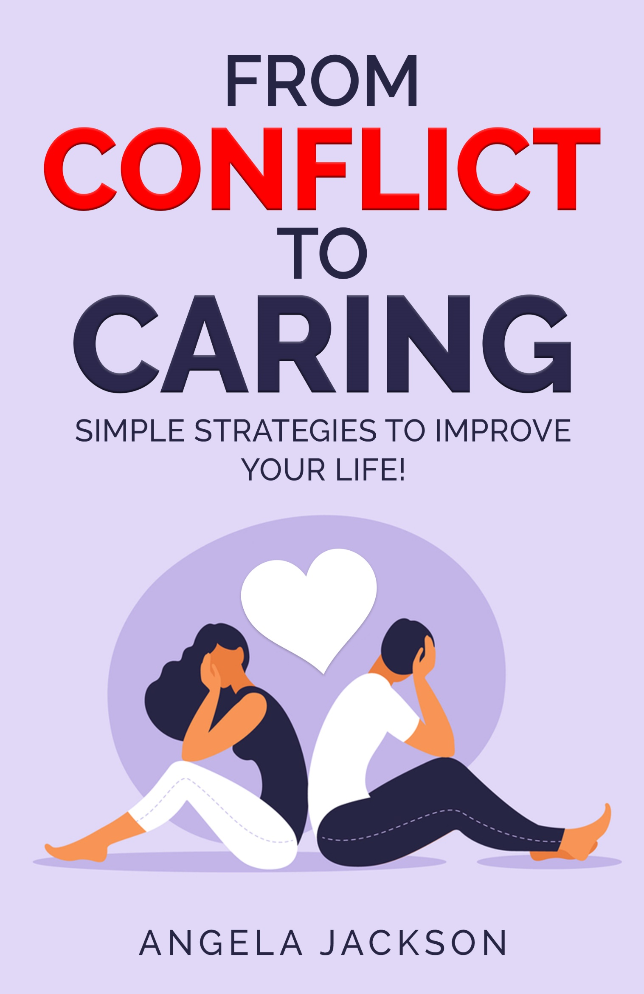
From Conflict to Caring

If you asked, most people would say we get into conflict around three subjects––money, politics and religion. I’d add sex to the list as well. So, if we avoid those topics––no conflict. Right?
But what about differences in values, in temperament, or taste? What about conflict around our unmet needs or resentments about who left the toothpaste cap undone or the towel lying on the floor? I could go on, but you get the point.
After working with couples and individuals for the past thirty years, I’ve concluded that conflict is conflict is conflict. We all have it, though many of us wish we didn’t. It’s part of being human.
Maybe we’re conflicted about a decision we have to make. For example, you need to move into a new home and you’ve been looking for months and found a couple of possibilities but now you can’t make up your mind. Which should you choose? One is located in a nice neighborhood with convenient shopping nearby, but it’s dark inside. The other is full of light but the neighbourhood is run down. You have only one day left to decide. Which one is best? You feel conflicted, but know you must choose.
Did you know that most conflicts come from within? It could be a simple one, like deciding what to wear. You have a grey outfit ready to put on but when you wear grey you feel blah. You’ve worn your blue outfit twice this week and you like it but don’t want to look as if you have nothing else in your closet, which is closer to the truth than you’d like to admit. Which should you pick? You feel conflicted.
Conflict can arise when we need to make the simplest decisions, which some of us put off indefinitely. We hope the problem or challenge will go away. We want to ignore it and let the good times roll. In time a decision will be made on its own, right?
Not exactly, because not making a decision is a decision and if we keep procrastinating, we deplete our energy and end up walking around anxious or depressed, but fail to realize that we feel this way because we’ve put the decision on hold. Meanwhile the conflict continues…

Do I have to finish this report right now or can I take a walk? It’s a lovely day outside and I need the exercise, but the report is due. Can I take the time to look after myself?

Or
This job pays well, but the work is boring. I’d like to do something more gratifying, like open a bicycle shop and tinker with bikes, but my partner says no, we have to have security which means a regular paycheck. I’m torn between doing what I want and…

Or

I need to choose which high school my daughter will attend. One offers a rich cultural program, the other excels in athletics. She’s good at both and wants me to choose. I don’t want to make the wrong decision because it will affect the rest of her life. Which one should I pick?

Conflict also comes from without. For example, you work with people who drive you nuts. They’re always looking over your shoulder and muttering about what you’re doing and they pounce on any little error you make and criticize you. Your shoulders are hunched, you feel boxed in and you want to scream with frustration, but you’re a new hire. You have to prove your worth but you dread coming to work and fear you might be developing an ulcer. The job pays well and you like the money, but…

Or

Your relationship has been flagging for a while. You’ve gone through rough patches before but this feels different. You’re bored and dis-interested. You barely communicate with each other but at the same time, you’re comfortable and don’t like change. The question torments you. Should I stay or should I leave?

Most of us experience conflict within ourselves and with other people on a regular basis. Its easy to feel serene around our pets, because they don’t talk back or insist on being right, but human beings do what I call, the ‘conflict dance.’
This dance has familiar steps. It starts out with wanting to be seen, heard and understood, something we all desire. At the beginning of a relationship, we’re attentive and listen to what the other says but as time goes by, we think we’ve heard it all before and our interest wanes. And guess what? The other partner feels the same. That’s when the trouble begins. For when people start ignoring one another or taking each other for granted, nobody gets what they need. And resentments build. For example, one person feels ignored and snaps at the other. The other reacts. The conflict escalates. Soon they’re shouting nasty words and feeling a sense of power, but its only temporary, for later comes a feeling of regret or remorse. Sure, the make-ups can be fun, but after a while, even those moments lose their luster and both parties end up feeling slighted. This behavior then becomes habitual, with both parties walking around feeling wounded and blaming the other and neither one has a clue about how they got this way.
Let’s take another scenario. In this story Person A dominates the relationship and at first Person B complies. Sooner or later Person B starts to become frustrated with the situation and starts to withdraw and withhold. Eventually B leaves the relationship, or he/she strikes back and all hell breaks loose. Either way, they’re doing the ‘conflict dance,’ repeating steps which they’ve learned together and practiced over time. The withdrawer holds frustration in, the dominator lets it out, but neither gets what they really want.
Another example. He does something that offends you. You feel angry and not considered. You stuff your feelings, but keep a list. The list grows. One day you share your list with him. He says you’re oversensitive and too emotional. You say that talking to him is like speaking to a brick wall. He swears and storms out of the room. You stand there and cry, feeling hopeless and dejected. Or you fume and chase after him, maybe throw something at him. Either way, nothing is solved.
Or. She nags you, always coming at you with “the honey-do list,” –– fix this, you forgot that, you left a mess, you did it wrong. You walk around with a dark cloud hanging over your head, resentment brewing inside, but saying nothing. Soon you are fuming. Why can’t she leave you alone? You love her but even when you’re watching the sports channel and getting relief, she comes into the room and demands your attention. You’ve asked her to give you some space but she doesn’t seem to hear. What can you do?
You’re ready to snap–– and one day you do. She is stunned. You are fed up. But neither of you is willing to take responsibility for your actions, so the beat goes on...
These are just a couple of examples. Your story might be more complex, but the truth is, as long as we’re alive there will be conflicts. My mother used to say as long as there is life, there is hope. I think this is true and I also believe that as long as there is life, there is conflict. (The alternative is the flat line and who want’s that?)

So how can we handle conflict in a way that doesn’t cause damage to ourselves or hurt anyone else? That’s the focus of this book. We’re going to take a look at some common themes and learn a few tricks to handle conflict in a positive manner, so we don’t end up feeling depleted or stuck in reactions. Then we’ll be able to move forward with our real purpose in life––to live consciously, enjoy our relationships and be able to express ourselves authentically.

Are you with me? Ready to take the leap? Then let’s begin.

I’m going to share four simple strategies with you, which, if you use them, will make a big difference in your life.

Four Simple Strategies
- Go Within
- Stop Procrastinating
- Make a Decision
- Change the Dialogue

GO WITHIN

Most conflict comes from lack of communication, which in turn comes from our inability to sit quietly and have a look at who we are and what we need. Here’s a fundamental truth. We can not give to others what we don’t have ourselves. We need to take time to get to know ourselves in an authentic way. and the best way to start is by making a commitment to go within.
Have a look at your day and choose fifteen minutes of uninterrupted time where you can be with yourself. Once you’ve blocked out this time and are ready to begin, turn to the next page and we’ll continue.

Exercise One - Take Time.

Sit on a comfortable chair, close your eyes and do a mental body scan, starting with your head then working your way through your body. Notice how your body feels. Is your jaw tight? If so, breathe into it, telling your jaw to relax. How about your shoulders? Any tightness there? Breathe into your neck and shoulders, telling them to let go and relax. Continue to do this throughout your body, checking for stiffness or sore spots and breathe into each body part. When you have finished, continue to sit quietly and simply breathe in and out, following your breath. Do this until you feel relaxed and peaceful.
When you’ve finished, ask yourself two questions.

- How do I feel?
- What do I need to learn about me?

Sit with the questions. Don’t worry about the answers, just roll the questions around in your mind and let the answers materialize. When they do, jot them down. Practice the above routine every day if possible, but at least three times a week. Make the commitment to take time to be with yourself. Learn to trust your deeper knowledge and gradually the answers will come. Once you have done this for a while, you’ll begin to treasure your alone time. And you’ll be clear on who you are and what you need.

STOP PROCRASTINATING

How often have you said, I’ll think about it tomorrow? Or rushed around avoiding what you need to face, like the rabbit in Alice in Wonderland who keeps saying, I’m late, I’m late, for a very important date? Have you rushed around at the last minute because you’ve procrastinated, only to hand in shoddy work? Or not trying what the other person wants because you’re afraid you won’t be able to fulfil their needs? Have you ever said something like this is to yourself: Stupid me, I should have bought the damn thing when I had the chance but now its too late and its all my fault.
If you can relate to any of the above, get out a notebook or use the space below to answer the following questions.

Exercise Two – Taking Time

- What have I been avoiding in my life?

- Why am I doing this?

- How is it affecting me?

NOTE. If you’ve been spending time alone with yourself every day, the answers will appear. Trust what comes up. You have all the knowledge you need within, all you need to do is listen to yourself.

MAKE A DECISION.

Remember, not making a decision IS a decision and it robs us of energy. Or we go squirrely trying to figure things out and can’t shut down the head noise enough to be clear.
Good decisions require both right and left brain thinking, factual and creative.

Exercise Three - Examine Alternatives

Pick a decision that you’ve been avoiding. It doesn’t need to be a major one, a simple decision you’ve been putting off will be fine.
Get out a notebook. Title it Making a Decision. Divide the page into two columns. Label one Pro’s and the other Con’s. Start with the Pro’s.
Write out all hoped for results from making this decision, one at a time. Then move to the Con’s. See the list in black and white on the same page. Which list is longer? Any idea why? Look at the Pro’s again. Which one’s appeal to you the most? Circle these. Then move to the Con’s. Which ones scare you the most? Underline them.
Now bring your intuition into play. Sit quietly for 5 minutes. You already know how to do this so it will be a breeze. Simply sit, noticing your thoughts then letting your thoughts go. Ask your intuition to guide you. Let it collaborate in your decision-making process.
When you feel ready, shake out your body and open your eyes. Go over your list of pros and cons. Notice how you feel when you consider them one by one. What is your intuition telling you? If you get an instant ‘hit,’ write it down. If you are new to listening to your intuition, ask it to be clear and trust the process.
Continue to sit until you have a sense of what truly is best for you. Write this down. Then make a decision and go for it. What’s the worst that can happen? Can you live with it? Yes? No? Maybe? Write this out as well.
Even if you make a decision you later regret, so what. You’ve learned something. You have not been destroyed by what you decided and guess what? You’ve become stronger in the process. This will take you a long way in life. You’re no longer stuck in your head and living in limbo. You’re on a journey of discovery, one that will have obstacles along the way, but now you know you can deal with them.
Incidentally, we all make mistakes. It’s called learning. We’re not supposed to be perfect. We’re supposed to be human and fully ourselves. Give yourself a pat on back and be proud of what you’ve already achieved.

CHANGE THE DIALOGUE

This activity doesn’t mean you have to start speaking differently right away, although it can. What it does require is that you be willing to look at the messages you are sending when you interact with others.
Did you know that when you judge or criticize another person, it usually is a reflection of what is going on with you? For example, if you find someone you work with or live with, controlling or unbearably slow, ask yourself this question. Where have I been controlling? (Maybe in my last relationship) Where have I been slow? (Maybe in making the very decision I’ve been avoiding.)
As long as we project outwards, we can’t see inwards. Makes sense, right? Typically, we project onto others what we don’t want to look at in ourselves, especially if it is some quality we dislike. Which is why you need to practise exercise one regularly, so you can become comfortable with yourself and able to see who you really are, warts and all. Then you can notice patterns and tip-toe toward your defenses.
Do you criticize others because you were criticized as a kid? Would you like to change this? Do you judge others because deep down you feel you are not good enough?
Your projections might be hiding in your subconscious mind, but you’re not afraid to look at them, are you?
When you can see your own behavior without glossing over it, you are in a much better position to look at the behavior of the person/persons you are agitated by. Perhaps you can even view them with compassion. We’re all on this journey called life and we’re doing the best we can as we travel along.
Many of us think if only he/she could do what I want, life would be so much more enjoyable. But would it? Your partner, your co-worker, your child are your teachers. They mirror what you don’t want to see in yourself, so pay attention to what they reflect and learn to be grateful.
You can’t change them, but you can change yourself and your attitude about them. This is totally within your power. And when you are willing to do this, the behavior of others doesn’t seem to be quite as annoying.

Yes, there will be moments when you want to scream or stomp with frustration. That’s normal so find a private place and go for it. If you’re at work, go to the washroom, make sure you’re alone then have a mini-tantrum and experience release. There will also be times when the world hangs heavily on your shoulders and you need to take time out. So do it. Watch Netflix, read a book, go for a leisurely stroll, have a bubble bath or go to bed early. Some days are diamonds, others are stones.

In the meantime, you have four simple but profound strategies to use whenever you feel frustrated, stuck in procrastination, have trouble making a decision and are aggravated by others.

Don’t expect to do any of it perfectly. It takes time to create new habits, so just plug along and keep practicing. Give yourself a pat on the back whenever you notice you’ve taken a step forward and changed an old habit. Celebrate your results, and remember to practice, practice, practice.

One more handy tip.
THE ANGER-SNEEZE EVENT

The next time you feel frustrated and want to scream at someone, go for it, but do it safely, so you won’t cause yourself or anyone else harm.

Here’s how:
Cover your mouth with both hands and press them against your mouth. Draw in a deep breath and scream into your hands. It will look and sound like you’re sneezing. You can do this in private or public. If its public, you may even get a blessing!

If you want more ideas and strategies to help you navigate life’s challenges and would like to try individual coaching with me, please contact me at: angelspeak4@gmail.com
You can also book a call at: https://calendly.com/angelahelps and experience a coaching session absolutely free.
If you have difficulty managing anger, grab a copy of Celebrating Anger on Amazon. It’s full of activities and stories and is an international Best Seller!
There is also my subsequent book, Celebrate Life, which contains tools for creating the life you love to live.

Thank you for spending time with me and investing in yourself. I wish you much success and many blessings on your journey.

With much love,
Angela Jackson

Please email me at angelspeak4@gmail.com and tell me if you enjoyed this book and visit my website at: angelajacksonbooks.com

