
Customer Questionnaire

- Customer Information:
  - Name:
  - Social Media Handles:
    - Facebook
    - Instagram
    - Tik Tok
    - Youtube Etc.
  - Domain:
  - Is your domain connected to systeme.io?
- Website Requirements:
  - Systeme.io LOGIN Details username/password:
  - Please include image for Top of your Link In Bio Page.
  - Provide Main Brand Color and color accents. Please review https://coolors.co/ and provide 3-4 hex color codes# that you would like to be used on your website. You can also use this as a guide: (You can skip this step if you already have a sales funnel and you want your link in bio to match your brand).

COLOR AND MEANING IN BUSINESS BRANDING

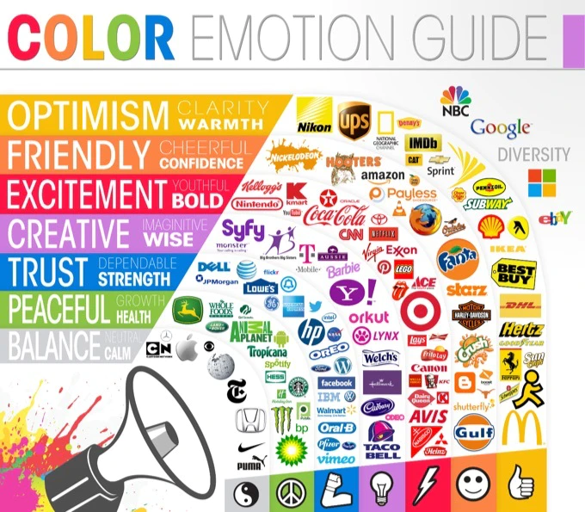

- Product Information – Please provide all products you want added to your link in bio page. Include the Canva Template Link (if applicable). You can also include any products where you are an affiliate, and would like to promote in your link in bio page.
1.

2.

3.

4.

