Venue Checklist for
Club Party Events

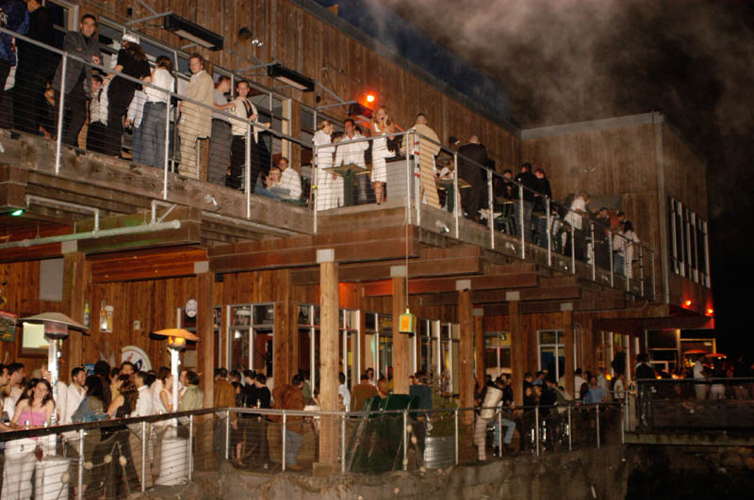

By Party Profit Secrets: www.skool.com/party

Stop losing thousands on venue mistakes! This comprehensive venue checklist, crafted from 22+ years of nightlife experience, reveals the critical factors most promoters miss when booking club venues. From hidden costs and technical requirements to legal pitfalls and negotiation strategies, this essential guide will protect your investment and ensure your next club event runs flawlessly.
Comprehensive Venue Selection Checklist
for Club Party Promoters

Your venue choice can make or break your event's success. This comprehensive checklist guides you through the critical factors every promoter must consider before signing a venue contract. From capacity requirements and sound systems to emergency exits and insurance needs, learn the insider criteria that top promoters use to evaluate and secure profitable venues.

Initial Planning Phase
- Define event concept and target audience.
- Determine expected attendance.
- Set budget parameters.
- Other revenue-earning “channels” possible with this Venue?
Ex. Can you get a kickback from the Bar?
- Can you bring your own Bar and Bar Staff in?
- Coat Check?
- VIP bottle service (is the venue set up for that)?
- Parking, ex. Valet parking services.
- Identify preferred date(s) and time. Lock in the date with a written contract.
- Define geographic area preferences.
- Who will be your main point of contact at the Venue and how accessible will they be leading up to the event and during the event?
- Are there any at all Unique Features or about the location that you can use in your marketing to HYPE the Event Up?

Venue Search Methods
- Contact real estate brokers specializing in commercial spaces.
- Visit the city planning office for new developments.
- Network with liquor distributors for leads.
- Research competitor event locations.
- Drive around target areas for unique spaces.
- Connect with existing club owners.
- Are there new club owners starting up?
- Think of unique “spaces” that have not yet been used for events of your type.
- Check social media for emerging venues.

Location Assessment
- **Accessibility**
- Handicap accessible?
- Public transportation proximity
- Parking availability and capacity
- Multiple entry/exit points
- Loading/unloading zones
- Neighborhood safety

- **External Features**
- Street visibility
- Space for exterior branding
- Covered entrance area
- Potential for outdoor areas
- Neighborhood noise restrictions
- Smoking section outside/inside?

Legal and Safety Requirements
- **Licenses and Permits**
- Valid liquor license
- Dance permit
- Entertainment license
- After-hours permit/times
- Maximum legal capacity
- Fire safety compliance
- Emergency exits
- Insurance requirements
- Handicap requirements
- Does the City ordinance have specific requirements?

Technical Infrastructure
- **Sound System**
- Built-in system quality
- External system compatibility
- Acoustics assessment
- Sound isolation
- DJ booth location and size.
Can the venue be flexible with that?
- Stage for DJ or Dance area, or fashion show
- **Lighting**
- Existing lighting infrastructure
- Dimmer controls
- Special effects capability
- Power supply adequacy

Interior Layout
- **Dance Floor**
- Size and material (Carpeted or Wood), or portable?
- Location within venue
- Flow with other areas
- What are you allowed to do and NOT allowed to do?
- Can you serve food/snacks there?
- Know the exits and entrances and make sure you can “control” them.
- Take pictures to use in your Marketing of the event leading up to the party.

- **VIP Areas**
- Separate sections possibility
- What is required to secure those VIP areas w/regards to manpower?
- Private access options
- Bottle service capability

- **Support Areas**
- Bar locations and size
- Restroom capacity and condition
- Coat check possibility
- Storage space
- Staff areas
- Do they have enough Tables and Chairs for the number of guests and VIP’s?
- Can you have an area for your “finger food” Early Bird area?

Operational Considerations
- **Climate Control**
- AC capacity
- Ventilation system
- Temperature control access
- Will the venue have adequate staff to handle your size crowd?
- Can you hang/attach banners and other props at the location?

- **Security**
- Security camera coverage
- Entry point control
- You must be able to bring your Very Own Meet and Greet Person at the door.
- Important: Have one of their Staff Verify ID at the door (this removes YOUR LIABILITY if any underage guests get into the venue).
- Emergency protocols
- Staff/security positioning options

Financial Assessment
- **Costs**
- Rental fee structure / Try to avoid paying ANY RENTAL for your first parties.
- Know the prices of the drinks in advance
Why? Because you want prices to be at industry standards.
- Security deposits, if any?
- Insurance requirements
- Staffing requirements
- Additional equipment needs
- If bar kickback - when will you get paid and what control system is used to ensure you receive the correct amount?
- Are there any hidden Costs Or Revenue Potentials?

- **Revenue Potential**
- Bar sales arrangements
- Ticket sales capacity
- VIP table potential
- Sponsorship opportunities / collect all of this in ADVANCE, NOT after the event!
…over Deliver for your sponsors and make sure they get VIP treatment at the Venue as well.

- What “reputation” does your venue-in-mind have “around town?” Is it considered safe, upscale, middle of the tree, or New and Happening?
- Can you Pack The Place and if so, can the venue Open Up More Rooms if need be on a short notice?

Contract Considerations
- Cancellation policy
- Damage liability
- Setup/breakdown times
- Staff requirements
- Equipment inclusion/exclusion
- Exclusive vendor requirements
- Payment terms
- Insurance requirements

Pre-Booking Verification
- Test run of sound system
- Lighting demonstration
- Walk-through during target hours
- Reference check with past events
- Neighborhood assessment
- Review all permits and licenses
- Verify insurance requirements
- Check the venue's social media presence and reviews

Remember to:
- Document everything with photos
Ex. It does not hurt to take some videos of the venue and especially if you are afraid of being held liable for any damages… and especially if it was already damaged before you had your event there.
- Get all agreements in writing
- Build relationships with venue management
- Help them become WINNERS in this relationship too.
- Market the Venue to the Best of your ability.
- Consider the long-term potential for recurring events (ex. Lock in New Year's for Next year, one year beforehand…)
- Always have backup venues in mind in case “shit” happens.

OTHER:
Are there REALLY UNIQUE Features of this location that can be used in Marketing?
You want to USE that in your event promotion if the venue has something unique like that.

