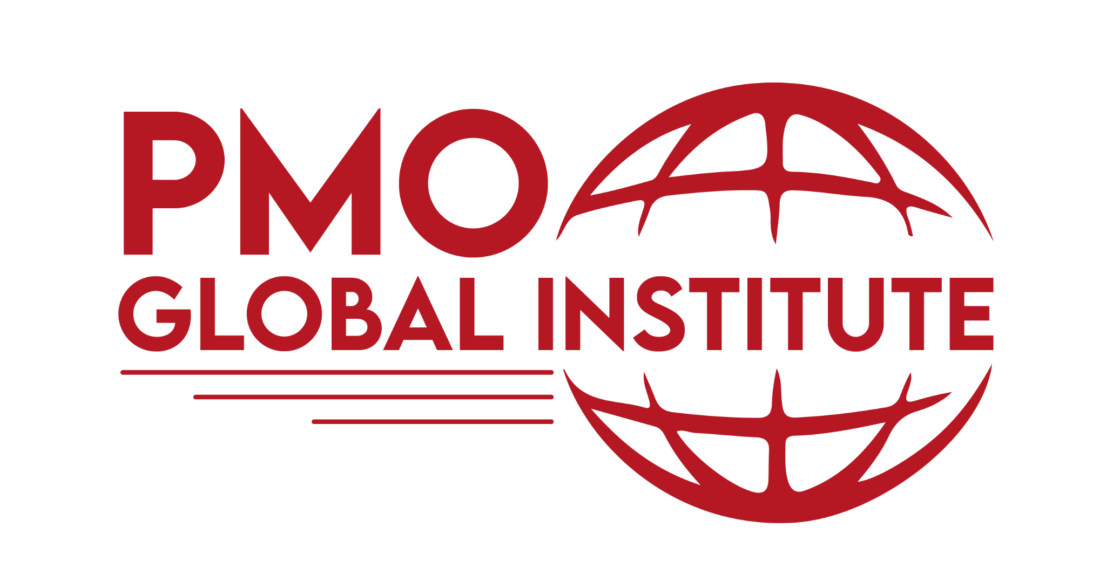

PMO Health Check

A PMO health check is an independent review of a project to make sure that it's doing what it says it will and that the supporting documentation is up to date and in good order.

Doc Name: PMO Health Check | Artifact Type: Template
Doc Version: | Artifact ID PMTF - 001:
Project ID: | Artifact Version:

Version | Prepared by | Approved by | Date | Revision
0.1

Background

Many projects do not go according to plan and may cause significant concern to management about the best approach to recover or rescue the situation. PMO health checks, using a set of project benchmarks, compare actual and expected project status in order to identify root causes and remedial actions needed to make the project safe.

PHASE 1 - QUICK CHECK

PMO Statements | Response (Yes/No)
Do you have the PMO Charter? If yes, do you use it?
Do you have the PMO roadmap and PMO is running in alignment?
Have you set the PMO KPIs and done your quarterly PMO performance review?
Are sponsors and project teams engaged?
Are there timely decision making in the projects or programs?
Are key PMO stakeholders getting the value from the PMO?
Are some/all programs and projects being approved with well-founded business cases linking their benefits to explicit organizational goals?
Is there full confidence regarding the right mix of programs/projects to deliver the organization’s overall strategic objectives and goals?
Is there full confidence about how and when the organization’s overall strategic objectives and goals will be delivered?
Are programs/projects frequently competing for key resources, causing delays and/or quality issues?
Do you see suitable, objective performance measures/indicators?
Are you experiencing large or frequent unmitigated risks?
Are value/benefits being realized because the sustaining organizations are not prepared for the project outputs?
Projects plans are adaptive and calibrated based on project complexity, duration and depth and breadth of resources required.
Project plans are leveraged by the standard template provided by the PMO?
Project plans include formal communication plans and samples of project status reports by stakeholder groups.
Projects/Programs having weekly/monthly status meetings?
Project team updating timesheet on daily or weekly basis?
Deployed project performance scorecards are maintained at the project, portfolio and overall PMO level.
The PMO's standards and practices are scalable and always calibrated based on what outcomes will best benefit the organization.
PMO standards and practices are built around a framework that is streamline and as bureaucracy-free as possible.
PMO leadership is focused on leveraging project manager's success and not on policing compliance.
PMO leadership conducts formal project plan reviews to ensure that the plan does not over extend team members, minimizes cross project resource contention and uses a "pull"/outcome driven approach.
PMO leadership provides education and training to its project professionals based on the skills needed to execute the projects well in advance of the next projects to be activated.

PHASE 2 - REPORTING

OBSERVATIONS | POSSIBLE IMPACTS | RECOMMENDATIONS
e.g. Process, procedures are not there | Different project team manage projects differently | Develop and implement 2PG.
e.g. Risks are not captured and managed properly | Risk may become issues and may become very costly | Develop risk register and ensure risk register being used across projects

NOTE:
List the key observations that present opportunities for improvement. These observations must be supported by possible impacts that could occur within the project/program. Some of these possible impacts may already be occurring within the project. A recommendation for the observations should also be provided.

PMO Health Check Report Sign Off
I have reviewed and approved the PMO health check for <Name of the Organization>.

< Location, Date>
< Name of the PMO Sponsor or others approving this document>
< Signature>

