Carmela Pirillo, CPA
www.carmelapirillo.com
(647) 828-5531

AMAZON Monthly Seller Fee, FBA and Advertising Invoices
Reports > Tax Document Library > Click on the Seller Fee Invoices tab
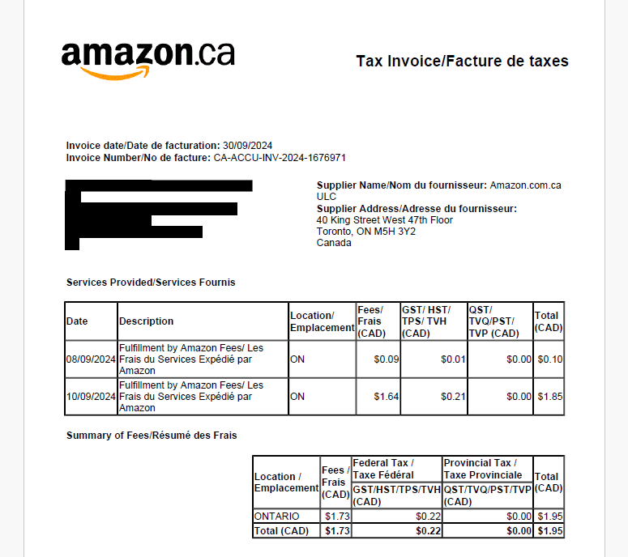

AMAZON Sales Summary Report
Reports > Payments > Reports Repository NEW > Acct Type (Standard Orders) > Report Type (Summary) > Select data range > Request Report
Note:
For US marketplace, the account type selected should be All Unified Reports
For MX marketplace, the account type selected should be Standard Orders
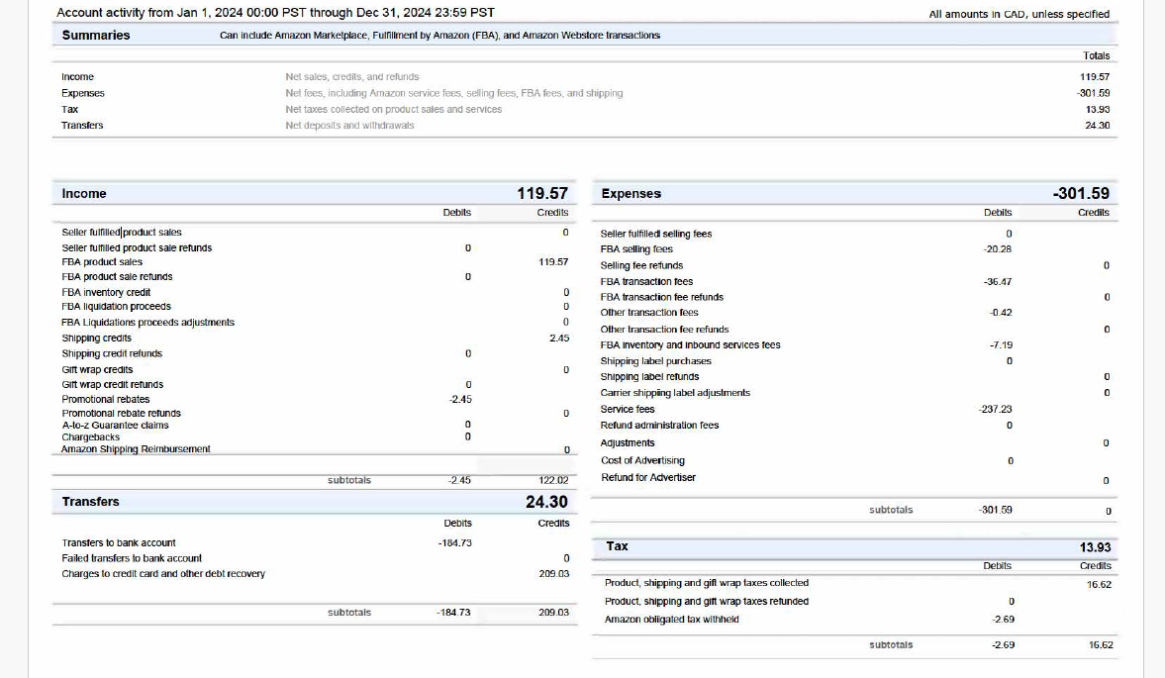

AMAZON Year End Inventory Report
You will need to include the following in your total ending inventory.
- Any inventory that you have at your house or prep centre.
- Any inventory that you purchased and is on the way (in transit).
- Any inventory at the FBA warehouses (download the report as explained below)
Go to your Seller Account and click on Reports>Fulfillment>Inventory Ledger. Choose Summary view, Country and Daily Report. Select your exact year end date and request a .csv download.
To this report you will have to add the cost per unit (not selling price) in order to calculate the total ending inventory at year end.

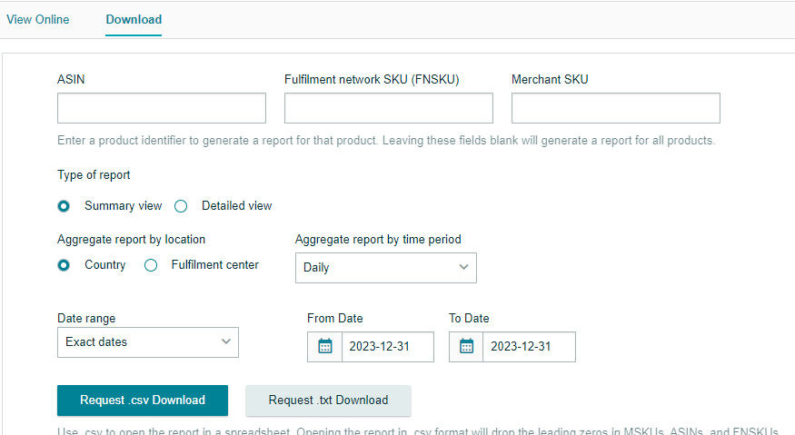

AMAZON Payout Statements
Reports > Payments > Choose Settlement Period > Print this page (found at the bottom right of online report)
Note:
If the Settlement Period is not available to select from the drop-down menu click in the bottom right corner to view transaction periods. Choose the date range and download a .csv report.
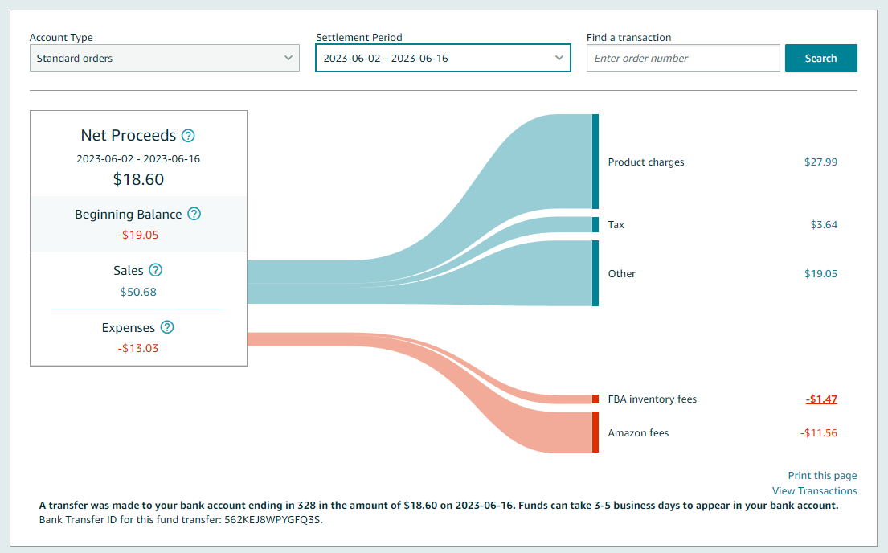

*** AMAZON Sales Tax Report – download only if requested by the bookkeeper!!! ***
Reports > Tax Document Library > Generate Tax Report > Report Type: Combined report>choose the month or specific date > click Generate
This report provides you with the total sales in the period, sales tax collected AND whether your items are taxable and non taxable. This is used to double check if your tax settings are correct based on your sales tax registration.

