HERE ARE THE FIRST TEXTS FOR YOU TO PROMOTE THE EBOOK "THE 5 WOUNDS OF THE SOUL"

Attention: I wanted to tell you something right away. If a Person writes to you on Messenger but is not your Friend on Facebook, the messages end up in “Message Requests”.
So check every day that no messages have ended up there. You must click on the 3 dots at the top of messenger and then on Message Requests.
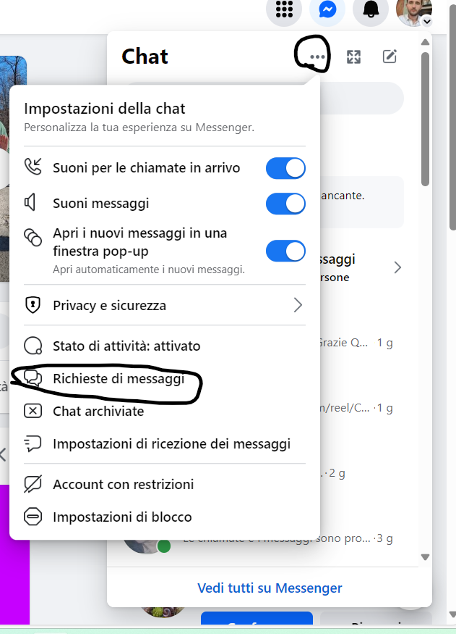

POST 1

Who Wants a Free PDF on the “5 Wounds of the Soul?”
In the pdf you will be able to recognize your wounds with a checklist of questions to tick off and you will find simple exercises to resolve them.
Comment I WANT IT and I'll send it to you privately. I'll leave it available until ………………..(insert date, I recommend a maximum of 15 days)

___________________________________________________________
Note for you:Also add the photo of the ebook cover in the comments to this post. Go to the Ebook Canva Project, then go to Share > Download > Select Page Number 1 > and Download as png. And then simply add it in the comments with the writing: Here is the cover of the ebook that I will send you privately.
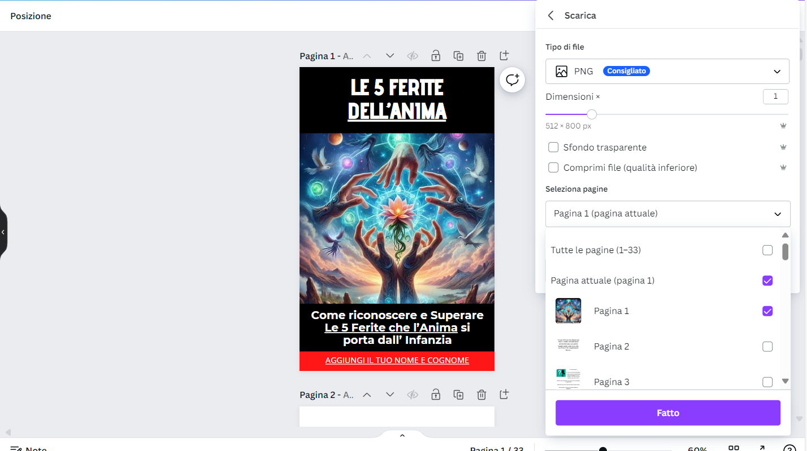

FROM THE SECOND POST ONWARDS USE THIS STRATEGY

1: Take the first post you wrote and click on the publication date(Attention, in the photo you can see that I published it as private, obviously you will have to publish it as public)
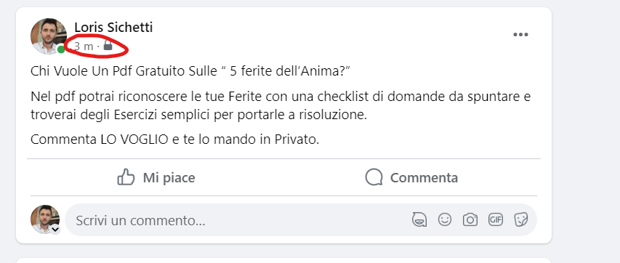

2: Your post will open in a New Screen:Simply copy and save that link to a word document or wherever you want.
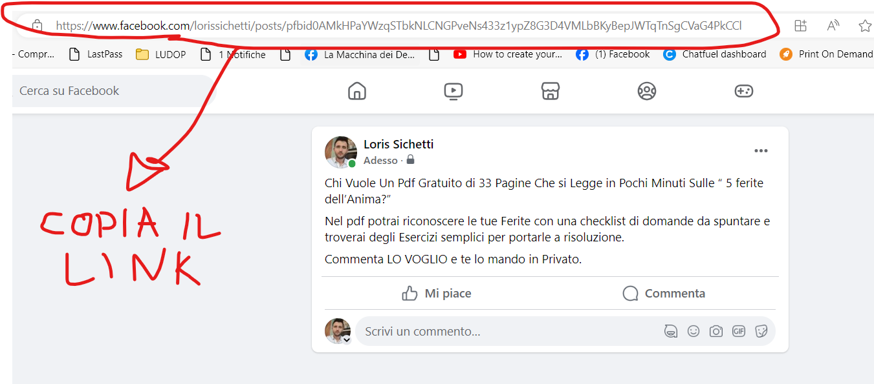

3: You will share this Link as the First Comment in all the Posts you write regarding the Ebook (from the second onwards),by inviting people to comment on the Post they find by clicking on the link in the First Comment.
In this way you will receive all the I WANT IT in the first Post and if you do a good job you will find dozens of comments in that Post.
In this way Facebook will show it to more people, the Post always comes back to the top of your Wall, interaction is created and users, seeing that there is demand, feel more encouraged to comment.

POST 2
Do you often feel rejected or unaccepted by others?
Do you wonder why it seems difficult to make yourself understood and appreciated for who you really are?
If the Answer is Yes then Your Soul may have the Wound of Rejection, a wound that we have carried since Childhood!
Click on the first link in the comments and comment on the post that will appear with the word I WANT to receive a free e-book on the 5 wounds of the Soul.
In the Ebook, by checking some simple questions you will be able to understand if you have this wound or more wounds and you will find simple exercises to lead to healing.
Please don't comment on this post!
First click on the first comment you find and then comment on the post that opens.

__________________________________________________________________
I'll show you an example of how you should do it but by now you understand, from the third post onwards it's always the same thing.

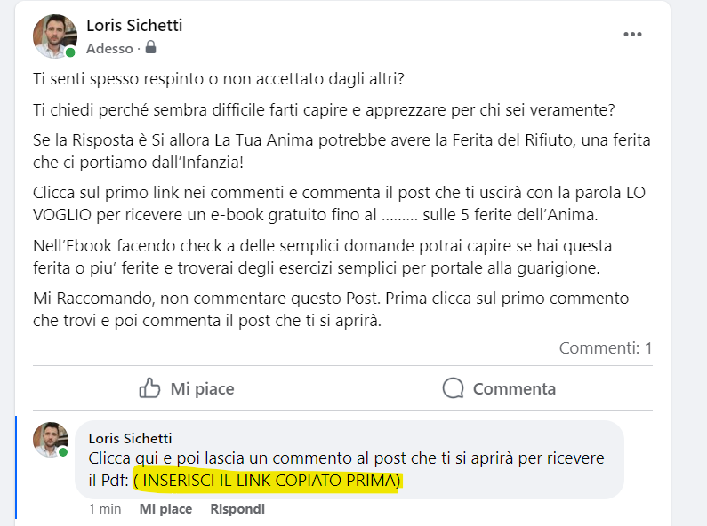

POST 3
Are you constantly afraid of being left alone or abandoned?
Do you find yourself avoiding deep relationships for fear of being hurt or abandoned?
If the Answer is Yes then Your Soul may have the Wound of Abandonment, a wound we have carried with us since Childhood!
Click on the first link in the comments and comment on the post that will appear with the word I WANT to receive a free e-book on the 5 wounds of the Soul.
In the Ebook, by checking some simple questions you will be able to understand if you have this wound or more wounds and you will find simple exercises to lead to healing.
Please do not comment on this post. First click on the first comment you find and then comment on the post that opens

POST 4
You often ask yourself “Who am I?”
Or “What is my Purpose in this World?”
If the Answer is Yes then Your Soul could have the Wound of Rejection, a wound that we carry from Childhood and your Mask could be that of the Fugitive...
Click on the first link in the comments and comment on the post that will appear with the word I WANT to receive a free e-book on the 5 wounds of the Soul.
In the Ebook, by checking some simple questions you will be able to understand if you have this wound or more wounds and you will find simple exercises to lead to healing.
Please do not comment on this post.
First click on the first comment you find and then comment on the post that opens
POST 5
Do you often find yourself wondering, “Do I think they will reject me if I make this request?”
Or maybe you feel insecure and vulnerable at the idea of ​​rejection?
If the answer is yes, you may have a Soul wound linked to the Fear of Rejection.
This wound can take root deep within us, influencing our decisions and our self-esteem.

If you want to discover the origin of this fear and how to overcome it, click on the first link in the comments and comment on the post that will appear with the word "I WANT IT."
In exchange, you will receive a free e-book about the 5 Wounds of the Soul.
Through simple questions and exercises proposed in the e-book, you will have the opportunity to deepen your understanding of this wound and embark on a path towards healing.

Remember not to comment directly on this post.
First, click on the first available comment and comment on the post that will open for you. The Ebook will be available for a few more days!

POST 6
Do you find yourself thinking, "I don't dare ask for fear of being rejected" or do you find yourself fearing the negative judgment of others with the constant worry of being rejected?
These feelings could be indicative of a wound in the Soul related to the Fear of Rejection, and your mask could be that of the Fugitive.

If you wish to explore this dimension further, click on the first link in the comments and comment on the post that will appear with the word "I WANT IT."
In exchange, you will receive a free e-book that will help you, through targeted questions and exercises included in the e-book, to recognize and overcome this Fear.

Remember NOT to comment directly on this post.
First, click on the first available comment and then write I WANT IT in the Post that will come out.
The Ebook will be available until ……………………

POST 7

If you often ask yourself, “Why am I not enough for you?” or you feel the weight of comparison with others, thinking: "Why can't I do things like others?"
If the answer is yes you could have the wound of the Soul linked to Humiliation, and your mask could be that of the Masochist.

If you would like to explore this emotional dimension, I invite you to click on the first link in the comments and comment on the next post with the word "I WANT IT."
In exchange, you will receive a free e-book that deepens your understanding of the wound of Humiliation with the Masochist's Mask.
Inside the e-book, you will find key questions and exercises to start your journey towards awareness and healing.

Remember to avoid commenting directly on this post.
First, click on the first available comment and then express your interest in the next post.
The Ebook will still be available for 8 days, start your journey towards your authenticity!
If today you have these wounds remember that you are wearing a mask, you are not expressing your True Self and your True Potential!

POST 8

If you often think: "I'm afraid of being punished if I enjoy life too much" or you find yourself doing a lot for others without receiving the recognition you desire...
You could carry a soul wound linked to humiliation from childhood. Your mask could be that of the "Masochist"
If you want to discover the origin of this fear and how to overcome it, click on the first link in the comments and comment on the post that will appear with the word "I WANT IT."
In exchange, you will receive a free e-book about the 5 Wounds of the Soul.
Through simple questions and exercises proposed in the e-book, you will have the opportunity to deepen your understanding of this wound and embark on a path towards healing.
Remember not to comment directly on this post.
First, click on the first available comment and comment on the post that will open for you. The Ebook will still be available for 7 days!

POST 9

If you often find that you have high expectations of your partner or feel a sense of betrayal when others do not keep their promises, you may be involved in a Soul wound related to Betrayal, with your mask being that of the “Controller ”

If you want to find out if your Soul has carried this wound from childhood, I invite you to click on the first link in the comments and comment on the next post with the word "I WANT IT."
In exchange, you will receive a free e-book about the 5 Wounds of the Soul.
Inside the e-book, you will find precise questions to tick off with which you will understand if you have the wound of betrayal or other wounds.
Plus you will find a very simple exercise to begin inner healing

Remember to avoid commenting directly on this post.
First, click on the first available comment and then express your interest in the next post.
ATTENTION: The Ebook will be available until ………………, so there are only 6 days left.

POST 10
Do you expect others to adhere to your beliefs?
Or do you notice that you often use the phrase “Do you understand? during your interactions?”
If the answer is yes, it is very likely that you have had a wound linked to betrayal since childhood and to defend yourself from this wound you have worn the Controller's Mask.
Does all this resonate with you?
If the answer is yes, I invite you to request the free Ebook "the 5 wounds of the Soul".
Inside the Ebook you will find a series of affirmations and questions that will help you understand if you have this wound or other wounds (there are 5 in total)
Once you recognize the wounds that your Soul carries you will find a very simple exercise to begin internal healing.

If you want it, click on the first link you find in the comments below, and then in the post that opens, comment I WANT IT and I'll send you the ebook privately.
A hug
FIRST NAME.
Ps. Do it now though, because I will only send the ebook free for another 5 days

POST 11
Do you find yourself firmly thinking that "if someone cheats on me it's over, there are no second chances"?
Or maybe you feel the constant need to "double check everything other people do"?
These attitudes could reflect a Soul wound related to Betrayal, with your mask being that of the Controller.

To explore these dynamics more deeply, think about some questions:

Where does your belief that there are no second chances in the case of betrayal come from?
What do you feel when you feel the need to constantly double-check the actions of others?
Have you ever experienced a situation where your rigidity in giving second chances affected your relationships?

If you would like to delve deeper into this path of self-exploration, click on the first link in the comments and comment on the next post with the word "I WANT IT".
In exchange, you will receive a free e-book about the 5 Wounds of the Soul.
Inside the e-book, you will find in-depth questions and practical exercises to start your journey of awareness and personal growth.

Remember not to comment directly on this post, but to proceed to the next step after clicking on the first available comment.
THE EBOOK IS STILL AVAILABLE FOR 4 DAYS.

POST 12
If you often find yourself thinking, “I have a hard time asking for help,” or notice that you tend to experience chronic exhaustion?
Then your Soul could bring you from Childhood a Wound linked to Injustice, and today you could wear the mask of the Rigid, as a tool of Self-Defense.

I'll ask you some questions:

What do you think causes your difficulty in asking for help?
How has injustice affected your ability to receive support from others?
How might your propensity for chronic exhaustion be linked to the wound of Injustice?

If you want to delve deeper into all this, click on the first link in the comments and comment on the next post with the word "I WANT IT".
In exchange, you will receive a free e-book that explores the Wound of Injustice with the Mask of the Stiff, as well as all 5 Wounds of the Soul.
Inside the e-book, you will find questions to tick and practical exercises to start a process of awareness and inner healing.

Remember not to comment directly on this post, but to proceed to the next step after clicking on the first available comment.
But Act Now!
The Ebook will be available for 3 more days!

POST 13
Still 2 Days to Receive the Ebook "The 5 Wounds of the Soul"
Let's explore the Wound of Injustice again.
Does this phrase resonate with you?
"I justify myself when I rest or have fun"
Or…
"I often use the words Never, Always, Very!"
If they resonate with you then you could carry the wound of Injustice from your childhood, and if so, now it's not really you!
Your Soul is not really expressing its light and authenticity but it is the ego that prevails with the mask of "rigid!"
Ask me today for the ebook "the 5 wounds of the soul".
It's free and will help you recognize the wounds you carry from childhood by answering simple questions and will also help you take a first step towards self-healing with a simple but powerful exercise reported.
But Act Now, in 2 days I will no longer give this Ebook for free.
To receive it, click on the first link in the comments and comment on the next post with the word "I WANT IT".
Remember not to comment directly on this post, but to proceed to the next step after clicking on the first available comment.
Still only available tomorrow and the day after, so ask me now.

POST 14

Do these phrases resonate with you?
"I felt rejected, so now I try to be perfect"
"My biggest fear is coldness, which is why I mask it by always trying to be affectionate and warm with others"
If the answer is yes, you should know that these are typical phrases of those who suffer from the wound of Injustice and Wear the Rigid Mask!
The good news is that you can learn to recognize your wounds and overcome them!
STILL TODAY AND TOMORROW you can request the Ebook on the 5 wounds of the Soul for free.
The only thing you have to do is click on the first comment you find below, and then comment I WANT IT on the post that will open immediately after.
I will send you the Ebook privately and by answering some simple questions you will find you will be able to understand what wounds you have from childhood and you will find a Simple but Powerful Exercise to self-heal these wounds.
But do it today!
Tomorrow will be the last day to request the Ebook!

POST 15
Last Day to Request the Ebook "The 5 Wounds of the Soul"
Why ask me?
The reason is simple, today YOU ARE NOT YOU, you are not expressing your TRUE SELF and your TRUE TALENTS but simply today you are expressing your EGO, a Mask that you have worn since childhood, linked to 5 very specific wounds.
Thanks to the Ebook, by answering simple questions, you will be able to understand for yourself what wounds you carry from childhood and the masks you have today, and finally you will find a SIMPLE BUT POWERFUL Exercise to bring the wounds into self-healing.
How to request it?
Just click on the first link you find in the comments, a subsequent post will open and just write I WANT IT in the post that will open. Then expect a private message from me that I will send you the Ebook
When to ask me?
TODAY. In fact, today is the last day to request this powerful self-healing tool for free. So click on the first link and then comment "I want it" on the post that will come out.
A hug.
FIRST NAME.

END.

HOW TO ATTACH IMAGES TO POSTS.
Decide whether to insert images on each post or leave only the text.
But the First Post I advise you to leave only the Text!
Then from the Second Post onwards you can add your photos, this is the advice, but just text is fine too.

HOW TO CREATE IMAGES WITH ARTIFICIAL INTELLIGENCE.
You can create beautiful images to attach to posts also thanks to Artificial Intelligence.
The first thing to do is click here:BING IMAGES

Then you just need to enter some commands.
The command I recommend is this: “Create a Magical Style Image that describes (and here add the wound of the soul you want to describe)”

You can also add specific phrases or the mask.

Example:“Create me a Magical Style Image that describes a person who feels rejected.
Or “ “Create me a Magic Style Image that describes the ego and the mask of the rigid”

You'll see that fantastic images will come out!
Experiment with various commands and use your creativity!
Once you have chosen the images you like, simply download them and attach them to the posts.
HOW TO RESPOND TO COMMENTS
1: First of all, be quick. Try to respond immediately to the people in the comments and immediately write them the message I recommend below.
2: Always put a little heart in the comments! Increase Interaction.
3: Always Reply to the Comment with the Writing: Okay! I wrote you a private message, also check message requests if you don't see it.

WHAT TO WRITE IN THE MESSAGE

“Hi NAME, I'm NAME, how are you?
As per your request, I am sending you the Ebook "The 5 Wounds of the Soul".
You can find it here: (INSERT THE CANVA LINK AS WE SEEN FROM THE TUTORIAL)
In these 15 days in which I am giving away this E-book I have decided to also give away a 30 minute Holistic consultation without obligation on this topic.
If you wish to receive it we can set a date immediately, perhaps in 3/4 days so I can give you time to read the Ebook (it can be read in 20 minutes) and then we can talk without obligation about what has come out.
What do you think about it?
A hug
FIRST NAME."

If he replies, it's fine, just give him the calendly link and tell him that he can choose the date and time for the consultation himself. (you can find the tutorial to create it in 5 minutes on the video course page).
If he replies that he doesn't want to do the counseling for the moment, you tell him that it doesn't matter and that he will find your number in the ebook if he thinks about it, that's all.

END!

The Last Step Obviously is then doing the consultancy and proposing your path for €1,500 following the Script you prepared before.

Good work and good luck on your launch!
Please write me an email atinfo@successoolistico.itand tell me about your adventure in 15 days and use the 17 days of Coaching that you have included in the Offer!
I will send you one post a day (the same ones you find here) directly by email. Just reply to that email with your questions.

ATTENTION:The Product you Got Today is an extract of the Second Month of the Funnell Holistic Success System that my clients paid €500 for.
I also provided them with the site for people to download the e-book, a sequence of 10 emails to send to those who requested the ebook and 30 posts + 30 stories to promote the ebook.

Here is my advice:Start with a 15-day E-book Promotion and in betweenSign up for My Funnel Holistic Success Program!

Start from the First Month of the System, where you will finally have your first website to sell consultancy and courses, and then in the second month of the system you will present the e-book again but with the complete strategy, i.e. with a website to download the ebook, the sequence of E -mail and 30 complete posts + 30 stories.Here is the site template provided to download the Ebook.

This is the definitive step to sell new routes every month with minimal effort:

"Holistic Success Funnel"

Every Month A New Complete Funnell Ready to Use to Sell Routes from €1,500 to €5,000

Internet sites to sell your consultancy and courses
Internet sites to give free guides to your customers, show them who you are and automatically present your path to them
Free guides to give to your customers ready to use
Posts and Images Ready to Use Every Month
All Material Ready to Use. All you need is a PC and 1/2 days of work per month.
No technical expertise required
NO PAID ADVERTISING. We will only use your Facebook/Instagram Profile

The REAL value of each funnel is at least €3,000, this is the price any serious agency would ask you.

But from 2024 you can have our funnels for just €149 per month (€5 per day). With this price you don't even pay for a social media manager agency that ONLY publishes your POSTS.

Plus DURING THE YEAR I run promotions where you can get the first MONTH for FREE!

>> CLICK HERE TO FIND OUT IF THE FREE FIRST FUNNELL PROMOTION IS NOW ACTIVE.

I'm waiting for you and I love you
Loris Sichetti.

