

Table of Contents
THE BREAKING FREE JOURNEY 3
Welcome to Breaking Free 3
How to Use this Workbook 3
Session 1: Old Self / New Self 6
PERSONALITY TRAITS 7
Part 1 — The Old Self 8
Part 2 — The Cost of Staying the Same 9
Part 3 — Your New-Self Vision 9
New-Self Declaration 10
Session 2: Generating New Habits 11
Designing New Habits 14
Identity Alignment Exercise 14
Session 3: Identify your Simple Viable Habit (SVH) 16
Journal Momentum Tracker 18
FEEDBACK LOOP: 18
Daily Reflection: 19
Session 4: Integration 21
23
Session 5: Embodiment & Sharing 24
Your Transformation Story 24
Sharing & Community 25
Appendices 26
NeuroScience Corner 26
Ancient Wisdom 26
Full Immersion 26
Assignment Checklist 27
New-Self and Habit Mechanism 27

THE BREAKING FREE JOURNEY
Transform Your Identity. Transform Your Habits. Transform Your Life.
Created & Guided by James Guzzetta | JourneyIn2

Welcome to Breaking Free
This workbook is designed to guide you through a transformational journey of identity, habit change, and personal embodiment.
Breaking Free is not simply about stopping unwanted habits. It is about transforming the identity underneath the habit so your behaviors naturally begin aligning with the person you truly want to become.
Throughout this course, you will:
- Explore your current “Old-Self” identity
- Create a compelling “New-Self Vision”
- Learn how Habits work (Hooks & Loops)
- Design supportive habits aligned with your new identity
- Discover your Simple Viable Habit (SVH)
- Integrate new behaviors into daily life
- Embody and share your transformation

How to Use this Workbook
This workbook is designed to be:
- Reflective
- Practical
- Honest
- Action-oriented
- Transformational
Suggested Daily Practice:
- Spend a minimum 10–20 minutes journaling daily
- Complete the exercises completely & honestly
- Revisit and expand your New-Self Vision frequently
- Practice your SVH daily
- Observe your progress without judgment
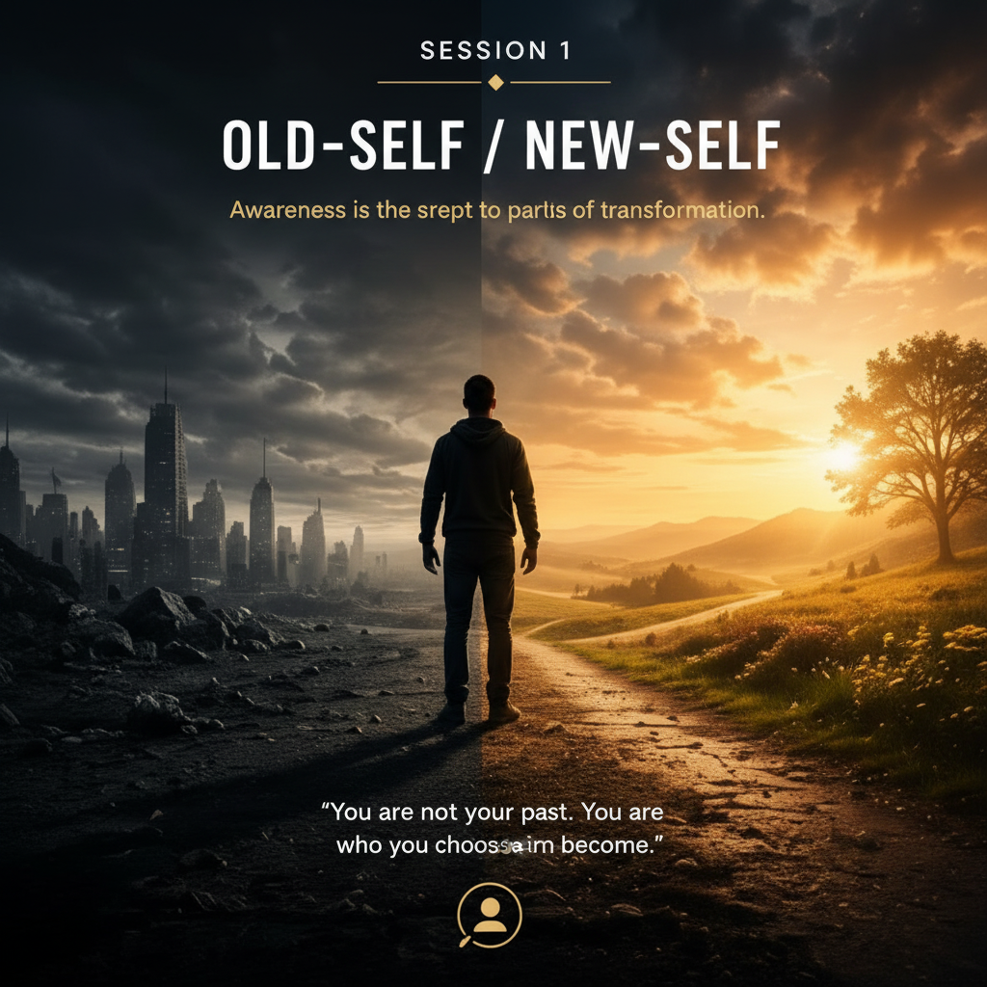

Session 1: Old Self / New Self
Assignment Theme: Understanding your current identity and creating a compelling vision of who you are becoming. This is where you candidly see your current identity (its positives/negatives), and what you want to become, to better assess the differences you want to change.
Assignment #1: Create two lists: 1) Old Self and 2) New-Self characteristics. Be open, reflective, and honest with all your entries writing as many positive and negative things about yourself. The more candid, the better they will serve you.

PERSONALITY TRAITS

This list is very subjective, no rights, no wrongs. Merely how you perceive yourself.
Once you have 10-20 traits for each column, prioritize them and transfer the top three to the next template for easiser access.
Old Self – Positive | Old Self – Limiting | New Self – Positive | New Self – Limiting

Part 1 — The Old Self
Reflection Questions
Current Identity
- How would you describe your current self-perception?

- What limiting habits or behaviors continue repeating in your life?

- What emotions are most connected to these habits?

- What internal stories do you repeatedly tell yourself?
Examples:
- “I always fail.”
- “I’m not disciplined.”
- “I never follow through.”
Your reflections:

Part 2 — The Cost of Staying the Same
Reflection
If nothing changes over the next:
1 Year:

5 Years:

10 Years:

Part 3 — Your New-Self Vision
Your Future Self
Imagine the highest version of yourself already exists.
Who are they?

How do they think?

How do they behave?

How do they treat themselves?

What habits naturally support this version of you?

New-Self Declaration
Write a short declaration describing the person you are becoming.
Example: “I am becoming someone who trusts myself, follows through consistently, and lives with clarity, peace, and purpose.”
My Declaration:

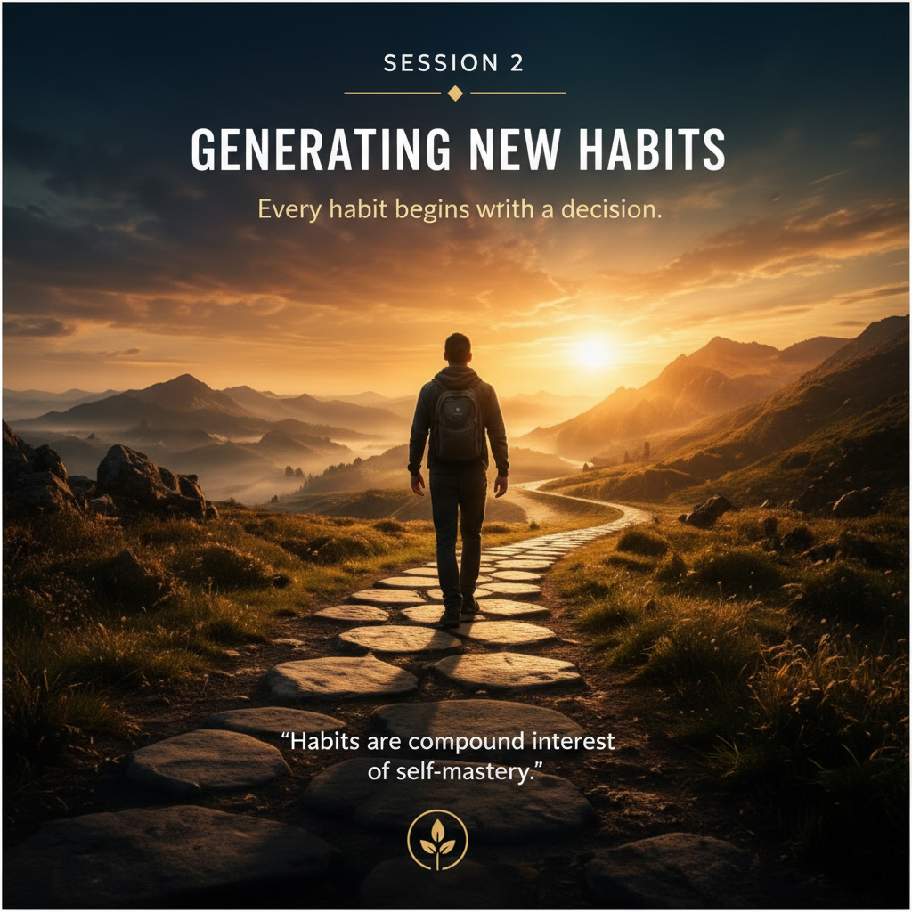

Session 2: Generating New Habits
Assignment Theme: Building habits that align with your New-Self Vision. Armed with a deeper understanding of your New-Self Vision, we will select key habits that will support your vision toward a true foundational transformation. From this short list of 2-3 key habits. In the next session we will generate and practice a Simple Viable Habit set for your practices.

UNDERSTANDING HABITS
Key Insight
Habits follow identity.
When your self-perception changes, your behaviors begin changing naturally.

CURRENT HABIT INVENTORY
List Your Current Habits
Habit | Supports Old-Self or New-Self? | Emotional Trigger
HABIT TRIGGERS
Reflection Questions
- What situations trigger your limiting habits?

- What emotional states trigger them?

- What needs are these habits attempting to fulfill?

Designing New Habits
Brainstorm New Supporting Habits
List habits that support your New-Self Vision.
New Habit Why It Matters |  |  | Difficulty Level
______________________ ______________________________ |  |  | _______________
______________________ ______________________________ |  |  | _______________
______________________ ______________________________ |  |  | _______________
______________________ ______________________________ |  |  | _______________

Identity Alignment Exercise
For each new habit ask:
“What type of person naturally does this?”
Example:
- A healthy person exercises.
- A peaceful person meditates.
- A disciplined person follows through.
Your reflections:

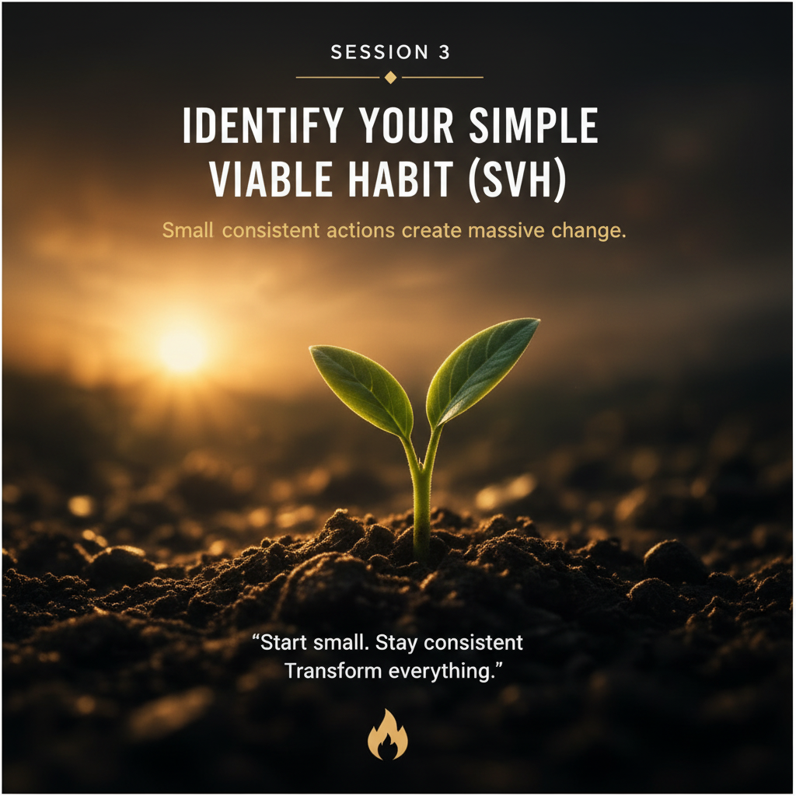

Assignment Theme: Choosing the smallest possible habit that creates momentum. Often, we want changes to happen quickly, so we take on larger challenges and hope for the best. I’ve found that this is the long route to our objective – in this case, is Transformation – which can be a slow process, but one that lasts. Try operating at the speed of Life vs. Light and you many find they are really the same.

Session 3: Identify your Simple Viable Habit (SVH)

WHAT IS AN SVH?
A Simple Viable Habit is:
- Small
- Easy
- Sustainable
- Repeatable
- Identity-building
The goal is consistency, not intensity.

EXAMPLES OF SVHs
Goal | Simple Viable Habit
Meditation | 2 minutes daily
Exercise | 5 pushups
Journaling | Write one sentence
Reading | Read one page
Gratitude | Write one gratitude item
Marathon | Start by putting on running shoes

YOUR 2-3 TARGET HABITS

YOUR SVH FOR EACH
What is one habit small enough that you cannot fail?

SVH DESIGN QUESTIONS
Why does this habit matter?

What identity does this reinforce?

When will you do it?

Where will you do it?

What might interfere with consistency?

What support systems can help?

Journal Momentum Tracker
Assignment Theme: This tracker is provided to get you started with a new pattern of habit change. Annotate your daily progress.
Use a number rating of 1 - n times/day you repeat the new SVH or Habit. It will help you get on course, be consistent with your practice, and achieve results faster. If you choose to use it for more than one month add a blank page and copy the Daily Reflection to that page.
FEEDBACK LOOP: Learning from Experience (Entry chart on next page)
Transformation is not a straight line; it is a series of corrections. Use this template whenever you experience a lapse or encounter friction.
1. The Event (What happened?): Be objective, like a scientist reporting on an experiment. Avoid self-judgment.
- Time/Location: _________________________________________________
- The Trigger: (e.g., I was stressed, I was in the kitchen, I was tired)
2. The Friction Check (Why did it happen?): Check the box that best describes the point of resistance:
- [ ] Environmental: The cue was too obvious, or the friction to perform the habit was too high.
- [ ] Temporal: The timing of the habit conflicted with my energy levels or schedule.
- [ ] Identity: I felt disconnected from my "New-Self Vision" in that moment.
3. The Adjustment (The "System" Fix): What one small, physical change will I make to ensure the environment supports my habit next time?
- (Example: "I will move my phone to another room" or "I will set my running clothes out the night before.")
- The Pivot (The B-Plan): If this happens again, what is the "Simple Viable Habit" version I will perform instead? (e.g., "If I can't do my full 20-minute workout, I will do 2 minutes of stretching.")
- 5. The New Insight: What did this experience teach me about my journey toward my New-Self?

Daily Reflection:
ASK: "What 'Hard Question' did I answer today that changed my view of my habit?".
(Each cell uses wrap-text).

Date | Event | Friction | Adjustment | Pivot | New Insight

"Mastery is not about never failing; it is about how quickly you can complete this loop. Each time you fill this out, you are not failing—you are debugging your system. Keep going."



Theme: Integrating your new identity and habits into daily life. This is where all your work and perserverance start to show up in your behavior and how you start feeling about yourself. Remember, this is a major transsition point in your transformation. It’s very much like evolving from learning to become the teacher. Be patient and kind to yourself during this time. It can be he richest experience – that only pales to the full integration of your efforts.

Session 4: Integration

INTEGRATION REFLECTION
What changes have you noticed so far?

What resistance still appears?

What situations challenge your new identity?

ENVIRONMENTAL DESIGN
Your environment either supports or sabotages your transformation.
What environmental changes would support your New-Self Vision?
Examples:
- removing distractions
- changing routines
- healthier relationships
- organized workspace
Your reflections:

SELF-TRUST INVENTORY
Complete the following:
I trust myself more when I:

I lose trust in myself when I:

One way I can strengthen self-trust this week:


Theme: Living your transformation and sharing your experience. As we know, change cannot last in a vacuum – at least not for human beings. We are a spirit/soul living in a social animal and we prosper when we’re connected. Famiies, friends, and communities are where we thrive and express ourselves.
You are welcome to join the Journey In2 community. Please contact james@journeyin2.com.

Session 5: Embodiment & Sharing
EMBODIMENT
Reflection Questions
How has your self-perception changed?

What new habits feel natural now?

What are you most proud of?

What future vision excites you now?

Your Transformation Story
Write a brief summary of your Breaking Free journey.
Include:
- What you struggled with
- What changed
- What you learned
- Who you are becoming

Sharing & Community
Transformation becomes stronger when shared.
Reflection
Who can support your continued growth?

Appendices

NeuroScience Corner
The Power of Neuroplasticity: Your brain is not a fixed circuit; it’s a dynamic, adaptable structure. Every time you consciously choose a new action, you forge new neural pathways.
Like water carving a canyon, consistent, small actions (Simple Viable Habits’ or SVHs) physically reshape your brain, weakening old habit loops and strengthening new ones.
“Start small. Stay Consistent. Transform your brain”

Ancient Wisdom
Ancient philosophies across cultures, from Shamanism (30,000 years ago) to Stoicism, Taoism emphasize the value of enduring, small efforts over time.
Marcus Aurelius taught that a well-lived life is built from actions, and if each performs its own task, will be content. Lao Tzu spoke of “A journey of a thousand miles begins with a single step.
Shamans across the worlds learned how to transcend space and time, and therefore death, as a transition point.
This Breaking Free Journey is based on this dual foundation of science and philosophy. My wish is that some parts of this wisdom and knowledge are awakened in you through this course.

Full Immersion
The more energy and time you can invest into this transformation process, I can guarantee you will experience life as you never imagined. Doors will open, where none appeared before. Opportunities will come to you just in time. The more you share your new life, the greater your fulfillment and enjoyment.

Composite Progress Scores
S1 | S2 | S3 | S4 | S5 | Total Avg

Assignment Checklist
Session 1: Old Self / New Self 4
Part 1 — The Old Self 4
Part 2 — The Cost of Staying the Same 5
Part 3 — Your New-Self Vision 5
New-Self Declaration 6
Session 2: Generating New Habits 7
Designing New Habits 9
Identity Alignment Exercise 9
Session 3: Identify your Simple Viable Habit (SVH) 10
Momentum Tracker 12
Session 4: Integration 14
Session 5: Embodiment & Sharing 16
Your Transformation Story 16
Sharing & Community 17

New-Self and Habit Mechanism
Once you have identified your New-Self Vision (even as a preliminary sketch), you will have a foundation upon which to generate New Habits that are designed to support your vision.
And, now you have the leverage to change your limiting Habits to those that will support your New-Self Vision. But first, you need to identify the Habit Hooks that are keeping you stuck in a Habit Prison. As you replace them with health, supportive habits, the freedom you are looking for will start happening. As these depictions show, all New Habits gravitate and support your Vision. Use this barometer to select other Habits you choose to change in time.
As we explored in the Course, the Key elements of the mechanism include Hooks (attachments which keep you stuck in unproductive patterns) and the Loop, which is the perpetual cycle of patterns.
Remember how important your New-Self Vision is to breaking up the sticky Loop patterns.

HOOKS
Sometimes this is the area where you are feeling stuck and the mistake is to focus on it as the source of the problem. At Journey In2, we have learned that it is a red herring. Changing the habit alone or its attachment does nothing but postpone the habit for a period of time. To change on a long-lasting basis, you need to change how you think about your self – your Self-Identity.
A smoker who gives up cigarettes, will eventually find themselves craving one again because they still identify as a smoker. Changing that identity to someone who now rewards themselves by jogging and eating healthy foods, soon starts self-identifying as a non-smoker, dropping the cigarette craving in exchange.
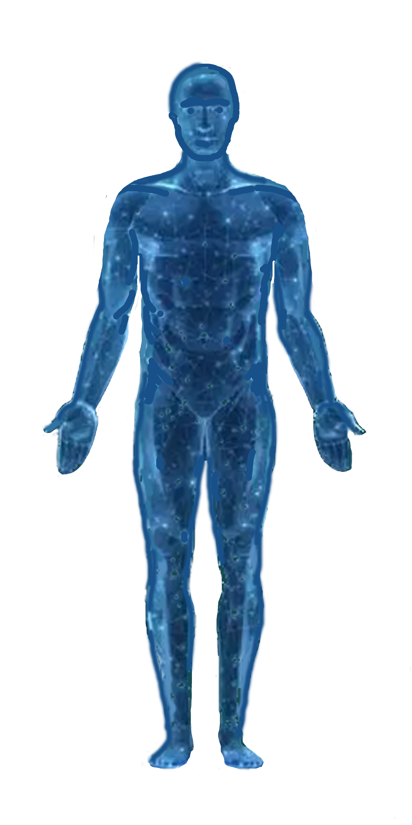
Person
Event
Thing
C. External Sources
B. Internal Sources
Thought
Feeling
Hooks are attachments (emotional, mental, physical)
A. Internal
Conditions
- Vulnerable
- Trauma
- Change

Hook Examples
“I scroll social media when I am anxious”
“I eat snacks when I walk past the kitchen”
“I get tongue-tied when I need to speak in public”

LOOPS
You can’t do much about Cues because they’re outside your realm of control. However, as you alter your reaction or response (habit pattern), you start to manage your emotions and thoughts with much more mastery. Reinforcing the New Habit with a superior Reward helps solidify your New Habit.
3. Reward
Internal
External
Hooks
Inner Critic
1. Cue
(Trigger)
4. Craving
2. Habit
Eventually, your previous cravings become part of your Habit Design and will further set the New Habit as an embodied response vs. knee-jerk reaction.

And your Inner Critic becomes your quieter and more complimentary Advocate. Its like releasing the sandbags from a hot-air balloon that is weighed to the ground. Now, you begin to soar above all the noise and chatter, like a hummingbird, and start enjoying the finer nectar of life.
People who fail did not realize how close they were to success when they gave up.” - Thomas Edison

Additional Maps
- Trigger → Behavior → Reward Loop
- Small Action → Momentum → Identity
- Practice → Consistency → Embodiment
- Alignment → Purpose → Contribution

Neuroscience Sidebars
- Neuroplasticity and identity reinforcement
- Habit loops and automatic behavior systems
- Dopamine and momentum creation
- Environmental reinforcement and behavior shaping
- Embodiment and identity stabilization
Example Topics
- “Why habits feel automatic”
- “How repetition rewires the brain”
- “Why small wins create transformation”
- “Identity and neural reinforcement”

Quotes & Callouts
Examples
“You cannot consistently act in a way that is inconsistent with how you see yourself.”
“Small repeated actions become identity.”
“The person you’ve been is not the person you must remain.”
“Consistency creates momentum.”

