Breaking Free Assignment #1
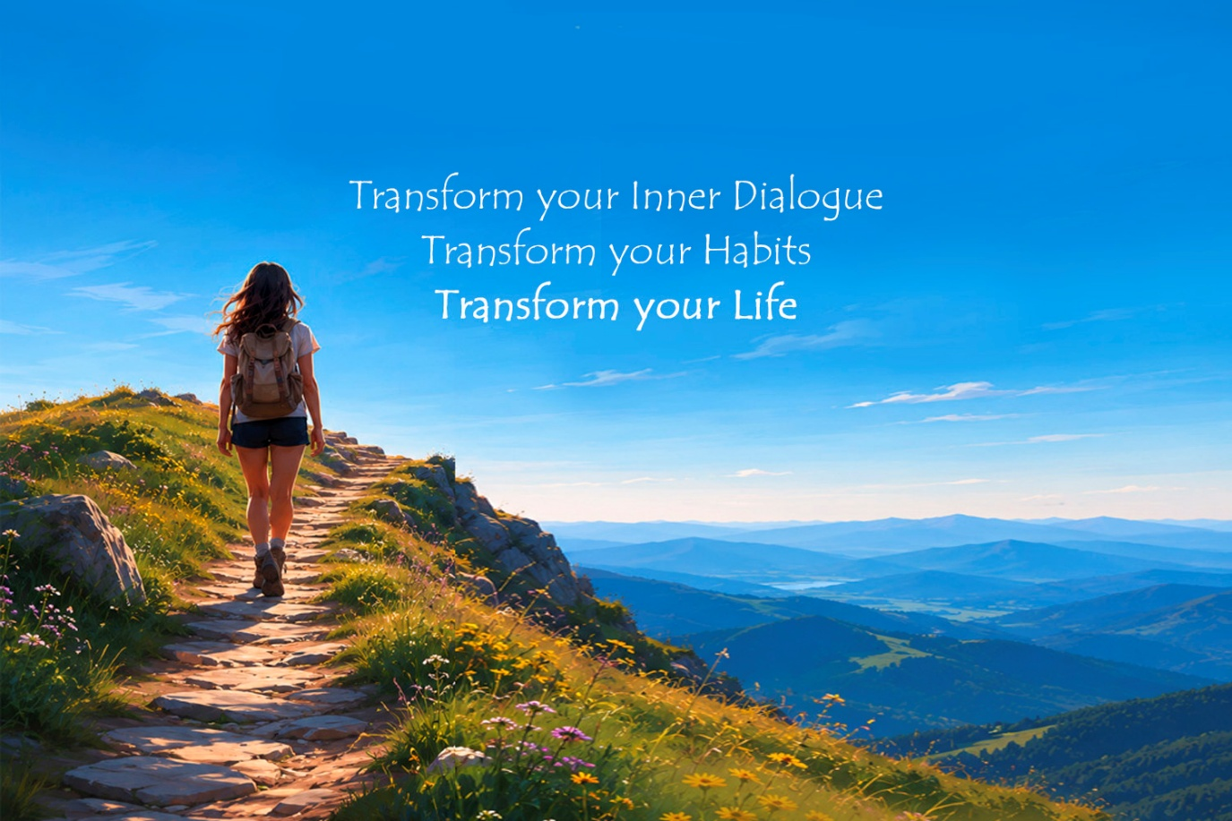

Session 1: Old Self / New Self
Assignment Theme: Creating your New-Self Vision.
Key Insight: Habits follow identity. When your self-perception changes, your behaviors start changing naturally.
Assignment: For this first assignment, create two lists: 1) Old Self Traits and 2) New-Self Traits. Be open, reflective, and honest with all your entries writing as many positive and negative things about yourself. The more candid, the better they will serve you.

EXERCISE #1
Part 1 — The Cost of Staying the Same
Reflection
Where do you think you’ll be If nothing changes over the next:
1 Year:

3 Years:

Part 1 - The Old Self
Reflection Questions
Current Identity
- How would you describe your current self-perception?

- What limiting habits or behaviors repeat in your life?

- What emotions are most connected to these habits?

- What internal stories do you repeatedly tell yourself?

Examples:
- “I always fail.”
- “I’m not disciplined.”
- “I never follow through.”
- “I not worthy.”
- “I can’t do it.”

Part 2 — Your New-Self Vision
Your Future Self
Imagine the highest version of yourself already exists.
Who are you?

How do you think?

How do you behave?

How do you treat themselves?

What habits naturally support this version of you?

New-Self Declaration
Declaration Tip
Drafting Your Declaration Your declaration is a bridge between your current reality and your future identity. Use these three:
* Action-Oriented: Does your declaration describe an identity (who you are becoming) rather than just a goal (what you want to achieve)?. *
Truthful: Is it a statement you can believe as you say it, even if you aren't "there" yet?. * Present Tense: Write as if the transition has already begun, as this reinforces neuroplasticity and the forging of new neural pathways.
Example Refinement: > * Weak: "I want to try to be more disciplined." * Strong: "I am becoming someone who trusts my own word, follows through with consistency, and honors my every day commitments."

Write a short declaration describing the person you are becoming.
My Declaration:
I, (your name), on this day declare, “I am am becoming someone who trusts myself, follows through consistently, and lives with clarity, peace, and purpose. embodying the following qualities, values and characteristics I was meant to be and live.”:

Your Signanature Location Date

