BUSINESS FUNDING 101

DUANE_THESUCCESSKING

How should you proceed
Building business credit and getting your business funded is a process that, when followed, will allow you to expand your business to successful heights, faster than the average Entrepreneur. I want to share some basic foundational items and some specific actions you should take as an entrepreneur, seeking to establish your business properly.

Things You will Need to Get Done/Do

- Register your business
Registering a business with your state is the first step you need to consider. When a business is established in such a way that it is state recognized, it is prepared to be used to the benefit of the Entrepreneur.
If you are filing/registering an LLC business, for example, you will need to establish the LLC paperwork with your state so that the entity is given a number from the state that is recognizing it. A good place to set up the business is zenbusiness.com
You will also register the business with the Federal Government and get an EIN number. This is easily done by going to IRS.gov/Ein. This registration process prepares the business for operation in the state and country.

- Get an Address or Virtual Address:
WHERE WILL YOUR BUSINESS BE LOCATED? - USE THIS ADDRESS OR USE VIRTUAL ADDRESS
- OPUS
- IPOSTAL
- ANYTIME MAILBOX
- REGUS
- ALLIANCE

- Things to Get in Place:
- MAKE A BUSINESS LOGO
- MAKE YOUR BUSINESS SIMPLE ONE PAGE WEBSITE - UNLESS YOU NEED MORE
- GET A TOLL-FREE BUSINESS PHONE NUMBER / REGULAR NUMBER
- PHONE.COM OR EVOICE
- REGISTER YOUR BUSINESS NUMBER WITH THE 411 DIRECTORY
- GET A BUSINESS EMAIL ADDRESS( NAME@YOURDOMAIN.COM)
- FIND YOUR NAICS(SIC) CODE - YOU NEED THIS TO OPEN BIZ BANK ACCOUNT

- Get a D-U-N-S number
Establishing a Duns number will allow the business to build credit history that will benefit further expansion.
What is a DUNS number: A Data Universal Numbering System (DUNS) number is a unique nine-digit identifier for businesses, issued by the credit bureau, Dun & Bradstreet. It is standardized across global industry and trade associations with more than 300 million businesses registered. You can think of it as your business’s social security number, except you must request one rather than automatically being assigned one.
- Get registered with other Business reporting agencies
Registering with Experian Business is critical for the success of your business.
- Official Experian website and business credit reports
- Easy to read business credit and background information
- Includes the Intelliscore PlusSM and Financial Stability Risk rating
- Check and build your business credit score
- Monitor your business credit report with identity protection alerts
- Access international business credit reports
- Mobile friendly interface
- Competitive low prices
Registering with Equifax Business is also critical for the success of your business.

One of the best places to be registered is NAV. I recommend you sign up for NAV business boost $49.00 a month, but invaluable.
Nav helps you identify the best option among our trusted partners for your business so you can make smarter decisions quickly and confidently. Better business credit scores open the door to better options for your business — and it all starts with our business credit-boosting detailed reports.
Use Nav's exclusive benefits to potentially help establish your business credit rating, get cash flow analytics, and personalized recommendations for your small business you cannot find anywhere else.

- Get a Bank Account
The Laws in many states require that an LLC (for instance) get a bank account. Having a bank account will allow you to begin building a reputation with a bank. It is my recommendation that you bank with a 2nd tier bank in your local area. By this I mean a bank with a few locations in your region and not nationally. By building a local presence your company will have an easier time getting products and services to continue expanding for the future,

- Final Items Before Business Credit/Funding
CREATE SOCIAL MEDIA ACCOUNTS FOR YOUR BUSINESS
ADD YOUR BUSINESS TO YELP
ESTABLISH BUSINESS PRESENCE WITH GOOGLE

Establishment of Business Credit toward cash Funding:

- Get accounts that report Tier 1
Starting your business credit journey should happen with those who report on net 30 terms. Here is a brief list of some small trade lines where you can start:
1) Business T-shirt Club - https://tinyurl.com/tshirtclub-credit...
2) Nav - https://tinyurl.com/CREDITPLUG-Nav
3) Office Garner - https://tinyurl.com/2zxr26yn
4) CEO Creative - https://tinyurl.com/theceocreative-cr...
5) Crown Office Supplies - https://tinyurl.com/crownoffice-credi...
6) Creative Analytics DC - https://tinyurl.com/creativeanalyticsdc
7) Shirtsy - https://tinyurl.com/shirtsy-creditplug
8) Wise Business Plan - https://tinyurl.com/CREDITPLUG-WBP

Other Tier 1 account opportunities:

GET 5-10 TIER 1 ACCOUNTS ADDED TO BUSINESS CREDIT PROFILE
- QUILL
- GRAINGER
- ULINE
- SUPPLYWORKS
- SUNBELT RENTALS
- CROWN OFFICE SUPPLIES
- SUMNA OFFICE SUPPLIES
- STRATEGIS NETWORK SOLUTIONS
- WISE BUSINESS PLANS
- BUSINESS TSHIRT CLUB
- MONOPOLIZE YOUR MARKETPLACE
- CEO CREATIVE
- CREATIVE ANALYTICS
- PUFFER WEB
- MSC DIRECT
- SHIRTSY
- PILOT AXLE FUEL CARD
- BP BUSINESS SOLUTIONS
- US PLASTICS
- ATOB FUEL CARD
- CIRCLE K FUEL CARD
- OHANA OFFICE PRODUCTS
- RED SPECTRUM
- OFFICE GARNER
- JJ GOLD
- SYKES MARKETING GROUP
- BIZ CREDIT CENTRAL
- BURST BIZ

- GET 5-10 TIER 2 VENDORS

- HONDA POWER EQUIPMENT
- AMAZON PBI
- CATERPILLAR
- NEWEGG
- HERTZ RENTAL CAR
- ENTERPRISE RENTAL CAR
- LOWES ACCOUNTS RECEIVABLES
- WINN DIXIE GROCERY
- AMAZON NET 55
- BEST BUY BUSINESS
- DELL BUSINESS CREDIT CARD
- PITNEY BOWES POSTAGE ACCOUNT
- FLOOR N DECOR
- JCPENNEY
- UBER FOR BUSINESS
- TIFFANY & CO
- SAMS CLUB STORE CARD
- VERIZON WIRELESS
- CREDIT STRONG
- GUITAR CENTER
- HOME DEPOT COMMERCIAL
- B AND H PHOTOS
- TRACTOR SUPPLY
- NTB NATIONAL TIRE AND BATTERY
- OREILLYS AUTO PARTS
- ADVANCED AUTOPARTS
- BUDGET RENTAL CAR
- DISCOUNT TIRES
- MENARDS COMMERCIAL CREDIT ACCOUNT
- T MOBILE WIRELESS FOR BUSINESS
- AT&T WIRELESS FOR BUSINESS

- BUSINESS CREDIT BUILDER ACCOUNTS
CREDIT STRONG
DIVVY
SELF

- Open a business credit card
The first place you can try is the local bank you are using, but the list below is some of my favorites for credit cards and funds.
This list is invaluable if building credit the correct way is your goal
1) Divvy (NO CREDIT CHECK) - https://tinyurl.com/59kfh95d
2) Fundbox (SOFT CREDIT CHECK)- https://tinyurl.com/FUNDBOX-600-FICO
3) Revenued (NO CREDIT CHECK) - https://tinyurl.com/revenued-flex-line
4) Capital-on-Tap (SOFT CREDIT CHECK)- https://tinyurl.com/Creditplug-capita...
5) CORPAY (REPORTS TO D&B) - https://tinyurl.com/corpay-mastercard
6) IDEA Financial (NO CREDIT CHECK) -https://tinyurl.com/idea-financial
7) Fast Capital 360 (SOFT CREDIT CHECK) - https://tinyurl.com/fast-cap-360-BLOC
8) Ramp (NO CREDIT CHECK)- https://tinyurl.com/Ramp-Visa-No-PG
9) Brex (NO CREDIT CHECK) - https://tinyurl.com/CREDITPLUG-Brex
10) Torpago (NO CREDIT CHECK) - https://tinyurl.com/torpago
11) Karat Card (NO CREDIT CHECK) - https://tinyurl.com/CREDITPLUG-karat
12) AtoB Gas Card (NO SSN REQUIRED!) - https://tinyurl.com/2935hw3h

- NO Personal Guarantee CREDIT/BANK CARDS
CAPITAL ON TAP
GET KLEER CARD
DIVVY
TORPAGO
SAM'S CLUB MASTERCARD
RAMP CORP CARD
BREX CORP CARD

The above accounts are a good place to start your business credit journey.

- Pay on time
Paying your bill on time will help your Paydex score which will keep you growing your business.
The PAYDEX Score is a business credit score that Dun & Bradstreet (D&B), a business credit bureau, generates. It measures how well your company pays its suppliers, vendors, and other businesses it may work with. Scores range from 0 to 100, and a score of 0 represents the highest risk of a delinquent payment. You want to maintain an 80 or higher score.
- Monitor your credit
Your business should be monitored by you on Dun and Bradstreet, Experian business and Equifax business. You can tract these using the Nav.com site as well.

- Business Funding and Real Estate financing options
Business Loans

1) ROK FINANCIAL (SOFT CREDIT CHECK) - https://tinyurl.com/creditplug-funding
2) NATIONAL BUSINESS CAPITAL (SOFT CREDIT CHECK) - https://tinyurl.com/ax4zrnaz
3) SOUTHEND CAPITAL (SOFT CREDIT CHECK)- https://tinyurl.com/550-FICO-LOAN
4) MULLIGAN FUNDING (SOFT CREDIT CHECK)- https://tinyurl.com/CREDITPLUG-Mullig...
5) ARF FINANCIAL (SOFT CREDIT CHECK)- https://tinyurl.com/ARF-FINANCIAL-CRE...
6) SMART BIZ LOANS (SOFT CREDIT CHECK)- https://tinyurl.com/Smart-Biz-Loans
7) UPLYFT CAPITAL (SOFT CREDIT CHECK)- https://tinyurl.com/uplyft-capital-cp
8) GUIDANT FINANCIAL (SOFT CREDIT CHECK)- https://www.gfprequal.com/creditplug
9) Sellers Funding (NO CREDIT CHECK) - https://tinyurl.com/CREDITPLUG-SF

OTHERS:

POPCASH FUNDING
APPROVED FINANCIAL SOLUTIONS
ACCION
LITTFUND
BITTY LOANS UP TO $25K
DAVID ALLEN CAPITAL $25K AND UP
KABBAGE FUNDING
RELIANT FUND
SBA MICROLOAN
SBA 7(A) LOAN

BUSINESS CREDIT AUTO FINANCING GO TO ALLY’S WEBSITE (ALLY.COM/AUTO/DEALER-LOCATOR/) TO SEE WHAT DEALERS IN YOUR AREA THEY WORK WITH. GO THERE, SELECT CAR ASK FOR CORPORATE FINANCE MANAGER (FLEET SALES)OR JUST ASK ABOUT BUSINESS VEHICLE FINANCING . OR GO TO (VROOM.COM) SEE IF THERE IS ANYTHING YOU LIKE IF SO CALL 1-855-624-1300 AND INQUIRE ABOUT BUSINESS VEHICLE FUNDING WITH NO PG

SHORT TERM RENTAL LEASING
AIRBNB - GO THRU AIRBNB PLATFORM
CALL LOCAL UPSCALE COMMUNITIES REQUEST CORPORATE LEASING MANAGER ARRANGE MEETING. RENT UNIT WITH NO PG

WHAT DOES NO PG MEAN? — PERSONAL GUARANTEE . YOUR DEBTS DO NOT BELONG OR ARE ATTACHED TO YOUR NAME ONLY THE BUSINESS AS ITS OWN ENTITY

*** IF YOUR PERSONAL CREDIT IS GOOD YOU CAN SKIP TIER1 AND GO STRAIGHT TO TIER 2 TO SOLIDIFY FOUNDATION

IF YOUR PERSONAL CREDIT IS 750+ TIME TO MOVE ON TO TIER 3 BANK CASH CREDIT CARDS
- CHASE BANK
- TRUIST BANK
- PNC BANK
- US BANK
- AMEX FOR BUSINESS
- WELLS FARGO
- NAVY FEDERAL
- CAPITAL ONE
** BE AWARE OF CAPITAL ONE AND DISCOVER THEY REPORT UTILIZATION ONTO PERSONAL CREDIT REPORT

BONUS : WHILE BUILDING BUSINESS CREDIT STILL BUILD PERSONAL CREDIT. ULTIMATE BOSS HACK
- DISPUTEBEE.COM
- TRACKING.CREDITSTRONG.COM
- CREDITBUILDERCARD.COM
- COLLECTIONSHIELD360.COM

START YOUR OWN CREDIT REPAIR BUSINESS
CREDITREPAIRCLOUD.GRSM.IO

Real Estate Investment Financing

1) Airbnb Funding (NO CREDIT CHECK) - https://tinyurl.com/AIRBNB-FUNDING
2) New Silver (NO CREDIT CHECK) - https://tinyurl.com/NEW-SILVER

Companies that have given my business 25k and above in Credit: Click on name to go to page

American Express


Bank of America
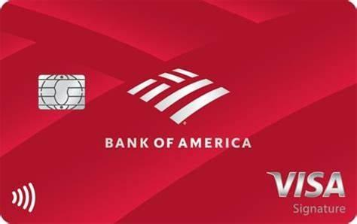

Capital On Tap



Corpay


GM Business


Navy Federal Credit Union
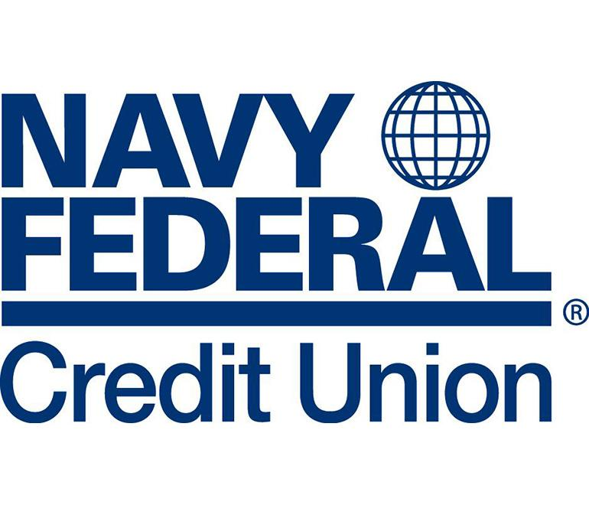

Truist Bank


US BANK
