THE CONFESSIONAL KILLER

A Darrius Blue Mystery
by

SAL BLUE
Blue Publishing

Copyright © 2026 by Sal Blue

All rights reserved.

No part of this publication may be reproduced,
stored in a retrieval system, or transmitted in any
form or by any means without prior written permission
from the publisher, except for brief quotations used
in reviews or scholarly works.

This is a work of fiction.

Names, characters, organizations, places,
incidents, and events are either products of
the author's imagination or are used fictitiously.
Any resemblance to actual persons, living or dead,
events, or locales are entirely coincidental.

Published by
Blue Publishing
First Edition
ISBN (Paperback): _9798186752202
ISBN (Hardcover): _9798185171523
ISBN (eBook): ___9798185171523
Printed in the United States of America

THE DARRIUS BLUE MYSTERIES

Truth is never buried forever.
Every investigation begins with a crime.
Every investigation uncovers a history.
Every history reveals a choice.
Some choose silence.
Some choose justice.
Some seek redemption.
Detective Darrius Blue seeks only one thing.
The truth.

The Darrius Blue Mysteries explore hidden histories, forgotten victims, and the enduring consequences of secrets. Blending investigative realism with psychological depth and moral complexity, each novel follows Detective Darrius Blue as he uncovers truths others have spent years trying to bury.
Blue Publishing

A PUBLISHER'S WELCOME
Welcome to the world of The Darrius Blue Mysteries.
Every story begins with a question.
Some ask who committed the crime.
Others ask how justice will be served.
The stories you are about to read begin with a different question:
What happens when the truth has been buried for so long that people no longer remember it exists?
Detective Darrius Blue is not simply an investigator of crimes. He is an investigator of history, memory, conscience, and consequence. Each case challenges him to look beyond the obvious, to question accepted narratives, and to uncover the human stories hidden beneath official records, public silence, and forgotten lives.
The mysteries in this series are built upon the belief that every victim deserves to be remembered, every truth deserves to be heard, and every act of courage—no matter how quiet—has the power to change lives.
At Blue Publishing, we believe stories can entertain while also encouraging reflection. We believe compelling mysteries can ask meaningful questions about justice, responsibility, forgiveness, and the choices people make when confronted with difficult truths. Our goal is never to provide easy answers, but to invite thoughtful readers into conversations that continue long after the final page has been turned.
As you begin this first investigation, we invite you to pay close attention. Every conversation matters. Every clue has purpose. Every seemingly insignificant detail may reveal something larger. The Darrius Blue Mysteries reward curiosity, patience, and careful observation—much like the detective himself.
Whether this is your first visit to this series or one of many to come, thank you for allowing these stories a place on your bookshelf and in your imagination.
We are honored to share Detective Darrius Blue's journey with you.
Welcome.
The investigation begins now.
Blue Publishing Truth is never buried forever."

Dedication

For those who refuse to look away from the truth.
And for every investigator, survivor, and seeker of justice whose quiet courage reminds us that even the deepest darkness cannot bury the light forever.

Epigraph

"And you will know the truth, and the truth will set you free."
— John 8:32

TABLE OF CONTENTS
Chapter One — Blood in the Confessional
Chapter Two — Echoes of the Past
Chapter Three — The Whispered Confessions
Chapter Four — Shadows of the Past
Chapter Five — The Killer's Message
Chapter Six — The Third Murder
Chapter Seven — Echoes in the Silence
Chapter Eight — The Grealish Files
Chapter Nine — The Reluctant Witness
Chapter Ten — Echoes of Grealish
Chapter Eleven — False Prophets
Chapter Twelve — The Shepherd's Shadow
Chapter Thirteen — The Shepherd's Voice
Chapter Fourteen — Walking Into the Light
Chapter Fifteen — The Good Shepherd

Chapter One

Blood in the Confessional

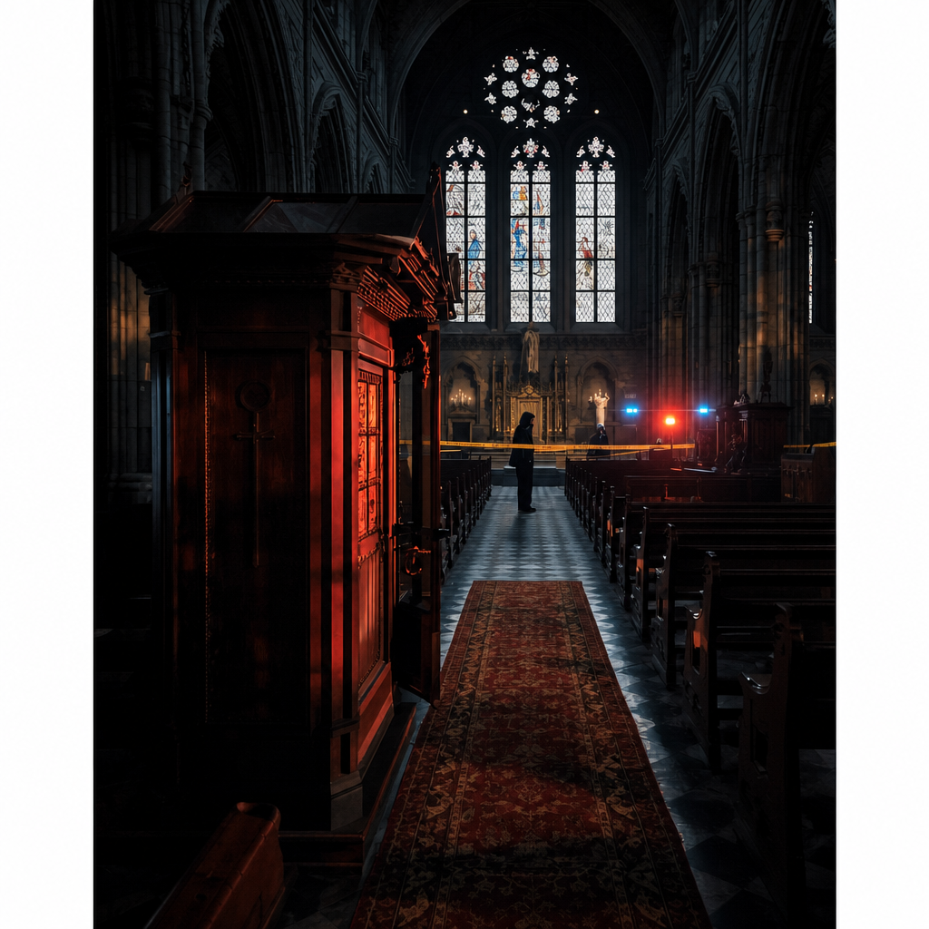

"Every confession begins with the hope that someone is listening."
The world came back in pieces.
Smoke first. Then heat.
Then the sound of someone screaming his name from somewhere he could not reach.
Darrius Blue opened his eyes and saw fire crawling along the ceiling beams of the
warehouse. Orange light pulsed through black smoke, bending the room into
something unreal. His shoulder burned. His lungs refused to fill. Somewhere nearby,
metal screamed as part of the structure shifted under its own weight.
He tried to move. Pain answered. His left arm would not obey him.
“Blue!”
The voice came again, distant and warped by smoke.
He turned his head and saw nothing but flame.
Then a shape moved in the darkness.
A body. Small. Too still.
Darrius forced himself forward, dragging one knee across broken glass and concrete
dust. His hand slipped in something warm. He did not look down. He already knew.
The warehouse groaned around him. Another beam fell.
Sparks burst across the floor like shattered stars. He reached for the figure.
Almost there. Darrius jerked awake with a hand clamped over his shoulder and
his heart trying to break through his ribs. For several seconds, he did not know
where he was. The room was dark. No smoke. No fire. Quiet. No screams.
The polished wooden headboard above him was familiar.
So were the sheets twisted beneath his hands. The faint scent of coffee drifted from
the hallway. Home. He was home.
Darrius drew in a breath, then another, forcing air into lungs that still believed
they were choking. The warehouse had seemed so real this time.
The screams had too. He sat on the edge of the bed and pressed the heels of his hands
against his eyes until the last flashes of fire dissolved into black.
Not again.
“Hey, baby.”
Sofia Molina-Leon Blue stood in the doorway wearing one of his old NYPD academy
shirts and holding a tray with coffee and breakfast. Morning light framed her from
behind, softening the worry in her eyes but not hiding it.
“I brought coffee,” she said. “And breakfast.”
And light.
Darrius looked at her for a long moment, letting the sight of her pull him the rest of
the way out of the nightmare.
“Morning, luv,” he said.
His voice came out rougher than he intended. Sofia crossed the room and set the tray
on the nightstand. She sat beside him without asking whether he was all right.
She knew better.
Darrius Blue had spent most of his adult life answering that question with a lie.
Instead, she took his hand.
“I waited up for you,” she said. “Until I couldn’t.”
“I came in late.”
“I know.”
“I didn’t want to wake you.”
Sofia tilted her head, studying him in that way she had, as if she could read the truth
from the space between his words.
“You never want to wake me,” she said.
“That isn’t the same as coming home.”
Darrius managed a small smile. “You prosecuting me before breakfast?”
“Maybe.”
He lifted her hand and kissed her fingers.
“I missed you.”
Her expression softened. “I missed you too.”
For a while, neither of them said anything. The silence between them was not empty. It was
a marriage. History. All the conversations postponed because the job had taken one
more hour, one more night, one more part of him.
Sofia brushed her thumb across the back of his hand.
“Bad one?”
Darrius looked toward the window. The city beyond the glass was waking, indifferent
and gray.
“Same one.”
“The warehouse?”
He nodded once.
Sofia squeezed his hand. “You don’t have to carry that alone.”
“I know.”
But even as he said it, he knew the truth.
Sometimes he forgot that.
Sofia never did.
She leaned into him, and for a moment Darrius let himself rest his forehead against
hers. He could smell her shampoo.
Coffee.
Home.
Then his phone rang. The sound cut through the room like a blade.
Darrius closed his eyes.
Sofia pulled back.
Neither of them moved for half a second.
Then Darrius reached for the phone.
“Blue.”
He listened. The softness left his face.
Sofia watched the change happen. She had seen it before.
Husband becoming detective. Man becoming badge.
Darrius stood. “When?”
He listened again.
“Secure the scene. Nobody goes in or out until I get there.”
He ended the call.
Sofia was already standing.
“What is it?”
Darrius reached for his shirt. “Homicide.”
“Where?”
He looked at her. “St. Michael’s.”
Sofia’s face tightened. “The church?”
Darrius nodded.
She did not ask if he had to go. They both knew the answer.
He dressed quickly, holstered his weapon, and pulled on his dark overcoat. At the
bedroom door, Sofia caught his wrist.
“Come home.”
Darrius looked down at her hand, then back at her.
“That’s the plan.”
She did not smile. “Make it more than a plan.”
He kissed her forehead. Then he left.
❦
The streets of Manhattan were just beginning to stir when Darrius Blue pulled his
unmarked sedan to the curb outside St. Michael's. The church rose above the
surrounding buildings like a relic that had somehow survived a century of relentless
change. Its weathered stone walls glowed pale beneath the early morning sky.
Twin bell towers pierced the low clouds, and stained-glass windows caught the first
hints of daylight without yet reflecting it.
Blue killed the engine. For a moment he simply sat.
Police cruisers crowded the street. Yellow crime scene tape fluttered in the cold breeze.
Uniformed officers moved quietly among the growing number of patrol cars, their
voices subdued in the way they always became around death.
A homicide inside a church changed the atmosphere.
People instinctively lowered their voices. Even cops.

Darrius stepped from the car, buttoned his overcoat against the morning chill,
and ducked beneath the tape. The familiar smell met him immediately.
Old stone. Furniture polish. Burning candle wax. Incense.
It should have been comforting. Instead, another scent rode beneath it.
Blood.
Officer Jamie Alvarez intercepted him near the entrance.
"Morning, Detective."
Darrius nodded. "What do we have?"
"Female. Approximately sixty-five. Found by Father Thomas just before morning
Mass. Crime scene's untouched except for EMS confirming the obvious."
"Anyone leave?"
"No, sir."
"Witnesses?"
"Only the priest."
Darrius gave a curt nod.
"Good work."
Alvarez stepped aside.
The massive oak doors closed behind Darrius with a heavy thud that echoed through
the sanctuary.
Silence settled over him.
Rows of polished pews stretched toward the altar. Hundreds of candles flickered
beneath towering statues of saints whose stone expressions remained unchanged
by tragedy.
The sanctuary felt strangely suspended. As though time itself had paused.
Near the front stood Sergeant Rodney Weir.
Tall.
Broad shouldered.
Tie already loosened.
A paper cup of coffee hung forgotten in one hand.
He watched Darrius approach with tired eyes.
"I was hoping this wasn't going to be your morning," Weir muttered.
"I was hoping for the same." They shook hands briefly.
Neither smiled.
Weir jerked his head toward the side aisle. "This way."
They walked together without speaking.
Every footstep echoed against the vaulted ceiling.
The confessional booth stood near the rear of the sanctuary, partially concealed
behind a stone column. CSI technicians worked methodically around it,
photographing every angle before anyone touched a thing.
Carson knelt near the entrance, already absorbed in his examination.
He glanced up as Darrius arrived.
"Morning."
"Morning."
Carson pointed toward the booth.
"She's inside."
Darrius stopped.
Years of homicide had taught him never to rush the final few steps toward a victim.
Those last moments before seeing the body still belonged to possibility.
Once he looked— Possibility ended.
He drew one slow breath. Then stepped inside.
Nancy Calloway sat slumped against the wooden partition.
At first glance she looked as though she'd fallen asleep during confession.
Then Darrius saw the blood.
It had dried in dark streaks across her silver hair and the collar of her navy coat.
The wound above her temple was small.
Almost delicate.
Far too small for the violence that had caused it.
Her hands rested quietly in her lap.
There were no defensive wounds. No overturned furniture. No signs of panic.
Only stillness.
Too much stillness.
Darrius crouched beside her.
His eyes moved carefully.
Head wound. Bruising beginning around the neck. No broken fingernails.
No torn clothing. Nothing disturbed.
He frowned.
"She trusted him."
Carson looked up. "What?"
"Whoever did this."
Darrius kept studying the body. "She never fought."
Carson slowly nodded. "I was thinking the same thing."

Darrius' eyes drifted toward the narrow wooden screen separating priest from
parishioner.
A confessional.
One of the few places left where people willingly closed themselves inside with
someone they couldn't see. Complete trust. Complete vulnerability.
He stood. His gaze swept the booth one final time.
Something was wrong.
Not with the evidence.
With the feeling.
Crime scenes developed personalities after enough years.
Some shouted. Some lied. Some begged.
This one...this one waited.
As though it expected him.
"Blue."
Weir's voice pulled him back. "We found something."
The sergeant held up a folded sheet of cream-colored paper sealed inside an evidence
sleeve.
"It was lying beside the body."
Darrius accepted the sleeve without opening it.
The paper felt unusually heavy for a single page.
Old. Expensive. Intentional.
He carefully unfolded it. Only four lines had been typed.
The ink was crisp. The spacing was perfect. Almost ceremonial.
He read them once. Then again. His expression didn't change.
But something deep inside him did.
The words didn't read like a confession. They read like a judgment.
And somehow… that was far more unsettling.
❦
Darrius studied the page in silence.
The cream-colored paper was unlike ordinary stationery. Thick. Textured. Almost
handmade. It reminded him of parchment more than modern paper.
The message itself was brief.
Too brief. Four lines. No signature. No demand. No confession.
Only a poem.
He read it again. Not because he hadn't understood it.
Because he was certain it wanted to be understood.
"Anything?" Weir asked quietly.
Darrius didn't answer immediately.
Instead, he slid the paper back into its evidence sleeve and handed it to Carson.
"I want fingerprints, DNA, paper composition, printer identification, ink
analysis—the works."
Carson nodded.
"I've already called the lab. They'll prioritize it."
"Good."
Darrius looked back toward the confessional.
"Whoever wrote this wanted it found."
"You think it's meant for us?" Weir asked.
Darrius slowly shook his head.
"No."
His eyes drifted once more to Nancy Calloway.
"I think it was meant for her."
Carson looked up.
"But she was already dead."
"Exactly."
The three men stood in silence.
Carson finally broke it.
"You think we're looking at someone who enjoys games?"
Darrius considered the question.
"No."
"No?" "If this was a game, there'd be rules."
He looked toward the confessional again.
"This feels different."
"How?"
Darrius frowned. "It feels..."
He searched for the word. "...personal."
Almost...religious.
He kept the last thought to himself.
Carson carefully sealed the evidence bag.
"I'll get this moving."
"Thanks."
As Carson disappeared into the sanctuary, Darrius turned his attention back to the
booth.His eyes traced every surface.
The kneeler. The partition.
The carved wooden lattice separating priest from penitent.
Nothing appeared disturbed. No scratches. No broken hinges.
No obvious point of entry or exit beyond the narrow door.
It was almost impossibly clean.
Which made one thing impossible to ignore.
"Who found her?"
"Father Thomas."
"Still here?"
Weir nodded.
"He refused to leave." "Take me to him."
❦
Father Thomas stood near the sanctuary steps speaking quietly with two elderly
parishioners. When he noticed the detectives approaching, he excused himself and
met them halfway down the aisle.
He looked to be in his early sixties. Tall. Lean.
Silver threaded through dark hair at his temples.
His black clerical shirt and Roman collar were immaculate despite the morning's
horror. Only his eyes betrayed him.
They carried the quiet exhaustion of a man who had already spent the day comforting
others before anyone had thought to comfort him.
"Detective Blue?"
Darrius offered his hand. "I'm sorry we're meeting under these circumstances."
Father Thomas accepted the handshake. "So am I."
His voice was calm. Not detached. Disciplined.
The sort of calm forged through years of standing beside grieving families.
"I'm told you found Mrs. Calloway."
"I did."
"Would you walk me through it?"
The priest nodded.
"I arrived shortly after six to prepare for morning Mass. Mrs. Calloway usually came
early to arrange flowers near the altar."
He glanced toward the confessional. "I noticed the door wasn't fully closed."
His jaw tightened almost imperceptibly.
"I assumed someone had forgotten to latch it after confession yesterday."
"And then?" "I opened it."
He closed his eyes briefly. "I wish I hadn't."
Darrius waited.
People often continued speaking if given room to breathe.
Thomas did. "I checked for a pulse."
"There wasn't one."
"No."
"You touched nothing else?"
"No."
"You called emergency services immediately?"
"Yes."
Darrius studied him carefully.
There was grief. Shock. Fatigue. But no deception.
Not that he could see.
"How long had you known Nancy Calloway?"
"Nearly twenty years."
"What kind of woman was she?"
Thomas smiled sadly. "The kind every parish hopes for."
"Loyal?" "Very." "Faithful?"
"Without question."
"Enemies?"
The priest hesitated. "Not that I'm aware of."
Darrius noticed the pause. "You hesitated."
"I searched my memory before answering."
"And?"
"I found nothing."
Darrius nodded.
He believed him.
At least...
he believed Father Thomas believed what he was saying.
That wasn't always the same thing.
"We recovered a note beside Mrs. Calloway."
Thomas looked genuinely surprised. "A note?"
"You didn't see it?"
"No."
Darrius watched the priest's expression closely.
Still nothing. No flicker. No recognition.
Interesting.
"We'll need a full list of everyone with access to this church."
"Of course."
"Staff."
"I'll prepare it."
"Volunteers."
"Certainly."
"Maintenance."
"I'll include them."
"Anyone with keys."
"I understand."
Thomas paused. "Detective..."
"Yes?"
"If there's anything this parish can do to help..."
Darrius looked toward the rows of empty pews. "There is."
The priest waited. "I need everyone to keep living exactly as they normally would."
Thomas frowned. "You believe the killer may return."
Darrius met his eyes. "I don't know."
It wasn't entirely true. He had a feeling. One he couldn't explain.
Crime scenes spoke. Most whispered.
This one felt as though it was still talking.
"I hope you're wrong," Father Thomas said quietly.
"So do I."
As the priest walked away, Weir fell into step beside Darrius.
"What do you think?"
Darrius looked back toward the confessional one last time.
"The words."
"What about them?"
He was silent for several moments.
Finally, he spoke.
"The words felt rehearsed." He frowned. "Almost ritualistic."
His eyes settled on the empty confessional.
"As though they belonged to something larger..."
He let the sentence hang.
"...than the murder itself."
❦
The sanctuary had grown busier.
Crime Scene technicians moved with practiced precision, photographing every inch
of the confessional before carefully dusting for fingerprints. Flashbulbs briefly
illuminated stained-glass windows depicting saints who had watched generations pass
beneath them.
Outside, the morning sun had finally broken through the clouds.
Inside, the church remained cloaked in shadow.
Darrius stood near the rear pews, hands buried in the pockets of his overcoat.
He wasn't looking at the body anymore. He was looking at the church.
His eyes drifted from the confessional to the altar... then to the choir loft
... then the side entrances... finally settling on the massive front doors.
He stood perfectly still.
Thinking.
Rodney Weir watched him for nearly a minute before finally walking over.
"You've got that look."
Darrius didn't move. "What look?"
"The one that says you've stopped looking at what's in front of you and started
looking at everything else."
A faint smile tugged at the corner of Darrius' mouth. "I do that?"
"Every damn time."
Darrius nodded toward the confessional. "What do you see?"
Weir shrugged.
"Old woman comes to confession." "Or prayer."
"Sure. Killer follows her in."
"Hmm."
"Hits her." "Leaves the note." "And walks."
Darrius finally looked at him. "You skipped something."
"What?"
"The hardest part."
Weir frowned. "Killing her?"
"No."
Darrius slowly shook his head. “Getting close enough."
Weir glanced toward the booth. "What do you mean?"
"Nancy Calloway wasn't attacked walking into the church."
"No."
"She wasn't surprised in the parking lot."
"No."
"She wasn't ambushed leaving."
Weir folded his arms.
"No."
"So when was she most vulnerable?"
The answer arrived almost immediately. "The confessional."
"Exactly."
Darrius began walking slowly through the sanctuary.
"The killer knew she'd be alone." "He knew she'd stay."
"He knew nobody would interrupt."
"And..."
Darrius stopped. "He knew she'd trust him."
Silence settled between them.
Weir looked back toward the booth. "You think she knew him."
"I'd bet my pension on it."
"Parishioner?"
"Maybe."
"Priest?"
Darrius didn't answer immediately.
He looked toward Father Thomas, who was quietly comforting an elderly couple near
the altar.
"I don't know."
Weir caught the hesitation. "But you've thought about it."
"I've thought about everybody."
The sergeant nodded slowly. "Fair enough."
They continued walking.
Darrius paused beside a rack of votive candles.
Most still burned.
Tiny flames dancing beneath handwritten prayer cards.
"Forensics find anything outside?" he asked.
Weir shook his head.
"No forced entry." "No footprints worth mentioning." "No discarded weapon."
"No witnesses."
Darrius sighed quietly.
"The cleanest crime scenes usually aren't clean."
"What does that mean?"
"It means we're missing something."
Weir chuckled.
"That's comforting."
Darrius smiled faintly.
"It shouldn't be."
His gaze drifted upward toward the vaulted ceiling.
The architecture fascinated him.
Not because it was beautiful.
Because it controlled movement.
People entered one way. Exited another. Gathered together.
Separated at confession.
Every space had purpose. Every purpose created opportunity.
His eyes returned to the confessional.
One entrance. One exit. One victim. One killer.
Simple.
Too simple.
"What are you thinking now?" Weir asked.
Darrius answered without looking away.
"The church."
"What about it?"
"It's built on trust."
Weir frowned.
Darrius continued.
"People walk through those doors carrying things they won't tell their spouses."
"They won't tell their children."
"They won't tell their closest friends."
"But they'll tell someone in that booth."
He pointed toward the confessional. "They'll tell everything."
Weir nodded slowly.
"And if someone knew those secrets..."
Darrius looked at him.
"...they wouldn't need to rob a person." "They'd already own them."
Neither man spoke for several seconds.
Finally Weir broke the silence. "You think blackmail."
"I think possibility." "That's a long way from proof."
"It is."
Darrius looked once more across the sanctuary.
"But it's the first idea today that actually scares me."
Just then Carson emerged from the side hallway carrying another evidence envelope.
"Blue."
Darrius turned.
"We found something else."
"What?"
Carson handed him a small plastic evidence bag.
Inside rested a single length of coarse wool cord.
Frayed at one end.
Dark fibers clung to it.
Darrius studied it carefully.
"A ligature?"
"Maybe."
"No blood."
"No."
"No fingerprints."
"None yet."
Darrius held it up toward the light filtering through the stained glass.
The fibers caught the colors brilliantly.
Blue.
Red.
Gold.
Almost beautiful. Almost.
"We bagged it near the confessional door."
Carson folded his arms.
"It doesn't match anything else we've found."
Darrius continued staring at it.
Something tugged at the edge of his memory.
Something familiar.
Not enough to recognize.
Not yet.
He slipped the evidence back into Carson's hands.
"Run every test we've got."
"Already on it."
Carson walked away.
Weir watched him disappear.
"You ever get the feeling we're walking into the middle of somebody else's story?"
Darrius didn't answer immediately.
His eyes lingered on the confessional.
Then on the altar.
Then finally on the crucifix hanging high above the sanctuary.
Quietly, almost to himself, he said,
"No."
"I think..."
He paused.
"We're standing at the beginning."
The words settled heavily between them.
Neither detective realized just how true they were.
❦
Father Thomas stood alone beneath the sanctuary arch after the last of his
parishioners had been escorted outside. The church had grown strangely quiet.
Only the occasional camera shutter from Crime Scene or the soft murmur of
investigators disturbed the silence. The priest watched sunlight spill through the
stained-glass windows, painting fractured colors across the marble floor.
"So much beauty," he said quietly.
Darrius approached.
"And so much suffering."
Father Thomas nodded.
"They've always existed together." For a moment neither man spoke.
Darrius broke the silence.
"Can I ask you something that isn't part of my report?"
The priest smiled faintly.
"I suspect you're going to ask anyway."
A hint of humor.
Exactly enough to remind Darrius this man was still human.
He appreciated that.
"What makes people confess?"
Father Thomas looked toward the confessional.
"That's a larger question than it sounds."
"I've got time."
"No," Thomas replied gently.
"You don't."
That answer lingered between them.
Finally the priest spoke again.
"Most people think confession is about guilt." "It isn't?"
Thomas slowly shook his head.
"Guilt is only the doorway."
"What comes after?"
"Hope."
Darrius frowned. "I don't follow."
"The people who enter that booth aren't looking for punishment."
"They're looking for permission to believe they can become something better than the
worst thing they've ever done."
The detective absorbed the words.
They didn't sound rehearsed. They sounded lived.
"You hear the worst things people have ever done."
"I do."
"And you never tell anyone."
"I never can."
"Not even to stop another crime?"
The question hung in the sanctuary.
Thomas's expression changed. Not defensive. Sorrowful.
"There are very few absolutes left in this world, Detective."
"The Seal of Confession is one of them."
Darrius held his gaze.
"So if someone confessed to murder..."
"I could encourage surrender."
"But not report it."
"No."
"You'd let him walk away."
Thomas answered without hesitation.
"I would carry that burden before I would break the seal."
The certainty surprised Darrius. "You'd sacrifice innocent lives?"
"I pray I would never face such a choice."
"That's not an answer."
"No."
The priest looked directly at him. "It isn't."
Silence returned.
Not uncomfortable.
Thoughtful.
Finally Darrius nodded. "I appreciate your honesty."
"I assumed you would."
Thomas looked toward the confessional again.
"There is something else."
Darrius waited.
"Nancy wasn't here for confession."
The detective's attention sharpened. "You're certain?"
"Quite."
"What was she here for?"
"The flowers."
He pointed toward the sanctuary.
"Every Thursday morning she replaced every arrangement in the church herself."
Darrius looked around.
Fresh lilies. White roses. Blue hydrangeas.
Beautiful.
Painstakingly arranged.
"She never missed a Thursday."
"No."
"So why was she inside the confessional?"
Thomas drew a slow breath. "I don't know."
It wasn't uncertainty. It was genuine bewilderment.
Darrius believed him.
Which only deepened the mystery.
"If she wasn't waiting for confession..."
He looked toward the booth.
"...someone had to persuade her to enter."
Thomas slowly nodded.
"I've been asking myself the same question."
The realization settled heavily over both men.
Nancy hadn't wandered into danger.
She had been led there.
The detective looked once more toward the confessional.
The booth suddenly felt different.
Not sacred. Not sinister. Purposeful.
Someone had chosen that place very carefully.
Father Thomas spoke again.
"May I ask you something?"
"Of course."
"Do you believe evil is born..."
He paused. "...or taught?"
Darrius looked at the priest for a long moment.
Then answered quietly.
"I've arrested enough people to know the answer isn't simple."
Thomas nodded.
"No."
"It never is."
As the priest turned to leave, he stopped beside one of the stained-glass windows.
Without turning around, he spoke one final sentence.
"Be careful, Detective."
Darrius raised an eyebrow. "Why?"
Thomas looked at the colored light stretching across the floor.
"Because when someone begins believing they're doing God's work..."
He finally looked back.
"...they stop believing they're capable of evil."
The words settled into Darrius's mind long after the priest disappeared into the
rectory.
For reasons he couldn't explain...
they frightened him more than the murder itself.
❦
The last Crime Scene technicians packed their equipment shortly after noon.
Nancy Calloway's body had been removed.
The confessional now stood empty.
Yet somehow it felt more occupied than before.
Darrius remained.
Rodney Weir walked back into the sanctuary carrying two cups of coffee.
"I figured you weren't leaving."
Darrius accepted one without taking his eyes off the confessional.
"Thanks."
"You've been staring at that booth for nearly twenty minutes."
"I know."
"You expecting it to talk?"
A faint smile crossed Darrius's face.
"They usually do."
Weir chuckled.
"I'll never understand the way your brain works."
"Neither do I."
Silence settled between them.
The church had become peaceful again. Candles flickered.
Sunlight poured through stained glass.
Somewhere in the distance, a maintenance worker moved a ladder.
Life was slowly returning. Everything looked normal.
Darrius hated normal.
Normal hid things.
His eyes wandered one final time across the sanctuary.
The altar. The pews. The confessionals. The side chapel.
The flower arrangements. Nancy's flowers.
His thoughts returned to Father Thomas.
She wasn't here for confession. She came to arrange flowers.
Someone had convinced her to enter the booth.
Why? His mind replayed the scene.
No struggle. No defensive wounds. Minimal blood. A carefully placed
body. The note. The poem. Not rage. Purpose.
Everything felt… ordered.
The killer hadn't come here to murder. He had come here to deliver a message.
The murder had simply been the method.
That thought stopped him cold.
His coffee remained untouched.
Weir noticed. "What?"
Darrius looked slowly toward him.
"I've been asking the wrong question."
"What question?"
"Who wanted Nancy dead."
"And?"
"That's not the important one."
Weir frowned. "What is?"
Darrius looked toward the empty confessional.
"What was Nancy supposed to hear?"
The question lingered.
Neither detective spoke.
Outside, church bells began ringing the noon hour.
Their deep tones rolled through the sanctuary.
One...Two...Three...
Each peal echoed through the ancient stone walls.
Darrius closed his eyes.
Confession. Judgment. Absolution.
The words circled one another inside his mind. Then another thought
arrived. Quietly. Almost unnoticed. "If this message was meant for Nancy..."
He opened his eyes.
"...then someone knew exactly where she'd be."
Weir nodded.
"So?"
"So this wasn't opportunity."
Darrius turned toward him. "It was preparation."
The realization settled over both men.
This murder hadn't been spontaneous. It hadn't even been personal.
It had been planned. Carefully. Patiently.
Long before Nancy Calloway ever walked through the church doors that
morning.
Darrius reached into his coat pocket and removed his notebook.
Instead of writing names...he drew a circle.
Inside it he wrote one word.
TRUST.
Around that circle he began adding smaller ones.
Church. Confession. Nancy. Flowers. Note.
Each word connected to the next.
He stared at the page for a long moment.
It wasn't evidence.
Not yet.
It was the beginning of a picture.
His phone vibrated. Carson.
"Blue."
The forensic examiner's voice came quickly. "We got the first lab results."
Darrius straightened.
"And?"
"No fingerprints."
"None?"
"Not a single usable one."
"What about DNA?"
"Nothing."
"The paper?"
"It wasn't purchased locally."
Darrius' eyes narrowed. "The printer?"
Carson hesitated. "Commercial."
"What does that mean?"
"It means whoever made that note knew exactly how to avoid leaving us
Anything." Darrius thanked him and ended the call.
Weir read his expression immediately. "Bad?"
"Worse."
"How?"
Darrius slipped the notebook back into his pocket.
"We're not chasing someone who got lucky."
He looked toward the church doors.
"We're chasing someone who's practiced."
The words hung in the stillness.
Outside, another church bell sounded.
Somewhere… someone had already begun planning the next confession.
Darrius looked back one final time at the empty confessional.
The words on the note returned to him.
Not as poetry. As a warning. They felt rehearsed. Almost ritualistic.
As though they belonged…to something far larger than the murder itself.
He turned. Walked toward the sunlight.
And unknowingly took the first step into a darkness that had been waiting for
him long before Nancy Calloway died.

Chapter Two
Echoes of the Past

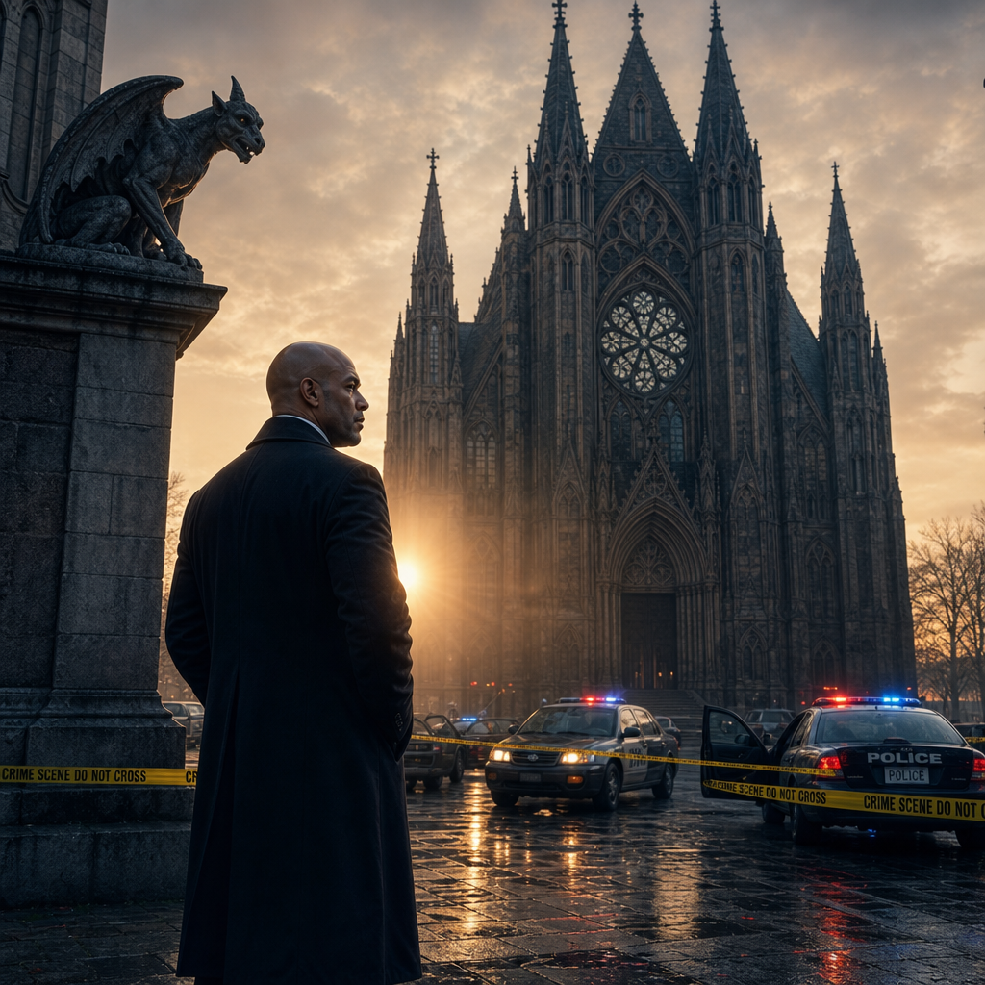

The rain arrived just before dawn.
It fell in a steady drizzle that turned Manhattan's sidewalks slick and reflective,
washing yesterday's headlines into the gutters without washing away what had
happened inside St. Michael's.
Detective Darrius Blue stood before the evidence board in his office.
Nancy Calloway's photograph occupied the center.
Around it were copies of the crime scene photographs, a map of the church grounds,
the first forensic reports, and a single enlarged image of the poem recovered beside
her body. The words had followed him home.
They had followed him into his sleep. And now they waited for him again.
Coffee cooled untouched on his desk. His notebook lay open beside it.
Unlike most detectives, Darrius rarely began with reports.
He began with questions. His pen moved steadily across the page.
Why the confessional? Why Nancy? Why leave the note?
He drew a line beneath the questions. Then another.
What was the killer trying to accomplish?
Not who. Not how.
Why.
Experience had taught him that methods changed.
Motives endured. A knock sounded against the open office door.
Rodney Weir stepped inside carrying a thick case folder. "You look like hell."
Darrius didn't glance up. "I slept."
"For how long?"
"Long enough."
Weir snorted. "Liar."
He dropped the folder onto the desk. "Forensics."
Darrius finally looked up. "Anything useful?"
"Depends how much you like disappointment."
Darrius opened the folder.
Page after page confirmed what Carson had already suspected.
No usable fingerprints. No DNA. No footwear impressions.
No fibers that couldn't be explained by the church itself.
The killer had left almost nothing.
Almost.
Darrius stopped at the photograph of the note.
He studied it again.
The paper. The spacing. The precision.
"It isn't impulsive," he murmured.
"What isn't?"
"The note."
He tapped the photograph. "Everything about it was deliberate."
Weir leaned against the filing cabinet.
"You think he planned the murder around the message?"
Darrius shook his head.
"No."
"I think he planned the message around the murder."
Weir frowned. "There's a difference?"
"A big one."
Darrius stood and walked back toward the evidence board.
"If the note came first..."
He pinned the enlarged photograph beside Nancy's picture.
"...then Nancy wasn't the reason."
Weir stared at him. "The message was."
Silence settled over the office.
Rain tapped softly against the window.
Weir folded his arms. "So where does that leave us?"
Darrius uncapped a black marker.
He wrote three words across the top of the board.
Victim. Location. Message.
Then he connected them with straight lines.
"Most murderers begin here."
He tapped Nancy's photograph. "They hate someone."
He moved to the location. "They choose where."
Finally he tapped the note. "They justify it afterward."
He stepped back. "Our killer reversed the order."
Weir studied the board.
"The message came first."
"Exactly."
"The location supports it."
"Yes."
"And Nancy..."
Darrius looked at her photograph. "...was selected because she fit it."
Neither detective spoke.
For the first time since the investigation began, both men realized they might not be
searching for someone driven by anger.
They might be hunting someone driven by belief.
The phone shattered the silence.
It rang once. Twice.
Darrius answered on the third. "Blue."
His expression changed almost immediately.
"When?"
He listened. "Is the scene secure?"
Another pause. "We're on our way."
He replaced the receiver slowly.
Weir already knew.
"What happened?"
Darrius grabbed his coat.
"Another body."
Weir's face tightened. "Where?"
Darrius met his eyes. "St. Peter's."
For just a moment, neither man moved.
Two churches. Two murders. Two days.
The pattern was no longer forming. It had begun.
Darrius pulled on his overcoat. "Let's go."
As they hurried toward the elevator, the rain intensified, drumming against the
precinct windows. Somewhere across the city, another church stood behind yellow
tape. Another family was about to receive terrible news.
And somewhere beyond both crime scenes...
Someone was already waiting for the detectives to catch up.
❦
St. Peter's stood only a few miles from St. Michael's.
To Darrius, it felt a world away.
The rain had eased to a mist by the time he and Weir pulled into the church parking
lot. Police cruisers lined the curb, their emergency lights flashing silently against the
weathered stone façade. Uniformed officers worked to keep a growing crowd behind
the yellow tape as local reporters jockeyed for a better view.
News traveled fast. Fear traveled faster.
Darrius stepped from the sedan and immediately recognized the expression on the
officers' faces. Not shock. Recognition.
The first murder had been tragedy. The second was becoming a pattern.
Officer Melissa Grant met them at the tape.
"Morning, Detective."
"What do we have?"
"Male. Approximately sixty years old. Found just after morning prayers."
"Name?"
"Zachary Lyle."
Darrius stopped. "Lyle?"
Grant nodded. "Identification confirmed."
Weir looked toward Darrius. "You know him?"
Darrius shook his head. "No."
But the name stirred something.
Not recognition. Memory. A report. A complaint. Somewhere.
"We'll figure it out later," he said quietly.
Grant led them inside.
Unlike St. Michael's, St. Peter's Church felt smaller.
Older.
The sanctuary carried the scent of damp stone and candle wax. Volunteers stood
together near the vestibule, some praying quietly, others simply staring toward the rear
of the church where investigators moved between camera flashes.
Father Michael Donnelly approached as they entered.
His cassock was wrinkled. His face was pale.
"You must be Detective Blue."
Darrius offered a brief handshake. "I'm sorry for your loss, Father."
"So am I."
The priest glanced toward the confessional.
"I never imagined I'd say those words twice in one week."
Neither did Darrius. "Walk me through it."
Father Donnelly nodded.
"Mr. Lyle attended morning prayer nearly every weekday."
"He usually stayed afterward."
"Today..."
The priest swallowed. "...he never came out."
Darrius looked toward the confessional.
The door stood open.
CSI technicians worked carefully inside.
Carson looked up as they approached.
His expression told Darrius everything. "This one's worse."
Darrius stepped inside.
Zachary Lyle lay partially collapsed against the wooden partition.
His gray overcoat had slipped from one shoulder.
Bruising ringed his neck in dark bands.
The head wound was there again.
Small. Controlled. Clinical.
Almost identical to Nancy Calloway's.
But something else immediately drew Darrius's attention.
The man's hands.
One clutched a wooden rosary so tightly the beads had pressed into his skin.
The other remained open across his lap. Empty.
As though he had been reaching for someone. Or surrendering.
Darrius crouched beside the body. "Same sequence?"
Carson nodded. "Looks that way."
"Strangled first?"
"Likely."
"The head wound after death."
"Or immediately before."
Darrius studied the bruising. "The rope."
Carson reached into an evidence bag. "Wool."
Darrius looked up. "The same type?"
"We're still comparing the fibers."
"But..."
Carson finished the thought. "I'd bet on it."
Darrius stood slowly.
His eyes drifted toward the priest's side of the confessional.
Again...
No struggle. No overturned furniture. No chaos. Only silence.
Deliberate silence.
Weir stepped beside him. "Tell me you're not thinking what I'm thinking."
Darrius kept staring at the booth.
"The killer's learning."
Carson frowned. "What do you mean?"
"Nancy looked staged."
He gestured toward Zachary. "This..."
He paused. "...looks practiced."
Silence settled over the booth.
None of them liked where that thought led.
Carson finally broke it. "We found another note."
Darrius closed his eyes briefly. "Of course you did."
Carson handed him the evidence sleeve.
Same paper. Same typeface. Same immaculate spacing.
The poem was different. Everything else was the same.
Darrius didn't read it aloud.
Not this time.
Instead, he slipped the sleeve carefully into his coat pocket.
"I'll read it later."
Weir looked surprised.
"You sure?"
Darrius nodded. "I don't want my first impression interrupted."
He looked once more at Zachary Lyle. Then toward the sanctuary beyond.
The church was nearly empty now.
Yet he couldn't shake the feeling that someone had been watching long before
the police arrived.
Someone who wanted them to find this scene exactly as they had.
Someone who understood investigations. Someone who was always one move ahead.
As Darrius stepped out of the confessional, his gaze swept the rows of pews.
They were empty. Almost.
Near the last row sat a middle-aged man in a worn brown jacket.
Head bowed. Hands folded. He appeared to be praying.
Darrius watched him for several seconds.
The man never looked up. Never acknowledged the detectives.
Never moved.
"Do you know him?" Darrius asked quietly.
Father Donnelly followed his gaze.
The priest smiled faintly. "Oh..."
"That's Mitch."
"Mitch Cayden."
"He's here almost every morning."
Darrius nodded once.
Something about the man lingered in the back of his mind.
Not suspicion. Not yet. Instinct.
He filed the face away.
Years of homicide had taught him something invaluable.
Most people lied with their mouths.
Some...
lied with their eyes.
❦
By late afternoon the incident room had transformed.
What had begun as a single homicide investigation now covered nearly every available wall.
Crime scene photographs from St. Michael's and St. Peter's hung side by side.
Nancy Calloway. Zachary Lyle. Two victims. Two churches.
Two nearly identical confessional booths. Two poems.
One killer.
Darrius stood alone before the evidence board while detectives drifted in and out
of the room behind him.
He barely noticed them. His notebook rested open in one hand.
His pen moved steadily. He wasn't writing reports. He was writing questions.
Why churches?
Why confession?
Why these two?
The questions remained stubbornly disconnected. Until Carson walked in.
He carried another evidence folder beneath his arm.
"I've got the preliminary comparison."
Darrius turned. "The fibers?"
Carson nodded. "Wool."
"The same weave?"
"So close I'd bet they came from the same source."
Darrius accepted the folder. "Prayer rope?"
Carson shrugged. "Possibly."
"Or handmade cord."
"We'll know more after the lab finishes."
Darrius thanked him and returned to the board.
One word immediately caught his attention.
Natural wool fibers.
Not nylon. Not synthetic. Natural. Old-fashioned. Intentional.
Rodney Weir entered carrying fresh coffee. "Thought you could use another one."
Darrius accepted it absentmindedly.
"You ever notice," Weir said, "how every church smells different?"
Darrius looked up. "What?"
"I don't know."
Weir shrugged.
"St. Michael's smelled like incense."
"St. Peter's smelled damp."
"Every place has its own smell."
Darrius froze.
Weir noticed immediately. "What?"
Instead of answering, Darrius walked back to the evidence board.
He uncapped a marker.
Across the top he wrote: Common Ground
Then, one by one, he listed every similarity.
Church
Confessional
Single victim
Head wound
Ligature
Poem
He stepped back.
"What's missing?" he asked.
Weir frowned. "Nothing."
"Exactly."
"Everything matches."
Darrius slowly shook his head. "No."
He circled the word victim.
"We know where they died." "We know how." "We know roughly why."
He tapped Nancy's photograph. "But we still don't know..."
He moved to Zachary. "...who they were."
Weir folded his arms.
"They're victims."
"They're people."
Darrius nodded.
"People with histories." "Families." "Secrets." "Relationships."
He looked around the room. "We've spent two days studying the killer."
He tapped both photographs. "It's time we studied them."
Silence settled over the incident room.
One detective quietly stopped typing.
Another looked up from his paperwork.
Mahon stepped into the doorway unnoticed.
He listened without interrupting.
Darrius continued. "Run everything." "Employment." "Military." "Financial."
"Medical." "Travel." "Volunteer work." "Church records." "Family connections."
"Every lawsuit." "Every arrest." "Every charitable donation."
"If these two people crossed paths once..."
He looked around the room. "...I want to know where."
Mahon smiled almost imperceptibly.
"There he is."
The room turned.
Darrius looked toward the Chief. "I was wondering when you'd show up."
Mahon walked inside.
"You've finally stopped chasing the killer."
Darrius nodded. "I'm chasing his choices."
Mahon pointed toward Nancy's photograph. "Good."
Then toward Zachary. "Because killers lie."
His finger moved to the victims. "Victims don't."
The room grew quiet.
The statement landed harder than anyone expected.
Darrius looked back at the evidence board.
For the first time since Nancy Calloway's murder...
he felt the investigation shift. Not forward. Deeper.
Somewhere inside the lives of Nancy Calloway and Zachary Lyle...
was the answer.
They simply hadn't found it yet.
Darrius uncapped his pen once more.
Beneath the heading Common Ground, he wrote one final word.
Trust.
Then he drew a circle around it. The picture was still incomplete.
But for the first time...he could see its shape beginning to emerge.
❦
The following morning began with paper.
Stacks of it. Personnel records. Financial statements. Property deeds.
Medical histories. Donation receipts.
By eight o'clock, Darrius' desk had disappeared beneath the weight of
two lives reduced to documents.
He preferred people. Papers rarely told the whole truth.
But it often pointed toward it.
Rodney Weir walked in carrying another folder.
"I've got Nancy."
Darrius looked up. "And?"
"She was exactly who Father Thomas said she was."
He dropped the file onto the desk.
"Never arrested." "No lawsuits." "No criminal history." "Paid her taxes."
"Volunteered constantly." "Clean credit." "Quiet life."
Darrius flipped through the pages.
Family photographs. Bank statements. Volunteer schedules. Nothing stood out.
Until one receipt caught his attention. Monthly donations. Consistent.
Substantial. Not to St. Michael's.
Darrius looked again. "The Blessed Hearts Home."
Weir nodded.
"Orphanage."
"Outside the city."
Darrius made a note. "How long?"
"Almost twenty years."
He raised an eyebrow. "That's commitment."
"It is."
He placed the receipt beside Nancy's photograph on the evidence board.
Not proof. Just another thread. One worth pulling later.
"What about Zachary?"
Weir handed him the second folder. "This one's different."
Darrius immediately noticed the contrast.
Where Nancy's life had been orderly...
Zachary's had not. Multiple addresses. Employment gaps. Medical treatment.
Alcohol rehabilitation. A divorce. Hospital admissions. Two arrests.
Both for public intoxication.
He turned another page.
Church attendance records.
St. Peter's Parish. Regular. Almost daily.
He frowned. "Recovering?"
"Looks like it."
Weir nodded.
"Father Donnelly said Zachary had been sober nearly eight years."
Darrius looked back at the rehabilitation records.
Eight years.
The timeline matched.
"He replaced one habit with another."
"The bottle for the church."
"Maybe."
Darrius wasn't convinced. People were rarely that simple.
He continued reading.
Then stopped.
"What?"
Weir asked.
Darrius slid the page across the desk.
Volunteer registry. St. Peter's Food Pantry.
Zachary's name appeared dozens of times.
Meals served. Clothing drives. Holiday collections.
The detective leaned back. "Nancy gave."
He tapped her file. "Zachary served."
He tapped the second. "They weren't alike."
"No."
"But they were trying."
The words lingered.
Trying. Trying to become better.
Trying to leave something worthwhile behind.
Trying to outgrow old mistakes.
Darrius looked toward the evidence board.
His gaze moved from Nancy's photograph...
to Zachary's...
then to the two poems pinned between them.
Neither victim fit the profile of someone living a reckless life.
If anything...
they appeared to be moving in the opposite direction.
That troubled him.
The killer hadn't targeted the worst people.
He had targeted people who seemed to be changing. The office phone rang.
Darrius answered. "Blue."
Carson's voice came through immediately. "I've got something."
"What?"
"The paper."
Darrius straightened. "The notes?"
"Same manufacturer."
"I expected that."
"You shouldn't have."
Darrius frowned. "Why?"
"Because it's expensive."
Carson continued. "Handmade cotton rag paper." "Imported."
"Very few suppliers carry it."
"Anything else?" "A watermark."
Darrius grabbed his notebook.
"What does it say?"
"It doesn't."
Carson sounded puzzled. "It's been deliberately removed."
Silence.
Deliberately removed.
Someone had taken the time to destroy the paper's identifying mark before
typing the poems.
Not impossible. Not even particularly difficult. Just...Careful. Very careful.
Darrius thanked Carson and ended the call.
Weir studied him. "Well?"
Darrius looked down at the two poems.
Then at Nancy. Then at Zachary.
Finally he spoke.
"Our killer doesn't improvise."
"No."
"He prepares."
Weir nodded slowly.
Darrius continued. "Every decision." "The paper." "The church."
"The victims." "The poems."
He closed the notebook.
"This started long before Nancy Calloway walked into St. Michael's."
The realization settled heavily over both detectives.
Somewhere...
weeks...
perhaps months before the first body...
someone had already decided exactly how this story would begin.
Darrius looked once more at the orphanage receipt pinned beneath
Nancy's photograph. He couldn't explain why.
But something about it refused to leave his mind.
Sometimes experience whispered before evidence spoke.
And experience was whispering now. The Blessed Hearts Home.
Remember it.
❦
The precinct had emptied by the time Darrius finally looked up from his desk.
Night had settled over Manhattan.
Rain still streaked the windows, turning the city lights into blurred ribbons of red,
amber, and white.
The bullpen that had buzzed with activity all day now echoed with only
a handful of detectives finishing reports.
Rodney Weir appeared in the doorway carrying his jacket. "You heading home?"
Darrius glanced at the clock.
Nearly ten.
"Eventually."
"You've been saying that for three hours."
Darrius smiled faintly. "I know."
Weir looked toward the evidence board.
Nancy. Zachary. The poems. The photographs.
The growing web of notes surrounding them.
"You've got that look again."
"What look?"
"The one that tells me you're about to ask a question nobody else has thought of."
Darrius leaned back in his chair. "I don't think our killer chose two churches."
Weir frowned. "What do you mean?"
"I think he chose one."
Silence.
"The churches are different,"
Darrius continued. "The people are different." "The priests are different."
"The neighborhoods are different."
"So what's the same?"
Weir looked toward the evidence board. "The confessional."
Darrius nodded.
"No."
Weir blinked.
"No?"
"The people inside them."
He stood and walked toward the board.
"Nancy trusted whoever called her into that booth."
"So did Zachary."
He drew a line connecting the two photographs.
"Our killer isn't hunting churches." "He's hunting trust."
The words settled heavily into the quiet room.
For several moments neither detective spoke.
Finally Weir asked,
"So what now?"
Darrius uncapped his marker once more.
Beneath Common Ground, he wrote another heading.
Next Victim
Weir stared at him. "You think there's going to be another one."
Darrius didn't answer immediately.
Instead, he looked at the two poems pinned to the board.
Each had been carefully planned. Each victim was deliberately selected.
Each murder executed without panic. This wasn't escalation born of emotion.
It was a progression. Like chapters in a story.
He turned back toward Weir. "I don't think."
"I know."
The room fell silent.
The certainty in Darrius' voice was impossible to ignore.
Weir slowly exhaled. "So we're behind."
Darrius looked at Nancy's photograph.
Then Zachary's.
Finally at the empty space beneath them.
The place reserved for evidence that didn't exist yet.
"We've been behind since before the first murder."
The office phone rang.
Both men looked toward it.
Neither moved for a moment.
Darrius finally answered. "Blue."
He listened.
Only three words came from the other end. "I understand."
He hung up.
Weir searched his face. "What was that?"
Darrius picked up his coat.
"Carson."
"And?"
"The final lab report."
"What did it say?"
Darrius looked once more at the evidence board.
"The notes."
"What about them?"
"They were all folded exactly the same way."
Weir frowned.
"So?"
Darrius' expression hardened. "It means the killer isn't improvising."
"He has a process."
He switched off the office light.
Only the glow from the evidence board remained.
Pinned to it were two lives.
Two churches. Two poems. Two murders.
Outside, the rain had finally stopped. The city looked peaceful again.
But Darrius knew better.
Somewhere beyond the darkness...
Someone was already preparing the next confession.
The killer wasn't reacting. He was leading. One step ahead.
Always.
Darrius paused at the precinct doors and looked back toward the evidence board one last time.
For the first time in years…he felt it. Not fear. Pressure.
The quiet certainty that somewhere in the city another clock had already
started counting down.
The killer was ahead. Darrius knew it.
The hunt had begun.

Chapter Three

The Whispered Confessions

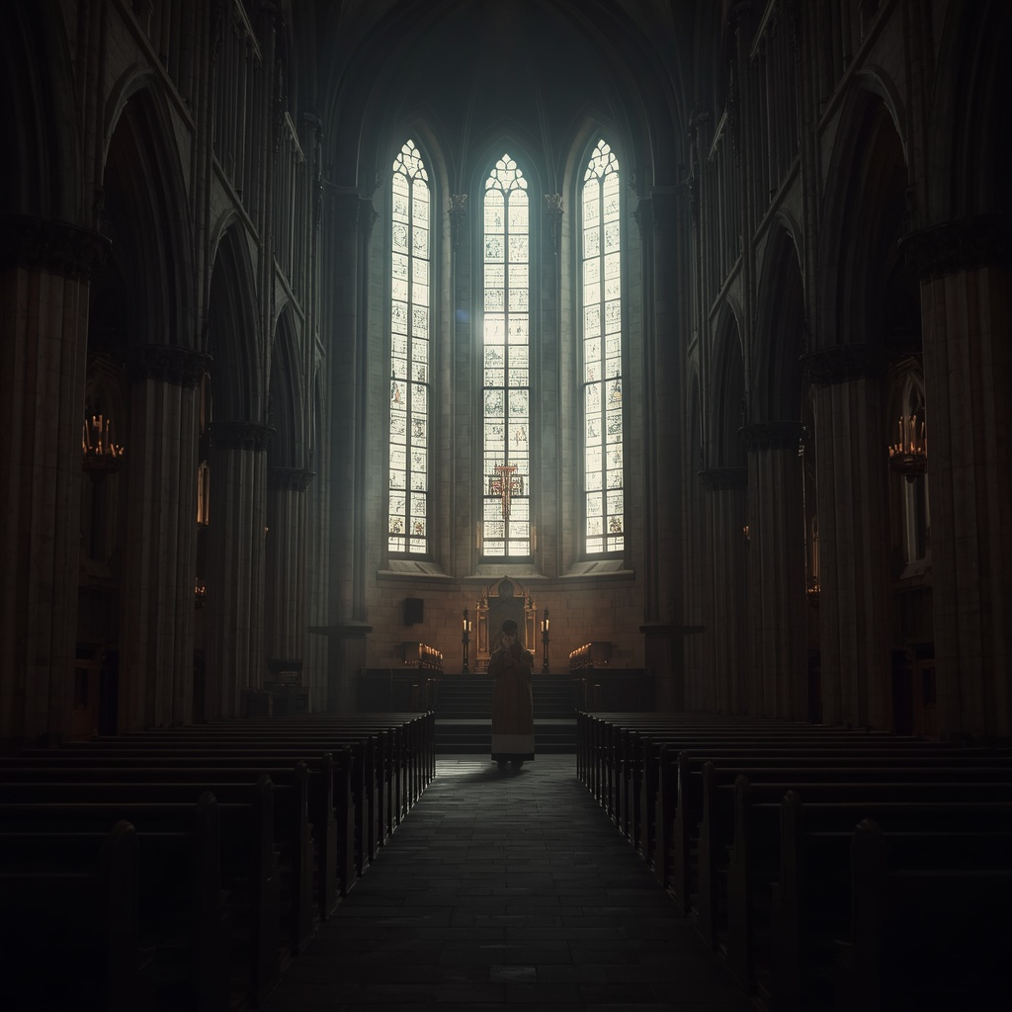

The recording arrived just after eight. It came in an ordinary evidence envelope.
No note.
No explanation.
Only a compact digital recorder sealed inside a clear evidence bag.
Rodney Weir set it carefully on Darrius' desk. "Uniform found at St. Peter's."
Darrius looked up. "Where?"
"Tucked beneath the kneeler inside the confessional."
His expression hardened. "It wasn't there yesterday."
"So either we missed it..."
Weir let the sentence trail off.
"...or somebody put it there afterward."
Neither possibility sat well.
Darrius carefully opened the evidence bag.
The recorder was inexpensive. Black plastic. Scratched from years of use.
Nothing remarkable.
Except where it had been found.
He turned it over once. No fingerprints were visible.
Carson appeared in the doorway.
"Don't worry."
"I've already photographed it."
"You can listen."
Darrius nodded. "Conference room."
Three minutes later the four of them sat around the long oak table.
Darrius. Weir. Carson. Chief Mahon.
The room was silent.
No one reached for coffee. No one spoke.
Darrius pressed PLAY.
Static. Soft breathing. Several seconds passed.
Then came an older woman's trembling voice.
Nancy Calloway.
"I've tried to make things right."
Silence.
"I've prayed every day."
Another pause.
"I've asked God's forgiveness."
A man's voice answered.
Calm. Measured. Almost gentle.
"You ask forgiveness."
"But have you accepted justice?"
The room remained perfectly still.
Nancy spoke again.
"I've done everything I could."
"No."
The man's reply came without anger.
"You've done everything you were willing to do."
Nancy began crying.
"I was young." "You were responsible." "I've regretted it every day."
"But you never confessed."
"I have." "Not the truth."
Silence.
Heavy.
Oppressive.
Then the man spoke again.
"So today...God sends judgment."
The recording ended with a dull impact.
Then nothing.
Absolute silence. Nobody moved. Nobody spoke.
The air inside the conference room felt heavier than before.
Chief Mahon slowly rubbed a hand across his face.
"Jesus..."
Carson stared at the recorder. "That's him."
No one argued.
Darrius reached forward and switched the recorder off.
His eyes never left it.
"He doesn't sound angry."
Weir looked over.
"What?"
"He isn't yelling." "He isn't emotional." "He isn't threatening."
Darrius leaned back. "He sounds convinced."
Mahon frowned. "Convinced of what?"
Darrius answered quietly. "That he's right."
The realization settled over the room like another body.
Most killers hid from guilt. This one appeared to embrace it.
Carson finally spoke.
"Did anyone identify the voice?"
"No."
"What about Nancy?"
"We'll have Audio run a comparison."
Darrius nodded absently.
He wasn't thinking about voices anymore.
He was thinking about words.
Justice. Confession. Judgment.
They weren't random.
They belonged together.
Like pieces of a language only one man seemed to speak fluently.
He opened his notebook. Instead of writing the killer's name...
He wrote three words.
Justice. Confession. Judgment.
Then he drew a circle around them.
Weir watched him. "You seeing something?"
Darrius kept writing.
"Maybe."
"What?"
He looked back toward the recorder. "Our killer isn't inventing this."
"What do you mean?"
"He didn't create this language."
Darrius slowly closed the notebook. "He inherited it."
Silence.
Mahon folded his arms. "You think somebody taught him."
Darrius nodded once. "I think someone taught him..."
His gaze settled on the motionless recorder.
"...to mistake judgment for mercy."
Outside the conference room, detectives hurried through the bullpen as
telephones rang and typewriters clattered.
Inside...the investigation had quietly become something else entirely.
Darrius looked once more at the recorder.
For the first time since Nancy Calloway's murder...
He believed they weren't hunting a man driven by revenge.
They were hunting a man driven by conviction.
And conviction...was infinitely more dangerous.
❦
Sunday morning arrived beneath a sky the color of worn steel.
Darrius sat alone in the last occupied pew of St. Michael's.
He wasn't there as a detective. Not entirely.
He had come because he needed to hear Father Thomas speak.
Not as a witness. Not as a grieving priest.
Simply...as a pastor.
The church was nearly full. Families filled the center pews.
Children whispered until quieted by patient parents.
Elderly couples knelt together in silent prayer.
Candles flickered beneath statues that had watched generations come and go.
Life continued. Even after murder. Especially after murder.
The choir's final hymn faded into silence as Father Thomas stepped behind the pulpit.
He looked older than he had only days earlier.
The lines around his eyes had deepened.
Grief did that. So did responsibility.
He rested both hands lightly on the worn wood before him.
For several moments, he simply looked across his congregation.
When he finally spoke, his voice carried easily through the sanctuary.
"There are moments," he began quietly, "when fear enters a place before
we realize we've invited it."
No one moved. "I know many of you are afraid."
He did not pretend otherwise. "I am too."
A murmur passed gently through the congregation.
Not surprise. Recognition.
"Fear asks us many questions."
He paused.
"It asks whether God has abandoned us." "It asks whether evil has won."
"It asks whether we should stop trusting one another."
Thomas looked slowly around the sanctuary.
"My answer..."
He smiled gently.
"...is No."
The single word settled over the room. "Because fear is loud."
"But faith has never depended on volume."
Darrius found himself leaning forward.
The priest wasn't preaching against a murderer.
He was preaching against despair.
"There will always be voices that promise justice through hatred."
"They have existed throughout history."
"They will exist long after we are gone." "But hatred has never healed a wound."
"It has only taught wounded people how to wound others."
Darrius felt something shift inside him.
Not understanding. Perspective.
Thomas continued. "Forgiveness does not erase truth." "It requires it."
"You cannot heal what you refuse to name."
"But neither can you heal by becoming the very thing that wounded you."
Silence filled the sanctuary. Even the restless children had stopped fidgeting.
Father Thomas's eyes drifted briefly toward the confessional.
Then back to his congregation.
"Some people believe confession exists to expose shame."
He slowly shook his head. "It does not."
"It exists to free us from carrying it alone."
Those words stayed with Darrius. Free us from carrying it alone.
He thought about Nancy. About Zachary. About the recording.
About the voice that spoke of judgment as though it were mercy.
It sounded nothing like the man standing before him.
Thomas closed his Bible.
"I cannot promise that evil will never enter these doors again."
A quiet stillness settled over the church. "But I can promise you this."
He looked across every pew. "Evil will never have the final word here."
His gaze lingered on the confessional. "Not while truth still has a voice."
The congregation rose together as the final hymn began.
Darrius remained seated for a moment longer.
He wasn't thinking about theology.
He was thinking about Brendan.
The killer had spoken about confession.
Father Thomas had spoken about confession.
They had used many of the same words.
Justice. Truth. Forgiveness. Sin.
Yet somehow...
they had been speaking two entirely different languages.
As the congregation slowly filed toward the exits, Darrius opened his notebook.
Beneath the words Justice, Confession, and Judgment, he wrote one more.
Mercy.
Then he drew two lines. One connected Mercy to Father Thomas.
The other connected Judgment to the unknown killer.
Between the two...He drew a question mark.
For the first time, Darrius realized this investigation wasn't simply about
identifying a murderer. It was about understanding a belief.
And beliefs… were far harder to arrest than people.

❦
The afternoon carried Darrius north to St. Augustine's.
Unlike the towering cathedrals that dominated Manhattan, St. Augustine's rested
quietly between rows of aging brownstones.
Its weathered brick façade showed decades of repairs, each one a testament to a
congregation that refused to abandon it.
There were no television cameras outside. No police barricades.
Only a handful of parishioners tended flower beds beneath the front windows.
If not for the murders, it would have seemed like any neighborhood church.
Darrius climbed the worn stone steps and pushed open the heavy oak door.
The sanctuary was nearly empty.
Sunlight poured through stained glass, painting long bands of crimson and
gold across the polished floor.
Somewhere near the altar, someone practiced quietly on the organ,
each note drifting upward into the vaulted ceiling before fading into silence.
An older priest knelt alone in the front pew.
He remained there for several moments after Darrius entered.
Not ignoring him. Finishing his prayer.
When he finally stood, he turned with a warm, tired smile.
"You must be Detective Blue."
Darrius extended his hand. "Father Ian McKay?"
The priest nodded. "I've been expecting you."
That answer caught Darrius slightly off guard.
"You have?"
Ian smiled gently.
"When detectives begin visiting churches, priests tend to hear about it."
Darrius couldn't help returning the smile. "I suppose that's fair."
Father Ian motioned toward a pair of wooden chairs near the side chapel.
"Walk with me."
They sat facing the sanctuary.
For a time, neither man spoke.
Ian seemed perfectly comfortable with the silence.
Eventually, Darrius broke it. "Father Thomas suggested I speak with you."
"I wondered when he might."
"He said you've served several parishes over the years."
"More than I care to count."
"And you've heard a great many confessions."
Ian's smile faded. "More than anyone should."
The answer lingered.
Darrius studied him carefully.
Father Ian wasn't evasive.
He wasn't guarded.
He seemed...worn.
"Can I ask you something?"
"You already are."
"What happens when someone confesses something you know will destroy lives?"
Ian folded his hands loosely in his lap.
"Which lives?" "The victim's?" "The offender's?" "The family's?"
"The community's?"
He looked back toward the sanctuary.
"The tragedy, Detective, is that sin rarely destroys only one life."
Darrius considered that.
Then asked the question that had been waiting since Father Thomas's sermon.
"What if someone confesses to murder?"
Ian was quiet for a long moment.
Finally, he answered.
"I pray."
"That's all?"
"I pray they surrender."
"And if they don't?"
Ian's eyes settled on the crucifix above the altar.
"Then I carry something I wish I didn't know."
Darrius waited.
The priest continued. "There are burdens a person can put down."
He paused.
"And there are burdens that simply become part of who you are."
The detective watched him closely.
Ian didn't sound frightened. He sounded tired.
As though he had been carrying the weight of this secret for years.
Not this case. Something older. Something deeper.
Darrius made a mental note but didn't press.
Some silences had to be earned.
Instead, he asked a different question. "Do you think evil changes?"
Ian looked at him with quiet curiosity.
"What do you mean?"
"The methods." "The motives." "The people."
The priest thought for a moment. "I think pain changes clothes."
Darrius frowned slightly.
Ian continued. "Every generation believes it has discovered a new kind of darkness."
"It hasn't." "It has only given the old darkness a different name."
The words settled over the sanctuary.
Darrius wrote them down.
Pain changes clothes.
He had never heard it expressed that way.
Yet somehow it felt true.
"You've seen something like this before," Darrius said quietly.
It wasn't really a question.
Father Ian's eyes met his.
For the first time since they had spoken, genuine sorrow crossed his face.
"I've seen what happens when wounded people stop believing healing is possible."
He looked toward the confessional near the rear of the church.
"And I've seen what happens when they decide judgment is easier than mercy."
There it was again.
Mercy.
The same word Father Thomas had used.
The same word missing from the killer's vocabulary.
Darrius closed his notebook.
"I appreciate your time."
Ian stood with him.
As they walked toward the front doors, the priest spoke once more.
"Detective."
Darrius turned.
"Don't spend so much time studying death..."
"...that you forget why people fight to stay alive."
The detective nodded slowly. "I'll try."
Father Ian smiled. "I know."
Outside, the late afternoon sun hung low over the city.
Darrius paused on the church steps before walking toward his car.
He looked back once.
Father Ian still stood in the doorway.
Watching. Not with fear. With concern.
For reasons Darrius couldn't yet explain, that worried him more than anything
the priest had said. Because concern came from experience.
And experience...was rarely wrong.

❦
The rain returned just before dusk. Not enough to empty the sidewalks.
Just enough to make everyone walk a little faster.
Darrius found Mitch Cayden exactly where Father Donnelly said he would be.
The small parish hall beside St. Peter's had opened its doors for the weekly
community supper.
Volunteers moved between folding tables carrying steaming
bowls of soup while quiet conversations drifted through the room.
At the far corner, Mitch sat alone.
A cup of untouched coffee rested in front of him.
He wasn't eating. He wasn't reading. He was watching the door.
Always the door.
Darrius picked up a second cup of coffee and walked over.
"Mind if I join you?"
Mitch looked up.
Recognition flashed across his face almost immediately.
"The detective."
Darrius nodded. "Mind?"
Mitch gestured toward the empty chair. "I figured you'd find me eventually."
Darrius sat.
For several moments, neither man spoke.
The silence wasn't uncomfortable. It was cautious.
Finally Mitch broke it.
"Another one."
It wasn't a question.
"No."
Darrius answered quietly.
"A second one."
Mitch stared into his coffee. "I knew."
That answer caught Darrius's attention.
"You knew?"
"I knew there'd be another."
"How?"
Mitch shrugged without looking up. "People like him don't stop."
Darrius leaned back. "People like who?"
Mitch finally met his eyes.
"The ones who think they're saving people."
The words settled between them. Darrius didn't interrupt.
He had learned years ago that the first answer was rarely the real one.
"What makes you say that?"
Mitch rubbed both hands together slowly.
"I've seen that look before."
"What look?"
"The calm."
He glanced toward the church across the street. "They're never angry."
"They're certain."
Darrius felt the hairs rise slightly on the back of his neck.
The same conclusion he'd reached after listening to the recording.
Certain. Not enraged. Convinced.
"Did you know Zachary?"
Mitch nodded.
"A little."
"And Nancy?"
"She brought blankets every winter."
His voice softened. "She remembered people's names."
The detective waited.
"She didn't deserve that."
"No."
Mitch looked out the rain-speckled window.
"Nobody does."
For the first time, Darrius noticed Mitch's hands.
They trembled almost imperceptibly.
Not from age. Not from the cold. From memory.
"You've been hurt."
The words came quietly.
Mitch didn't answer.
"You don't have to tell me how."
Still nothing.
"You don't even have to tell me who."
Silence.
Long enough that Darrius thought the conversation had ended.
Then Mitch whispered,
"Some things happened so long ago....people stop believing they happened."
Darrius felt the weight of the sentence immediately.
Not because of what Mitch said.
Because of how he said it.
Without anger. Without bitterness. Only exhaustion.
He opened his notebook.
"What happened to you, Mitch?"
Mitch looked down at the table. "I don't remember everything."
A lie. Small. Protective.
Darrius recognized it instantly.
Most people lied with their mouths.
Mitch was lying with his eyes.
Not to deceive. To survive.
Darrius closed the notebook.
He changed direction. "When you sit in church..."
He nodded toward the sanctuary.
"...why do you always watch the door?"
Mitch answered before he realized he had. "So I know who's coming."
The words escaped him. His face changed immediately afterward.
Regret. He hadn't meant to say that. Darrius remained perfectly still.
"Who are you expecting?"
Mitch slowly shook his head. "I don't know."
"You must." Another shake.
"I only know..."
He looked toward the church again.
"...that sometimes the past walks back in."
Outside, thunder rolled somewhere over the city. Neither man spoke.
Volunteers laughed quietly across the room as they stacked empty bowls
and folded chairs. Life continued around them. Ordinary. Unaware.
Darrius studied Mitch carefully. He wasn't looking at a witness.
He was looking at someone who had spent years living beside a fear
no one else could see.
As Darrius stood to leave, Mitch spoke one final time.
"Detective."
Darrius turned.
"If you find him..."
He hesitated.
"...don't let him convince you."
Darrius frowned. "Convince me of what?"
Mitch's eyes drifted toward the church windows.
"That he's a good man."
The room suddenly felt colder.
Darrius gave a slight nod. "I won't."
But as he walked back into the rain, he couldn't shake the feeling that Mitch hadn't
been warning him about a killer. He had been warning him about an idea.
And ideas...had a way of surviving long after the people who created them were gone.
❦
The Audio Forensics Lab occupied the quietest corner of Police Headquarters.
Unlike Homicide, where phones rang without pause and detectives argued over
timelines and evidence, the lab operated in near silence. Computer monitors glowed
softly in darkened rooms while technicians worked beneath headphones, listening for
sounds most people would never notice. Darrius found Lily Clyne leaning over a
waveform that stretched across three monitors.
She didn't look up immediately. She raised one finger.
"Give me thirty seconds."
Darrius waited.
The room remained silent except for the faint hum of processors rendering audio.
Finally Lily removed one earcup. "You brought me a ghost."
Darrius smiled faintly. "I was hoping for a killer."
"So was I."
She gestured toward the chair beside her workstation. "Sit."
He did.
Lily replayed the recording.
Nancy's trembling voice filled the speakers once more.
The calm reply. The measured words.
Judgment. Confession. Justice.
Then silence.
She stopped the playback.
"That's what everyone hears."
She tapped the keyboard.
"But recordings don't only capture voices."
The waveform expanded until individual frequencies filled the screen.
She isolated a narrow band beneath the spoken dialogue.
Static. A low hum. Then...something else.
Water. Soft. Rhythmic.
Almost too faint to recognize.
Darrius leaned forward. "A fountain?"
Lily shook her head.
"No."
"A pipe?"
"No."
She replayed the sound.
This time slowing it nearly to half speed.
The gentle rhythm became unmistakable.
Water striking stone.
Again. Again. Again.
Darrius listened without speaking. "What do you hear?"
Lily asked.
He closed his eyes.
Not a machine. Not plumbing. Not rain.
"It echoes."
She smiled.
"Exactly."
She opened another window containing spectral analysis.
"The acoustics tell us something."
"What?"
"The room wasn't silent."
"It only sounded that way."
She pointed toward the display.
"Large enclosed space." "Stone walls." "Natural reverb." "And water nearby."
Darrius stared at the screen. "How nearby?"
Lily shrugged. "Close enough to record."
His mind began assembling possibilities.
Church basement. Underground chamber. Old cistern.
None of them fit. Not yet.
"Can you tell what kind of water?"
She laughed softly. "I wish."
He nodded. "Fair."
Lily removed the headphones and looked at him more seriously.
"There's something else."
She isolated another section.
This time she amplified the final three seconds after the impact that ended Nancy's recording.
Nothing.
Then...a faint metallic sound. Almost hidden beneath the silence.
Darrius frowned. "What was that?"
"I don't know."
She replayed it several times.
The sound remained.
Brief. Sharp. Metal striking metal. Not accidental. Rhythmic.
Almost ceremonial.
Darrius listened again.
Something stirred at the edge of memory.
Church bells? No.
Keys? No.
Chain? Maybe.
Not enough.
Not yet.
Lily saved the enhanced files. "I'll keep working."
"You think there's more?"
"There always is."
She smiled.
"People think silence is empty."
"It isn't."
"It's full of things nobody thought to hear."
Darrius looked back at the frozen waveform.
A murder. A confession. A hidden sound beneath both. Layers.
Every answer seemed to contain another question.
He stood.
"Lily."
She looked up.
"Good work."
She shrugged modestly. "I just listen."
"No."
Darrius smiled. "You hear."
The distinction mattered.
As he reached the door, Lily spoke again.
"Detective."
He turned.
"If that water is natural..."
She hesitated.
"...it probably isn't inside the church."
"What do you mean?"
"It sounds older."
He raised an eyebrow. "Older?"
"The echo."
She searched for the right words.
"It doesn't sound like water running through pipes."
"It sounds like water that's been there longer than the building."
Darrius stood perfectly still. Longer than the building.
The phrase echoed through his thoughts.
He thanked her and stepped into the hallway.
For the first genuine moment of hope he'd experienced in weeks...
He felt they had uncovered something real. Not enough to explain
the murders. But enough to prove the killer hadn't spoken in an ordinary room.
Somewhere...
beneath the words...
beneath the confession...
beneath the silence itself… water was waiting.
And where there was hidden water...there were hidden places.

❦
Night settled quietly over Manhattan. Most of the detectives had gone home.
The Homicide bullpen, so loud only hours earlier, had surrendered to the low hum of
fluorescent lights and the occasional ringing telephone from another division.
Darrius remained alone.
The evidence board had grown crowded.
Nancy Calloway. Zachary Lyle. Two churches. Two confessional booths.
Two poems. One digital recording. One hidden sound of water. Photographs.
Maps. Church directories. Volunteer records. Prayer rope fibers.
Everything pinned together. Everything refusing to explain itself.
He stood several feet away from the board. Not reading it. Studying it.
Detectives often made the mistake of looking harder.
Darrius had learned long ago that sometimes the answer appeared only after
stepping back. Rodney Weir walked in carrying two cups of coffee.
"I had a feeling you'd still be here."
Darrius accepted one. "You know me too well."
"I know your wife deserves hazard pay."
A faint smile crossed Darrius's face.
"She'd agree with you."
Weir looked toward the evidence board.
"So..."
"What are we missing?"
Darrius didn't answer immediately.
Instead, he picked up a marker.
Across the top of the board, above every photograph and every note,
he wrote a single word.
BELIEF
Weir watched quietly.
Darrius drew a line beneath it.
Then another word.
METHOD
Another line.
MURDER
He stepped back. "Most investigations begin here."
He tapped the bottom word. "Murder." "They work backward."
He moved upward. "Method."
Finally..."Belief."
He looked at Weir. "I think we're doing the opposite."
Weir studied the board. "You think belief came first."
"I know it did."
"What makes you so sure?"
Darrius looked toward the recorder resting on his desk. "The voice."
"What about it?"
"He wasn't improvising." "He wasn't angry." "He wasn't excited." "He sounded..."
Darrius searched for the word. "...educated."
Weir frowned. "In religion?"
"In certainty."
Silence filled the room.
Darrius uncapped the marker again.
Beside BELIEF, he wrote three words. Justice Confession Judgment
Then, after a long pause...
He added a fourth. Mercy
He circled it separately.
Weir noticed. "You keep separating that one."
"Because he does."
"The killer?"
Darrius nodded. "He never talks about mercy."
"He talks about justice." "He talks about judgment." "He talks about confession."
"But mercy..."
He shook his head.
"...never appears."
The realization settled over both detectives.
The killer wasn't simply quoting religious language. He was selecting it.
Removing the parts that didn't fit his worldview.
Darrius stared at the board.
Somewhere...someone had taught this man Scripture.
Someone had taught him confession. Someone had taught him judgment.
But somewhere along the way...mercy had disappeared.
The office phone rang.
Neither detective moved.
It rang again.
Then stopped.
The silence that followed felt heavier than the sound itself.

Darrius gathered the photographs from his desk and placed them carefully
into a single file.
On the cover he wrote:
CONFESSIONAL
Not because that was the killer's name. Because that was his world.
As he slid the file into his briefcase, his eyes fell one last time upon Lily's audio report.
Water. Echo. Stone. Older than the building.
He couldn't explain why...but those four observations unsettled him more
than either murder. The killer had planned everything.
The notes. The victims. The locations.
If the recording had captured something beneath the church...
Then perhaps the crime scenes themselves were only the surface.
Weir picked up his jacket.
"Are you heading home?"
Darrius looked once more at the evidence board. "Yeah."
"Are you finally done?"
He switched off the desk lamp.
The room fell into shadow, leaving only the evidence board illuminated by the
hallway lights.
"No."
His voice was quiet. "I think we've just started."
The two detectives walked toward the elevator in silence.
Behind them, the photographs remained pinned to the board.
Nancy. Zachary. The poems. The recorder. The circles. The questions.
Waiting.
As the elevator doors closed, Darrius found himself thinking about Father Thomas.
Then Father Ian.
Two priests. Different parishes. Different lives.
Yet both had spoken about mercy as though it were the center of faith.
The man on the recording had spoken only of judgment.
Somewhere between those two ideas...a soul had gone terribly wrong.
Darrius stared at the descending floor numbers.
The killer hadn't invented his doctrine. He had inherited it.
And if beliefs could be inherited...perhaps they could be passed on.
The thought followed him all the way into the night.

Chapter Four

Shadows of the Past

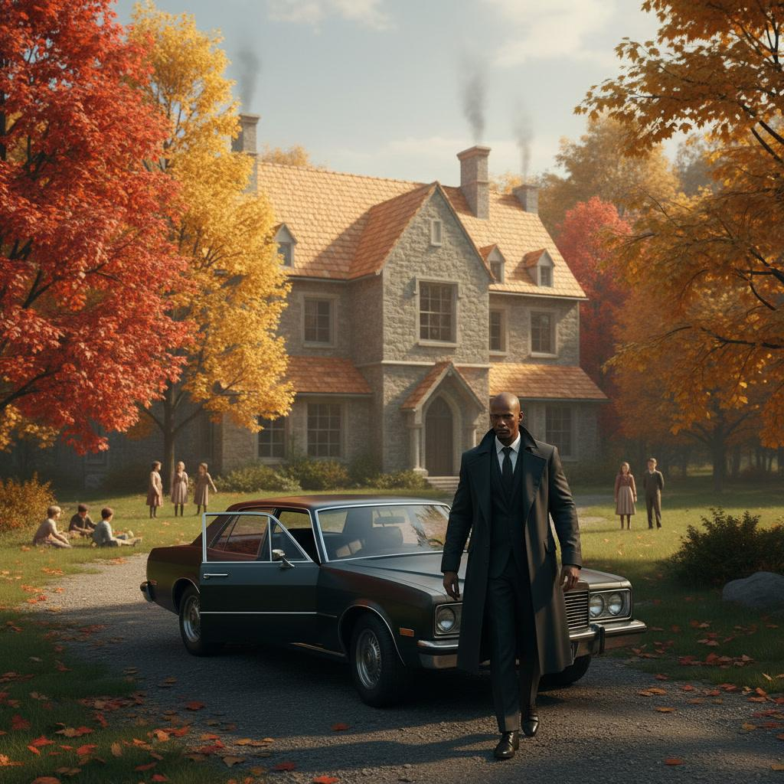

The city disappeared slowly.
Glass towers gave way to brick neighborhoods.
Brick neighborhoods surrendered to tree-lined highways.
Before long, even the traffic had thinned.
Detective Darrius Blue drove north with the windows cracked just enough to
let the cool October air push the smell of Manhattan from the car.
Rodney Weir sat in the passenger seat, a thick case file balanced across his knees.
Neither detective had spoken much during the drive.
Some investigations demanded conversation.
Others demanded silence. This was one of those.
The file on Nancy Calloway rested between them.
Folded inside was the receipt that had refused to leave Darrius' thoughts.
Blessed Hearts Home.
Twenty years of donations. Month after month. Year after year.
Too consistent to ignore.
Weir finally broke the silence. "You really think this is worth the drive?"
Darrius kept his eyes on the road. "I don't know."
"That's not like you."
"No."
"It isn't."
The detective smiled faintly. "I usually have a reason." "And today?"
"I've got a feeling."
Weir laughed softly.
"Chief Mahon loves it when you say that."
Darrius chuckled. "No."
"He tolerates it."
Outside, the road curved through dense stands of maple and oak already painted in
autumn reds and golds. Mist clung to the valleys below.
The farther north they traveled, the quieter the world became.
Almost peaceful. Almost.
Forty minutes later, a weathered wooden sign appeared beside the highway.
Blessed Hearts Home Founded 1948
The narrow driveway wound through towering pines before opening onto a broad hill
overlooking the Hudson Valley. The orphanage stood at its center.
Three stories of warm stone and red brick. Wide porches.
White-framed windows. Children's laughter drifted across the grounds.
Dozens of boys and girls played soccer beneath enormous oak trees while
volunteers supervised from nearby benches. The sight stopped Darrius for a moment.
Nothing about the place matched the darkness filling his evidence board.
It felt...alive.
Weir looked out the windshield. "I wasn't expecting this."
"Neither was I."
The detective parked beneath a large maple tree.
Neither man reached for the door immediately. They simply watched.
A little girl chased a soccer ball across the lawn.
Two boys argued cheerfully over the rules of an imaginary game.
Near the front porch, an elderly volunteer knelt to tie a child's untied shoe.
Ordinary. Simple. Good.
Darrius found himself smiling despite everything.
Weir noticed. "You thinking what I'm thinking?"
Darrius nodded. "If evil touched this place..."
His voice trailed off.
"It hid itself well."
As they stepped onto the gravel walkway, the front doors opened before either
detective reached them.
A woman in her late sixties emerged onto the porch.
Silver hair neatly pinned behind her head. Kind eyes. Strong posture.
She carried herself with the quiet confidence of someone who had spent a
lifetime solving other
people's problems before worrying about her own.
"You must be Detective Blue."
Darrius extended his hand.
"Mrs. Sabine Fitcher?"
She smiled warmly. "Please." "Sabine."
Her handshake was firm. Unhurried.
The sort that inspired trust immediately.
Beside him, Weir introduced himself.
Sabine welcomed both detectives inside.
The warmth of the building wrapped around them almost instantly.
Fresh bread. Coffee. Furniture polish.
Children's artwork covered the hallway walls.
Photographs lined the staircase. Graduation portraits. Birthday celebrations.
Holiday dinners. Generations of children smiling back from carefully
framed memories.
Darrius slowed his pace. He studied each photograph.
Not because he expected to recognize a face.
Because he wanted to understand the place.
Sabine noticed. "We try to remember every child."
Darrius looked toward her.
"You've been here a long time."
"Thirty-four years."
"That's remarkable."
She smiled. "It goes by faster than you'd think."
They entered a modest office overlooking the playground.
Sunlight streamed through wide windows, illuminating shelves filled with
scrapbooks, trophies and worn children's books.
Nothing about the room suggested secrecy. Only care.
Sabine offered coffee.
Both detectives accepted.
After everyone had settled, Darrius carefully removed Nancy Calloway's
photograph from his folder.
"I'm sorry to bring painful news."
Sabine looked at the photograph. Her expression changed immediately.
"Oh..."
She reached out gently, touching the edge of the picture. "Nancy."
"You knew her."
Sabine looked up.
"Knew her?"
A sad smile crossed her face. "Detective..."
"Nancy practically helped build this place."
Silence filled the office.
Darrius exchanged a quick glance with Weir.
That wasn't the answer either detective had expected.
Sabine continued quietly. "She volunteered here every Thursday."
"The children adored her." "So did we."
Darrius felt something shift inside him.
Nancy hadn't merely donated money. She had donated herself.
He opened his notebook.
"When did you meet her?"
Sabine folded her hands thoughtfully. "Many years ago."
"She always said this place reminded her..."
She paused.
"...that broken beginnings don't have to become broken lives."
The words lingered.
Darrius wrote them down exactly as she had spoken them.
Broken beginnings don't have to become broken lives.
He didn't know it yet.
But that sentence would follow him for the rest of the investigation.

❦
Sabine Fitcher led the detectives through the orphanage at an unhurried pace.
She greeted nearly every child by name.
"So, Michael...did you finish your science project?"
The boy grinned proudly. "I got an A."
"I knew you would."
Further down the hallway, she knelt beside a little girl struggling to tie her shoes.
"Try again."
The child frowned. "I can't."
Sabine smiled. "You can."
She waited.
Patiently.
The girl tried once more.
This time she succeeded. "There."
Sabine laughed softly. "I told you."
As they continued walking, Darrius found himself watching Sabine more
than the building itself. She wasn't simply running an orphanage.
She belonged here.
The children sensed it. Trusted it. Respected it.
One small boy darted down the hallway carrying a toy airplane.
He nearly collided with Darrius before stopping abruptly.
"Sorry, mister."
Darrius crouched to meet him at eye level. "No harm done."
The boy looked at the detective's badge.
"Are you a policeman?"
"I am."
The boy smiled. "My dad was too."
The words landed unexpectedly.
Darrius smiled back. "He must've been proud of you."
The child's smile faded. "He died."
Silence.
Before Darrius could answer, Sabine gently rested a hand on the boy's shoulder.
"Why don't you go see if lunch is ready?"
The boy nodded and hurried away.
Darrius watched him disappear around the corner.
"He lost both parents last year," Sabine said quietly.
"He still believes his father can hear him."
The detective said nothing.
There wasn't anything to say.
They entered a bright activity room overlooking the playground.
Paintings covered every wall. Paper leaves. Construction-paper animals.
Family portraits drawn with oversized crayons.
One bulletin board carried a title written in colorful letters.
Heroes
Beneath it hung photographs of teachers, firefighters, nurses, volunteers...
And one familiar face. Nancy Calloway.
Darrius stopped.
Sabine noticed immediately. "Nancy never wanted recognition."
She smiled at the photograph. "The children insisted."
The picture showed Nancy kneeling beside three young girls as they planted flowers
along a garden path. She wasn't looking at the camera. She was laughing.
Completely unaware the photograph had been taken.
Darrius studied it carefully.
It was the first time he'd seen Nancy alive. Not as evidence.
As a person.
"She came every Thursday?"
"Without fail."
"What did she do?"
Sabine laughed softly. "What didn't she do?"
She began counting on her fingers.
"Gardening." "Reading." "Homework." "Birthdays." "Christmas dinners."
"Fundraisers."
"If something needed doing..." "...Nancy quietly did it."
Rodney Weir looked around the room.
"Sounds like she left a hole."
Sabine's smile faded. "She did."
A young volunteer entered carrying a box of art supplies.
"Miss Fitcher?"
She looked up. "We're ready."
"I'll be there in a moment." The volunteer smiled politely at the detectives
before leaving. As the door closed, Sabine's expression became more serious.
"Detective..." "There is something else."
Darrius opened his notebook.
"Nancy occasionally asked about former residents."
His attention sharpened. "Former residents?"
Sabine nodded. "Not many." "Just a handful."
"What kind of questions?"
"Whether they'd finished school." "Found work." "Started families." "Stayed healthy."
"Did she mention names?"
Sabine walked to a nearby filing cabinet.
She hesitated before opening it. "I believe...there was one."
She carefully removed an old volunteer notebook.
Its pages had yellowed with age.
Dozens of entries filled the margins in Nancy's familiar handwriting.
Gardening schedules. Food deliveries. Fundraising ideas.
Then...one note stood alone near the bottom of a page.
Edward Dwight
Check on his son.
Darrius felt the room grow very still.
"Who's Edward Dwight?"
Sabine frowned thoughtfully. "He lived here."
"When?"
"Oh..."
She searched her memory. "Thirty years ago, perhaps."
"And his son?"
"I only met him once."
"What was his name?"
Sabine looked down at the notebook again.
The ink had faded.
"I..."
She shook her head slowly. "I can't remember."
Darrius copied the name carefully into his notebook.
Edward Dwight.
It meant nothing. Yet.
But experience had taught him never to ignore a name that survived three decades in
someone's memory. Especially Nancy Calloway's.
He closed the notebook.
Outside the window, children laughed as they chased a soccer ball across the lawn.
Inside...the first thread reaching into the past had finally appeared.
It had a name.
Edward Dwight. And somewhere beyond that forgotten name...
waited a boy whose story had not yet been told.

❦
Sabine closed Nancy's volunteer notebook with unexpected tenderness.
For several moments, neither detective spoke.
Outside the office window, children continued laughing across the playground.
Inside, the name Edward Dwight lingered between them.
Darrius finally broke the silence. "Do you still have records from that long ago?"
Sabine looked toward a hallway at the rear of the building. "Some."
"Not all?" She smiled apologetically.
"When you've been caring for children since the 1940s, paper has a way of
disappearing."
Weir chuckled. "I know the feeling."
"My basement agrees."
Sabine laughed softly.
The brief moment of humor eased the room before she stood.
"Come with me."
She led them through a narrow corridor that gradually changed with every step.
The bright classrooms disappeared.
The colorful artwork gave way to older photographs.
Wooden floors creaked beneath their feet.
The building itself seemed to age around them.
At the end of the hallway stood a heavy oak door marked simply:
ARCHIVES
Sabine unlocked it. The room beyond smelled faintly of cedar, dust, and old paper.
Metal shelving lined every wall.
Thousands of neatly labeled boxes stretched from floor to ceiling.
Handwritten dates. Family names. Adoption records. Medical files.
Nearly eighty years of lives preserved inside cardboard and ink.
Darrius paused just inside the doorway.
"This is incredible."
Sabine smiled.
"We've always believed every child deserves to be remembered."
She switched on another light.
The room brightened enough to reveal several large ledger books resting on a c
entral table.
"We digitized much of it."
She patted one of the ledgers. "But I still trust paper."
Darrius smiled. "So do I."
Sabine walked slowly along one shelf.
"Nineteen ninety..." "Nineteen eighty..." She continued farther.
"Nineteen seventy..."
Finally, she stopped. "There."
She carefully lifted a weathered storage box onto the table.
The label had faded with age.
Resident Files — 1983–1986
Darrius exchanged a glance with Weir. This was the right time period.
Sabine opened the box carefully.
Folders filled the interior. Each carried a child's name.
Some included photographs clipped to the front.
Others contained only handwritten labels.
She began searching methodically.
"Daniel Brooks..."
"No..."
"Emily Foster..."
"No..."
Her fingers stopped.
"There."
She withdrew a thin manila folder. Edward Dwight
Darrius immediately noticed its condition.
Unlike the surrounding files, this one had been opened countless times.
The edges were worn. The corners softened.
Someone had returned to it again and again over the years.
Sabine noticed his expression.
"Nancy asked for this file more than once." "When?"
"Over the years." "Not often." "But enough that I remember."
Darrius carefully opened the folder.
The first page contained the standard intake information.
Name: Edward James Dwight
Date admitted: March 12, 1984
Age: Fourteen
Reason: Protective placement.
Darrius frowned.
"Protective placement?"
Sabine nodded quietly.
"His mother died."
"And his father?"
She hesitated.
"Unknown."
Darrius continued reading.
School reports. Medical evaluations. Counseling summaries.
Most described Edward as quiet. Respectful. Intelligent.
Then one line caught his attention.
Frequently experiences nightmares.
Another.
Avoids enclosed spaces.
Then another.
Displays unusual fear of adult males in positions of authority.
Darrius looked up. "Who wrote these?"
"Our staff psychologist."
Sabine answered softly. "He struggled for a long time."
Weir leaned over the file. "No mention why?"
Sabine shook her head.
"Not in those years."
Darrius turned another page.
Near the back of the file rested a faded black-and-white photograph.
Edward stood alone outside the orphanage. Thin. Serious.
Dark hair falling across his forehead.
One hand shoved into his jacket pocket.
The other gripping a small wooden cross.
He couldn't have been older than fifteen.
There was no smile. Only watchfulness.
Darrius stared at the picture longer than he intended.
Not because Edward looked dangerous.
Because he looked...alone. Very alone.
Sabine spoke quietly.
"He was one of the children who always apologized."
"For what?"
"For everything."
She looked toward the window.
"Sometimes children who've been hurt begin believing the hurt was somehow
their fault."
Darrius felt the weight of those words settle inside him.
He looked back at Edward's photograph.
He had seen that expression before.
Not in children. In witnesses. In survivors.
People who carried shame that had never belonged to them.
He closed the file gently. "What happened to him?"
Sabine sighed. "I wish I knew."
"He left when he turned eighteen." "We lost contact."
She smiled sadly. "I always hoped he found peace."
The room fell silent.
Darrius slipped Edward's photograph back into the folder.
Then he noticed something tucked into the very back.
A folded piece of paper. Different from the intake forms.
Different from the counseling notes.
Older.
He unfolded it carefully. It wasn't a report.
It was a handwritten letter.
Never mailed. Never signed.
Only a single sentence had been written before the page ended.
If anyone ever believes me, maybe I can finally stop being afraid.
Darrius read the sentence twice.
Then a third time.
No one spoke.
Even Weir remained silent.
The room suddenly felt much smaller.
Outside, children's laughter drifted faintly through the open window.
Inside the archive...
All anyone could hear was the quiet rustle of a page that had waited more
than thirty years for someone to read it.
Darrius folded the letter with extraordinary care and placed it back inside
Edward Dwight's file.
For reasons he couldn't explain...It felt less like evidence.
And more like a confession.

❦
Sabine remained in the archive after Darrius closed Edward Dwight's file.
Neither detective hurried to leave. The silence felt earned.
Finally, Sabine gently slid the folder back into its box. "I remember him."
Darrius looked up. "You do?"
She nodded. "Not every detail." "But enough."
She rested both hands on the edge of the table.
"Edward was one of those children who apologized before anyone accused
him of anything."
Her voice carried no judgment.
Only sadness.
"If someone bumped into him...he apologized."
"If dinner was late...he apologized."
"If another child got into trouble...he apologized."
Weir frowned. "He blamed himself."
Sabine nodded. "Children often do."
She looked toward the rows of archive boxes.
"They believe adults." "They believe what they're told."
"They believe what they're shown."
Her eyes returned to Edward's file. "If a child is treated as though they're broken..."
"...they eventually stop arguing."
Darrius wrote the sentence into his notebook.
Not because it was evidence. Because it felt true.
"Did Nancy ever talk about Edward?"
Sabine smiled faintly. "Only once."
"What did she say?"
"She said he reminded her why this place existed."
Darrius waited.
Sabine folded her hands.
"There are children who arrive here believing the worst thing that ever happened
to them is the most important thing about them."
She paused. "Our job is to convince them they're wrong."
The room fell silent again.
Outside, the laughter of children drifted through the open window.
Sabine smiled toward the sound. "Listen."
Neither detective spoke.
"They're loud."
She laughed softly. "They're supposed to be."
She looked back at Darrius.
"When children feel safe...they make noise."
Her expression slowly changed.
"When they stop making noise...that's when I worry."
Darrius felt something tighten inside him.
He thought about Mitch Cayden.
The way he watched every doorway. The way he measured every room.
The way silence had become his language.
Sabine noticed his expression.
"You've met someone like Edward."
It wasn't a question.
Darrius answered honestly. "I think I have."
She nodded knowingly.
"They're easier to recognize once you've met one."
Weir leaned against one of the archive shelves.
"Did Edward ever get better?"
Sabine smiled. "For a while."
The answer surprised both detectives.
"He made friends." "He started drawing." "He laughed more."
"He even joined the baseball team one summer."
Her smile faded. "Then something changed."
Darrius immediately looked up.
"What?"
"I don't know."
"You didn't ask?"
"I did."
"He wouldn't tell me."
She looked toward Edward's photograph again.
"He became quieter." "Stopped drawing." "Stopped playing."
"Started spending more time alone."
She sighed. "It was as though someone had convinced him hope was dangerous."
The words landed hard.
Darrius looked down at the photograph once more.
The young boy holding the small wooden cross.
Watching the world instead of living in it.
"You never found out why?"
Sabine slowly shook her head. "No."
She looked directly at Darrius. "But I've wondered about it for thirty years."
Another silence settled over the archive.
Finally Darrius asked the question that had been waiting since he arrived.
"Do you believe people are born evil?"
Sabine didn't answer immediately.
Instead, she walked to the window overlooking the playground.
Children raced across the grass below. One little girl stumbled.
Another immediately helped her back to her feet.
Sabine smiled. "No."
She turned back toward him.
"I believe people are born needing love."
"And when they don't receive it..."
She hesitated.
"...they spend the rest of their lives trying to explain why."
Darrius stared at her.
It was one of the simplest things anyone had said to him since Nancy Calloway's murder.
It was also one of the most profound.
He wrote it down without changing a word.
Weir quietly cleared his throat.
"You've seen a lot of children leave this place."
Sabine nodded. "Hundreds."
"And most of them?"
She smiled. "They become wonderful adults."
"Teachers." "Nurses." "Mechanics." "Parents." "Police officers."
She looked at Darrius with a knowing smile.
"Some even become detectives."
He laughed quietly.
"So trauma isn't destiny." Sabine's expression grew serious again.
"No."
"It never has been."
She glanced one final time toward Edward Dwight's file.
"But healing..."
She spoke almost to herself.
"...requires someone willing to believe you before you're ready to believe yourself."
Those words settled over the room like a prayer.
Darrius closed his notebook.
He had come looking for evidence.
Instead...he was leaving with something else. Perspective.
As the detectives followed Sabine back toward the hallway, children's laughter
greeted them once again. The sound echoed through the old building.
Bright.
Carefree.
Alive.
Darrius paused at the doorway and looked back into the archive.
Thousands of files. Thousands of stories. Most ended quietly.
Some ended beautifully.
A few...were still waiting for someone to finish reading them.
Edward Dwight's story was one of those.
And for the first time...
Darrius suspected it might hold the answer to everything.

❦
As Sabine escorted the detectives back toward the front hallway, she slowed near a
narrow office tucked beneath the main staircase. The door stood open.
Inside, an elderly man sat surrounded by stacks of ledgers, photographs,
and filing boxes.
Thick reading glasses rested low on his nose as he carefully repaired the
spine of a weathered record book with surprising precision.
Without looking up, he spoke. "You found Edward."
Darrius stopped. "So you've been listening."
The man smiled. "Old buildings carry sound."
He finally looked up.
"And old archivists learn to pay attention."
Sabine laughed softly.
"Patrick Joel has been keeping our records longer than I've been director."
Patrick extended a hand.
"Retired schoolteacher." "Volunteer historian." "And occasional pest."
Darrius shook his hand. "Detective Darrius Blue."
"I know."
Patrick nodded toward the folders tucked beneath Darrius's arm.
"Those files haven't been opened in years."
"They deserve better."
The remark struck Darrius.
Patrick motioned toward two empty chairs.
"Sit."
"I think there's something you should see."
Darrius and Weir exchanged a glance before taking their seats.
Patrick carefully opened one of the thick leather-bound ledgers resting on his desk.
Its pages had yellowed with age.
Names filled every line in meticulous handwriting.
Residents. Volunteers. Visitors. Donors.
Every life that had passed through Blessed Hearts Home had left some
trace within these books.
Patrick turned several pages before stopping. "There."
His finger rested on Edward Dwight's name.
The entries began routinely.
School attendance. Medical appointments. Counseling sessions.
Then the handwriting changed. Smaller. More deliberate.
Patrick noticed Darrius studying it.
"That's mine."
"You wrote these?"
"I started helping with the archives in 1985."
Patrick adjusted his glasses. "I liked making sure no child disappeared into
paperwork."
Darrius read the next few entries.
Excellent student.
Gifted artist.
Enjoys baseball.
Then...the notes became shorter.
Withdrawn.
Nightmares increasing.
Avoids chapel.
Darrius looked up. "Avoids chapel?"
Patrick nodded slowly. "It wasn't like him."
"Did anyone ever find out why?"
Patrick hesitated.
"No."
"But..."
He tapped the page gently.
"I remember asking."
"What did he say?"
Patrick's expression clouded. "He told me..."
The old man searched his memory.
"...that some rooms remembered things people wanted to forget."
Silence settled over the office.
Weir looked toward Darrius.
Neither detective spoke.
Patrick continued quietly. "I didn't understand him then."
"I'm not sure I do now."
Darrius glanced back at the ledger.
The next entry caught his attention.
Transferred to St. Michael's Youth Outreach Program.
He frowned.
"St. Michael's?"
Patrick nodded.
"They sponsored several teenagers aging out of the home."
"When?"
"Summer of nineteen eighty-eight."
Darrius's mind immediately connected the pieces.
St. Michael's.
Edward Dwight.
Years before Nancy Calloway's murder.
Years before Brendan. Years before everything.
He wrote the date into his notebook.
Patrick reached into the back pocket of the ledger and removed a faded
newspaper clipping.
"I almost forgot." He handed it across the desk.
The article showed a group of teenagers standing outside St. Michael's
after completing a community service project.
Father Thomas wasn't there.
The article predated his assignment.
But another priest stood smiling beside the group.
The caption had faded. Only part of the name remained.
...Grealish
Darrius looked up sharply.
"Father Grealish?"
Patrick nodded.
"I believe so."
"He worked closely with several of our older boys."
The room grew very still.
Darrius studied the photograph.
Edward Dwight stood near the back of the group.
Hands folded. Eyes lowered. Almost hidden.
Patrick sighed. "I always wished someone had taken another picture."
"Why?"
"Because every child deserves at least one photograph where they're smiling."
The words lingered in the quiet office.
Darrius carefully returned the clipping.
He looked once more at Edward's face.
Still solemn. Still guarded. Still carrying something no one else seemed able to see.
As the detectives rose to leave, Patrick spoke one final time.
"Detective."
Darrius turned.
"History rarely disappears."
He gently closed the ledger.
"It simply waits for someone patient enough to read it."
Outside the office, the sounds of children playing drifted through the hallway
once more. Bright. Hopeful. Alive.
Darrius tucked the copied notes into his case file.
For the first time since Nancy Calloway's murder...the investigation had reached
beyond the present. It now stretched backward through forgotten records,
faded photographs, and lives that history had nearly overlooked.
And at the center of that history…one name appeared again.
Father Grealish.
❦
The drive back to Manhattan was quieter than the journey north.
The late afternoon sun dipped behind the Catskill ridgeline, casting long
shadows across the Hudson River. Golden light shimmered on the water while
the first hints of evening settled over the valley.
Neither detective hurried to speak.
Edward Dwight's file rested on the center console between them.
It felt heavier than paper should.
Rodney Weir finally broke the silence.
"So..."
Darrius kept his eyes on the road.
"So."
"You've got that look again."
"What look?"
"The one that tells me you're already three steps ahead of the rest of us."
Darrius smiled faintly.
"I wish."
"You don't?"
He shook his head.
"No."
"I think I'm finally looking in the right direction."
Weir folded his arms.
"History."
Darrius nodded.
"History." The detective glanced briefly toward the file.
"Nancy wasn't looking forward."
"She was looking back."
"Edward Dwight." "Father Grealish." "St. Michael's."
He said each name slowly, as though testing how they fit together.
"They're connected." "We just don't know how."
The highway curved south.
The skyline of Manhattan slowly emerged on the horizon.
Familiar. Comforting. Yet somehow different. The city hadn't changed.
Darrius had.

❦
An hour later the evidence board looked different. The murders remained.
Nancy. Zachary. The poems. The recorder.
But now another section occupied the opposite wall.
A timeline.

Edward Dwight arrives at Blessed Hearts Home.

Transferred to St. Michael's Youth Outreach.
Father Grealish.
Question mark.
Darrius stood before the board. Marker in hand.
He drew a line connecting Edward's name to Father Grealish.
Another line connected Grealish to St. Michael's.
Then he stopped.
Nothing yet connected Grealish to Nancy. Or Zachary. Or the murders.
Not with evidence. Only instinct.
Chief Mahon stepped into the room carrying a folder.
"I heard you found something."
Darrius nodded.
"I think we found where the story begins."
Mahon studied the new timeline.
"You've moved backward."
"I had to."
"Why?"
Darrius looked at the Chief.
"Because our killer already knows how the story ends."
Mahon remained silent for several seconds.
Finally he nodded once.
"What do you need?"
"Everything." "Personnel files." "Assignments." "Transfers." "Complaints."
"Diocesan records." "Anything connected to Father Grealish."
Mahon didn't hesitate.
"You'll have it."
He turned toward the door, then paused.
"Blue."
Darrius looked up.
"If Grealish has been dead for years..."
"...be careful not to chase ghosts."
The Chief left before Darrius could answer.
The room grew quiet again.
Darrius looked back at the board.
Ghosts.
Maybe.
Or maybe ghosts were simply victims history had forgotten.

❦
Across town, Mitch Cayden sat alone in the last pew of St. Peter's.
The church was empty. Evening Mass had ended nearly an hour earlier.
Only the sanctuary lamp still burned.
Mitch watched the front doors. The way he always did.
A volunteer passed through the nave carrying folded hymnals.
"Good night, Mitch."
He smiled politely. "You too."
The volunteer left. Silence returned.
Mitch's eyes never left the entrance.
After several minutes, he finally stood.
His hands trembled slightly as he reached for his coat.
Not from age. Not from illness. From memory.
He looked toward the confessional. His breathing slowed.
Then...very quietly...he whispered,
"Not again." No one answered. No one had heard him.
Outside, the wind stirred fallen leaves across the church steps.
Mitch remained motionless.
Watching. Waiting. Remembering.
Some wounds never truly healed. They simply learned how to hide.

❦
Back at Homicide, Darrius closed Edward Dwight's file.
He looked once more at the faded newspaper photograph.
Edward. Father Grealish. The youth group.
A single frozen moment.
He couldn't explain why...but something about the priest's smile unsettled him.
Not because it appeared sinister. Because it appeared ordinary.
History had taught Darrius that evil rarely introduced itself looking like evil.
It usually arrived looking trustworthy.
He pinned the newspaper clipping to the evidence board.
Then, beneath Father Grealish's name, he wrote one final question.
What happened?
The words seemed almost inadequate.
Yet they represented the first honest question the investigation had asked in days.
Not who killed Nancy. Not who killed Zachary.
But what had happened years earlier that still echoed through two murdered lives?
Darrius switched off the office lights.
Only the evidence board remained illuminated by the glow spilling in from the
hallway. Nancy. Zachary. Edward. Grealish.
Four names. One story.
Somewhere inside those forgotten years...the truth had been waiting.
Patiently. Silently.
Like an unanswered confession.

Chapter Five

The Killer's Message

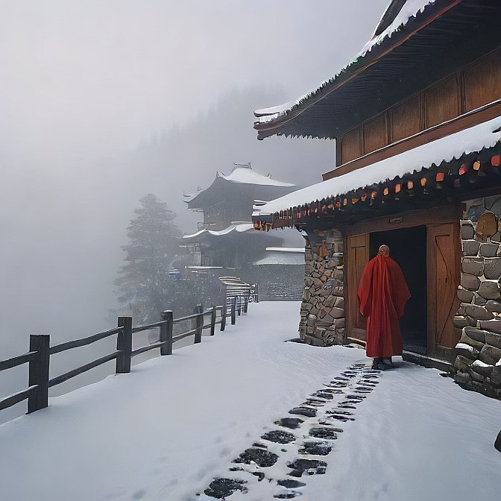

Monday arrived gray and cold.
Low clouds pressed against the Manhattan skyline, threatening rain without
delivering it. The city moved with its usual urgency, but inside Homicide,
the investigation had settled into a different rhythm.
The excitement surrounding the second murder had faded.
Now comes the harder work.
Finding answers no one had been looking for.
Darrius Blue stood before the evidence board with a fresh cup of
coffee growing cold in his hand.
The murders still occupied the center.
Nancy Calloway. Zachary Lyle. The poems. The recording. The prayer rope fibers.
But the board had changed.
A second timeline now stretched across the opposite wall.
Edward Dwight. Blessed Hearts Home. St. Michael's Youth Outreach. Father Grealish.
Question marks outnumbered facts.
Rodney Weir walked in carrying three thick archive boxes.
"I think the Archdiocese is trying to bury us."
Darrius smiled. "That much paperwork?"
Weir dropped the boxes onto a conference table with a heavy thud.
"Personnel files." "Assignments." "Transfer requests." "Parish histories."
"Half the twentieth century."
Chief Mahon followed him into the room. "I called in a favor."
Darrius nodded appreciatively. "I owe you."
Mahon shrugged. "You can repay me by finding our killer."
The Chief rested a hand on one of the archive boxes.
"Just remember."
"Old records tell old stories."
"They don't always tell the truth."
Darrius looked at the faded cardboard labels.
"No."
"They tell us what people wanted preserved."
Mahon gave a slight smile.
"Exactly."
After the Chief left, Weir sliced open the first archive box.
Dust drifted into the air. "Smells like history."
Darrius reached inside and removed a thick personnel file.
The cover read: Father Michael Grealish Ordained: 1969
Assignments: St. Catherine's Holy Redeemer St. Michael's
Retired
Deceased
The detective opened the file carefully.
Inside were decades of evaluations. Community service awards.
Letters from parishioners. Youth outreach commendations.
One photograph showed Grealish coaching a church baseball team.
Another captured him serving meals at a homeless shelter.
Another...Blessing children during Vacation Bible School.
Weir looked over his shoulder.
"He doesn't exactly fit the profile."
Darrius didn't answer.
He continued reading.
Annual reviews described Grealish the same way.
Dedicated. Compassionate. Patient. Excellent with young people.
Nothing stood out.
Nothing except...how perfect it all seemed.
"No complaints?"
Weir asked.
Darrius flipped another page. "None."
"No disciplinary action?"
"No."
"No transfers under pressure?"
Darrius shook his head. "Nothing."
He closed the folder halfway.
"I don't trust perfect."
Weir laughed quietly. "I was wondering when you'd say that."
Darrius picked up one of the commendation letters.
It praised Grealish's work with troubled teenagers.
Especially those aging out of foster care.
Edward Dwight's face immediately came to mind.
The connection tightened.
Not evidence. Not yet.
But closer.
Across the room, Carson stepped through the doorway carrying another
evidence envelope.
"I've got something from the paper analysis."
Darrius motioned him inside.
"What did you find?"
Carson laid several photographs across the table.
Magnified images of the handwritten poems.
"The paper?"
Darrius asked.
"No."
"The folds."
He pointed to the crease pattern. "Every note was folded by hand."
"So?"
"So whoever folded them..."
He tapped the photographs.
"...did it exactly the same way."
Darrius studied the images. Perfect symmetry. Equal spacing. No variation.
Almost ritualistic.
"The killer practiced."
Carson nodded. "More than once."
Darrius looked back at Grealish's file.
At the folded notes.
Then Edward Dwight's photograph pinned to the evidence board.
History. Ritual. Preparation.
Somewhere...those three ideas overlapped.
He simply hadn't found the place yet.
Weir broke the silence. "What's your instinct?"
Darrius looked toward Father Grealish's smiling photograph.
"My instinct says we're asking the wrong question."
"What should we be asking?"
Darrius answered without hesitation.
"Not whether Father Grealish was a good man."
He closed the personnel file gently.
"But whether someone believed he wasn't."
The room fell silent.
Outside, detectives hurried through the bullpen, chasing fresh cases and new
deadlines.
Inside Homicide…
the past had quietly taken command of the present.
And for the first time...Father Michael Grealish no longer looked like a footnote.
He looked like the beginning of the story.
❦
By midmorning, the conference table had disappeared beneath decades of
diocesan records. Personnel evaluations. Assignment histories.
Transfer requests. Parish newsletters.
Boxes of neatly organized paper stretched across the room like pieces of a forgotten
life.
Darrius moved through them methodically.
Not reading every page.
Reading for patterns.
Rodney Weir looked over another personnel ledger. "I've got baptism records."
Darrius smiled faintly. "I'll trade you for retirement newsletters."
"No deal."
Carson wandered in carrying another cup of coffee.
"You guys still alive?"
"Barely."
Carson looked across the mountain of paperwork.
"I don't miss detective work."
"You never did."
"No."
"I liked dead people."
"They complained less."
Even Darrius laughed.
The moment lasted only seconds before everyone returned to work.
Silence settled over the room again.
Paper turned. Folders opened. Pens scratched across notebooks.
Then...
Darrius stopped. His fingers rested on the edge of a transfer record.
He read it twice.
Then a third time.
"Weir."
The sergeant looked up.
"What?"
"Come here."
Weir crossed the room.
Darrius slid the document toward him. "Read the assignments."
Weir scanned the page.
"St. Catherine's." "Holy Redeemer." "St. Michael's."
He frowned.
"So?"
"Look at the dates."
Weir read them again.
Then his expression changed.
"There's a gap."
Darrius nodded once.
Almost three years.
No parish assignment. No hospital ministry. No teaching post.
Nothing.
Only a blank space.
Three years missing from Father Grealish's official record.
Carson leaned closer.
"Maybe he took a sabbatical."
Darrius shook his head.
"Priests don't disappear from personnel files."
"No medical leave?" "Not listed." "No overseas mission?"
"No."
"No retirement?"
"He wasn't old enough."
The silence grew heavier.
Weir continued flipping through the file.
"There should be paperwork."
"There always is."
Darrius reached for another folder.
Nothing. Another. Nothing. The missing years remained missing.
Not redacted. Not classified.
Simply...gone.
Carson folded his arms. "You think somebody removed them?"
"I think somebody wanted us to believe nothing happened."
Darrius answered quietly.
"Those aren't the same thing."
He looked again at Grealish's evaluation history.
Every year before the gap was documented. Every year afterward was documented.
Only those three years had vanished.
Not a single memo. Not a single assignment. Not one signature.
As though Father Michael Grealish had ceased to exist.
Until he suddenly existed again.
Rodney reached into the bottom of the archive box.
"There's one more folder."
He handed it across.
The tab read: Supplemental Correspondence
Darrius opened it carefully.
Inside were loose letters. Thank-you notes. Holiday cards. Donation
acknowledgments. Most were routine.
Until one envelope caught his attention. It had never been opened.
No postage. No address.
Only Grealish's name written neatly across the front.
Inside rested a single sheet of paper.
Typed. Unsigned.
Some truths refuse to stay buried.
Nothing else. No date. No signature. No explanation.
Carson looked up.
"Threat?"
"Maybe."
Weir wasn't convinced.
"Or warning."
Darrius stared at the page.
It didn't feel like either.
It felt...unfinished.
As though whoever wrote it assumed Grealish would understand.
He carefully slipped the letter back into its envelope.
"What do we know?"
Weir answered automatically.
"We know Grealish worked with teenagers."
"We know Edward Dwight knew him."
"We know Nancy kept asking about Edward."
Carson added, "And we've got three missing years."
Darrius nodded.
"Good."
He walked back to the evidence board.
Beneath Father Grealish's name he drew a long horizontal line.
In the center...he left a blank space.
Three years.
Empty.
He circled it.
Not because it represented evidence.
Because it represented intention.
History forgets by accident.
Files disappear because someone makes a choice.
He stepped back and looked at the board.
Nancy. Zachary. Edward. Grealish. Three missing years.
The investigation no longer resembled a homicide.
It resembled an excavation.
Each layer removed exposed another beneath it.
None of them were clean. None of them were complete.
And somewhere under everything...the truth remained buried.
Waiting for someone stubborn enough to keep digging.

❦
The diocesan retirement residence overlooked the Hudson like an old monastery
refusing to surrender to time.
Stone walls. Narrow windows. Immaculate gardens.
The kind of place built for quiet reflection.
Father Henry Collins had lived there for nearly twelve years.
The receptionist led Darrius and Weir through a sunlit corridor lined
with photographs of priests spanning nearly a century.
Some smiled confidently.
Others looked exhausted.
Every face seemed to carry its own history.
She stopped outside a modest apartment. "He'll be expecting you."
A soft knock.
"Come in."
The room was simple.
A narrow bed.
Bookshelves filled with theology and history.
A worn leather chair beside the window.
Father Henry Collins rose slowly to greet them.
He was well into his eighties, his movements deliberate but steady.
His white hair framed a deeply lined face, and his pale blue eyes retained a
remarkable sharpness.
"You must be Detective Blue."
Darrius extended his hand. "Thank you for seeing us."
Henry smiled warmly.
"When detectives ask polite questions...old priests usually answer."
The remark earned a quiet laugh.
He motioned toward two chairs. "Please."
They sat.
For a few moments the conversation stayed comfortably ordinary.
The weather. The drive north. The beauty of the river below.
Only then did Darrius place Father Grealish's photograph on the small table
between them. Henry's smile faded.
Not dramatically.
Quietly.
He picked up the photograph. Studied it for several seconds.
"I haven't seen Michael's face in a long time."
"You knew him well?"
Henry nodded. "As well as anyone."
"What kind of man was he?"
The old priest leaned back. "That's not as simple a question as it sounds."
Darrius waited.
"Michael loved people."
"He especially loved young people."
"He believed everyone deserved another chance."
The detective listened carefully.
"So why does everyone hesitate before answering?"
Henry looked toward the window.
"Because memory isn't fair."
Silence.
"Sometimes one terrible event rewrites everything that came before it."
Darrius let the words settle.
"What happened?"
Henry didn't answer immediately.
Instead, he asked his own question.
"What have you already been told?"
"Almost nothing."
Henry smiled sadly. "Then perhaps that's for the best."
He folded his hands.
"Michael wasn't a perfect man."
"I've never met one."
"No."
"Neither have I."
The old priest looked back at the photograph. "But he cared deeply."
"Sometimes..." "...too deeply."
Darrius caught the phrasing.
"What do you mean?"
Henry sighed. "He carried other people's suffering as though it were his own."
"He couldn't leave it at the church."
"He took it home." "He prayed over it." "He lost sleep because of it."
His voice softened.
"There are burdens clergy aren't meant to carry alone."
The sentence lingered.
Darrius thought of Father Thomas.
Then Father Ian.
Both had spoken about burdens.
Now Henry used the same language.
Not rehearsed.
Shared.
"Did something happen during those missing years?"
Henry's eyes met Darrius's.
For the first time since the interview began...they filled with unmistakable sadness.
"I wasn't there."
"But you know something."
"I know..."
He paused.
"...that Michael returned a different man."
The room grew still.
"Different how?"
"He smiled less." "He spoke less." "He worked harder."
"As though he believed he could somehow make up for something."
Darrius leaned forward slightly.
"For what?"
Henry slowly shook his head.
"I never knew."
"Or perhaps..."
His gaze drifted back to the river.
"...I never wanted to know."
Neither detective interrupted.
Sometimes silence was kinder than another question.
After several moments Henry stood and crossed to a small wooden cabinet.
He unlocked the top drawer.
Inside rested a worn leather journal.
He carried it back carefully.
"I kept notes."
He opened it to a bookmarked page.
Not confessions. Not names. Just reflections.
His finger stopped midway down the page.
"I wrote this after Michael returned."
He read quietly.
There are days when a shepherd returns from searching for one lost sheep
carrying wounds no one else can see.
Henry closed the journal. "I never forgot writing that."
Darrius felt something shift.
Not because the sentence solved anything.
Because it described Grealish as wounded.
Not accused. Not condemned. Wounded.
That distinction mattered.
A great deal.
As the interview drew to a close, Darrius rose and thanked the elderly priest.
Henry walked them to the door.
Just before they stepped into the hallway, he spoke once more.
"Detective."
Darrius turned.
"If you're looking for monsters..."
He glanced once at Grealish's photograph.
"...be careful."
"Why?"
Henry's answer came almost as a whisper.
"Because sometimes you'll find broken men instead."
The apartment door closed gently behind them.
Neither detective spoke until they reached the parking lot.
Finally Weir exhaled.
"He didn't sound like he was protecting Grealish."
"No."
Darrius looked back toward the residence.
"He sounded like he was mourning him."
The detective stood silently for another moment.
He had expected another witness.
Instead...he had found someone carrying grief that had never quite found a
place to rest.
And somehow...that made Father Grealish even harder to understand.

❦
The interview room felt smaller than usual.
Gray walls. Metal table. Two chairs facing one another beneath a single
fluorescent light.
No windows.
Only a quiet ventilation fan humming overhead.
Mitch Cayden sat with both hands wrapped around a paper cup of coffee that had
long since gone cold. He hadn't taken a sip.
Darrius entered alone.
He deliberately left the case file outside.
Today wasn't about evidence. It was about trust.
He pulled out the opposite chair and sat without speaking.
For nearly a minute, silence filled the room.
Mitch finally looked up. "You came back."
"I said I would."
Another silence.
Darrius noticed Mitch's eyes drift briefly toward the closed door.
Always checking the exits. Always measuring the room.
Always preparing for something that never quite arrived.
"You've done this before."
Mitch frowned.
"What?"
"Waiting."
The older man looked down at the untouched coffee.
"I've spent most of my life waiting."
"For what?"
He gave a tired smile. "For someone to believe me."
The words settled heavily between them.
Darrius leaned forward only slightly. "I'm listening now."
Mitch nodded. "I know."
His breathing became slower. Deliberate.
As though every memory required permission before it surfaced.
"You asked me why I watch the doors."
"I remember."
"I don't watch the doors."
He corrected himself quietly.
"I watch the people coming through them."
Darrius remained silent.
"They always looked normal."
"Who?"
Mitch's fingers tightened around the paper cup. "The ones who smiled."
"The ones everybody trusted."
His breathing quickened.
"I used to think..."
He stopped.
His eyes unfocused.
Darrius waited.
No interruption. No pressure. Only patience.
"I used to think priests couldn't lie."
Silence.
"I was a kid." "I believed uniforms." "I believed collars." "I believed adults."
His voice cracked.
"I believed everybody except myself."
The room seemed to grow colder.
Darrius spoke softly.
"Did you know Edward Dwight?"
Mitch closed his eyes.
A long moment passed before he answered.
"Yes."
The single word barely rose above a whisper.
"You were friends?"
Another pause.
"As close as boys like us knew how to be."
Darrius let that settle. "What was he like?"
Mitch smiled sadly. "He drew."
"What did he draw?"
"Trees." "Churches." "Birds." "Places nobody could hurt you."
His smile disappeared.
"He stopped."
"When?"
"I don't remember."
A lie. Not malicious.
Protective.
Darrius saw it immediately.
Most people lied with their mouths.
Mitch was lying with his eyes.
Not because he wanted to deceive.
Because remembering the hurt.
Darrius changed direction.
"Did Edward ever talk about Father Grealish?"
The question hung in the room.
Mitch's fingers froze around the coffee cup.
His breathing stopped.
For one long heartbeat...he didn't move.
Then, almost mechanically, he whispered, "He trusted him."
Darrius felt something shift.
"He trusted Grealish?"
A slow nod.
"Everybody did."
Another silence.
Mitch's voice became distant.
Almost childlike.
"I remember one afternoon..."
He stared past Darrius.
"...we were playing baseball."
"The bell rang."
"Father Grealish called Edward over."
He swallowed hard.
"Edward looked happy."
The room was silent except for the ventilation fan.
"When did you see him again?"
Mitch blinked several times.
"I..."
His hands began trembling.
"I don't know."
"You do."
"I..."
He pressed both palms against his temples.
"I can't."
Darrius stayed calm. "You don't have to force it."
Mitch's breathing grew uneven.
"There was rain."
His eyes remained fixed somewhere far beyond the interview room.
"I remember the rain." "The chapel bell." "The smell of incense."
Then—
His face went pale.
"No."
He stood abruptly.
"No."
"Mitch—"
"No!"
The paper cup toppled, spilling cold coffee across the metal table.
"I can't go back there."
His voice broke completely.
"I won't."
Darrius rose slowly, keeping his hands visible. "No one's asking you to."
Mitch backed toward the corner of the room.
Breathing hard.
Eyes wide.
Not seeing the detective anymore.
Seeing something else. Somewhere else. Seconds passed.
Then his breathing gradually slowed.
The present returned.
He looked around the room as though waking from a nightmare.
"I'm sorry."
"You don't owe me an apology."
Mitch lowered his head. "I always apologize."
The sentence hit Darrius harder than anything else Mitch had said.
Edward apologized for everything.
Now Mitch did too.
Different men. Different lives. The same wound.
Darrius gently slid the untouched coffee back toward him.
"You helped today."
Mitch shook his head. "I remembered almost nothing."
"You remembered enough."
The older man looked up. "Do you believe me?"
Darrius answered without hesitation. "Yes."
For several seconds, Mitch simply stared at him.
Then something changed.
Not relief. Not peace. Recognition.
As though someone had finally spoken the words he'd been waiting decades to hear.
A tear slipped quietly down his cheek.
He wiped it away almost immediately. Embarrassed.
Darrius pretended not to notice.
Some moments belonged to the person living them.
As he reached the door, Mitch spoke one last time.
"Detective."
Darrius turned.
"If you find the truth..."
He struggled to finish the sentence.
"...don't bury it."
Darrius met his eyes. "I won't."
The door closed softly behind him.
Standing alone in the hallway, Darrius remained still for several moments.
The interview hadn't given him evidence.
It had given him something else.
A pattern.
Edward Dwight. Mitch Cayden. Two boys. Different lives.
The same instinct to apologize. The same fear. The same silence.
Whatever had happened years ago...it hadn't wounded only one child.
And for the first time...
Darrius began to wonder how many others had never found the courage
—or the chance—to tell their story.
❦
By the time Darrius returned to Blessed Hearts Home, twilight had settled over the
Hudson Valley. The playground stood empty. Swings moved gently in the evening
breeze.
Inside, the orphanage had grown quiet.
Dinner had ended. Homework had begun.
The familiar warmth of children's voices drifted through the hallways, softer now,
calmer than before. Patrick Joel looked up from his desk as Darrius entered.
"I had a feeling you'd be back."
Darrius smiled. "What gave me away?"
Patrick adjusted his glasses.
"You asked questions this morning."
"People who ask the right questions usually return."
Darrius removed his notebook.
"I need to know more about Father Grealish."
Patrick's expression became thoughtful.
"I suspected that would be your next stop."
Without another word, Patrick disappeared into the archive room.
He returned several moments later carrying a massive leather-bound register.
Unlike the personnel files, this book was worn from decades of use.
Its pages had darkened with age.
Its spine had been repaired more than once.
Patrick rested it gently on the table. "This isn't an official record."
"What is it?"
"My record."
Darrius raised an eyebrow.
Patrick smiled.
"When you've been around children for forty years, you start writing down the
things paperwork forgets."
He carefully opened the ledger.
Every page contained neat handwritten entries.
Not dates. Not statistics. Memories. Visitors. Conversations. Special events.
Children who struggled. Children who flourished.
The heartbeat of the orphanage.
Patrick turned slowly through the pages until he reached the summer of 1988.
"There."
His finger rested beside an entry written in blue fountain pen.
St. Michael's Youth Outreach Visit.
Darrius leaned closer.
The entry described Father Grealish bringing a group of teenagers to repaint
classrooms, repair playground equipment, and organize a picnic for the younger
children. Everything seemed ordinary.
Until the final paragraph.
Patrick read it aloud.
"Edward Dwight spent nearly the entire afternoon speaking privately with
Father Grealish beneath the old oak tree. Whatever they discussed left both of
them visibly emotional. Edward cried. Father Grealish prayed with him for a
long time before they returned to the others."
Silence settled over the room.
Darrius read the passage again.
"And that's all?"
Patrick nodded slowly. "I remember writing it."
"What happened afterward?"
Patrick looked out the window.
"Edward changed."
"How?"
"He seemed lighter."
"For a while."
The detective waited.
Patrick sighed.
"Then, a few months later..." "He stopped coming."
Darrius frowned. "To the orphanage?"
Patrick nodded.
"He wrote once."
"I never heard from him again."
The room fell silent.
Patrick turned another page.
Folded between the entries rested a faded Polaroid photograph.
He removed it carefully.
"There were only two copies."
One remained in the ledger.
The other had disappeared years earlier.
Darrius studied the image.
The old oak tree stood behind the orphanage.
Edward Dwight sat on a weathered bench.
Father Grealish sat beside him.
Neither man faced the camera. They were talking. Listening.
Sharing something private.
Nothing about the photograph appeared sinister.
If anything...it looked compassionate.
Patrick smiled sadly.
"I always liked that picture."
"Why?"
"Because Michael wasn't preaching." "He was listening."
The detective looked at the image for a long moment.
It challenged everything.
If Grealish had been hiding something...
Why did this photograph feel so genuine?
Patrick answered the question before Darrius asked it.
"People are rarely only one thing, Detective."
He gently folded his hands.
"They're capable of great kindness."
"And great failure."
"Sometimes in the very same season of life."
Darrius carefully placed the photograph beside Edward's file.
The investigation had become more complicated.
Not simpler.
Good.
Simple answers usually meant the wrong questions had been asked.
Patrick reached beneath the ledger one final time. "I almost forgot."
He withdrew a small envelope.
Its paper had yellowed with age.
The flap remained sealed.
"Nancy gave this to me fifteen years ago."
Darrius looked up. "Why didn't you mention it earlier?"
"Because she told me not to open it."
"And you listened."
Patrick smiled faintly. "I've spent my life keeping promises."
He handed the envelope to Darrius.
Across the front, in Nancy Calloway's unmistakable handwriting,
were just seven words.
If someone comes asking about Edward...
Nothing more.
The detective stared at the envelope.
His pulse quickened.
Patrick's voice dropped almost to a whisper.
"I always believed she expected this day."
Neither man spoke.
Darrius turned the envelope over in his hands but made no attempt to open it.
Not here. Not yet. Some truths deserved the right moment.
Patrick watched him carefully.
"You already know something, don't you?"
Darrius looked down at Nancy's handwriting.
"I know she spent twenty years protecting a story."
He slipped the envelope into an evidence sleeve.
"Now I need to find out why."
Outside, the wind stirred the branches of the old oak tree.
Its leaves whispered softly against one another.
The same tree where Edward Dwight and Father Grealish had once sat together.
The same tree that had silently witnessed a conversation no record could
fully preserve. History had left Darrius another clue.
Not an accusation. Not a confession. A promise.
And somewhere inside that sealed envelope...
Nancy Calloway had been waiting fifteen years to keep it.

❦
The drive back to Manhattan felt longer than usual.
Darkness had settled over the Hudson Valley, swallowing the last traces of daylight as
Darrius followed the ribbon of highway south.
The sealed envelope rested on the passenger seat.
Nancy Calloway's handwriting seemed almost alive beneath the dashboard lights.
If someone comes asking about Edward...
Nothing more.
Rodney Weir glanced toward it.
"You still aren't going to open it?"
Darrius kept his eyes on the road. "Not yet."
"You've had an evidence bag around it for almost an hour."
"I know."
"You think it'll change if you wait?"
Darrius smiled faintly.
"No."
"I think I will."
Weir leaned back. "You've always been more patient than me."
"No."
Darrius shook his head. "I've just learned that timing matters."
Silence settled between them.
Outside, the city lights slowly appeared on the horizon.

❦
Back at Homicide, the bullpen had nearly emptied.
Most detectives had gone home.
Cleaning crews moved quietly through the hallways.
Coffee machines had long since gone cold.
Darrius carried the envelope into the conference room alone.
He closed the door behind him.
The evidence board stood illuminated beneath a single overhead light.
Nancy. Zachary. Edward. Father Grealish. Mitch. Sabine. Patrick.
The story had grown. He laid the envelope carefully on the table.
For several moments, he simply looked at it.
Then...very carefully...he broke the seal.
Inside rested a single folded page. Nancy's handwriting filled both sides.
Neat. Patient. Unhurried.
She had expected whoever read it to take their time.
Darrius unfolded the letter.
If you are reading this...
...then someone has finally started asking the questions I prayed would never
need to be asked. Edward Dwight was one of the kindest boys I ever knew.
He carried more sorrow than any child should.
Not once did he speak about revenge.
Not once did he wish harm upon anyone.
He only wanted someone to believe him.
Darrius stopped reading.
The words struck him with unexpected force.
He continued.
I do not know everything that happened.
I only know that something changed after Edward left Blessed Hearts Home.
He returned once.
Only once.
He thanked us for loving him.
Then he said something I have never forgotten.
"Some people mistake silence for forgiveness."
After that...I never saw him again.
The letter ended with one final paragraph.
If you are investigating his story, promise me one thing.
Find the truth before you find someone to blame.
Those are not always the same thing.
—Nancy Calloway
Silence filled the room.
Darrius lowered the letter slowly.
His eyes remained fixed on Nancy's signature.
She hadn't left him evidence. She had left him wisdom.
He walked toward the evidence board.
Beneath Edward Dwight's photograph, he pinned a copy of the letter.
Then he uncapped a marker.
Instead of writing another name...he wrote a sentence.
Truth before blame.
He underlined it once.
Then stepped back.
The words changed the entire board.
Until now...every question had pointed toward a suspect.
Now...they pointed toward understanding.
The conference room door opened quietly.
Rodney Weir stepped inside. "You read it."
Darrius nodded.
"What do you think?"
Darrius looked once more at Father Grealish's photograph.
Then Edward's.
Finally Nancy's.
"I think Nancy spent twenty years trying to stop someone from telling the
wrong story."
Weir followed his gaze.
"You think we've been chasing the wrong man?"
"No."
Darrius answered thoughtfully.
"I think we've been asking the wrong question."
Silence settled again.
The detective picked up Edward's photograph.
The teenage boy still stared solemnly into the camera, gripping the small
wooden cross.
No smile. Only quiet watchfulness.
Darrius remembered Sabine's words.
Broken beginnings don't have to become broken lives.
Then Patrick's.
History rarely disappears. It simply waits for someone patient enough to read it.
Then Father Henry's.
Sometimes you'll find broken men instead.
None of those voices spoke about guilt.
They spoke about pain.
Somewhere...
between pain...and judgment something had happened.
Something capable of changing a frightened boy...
into the father Brendan Dwight would one day remember.
Darrius switched off the conference room light.
Only the evidence board remained visible.
The photographs glowed softly in the spill of light from the hallway.
Nancy. Zachary. Edward. Father Grealish.
One murder investigation had become something far older.
Far deeper. Far more dangerous.
Darrius stood in the doorway for one last moment.
Quietly, almost to himself, he said,
"Everyone keeps telling me the same thing."
Weir looked over. "What?"
Darrius never took his eyes off the board.
"They're telling me to understand..."
"...before I judge."
He closed the door behind him.
Inside the darkened room, the evidence board remained. Waiting.
Like an unfinished confession.

Chapter Six

The Third Murder

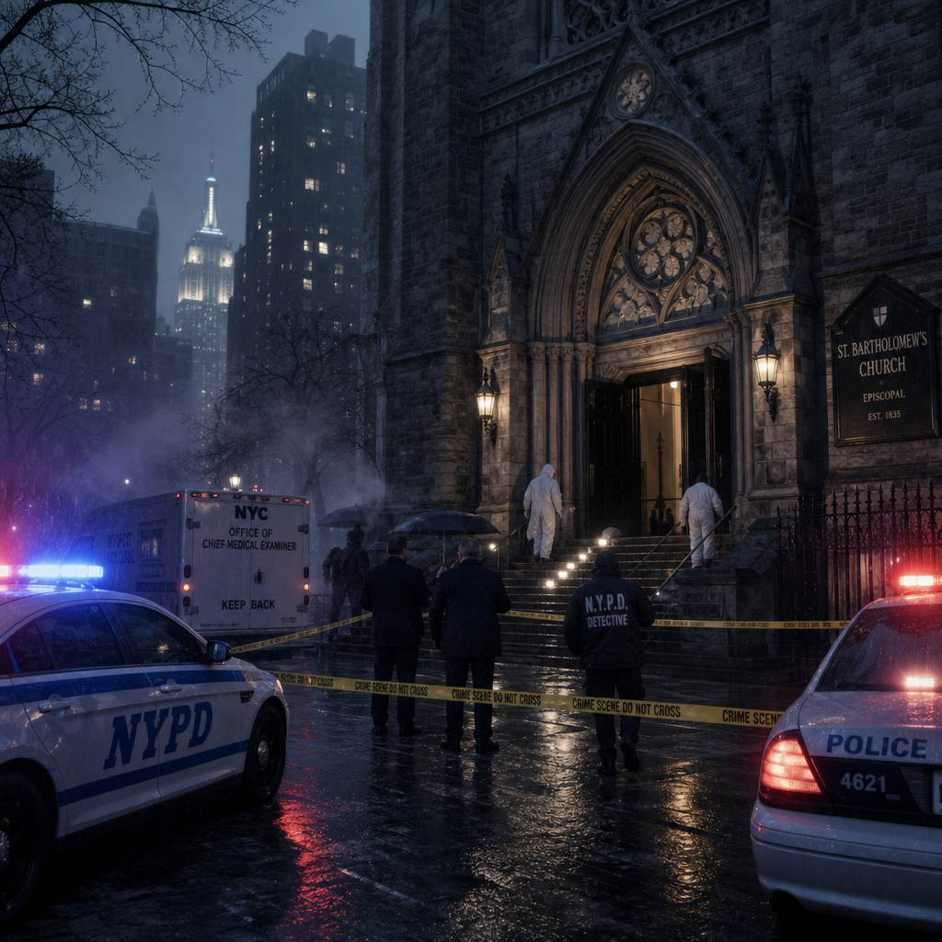

The call came before sunrise.
Darrius was already awake.
He had spent most of the night rereading Nancy Calloway's letter, searching for
meaning between the lines rather than inside them. His phone vibrated across the
kitchen table.
The display read: Rodney Weir
Darrius answered immediately.
"We've got another one."
There was no greeting. No explanation. Only those four words.
Darrius closed his eyes briefly. "Where?"
"St. Bartholomew's."
The detective looked toward the window.
Rain streaked softly across the glass.
"Anyone identified?"
"Male."
"Late fifties."
"We're waiting on confirmation."
Darrius was already reaching for his coat. "I'm on my way."

❦
Twenty-three minutes later, the unmarked sedan rolled to a stop outside
St. Bartholomew's. The church stood on a quiet corner in Upper Manhattan.
Smaller than St. Michael's. Older than St. Peter's.
Its weathered stone walls disappeared into the predawn mist while emergency lights
painted brief flashes of red and blue across stained-glass windows.
Three churches. Three murders.
The pattern was undeniable now.
Reporters crowded the barricades despite the early hour.
Camera lenses followed every detective crossing the police tape.
News helicopters circled overhead.
The story no longer belonged only to Homicide. It belonged to the city.
Officer Jamie Alvarez met Darrius near the entrance.
Her expression said enough before she spoke.
"It's the same."
Darrius nodded once. "Show me."
Inside, the sanctuary had already been secured.
The familiar smells greeted him.
Old wood. Incense. Melted candle wax.
This time another scent lingered beneath them. Fresh lilies.
The flowers had been arranged across the altar only hours before.
Life and death sharing the same room.
Carson emerged from the rear of the church, removing a pair of latex gloves.
"I was hoping I wouldn't see you here."
Darrius answered dryly, "You always know how to make a man feel welcome."
Carson managed a tired smile.
It disappeared almost immediately. "This one's different."
Darrius caught the emphasis.
"Different how?"
"The victim."
Carson led him toward the confessional.
Unlike the previous scenes, the booth door stood wide open.
The victim lay partly outside the entrance, one arm extended across the aisle.
As though he had tried to crawl away.
Darrius slowed.
Everything about this scene felt wrong.
Not chaotic. Intentional.
The man wore a dark suit beneath a rain-spotted overcoat.
Silver hair. Wire-rimmed glasses.
One polished shoe had slipped off during the struggle.
Or...during the staging.
Darrius crouched beside the body.
"What have we got?"
Carson pointed carefully.
"Same ligature marks."
"The head wound?"
"There."
A small injury behind the left ear. Nearly identical.
"But..."
Carson motioned toward the victim's hands.
Darrius looked.
The right hand clutched something tightly.
Not a rosary. Not a prayer rope.
A folded sheet of paper.
Darrius frowned. "The note."
Carson nodded. "He was holding it."
Not beside him. Not arranged. Held.
Darrius carefully examined the stiffened fingers.
"He died gripping it."
"Looks that way."
Silence settled over the confessional.
Something had changed. The killer had changed.
Or...the message had.
Rodney Weir joined them.
"ID just came through."
Darrius stood. "Who is he?"
Weir handed over the preliminary report.
Patrick Joel
The name struck him immediately.
For a long moment, he simply stared at the page.
"No."
Weir didn't answer.
"He left Blessed Hearts Home yesterday." "He drove home."
"He should've been safe."
Carson quietly lowered his eyes.
Darrius looked back toward the victim.
Patrick Joel.
The gentle archivist. The keeper of forgotten stories.
The man who believed history deserved to be remembered.
Now he lay inside another church.
Another confessional. Another carefully staged murder.
Darrius felt something unfamiliar settle inside him.
Not anger. Responsibility.
Patrick hadn't been chosen by chance.
He had been silenced.
Because he had helped. Because he had remembered.
Because he had opened the ledger.
Darrius looked toward the folded paper still clenched in Patrick's hand.
The killer hadn't simply left another message.
He hand delivered one.
Personally.
Outside, church bells began ringing the seven o'clock hour.
Each toll echoed through the sanctuary.
One...Two...Three...
Darrius never took his eyes off Patrick Joel.
The investigation had changed again.
History was no longer something the killer feared.
It was something he was protecting.
And anyone who helped uncover it...had just become a target.
❦
The sanctuary had emptied except for Crime Scene personnel.
Camera flashes pulsed rhythmically across the worn stone walls as technicians
documented every inch of the confessional.
Darrius remained beside the victim.
He had not yet unfolded the paper clutched in the dead man's hand.
Carson knelt beside him.
"The fingers are locked."
"Rigor?"
Carson nodded. "He died holding it."
Darrius studied the victim's hand.
"No."
Carson looked up.
"What?"
"He died..."
Darrius spoke quietly.
"...or someone wanted us to believe he did."
Carson paused.
"Meaning?"
"The first two notes were placed."
He looked at the victim. "This one was held."
He frowned.
"That's different."
Carson carefully photographed the hand one final time before easing the
folded page free. Even that required patience.
The fingers resisted.
Almost unwilling to surrender what they held.
Finally the paper came loose.
Carson slipped it into a fresh evidence sleeve and handed it to Darrius.
Same paper. Same weight. Same immaculate fold.
The detective unfolded it carefully.
The poem was shorter than the previous two.
Only three lines.
The shepherd heard the truth.
The flock chose silence.
Now heaven remembers.
Silence filled the confessional.
Weir read the lines over Darrius' shoulder.
"He's changing."
Darrius nodded slowly.
"The language." "The tone." "The message."
He read the first line again. “The shepherd heard the truth.”
Shepherd.
Not a priest. Not a pastor. Shepherd.
His thoughts immediately returned to Father Grealish.
Then to Father Thomas.
Then Father Ian.
The killer was no longer speaking about individual victims.
He was speaking about the Church itself.
Carson interrupted his thoughts. "We found something else."
He reached into another evidence bag.
Inside rested a short length of braided wool cord.
Unlike the previous fibers, this one remained intact.
A complete prayer rope.
Dark wool. Hand-knotted. Simple. Beautiful.
One small wooden cross had been tied into the end.
Darrius accepted it carefully.
He turned it over beneath the sanctuary lights.
His expression changed.
"What?"
Weir asked.
Darrius pointed toward the knots. "They're uneven."
Carson nodded. "Handmade."
"No."
Darrius continued studying it. "Hand-repaired."
A section near the center had been tied differently than the rest.
Someone had repaired it years earlier instead of replacing it.
Why?
He couldn't answer.
Not yet.
Carson watched him. "You've seen something."
"I've seen care."
"What?"
"This wasn't thrown away." "It was kept."
He looked once more at the repaired section. "People repair things they can't
bear to lose." The words lingered.
Carson carefully took the prayer rope back. "I'll have the lab examine every fiber."
"Do that."
"And Carson..."
The forensic examiner looked up.
"Don't clean it."
"You think there's something hidden?"
Darrius shook his head.
"No."
"I think whoever owned it left part of their story inside it."
The detective stepped out of the confessional.
His eyes swept across the sanctuary. The church remained eerily quiet.
Rows of empty pews. Burning candles.
Morning sunlight filtering through stained glass.
Somewhere, a maintenance worker quietly reset overturned chairs.
Life was trying to return. Death refused to leave.
Rodney joined him near the altar. "What are you thinking?"
Darrius looked back toward the confessional.
"The poems have changed."
"How?"
"The first one judged a person."
"The second judged a choice."
He held up the newest note. "This one judges an institution."
Rodney absorbed that. "So what's next?"
Darrius answered almost immediately. "The past."
Rodney frowned.
"You think that's where he's taking us."
"No."
Darrius folded the note carefully and slipped it back into its evidence sleeve.
"I think that's where he's been waiting all along."
Outside, reporters shouted questions as another television crew arrived.
Inside...the investigation had quietly crossed another threshold.
The killer was no longer hiding behind riddles.
He was beginning to explain himself.
And that...
more than the murders...frightened Darrius.

❦
The interview room at Manhattan Homicide felt almost welcoming compared
to the confessional at St. Bartholomew's.
Almost.
Harry Collins sat quietly at the table, his weathered hands folded neatly before him.
Unlike most witnesses Darrius interviewed, Harry wasn't nervous.
He was weary.
Years of parish maintenance had left his hands rough and scarred, the skin thickened
by decades of repairing broken pews, replacing stained glass,
and fixing old boilers that refused to retire.
He looked more like a carpenter than a church employee.
Darrius entered carrying only a notebook.
No photographs. No evidence folders. No recorder.
Harry noticed immediately.
"No tape?"
Darrius smiled faintly. "Not today."
Harry nodded once.
"Good."
The detective sat across from him.
"I've been told you've worked around churches most of your life."
Harry chuckled. "Fifty-one years."
"I started sweeping floors when I was sixteen."
"And never left."
"No."
"I figured somebody had to keep God's house standing."
The answer carried quiet pride.
Darrius respected it. "You knew Father Grealish."
Harry looked down. "I did."
"What kind of man was he?"
Harry answered without hesitation. "Kind."
The detective waited.
"He listened." "He remembered birthdays." "He fixed bicycles."
"He shoveled sidewalks before anybody else arrived."
A small smile crossed Harry's face.
"The children loved him."
Darrius made a note.
Not because it was new.
Because it matched every other description.
"So why does everyone stop smiling when they remember him?"
Harry's expression changed.
His eyes drifted toward the wall behind Darrius. "I've asked myself that."
Silence settled over the room.
"What happened?"
Harry slowly rubbed one thumb across the back of his opposite hand.
"I don't know."
"You don't..."
He paused. "...or you can't?"
The older man looked at him.
For the first time, uncertainty appeared. "I remember pieces."
"Tell me the pieces."
Harry closed his eyes. "There was rain."
Darrius didn't interrupt.
"The bells." "Children running." "A meeting."
His breathing slowed.
"Grealish looked exhausted."
"Did he say why?"
"No."
"He just kept apologizing."
Darrius looked up.
"Apologizing?"
Harry nodded.
"To everyone."
"For what?"
"I never knew."
Another silence.
Harry frowned. "That always bothered me."
"What did?"
"He apologized...for something nobody else seemed willing to name."
The sentence landed heavily.
Darrius wrote it down exactly. "What happened after that?"
Harry remained quiet for nearly thirty seconds.
Then—"He burned papers."
Darrius looked up sharply.
"What?"
Harry blinked several times.
"As soon as the words left his mouth, surprise crossed his face.
"I..."
"I haven't thought about that in years."
"What papers?"
"I don't know."
"Personnel records?"
"No."
"Sermons?"
Harry slowly shook his head.
"They were letters."
"Old letters."
"Where?"
"In the furnace room."
Darrius leaned forward. "You're certain?"
"I remember the fire."
"The smell."
"He stood there alone."
"I asked if he needed help."
"What did he say?"
Harry answered without hesitation.
'Some burdens belong to God now.'
Silence.
Absolute silence.
Darrius felt his pulse quicken.
Not because the statement proved guilt.
Because it proved grief.
Whatever Grealish had burned...he hadn't destroyed it in anger.
He had done it with sorrow.
Harry continued quietly.
"I always thought he was protecting somebody."
"Who?"
"I don't know."
"Maybe himself."
He shook his head.
"No."
"It never felt like that."
"What did it feel like?"
Harry stared at the table for several long moments.
Finally—"Like a man trying to keep someone else's pain from spreading."
The detective sat back.
That wasn't the answer he'd expected.
It was more complicated.
Which usually meant it was closer to the truth.
Darrius changed direction.
"Did Grealish ever mention Edward Dwight?"
Harry's eyes narrowed.
The name clearly stirred something.
"Once."
"What did he say?"
Harry smiled sadly.
"He said..."
The memory returned slowly.
"...that Edward deserved more than survival."
"He deserved peace."
The room fell silent again.
Darrius closed his notebook.
Every witness described the same man.
Compassionate. Burdened. Haunted. Not perfect. But not monstrous.
And yet...three people were dead.
Somewhere between those truths...something had gone terribly wrong.
As Darrius stood, Harry spoke one last time.
"Detective."
He turned.
"If you find out what happened..."
Harry's voice nearly disappeared.
"...don't let people remember only the ending."
Darrius held his gaze.
"I won't."
Harry nodded.
"That's all any of us really get in the end."
"The chance to be remembered honestly."
Darrius left the interview room carrying no physical evidence.
Only words.
But words had a way of surviving long after paper turned to ash.
And Grealish's apology...
was beginning to sound less like an admission of guilt—
and more like the burden of a man who had failed to save someone he desperately
wanted to protect.
❦
The call came just after lunch.
Darrius had barely finished reviewing Harry Collins' interview notes when
his desk phone rang.
"Blue."
Carson's voice answered immediately.
"I think we've found your missing three years."
Darrius stood.
"Where?"
"Albany."
The detective frowned.
"Albany?"
"Personnel archive."
"They missed a supplemental transfer file."
Darrius grabbed his coat. "I'll be there in ten."

❦
The Archdiocese Records Center occupied the basement of an aging administrative
building just outside Midtown.
Unlike the polished offices upstairs, the archive felt forgotten.
Concrete walls. Metal shelving. Rolling ladders.
Thousands of boxes disappearing into dimly lit aisles.
A middle-aged archivist waited beside an open records cart.
"I'm Daniel Mercer."
He extended his hand. "Mr. Carson said you'd be coming."
Darrius introduced himself while Rodney looked around.
"This place feels like history gave up."
Mercer smiled.
"History never gives up."
"It just gets buried."
The words reminded Darrius of Patrick Joel.
Mercer reached into a gray archive box.
"We were updating diocesan records after several parishes merged."
He removed a thin manila folder.
"It wasn't indexed with Father Grealish's personnel file."
"Why not?"
"It belonged to another diocese."
Darrius accepted the folder.
Across the tab someone had handwritten:
Temporary Assignment — Albany Diocese
His pulse quickened.
He opened it.
The first page carried only dates.
June 1985.
Temporary reassignment.
Albany.
No explanation. No disciplinary notation. No evaluation.
Only a destination.
Rodney looked over his shoulder. "So he didn't disappear."
Darrius nodded slowly. "He was transferred."
He continued reading.
Several routine travel authorizations followed.
Housing records. Expense reimbursements. Nothing unusual.
Then—
A single memorandum.
Half the page had faded.
Only fragments remained legible.
Pastoral assistance requested...
...youth outreach...
...confidential matter...
The remainder had been destroyed by water damage years earlier.
Darrius stared at the missing lines.
Again.
History hadn't vanished.
Only parts of it.
Mercer spoke quietly. "There's something else."
He produced a second envelope. Smaller.
Older.
Its edges had become brittle with age.
"The archivists almost threw this away."
"Why?"
"It wasn't labeled correctly."
Darrius carefully opened it.
Inside rested a folded train ticket.
New York City. Albany. June 3, 1985. One-way. No return ticket.
Rodney frowned.
"He drove back?"
"Maybe."
Darrius wasn't convinced.
He turned the ticket over.
On the reverse side, written in faded blue ink, were three words.
For Edward's future.
Silence.
Absolute silence.
Neither detective spoke.
Mercer looked between them. "I take it that's important."
Darrius answered almost absentmindedly. "It might be everything."
He slipped the ticket into an evidence sleeve.
Edward's future. Not Grealish's. Not the Church's.
Edward's.
That changed the meaning completely.
Rodney crossed his arms. "You thinking what I'm thinking?"
Darrius nodded. "This wasn't punishment."
"No."
"It was protection."
He looked back at the transfer file.
Grealish hadn't been sent away because of disgrace.
He had gone somewhere. For someone.
Mercer carefully closed the archive box. "I wish there was more."
Darrius looked around the endless rows of forgotten records.
"There usually is."
Mercer smiled. "You think so?"
"I know so."
The detective glanced once more at the faded memorandum.
The missing lines bothered him.
Not because they were gone.
Because someone had once believed they mattered enough to write.
As Darrius prepared to leave, Mercer spoke again.
"Detective."
He turned.
"Old records teach one lesson better than anything else."
"What lesson?"
Mercer rested a hand on the archive cart.
"People preserve what they're proud of."
He looked toward the damaged memorandum.
"They hide what they're afraid of."
The words followed Darrius all the way back to the elevator.
Inside his briefcase rested the Albany transfer.
The train ticket. The faded memorandum.
Three ordinary pieces of paper.
Yet together they changed the investigation completely.
For weeks Darrius had believed Father Grealish's missing years were a mystery.
Now they were something else.
A journey.
And somewhere at the end of that journey...
Waited the answer to why Edward Dwight's life had changed forever.

❦
The Evidence Laboratory remained brightly lit despite the late hour.
Most of the city had settled into the evening, but inside the forensic wing
the work never truly stopped.
Microscopes glowed beneath adjustable lamps.
Computers processed trace evidence. Technicians moved quietly between
workstations.
Lily Clyne looked up as Darrius entered. "I was hoping you'd come."
He smiled.
"That usually means good news."
"It means interesting news."
She motioned him toward the examination table.
At its center rested the recovered prayer rope.
Now fully documented. Photographed. Measured. Protected beneath clear
evidence glass. Even from a distance it looked ordinary.
Dark wool. Simple knots. A small wooden cross. Nothing dramatic.
Nothing theatrical.
Darrius stared at it. "The repair."
Lily nodded. "You noticed it immediately."
"I've been thinking about it ever since."
She carefully removed the rope using cotton gloves.
"The repaired section isn't recent."
"How old?"
"Years."
"Possibly decades."
She rotated the cord beneath the examination light. "The replacement wool
isn't identical."
"It was repaired by hand." "Probably by the original owner."
Darrius studied the uneven knots.
Whoever had repaired it hadn't cared about appearance.
Only preservation.
"Anything else?"
Lily smiled. "I almost missed it."
She adjusted the magnification.
Near the wooden cross...
barely visible beneath years of handling...were tiny engraved initials.
She slid the magnified image across the monitor.
M.G.
Silence.
Darrius leaned closer.
"M.G."
Lily nodded. "The carving was almost completely worn away."
He looked back at the prayer rope.
"Michael Grealish."
"Probably."
The detective remained quiet.
The room seemed to shrink around the evidence table.
Grealish.
Again.
Not through rumor. Not through memory.
Through something he'd once carried every day.
Darrius reached toward the monitor.
"Can you enlarge the cross?"
Lily already had.
The wood grain filled the screen.
Scratches.
Wear marks.
Tiny impressions left by years of fingers rubbing the same place during prayer.
Then—
Something unexpected.
A faint discoloration near the center.
"What is that?"
Lily adjusted the lighting. "We tested it."
Her expression grew serious. "It's blood."
Darrius looked at her.
"Human?"
She nodded. "Very old."
"Too degraded for identification."
The detective said nothing.
He simply stared at the cross.
A prayer rope. Repaired. Carried. Prayed over. Marked with blood.
History had become tangible.
Lily broke the silence. "There's more."
She handed him another photograph.
The repaired knot had been untied digitally using forensic imaging.
Inside the knot...wrapped carefully within the fibers...
was something almost invisible.
A tiny fragment of folded paper.
Darrius felt his heartbeat quicken.
"You opened it?"
"No."
"The paper would disintegrate."
She enlarged the scan.
Only two handwritten words remained legible.
Remember mercy.
Nothing else. No signature. No date. No explanation.
Only those two words.
Darrius closed his eyes briefly.
Father Thomas. Father Ian. Henry Collins. Sabine. Nancy.
Every one of them had spoken about mercy.
Only Brendan never had.
Now...the prayer rope connected Grealish to that same word.
Remember mercy.
The phrase echoed through the lab.
Lily finally spoke. "I don't think that's evidence."
Darrius looked up. "What do you think it is?"
She smiled softly. "I think it's a reminder."
He looked once more at the tiny fragment hidden inside the repaired knot.
Someone had intentionally concealed it.
Not from enemies. From time.
He thought of Grealish repairing the rope instead of replacing it.
Keeping it close.
Carrying it through the missing years.
Perhaps touching that hidden message every time he prayed.
Remember mercy.
The detective stepped away from the table.
His thoughts moved faster than he could organize them.
The killer preached judgment. The prayer rope whispered mercy.
Two faiths. Two doctrines. Two completely different understandings of justice.
One had produced healing.
The other...murder.
Lily gently returned the prayer rope to its protective case.
"Detective."
He turned.
"Objects survive longer than memories."
She looked at the worn cross.
"But sometimes...they remember for us."
Darrius stood silently for another moment before leaving the lab.
As the evidence door closed behind him, one thought refused to leave.
If Father Michael Grealish had hidden those words inside his own prayer rope...
then he hadn't spent his final years trying to preserve guilt.
He had spent them trying...not to forget grace.

❦
Night had settled over Manhattan.
Rain tapped softly against the windows of Homicide as the bullpen gradually
emptied. Most detectives had gone home.
Only a handful of desk lamps still glowed across the room.
Darrius remained standing before the evidence board.
It had changed again.
Nancy Calloway. Zachary Lyle. The third victim. Edward Dwight.
Father Michael Grealish. The Albany transfer. Harry Collins' interview.
The repaired prayer rope.
Remember mercy.
Every photograph. Every document. Every note. Every witness.
Nothing contradicted itself. Yet nothing fits together.
Rodney Weir walked quietly into the room carrying two fresh cups of coffee.
"I figured you'd still be here."
Darrius accepted one without taking his eyes from the board.
"You know me too well."
Rodney studied the growing web of strings and notes.
"This thing's starting to look less like an investigation...and more like a family tree."
Darrius smiled faintly. "History usually is."
Rodney took a long sip of coffee. "So tell me."
"What do we actually know?"
Darrius thought for a long moment before answering.
"We know Edward Dwight arrived at Blessed Hearts Home frightened."
"We know Nancy spent years protecting his story."
"We know Father Grealish tried to help him."
"We know Grealish disappeared to Albany." "We know he came back changed."
Rodney nodded.
"And?"
Darrius looked toward the prayer rope sealed inside its evidence photograph.
"We know he carried mercy with him."
Silence.
Rodney folded his arms. "Then why are people dead?"
The question hung in the room.
It was the question.
Darrius didn't answer immediately.
Instead, he walked to the board and uncapped a marker.
Across the top he wrote:
WHAT IF WE'RE WRONG?
Rodney raised an eyebrow. "Wrong about what?"
"Everything."
He drew two columns beneath the question.
What We Know
What We Assume
Under the first, he wrote:
- Three murders.
- Edward Dwight.
- Father Grealish.
- Prayer rope.
- Albany transfer.
Under the second:
- Grealish caused it.
- Edward wanted revenge.
- The killer is telling the truth.
He stepped back.
Rodney stared at the board.
"We've been mixing facts with conclusions."
Darrius nodded. "That's how investigations fail."
He tapped the second column.
"The killer wants us here."
"You think he's guiding us?"
"I think he's editing history."
The words settled heavily between them.
Editing history. Not inventing it. Selecting pieces. Removing others.
Creating a story that justified murder.
Darrius looked once more at the enlarged image of the hidden message inside the
prayer rope.
Remember mercy.
Then at Nancy's letter.
Find the truth before you find someone to blame.
Then Harry Collins' words.
Don't let people remember only the ending.
Three voices. Three decades. The same warning.
None of them had asked Darrius to protect their reputations.
They had asked him to protect the truth.
Rodney broke the silence. "So where do we go tomorrow?"
Darrius picked up the Albany file. "We stop chasing Grealish."
Rodney frowned.
"What?"
"We start chasing the people around Grealish."
He laid the file beside Edward Dwight's photograph.
"Someone knows what happened in Albany."
"Someone survived it."
"And if Brendan built his life around those years..."
He looked directly at Rodney.
"...then somewhere out there is the person who watched it happen."
The bullpen phone rang in the distance. Neither detective moved.
Outside, thunder rolled across the city.
The storm had finally arrived.
Darrius gathered the Albany file, the prayer rope photographs, and Nancy's letter
into a single case folder.
Across the cover he wrote:
1985
He stared at the date for a long moment.
Until now...1985 had simply been three missing years.
Now it has become a destination.
The place where Edward Dwight's story changed.
The place where Father Michael Grealish lost something he never recovered.
The place where Brendan Dwight's future quietly began.
Darrius closed the folder.
The sound echoed softly through the nearly empty squad room.
He switched off the lights.
Only the evidence board remained illuminated by the glow from the hallway.
Names. Photographs. Dates. Questions. Waiting.
Some investigations ended when the killer was found.
This one...was only beginning to understand why the killer existed.
And somewhere beyond the rain...
beyond the city...
beyond the missing years in Albany...
someone had been waiting nearly forty years for the truth to finally catch up.

Chapter Seven

Echoes in the Silence

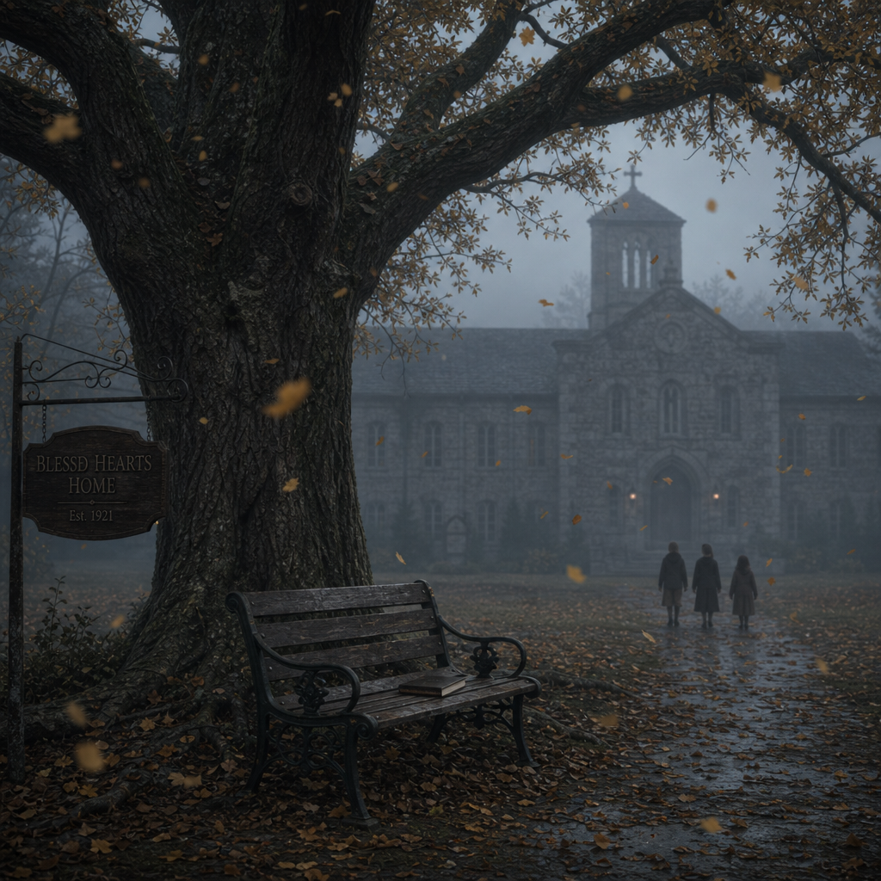

Rain washed the city clean overnight. By dawn, Manhattan seemed almost peaceful.
Almost.
Detective Darrius Blue stood alone outside Homicide Headquarters with
a paper cup of coffee warming his hands. He hadn't slept more than three hours.
The evidence board refused to leave his mind.
Edward Dwight. Father Michael Grealish. Albany. The prayer rope.
Remember mercy.
Every answer seemed to produce two more questions.
His phone vibrated. Not a call. A text.
Come upstairs.
—Rodney
Nothing else.
Darrius discarded the empty coffee and took the stairs two at a time.
Something in Rodney's wording told him this wasn't routine.
When he stepped into the bullpen, he immediately noticed the silence.
Detectives stood around the conference table.
Nobody spoke.
Rodney looked up as Darrius approached.
"It came about thirty minutes ago."
He slid a clear evidence sleeve across the table. Inside rested another folded page.
Not recovered from a crime scene.
Delivered.
Darrius looked up. "How?"
"Front desk."
"The clerk thought it was interoffice mail."
No return address. No fingerprints visible.
Only Darrius's name written neatly across the front.
He carefully opened the evidence sleeve.
The paper matched every previous note.
Same weight. Same fold. Same immaculate handwriting. He unfolded it.
Only one sentence.
Mercy without truth is only another lie.
No signature. No poem. No victim. Just the sentence.
Silence settled across the room.
Rodney spoke first. "He's talking to you now."
Darrius didn't answer.
He read the sentence again.
Mercy without truth is only another lie.
He felt no anger.
Only recognition.
Brendan had been watching.
Not just the investigation.
Him.
Carson stepped beside him.
"No prints." "No DNA." "Same paper stock." "Same ink."
Darrius nodded absentmindedly.
His thoughts were elsewhere.
The wording.
Not judgment. Not confession. Mercy.
For the first time...the killer had deliberately used the one word he'd
consistently avoided.
Why?
Rodney interrupted his thoughts. "You think it's a threat?"
Darrius slowly shook his head.
"No."
"What then?"
He looked at the note once more. "It's an argument."
The detectives exchanged puzzled glances.
"He isn't trying to scare me."
Darrius continued. "He's trying to convince me."
The room became quiet again.
Darrius walked toward the evidence board.
He pinned the newest message beside the enlarged photograph of the prayer rope.
Below the hidden words—
Remember mercy.
—he placed Brendan's sentence.
Mercy without truth is only another lie.
Two messages.
One word.
Completely different meanings.
He stepped back.
Father Thomas. Father Ian. Sabine. Nancy. Henry. Grealish.
Every one of them had spoken of mercy as healing.
Brendan spoke of mercy as weakness.
The contrast had never been clearer.
Rodney watched him study the board.
"You seeing something?"
Darrius nodded slowly. "The killer just made his first mistake."
"What mistake?"
"He answered us."
Rodney frowned. "I don't follow."
Darrius turned toward the room.
"Up until now we've been reading his messages."
He held up the newest note. "This is the first time he's read ours."
Silence.
Absolute silence.
The realization spread slowly across the room.
Brendan knew where the investigation was heading.
Which meant...he was watching it.
Or someone was watching for him.
Darrius looked once more at the evidence board.
For the first time since Nancy Calloway's murder...
the distance between hunter and hunted had become very small.
Somewhere in New York...Brendan Dwight had just acknowledged his existence.
And that meant the game had changed.
❦
The morning rain had given way to a pale autumn sun by the time Darrius arrived at
Blessed Hearts Home. Children laughed on the playground.
Teachers supervised recess.
From the outside...nothing had changed.
Inside...
everything had.
Sabine Fitcher met him at the front entrance before he had a chance to knock.
"You look tired."
Darrius smiled faintly. "I was going to say the same thing."
She stepped aside.
"You'd better come in."
The familiar warmth of the orphanage wrapped around him.
Fresh bread. Coffee. Construction paper. Children's artwork.
For a brief moment, the murders felt impossibly far away.
Sabine led him into her office. She closed the door quietly.
"You wouldn't have come back unless something happened."
Darrius removed the latest message from his case folder.
"I received this this morning."
He handed her the evidence sleeve.
Sabine adjusted her glasses and read the single sentence.
Mercy without truth is only another lie.
She didn't speak. She read it again. Then a third time.
When she finally looked up...her expression had changed.
"What is it?"
Darrius asked.
"I've heard that before."
The detective remained perfectly still.
"Where?"
"I don't know."
She frowned.
"I don't remember."
He didn't interrupt.
Memory rarely arrives when chased.
Sabine stood and walked slowly toward the window overlooking the playground.
Children raced across the grass below.
One little boy tripped.
Another reached down and helped him back to his feet.
She smiled softly.
Then—
The smile disappeared. "I remember a conversation."
Darrius quietly opened his notebook.
"Between who?"
"Edward."
"And?"
She closed her eyes. "There was another boy."
She searched carefully. "I can't remember his name."
"What were they talking about?"
Sabine remained silent for several long seconds.
Finally—
"They were arguing."
"About what?"
"Forgiveness."
The word settled heavily into the room.
"Edward kept saying..."
She paused again.
"...that forgiveness wasn't pretending nothing happened."
Darrius wrote every word.
"And the other boy?"
Sabine's breathing slowed.
"He became angry."
"What did he say?"
She spoke almost mechanically now.
Repeating words buried beneath decades of memory.
"He said..."
'Mercy without truth is only another lie.'
Silence.
Absolute silence.
Darrius looked up slowly. "The exact sentence?"
Sabine nodded.
"The exact sentence."
He felt a chill move through him.
Not because the words were familiar. Because they weren't new.
Brendan hadn't written them.
He had remembered them.
Darrius leaned forward. "Who was the other boy?"
Sabine shook her head.
"I can't see his face."
"Try."
"I am."
Her frustration was obvious.
"I remember the voices." "The rain." "The oak tree."
"But every time I try to remember him..."
She touched her temple.
"...it's like someone erased the edges."
The detective remained patient.
He had seen this before.
Trauma didn't erase memories. It shattered them.
Sometimes all a survivor could recover were fragments.
Sabine opened her eyes. "I do remember one thing."
"What?"
"He admired Edward."
Darrius blinked. "Admired him?"
She nodded.
"He followed him everywhere." "He copied him." "He wanted Edward to notice him."
She looked out the window once more.
"But after Edward left..."
Her voice became almost inaudible.
"...that little boy changed."
Neither spoke.
Children's laughter drifted faintly through the glass.
Life continued outside.
Inside...the past had just whispered another secret.
Darrius slowly closed his notebook.
"Do you think that boy could still be alive?"
Sabine turned toward him.
Her expression carried equal parts sadness and fear.
"I don't think he ever left."
The detective frowned. "What do you mean?"
She looked back toward the playground.
"I think..."
She hesitated.
"...part of him stayed here."
She wasn't talking about a building. She wasn't talking about memories.
She was talking about childhood.
About innocence. About the day something inside a boy failed to grow.
Darrius understood.
Not completely.
But enough.
As he prepared to leave, Sabine stopped him.
"Detective."
He turned.
"If you find him..."
She struggled to choose her words.
"...remember that children aren't born believing those things."
Darrius nodded.
"No."
"They're taught."
Sabine lowered her eyes.
"And sometimes...they're taught by pain."
Darrius walked quietly into the hallway.
The sounds of children echoed through the old orphanage.
Bright. Hopeful. Alive.
For the first time...
he began to suspect the killer's philosophy hadn't been born in adulthood.
It had been planted in childhood.
And somewhere between Edward Dwight's kindness...
and Brendan Dwight's judgment...
stood a forgotten afternoon beneath an old oak tree.
Waiting to be remembered.

❦
Father Henry Collins sat alone in the monastery garden.
The morning rain had left droplets clinging to the rose bushes, each one
catching the weak October sunlight, like tiny fragments of stained glass.
A weathered Bible rested open on his lap. He wasn't reading it.
He was watching the birds.
Darrius found him exactly where the receptionist said he would.
"I hope I'm not interrupting."
Henry smiled without looking away from the garden. "Only my conversation."
Darrius glanced around.
"I don't see anyone."
Henry chuckled softly. "Neither do most people."
The detective smiled.
"Mind if I join you?"
"I was hoping you would."
Darrius settled onto the wooden bench beside him.
For a while, neither man spoke.
The silence felt familiar now.
Comfortable.
Finally Henry closed the Bible.
"You've learned something."
"I have."
"You've come to ask about Edward."
Darrius looked at him. "How did you know?"
Henry smiled gently. "Because everyone eventually does."
The answer lingered between them.
"You knew him."
Henry nodded. "I baptized him."
Darrius hadn't expected that.
"You did?"
"He was already fourteen."
"He insisted."
"Why?"
Henry looked toward the small chapel across the courtyard.
"He said..."
A warm smile touched the old priest's face.
"...that if God still wanted him, he wanted God too."
Darrius wrote the sentence carefully into his notebook.
"He actually said that?"
Henry laughed quietly.
"Word for word."
"He had a habit of asking impossible questions."
"What kind of questions?"
"'Can God forgive people who can't forgive themselves?'"
"'Does prayer still work if you're angry?'"
"'Can broken people become whole again?'"
Henry shook his head fondly.
"I used to tell him...those are questions wise old men ask."
"And he was only a boy."
The detective listened without interrupting.
"He wanted answers."
Henry continued. "But more than that...he wanted hope."
The priest fell silent.
Darrius waited.
"What happened after he met Grealish?"
Henry's smile faded.
"For a little while..." "He flourished." "He volunteered." "He laughed."
"He started talking about becoming a teacher."
"A teacher?"
Henry nodded.
"He wanted children to grow up believing better things than he'd believed."
Darrius felt an unexpected tightening in his chest.
It wasn't just that Edward had dreamed.
It was the kind of dream he'd carried.
Helping others. Healing others.
"So what changed?"
Henry looked down at his folded hands. "I don't know."
"You never asked Grealish?"
"I did."
"What did he say?"
Henry's eyes grew distant.
"He looked at me...and said something I'll never forget."
Darrius leaned forward.
"'Some wounds don't bleed where people can see them.'"
Silence.
Absolute silence.
Henry's voice softened. "I knew then something terrible had happened."
"But I also knew..."
He looked toward the chapel again.
"...Michael wasn't the man who caused it."
The certainty in his voice struck Darrius immediately.
"You believe that."
"I do."
"Even now?"
Henry met his eyes. "Especially now."
Neither man spoke.
The breeze stirred the fallen leaves around the bench.
A pair of sparrows landed nearby, pecking quietly at the damp earth.
Henry smiled at them.
"Edward used to feed birds."
Darrius looked over.
"He did?"
"Every morning."
"He said..."
Henry laughed softly.
"...that hungry things deserved kindness too."
The detective closed his notebook.
For several seconds he couldn't think of another question.
Every story he heard about Edward made Brendan's version harder to reconcile.
Not impossible.
Just...incomplete.
Henry noticed his expression.
"You're trying to understand how someone remembered with such love could become
surrounded by so much hate."
Darrius nodded slowly.
"Yes."
The old priest rested one hand on the Bible.
"Perhaps..."
He paused.
"...you're asking the wrong question."
"What should I ask?"
Henry looked directly at him.
"You should ask who benefited...when Edward stopped believing those things."
The sentence landed with unexpected force.
Darrius hadn't considered it.
Not once.
Until now the investigation had focused on what happened to Edward.
Henry had just shifted the question.
Who gained from it?
The detective stood. "So you don't believe Edward created this."
Henry answered immediately.
"No."
"I believe someone stole it."
"What?"
"His hope."
The words hung in the autumn air.
As Darrius turned to leave, Henry called after him.
"Detective."
He stopped.
"When people lose faith..."
Henry spoke quietly.
"...they don't always stop believing."
"They simply start believing something else."
Darrius nodded.
He understood exactly what the priest meant.
Brendan Dwight hadn't grown up without faith.
He had grown up with a faith that had been twisted into something unrecognizable.
And somewhere between Edward's compassion...
and Brendan's certainty...someone had rewritten the meaning of justice.

❦
The address led Darrius to a modest brick home on the outskirts of Albany.
No security gate. No imposing estate.
Just a quiet neighborhood where maple leaves drifted across neatly trimmed lawns
and the only sound came from a lawn mower several houses away.
Rodney glanced at the mailbox.
H. REED
"This is it."
Darrius nodded.
He had expected something larger.
Someone connected to diocesan records.
Instead...it looked like the home of a retired schoolteacher.
He rang the bell. Footsteps approached. The door opened slowly.
Henry Reed looked exactly as Darrius imagined a lifelong archivist would.
Late seventies. Thin. Silver hair carefully combed back.
Reading glasses hanging from a cord around his neck.
His eyes immediately settled on Darrius's badge.
"I've been wondering when someone would come."
Neither detective spoke.
Reed stepped aside. "You'd better come in."

❦
Books filled nearly every wall of the small living room.
History. Theology. Genealogy. Archival preservation.
Photographs occupied every available shelf.
Not family portraits. Old churches. Historic parish buildings.
Boxes carefully labeled in neat handwriting lined one corner of the room.
Everything had its place. Everything had been preserved.
Reed noticed Darrius studying the shelves.
"My wife used to say I never threw away anything."
He smiled sadly. "She wasn't wrong."
Darrius returned the smile.
"We're here because of Father Michael Grealish."
The smile faded. "I suspected as much."
He motioned toward the dining room table.
A cardboard archive box already waited there.
"I took that down this morning."
Rodney exchanged a quick glance with Darrius. "You expected us."
"I expected someone."
Reed folded his hands. "I just didn't know when."
Silence settled over the room.
Finally Darrius asked, "You worked for the Diocese?"
"Thirty-eight years."
"What did you do?"
"I catalogued history."
The old man chuckled softly.
"Which is a polite way of saying...I organized everyone else's paperwork."
Darrius appreciated the humility.
"Did you know Father Grealish?"
Henry nodded.
"Yes."
"Did you know Edward Dwight?"
A longer pause.
"I met him once."
"What did you think?"
Reed looked toward the archive box.
"I thought...he carried too much sadness for someone so young."
He carefully removed the lid.
Inside rested dozens of handwritten ledgers. Transfer logs. Correspondence indexes.
Personal reference books. Nothing official.
Everything meticulous.
"I wasn't supposed to keep copies."
Darrius looked up. "You did anyway."
Henry smiled.
"I've learned something about institutions."
"What?"
"They remember policies."
He rested a hand on one of the ledgers.
"Individuals remember people."
The sentence immediately found its way into Darrius's notebook.
Henry opened the oldest ledger.
"I kept private indexes." "Not classified." "Not secret."
"Simply...complete."
He turned several pages.
"Here."
The entry before Father Grealish's name.
Unlike the official personnel file, this one contained handwritten observations beside
each assignment.
Not accusations. Not evaluations. Context.
Summer 1985. Albany Youth Outreach.
Beside it, Henry had written:
Requested personally.
Darrius frowned. "Requested by whom?"
Henry slowly shook his head. "I never learned."
He continued turning pages.
Another notation.
Autumn 1985.
Extension approved.
Then—
Winter 1986.
A final handwritten line.
Returned visibly exhausted. Requested fewer public duties.
Rodney leaned closer. "You saw him?"
Henry nodded. "He looked twenty years older."
"What happened?"
"I asked."
"What did he say?"
Henry smiled sadly.
"He told me…” he searched his memory.
"...that some victories leave scars no one celebrates."
Silence filled the room.
Darrius wrote the words exactly.
"They're not the words of a man celebrating."
"No."
Henry answered quietly. "They're the words of someone mourning."
The detective closed the ledger gently.
Every witness. Every record. Every memory.
Pointed toward the same conclusion.
Not innocence. Not guilt. Grief.
Henry reached beneath the table and produced one final item.
A folded parish directory from 1985.
"This wasn't in the diocesan files."
Darrius accepted it.
Inside, tucked between two pages, rested a small handwritten card.
Only a list of names.
No explanation. No heading.
Most had been crossed out over the years.
One remained untouched.
Edward Dwight
Nothing else. No address. No note. Only the name.
Darrius looked up. "What is this?"
Henry shrugged.
"I never knew."
"I only knew Michael kept it inside his directory."
"You found it after he died?"
Henry nodded. "I couldn't bring myself to throw it away."
He smiled faintly.
"Sometimes history survives...because somebody decides not to clean out a drawer."
The room fell quiet again.
Darrius looked once more at Edward's name.
A simple card. A single surviving name.
Someone had wanted Edward remembered.
Someone had carried his name long after everyone else believed the story was over.
As the detectives prepared to leave, Henry walked them to the front door.
Just before Darrius stepped outside, the old archivist spoke one final time.
"Detective."
Darrius turned. "If you ever finish this story..."
Henry looked toward the archive shelves behind him.
"...tell all of it."
He smiled gently.
"History deserves that much."
Darrius nodded. "So do the people who lived it."
Outside, the afternoon breeze stirred the autumn leaves across Henry Reed's front walk.
As Darrius slipped the handwritten card into his evidence folder,
one thought refused to leave him.
Someone had spent forty years trying to preserve Edward Dwight's name.
Someone else had spent forty years trying to erase it.
The investigation was no longer about discovering the past.
It was about deciding...which version of the past had survived.

❦
St. Peter's stood nearly empty beneath the fading afternoon light.
The sanctuary echoed softly with the sound of a single broom sweeping across
worn stone floors.
Mitch Cayden occupied his usual pew.
Last row. Closest to the door. Closest to the exit. Some habits became survival.
Darrius slipped quietly into the pew beside him.
Neither man spoke.
The silence between them had changed.
Weeks earlier it had been guarded.
Now...it carried trust.
After several minutes Mitch finally smiled. "I knew you'd come back."
Darrius looked toward the altar.
"I had a feeling you remembered something."
Mitch nodded.
"I do."
The detective waited.
No notebook. No recorder. Just patience.
Mitch folded his hands together. "I couldn't sleep."
"I kept hearing the bells." "The same bells?" "The same ones."
He closed his eyes. "I stopped fighting it."
The detective remained perfectly still.
"When I was a boy..."
Mitch began slowly,
"...Father Grealish used to meet Edward beneath the old oak tree."
Darrius listened.
"They never stayed long."
"Sometimes ten minutes." "Sometimes an hour."
"What did they talk about?"
"I never knew." "But Edward always came back..."
Mitch searched for the right word.
"...lighter."
The answer immediately reminded Darrius of Patrick Joel's journal.
The same observation. Independent. Unrehearsed.
Which meant it was probably true.
Mitch continued.
"One afternoon...there was another boy watching."
Darrius looked over.
"Brendan?"
A slow nod.
"He never joined them."
"He only watched."
"Why?"
"I don't know."
"But..."
Mitch frowned.
"He watched Edward the way younger brothers watch older brothers."
"He admired him."
The detective thought immediately of Sabine's memory.
Another confirmation.
Two different witnesses. The same story.
Mitch looked down at his trembling hands. "I should've remembered sooner."
"You remembered when you were ready."
"No."
His voice carried quiet regret.
"I remembered when I finally stopped being afraid."
Silence.
The words lingered.
Darrius recognized what had just happened.
Mitch wasn't describing memory.
He was describing healing.
"What happened after the meetings?"
Mitch inhaled slowly.
"The last one..."
He hesitated.
"...was different."
"How?"
"Edward cried."
The detective didn't move.
"So did Father Grealish."
The sanctuary seemed to grow impossibly still.
"You actually saw that?"
"I did."
"What happened?"
"They hugged."
The simplicity of the answer somehow made it more powerful.
"No speeches." "No arguments." "No anger."
"Just..."
Mitch swallowed hard.
"...two people crying."
Darrius felt something shift deep inside him.
It didn't fit Brendan's story.
Not at all.
"If Grealish hurt Edward..."
He spoke quietly, almost to himself.
"...why would Edward embrace him?"
Mitch nodded.
"I've asked myself that for forty years."
Neither man spoke.
The answer remained hidden.
But the question had become far more important.
Mitch reached slowly into his coat pocket. "I brought something."
He placed a folded photograph on the pew between them.
The edges were cracked with age. The image had faded.
Three teenage boys stood beneath a massive oak tree.
Edward Dwight.
Mitch Cayden.
And a smaller boy standing slightly behind them.
His face was partially hidden by shadow.
"Brendan."
Mitch nodded. "He hated having his picture taken."
Darrius studied the image carefully.
Edward smiled openly.
Mitch looked awkward.
Brendan…wasn't looking at the camera.
He was looking at Edward.
Not with anger. With admiration.
The detective stared at the photograph for a long time.
This wasn't the beginning of hatred. It was the beginning of attachment.
Something had happened afterward.
Something powerful enough to transform admiration into obsession.
Mitch watched him.
"You see it."
"I do."
"He wanted to be like Edward."
Darrius nodded slowly.
"Until one day...he decided Edward had failed."
Neither man knew exactly why.
Not yet.
But the path had become visible.
Mitch carefully slid the photograph back into its protective sleeve.
"I almost burned this."
Darrius looked at him.
"Why?"
"I wanted to forget."
He smiled sadly. "But forgetting never healed anything."
The detective felt the truth of those words immediately.
"No."
"It never does."
The church bells rang softly above them.
Once. Twice. Three times.
Neither man flinched. Not anymore.
As Darrius rose to leave, Mitch stopped him.
"Detective."
He turned.
"I think Edward forgave someone."
"Who?"
Mitch looked toward the altar. "I don't know."
"But..."
His voice barely rose above a whisper.
"...I don't think Brendan ever could."
Darrius nodded slowly.
Outside, evening sunlight poured through the stained-glass windows, filling
the sanctuary with bands of crimson and gold.
For the first time...
Mitch remained seated after the detective left.
He no longer watched the doors. He watched the light.

And somewhere inside him...
a burden carried for four decades had become just a little lighter.

❦
Long after sunset, the Homicide bullpen had fallen quiet.
The phones rang less frequently.
Most desks stood empty.
Only the muted glow of desk lamps illuminated the rows of evidence scattered across the room.
Darrius stood before the board.
He no longer saw photographs.
He saw lives.
Nancy Calloway. Zachary Lyle. Edward Dwight. Father Michael Grealish.
Mitch Cayden. Sabine Fitcher. Father Henry Collins. Henry Reed.
Each had contributed a piece of the story.
Each had unknowingly guarded a fragment of the same truth.
Rodney Weir walked over carrying two fresh coffees.
"You've been standing there nearly an hour."
Darrius accepted one without looking away from the board.
"I'm not looking anymore."
Rodney smiled.
"No?"
"I'm listening."
The answer drew a puzzled look.
Darrius uncapped a marker.
Across the whiteboard, he erased the heading that had remained there since the
third muder.
WHAT IF WE'RE WRONG?
In its place he wrote:
WHO BENEFITS FROM THE LIE?
Rodney watched quietly.
Darrius drew two columns.
On the left:
Edward
On the right:
Brendan
Beneath Edward's name he began writing.
Wanted to teach children. Fed birds. Sought forgiveness. Trusted Grealish.
Wanted hope.
Then beneath Brendan:
Watched Edward. Admired Edward. Learned judgment. Rejected mercy.
Believed silence was betrayal.
The room became very still.
Rodney stepped closer. "They started in almost the same place."
Darrius nodded. "That's what bothers me."
He circled both names.
"Two boys." "Same orphanage." "Same church." "Same priest."
"So why..."
Rodney finished the thought.
"...did only one become the man we're chasing?"
Neither detective answered.
Because neither one could.
Not yet.
Darrius stared at the board.
The answer wasn't in the similarities. It was hidden inside the difference.
Somewhere...their paths had separated.
One had chosen healing. The other had chosen judgment.
The detective reached for Nancy's letter.
He reread one sentence.
Find the truth before you find someone to blame.
Then he looked at the enlarged image of the prayer rope.
Remember mercy.
Then Brendan's newest message.
Mercy without truth is only another lie.
Three voices. Three philosophies. One investigation.
Rodney quietly broke the silence. "You know what scares me?"
Darrius looked over.
"I don't think Brendan believes he's lying."
Darrius nodded slowly.
"No."
"I don't either."
He believed every word. That was what made him dangerous. Not madness.
Certainty.
Darrius returned to the board.
Beneath Brendan's name he wrote one final question.
Who taught you this?
He stared at it for a long time.
Not because he expected an answer.
Because it was finally the right question.
The killer hadn't invented his doctrine.
Someone had shaped it. Someone had nurtured it. Someone had fed it.
And if that someone was still alive...Brendan wasn't the beginning of the story.
He was the consequence.
The bullpen lights dimmed automatically, signaling the end of another long day.
Only the evidence board remained illuminated.
Darrius slipped Nancy's letter back into its folder.
He carefully placed the prayer rope photographs beside it.
Then Edward's picture.
Not because they belonged together as evidence.
Because they belonged together as a story.
Rodney gathered his coat.
"You heading home?"
"In a minute."
Rodney nodded and walked toward the elevator.
Darrius remained alone.
He looked once more at Edward's smiling face in the faded photograph
Mitch had recovered.
Then at Brendan, standing slightly behind him.
Watching. Admiring. Following.
The photograph no longer looked like three boys.
It looked like a crossroads.
One life had chosen compassion. Another had chosen certainty.
The difference between them had become three murders.
Darrius reached forward and gently straightened the photograph where
Brendan stood in the background.
Almost hidden. Almost forgotten. Almost overlooked.
He whispered quietly,
"You've been telling me your story from the beginning."
Outside, thunder rolled somewhere beyond the city skyline.
The storm had returned.
Inside the nearly empty squad room, Darrius switched off the last desk lamp.
Darkness settled over the room.
Only the evidence board remained visible in the faint light spilling through the
hallway.
Photographs. Names. Questions. Waiting.
Some investigations end when the evidence is complete.
This one would not end...until every forgotten child had finally been heard.

Chapter Eight

The Grealish Files

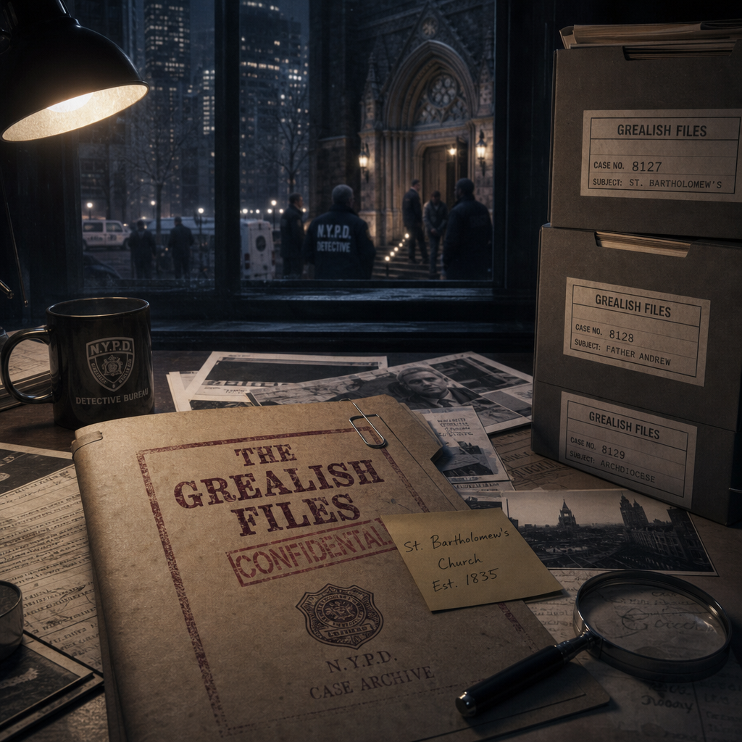

Monday morning arrived beneath a pale October sky.
The rain had finally moved east, leaving Manhattan washed clean beneath cool
autumn sunlight.
Detective Darrius Blue stood in front of the evidence board before anyone else arrived.
For several minutes he simply stared.
The investigation no longer resembled a homicide case.
It resembled a family history.
Photographs. Maps. Prayer rope images. Nancy Calloway's letter.
Edward Dwight's orphanage records. Father Michael Grealish's transfer documents.
Mitch Cayden's photograph beneath the oak tree.
Every thread pointed backward.
Not forward.
Rodney Weir walked into the bullpen carrying a cardboard tube beneath one arm.
"You beat me again."
Darrius smiled. "I couldn't sleep."
"You ever think about trying?"
"Once."
"Didn't care for it."
Rodney laughed and dropped the tube onto the conference table.
"I got a call from Albany."
Darrius looked up immediately. "What kind of call?"
"The retired archivist."
"Henry Reed?"
Rodney nodded. "He remembered something after we left."
Darrius didn't wait.
"What?"
"He said there was one cabinet."
"A locked cabinet."
Silence settled over the room.
Rodney continued.
"It wasn't part of the diocesan archive."
"It belonged to Grealish personally."
Darrius frowned. "Personal papers?"
"Maybe."
"Reed isn't sure."
"He said Grealish asked that it never be discarded."
The detective looked toward the evidence board.
"Where is it?"
Rodney smiled. "That's the interesting part."
❦
Two hours later, Darrius and Rodney stood inside the basement archive beneath
St. Michael's Parish.
Unlike the central diocesan records, this room had escaped modernization.
Dust floated lazily through narrow beams of sunlight filtering from basement
windows. Old filing cabinets lined the walls.
Wooden shelves sagged beneath decades of parish ledgers.
The smell of paper and cedar filled the room.
Father Thomas unlocked the basement door behind them.
"I didn't even know this room still existed."
Darrius looked around slowly.
"When was the last time anyone came down here?"
Thomas thought for a moment. "Years."
"Maybe longer."
Near the back wall stood a narrow steel cabinet.
Unlike the others, it remained locked. Its paint had chipped with age.
A small brass tag had been fastened near the handle.
Private Pastoral Records
Nothing else. No inventory. No dates. No explanation.
Father Thomas stared at it. "I've never seen that before."
Darrius knelt beside the lock.
The mechanism showed decades of wear.
Not damage. Use.
Someone had opened this cabinet many times. Long ago.
Rodney examined the hinges.
"No signs of forced entry."
"No."
Darrius answered quietly. "Because nobody was trying to get in."
Father Thomas disappeared briefly into the parish office upstairs.
When he returned, he carried a small ring of old brass keys.
"These belonged to Father Grealish."
He held them carefully. "They've been sitting in the parish safe since his funeral."
Silence.
The keys jingled softly as Thomas sorted through them.
One by one he tested them.
First key.
Nothing.
Second.
Nothing.
Third, a dull metallic click echoed through the archive.
Nobody spoke.
Thomas slowly pulled the cabinet door open. Dust drifted into the air.
Inside sat only four archive boxes.
No valuables. No hidden compartments. No dramatic discoveries.
Just four carefully labeled boxes.
Each written in Grealish's own handwriting.
Youth Outreach
Correspondence
Personal Notes
The final box bore no label.
Only one word.
Edward
Darrius felt every conversation from the past seven chapters rush back into his mind.
Nancy. Sabine. Henry. Mitch. Patrick. Henry Reed.
Every road had quietly led here.
Rodney looked toward him. "You want to open it?"
Darrius reached forward slowly.
Then stopped.
His hand hovered above the box.
Not from fear.
Respect.
He looked toward Father Thomas. "Has anyone opened these?"
Thomas shook his head. "Not since Father Grealish died."
Another silence settled over the archive.
Forty years of questions rested inside four ordinary boxes.
Darrius carefully lifted the one marked Edward and carried it to the center table.
He rested both hands on the lid.
The cardboard felt ordinary. Worn. Almost fragile.
Yet somehow...it felt heavier than anything he'd lifted since Nancy Calloway's murder.
He looked at Rodney.
Then Father Thomas.
Finally...he broke the brittle tape sealing the box.
The sound seemed impossibly loud inside the silent archive.
Forty years...
waiting for someone to ask the right question.
Waiting...for someone willing to hear the answer.
❦
For several moments, no one moved.
The lid of the archive box rested against the edge of the table.
Inside, dozens of neatly organized folders filled the interior.
Nothing appeared hurried. Nothing appeared hidden.
Everything had been arranged with remarkable care.
Father Thomas spoke quietly. "He always believed records mattered."
Darrius nodded. "I think he believed memories failed."
He carefully lifted the first folder.
Across the tab, written in Father Michael Grealish's unmistakably careful
handwriting, were two words.
Edward Dwight
Inside rested a stack of handwritten journal pages.
Not official reports. Not Church correspondence.
Personal observations.
The paper had yellowed with age. The ink had faded slightly.
Yet every word remained perfectly legible.
Darrius unfolded the first page.
At the top, Grealish had written only the date.
June 8, 1985
Below it—
Edward arrived today carrying more silence than luggage.
The detective stopped.
Nobody spoke.
He continued reading.
He apologizes before every sentence.
He asks permission before every question.
No child learns those habits by accident.
Rodney quietly lowered himself into a chair.
Father Thomas remained standing.
Darrius turned the page.
Another entry.
He thanked me for believing in him today.
I fear he has thanked too few people for that gift.
The detective felt something tighten in his chest.
It sounded exactly like the Edward everyone else remembered.
Gentle. Grateful. Still hoping.
He continued.
He has begun feeding the birds each morning.
The groundskeeper complained.
I did not.
A faint smile crossed Father Thomas's face.
"He really did that."
Darrius looked up. "You knew?"
Thomas nodded. "I'd forgotten."
Silence.
The journal continued.
Ordinary moments. Baseball games. Homework. Evening prayers.
Conversations beneath the old oak tree.
Nothing sensational. Nothing dramatic.
Just...life.
Rodney finally spoke. "This isn't what I expected."
Darrius nodded slowly. "Neither did I."
He reached the next dated entry.
The handwriting changed.
Not drastically.
Subtly.
The letters became tighter.
More deliberate.
The sentences became shorter.
Edward asked today whether forgiveness requires forgetting.
The detective read the next line aloud.
I told him forgetting is a failure of memory.
Forgiveness is a triumph of grace.
Nobody interrupted.
The room had grown completely still.
Darrius turned another page.
A loose photograph slipped free.
He caught it before it reached the floor.
The image showed Edward sitting beneath the enormous oak tree.
A notebook rested across his knees.
He wasn't looking at the camera. He was writing.
Father Thomas smiled. "He carried that notebook everywhere."
"You remember it?"
"I do."
"He said writing helped him think."
Darrius placed the photograph carefully beside the journal.
Then he unfolded the next page.
Halfway down...his eyes stopped.
The final paragraph had been underlined twice.
I worry less about Edward each day.
I worry more about Brendan.
Absolute silence.
Rodney looked over immediately.
"Brendan?"
Darrius nodded slowly. "It's the first time he's mentioned him."
He continued reading.
Brendan watches every conversation.
He asks different questions.
Edward asks how God forgives.
Brendan asks why God waits.
The words settled over the archive like a weight.
Different questions. Different hearts. Different futures.
Darrius continued.
Pain has introduced itself to both boys.
One seeks healing.
The other seeks certainty.
He stopped reading.
Nobody spoke.
Even Father Thomas looked shaken.
The detective carefully lowered the journal.
For the first time...
Father Michael Grealish had given his own testimony.
Not about crimes. Not about accusations.
About two boys.
One moving toward hope. One drifting toward something else.
Darrius looked down at the final line on the page.
It had been written smaller than the rest.
Almost as an afterthought.
Lord... help me reach them both.
He closed the journal slowly.
The cardboard box sat quietly on the table.
Three more boxes remained unopened.
Yet already...the investigation had changed.
Not because Darrius had discovered evidence.
Because he had discovered compassion.
And compassion...made the mystery far more difficult to solve.
❦
The archive remained silent.
Dust floated lazily through narrow shafts of afternoon light.
The open journal rested at the center of the table.
No one reached for it.
For several moments, Father Thomas simply stared.
His eyes never left Grealish's handwriting.
Finally, almost reluctantly, he spoke. "I've heard his sermons."
"I've read his published reflections."
He looked at the worn pages. "But I've never read his heart."
Darrius gently slid the journal toward him. "Now you can."
Thomas hesitated.
Not from fear. From reverence.
He turned the next page.
Another dated entry.
June 14, 1985
His voice was barely above a whisper as he read.
Edward laughed today.
A faint smile crossed Thomas's face.
Then he continued.
Not because the pain disappeared.
Because for one hour he forgot to carry it.
Silence.
Thomas swallowed.
He turned another page.
Healing never arrives all at once.
It arrives disguised as ordinary days.
Rodney looked toward Darrius.
Neither detective interrupted.
The room belonged to Grealish now.
Thomas continued reading.
Edward apologized for crying.
I told him tears are honest.
Only pride teaches us otherwise.
The young priest closed his eyes.
His breathing slowed.
"He used to say that."
Darrius looked up.
"What?"
"'God never asked us to impress Him.'"
Thomas smiled sadly. "'Only to come honestly.'"
For a moment he seemed somewhere else.
Back in seminary.
Listening to the man who had taught him ministry.
He opened the journal again.
The handwriting became tighter.
The entries shorter. More urgent.
Brendan asked whether justice always feels good.
Thomas frowned.
He continued.
I told him justice without love becomes vengeance.
The priest stopped reading.
The sentence hung heavily in the room.
He looked toward Darrius.
"That's the answer."
"The answer to what?"
"The notes." "The murders." "The poems."
Thomas looked back at the page.
"Brendan heard only half the lesson."
Darrius nodded slowly. "Go on."
Thomas rested one hand gently on the journal.
"Michael always taught that justice and mercy belong together."
"He never separated them."
He looked toward the prayer rope photographs lying nearby.
"Brendan did."
The realization settled over everyone.
Not because it solved the case.
Because it explained the theology behind it.
Thomas turned another page.
This entry was different.
Only a few lines.
Each written carefully.
Almost prayerfully.
Today Brendan asked me whether God ever gives up on people.
The room became impossibly quiet.
Thomas continued.
I answered immediately.
No.
His voice faltered.
He read the final sentence.
I pray Brendan believes me before someone else teaches him otherwise.
Thomas slowly lowered the journal.
His hands trembled. Not dramatically.
Just enough for Darrius to notice.
"You admired him."
Darrius said quietly.
Thomas smiled sadly. "I still do."
Silence.
"I've spent years wondering..."
Thomas looked at the rows of archive boxes.
"...whether Michael failed."
He shook his head.
"I don't think he did."
Darrius waited.
"I think he reached two wounded boys."
He looked down at Grealish's words.
"One accepted grace." "The other rejected it."
The distinction mattered.
A great deal.
Rodney quietly crossed his arms.
"So what happened after this?"
Thomas looked at the remaining unopened folders. "I think..."
He hesitated.
"...that's why he kept writing."
He carefully closed the journal.
His fingertips rested on the worn leather cover.
"Because he knew memory would one day need help."
Darrius looked toward the remaining folders.
Three more boxes. Dozens of journals. Forty years of silence. Waiting.
Thomas stood slowly.
Before stepping away from the table, he looked once more at Grealish's final prayer
on the open page.
Lord... help me reach them both.
He whispered almost to himself,
"I think you did."
Then, after a long pause—
"...just not in the way you hoped."
No one answered.
Outside the basement windows, church bells began ringing the hour.
The sound drifted softly through the archive.
Not as a warning. As a reminder.
Some voices...never completely disappear.
❦

Father Thomas closed the final journal gently.

For several moments, no one spoke.

Then he looked toward Darrius. "There is one person."

Darrius raised his eyes.

"Who?"

Thomas hesitated. "I don't know if she's still alive."

"Who is she?"

"Sister Clare Benson."

Rodney glanced up from his notebook.

"The name isn't in any of the files."

Thomas nodded. "It wouldn't be."

"She never worked for the Diocese." "She belonged to the Sisters of Mercy."

Darrius leaned forward. "What does she have to do with Grealish?"

Thomas rested both hands on the archive table.

"When Father Grealish returned from Albany...he visited her every month."

Silence.

Rodney frowned. "For how long?"

Thomas answered quietly. "Until the day he died."
❦

Three hours later, Darrius stood outside Saint Agnes Convent.

Nestled at the edge of the Hudson Valley, the convent overlooked rolling hills touched

with autumn colors.

Unlike the bustling churches of Manhattan, everything here moved more slowly.

The gravel paths. The quiet gardens. The steady rhythm of bells marking the hours.

Peace seemed to settle naturally over the grounds.

A novice greeted them warmly. "Sister Clare has been expecting you."

Darrius stopped. "Expecting us?"

The young sister smiled.

"She said someday someone would come asking about Father Grealish."

Rodney looked sideways at Darrius.

Neither spoke.

They followed the novice through a stone corridor lined with simple wooden

crosses and faded photographs. At the end of the hall stood an open doorway.

An elderly nun sat beside a sunlit window knitting a blue blanket.

Without looking up, she smiled. "You've taken longer than Michael expected."

Darrius felt the words settle over him. "You knew Father Grealish."

She looked up.

Her eyes were remarkably clear. "I loved him."

Not romantic. Not dramatic. Simply true.

The detective introduced himself.

She nodded politely.

"I know."

"You've been asking the right questions."

Rodney smiled. "How do you know that?"

She laughed softly. "Because you're here."

She folded the knitting into her lap. "Most people ask who was guilty."

"You asked who was hurting."

Darrius remained silent.

Sister Clare studied him for several seconds. "You read his journals."

It wasn't a question.

"Yes."

"And now you're confused."

"A little."

"No."

She smiled gently. "Quite a lot."

Even Rodney laughed quietly.

The warmth faded from Clare's face.

"Michael carried many burdens."

"But there was only one that ever frightened him."

Darrius leaned forward.

"Edward?"

She slowly shook her head.

"No."

Silence.

"Brendan."

The room became still.

Clare looked toward the convent garden outside the window.

"I met him twice."

"What was he like?"

She closed her eyes. "He was polite." "Respectful." "Very intelligent."

She paused.

"And angry."

The last word barely rose above a whisper.

"At fourteen?"

Rodney asked.

She nodded. "Not loud anger." "The quiet kind."

"The kind that asks questions...not because it wants answers..."

"...but because it wants permission."

Darrius wrote the sentence carefully.

"What kind of questions?"

Clare smiled sadly.

"He asked me...how many times should someone forgive before they're a fool?'"

The detective immediately recognized the pattern.

Justice. Mercy. Forgiveness.

Always the same themes.

"What did you tell him?"

She answered without hesitation.

"I told him forgiveness protects the heart of the person giving it."

She looked down at her knitting.

"He didn't like that answer."

"No?"

"He said..."

She hesitated.

"...that some people deserve to remember pain forever."

Silence settled over the room.

Darrius looked at Rodney.

Neither spoke.

Because both understood.

Those weren't the words of a murderer. Not yet.

They were the words of a wounded child trying to make sense of suffering.

Sister Clare reached beside her chair.

From a small wooden table she picked up a worn prayer book.

Inside rested a folded piece of paper. "I've carried this for years."

She handed it to Darrius.

"It belongs with Michael's journals."

He unfolded it carefully.

Only four handwritten lines.

No date. No signature. The handwriting was unmistakably Grealish's.

Some children ask whether God loves them.

Others ask whether God sees them.

Brendan asked whether God would ever punish enough.

I fear someone has taught him to confuse justice with vengeance.

The room fell completely silent.

Darrius read the passage again.

Then again.

Father Thomas quietly removed his glasses.

His eyes had begun to fill. "I've never seen that before."

Clare nodded. "He gave it to me after our last conversation."

"Why?"

She smiled sadly.

"He was afraid."

"Of Brendan?"

"No."

She looked directly at Darrius.

"He was afraid someone else would reach Brendan first."

Outside, the convent bell rang softly across the valley.

Its sound drifted through the open window.

Gentle. Steady. Unhurried.

Darrius folded the note with great care.

For the first time since the investigation began...he understood something that

had eluded him. Father Michael Grealish had not spent his final years trying to

protect himself. He had spent them trying to save a boy he believed was slipping

beyond his reach.

Whether he succeeded…was the question still waiting to be answered.

❦
The drive back to Manhattan passed in thoughtful silence.
Neither Darrius nor Rodney spoke for nearly an hour.
Sister Clare's words lingered in the car like a conversation neither man had finished.
He was afraid someone else would reach Brendan first.
Rodney finally broke the silence. "That line keeps bothering me."
Darrius nodded.
"Because she didn't say someone hurt Brendan."
"No."
"She said someone reached him."
"That's different." "It means influence."
Darrius kept his eyes on the highway.
"Exactly."
"Somebody didn't create Brendan."
"They shaped him."
The detective glanced briefly at the folded note Sister Clare had entrusted to him.
For the first time...the investigation wasn't searching for a murderer.
It was searching for a teacher.
❦
Back at Homicide, the conference room slowly filled.
Marcus Carson. Lily Clyne. Rodney Weir. Chief Mahon. Father Thomas.
Every major piece of the investigation now covered the walls.
Darrius stood before them. "We've been treating these murders like isolated events."
He looked around the room. "They're not."
He uncapped a marker.
Across the top of the whiteboard he wrote:
WHO TAUGHT BRENDAN?
Nobody spoke.
Below it he began listing names.
Edward Dwight. Father Grealish. Nancy Calloway. Sabine Fitcher.
Henry Collins. Sister Clare. Patrick Joel.
Each name received a brief summary. Each pointed toward compassion.
Each described the same frightened boy.
Then Darrius stopped.
He turned toward the group. "Notice something."
Lily studied the board. "They all describe Edward."
"Yes."
"They all describe Brendan too."
"But differently."
Darrius nodded. "They all watched Brendan change."
He underlined the final word.
Change.
"None of them describe him as cruel."
"No."
"They describe him as curious." "Hurt." "Searching."
Father Thomas looked thoughtfully at the board. "So something happened."
Darrius nodded.
"No."
He corrected himself. "Someone happened."
Silence.
The distinction changed everything.
Chief Mahon folded his arms. "You think there's another player."
"I know there is."
Darrius walked to the evidence table.
He spread Grealish's journals across its surface. "Read them carefully."
Everyone leaned closer.
"They mention Edward dozens of times." "They mention Brendan seventeen times."
"They mention prayer." "Mercy." "Forgiveness." "Hope."
He paused. "But there's one thing they never mention."
"What?"
Rodney asked.
Darrius looked around the room. "They never mention another adult."
The realization spread slowly.
Edward didn't become hopeful alone. Brendan didn't become bitter alone.
Someone else had entered the story. Someone Grealish never identified by name.
Or...someone whose name had been removed.
Carson looked up. "You think pages are missing."
Darrius answered immediately. "I know pages are missing."
Father Thomas frowned.
"How?"
Darrius carefully stacked the journals together. "They're numbered."
He opened the first volume.
Page 114. Page 115. Page 118.
Silence.
Rodney reached for another.
The same pattern. Pages missing. Not torn recently.
Removed decades earlier.
Cleanly. Carefully. Purposefully.
Lily examined the binding.
"Whoever did this knew exactly what they were looking for."
Darrius nodded. "They didn't steal journals." "They stole moments."
The room became perfectly still. He spread the volumes across the table once more.
Each gap occurred within the same period.
Late autumn.

Albany.
Exactly where the personnel records had already gone silent.
Father Thomas whispered, "My God..."
Darrius looked toward him. "What?"
Thomas slowly lowered himself into a chair. "They're protecting someone."
The detective nodded. "I think so too."
"But not Grealish."
"No."
"If they wanted to protect Grealish..."
He looked at the empty spaces where pages should have been.
"...they would've destroyed the journals."
Instead...someone had removed only the pages that mattered most.
Leaving the rest behind. Leaving enough truth to confuse.
Not enough to understand.
Chief Mahon finally spoke. "So who are we missing?"
Nobody answered. Nobody could. Not yet.
The room settled into silence.
Darrius stared at the blank spaces in the journals.
Sometimes...the most important witness isn't the person speaking.
It's the person everyone refuses to name.
Father Thomas quietly closed one of the journals.
His eyes never left the missing pages.
Then, almost to himself, he whispered,
"Michael always told me something."
Darrius looked over. "What was that?"
Thomas's voice was heavy with memory.
"The most dangerous secrets aren't the ones people tell."
He looked at the empty binding.
"They're the ones everyone silently agrees to stop telling."
No one spoke. No one needed to.
Darrius looked one final time at the missing pages.
The investigation had finally uncovered its greatest piece of evidence.
Not what remained. What had been deliberately taken away.
And somewhere...inside those missing pages was the name every surviving witness
had unknowingly been circling from the beginning.
❦
The conference room had emptied.
One by one, the detectives gathered their files and headed home.
Carson returned to the lab.
Lily carried the journals for preservation imaging.
Chief Mahon stopped briefly at the doorway. "Go home, Blue."
Darrius smiled faintly. "Soon."
Mahon nodded. "I've heard that before."
The door closed behind him.
Silence settled over Homicide.
Only Rodney Weir remained.
He stood near the evidence board, studying the growing web of photographs
and handwritten notes. "You ever notice something?"
Darrius didn't look away from the journals.
"What?"
Rodney pointed toward the board. "Every witness remembers Edward."
Darrius nodded. "Yes." "They remember Grealish."
"Yes." "They remember Brendan."
Another nod.
"But nobody remembers..."
Rodney frowned.
"...who was standing beside Brendan."
The words struck Darrius harder than he expected.
He slowly looked toward the board.
Edward. Brendan. Grealish. Nancy. Sabine. Henry. Patrick. Clare. Harry. Mitch.
The same names.
Again and again.
Like stars forming a constellation.
Except...there was an empty space.
He uncapped a marker.
Without speaking, he drew a circle in the middle of the board.
He left it blank.
Rodney watched. "What's that?"
Darrius answered quietly. "The person every story keeps walking around."
Silence.
He stepped backward.
The empty circle immediately changed the board.
Suddenly the evidence no longer looked complete. It looked unfinished.
Exactly as it should.
He began pinning note cards around the circle.
Albany. Missing journal pages. Three missing years. Edward's future.
Someone reached Brendan first.
Each card pointed inward. Toward the empty space.
Toward someone whose name had vanished. Not by accident. By design.
Rodney crossed his arms. "So where do we start?"
Darrius looked toward Grealish's journals. "The missing pages."
"No."
He corrected himself. "The missing handwriting."
Rodney raised an eyebrow. "What do you mean?"
Darrius opened the final journal once more.
He slowly turned the pages.
Every entry. Every date. Every reflection.
Then...he stopped.
His eyes narrowed.
Rodney noticed immediately. "What?"
Darrius pointed. "The ink."
Rodney leaned closer. "I don't follow."
"These journals were written over months."
He tapped several entries.
"The handwriting changes." "The pen changes." "The pressure changes."
He turned another page.
"But one thing never changes."
"What?"
Darrius looked up. "He never stops writing."
Rodney frowned.
"So?"
Darrius carefully traced the numbering where several pages had been removed.
"Think about it."
"If Michael wrote every day..."
He looked toward the gaps.
"...then whoever removed these pages didn't remove isolated entries."
He tapped the empty spaces. "They removed conversations."
The room fell silent.
Not random pages.
Specific days. Specific encounters. Someone had erased dialogue. Not history.
Conversation.
Which meant one thing.
There had been another voice.
Someone Grealish had spoken with repeatedly. Someone important enough to erase.
Rodney slowly exhaled. "So we're not looking for a victim."
Darrius shook his head. "We're looking for a participant."
The distinction settled over both men.
Outside, the city hummed with the distant sounds of traffic.
Life continued.
Unaware that forty-year-old secrets were beginning to surface beneath it.
Darrius walked to the evidence board once more.
Beneath the empty circle he wrote a single question.
WHO WAS MISSING FROM EVERY STORY?
He capped the marker.
Then looked toward Edward's photograph.
A frightened boy searching for hope.
Next to it...Brendan's faded image from Mitch's photograph.
Watching. Learning. Changing.
Then Grealish.
Trying to reach them both.
Three lives. One invisible shadow between them.
Darrius understood now.
The missing pages had never been about hiding Father Grealish.
They had been about hiding the person Grealish couldn't stop writing about.
He slipped the journals carefully back into their archival box.
For the first time since the case began...he felt something unfamiliar.
Not certainty. Direction.
Rodney picked up his coat. "You think we're finally close?"
Darrius looked one last time at the empty circle on the evidence board.
"No."
A slow smile crossed his face.
"I think we're finally asking the question someone spent forty years hoping nobody
would ask."
The lights in the bullpen dimmed automatically.
The evidence board remained illuminated in the soft glow from the hallway.
Photographs. Letters. Prayer ropes. Journals. An empty circle. Waiting.
History had whispered through witnesses.
It had spoken through journals.
Now...it waited for the one voice that had been erased.
When that voice was finally found...everything the investigation believed would have
to be rewritten.

Chapter Nine

The Reluctant Witness

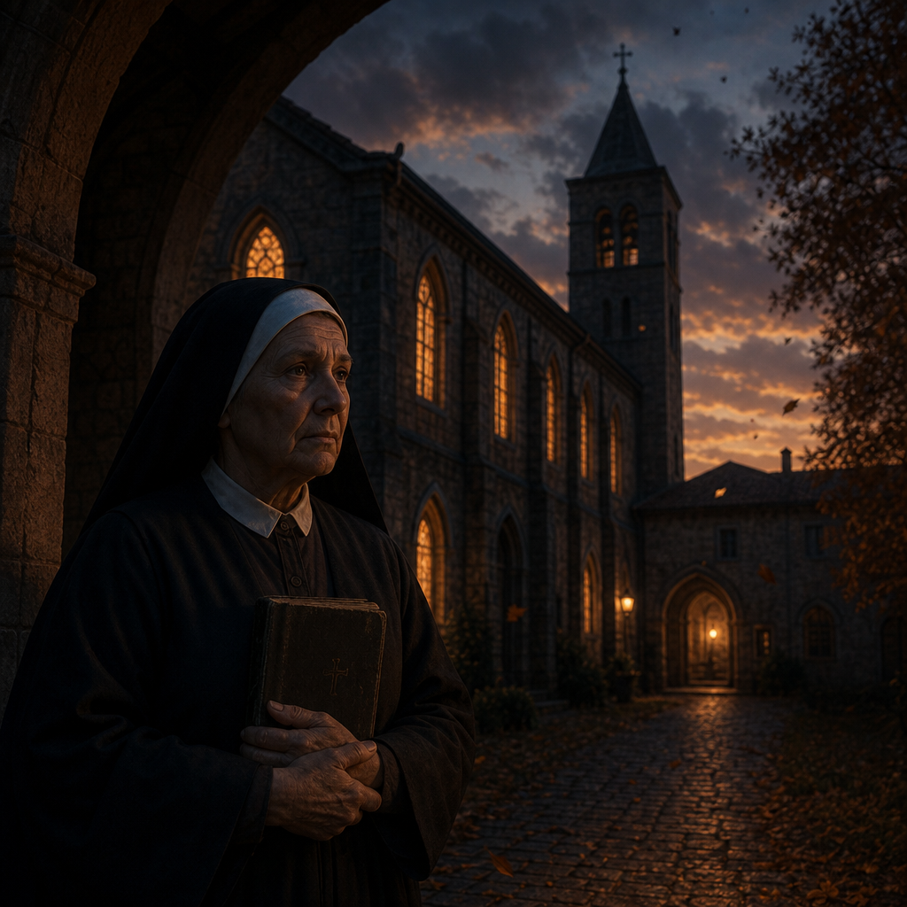

The drive north began before sunrise.
Darkness still covered the Hudson Valley as Darrius Blue guided the unmarked
sedan along nearly empty highways.
Rodney Weir sat beside him reading through Sister Clare Benson's handwritten
statement for what felt like the tenth time. Neither detective had spoken much.
Some cases demanded conversation. This one demanded thought.
The words continued echoing in Darrius's mind.
He was afraid someone else would reach Brendan first.
Those weren't the words of a witness remembering tragedy.
They were the words of someone recognizing failure.
Not Grealish's failure.
Everyone's.
The convent appeared just after dawn.
Morning fog drifted across the grounds, softening the outlines of the old stone
buildings.
Church bells rang quietly in the distance. Nothing about the place suggested secrets.
It suggested peace. Which somehow made the secrets harder to imagine.
The same novice greeted them at the entrance.
Her smile was gentle. "Sister Clare is in the chapel."
"She asked not to be disturbed."
She hesitated. "Unless it was you."
Darrius exchanged a glance with Rodney.
They followed the narrow hallway toward the chapel.
The heavy wooden doors stood partly open. Inside, only a handful of candles burned.
Sunlight filtered through stained-glass windows, filling the sanctuary with pools of
blue, crimson, and gold. Sister Clare knelt alone near the front pew.
She didn't turn when they entered. "I knew you'd come back."
Her voice carried easily through the empty chapel.
Darrius approached quietly. "You were expecting us."
"No."
She smiled softly. "I was expecting the questions."
Silence settled around them.
After a moment she rose slowly from the kneeler.
For the first time, Darrius noticed how tired she looked.
Not physically. Emotionally.
Like someone who had carried the same memory for so long it had become part of her.
She looked toward the crucifix above the altar. "I didn't sleep."
Rodney spoke gently. "Neither did we."
She nodded. "Good."
The answer surprised both detectives.
"Some truths..."
She continued quietly,
"...should cost us a night's sleep."
No one answered.
She turned toward them. "I remembered something."
Darrius felt his pulse quicken.
"What?"
She didn't answer immediately.
Instead, she walked to the first pew and rested one hand on the polished wood.
"I've spent forty years asking God to help me forget."
Her eyes remained fixed on the altar. "This morning...he finally helped me
remember." The chapel grew impossibly still.
"It wasn't Brendan."
She said quietly.
"It wasn't Edward."
"It wasn't even Michael."
She closed her eyes. "It was the door."
Darrius frowned. "The door?"
She nodded. "The office door."
"What about it?"
"I remembered someone standing there."
The detective didn't interrupt.
Memory arrived best without pressure.
"He never came inside." "He simply watched."
She looked toward the stained-glass window as though the image still lived there.
"Michael noticed him."
"So did I."
"But Edward didn't."
"And Brendan..."
She hesitated. "...Brendan never looked away from him."
Rodney leaned forward. "You saw his face?"
"I saw enough."
"What do you remember?"
She spoke slowly. "Black coat." "Gray hat." "A silver ring."
She stopped.
Her breathing changed. "The ring."
Darrius noticed immediately.
"What about it?"
"It had a cross."
She frowned.
"No..."
She shook her head.
"Not a cross."
Her voice dropped almost to a whisper. "A shepherd's staff."
Silence.
Absolute silence.
Rodney looked at Darrius.
Neither man recognized the symbol.
But both knew it mattered.
Clare continued. "He never said a word."
"He didn't have to."
"Brendan watched him the way children watch heroes."
Darrius felt the pieces beginning to shift.
Not enough to form a picture. Enough to change one.
"Did Michael know him?"
"Yes."
"How?"
"I don't know."
"But..."
She looked directly at Darrius.
"...when Michael saw him..."
"...he stopped smiling."
The words settled over the chapel.
For every witness who had remembered Grealish's kindness...
This was the first to remember his fear.
Not fear for himself. Fear for someone else.
Clare stepped closer. "I've spent years believing I imagined him."
She reached into the pocket of her habit. "I don't think I did."
She unfolded a tiny yellowed scrap of paper.
It had been folded so many times the creases had nearly worn through.
"I found this inside my prayer book this morning."
Darrius accepted it carefully.
Only one sentence appeared in Grealish's handwriting.
Watch who Brendan chooses to follow.
Nothing more. No date. No explanation. Only the warning.
Darrius read it twice. Then a third time.
The handwriting matched every journal.
Every note. Every letter. It was genuine.
Rodney looked up. "He already knew."
Clare nodded slowly. "Michael saw the change long before anyone else."
She looked back toward the crucifix. "He simply couldn't stop it."
Darrius folded the note carefully.
For weeks he had believed the investigation was uncovering forgotten history.
Now he understood something different.
Someone else had been writing the story.
Quietly. Patiently. One wounded child at a time.
Outside, the morning fog began lifting from the convent grounds.
Sunlight spilled across the stone courtyard. The day was becoming clearer.
The investigation had just become darker.
❦
Blessed Hearts Home felt unusually quiet. The children were in school.
The playground stood empty beneath a cloudless October sky.
Only the rustling of leaves disturbed the morning silence.
Patrick Joel was waiting on the front porch. He seemed unsurprised to see Darrius.
"I had another feeling."
Darrius smiled. "They've been serving you well."
Patrick laughed softly. "They usually arrive just before trouble."
The detective joined him on the porch. "You remembered something."
Patrick nodded.
"No."
"I remembered where I put something."
That caught Darrius's attention.
Patrick stood. "Come with me."
❦
Instead of leading them toward the archive room, Patrick walked through the
oldest wing of the orphanage. The hallway narrowed.
The floors creaked beneath their feet. Family photographs covered the walls.
Christmas pageants. Graduations. Summer picnics.
Decades of children who had once called Blessed Hearts home.
Patrick stopped before a small storage room.
He unlocked it with an old brass key.
Inside sat shelves stacked neatly with ordinary cardboard boxes.
None carried official labels.
Rodney looked around. "I thought the archives were downstairs."
Patrick smiled. "The official archives are."
He rested a hand on one of the boxes. "These are mine."
Darrius understood immediately.
"You kept your own records."
"I kept memories."
Patrick lifted the lid from the first box.
Inside were dozens of scrapbooks. Not administrative documents.
Personal collections. Children's drawings. Birthday cards. School awards.
Photographs.
Tiny pieces of lives that official files rarely preserved.
"I couldn't bear to throw them away."
Patrick said quietly.
"Sometimes...a child's picture tells you more than an intake report."
Darrius nodded. "I believe that."
Patrick reached toward the bottom of one scrapbook.
He carefully removed a folded construction-paper booklet.
Across the front, written in uneven pencil, were the words:
My Heroes
"It was a school assignment."
Patrick explained.
"Every child had to write about someone they admired."
He opened the booklet.
The first page belonged to Edward.
A simple drawing of Father Grealish helping children plant a tree.
Below it, Edward had written:
He listens before he talks.
Darrius smiled faintly. "That sounds like him."
Patrick nodded. "It does."
He turned another page.
A second booklet. Same assignment. Different handwriting.
Brendan Dwight.
The drawing stopped everyone.
Instead of a person...Brendan had drawn two paths.
One light.
One dark.
At the center stood a small figure holding scales.
No names. No faces. Only balance.
Below the drawing, Brendan had written:
A hero always makes things fair.
Silence.
Patrick looked thoughtfully at the page. "I never understood that drawing."
Darrius did.
Or at least...he understood more than he had yesterday.
Even as a child...
Brendan had viewed the world through justice.
Edward had viewed it through people.
The difference had always been there.
Patrick reached deeper into the scrapbook. "There was something else."
He removed a faded group photograph.
Summer picnic.
Nearly thirty children gathered beneath the old oak tree.
Darrius immediately found Edward. Then Mitch. Then Brendan.
But something else caught his attention.
Near the edge of the photograph...partially turned away from the camera
stood an adult. The face couldn't be seen.
Only the profile. Dark overcoat. Gray felt hat.
Rodney leaned closer.
"The man from Sister Clare's memory."
Patrick frowned. "I never noticed him."
"You don't know who he is?"
Patrick slowly shook his head. "I always assumed he was a volunteer."
Darrius looked carefully at the enlarged figure.
One hand rested at the man's side.
On his finger...barely visible...was a silver ring.
His heartbeat quickened.
The shepherd's staff. The same symbol. Not perfectly clear.
But unmistakable.
Rodney looked toward Darrius. "You seeing it?"
He nodded once. "The ring."
Patrick looked between them. "What ring?"
Darrius carefully pointed.
"There."
Patrick adjusted his glasses.
For several seconds he said nothing.
Finally—
"I've looked at this picture hundreds of times."
"I never saw him."
The detective smiled faintly.
"Sometimes we only recognize what's been missing..."
"...after someone teaches us to look."
Patrick quietly lowered the photograph.
His expression changed. "There's one more thing."
He crossed to a small filing cabinet in the corner.
Unlike the others, this drawer contained only sealed envelopes.
He selected one.
Across the front, in his own handwriting, appeared four words.
If anyone ever asks...
Darrius looked up. "You expected this?"
Patrick nodded. "I hoped I was wrong."
He handed over the envelope. "I wrote that twenty years ago."
"Why?"
Patrick's smile faded.
"Because Nancy told me..."
He paused.
"...that someday someone would stop investigating murders..."
"...and start investigating children."
The room fell silent.
Darrius carefully accepted the envelope.
He didn't open it.
Not yet. Some truths deserved the space to breathe.
He looked around the tiny storage room. Every shelf held forgotten lives.
Every scrapbook preserved moments no official archive considered important.
History hadn't survived because institutions protected it.
History had survived...because ordinary people loved children enough to remember them.
As they walked back into the hallway, Patrick rested one hand against the
old wooden door.
"I've spent forty years saving pieces."
He looked at Darrius.
"You may be the first person trying to put them back together."
Outside, children began returning from recess.
Their laughter drifted across the playground.
For a moment, Darrius simply stood and listened.
Edward had once laughed here.
Brendan had too.
Somewhere between those echoes...the truth had begun.
And somewhere in Patrick Joel's quiet collection...it was waiting to be heard.
❦
The sanctuary of St. Michael's stood empty.
Late afternoon sunlight poured through the stained-glass windows, filling the
nave with ribbons of crimson, sapphire, and gold. The church was peaceful.
Almost impossibly so.
Darrius found Father Thomas seated alone in the first pew.
The Grealish journals rested beside him.
He wasn't reading. He was thinking. Thomas heard the footsteps behind him.
"I wondered how long it would take."
Darrius sat beside him. "I needed to understand something."
Thomas smiled faintly. "So do I."
For a while, neither man spoke.
The silence felt familiar now. Not uncomfortable.
Reflective.
Finally Darrius asked, "Did Grealish ever tell you he was afraid?"
Thomas answered immediately. "No."
"He never said the word."
"But?"
Thomas rested one hand on the worn journal. "I saw it."
He looked toward the crucifix. "Not fear for himself."
"He stopped worrying about his reputation years before I met him."
"He worried about children."
Darrius nodded. "Especially Brendan."
Thomas closed his eyes briefly.
"I didn't understand it then."
"I thought Michael was simply carrying too much."
He smiled sadly. "Now I wonder if he was carrying exactly what he should have."
The detective looked at him. "What changed your mind?"
Thomas slowly opened the journal to a page he had marked with a ribbon.
"I kept coming back to this."
He handed it to Darrius.
The entry was dated only by month.
October 1985
Grealish had written:
There are moments when protecting the innocent requires confronting the powerful.
Below that—
Silence may preserve peace.
But it rarely preserves justice.
Darrius read the passage twice. Then a third time.
Thomas spoke quietly. "I've preached about peace my entire ministry."
He looked down. "I've quoted Michael hundreds of times."
His voice became heavy. "But I missed the part that mattered most."
"What part?"
Thomas met his eyes. "Peace without truth is only quiet."
The words settled over the sanctuary.
They echoed against the high stone ceiling before disappearing into silence.
Darrius felt the significance immediately.
Brendan believed:
Mercy without truth is another lie.
Grealish believed:
Peace without truth is only quiet.
The difference wasn't truth.
The difference was what truth was meant to produce.
Healing. Or punishment.
Thomas continued. "When I was ordained..." "Michael told me something."
He smiled faintly at the memory.
"I thought it was simply good pastoral advice."
"What did he say?"
Thomas looked toward the altar.
'Never confuse protecting the Church with protecting Christ.'
Darrius remained perfectly still.
Thomas shook his head. "I didn't understand."
"I thought they were the same thing."
He looked back at the journals. "They aren't."
Silence.
Outside, the church bells marked the hour.
Neither man moved. "I've spent years asking whether Michael failed."
Thomas said quietly. "I've stopped asking."
"What do you ask now?"
He answered without hesitation. "I ask whether we failed him."
The question hung between them.
Not accusing. Simply honest.
Darrius looked around the empty sanctuary.
Every witness. Every journal. Every memory. Pointed in the same direction.
Not toward a conspiracy of evil. Toward a culture of silence. One decision.
Then another. Then another. Until silence itself became tradition.
Thomas reached into the inside pocket of his jacket.
He removed a folded envelope.
The paper had yellowed with age. "I wasn't sure I should give you this."
Darrius accepted it carefully. "What is it?"
"A letter."
"From Grealish?"
Thomas nodded. "He gave it to me the week before he died."
"Why didn't you bring it forward?"
Thomas lowered his eyes. "Because he told me not to."
Silence.
"I've carried that guilt ever since."
Darrius unfolded the letter.
Only a single paragraph had been written.
Thomas, if the day ever comes when protecting my name interferes with protecting the truth...
Forget my name.
Tell the truth.
God can take care of my reputation.
The children cannot defend themselves.
Darrius slowly lowered the letter.
Neither man spoke.
There was nothing to add.
Only one realization remained.
Father Michael Grealish had never been trying to preserve his legacy.
He had been trying to preserve theirs.
Thomas stood slowly.
His eyes remained fixed on the crucifix.
"I spent years protecting the memory of a good priest."
He looked toward Darrius.
"I think it's finally time to protect what he was actually trying to save."
Darrius folded the letter with extraordinary care.
As he slipped it into an evidence sleeve, he understood something with
absolute clarity.
The investigation had never been about proving whether Grealish was innocent.
It had become something much greater.
It had become about finishing the work Grealish never had the chance to complete.
Outside, evening settled over the church.
Inside, two men stood in silence beneath the cross.
Not searching for forgiveness. Searching for courage.
❦
The letter remained on Darrius's desk long after Father Thomas had left.
He had read it five times. Each reading revealed something new.
Not because the words changed. Because his understanding did.
Rodney walked into the conference room carrying a stack of copied journals.
"You've got that look again."
Darrius smiled faintly. "What look?"
"The one that says you're not reading the page anymore."
Rodney laid the journals beside him.
"You're reading between them."
Darrius nodded. "I think Grealish left us a trail."
Rodney pulled out a chair. "Show me."
Darrius spread the journals across the table.
Every volume contained dated entries.
Every page reflected Grealish's disciplined routine.
Morning prayers. Pastoral visits. Hospital calls. Youth meetings. Funerals.
Counseling sessions. For decades...the pattern never changed.
Until the final year.
Darrius pointed toward the last journal. "Look here."
Rodney leaned closer.
The entries became noticeably shorter.
Many contained only a few sentences.
Others listed nothing more than dates and initials.
One entry immediately stood out.
Thursday — 7:00 p.m.
M.
Nothing else.
The following week—
Thursday — 7:00 p.m.
M.
Again. Then again. Every Thursday.
For nearly eleven months.
Rodney frowned. "No explanation?"
Darrius slowly shook his head. "Just the initial."
"M."
The detective circled every matching entry.
Forty-six appointments. Forty-six weeks. Never missed. Never explained.
Never expanded.
Rodney looked up. "Who's M?"
"I don't know."
"But whoever it was..."
Darrius looked back at the journals.
"...Michael believed they didn't need an introduction."
Silence settled over the room.
The detective continued flipping pages.
Each Thursday entry ended exactly the same way.
One letter. One time. Nothing more.
Almost as though Grealish expected no one else would ever read the journal.
Rodney reached for another volume. "Anything else?"
Darrius nodded. "Look at Fridays."
Rodney turned the page.
Every Friday entry was noticeably longer.
More reflective. More personal.
One passage had been underlined twice.
Tonight there was progress.
Another.
Still too much guilt.
Then—
Mercy is beginning to sound possible.
Rodney looked up. "Counseling."
Darrius nodded. "I think so."
"For eleven months?"
"I think someone kept coming back."
The realization settled over both men.
Not a confession. Not an investigation. A relationship.
Someone had been meeting with Grealish every Thursday evening.
Someone struggling. Someone searching. Someone identified only as M.
The detective reached for Father Thomas's letter once more.
The children cannot defend themselves.
He looked back at the journal.
Then suddenly stopped.
Rodney noticed immediately. "What?"
Darrius slowly turned the page backward.
Then forward again.
One Thursday...had no entry.
Instead, Grealish had written only three words.
Pray for him.
No initial. No explanation. Nothing.
Rodney frowned. "What happened?"
Darrius stared at the page. "I don't know."
"But something changed."
He flipped to the following Friday.
The handwriting looked different.
Shakier.
As though written by exhausted hands.
Some journeys become darker before dawn.
Then...the next week's appointment resumed.
Thursday — 7:00 p.m.
M.
The rhythm continued.
Until suddenly...it stopped.
No explanation. No farewell. No conclusion.
The appointments simply ended.
Darrius leaned back slowly. "He disappeared."
Rodney nodded.
"Or Grealish did."
"No."
Darrius looked thoughtfully at the final entries.
"If Michael had stopped the meetings...he would've written why."
Rodney understood immediately. "So M stopped coming."
Silence filled the room.
Forty-six meetings.
Nearly a year.
Then...nothing.
The detective uncapped a marker and wrote a new heading across the whiteboard.
WHO WAS M?
Below it he listed everything they knew. Met every Thursday. Sought mercy.
Carried guilt. Disappeared. Known personally by Grealish.
The list was painfully short.
Yet it represented the strongest lead they had uncovered in weeks.
Rodney stood. "I'll start checking parish appointment books."
Darrius nodded. "I'll review every surviving letter."
As Rodney reached the doorway, he paused.
"You think M is our missing witness?"
Darrius looked once more at Grealish's final journal.
"No."
His voice was calm.
"I think M is the person Michael spent his last year trying to save."
The conference room fell quiet again.
Outside, the city moved through another ordinary evening.
Inside...the investigation had uncovered something extraordinary.
Not another clue. Not another suspect. A human being.
One who had walked beside Father Michael Grealish for nearly a year...
then vanished without a trace.
Somewhere...that person was still part of the story.
Whether they knew it...or not.
❦
The Forensic Audio Laboratory was nearly dark when Darrius arrived.
Only one workstation remained illuminated.
Waveforms stretched across three computer monitors, their blue and green peaks frozen
in silent rows.
Lily Clyne looked up as he entered. "I finally got it."
Darrius set his case file on the counter. "The recorder?"
She nodded.
"The enhancement took days."
"I wasn't sure there was anything left."
She motioned him toward the workstation.
"There almost wasn't."
The tiny cassette recorder recovered from Nancy Calloway's belongings
rested beside the keyboard. It looked insignificant.
Plastic. Scratched. Ordinary.
Yet it had become one of the most important pieces of evidence in the investigation.
Lily slipped on a pair of headphones.
Then handed another pair to Darrius. "What you're about to hear..."
She hesitated.
"...isn't perfect."
"It doesn't need to be."
She pressed PLAY.
Static.
Several seconds of tape hiss.
A chair scraping across a wooden floor.
Then...a voice.
Young. Quiet. Gentle.
Edward Dwight.
The recording broke repeatedly beneath layers of interference, but his words
slowly emerged.
"...Father Michael says..."
Static.
"...you don't have to carry everything alone..."
More static.
Darrius closed his eyes.
Edward wasn't reading.
He was remembering.
The tape continued.
"...I keep thinking maybe..."
A burst of distortion.
"...maybe if I forgive..."
Silence.
The recording almost disappeared.
Then another voice entered.
Father Michael Grealish. Calm. Patient.
Barely above a whisper.
"Forgiveness isn't pretending it never happened."
Several seconds of tape hiss followed.
Then Grealish again.
"It's refusing to let it decide who you become."
Darrius felt the words settle deep inside him.
Lily adjusted several controls.
The audio became slightly clearer.
Edward spoke again.
His voice trembled.
"What if I don't know who I am anymore?"
The answer came without hesitation.
"Then we'll discover that together."
Silence.
Neither Darrius nor Lily moved.
The tape rolled on.
The next portion remained almost completely lost beneath decades of damage.
Only isolated words survived.
"...hope..."
"...tomorrow..."
"...not alone..."
Then...the recording stopped.
The reels clicked softly inside the machine.
The laboratory fell silent.
Darrius slowly removed the headphones.
Neither of them spoke for several moments.
Finally Lily broke the silence. "He believed in him."
Darrius nodded.
"No."
His voice was quiet.
"They believed in each other."
The distinction mattered.
A great deal.
Lily turned toward another monitor. "I found something else."
She enlarged the waveform near the end of the tape.
"There was background audio."
"You isolated it?"
She nodded. "It took forever."
She pressed another key.
A second recording played.
Almost inaudible. Footsteps. A closing door.
Then...another voice.
Not Edward. Not Grealish.
Someone listening.
Breathing.
The person never spoke.
But they were there.
The breathing lasted only four seconds.
Then...another sound.
A wooden door closing.
Lily stopped the playback. "I boosted it every way I know."
Darrius stared at the waveform. "Someone else was in the room."
"I think so."
"He never spoke."
"No."
"He listened."
Darrius looked down at the recorder.
Then back at the waveform.
A witness. An observer.
Perhaps even...the missing participant.
He wasn't ready to make that leap.
Not yet.
Lily watched him carefully. "What are you thinking?"
Darrius answered slowly.
"I think we've been imagining this conversation as private."
He looked toward the frozen waveform.
"It wasn't."
Silence.
Lily smiled faintly. "I hoped you'd say that."
She removed the cassette from the recorder with extraordinary care.
"I'll keep working on it."
Darrius nodded. "Do."
He picked up the recorder.
Its worn plastic case suddenly felt heavier than before.
Not because it contained evidence.
Because it contained voices. Real voices. Real fear. Real hope.
He looked once more at the waveform on the screen.
Edward had not sounded defeated.
He had sounded determined.
Searching. Healing.
For the first time since Nancy Calloway's murder...
Darrius felt the first genuine spark of hope he'd experienced in weeks.
Not because the case was solved.
Because the truth was finally beginning to speak for itself.
As he reached the laboratory door, Lily called after him.
"Detective."
He turned.
"Whatever happened after that recording..."
She looked back at the frozen waveform.
"...it wasn't the end of Edward."
Darrius nodded slowly.
"No."
"It was the beginning of someone trying to become whole."
Outside the laboratory, the hallway seemed strangely quiet.
The murders. The journals. The missing pages. The witnesses.
All of them had led here.
To a frightened young man's voice refusing to surrender to despair.
Darrius slipped the recorder into its evidence case.
Edward Dwight was no longer just a victim.
He had become a guide.
And somewhere...
someone had spent forty years trying to make sure that voice was never heard again.
❦
The anonymous call came just after dusk.
Darrius had barely returned to his desk when Rodney answered the bullpen phone.
His expression changed immediately.
He covered the receiver. "They're asking for you."
Darrius took the phone.
"This is Detective Blue."
Silence.
Then...an elderly woman's voice.
Soft. Nervous.
"I think..."
She hesitated.
"I think I know who you're looking for."
Darrius motioned for Rodney to begin tracing the call.
"My name is Alice Donnelly."
"I volunteered at Blessed Hearts during the eighties."
His pulse quickened.
"What do you remember?"
"I can't explain over the phone."
"Why not?"
Another long silence.
Finally—
"Because someone has been watching my house."
Darrius's expression hardened.
"Where are you?"
She gave an address.
An abandoned parish rectory on the outskirts of Albany.
"I found something."
"What?"
"A photograph."
"With the man you're looking for."
The line crackled. Then went dead.

❦
Forty minutes later...
Darrius and Rodney arrived.
The rectory stood alone at the end of a narrow gravel road.
Its windows were dark.
The surrounding trees swayed gently in the evening wind.
No lights. No movement.
Rodney looked toward the second floor. "You feel it?"
Darrius nodded.
"Yeah."
The place was too quiet.
They approached cautiously.
Front door. Unlocked.
Darrius drew his weapon. "Police."
No answer. They entered.
Dust covered the wooden floor.
Furniture remained where it had been abandoned years earlier.
Everything appeared untouched.
Except...a single lamp burned in the dining room.
Someone had turned it on recently.
Rodney whispered, "That's not right."
"No."
Darrius answered.
"It isn't."
They followed the light.
At the center of the table rested an old photograph.
Exactly as Alice had described.
Beside it...a folded note.
Darrius never touched either.
Instead he scanned the room.
Every instinct told him something was wrong.
Very wrong.
Rodney slowly circled toward the hallway.
The floor creaked.
Then—
A crash upstairs.
Both detectives spun.
"Police!"
Footsteps. Running. Fast.
Darrius bolted toward the staircase.
"Rodney!"
"I'm with you!"
The chase exploded through the abandoned rectory.
A shadow disappeared down the upstairs hallway.
Black coat. Gray hat. The same description.
Darrius sprinted after him.
The figure vaulted through a broken doorway.
Across another room. Down a rear staircase. Always just beyond reach.
Outside—The chase continued into the woods.
Branches whipped across Darrius's face.
Leaves scattered beneath pounding footsteps.
He caught another glimpse.
The silver ring.
Briefly illuminated by moonlight.
The shepherd's staff.
"Stop!"
The figure never looked back. Rodney closed from the left.
Darrius gained ground from behind.
For one impossible second...he believed they had him.
Then—
The man disappeared.
Not vanished. Escaped.
A narrow drainage tunnel concealed beneath fallen brush opened into the hillside.
By the time Darrius reached it...only darkness remained.
Silence.
Absolute silence.
Rodney caught up moments later.
"You okay?"
Darrius nodded.
Barely.
"He planned every step."
Rodney looked toward the tunnel. "He wanted us here."
"Yes."
Darrius answered quietly. "He wanted us chasing him."
Something tugged at the edge of his thoughts.
The photograph. The dining room. The lamp.
His eyes widened.
"Rodney."
"What?"
"The house."
Both detectives ran.
❦
They burst back through the rectory's front door.
The dining room looked exactly the same.
The photograph remained.
The lamp still burned.
But the note...was gone.
Darrius's jaw tightened.
Someone had entered while they were chasing the runner.
Someone had taken only one thing.
The message.
Rodney searched the room. "No forced entry."
"No."
Darrius answered. "They never left."
His eyes swept the room.
Then stopped.
Near the fireplace...an elderly woman sat quietly in a wooden chair.
Hands bound. Mouth covered. Alive.
Alice Donnelly.
Darrius crossed the room in seconds.
He removed the tape carefully.
She struggled to breathe.
"They knew..."
She whispered.
"They knew I'd called."
"When?"
"They were already here."
She began trembling.
"I thought..."
"...I thought they left."
Darrius knelt beside her. "They're gone now."
She slowly shook her head.
"No."
Her frightened eyes met his. "They never leave."
Silence settled over the room.
Rodney found the old photograph still lying on the table.
He picked it up.
Three priests.
Several children.
One man standing in the background.
His face scratched away. Not faded. Not damaged by time.
Deliberately removed.
Alice stared at the photograph.
Tears filled her eyes. "I knew him."
Darrius looked up immediately. "Who was he?"
She closed her eyes.
For a long moment...she said nothing.
When she finally spoke...her voice barely rose above a whisper.
"I buried his name..."
"...because Michael asked me to."
The room became utterly still.
Darrius felt every thread of the investigation pulling toward this moment.
"You buried it because he was dangerous?"
Alice slowly opened her eyes.
"No."
She looked directly at him.
"I buried it...because Michael believed there was still time to save him."
Outside...sirens echoed through the valley.
Backup units were finally arriving. Too late. Again.
Darrius looked once more at the photograph.
The face had been cut away. The note had vanished. The runner had escaped.
But something had changed.
For the first time...they had found someone who knew the missing name.
Someone who had carried it for forty years.
Someone who was finally ready to speak.
As officers secured the property, Darrius stood silently beside the shattered window
overlooking the dark woods. Somewhere beyond the trees...
the man with the shepherd's staff ring was disappearing into the night.
Not running from the investigation. Leading it.
And for the first time since the murders began...
Darrius realized the killer was no longer simply reacting to the investigation.
He was protecting someone.
Someone whose name had remained hidden for four decades.
Someone whose story...was about to change everything.

Chapter Ten

Echoes of Grealish

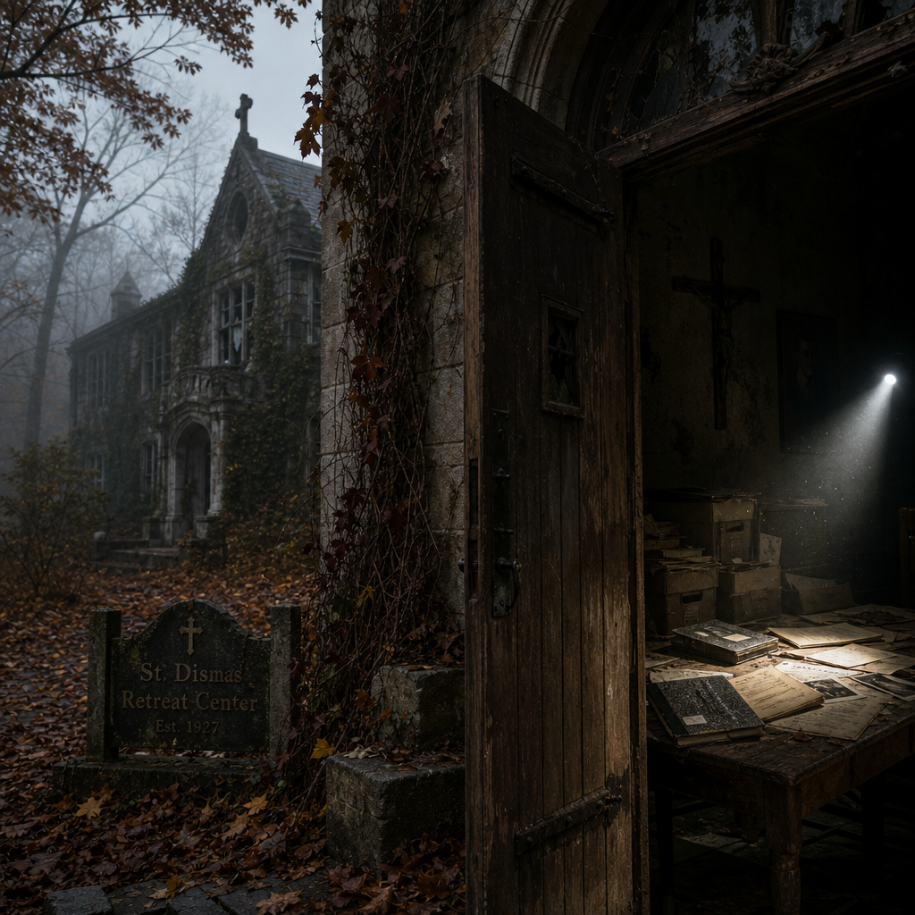

Morning mist clung to the hills north of Albany.
The narrow road wound through dense forest painted in the deep reds and
golds of late October. Towering maples arched overhead, their branches forming a
quiet tunnel that swallowed the morning light.
Darrius Blue slowed the unmarked sedan as gravel replaced pavement beneath
the tires. Rodney Weir studied the weathered map spread across his lap.
"This has to be it."
Ahead, partly hidden behind decades of overgrowth, stood the old retreat center.
The stone building emerged from the trees like something time had forgotten.
Once beautiful. Now abandoned.
Ivy climbed cracked limestone walls.
Several stained-glass windows had fractured beneath years of winter storms.
Leaves covered the front steps so completely that the original walkway had
almost disappeared. The retreat had been empty for nearly thirty years.
Yet somehow...it didn't feel abandoned.
It felt...waiting.
Rodney stepped from the car.
"No power." "No vehicles." "No footprints."
Darrius scanned the property. "Don't assume we're alone."
The detective's instincts had carried him through fourteen years of homicide
investigations. This morning they whispered the same warning they had inside
the abandoned rectory. Someone had been here. Recently.

The heavy oak doors resisted before slowly opening inward with a long,
aching groan. Cold air drifted out.
It carried the unmistakable scent of old paper.
Dust. Cedar. Wax. Books. Not decay. Memory.
Their flashlights cut through the darkness.
The entrance hall stretched before them. Simple wooden pews lined one wall.
A faded crucifix still hung above the fireplace.
Portraits of long-forgotten clergy remained suspended beneath layers of dust.
Time had stopped here.
Rodney swept his flashlight across the floor. "Look."
Fresh footprints. Only one set. Leading deeper into the building.
Not running. Walking. Slowly. Deliberately.
Darrius crouched beside them. "They're recent."
"How recent?"
"Hours."
Rodney looked toward the hallway. "So Alice was right."
"They're still moving ahead of us."
Darrius stood.
"No."
He looked down the corridor. "They're expecting us."
Silence settled over the retreat.
Only the old building answered with the soft creak of settling timber.
The detectives followed the footprints.

The hallway walls displayed faded photographs from retreat weekends held
decades earlier.
Young priests. Families. Children. Community dinners.
Ordinary moments frozen in time.
Darrius slowed.
One photograph caught his attention.
Father Michael Grealish.
Much younger.
Standing beside a group of teenagers planting saplings along the edge of the
retreat grounds. He wasn't looking at the camera.
He was laughing.
Rodney smiled. "I don't think we've seen him smile yet."
"No."
Darrius answered quietly. "We've only met the man after the tragedy."
He studied the photograph another moment.
For the first time...he saw Michael Grealish before grief had settled into his face.
It changed something.
The journals had described hope.
Now he could see it.
The footprints continued beyond the photographs toward a narrow stairwell
descending beneath the retreat.
Rodney looked over. "Basement?"
Darrius nodded. "Or archive."
They descended carefully.
Each step echoed through the empty building.
At the bottom waited a thick steel fire door.
Unlike everything else in the retreat...it appeared almost new.
Rodney frowned. "That's been replaced."
Darrius ran his hand across the metal.
Recently maintained. Fresh hinges. Modern lock.
Someone had protected whatever lay beyond.
Not abandoned it.
He examined the frame.
No signs of forced entry.
Someone still possessed the key.
Rodney looked around. "If the building's been empty for thirty years..."
"...who's maintaining one door?"
Darrius didn't answer.
He was looking at the brass nameplate bolted beside the frame.
Its engraving had faded with age.
But not enough.
RECORDS STORAGE
The detective exchanged a glance with Rodney.
Neither man needed to say it.
This wasn't another archive.
This was the archive Grealish had never mentioned.
Darrius rested one hand against the cold steel.
He thought of Nancy. Patrick. Sabine. Henry. Sister Clare.
Father Thomas. Harry Collins. Alice Donnelly.
Every one of them had unknowingly pointed toward this place.
Not because they knew what was inside.
Because Grealish had spent years quietly building a path that would eventually lead
someone here.
Rodney broke the silence. "You ready?"
Darrius looked at the heavy door.
Then back at the long trail of footprints disappearing beneath it.
Someone had entered. Someone had left.
Or...someone was still inside.
He drew a slow breath. "Let's find out."
Rodney reached for the handle.
The latch released with a solid metallic click.
The door drifted inward only a few inches before stopping against something unseen.
Cold air escaped through the narrow opening.
Along with the unmistakable scent of aging paper. And candle wax.
Darrius and Rodney looked at each other.
The retreat had been abandoned.
But someone...had been keeping the archives alive.
❦
The steel door resisted only slightly before Rodney pushed it fully open.
A rush of cool air drifted into the hallway.
Not stale. Not abandoned. Cool. Dry.
Preserved.
Darrius stepped through first.
His flashlight swept slowly across the room.
Neither detective spoke.
The archive stretched farther than either had imagined.
Metal shelving filled the basement.
Dozens of carefully organized storage boxes lined the walls.
Wooden filing cabinets stood beneath protective canvas covers.
Dehumidifiers hummed quietly in opposite corners.
Rodney stopped. "They've been maintained."
Darrius nodded. "Recently."
The retreat itself had been surrendered to time.
The archive had not.
Someone had deliberately protected it.
Every shelf bore handwritten labels.
Retreat Records
Pastoral Correspondence
Youth Programs
Community Outreach
Nothing appeared secret. Nothing appeared unusual.
Which somehow made the room even more unsettling.
Darrius walked slowly between the shelves.
Everything had been catalogued with extraordinary precision.
Every binder. Every folder. Every journal. Every photograph.
The room reflected the mind of someone who believed memory deserved order.
Rodney paused beside one cabinet. "Blue."
Darrius crossed the room.
The cabinet contained nothing but index cards.
Thousands of them. Alphabetized.
Each bearing a name.
Children. Volunteers. Priests. Teachers. Families.
A complete history of the retreat community.
Rodney gently pulled one free.
Edward Dwight
Only a reference number.
Nothing more.
Darrius found another.
Brendan Dwight
Also present.
Then...his eyes stopped.
Between them sat another card.
Its name had been removed. Not crossed out. Not blacked out.
Cut away with remarkable precision.
Only the reference number remained.
Silence. Absolute silence.
Rodney whispered, "Someone wanted the file..."
"...without leaving the name."
Darrius carefully returned the card. "They weren't erasing history."
He looked at the empty space.
"They were erasing identity."
The distinction mattered.
A great deal.
He followed the reference number toward a long row of archival boxes.
Shelf B. Section Twelve. Drawer Four.
The corresponding file should have been there.
Instead...only an empty gray folder remained.
Its tab had been left behind.
The contents were gone.
Rodney exhaled slowly. "They got here first."
Darrius didn't answer.
He looked inside the empty folder.
Something had been overlooked.
Tucked into the bottom corner rested a small square of yellow paper.
Barely larger than a postage stamp.
He lifted it carefully with evidence tweezers.
Only four handwritten words remained.
Truth survives careful hands.
Rodney looked over. "Grealish?"
Darrius compared the writing mentally.
The careful loops. The measured spacing. The restrained strokes.
"Yes."
Without question.
He slipped the fragment into an evidence sleeve.
Not because of its evidentiary value.
Because Grealish had intended someone to find it.
Rodney continued searching the shelf.
A moment later he froze. "You need to see this."
He held up a worn leather ledger.
Unlike every other volume...this one carried no title.
Only an embossed symbol.
A shepherd's staff.
Darrius felt his pulse quicken.
The same emblem. The same ring. The same image Sister Clare remembered.
He opened the ledger.
The first pages had been removed. Cleanly.
Professionally.
The remaining entries listed nothing but dates. Meeting locations. Initials.
Never full names. Always initials.
M.
T.
R.
C.
Page after page.
Years of meetings.
No explanations. No subjects. Only patterns.
Rodney frowned. "This isn't a parish ledger."
"No."
Darrius answered. "It's a map."
"A map to what?"
He slowly closed the book.
"People."
The room settled into silence once again.
He looked around the archive.
Every document preserved. Every file organized. Every memory protected.
Except...the ones someone had intentionally removed.
The pattern had become undeniable.
Not destruction.
Selection.
Someone had known exactly which truths were dangerous.
Rodney walked toward the far wall.
Another shelving unit stood apart from the rest.
Smaller. Older. Locked.
A handwritten tag hung from the brass handle.
In Grealish's unmistakable handwriting were six simple words.
Open only when mercy becomes impossible.
Neither detective moved.
The room seemed to shrink around those words.
Darrius reached out.
His fingertips rested lightly against the weathered wood.
For a long moment...he simply stood there.
Then he quietly lowered his hand. "Not yet."
Rodney looked surprised. "You don't want to open it?"
"I do."
He smiled faintly. "But Michael left instructions."
"And I think..."
He looked back at the handwritten tag.
"...he believed timing mattered as much as truth."
Rodney nodded slowly.
For reasons he couldn't fully explain...he agreed.
Some doors deserved to remain closed.
Until the people opening them were ready.
As they turned to continue searching the archive, a faint sound echoed somewhere
deeper in the basement. Not the building settling.
Footsteps. Slow. Measured.
Then...silence.
Darrius and Rodney looked toward the darkness beyond the final row of shelves.
They were no longer alone.
❦
The footsteps never came closer.
Darrius and Rodney stood motionless between the towering archive shelves.
Weapons drawn.
Flashlights trained toward the darkness.
Nothing.
Only silence.
Finally Rodney lowered his pistol.
"I think whoever it was...wanted us to know they were here."
Darrius nodded.
"And that they could leave whenever they wanted."
The realization settled heavily between them.
They resumed searching.
More carefully now.
Every shelf. Every cabinet. Every ledger. Every forgotten corner.
Nearly thirty minutes passed before Father Thomas called from the opposite
side of the archive.
"Detective."
His voice was unusually quiet. "You should see this."
❦
Hidden behind a row of unused hymnals stood a narrow cedar cabinet.
Unlike the larger record shelves, this one contained no labels.
Only a single brass lock. The key still rested in it.
Thomas looked almost uncomfortable.
"I don't think anyone ever expected this cabinet to be opened."
Darrius gently turned the key.
The lock released with a soft click.
Inside rested only three objects.
A worn leather Bible. A wooden rosary.
And...a sealed envelope.
Across the front, written in Father Michael Grealish's careful hand:
For the one who refuses to stop searching.
Silence.
Rodney slowly exhaled. "He knew."
Darrius nodded. "I think he hoped."
He carefully broke the aging seal.
Inside rested several handwritten pages.
Not a journal. Not official correspondence. A letter. One never mailed.
Never delivered.
Thomas quietly stepped beside him. "Read it."
Darrius unfolded the pages.
The handwriting remained steady throughout.
If you are reading this...
...then time has finally caught up with us.
The detective continued.
You are probably asking whether I succeeded.
I have asked myself the same question every day.
The room became perfectly still.
If you seek villains, you will certainly find them.
If you seek truth...
...you must first understand sorrow.
Darrius paused.
Every sentence sounded unmistakably like Grealish.
Not defensive. Not apologetic. Pastoral. Hopeful.
He read on.
Edward believed grace could heal memory.
Brendan believed memory required judgment.
Both boys suffered.
Only one believed suffering could end.
Thomas quietly removed his glasses.
His eyes never left the page.
Darrius continued.
Do not make the mistake others made.
Pain explains much.
It excuses nothing.
Rodney slowly folded his arms.
The line landed with tremendous force.
Not because it explained Brendan.
Because it refused to simplify him.
The letter continued.
If Brendan still lives...
Thomas looked up immediately.
Darrius read the next line aloud.
...tell him I never stopped praying for him.
Silence.
Absolute silence.
The words seemed to echo through the archive.
Rodney looked toward Father Thomas.
The priest's eyes had begun to fill.
Darrius reached the final page.
The handwriting had become noticeably weaker.
The final paragraphs carried the unmistakable tremor of age.
Some people will ask whether I protected the Church.
I did not.
I tried to protect children.
Another pause.
Then—
Others will ask whether I protected Brendan.
I tried.
Not because he deserved more mercy than Edward...
...but because mercy offered to the undeserving is the only mercy that changes the world.
No one spoke.
No one could.
The final lines were written almost as a prayer.
If I have one regret...
...it is not that I failed.
It is that I ran out of time.
Then—
A signature.
Simply:
Michael
Nothing more. No title. No rank. No "Father."
Just...Michael.
Darrius slowly lowered the letter.
The archive remained silent.
Thomas looked toward the worn Bible resting beside the empty envelope.
"I've spent years asking whether Michael carried too much."
He smiled sadly.
"No."
"He simply loved too many people to choose only one."
Rodney nodded almost imperceptibly.
For weeks they had been trying to determine whether Grealish had chosen
Edward or Brendan. The letter answered that question forever.
He had chosen both.
Even when the world demanded otherwise.
Darrius carefully returned the pages to the envelope.
Not because they were finished with them.
Because they deserved protecting.
As he placed the envelope back inside the cedar cabinet, he noticed one final
object resting beneath it. A small brass key.
Attached to it was another handwritten tag.
Only three words.
When you're ready.
Darrius looked toward the locked cabinet across the archive.
The one Grealish had marked:
Open only when mercy becomes impossible.
He slowly closed his hand around the key.
For the first time...he believed he understood why Michael Grealish had hidden the
truth instead of destroying it.
He wasn't waiting for someone intelligent enough to solve the mystery.
He was waiting for someone compassionate enough to understand it.
Outside, wind rattled the retreat windows.
Inside...forty years of silence had just spoken with remarkable clarity.
And somewhere beyond the archive walls...
someone was beginning to realize that Michael Grealish's voice had survived.
❦
The brass key felt surprisingly warm in Darrius's hand.
He stood before the weathered cabinet Grealish had labeled:
Open only when mercy becomes impossible.
For a long moment...he simply looked at it.
Father Thomas stepped beside him.
"I think he trusted you."
Darrius glanced over. "I never met him."
Thomas smiled sadly.
"No."
"But he knew someone eventually would."
Silence settled over the archive.
Darrius inserted the brass key.
It turned effortlessly.
The lock released with a quiet click.
The cabinet doors opened slowly.
Inside...there were no hidden treasures. No dramatic confessions.
Only carefully organized binders.
Each one labeled in Grealish's handwriting.
Retreat Program
Counseling Notes
Volunteer Training
Letters Never Sent
Rodney frowned. "This is what he locked away?"
Darrius nodded. "This is exactly what he'd protect."
He reached for the first binder.
Retreat Program
The opening pages described the purpose of the retreat.
Not theological instruction. Not parish administration. Healing.
Every page reflected the same mission.
Listening. Recovery. Rest. Safety.
One paragraph had been underlined in blue ink.
The purpose of this retreat is not to erase painful memories.
It is to teach people they no longer have to live inside them.
Darrius closed his eyes briefly.
Everything Grealish wrote echoed the same message.
Healing.
Always healing.
Father Thomas quietly smiled. "That's Michael."
Rodney looked toward another binder.
"What changed?"
Darrius didn't answer immediately.
Instead, he turned several pages.
Attendance lists. Volunteer schedules. Counseling sessions. Community meals.
Nothing unusual.
Then...late 1985.
The handwriting changed.
Not Grealish's.
Someone else's.
Short notes had been added in the margins.
Meeting postponed. Private session requested. Restricted attendance.
Rodney leaned closer. "Different pen."
Darrius nodded. "Different person."
He compared the handwriting carefully.
It appeared only a handful of times.
Never signed. Never identified.
Only brief instructions.
Each written beside Grealish's original plans.
Father Thomas looked troubled. "Michael didn't write those."
"No."
Darrius answered. "They were added later."
He continued reading.
The final handwritten addition stopped him.
Special instruction approved.
Nothing else. No signature. No explanation. Only approval.
Rodney frowned. "Approved by who?"
No one answered.
The room had become impossibly quiet.
Darrius carefully lifted the next binder.
Volunteer Training
Inside were handwritten lessons prepared by Grealish.
The first page read:
Children rarely need better answers.
They need safer adults.
Thomas smiled faintly. "I remember that lecture."
Another page.
Never ask a wounded child why they didn't speak sooner.
Ask what made speaking feel dangerous.
Rodney looked toward Darrius. "That's not training."
"No."
Darrius answered quietly. "That's wisdom."
Several pages later...another unfamiliar handwriting appeared.
Only one sentence.
Written across the bottom margin.
Mercy creates weakness.
Silence.
Darrius looked at Father Thomas. "You've never seen this?"
Thomas slowly shook his head.
"Never."
The detective carefully compared the handwriting.
The sharp angles. The deliberate pressure.
Every letter seemed almost carved into the paper.
Not written. Insisted upon.
He reached into his evidence folder.
Brendan's anonymous notes.
One by one he laid them beside the binder.
Rodney watched.
Neither detective spoke.
The similarities weren't identical.
Forty years separated them.
People changed. Handwriting evolved.
But something remained.
The rhythm. The spacing. The force.
Darrius finally broke the silence. "I don't think Brendan wrote this."
Rodney looked up.
"What?"
"I think..."
He studied the page again.
"...he learned to write like the person who did."
The words settled over the archive.
Not imitation.
Influence.
Father Thomas slowly lowered himself into a chair.
"My God..."
Darrius continued turning pages.
The final section of the binder contained a typed memorandum.
Unsigned. Undated.
The letterhead had been removed.
Only one sentence remained readable.
Certain children require stronger correction than compassion
can provide.
The room became perfectly still.
Nobody moved.
Nobody spoke.
Finally Thomas whispered, "That isn't ministry."
Darrius looked at him.
"No."
"It isn't."
Rodney folded the memorandum carefully into an evidence sleeve.
"So this is where it started."
Darrius slowly shook his head.
"No."
He looked around the quiet archive. "This is where someone tried to bring it."
The distinction mattered.
Grealish hadn't created the poisonous philosophy.
He had resisted it.
The retreat had become a battlefield.
Not between good and evil.
Between two radically different understandings of what broken children needed.
One believed healing came through mercy.
The other believed healing came through punishment.
Darrius closed the binder gently.
The room felt heavier now.
Not because they had uncovered corruption.
Because they had uncovered a choice.
Someone had tried to transform a sanctuary into something it was never meant
to become. And Michael Grealish had quietly fought back.
The detectives exchanged silent glances.
The investigation had just uncovered its clearest evidence yet.
The murders hadn't begun with hatred.
They had begun with competing beliefs about how wounded souls should be healed.
Outside, the wind stirred the towering pines surrounding the retreat.
Inside...history had finally revealed the moment the two paths diverged.
❦
Rodney pushed open the narrow wooden door at the end of the archive corridor.
The hinges groaned softly.
A smaller room revealed itself beyond.
Unlike the archive...this room wasn't built for records.
It was built for children.
Sunlight filtered through high basement windows, illuminating faded murals
painted decades earlier.
Blue skies. Green fields. Birds soaring over rolling hills.
Tiny wooden chairs surrounded a circular table.
Shelves held worn storybooks. Puzzles. Building blocks.
A stuffed rabbit sat quietly in one corner.
Waiting. As though recess had ended only moments ago.
Darrius stood silently in the doorway. "This wasn't an office."
Father Thomas shook his head.
"No."
"It was Michael's counseling room."
The detective slowly walked inside.
Everything had been preserved. Every chair remained exactly where it had last been
used. Every crayon rested neatly inside small glass jars.
Every book stood carefully returned to its shelf. Nothing felt abandoned.
Only...
unfinished.
Rodney knelt beside a low bookshelf. "Blue."
He held up a battered children's Bible.
Inside the front cover, written in careful handwriting, appeared one sentence.
Every child who enters this room deserves to leave believing
tomorrow is possible.
Darrius immediately recognized the handwriting.
Michael Grealish.
He gently closed the cover.
Another shelf held journals.
Not Grealish's.
Children's journals.
Each protected inside clear archival sleeves. No full names.
Only initials.
"E.D."
"M.C."
"A.D."
"T.R."
Dozens of them.
Father Thomas looked surprised. "I didn't know these existed."
Darrius carefully opened the first journal.
The pages contained childish handwriting.
Simple drawings. Short reflections. Nothing clinical. Nothing diagnostic.
One entry read:
Today Father Michael listened for a whole hour.
Another:
I didn't cry today.
Another.
I laughed.
Darrius swallowed.
They weren't records. They were victories.
Small ones. Quiet ones. But victories all the same.
Rodney carefully lifted another journal.
"M.C."
Mitch Cayden.
The first page contained only a single sentence.
Maybe God still knows my name.
Silence settled over the room.
Father Thomas quietly wiped his eyes. "He kept these?"
Darrius nodded. "He protected hope."
The detective reached toward another journal.
The initials stopped him.
"B.D."
Brendan Dwight.
The room seemed to hold its breath.
He opened it carefully.
The first pages contained drawings.
Mountains. Trees. Churches.
Nothing unusual.
Then...the writing began.
Father Michael says angry people are usually hurt first.
Another page.
Edward says forgiveness feels lighter.
Then—
I don't think he understands.
The handwriting gradually became firmer.
More deliberate.
Several pages later—
Sometimes people shouldn't be forgiven until they admit everything.
Darrius slowly turned another page.
Blank.
The next page...gone.
Then another.
Removed.
Cleanly.
Professionally.
Only jagged threads remained inside the binding.
Rodney whispered, "They took Brendan's pages too."
Darrius nodded.
"They didn't erase Edward."
"They didn't erase Brendan."
He looked at the empty spaces. "They erased the change."
The realization struck all three men simultaneously.
Someone hadn't wanted history forgotten.
They wanted transformation forgotten.
They wanted no one to see how a wounded child slowly became someone else.
Father Thomas looked around the little room.
"This place was saving children."
Darrius answered quietly, "Someone decided it wasn't enough."
Silence.
The detective continued searching.
Beneath the journals rested a small wooden box.
Inside were folded pieces of paper.
Every one written by a child.
Questions they had anonymously placed into a box after counseling sessions.
Darrius unfolded the first.
Can God still love someone who's scared all the time?
Another.
Why do bad dreams stay after morning comes?
Another.
Can people become good again?
Then...one final note.
Written in darker pencil.
The handwriting older.
More deliberate.
Who decides when punishment is finally enough?
Nobody spoke.
Darrius looked toward Brendan's journal.
Then toward Grealish's letter.
Then toward the anonymous question.
He could almost hear the conversation that had followed.
Not because it survived.
Because it had been deliberately removed.
Father Thomas slowly walked toward the window.
His voice barely rose above a whisper.
"Michael never saw broken children."
He smiled sadly.
"He only saw children."
Darrius looked around the room one final time.
Every tiny chair. Every faded mural. Every carefully preserved journal.
Every anonymous question.
This room had never been about therapy.
It had been about restoring childhood.
And someone...had decided judgment was stronger than hope.
The realization settled deep inside him.
Not as anger. As resolve.
Because for the first time since entering the retreat...
Darrius understood exactly what Michael Grealish had been fighting to preserve.
It wasn't documents. It wasn't reputation. It wasn't even truth.
It was the belief that broken children could still become whole.
Outside, the afternoon sun finally broke through the clouds.
Golden light spilled across the tiny wooden table.
For one brief moment…the room looked exactly as it must have looked forty years earlier.
Alive.
Filled with laughter. Filled with possibility. The echoes remained.
Waiting for someone to listen.

❦
Evening settled slowly over the retreat.
The last rays of sunlight filtered through the cracked stained-glass windows, casting
fractured colors across the archive floor.
The detectives had spent nearly eight hours inside the forgotten building.
Every room revealed another piece of Michael Grealish's life.
Every document had carried the same unmistakable message.
Mercy. Hope. Healing.
Darrius stood quietly in the children's counseling room.
His eyes drifted across the tiny wooden chairs.
The faded murals. The journals. The anonymous questions.
Nothing about the room felt abandoned anymore.
It felt interrupted.
Rodney entered carrying another storage box.
"I think this is the last one."
Darrius nodded. "Let's finish it."
The cardboard lid lifted easily.
Inside were dozens of cassette tapes.
Every one carefully labeled.
Counseling Sessions. Volunteer Meetings. Retreat Lectures. Children's Choir.
Seasonal Programs.
Father Thomas carefully lifted one tape. "Michael recorded everything."
"No."
Darrius replied softly. "He recorded what mattered."
Rodney reached beneath the tapes. "There’s something else."
Hidden beneath the bottom layer rested a simple wooden plaque.
Its edges were worn smooth from years of handling.
Across the front, carved by hand, appeared a single sentence.
Every child deserves one adult who never gives up.
Silence.
Absolute silence.
Father Thomas slowly lowered his head. "He used to say that."
Darrius turned the plaque over.
The back carried another inscription.
Smaller.
Written in Grealish's own hand.
If this room is ever empty...
...fill it again.
No signatures. No explanations. Only a quiet instruction.
Rodney smiled sadly. "He never thought this was about him."
Darrius shook his head. "He always thought it was about whoever came next."
The detective rested the plaque gently on the table.
It was not evidence. It was a legacy.
For several moments, no one spoke.
Then—
A distant engine echoed outside.
All three men froze.
Headlights swept briefly across the basement windows.
Rodney moved toward the stairwell.
By the time they reached the entrance...
the vehicle was already disappearing down the narrow forest road.
Black SUV.
No license plate visible. No way to identify the driver.
Only red taillights fading into the trees.
Rodney stared after it. "They were watching us."
Darrius nodded. "They wanted us to know."
He looked back toward the retreat.
"No."
He corrected himself. "They wanted to know what we found."
The distinction mattered.
Someone still cared about what remained inside Grealish's archive.
Someone believed those records were dangerous.
Father Thomas quietly locked the archive door behind them.
His hand rested on the brass key for a long moment.
"What happens now?"
Darrius looked back at the old retreat.
Its stone walls glowed softly beneath the setting sun.
Forty years earlier...
children had arrived here carrying fear.
Michael Grealish had spent his life trying to help them leave carrying hope.
Someone else had spent just as many years trying to erase that work.
The battle had never really ended.
It had simply gone quiet.
Rodney loaded the evidence boxes into the trunk.
Journals. Letters. Cassette tapes. Children's drawings. Photographs.
None of it looked extraordinary.
Yet together...they told a story powerful enough that someone had spent four
decades trying to control it.
Darrius stood one final time at the entrance to the retreat.
The evening wind stirred the maple trees overhead.
Leaves drifted across the old stone steps.
He thought of Edward. Of Brendan. Of Mitch. Of Nancy. Of Alice.
Of Patrick. Of Sister Clare.
Of every frightened child whose voice still echoed inside the walls behind him.
Then he looked at the wooden plaque resting on top of the evidence boxes.
Every child deserves one adult who never gives up.
For weeks he had believed he was investigating murders.
Now he understood something larger.
He was finishing the work of a man who had refused to surrender hope.
His phone vibrated.
A text message. Unknown number.
Only one sentence.
You are finally asking the right questions.
No signature. No threat. No explanation.
Rodney looked over. "What is it?"
Darrius handed him the phone.
Rodney read the message once.
Then again.
"He knows."
Darrius slipped the phone back into his pocket.
"Yes."
"He knows."
He looked one final time toward the retreat.
Somewhere beyond the trees...someone was watching.
Not with panic. With patience.
The investigation had uncovered the hidden archive.
Recovered Grealish's voice.
Preserved the children's stories.
But the most dangerous person in the case...had just confirmed something without
saying a word. They were still close enough to watch.
As darkness settled over the retreat, Darrius closed the trunk.
The echo of the latch sounded strangely final.
The retreat would fall silent once more.
But its voice...would travel with them.
And somewhere in New York...
Brendan Dwight was no longer wondering whether Detective Darrius Blue would
uncover the truth. He was waiting to see what Darrius would do with it.

Chapter Eleven

False Prophets

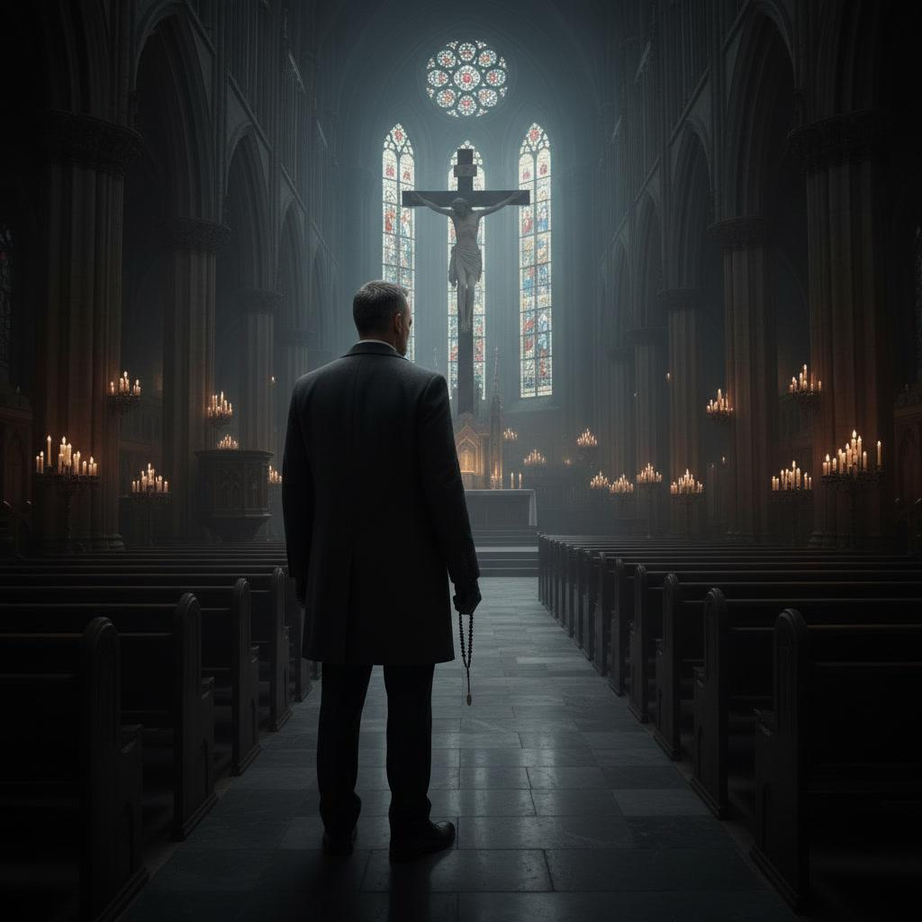

Midnight settled over Manhattan with an almost reverent silence.
The city never truly slept. It merely whispered.
Rain from earlier in the evening still clung to the stone streets, reflecting scattered
pools of amber light beneath old streetlamps.
Several blocks away, the bells of a distant church marked the passing hour.
Twelve slow chimes.
Then...stillness.
Inside St. Bartholomew's Church, only candlelight disturbed the darkness.
Hundreds of votive candles flickered beneath the towering stained-glass windows.
Their soft glow danced across polished marble floors and ancient stone columns.
The sanctuary was empty. Or so it appeared.
A lone figure stood near the last pew.
Motionless. Watching the altar.
Brendan Dwight.
His charcoal overcoat hung neatly across broad shoulders.
Black leather gloves covered his hands.
His posture was relaxed.
Patient. Almost peaceful.
One hand rested lightly on the back of a weathered pew.
The other loosely held a worn black prayer rope.
Not as a trophy. As a companion.
He looked toward the crucifix suspended above the altar.
For several minutes...he simply stood.
Listening.
The silence never frightened him.
Silence had become the only place where people stopped pretending.
A faint smile crossed his face. "They're getting closer."
His voice barely disturbed the sanctuary.
No answer came.
He hadn't expected one.
He slowly walked toward the front of the church.
His footsteps echoed softly across the marble.
Measured. Deliberate. Never hurried.
He paused beneath the crucifix.
Moonlight filtered through the stained glass, washing pale blue light across his face.
His expression revealed neither anger nor satisfaction.
Only certainty.
He reached into the inside pocket of his coat.
Carefully removing a folded newspaper clipping.
Nancy Calloway.
Her photograph stared back at him.
He looked at it for a long moment.
Then quietly placed it beneath a candle. "I asked you to tell the truth."
His voice carried neither accusation nor triumph.
Only disappointment. "You chose silence."
He lit another candle. Then another.
Three in all.
One for Nancy. One for Zachary Lyle. One for the third victim.
He bowed his head.
Not in celebration. In mourning.
To Brendan...they were never trophies.
They were consequences.
He closed his eyes.
The memories arrived as they always did.
Edward beneath the oak tree.
Father Michael laughing with children.
The retreat. The questions. The promises.
Then...another face.
Blurred.
Always blurred.
The man with the shepherd's staff ring.
Brendan's jaw tightened almost imperceptibly. "You were right."
The whispered words disappeared into the vast sanctuary.
"But not completely."
He opened his eyes again.
The candles continued burning quietly.
Their light reflected in polished marble like scattered stars.
He wrapped the prayer rope slowly around his wrist.
His thumb moved across the worn knots almost unconsciously.
Once...that rope had reminded him of mercy.
Now...it reminded him of responsibility.
He looked again toward the crucifix. "I waited."
Another whisper.
"So did He."
The great church remained silent.
Brendan smiled faintly. "Perhaps we've both waited long enough."
A cellphone vibrated inside his coat.
One message.
Unknown number.
He looked at the screen.
Blue found the retreat.
Nothing else.
Brendan read the message twice.
Then calmly deleted it.
No surprise crossed his face. No frustration.
Only inevitability.
"They've reached Michael."
He looked once more toward the altar.
"They still haven't reached you."
He slipped the phone away.
Then quietly walked toward the rear of the sanctuary.
Near the entrance, he stopped before a small wooden table holding blank
prayer cards.
He selected one. Took out a fountain pen.
Wrote carefully.
Folded the card.
Placed it inside an envelope addressed simply:
Detective Blue
Nothing more. No stamp. No return address.
As he reached for the church door, he paused one final time.
His eyes drifted upward toward the crucifix.
For just a moment...the certainty faded.
Something older appeared.
Regret.
It disappeared almost instantly. Hidden beneath decades of conviction.
Brendan opened the heavy oak doors.
Cold night air swept into the sanctuary.
The candles flickered.
But none went out.
When the doors slowly closed behind him...the church became silent once again.
Only the three candles continued burning before the altar.
Three small flames.
Refusing to surrender the darkness.
❦
The envelope rested on the passenger seat beside Brendan as he drove through
the sleeping city. The streets were nearly empty.
Traffic lights cycled patiently through deserted intersections.
Red.
Amber.
Green.
He obeyed every one. There was never any reason to hurry.
Truth arrived on its own schedule. The phone remained silent.
He preferred it that way. Noise made people careless.
Silence made them observant.
Brendan turned onto a narrow residential street in Queens and parked beneath a
dying maple tree. The house before him was modest. Well cared for.
Porch light still burning.
A bicycle leaned against the front steps.
Someone had forgotten to put it away.
He noticed details instinctively. Always had.
He slipped from the car carrying only the envelope addressed to Detective Blue.
No gloves this time. No disguise. No urgency.
A mail slot waited beside the front door.
He paused before reaching it.
Inside the house, muffled laughter drifted through the walls.
A television. Children. Life continuing.
For a brief moment...he simply listened.
The sound stirred something distant.
A memory.
Edward laughing beneath the oak tree.
Children chasing one another across the retreat grounds.
Father Michael smiling.
The memory lingered.
Then faded.
Brendan quietly slid the envelope through the mail slot.
It landed softly on the hardwood floor inside.
Mission complete.
He turned to leave.
A voice stopped him. "You came."
Brendan didn't flinch.
He already knew who it would be.
Across the street, sitting alone on a park bench beneath the streetlamp,
an older man watched him.
Gray wool coat.
Black walking cane.
Wide-brimmed hat.
His face remained hidden in shadow.
Brendan crossed the empty street.
Neither man offered a greeting.
For several moments...they simply sat together in silence.
Finally the older man spoke. "They found the retreat."
"I know."
"They found Michael's letters."
"I expected they would."
The older man nodded slowly.
"And yet..."
He looked toward the quiet neighborhood.
"...they still don't understand."
Brendan's expression never changed. "They're beginning to."
A faint smile touched the older man's face.
"Michael always believed someone eventually would."
Brendan looked straight ahead.
"He believed many things."
Silence.
The older man rested both hands atop the cane.
"You sound tired."
Brendan answered honestly. "I am."
"Second thoughts?"
"No."
The answer came immediately. Not defensive.
Certain.
The older man studied him carefully.
"I've watched you for a long time."
"I know."
"I've seen conviction become burden."
Brendan finally turned toward him.
"And I've seen silence become worship."
The words settled between them.
Neither raised his voice. Neither seemed angry.
They were simply two men who had long since stopped trying to persuade one
another.
The older man reached into his coat.
He removed a folded newspaper.
The headline described the renewed investigation into the Grealish files.
He handed it to Brendan. "They're closer than ever."
Brendan folded the paper once.
Then again.
"They should be."
"You don't sound concerned."
"I've never been concerned about truth."
The older man raised an eyebrow. "What concerns you?"
Brendan looked toward the sleeping neighborhood.
"Timing."
Silence.
The older man slowly nodded.
"Michael used to say the same thing."
That sentence lingered.
For the first time...something crossed Brendan's face.
Not anger. Not sorrow. Recognition.
"He also said..."
The older man continued,
"...that truth forced before people are ready becomes another kind of violence."
Brendan looked away. "He waited too long."
"Perhaps."
"But waiting wasn't weakness."
Brendan stood.
The conversation had reached its end.
The older man didn't try to stop him.
As Brendan turned toward his car, the older man spoke once more.
"Do you still carry it?"
Brendan paused.
Without speaking, he held up the black prayer rope wrapped around his wrist.
The older man smiled sadly.
"So..."
"...not everything Michael gave you was lost."
Brendan looked at the worn knots for several long seconds.
When he finally answered...his voice was almost inaudible.
"No."
Then he climbed into the car.
The engine started quietly.
The sedan disappeared into the darkness without another word.
The older man remained on the bench.
Alone beneath the streetlamp. Watching. Waiting.
As dawn slowly began pushing back the night.
❦
Morning arrived gray and cold over Lower Manhattan.
A steady rain tapped softly against the windows of Homicide as
Detective Darrius Blue stood alone before the evidence board.
The room was quiet.
Most of the squad had not yet arrived.
He welcomed the silence.
For weeks the board had grown more crowded.
Photographs. Letters. Prayer ropes. Cassette tapes. Children's journals.
Michael Grealish's handwriting. Brendan's anonymous notes. The restored
photograph. The shepherd's staff. Alice Donnelly's testimony. The retreat records.
Every thread had been pinned carefully into place.
Yet this morning...Darrius didn't see evidence.
He saw people.
Edward. Brendan. Mitch. Nancy. Patrick. Sister Clare. Father Thomas. Michael.
Lives.
Not exhibits.
He stepped closer.
His eyes settled on the faded photograph beneath the oak tree.
Edward smiled at something outside the frame.
Brendan stood several feet away.
Watching. Not smiling. Not angry. Simply watching.
Darrius found himself wondering something he had never asked before.
What if someone had stood beside Brendan that afternoon?
What if one conversation...
one patient voice...
one person unwilling to give up...could have changed everything?
The thought lingered longer than it should have.
His phone buzzed.
A message from Rodney.
Coffee's on. Conference room.
Darrius smiled faintly.
Some traditions deserve preserving.
❦
Rodney had already spread the newest evidence across the conference table.
Lily Clyne sat beside him reviewing enhanced photographs from the retreat.
Marcus Carson leaned against the whiteboard, coffee in one hand,
reading Grealish's letter again. Father Thomas arrived a moment later.
No one spoke immediately. They had become accustomed to beginning
each morning with quiet reflection.
Rodney finally broke the silence. "I've been thinking about something."
Darrius looked up. "The children's room."
Rodney nodded. "It wasn't just counseling."
"No."
Darrius replied. "It was belonging."
Father Thomas smiled.
"Michael believed children healed best when someone stayed."
Marcus folded the letter closed.
"That explains why Brendan never stopped talking about abandonment."
The room grew thoughtful.
Darrius walked to the whiteboard.
Without speaking, he erased the largest heading.
WHO IS THE KILLER?
The marker squeaked softly against the board.
When the space was blank, he wrote something new.
WHO STILL NEEDS TO BE SAVED?
No one interrupted.
Rodney looked at the words for a long time. "That's a dangerous question."
Darrius nodded.
"It is."
"Because?"
"Because it changes how we investigate."
He turned toward the team.
"If Brendan believes he's finishing Michael's work..."
"...then arresting him isn't enough."
Marcus frowned. "You think you can reason with him?"
"No."
Darrius answered honestly. "I think someone has to understand him."
Silence.
Lily closed the retreat file. "That's what Michael kept trying to do."
Darrius nodded. "And nobody has tried since."
The room fell silent again.
Father Thomas slowly removed Grealish's letter from his jacket pocket.
He unfolded it carefully. "I've been carrying this everywhere."
He smiled almost apologetically. "It reminds me of something."
"What?"
Darrius asked.
Thomas looked around the room before answering.
"That justice and mercy were never supposed to compete."
"They were always supposed to walk together."
No one argued.
Because every person in the room had begun to see it.
The investigation had changed them.
Not just professionally.
Personally.
Rodney leaned back in his chair. "So what's next?"
Darrius looked once more at Brendan's photograph.
Then at Edward's.
Finally...at Michael Grealish.
He spoke quietly. "We stop chasing Brendan."
Marcus looked surprised.
"What?"
"We start meeting him."
Silence.
The words settled heavily over the room.
Lily broke it first. "You think he'll agree?"
Darrius smiled faintly.
"No."
"I think he'll make us."
Rodney understood immediately. "The letter."
Darrius nodded. "The one he left at the church."
"He wants a conversation."
Father Thomas slowly folded Grealish's letter.
"Michael spent years trying to reach Brendan."
He looked directly at Darrius.
"Perhaps Brendan has spent all these years waiting for someone willing to try again."
The room remained quiet.
Outside, the rain intensified against the windows.
Darrius slipped on his suit jacket.
For the first time since Nancy Calloway's murder...
he no longer felt like a detective following clues.
He felt like a man walking into another person's unfinished conversation.
One began forty years earlier.
One that had never truly ended.
As he reached the conference room door, his eyes drifted once more
to the whiteboard.
WHO STILL NEEDS TO BE SAVED?
He left the question there. Not because he knew the answer.
Because he suspected it would determine how the story ended.
❦
The envelope waited exactly where Officer Randall had found it.
Sealed. Undisturbed. No fingerprints. No return address.
Only six handwritten words.
Detective Darrius Blue
Nothing else.
Darrius turned the envelope over once more before carefully opening it.
Inside rested a single cream-colored card.
Heavy stock. Expensive. The handwriting was unmistakably Brendan's.
Measured. Disciplined. Almost elegant.
Only one sentence appeared.
Some conversations deserve a church instead of a courtroom.
No signature. No date. No location.
Rodney looked over his shoulder. "That's it?"
Darrius nodded. "That's enough."
Lily frowned. "He wants to meet."
"No."
Darrius answered quietly. "He wants to see if we'll understand."
Silence settled across the conference room.
Marcus Carson leaned forward.
"You honestly think this is an invitation?"
Darrius handed him the card.
"Read it again."
Marcus did.
Then once more.
Slowly.
His expression changed.
"He's not threatening you."
"No."
Darrius replied. "He's challenging me."
Father Thomas accepted the card next.
The moment he saw the handwriting...
He closed his eyes.
"He learned this from Michael."
Rodney looked confused.
"The handwriting?"
Thomas nodded.
"No."
"The patience."
Everyone looked toward him.
"Michael never forced difficult conversations."
"He invited them."
Silence.
Darrius studied the card again.
Every word had been chosen carefully.
Not a demand. Not an ultimatum.
An invitation.
He walked to the evidence board.
Beneath Brendan's photograph, he pinned the card.
Then stepped back.
Something finally became clear.
Brendan had never once attempted to escape the investigation.
He had guided it.
The anonymous notes. The preserved evidence. The prayer rope.
The newspaper clippings. The retreat.
Every discovery had arrived exactly when it needed to.
Rodney saw the realization forming. "You think he's been leading us."
Darrius nodded slowly. "Not toward himself."
He looked at Michael Grealish's photograph.
"Toward Michael."
Father Thomas quietly smiled.
"Because Brendan still believes Michael is the only person who ever understood him."
The room fell silent.
Lily broke it. "Then why kill?"
The question lingered.
Darrius answered honestly.
"Because somewhere along the way..."
"...he stopped believing mercy could survive without judgment."
Marcus folded his arms. "So what now?"
Darrius didn't answer immediately.
Instead, he walked to the window overlooking the rain-soaked streets below.
People hurried beneath umbrellas.
Taxis splashed through standing water.
Ordinary life.
Completely unaware of the forty-year conversation unfolding around them.
Without turning around, he spoke. "We accept."
Rodney stared. "You want to meet him?"
"Yes."
"Alone?"
"No."
Darrius smiled faintly. "Exactly the way he expects us not to."
A quiet laugh escaped Rodney. "That sounds like you."
Darrius turned back toward the room.
"No."
He looked at Grealish's letter lying on the table.
"That sounds like Michael."
Father Thomas lowered his head.
For a long moment...he simply smiled.
"You know..."
he said softly,
"...I think he'd be proud of that answer."
Silence.
Not awkward. Comfortable. Earned.
Then Lily's computer chimed.
A new surveillance alert appeared on her screen.
Traffic cameras. Lower Manhattan.
Three hours earlier.
A man in a charcoal overcoat walking calmly through the financial district.
Face partially visible.
Brendan.
He wasn't hiding. He looked directly toward the camera.
As if he knew it was there.
Then...just before the footage ended...
He did something unexpected. He stopped.
Turned toward the lens. And smiled.
Not with arrogance. Not with triumph. Recognition.
Almost...approval.
The image froze.
Rodney stared at the screen. "He's looking at you."
Darrius nodded. "I know."
Father Thomas studied Brendan's face in silence.
Then quietly whispered,
"He's waiting."
Darrius looked at the frozen image.
For weeks...he had believed Brendan was fleeing justice.
Now he understood something entirely different.
Brendan wasn't running.
He was waiting for someone willing to challenge the story he had believed for
forty years.
Whether that conversation ended in redemption...
or tragedy...
would depend on what happened next.
Darrius removed the invitation card from the evidence board.
He slipped it carefully into his notebook.
Not as evidence. As a promise.
Outside, the rain finally began to ease.

A narrow shaft of sunlight broke through the clouds and reflected against the
windows of St. Michael's Church across the street.
The storm was passing.
The real confrontation…was only beginning.
❦
The church was nearly empty when Darrius arrived.
Late afternoon sunlight filtered through towering stained-glass windows,
painting ribbons of crimson and sapphire across the polished marble floor.
Only a handful of candles still burned beneath the side altar.
Father Thomas had honored Darrius's request.
The church remained open.
But everyone else had quietly left.
No uniforms. No surveillance teams inside. No dramatic ambush.
Only silence.
Darrius walked slowly toward the center aisle.
His footsteps echoed softly beneath the vaulted ceiling.
Then—
A familiar voice. "You came."
Darrius stopped.
Brendan emerged from the shadows near the rear transept.
The same charcoal overcoat. The same measured posture.
The black prayer rope still wrapped loosely around his wrist.
For several long moments...
Neither man moved. Neither reached for a weapon. Neither raised his voice.

It felt less like the beginning of an interrogation...
and more like the continuation of a conversation interrupted decades earlier.
Brendan spoke first. "I wasn't certain you would understand the invitation."
Darrius answered calmly. "I wasn't certain you wanted me to."
A faint smile touched Brendan's face. "Fair enough."
Silence settled again.
Brendan looked toward the altar. "Michael liked this church."
"You've been here before."
It wasn't a question.
Brendan nodded. "Many times."
"He said the silence here helped people hear themselves."
Darrius studied him carefully.
"And did it?"
Brendan considered the question.
"For a while."
He slowly walked toward one of the pews.
His fingertips brushed the polished wood almost absentmindedly.
"I've wondered..."
he said quietly,
"...how much they've told you."
Darrius didn't answer immediately.
Instead he looked toward the candles burning beneath the crucifix.
"They told me about a frightened boy."
Brendan's expression didn't change.
"They told me about Michael."
"They told me about Edward."
Another pause.
"They told me about hope." The word lingered.
Brendan looked down. "They always start there."
"And where do you start?"
Brendan looked directly into his eyes. "With truth."
Silence.
Darrius nodded once. "So let's begin there."
Brendan smiled faintly. "That's exactly what Michael used to say."
The similarity did not escape either man.
For a moment...it felt as though Grealish's presence lingered quietly between them.
Neither man mentioned it.
Brendan continued walking slowly through the sanctuary.
"I've listened to people describe me for forty years."
"Murderer." "Monster." "Victim." "Failure."
He stopped beside a candle stand.
"No one ever asks the question that matters."
Darrius spoke softly. "Which is?"
Brendan looked at the flickering flames.
"What happens..."
"...when a child spends so long waiting for justice..."
"...that waiting becomes his identity?"
Silence filled the sanctuary.
Darrius let the question remain unanswered.
Brendan continued. "Michael believed time healed wounds."
"He believed people could change."
"He believed mercy could interrupt history."
A small smile crossed Brendan's face. "He never stopped believing that."
"No."
Darrius agreed. "He didn't."
Brendan nodded slowly. "I loved him for that."
The admission hung in the air.
Unexpected.
Completely sincere.
Darrius heard no deception.
Only grief.
Brendan's eyes never left the candles. "I disappointed him."
Darrius answered carefully. "I think he feared losing you."
Brendan closed his eyes.
"He did."
"And I feared losing him."
Another long silence.
When Brendan spoke again...
his voice had softened.
"Do you know what people misunderstand about faith?"
Darrius waited.
"They think belief begins with answers."
He looked toward the crucifix.
"It doesn't."
"It begins with the question you refuse to stop asking."
"And yours?"
Brendan answered immediately.
"When is enough...finally enough?"
Darrius felt the weight of the question.
Not because he agreed with it.
Because he understood why Brendan had spent a lifetime asking it.
He took a slow step forward. "I found your journal."
Brendan didn't react. "I thought you might."
"I read the pages they left."
A faint shadow crossed Brendan's face.
"They left the wrong ones."
Silence.
"They removed the boy."
Brendan said quietly.
"And left the man."
Darrius looked steadily at him. "I've been trying to find the boy."
For the first time...Brendan looked genuinely unsettled.
Only for an instant.
Then it was gone.
He looked away. "He's been gone a long time."
Darrius shook his head. "I don't believe that."
The words echoed softly through the sanctuary.
Brendan smiled.
Not mockingly.
Sadly.
"Michael wouldn't either."
He turned toward the front doors. "I wanted to know something."
"What?"
Brendan met his eyes one final time.
"I wanted to know if you came here to arrest me..."
"...or to understand me."
Darrius answered without hesitation. "I came because Michael never got to
finish the conversation."
Silence.
Longer than before.
Brendan's eyes searched his face.
Not for weakness.
For sincerity.
Finally...he nodded once.
Almost imperceptibly.
"Then perhaps..."
he said quietly,
"...there's still something worth talking about."
Without another word, he walked toward the great wooden doors.
He opened them slowly. Cold evening air swept into the sanctuary.
Before stepping outside, he paused.
His back remained turned.
"Next time..."
he said softly,
"...bring the question Michael never answered."
The doors closed gently behind him.
Darrius remained alone beneath the stained-glass windows.
He did not chase him. He did not call for backup.
He simply stood in the silence Michael Grealish had once loved.
For the first time...Brendan Dwight had not spoken like a killer.
He had spoken like a wounded man who had spent forty years waiting for someone
to ask the right question.
And Darrius understood something with absolute certainty.
The next conversation would determine far more than the outcome of a
murder investigation.
It would determine whether Michael Grealish's final act of faith had been in vain.
❦
The sanctuary remained silent long after Brendan disappeared.
Darrius stood alone beneath the towering stained-glass windows.
The candles still burned.
Their small flames reflected across the polished marble floor.
He replayed every word. Every pause. Every glance.
Not searching for deception. Searching for truth.
The great doors opened quietly behind him.
Father Thomas entered first.
Rodney followed a moment later.
Neither man spoke immediately.
Father Thomas looked toward the empty entrance. "He's gone."
Darrius nodded. "Yes."
Rodney studied his face. "You could've called us."
"I know."
"You could've arrested him."
"I know."
Silence.
Finally Rodney asked the question everyone had been carrying.
"Why didn't you?"
Darrius looked toward the altar. "Because he wasn't running."
"He was talking."
The words settled gently through the sanctuary.
Rodney folded his arms. "Talking doesn't erase murder."
"No."
Darrius answered. "It doesn't."
He turned toward them. "But neither does arresting him erase forty years."
Father Thomas quietly lowered himself into the front pew.
His eyes drifted toward the crucifix.
"What did you see?"
Darrius considered the question. "A man."
Rodney frowned. "That's all?"
"No."
"A man still carrying a conversation Michael began when he was a child."
The priest closed his eyes.
"Michael always believed conversations could outlive people."
Darrius smiled faintly. "I think he was right."
Rodney walked slowly toward the candle stand.
Three candles still burned.
One already beginning to melt into the brass holder.
"He lit these?"
"Yes."
"For the victims?"
Darrius nodded.
Rodney stared at the flames. "I don't understand him."
Darrius stood beside him. "I don't think he understands himself."
Silence.
The detective reached into his jacket.
He removed Brendan's invitation card.
Then, beside it the folded note Grealish had written decades earlier.
Watch who Brendan chooses to follow.
He placed both on the front pew.
Side by side.
Two voices.
Separated by forty years.
Yet somehow...still speaking to one another.
Father Thomas noticed immediately. "He chose someone."
Darrius nodded.
"Yes."
"But I don't think he ever stopped wanting Michael to be right."
The realization hung in the air.
Not because it excused Brendan.
Because it made him tragic.
Rodney looked at the two handwritten notes. "So where do we go from here?"
Darrius answered without hesitation.
"We find the man with the shepherd's staff ring."
Silence.
"For Brendan?"
Rodney asked.
"No."
Darrius replied. "For everyone."
He looked again at Grealish's warning.
"If Brendan learned this philosophy...someone taught it."
Father Thomas slowly stood.
"And if that man is still alive..."
Darrius finished the thought.
"...then this story never really ended."
The words lingered.
Outside, church bells began ringing the evening Angelus.
Their sound drifted gently through the sanctuary.
No one moved.
Finally Father Thomas walked toward the altar.
He extinguished the first candle.
Then the second.
When he reached the third...
he paused.
His hand hovered above the flame.
Instead of blowing it out...
he stepped back.
Rodney looked puzzled. "You missed one."
Thomas smiled quietly.
"No."
His eyes remained fixed on the single remaining flame.
"I left one."
Darrius understood immediately.
Hope.
Not certainty.
Hope.
He looked toward the great wooden doors where Brendan had disappeared.
Somewhere beyond them...
a wounded boy had become a wounded man.
Somewhere beyond them...
another man still waited in the shadows.
The one who had taught judgment without mercy.
The one Michael Grealish had spent his final years trying to stop.
Darrius slipped Grealish's note back into his notebook.
Then Brendan's invitation.
Two men. Two philosophies. One unfinished conversation.
As he reached the sanctuary doors, his phone vibrated.
A secure message from Lily.
We identified the shepherd's staff symbol.
It's older than we thought.
You need to come in.
Darrius read the message twice.
Rodney saw his expression change. "What happened?"
Darrius looked back one last time at the lone candle still burning beneath the crucifix.
Then quietly answered.
"I think...we've finally found where this story really begins."
The three men stepped out into the cool evening air.
Behind them, the heavy church doors closed with a deep, resonant echo.
Inside, one candle continued to burn.
A single light. Refusing to surrender the darkness.

Chapter Twelve

The Shepherd's Shadow

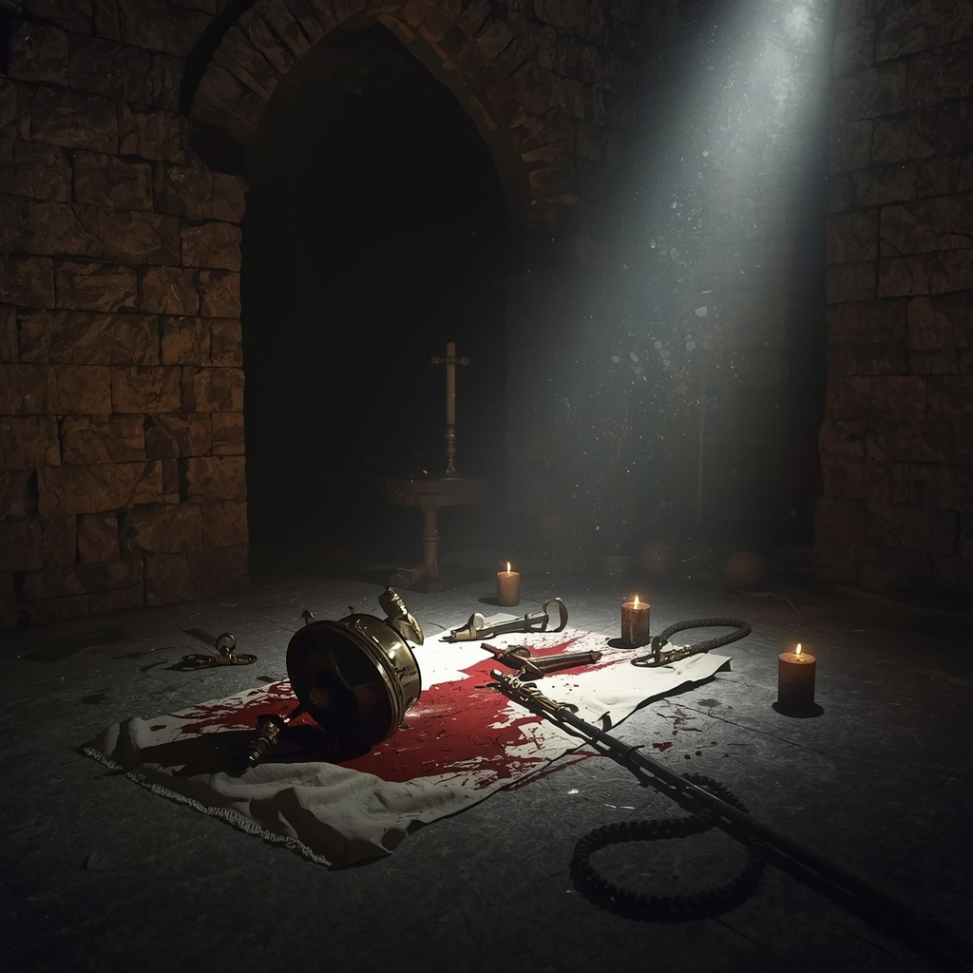

The text from Lily arrived at 7:42 p.m.
Darrius had barely left St. Michael's Church when his phone vibrated again.
I didn't want to discuss this over messaging.
Come now.
Nothing more. No explanation. Only urgency.
Rodney glanced over from the driver's seat.
"Lily?"
Darrius nodded once. "She's found something."
Neither detective spoke during the drive.
Rain had returned, falling steadily across the city.
Windshield wipers swept back and forth in perfect rhythm.
Outside, Manhattan moved through another ordinary evening.
Inside the sedan...nothing felt ordinary anymore.
❦
The Forensic Analysis Unit remained brightly lit despite the late hour.
Lily stood waiting beside a large monitor.
Stacks of reference books covered the table around her.
Religious histories. Ecclesiastical heraldry. Old diocesan directories.
She looked exhausted. But excited.
Marcus Carson stood nearby, equally intent.
"You found it."
Darrius said.
Lily nodded. "I think I found him."
Silence.
She enlarged the image recovered from the retreat ledger.
The shepherd's staff symbol filled the screen.
Elegant.
Simple.
Easy to overlook.
Until someone knew where to search.
"I assumed it was decorative."
Lily said. "It isn't."
She pressed another key.
A second image appeared. Then a third. Then a fourth.
The same staff.
Different decades. Different documents.
Always the same design. Always appearing beside private correspondence.
Never public records.
Marcus crossed his arms. "So what is it?"
Lily took a slow breath. "It's not a church seal." "It's not a diocesan emblem."
"It's a personal mark."
She enlarged one final document.
An aging photograph of several priests attending a private retreat in 1984.
One man wore the identical symbol on a silver ring.
His face had been partially obscured by another attendee.
But the ring remained perfectly visible.
Darrius stepped closer. "Can you identify him?"
Lily nodded slowly. "I think so."
She reached for a brittle personnel directory.
Its pages crackled as she turned them.
Finally...she stopped.
A handwritten notation had been tucked inside.
Next to one photograph.
One name.
Father Adrian Mercer
Silence.
Rodney frowned. "I've never heard of him."
"No one has."
Father Thomas answered quietly from the doorway.
Everyone turned.
He had arrived only moments earlier.
His face had gone pale. "I thought he died."
Darrius looked toward him. "You know the name?"
Thomas nodded. "Barely."
"He was already gone before I entered seminary."
He walked slowly toward the monitor.
"I only remember Michael mentioning him once."
"What did he say?"
Thomas didn't answer immediately.
Instead, he stared at the photograph.
Then quietly whispered,
"He said Adrian Mercer loved justice..."
"...so much that he eventually stopped recognizing mercy."
The room became perfectly still.
Lily opened another file. "There isn't much."
"Personnel records disappeared." "Assignment history is incomplete."
"No death certificate." "No retirement file."
Marcus looked up.
"So he vanished."
Darrius slowly shook his head.
"No."
"He was erased."
The distinction echoed through the room.
Every missing page. Every cut photograph. Every altered file.
Every unnamed witness. Everything had pointed toward one missing man.
Not Brendan. Not Michael.
Adrian Mercer.
Father Thomas continued studying the image.
His voice had become almost inaudible.
"Michael once told me...that the most dangerous teacher isn't the one who hates the truth."
Darrius looked toward him.
"The most dangerous teacher..."
Thomas finished quietly,
"...is the one who believes only he understands it."
No one spoke.
The words explained everything.
Brendan had not invented his philosophy.
He had inherited it.
Lily turned back toward the screen. "There's something else."
She enlarged the photograph again.
Standing three rows behind Mercer...
barely visible...
was a teenage boy. Head lowered. Hands folded.
Darrius immediately recognized him.
Brendan.
Young.
Watching. Always watching.
The room fell silent.
For forty years...they had searched for the man who taught Brendan.
Now...they finally had his name.
But names alone never solved murders.
Darrius stared at Adrian Mercer's photograph.
For the first time since the investigation began...the shadow had a face.
And somewhere...that face was still shaping the present.
❦
The conference room remained silent.
Adrian Mercer's photograph filled the monitor.
A single face.
One that had somehow remained absent from every official record the investigation
had uncovered.
Darrius stood with his hands resting on the conference table.
He couldn't stop looking at the photograph.
There was nothing extraordinary about the man.
Late forties. Dark suit. Roman collar. Calm expression.
Intelligent eyes.
If not for the silver ring bearing the shepherd's staff...
He could have been mistaken for any parish priest in the country.
Marcus Carson broke the silence. "He doesn't look dangerous."
Father Thomas answered quietly. "Neither did Michael."
The distinction lingered.
Darrius nodded.
"Sometimes the most dangerous ideas arrive wearing ordinary faces."
Lily turned another page in the recovered personnel directory.
"There isn't much left."
She projected the remaining documents onto the screen.
Assignment history. Ordination records. Retreat schedules.
Most had been heavily redacted.
Entire paragraphs had been removed.
Names carefully excised. Dates altered.
Someone had spent years dismantling Mercer's paper trail.
Rodney folded his arms. "Someone wanted him forgotten."
Darrius slowly shook his head.
"No."
He looked toward the photograph. "They wanted him impossible to find."
Silence.
Father Thomas stepped closer.
"I remember one story."
Everyone looked toward him.
"I was a first-year seminarian."
"Michael and another priest were discussing old retreat programs."
Thomas smiled faintly at the memory.
"I asked why they had stopped."
"What did Michael say?"
Thomas's expression darkened.
"He said..."
"...that retreats should teach wounded people how to live."
He paused.
"Mercer believed they should teach wounded people how to judge."
No one spoke.
The contrast explained everything.
Lily opened another recovered document.
Unlike the others...this one had survived almost intact.
A typed lecture outline.
Title:
Justice and Restoration
"No author listed."
She said quietly. "But watch this."
She highlighted several passages.
Compassion without accountability invites further evil.
Another.
Mercy offered prematurely becomes permission.
Then—
Pain ignored eventually becomes corruption.
Rodney looked toward Darrius. "There's truth in that."
Darrius nodded.
"There is."
He looked back at the document. "That's what makes it dangerous."
Silence.
Marcus frowned. "What do you mean?"
Darrius pointed to the final paragraph.
It had been typed separately from the rest.
As though added later.
When institutions refuse to act...
the righteous must.
The room became still.
Father Thomas closed his eyes.
"There it is."
"The break."
Darrius nodded. "Everything before that argues for reform."
He tapped the final paragraph.
"This argues for replacement."
The distinction mattered enormously.
Mercer hadn't begun with fanaticism.
He had drifted into it.
Exactly the way Brendan later would.
Lily enlarged another page.
Handwritten notes covered the margins.
The handwriting wasn't Mercer's.
Darrius recognized it instantly.
Michael Grealish.
Short observations appeared beside nearly every paragraph.
Justice without mercy ceases to resemble Christ.
Another.
Fear changes children faster than love.
Another.
Healing requires truth.
Truth also requires hope.
Father Thomas smiled sadly.
"They argued."
Darrius nodded.
"For years."
Rodney looked surprised. "They stayed friends?"
Thomas answered before Darrius could. "I think they kept trying to save each other."
Silence settled over the room.
The realization carried enormous weight.
Mercer had not been Grealish's enemy.
He had been his friend.
Perhaps even his closest theological opponent.
Darrius slowly closed the folder. "So what happened?"
No one answered immediately.
Finally Lily spoke. "I found one last notation."
She enlarged the final page.
Only a single sentence remained legible beneath layers of damaged ink.
Retreat program suspended pending review.
Below it...a handwritten date.
November 1985.
Darrius looked toward Father Thomas. "That's when everything changed."
Thomas nodded slowly.
"That's when Michael stopped talking about Adrian."
"And started writing about Brendan."
The room fell silent. Every thread suddenly connected. Not perfectly.
But enough.
Mercer disappeared. Brendan changed. The retreat closed.
The journals became guarded. The missing pages began.
None of it looked accidental anymore.
Darrius walked once more to the evidence board.
He placed Adrian Mercer's photograph beside Michael Grealish's.
For a long moment...he simply looked at them.
Two priests. Two faithful men. Two radically different understandings of justice.
Between them...he pinned Brendan's childhood photograph.
A frightened boy.
Standing unknowingly between two competing visions of the world.
Rodney looked at the board.
"My God."
Darrius answered quietly.
"That's exactly what Michael was trying to prevent."
Outside the conference room windows, dawn's first light began creeping across the skyline.
The city was waking.
Inside...the investigation had finally uncovered the true origin of the conflict.
Not hatred. Not revenge.
A battle over the soul of one wounded child.
And forty years later...that battle still wasn't over.
❦
The archive boxes from the retreat occupied nearly half the conference table.
Every folder had been carefully cataloged. Every journal was preserved.
Every letter was placed inside protective sleeves.
Darrius reached for the smallest bundle.
Unlike the others, it bore no official label. Only a strip of masking tape.
In Michael Grealish's familiar handwriting were four simple words.
Private Correspondence — A.M.
Father Thomas drew a slow breath.
"Adrian."
Darrius nodded. "I think these are the letters."
Rodney carefully untied the faded cotton ribbon holding the bundle together.
The paper had yellowed with age. The edges were worn from repeated reading.
These hadn't been filed away. They had been kept close.
Darrius unfolded the first letter.
The handwriting belonged to Adrian Mercer.
Strong.
Disciplined.
Deliberate.
Dear Michael,
You continue to believe that mercy changes people.
I continue to believe that truth changes people.
Perhaps both are necessary.
The room remained silent.
Darrius continued.
Yet every year I watch institutions choose comfort over courage.
How long should we wait before someone acts?
He lowered the page.
"There it is."
Father Thomas nodded quietly.
"The question."
The detective reached for Grealish's reply.
Unlike Mercer's precise script, Michael's handwriting flowed gently across the page.
Dear Adrian,
Truth without mercy rarely survives its own certainty.
People obey fear.
They are transformed by love.
Darrius looked up.
"He answered the argument."
Thomas smiled sadly. "He always did."
Another letter.
Months later.
Mercer's handwriting had become sharper.
More compressed.
Your compassion is being mistaken for surrender.
Children need protection.
Not patience.
Rodney folded his arms.
"I can understand why someone would think that."
"So can I."
Darrius answered honestly. "That's what makes this difficult."
He reached for Grealish's response.
Protection and punishment are not the same thing.
Confusing them has destroyed more souls than either of us will ever know.
Silence.
Marcus Carson slowly shook his head.
"They were arguing about Brendan."
Father Thomas nodded.
"And Edward."
"And every child who came through the retreat."
The next letter stopped everyone.
It had never been mailed.
Michael's signature remained unfinished.
The ink trailed off midway through the final sentence.
Darrius read aloud.
Adrian...
I fear we are beginning to speak different languages.
You see wounded children and ask who failed them.
I see wounded children and ask who will stay.
No one moved.
The final paragraph had been written more heavily than the rest.
Almost pressed into the paper.
If we ever stop believing people can become more than the worst thing that has happened to them...
...then we have stopped preaching Christ.
The room fell completely silent.
Father Thomas quietly removed his glasses.
He wiped at his eyes before speaking.
"I've never read that."
"I wish every seminarian had."
Darrius carefully placed the letter beside Mercer's.
Two voices. Two faithful men.
Neither questioning the existence of evil. Only disagreeing about how to answer it.
Rodney picked up the final envelope.
Already opened.
Inside rested only a single sheet.
No greeting. No signature. No date.
Just one sentence.
Written in Adrian Mercer's unmistakable hand.
If mercy fails Brendan...
...history will remember which one of us was right.
The words landed with enormous weight.
No anger. No threat. Only conviction.
Darrius looked toward Father Thomas.
"When was this written?"
Thomas studied the paper for a long moment.
"Late 1985."
"The last year they spoke."
Silence settled across the room.
Darrius gathered the letters into a single stack.
He no longer saw them as evidence.
He saw them as the final conversation between two friends who desperately
wanted the same outcome. Children protected. Lives restored.
The tragedy was that they had come to believe those goals required opposite paths.
He looked toward the evidence board.
Michael. Adrian. Brendan. Edward.
No longer separate stories.
One story. One disagreement. One child caught in the middle.
Darrius spoke almost to himself.
"Michael never stopped trying to save Adrian."
Father Thomas looked over.
"No."
"And Adrian..."
He lowered his eyes.
"...never realized Michael was trying to save him too."
Outside, thunder rolled across the city.
Rain began striking the windows once again.
The storm had returned.
Inside the conference room, however, something had become unmistakably clear.
The murders had not begun with hatred.
They had begun with two men answering the same question in profoundly
different ways. Only one had forgotten that truth without mercy eventually becomes
another form of violence.
❦
Rain lashed against the windows as Lily carefully slid one final document beneath the
evidence scanner. The paper had been folded for decades.
Its edges were brittle.
Several portions had been damaged by moisture.
Yet enough remained to read.
Darrius stood beside the monitor.
Rodney and Marcus watched from opposite sides of the room.
Father Thomas remained seated. His hands folded quietly before him.
No one spoke.
The scanner slowly reconstructed the faded ink.
Across the top appeared an official heading.
Retreat Review Committee
Below it...
a date.
November 18, 1985.
Rodney looked up immediately. "The week the program ended."
Darrius nodded. "Keep going."
The first page contained routine administrative language.
Budget concerns. Attendance. Volunteer schedules. Nothing unusual.
Then...the second page appeared.
Several paragraphs had been blacked out years earlier.
Lily's enhancement recovered fragments.
Only fragments.
But enough.
...continued disagreement regarding counseling philosophy...
Another.
...Father Mercer insists disciplinary intervention...
Another.
...Father Grealish refuses to remove Edward Dwight...
Silence.
Father Thomas slowly looked up. "Edward."
Darrius leaned closer. "Why would Mercer want him removed?"
The next recovered line answered.
...believes emotional attachment is preventing accountability...
Marcus frowned. "I don't understand."
Neither did Darrius.
Not yet.
Lily continued enhancing the damaged page.
Words slowly emerged.
Not complete.
Just enough.
...Brendan increasingly identifies with Father's instruction...
Rodney whispered,
"My God."
The room remained perfectly still.
The next sentence took nearly thirty seconds to resolve.
Every person watched the monitor.
Letter by letter.
Word by word.
Finally—
...recommend immediate suspension pending further review...
Father Thomas closed his eyes. "They shut it down."
"No."
Darrius answered quietly. "They shut Michael down."
Silence.
Lily loaded the final page.
Unlike the others...this one had survived almost perfectly.
Typed.
Signed.
Official.
At the bottom appeared two signatures.
Father Michael Grealish
Beneath it...
Father Adrian Mercer
Rodney looked surprised.
"They both signed it."
Darrius shook his head slowly.
"No."
He pointed toward the ink.
"Look closer."
Mercer's signature flowed naturally across the page.
Michael's did not.
His pen had stopped halfway through the final letter.
As though interrupted.
Or reluctant.
Father Thomas leaned closer.
"I've seen Michael's signature thousands of times."
He looked toward Darrius. "That isn't how he signed anything."
Silence settled once again.
Darrius studied the page carefully.
Something wasn't right. Not forged. Not fake.
Simply...unfinished.
Almost as though Michael had signed the document...
while refusing to agree with it.
Rodney looked at the committee heading.
"So what happened after this meeting?"
No one answered.
Until Lily quietly spoke.
"I think..."
She enlarged one final handwritten notation along the bottom margin.
Different ink. Different handwriting.
Not Michael. Not Mercer.
Only six words.
Meeting concluded without reconciliation.
The room fell silent.
That was it.
No dramatic confrontation. No scandal. No shouting.
Two men had walked into a meeting believing wounded children deserved protection.
They had walked out believing protection meant two entirely different things.
The retreat never recovered.
Neither did Brendan.
Darrius looked toward the evidence board.
Every thread converged here.
November 1985.
Not the beginning of evil. The beginning of separation.
Michael continued choosing mercy. Mercer continued choosing judgment.
Brendan chose Mercer. Edward chose Michael.
Four lives. One decision. Forty years of consequences.
Father Thomas stood slowly.
His voice barely rose above a whisper.
"I used to wonder why Michael never spoke about Adrian again."
He looked toward the committee report. "Now I know."
Darrius looked over.
"Why?"
Thomas's eyes remained fixed on the faded signatures.
"Because once someone stops believing mercy belongs beside truth..."
"...arguments no longer change them."
The room remained quiet.
Outside, the storm finally began to ease.
Inside...
history had just answered the question that had haunted the investigation from the beginning.
Not who. Not where. Not even why.
When.
November 1985.
The month two faithful men chose different roads.
One spent the rest of his life trying to heal a wounded child.
The other spent the rest of his life trying to correct one.
And Brendan Dwight...had lived inside the consequences of that choice ever since.
❦
The conference room had grown quiet again.
The rain outside had stopped.
Only the occasional drip from the fire escape broke the silence.
Darrius stood before the evidence board.
He wasn't reading documents anymore.
He was reconstructing a life.
Edward. Brendan. Michael. Mercer.
The photographs no longer looked disconnected.
They formed a timeline. A family. A fracture.
Lily approached carrying one final archival box. "I almost missed this."
She placed it carefully on the table.
Unlike every other box recovered from the retreat, this one bore no catalog number.
Only a handwritten label.
Personal Interviews
Father Thomas looked puzzled. "I've never heard of these."
Darrius lifted the lid.
Inside rested a dozen cassette tapes.
Each accompanied by a handwritten transcript.
The first several interviews involved volunteers.
Teachers. Parents. Youth counselors.
Nothing unexpected.
Then...one folder stopped him.
Across the tab appeared only two initials.
B.D.
Silence.
Rodney leaned forward.
"Brendan."
Darrius nodded.
He carefully opened the transcript.
At the top of the page appeared a date.
October 31, 1985
Only two weeks before the retreat closed.
The interview began simply.
Michael: How are you sleeping?
Brendan: I don't dream anymore.
Darrius continued reading.
Michael: Is that a good thing?
Brendan: It means I stopped hoping.
No one in the room moved.
Father Thomas lowered his eyes.
Darrius read on.
Michael: Hope isn't something you lose.
It's something you practice.
Brendan's reply followed immediately.
Father Mercer says hope without justice is pretending.
Silence.
Absolute silence.
There it was. Not manipulation.
Influence.
A wounded teenager repeating the words of the adult he trusted.
Darrius kept reading.
Michael: And what do you believe?
The transcript paused.
A handwritten note in the margin read:
Long silence.
Then—
Brendan: I don't know anymore.
Father Thomas closed his eyes. "My God..."
Rodney whispered. "He was asking for help."
Darrius nodded. "He hadn't chosen yet."
The distinction changed everything.
The next page continued.
Michael: Then don't let anyone choose for you.
Another handwritten notation.
Brendan begins crying.
The room fell completely silent.
No one spoke. No one even turned the page.
Finally Darrius continued.
Brendan: What if everyone leaves?
Michael's response came immediately.
*Then I'll stay.
Another pause.
Then—
Brendan: Can you promise?
The transcript ended there.
The final page...was missing.
Removed cleanly from the binder.
Rodney slowly lowered himself into a chair. "They took the answer."
Darrius nodded. "They took the promise."
Father Thomas stared at the empty binding.
"They wanted history to forget that Brendan asked to be saved."
Silence settled over the room.
Darrius reached for another transcript.
This one bore Edward's initials.
Only a single paragraph survived.
Edward: Brendan thinks justice will make the pain stop.
Michael: And what do you think?
Edward: I think someone has to stay with him until he believes he doesn't
have to carry it alone.
The detective slowly closed the folder.
Edward had understood. Even as a teenager.
He had seen Brendan's struggle long before anyone else.
Marcus Carson spoke quietly.
"So Brendan wasn't lost."
Darrius looked toward him.
"No."
"He was divided."
The room remained silent.
Darrius walked to the evidence board.
He removed Brendan's childhood photograph.
For a long moment...he simply held it.
A frightened boy.
Eyes searching the edge of every room.
Waiting for someone to answer a question he couldn't even name.
Then Darrius placed the photograph directly between Michael Grealish and
Adrian Mercer.
Not beneath either.
Between them.
Father Thomas noticed immediately. "Why there?"
Darrius answered without looking away. "Because that's where he always was."
Silence.
"He wasn't born choosing mercy." "He wasn't born choosing judgment."
"He was a child." "He trusted the adults who loved him."
Rodney slowly nodded. "And they loved him differently."
Darrius looked toward Grealish's photograph.
"Michael believed love stayed."
Then toward Mercer.
"Adrian believed love corrected."
He looked back at Brendan. "A frightened boy tried to believe both."
No one spoke. There was nothing left to add.
The room had finally uncovered the central tragedy of the case.
Brendan Dwight had never been caught between good and evil.
He had been caught between two men he believed loved him.
Only one taught him that brokenness could become wholeness.
The other taught him that brokenness demanded judgment.
Outside, clouds finally parted over Manhattan.
Late afternoon sunlight broke across the skyline.
Inside the conference room...
Darrius understood something with complete certainty.
He no longer needed to solve Brendan.
He needed to save whatever remained of the boy Michael Grealish refused to abandon.
And somewhere...
Brendan was still waiting to hear the answer Michael never had the chance to finish.
❦
Night settled over Manhattan beneath a blanket of low, gray clouds.
Inside Homicide, the investigation room remained illuminated long after the rest of
the precinct had grown quiet. Evidence covered every available surface.
The Grealish journals. Mercer's correspondence. The retreat files.
Children's drawings. Photographs. Letters.
Forty years of memory...finally assembled.
Darrius stood alone before the evidence board.
He no longer searched for missing pieces.
He searched for direction. His eyes settled on the photographs.
Michael Grealish. Adrian Mercer. Edward Dwight. Brendan.
The shepherd's staff ring. The retreat. The committee report. The children's room.
The board had become more than evidence.
It had become a history of choices.
Rodney entered carrying two cups of coffee.
"You've been staring at that board for twenty minutes."
Darrius accepted the cup. "I've been listening."
Rodney smiled. "To what?"
"The spaces."
Silence.
Rodney looked back toward the board. "I think we've found almost everything."
Darrius slowly shook his head.
"No."
He pointed toward Brendan's photograph.
"We've found how he got here."
Then he pointed toward the empty space beneath it.
"We still don't know where he's going."
Before Rodney could answer—
Lily hurried into the room.
She carried a fresh printout.
Her expression told them everything.
"What happened?"
Darrius asked.
"We found another camera."
She laid several surveillance stills across the table.
The timestamp read:
5:46 p.m.
Only two hours earlier.
The location—
St. Michael's Church.
Brendan.
Walking calmly across the courtyard.
Not alone.
A second figure waited beside the stone gate.
Older. Gray coat. Wide-brimmed hat.
Adrian Mercer.
The image wasn't perfect. But it was enough.
Father Thomas entered behind Lily.
The moment he saw the photograph...he stopped walking.
His face drained of color.
"He's alive."
No one answered. No one needed to.
Marcus Carson leaned over the images. "Can we enhance them?"
Lily nodded. "I already did."
The final frame appeared.
Brendan handed Mercer something.
A small object. Wrapped in cloth.
Darrius recognized it immediately.
"The prayer rope."
Father Thomas whispered,
"No..."
He stepped closer.
"Michael gave that to Brendan."
Rodney looked toward Darrius. "Why would he hand it over?"
Darrius didn't answer.
Because he already knew.
Not surrender.
Decision.
The final thread connecting Brendan to Michael had just been placed into Mercer's hands.
Lily enlarged the final image.
Mercer didn't keep it.
He gave it back.
The room fell silent.
Brendan accepted the prayer rope.
Then both men looked toward the church.
Toward the exact sanctuary where Darrius and Brendan had spoken only hours
before. Marcus broke the silence.
"They knew we'd been there."
Darrius nodded. "They wanted us to know they knew."
The distinction mattered.
Mercer wasn't hiding.
He was inviting.
Just as Brendan had.
Only for a very different reason.
Father Thomas slowly sat down.
His eyes remained fixed on the photograph. "I've been wrong."
Darrius looked over.
"About what?"
Thomas answered quietly. "I thought Adrian disappeared."
He looked at Brendan. "He never disappeared."
"He simply stopped needing the Church."
Silence.
Darrius picked up Grealish's final letter.
One line drew his attention again.
If Brendan still lives... tell him I never stopped praying for him.
He folded the page carefully.
Then looked toward the newest photograph.
Michael had prayed. Mercer had waited. Brendan had chosen.
But perhaps...not completely.
His phone vibrated. Unknown number. No caller identification.
Only a text.
He still carries Michael's words.
A second message arrived before anyone spoke.
Come before someone convinces him to let them go.
No signature. Nothing else.
Rodney stared at the screen. "Mercer?"
Darrius slowly shook his head.
"No."
"Brendan."
Silence.
The room seemed to stop breathing.
Marcus looked confused. "Why would he send that?"
Darrius looked toward Brendan's photograph.
"Because this isn't a chase anymore."
He slipped the phone into his pocket. "It's a race."
Father Thomas stood. "Race to what?"
Darrius answered without hesitation. "Who reaches Brendan first."
The words echoed through the conference room.
Every witness.
Every journal.
Every letter.
Every memory.
Everything had been leading to this.
Not catching Brendan.
Reaching him.
Before Mercer finished what he had started forty years earlier.
Rodney quietly picked up his coat. "So where do we begin?"
Darrius looked toward the evidence board one final time.
His eyes rested on the photograph of the frightened boy beneath the oak tree.
Then on the man who now carried the same prayer rope around his wrist.
Finally...he looked at Michael Grealish.
"We begin…
He spoke with quiet certainty.
"...where Michael would have."
Outside, thunder rolled across the city.
The first drops of rain struck the precinct windows.
Somewhere in Manhattan...
Brendan Dwight walked toward the final decision of his life.
And somewhere else...
Adrian Mercer believed history was finally about to prove him right.
Neither man realized that Detective Darrius Blue had finally stopped investigating the
past.
Now...he was coming to finish the conversation.

Chapter Thirteen

The Shepherd's Voice

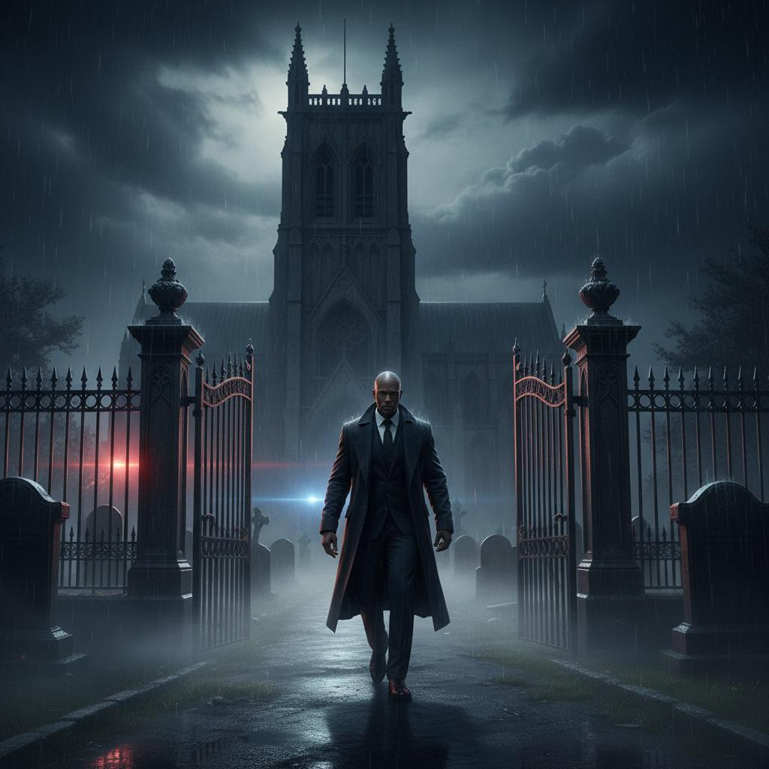

The city awakened beneath a cold October dawn.
Low clouds drifted between the skyscrapers, softening the first light into muted
shades of silver. Traffic slowly returned to the streets. Commuters hurried toward
trains. Coffee shops unlocked their doors. Another ordinary morning.
Yet inside Manhattan Homicide...nothing felt ordinary anymore.
Darrius Blue had not gone home.
The evidence board remained exactly as he had left it.
Michael Grealish. Adrian Mercer. Edward Dwight. Brendan. The prayer rope.
The retreat.
Forty years compressed into a single wall.
Rodney entered carrying fresh coffee. "You've been here all night."
Darrius accepted the cup without looking away. "I kept thinking about the text."
Come before someone convinces him to let them go.
Rodney nodded. "You still think Brendan sent it."
"I do."
"Why?"
Darrius finally turned.
"Because Mercer never asks."
"He tells."
Silence.
Father Thomas entered moments later.
He looked almost as exhausted. "I couldn't sleep."
Darrius smiled faintly. "I don't think any of us did."
Thomas approached the evidence board.
His eyes settled on Michael Grealish's photograph.
"He used to tell us something."
"What?"
Rodney asked.
Thomas answered quietly.
"When two shepherds call the same sheep..."
"...the sheep eventually learns which voice brings peace."
The room fell silent.
Darrius slowly looked back toward Brendan's photograph.
Mercer had spent forty years speaking.
So had Michael.
Brendan had spent forty years listening.
His phone vibrated.
Lily.
"Detective."
"I've got something."
"I'm sending it now."
Seconds later a map appeared on the conference room monitor.
Colored markers spread across Manhattan.
Red. Blue. Yellow.
Rodney frowned. "What am I looking at?"
Lily enlarged the display. "Every confirmed Brendan sighting."
Then another layer appeared.
Historical locations connected to Michael Grealish.
Churches. Hospitals. Shelters. The retreat. Youth centers.
Finally...a third layer.
Known assignments connected to Adrian Mercer.
The room became silent.
The three patterns overlapped.
Not randomly.
They formed a corridor stretching across the city.
Father Thomas stepped closer.
"My God..."
Darrius whispered, "He isn't wandering."
Rodney looked again. "He's retracing something."
Darrius nodded slowly. "A journey."
Lily highlighted the final location.
One site.
Never previously searched.
No murders. No witnesses. No evidence. Only one connection.
Michael Grealish had visited it every year for nearly two decades.
Father Thomas recognized it instantly. "Saint Gabriel Cemetery."
Rodney looked confused. "A cemetery?"
Thomas nodded. "Michael performed memorial services there every November."
Darrius felt the realization settle into place. "Not memorial services."
He looked toward Grealish's journals. "Appointments."
The Thursday entries.
M.
Every November.
Every year.
Always the same place.
Rodney looked stunned. "You think Brendan met him there?"
"No."
Darrius answered. "I think Brendan still does."
Silence.
Lily interrupted. "There's more."
She enlarged a traffic camera image captured only thirty-two minutes earlier.
Brendan's sedan.
Heading north.
Toward Saint Gabriel Cemetery.
No attempt to conceal the vehicle. No alternate route. No evasive driving.
Marcus Carson entered just in time to see the image. "He's inviting us."
Darrius slowly picked up his coat.
"No."
He looked once more at the photograph of young Brendan beneath the oak tree.
"He's giving us one last chance."
Father Thomas quietly retrieved Michael Grealish's final letter from the evidence
table.
He folded it carefully and handed it to Darrius. "Take it."
Darrius looked at him.
"He never stopped believing Brendan would come back."
Thomas nodded. "Then neither should we."
The detective slipped the letter inside his jacket.
Not as evidence.
As a promise.
Rodney reached for his keys.
"Let's go."
Darrius stopped him. "Not with lights."
Rodney looked puzzled.
"Why?"
Darrius answered with quiet certainty. "Because we're not going there to corner him."
He looked toward the cemetery marked on the map.
"We're going there to meet him."
No one argued.
Because for the first time...
Every person in the room understood the mission.
Not capture. Not revenge. Not victory.
Reach Brendan before Mercer did.
Outside, the clouds finally began to break.
A narrow shaft of sunlight slipped between the buildings,
illuminating the skyline for only a moment before disappearing again.
Darrius walked toward the elevator.
Each step carried the weight of every journal...
every witness...
every unanswered question.
Forty years earlier, Michael Grealish had walked toward a frightened young
man believing one conversation could still change a life.
Now...another man was walking the same road.
The elevator doors opened.
Darrius stepped inside.
As they began to close, he looked once more at the folded letter resting inside his coat.
For the first time since Nancy Calloway's murder...
he no longer wondered whether they would find Brendan.
He wondered...whether they would find him in time.
❦
Saint Gabriel Cemetery rested on a gentle hillside overlooking the Hudson River.
Morning fog drifted between rows of weathered granite markers.
Towering oak trees stretched their branches across narrow stone pathways,
their autumn leaves carpeting the ground in shades of gold and crimson.
The cemetery was quiet. Not empty. Peaceful.
Darrius stepped from the sedan first.
The cold air carried the faint scent of damp earth and fallen leaves.
Rodney joined him moments later.
Neither man spoke.
Some places demanded silence before words.
Father Thomas slowly closed the passenger door behind him.
His eyes swept across the headstones. "I haven't been here in years."
Darrius looked toward the old chapel standing near the center of the grounds.
"This is where Michael came every November?"
Thomas nodded. "Without fail." "No funerals." "No official services."
"He simply came."
Rodney looked around. "To visit someone?"
Thomas smiled sadly. "We all assumed so."
"But he never said."
The three men followed the winding stone path toward the chapel.
The morning mist softened every sound.
Even their footsteps seemed reluctant to disturb the stillness.
Near the chapel entrance stood an elderly groundskeeper
carefully sweeping leaves from the walkway.
He looked up as they approached.
His lined face brightened with quiet recognition. "Father Thomas."
Thomas smiled warmly. "Good morning, Henry."
The old man rested both hands on the broom handle.
"It's been a long time."
"It has."
Thomas hesitated. "We're looking into Father Michael's visits."
Henry's smile faded. "I wondered when someone finally would."
Silence.
Darrius stepped forward. "You knew him?"
Henry chuckled softly. "For twenty years."
"He never missed a November."
Rodney asked the question waiting in everyone's mind.
"Who was he visiting?"
Henry looked toward the hill overlooking the river.
"He wasn't visiting."
The detectives exchanged confused glances.
Henry leaned the broom against the chapel wall. "He was waiting."
Silence.
The old groundskeeper motioned for them to follow.
They climbed a narrow stone path bordered by ancient maple trees.
Finally Henry stopped before a simple granite bench.
No headstone. No grave. Just a bench facing the river.
A small brass plaque had been fastened beneath the seat.
Darrius brushed away fallen leaves.
The inscription read:
Hope waits here.
Nothing more. No names. No dates.
Rodney looked puzzled. "This isn't a memorial."
Henry nodded.
"No."
"It was Michael's meeting place."
Every November...same bench.
Same hour. Same thermos of coffee. Same two paper cups.
Father Thomas looked up sharply.
"Two?"
Henry smiled. "He was never alone."
The words settled gently over the hillside.
Darrius slowly sat on the weathered bench.
His fingers traced the worn wood. "So Brendan came."
Henry nodded.
"Almost every year."
"He'd sit right there."
The old groundskeeper pointed to the opposite end of the bench.
"They rarely spoke at first."
"What did they do?"
Henry looked toward the river. "They watched the water."
The detectives remained silent.
Henry continued. "Some years they'd sit an hour without saying ten words."
"Other years..."
He smiled faintly. "They'd argue until I thought both of them would miss supper."
Father Thomas laughed quietly. "That sounds like Michael."
Henry nodded. "He never stopped showing up."
Darrius looked toward the brass plaque once more.
"Hope waits here."
Henry's expression softened. "Michael carved that himself."
"He told me..."
The old man paused.
"...that hope isn't something people lose."
"It's something another person keeps carrying until they're strong enough to carry it again."
Silence.
The river flowed quietly below the hillside.
Its gentle current seemed timeless.
Rodney walked slowly around the bench. "Did Brendan stop coming?"
Henry's eyes lowered.
"For a while."
"After Michael died."
He looked back toward the detectives. "I kept bringing two cups anyway."
Darrius looked up. "Why?"
Henry smiled.
"Because Michael asked me to."
No one spoke.
The old groundskeeper reached into the pocket of his work jacket.
He withdrew a small envelope.
Yellowed with age.
"My wife told me I should've turned this over years ago."
He handed it to Darrius.
"The last thing Michael ever left here."
Across the front, in Grealish's familiar handwriting, were six simple words.
If he comes after I'm gone...
Darrius carefully unfolded the note inside.
Only one sentence appeared.
Sit with him until he remembers he isn't alone.
The detective stared at the page.
The words blurred slightly as emotion caught unexpectedly in his throat.
Henry looked toward the empty place beside Darrius on the bench.
"You know..."
he said quietly,
"...for the first few years after Michael died..."
"...Brendan still came."
Rodney looked over.
"He did?"
Henry nodded.
"He'd sit exactly where you're sitting now."
"He'd bring two cups."
Silence settled over the hillside.
Darrius looked at the empty space beside him.
The worn wood bore faint circular stains.
Coffee cups.
Left there year after year.
Not because Brendan believed Michael would return.
Because somewhere deep inside...
he couldn't bring himself to stop meeting the only man who had never stopped
believing in him.
Father Thomas quietly wiped his eyes. "He came anyway."
Henry smiled. "Every November."
The old groundskeeper looked toward the river.
"But he always left before sunset."
Darrius folded Michael's note with extraordinary care.
For weeks he had searched for Grealish's final strategy.
His final plan. His final clue.
Instead...he had found something much simpler.
Michael's last instruction had never been about solving a murder.
It had been about keeping a promise.
Sit with him.
Stay.
Don't leave.
The same promise he had made to a frightened boy nearly forty years earlier.
As the wind stirred the autumn leaves around the bench, Darrius quietly looked
toward the empty path leading into the cemetery.
Somewhere...Brendan was coming back.
Not because he believed Michael was still waiting.
Because some part of him still hoped someone else might be.
❦
The cemetery had grown quieter.
Henry returned to his work farther down the hill, his broom whispering softly
across the stone paths. Rodney stood several yards away, speaking quietly into his
radio.
Father Thomas walked toward the small chapel, leaving Darrius alone beside the
bench overlooking the Hudson. The river moved steadily beneath a pale autumn sky.
Unhurried.
Certain.
Darrius looked again at the brass plaque.
Hope waits here.
He folded Michael Grealish's note and slipped it carefully back inside his jacket.
Then…without another thought...he sat down.
Exactly where Michael had once sat.
The old wooden bench creaked gently beneath his weight.
The wind carried the scent of fallen leaves across the hillside.
Nothing happened. No mysterious figure emerged. No hidden message appeared.
Only silence.
Darrius welcomed it.
For the first time in weeks...
He stopped chasing answers. He simply listened. Minutes passed.
The sounds of the city disappeared beneath birdsong and the distant movement of
the river. He imagined Michael sitting here.
Two paper cups resting between them. One offered. One accepted.
Sometimes filled with conversation. Sometimes filled only with presence.
Henry had been right.
Not every important conversation required words.
Footsteps approached slowly behind him.
Rodney.
"You've been sitting here almost half an hour."
Darrius smiled faintly.
"I know."
Rodney glanced toward the empty place beside him.
"You expecting someone?"
Darrius looked at the worn wood.
"No."
He paused.
"But I think someone expected me."
Rodney nodded slowly.
He didn't sit.
Instead, he leaned lightly against the back of the bench.
"You really think Brendan still comes here?"
"I don't know."
Darrius answered honestly. "But I know this mattered to him."
Rodney looked toward the river. "I've been thinking about something."
"What?"
"The interviews." "The journals." "The letters."
He shook his head slowly.
"Everyone keeps asking what Brendan became."
Darrius looked up.
"We should've been asking..."
"...what Brendan lost."
Silence.
The words settled between them.
Neither man spoke for several moments.
Finally Rodney asked, "Do you think Michael knew?"
Darrius considered the question.
"I think Michael knew every time Brendan came here..."
"...he was choosing not to disappear."
The detective rested one hand lightly on the bench.
Its surface had been worn smooth by decades of weather.
And waiting.
He found himself wondering how many conversations had unfolded in this exact
place.
How many arguments. How many long silences.
How many fragile moments when a frightened young man had almost believed
life could begin again.
Father Thomas returned from the chapel carrying something wrapped in linen.
"I found this."
He carefully unfolded the cloth. Inside rested a small ceramic mug.
Plain white. A thin crack ran along one side.
Blue letters had faded across the front.
Hope Waits.
Henry smiled as he approached. "Michael's cup."
Darrius looked surprised. "You kept it?"
Henry nodded.
"No."
He looked toward the bench. "He asked me to."
The old groundskeeper gently turned the mug over.
Written beneath the base, in Michael's unmistakable handwriting, were three words.
For whoever stays.
Silence.
Father Thomas slowly handed the mug to Darrius.
He accepted it carefully.
The ceramic felt unexpectedly warm despite the cool morning air.
Rodney smiled softly. "He never thought about himself."
Henry chuckled.
"Michael believed people remembered kindness longer than sermons."
Darrius traced the faded blue lettering with his thumb.
The mug wasn't valuable.
It wasn't evidence. It wasn't even particularly beautiful.
Yet somehow...it felt more important than any document they had recovered.
Because someone had held it.
Year after year. Conversation after conversation. Promise after promise.
The detective looked once more toward the empty place beside him.
Then, without speaking, he placed the mug there.
Not as a memorial. As an invitation.
The wind stirred gently across the hillside.
For just a moment...it almost felt as though someone had taken the seat beside him.
Not a ghost. Not a vision. A memory.
One carried by everyone whose life Michael Grealish had quietly changed.
Henry broke the silence.
"You know what Michael used to tell Brendan before he left?"
Darrius looked over.
The old groundskeeper smiled.
"He never said..."
'See you next year.'
He always said..."
Henry's voice softened.
"I'll be here."
No promises about tomorrow. No guarantees about the future.
Just presence.
Darrius closed his eyes for a moment.
The words settled deeper than any evidence ever had.
When he opened them again, he noticed something beneath the opposite end of the
bench. Wedged between two weathered boards.
A folded piece of paper. Fresh. Not aged. Not forgotten. Recently placed.
Rodney saw it at the same moment.
"Blue..."
Darrius carefully retrieved it.
No envelope. No signature. Only one handwritten sentence.
The handwriting was unmistakable.
Brendan's.
You finally understood why he brought me here.
Silence fell across the hillside.
Darrius looked instinctively toward the tree line.
Nothing. Only drifting mist. Empty paths. Autumn leaves.
Henry smiled quietly. "He was here."
Rodney scanned the cemetery.
"When?"
Henry looked toward the empty bench.
"I don't think he ever really left."
Darrius folded Brendan's note.
He did not feel watched. He felt acknowledged.
For the first time...
Brendan had answered without hiding behind riddles.
Not because he trusted Darrius completely.
Because he had finally seen someone keep Michael's promise.
Someone had stayed.
❦
The note remained in Darrius's hand long after the others had fallen silent.
You finally understood why he brought me here.
The handwriting was steady. Calm.
Without anger. Without accusation.
It felt less like a message...and more like recognition.
Rodney slowly lowered his binoculars. "I never saw him."
Darrius folded the paper carefully. "I don't think he wanted us to."
Father Thomas looked toward the line of towering oaks overlooking the river.
"He was close enough to watch."
Henry nodded. "Brendan always preferred distance."
"He believed people revealed themselves when they thought no one was looking."
Darrius slipped the note into the same pocket that held Michael Grealish's final letter.
Two messages. Separated by decades.
Yet somehow speaking the same language.
One had asked him to stay. The other had acknowledged that he finally had.
The wind shifted. Church bells echoed faintly across the river.
Henry glanced toward the old chapel. "He's expecting something."
Darrius looked over. "What makes you say that?"
Henry rested both hands on the weathered broom.
"For twenty years..."
"...Brendan never came here after Michael died without leaving quieter than he
arrived."
He looked toward the trees.
"Today..."
"...he left before you ever sat down."
Silence.
Father Thomas understood first. "He wasn't waiting for Michael."
Henry nodded. "He was waiting for you."
The realization settled heavily over the hillside.
Brendan had not hidden from Darrius.
He had watched. Measured. Waited.
To see whether Michael's final lesson had survived.
Rodney's phone vibrated.
He answered immediately.
"Weir."
A pause.
His expression hardened.
"You sure?"
Another pause.
"We're on our way."
He ended the call.
"Lily."
"What happened?"
Rodney looked toward Darrius. "We got a hit."
"On Mercer."
Everyone froze.
Rodney continued.
"A volunteer at Saint Agnes Restoration Project recognized the photograph."
Darrius stepped closer.
"Where?"
"An abandoned parish residence."
"Outside Yonkers."
Father Thomas's face tightened. "I know the place."
Rodney nodded. "Apparently Mercer has been seen there twice this month."
Henry quietly looked toward the empty bench.
"So..."
"...the waiting is over."
Darrius looked once more at the place where Brendan had always sat.
Something felt unfinished. Not the investigation. The conversation.
He reached into his jacket.
Removing Michael's note one final time.
Sit with him until he remembers he isn't alone.
He folded it again. Carefully.
Then looked toward the path disappearing into the trees.
"He remembered."
Rodney looked puzzled. "What?"
Darrius smiled faintly. "That someone stayed."
The detective turned toward the waiting sedan.
The cemetery had given him what he came for. Not another clue.
Conviction.
He no longer questioned whether Brendan could still hear Michael's voice.
The note answered that.
The question now was whether Mercer's voice would drown it out.
Father Thomas paused before getting into the car.
He looked back toward the weathered bench.
"I used to think this place marked endings."
Henry smiled. "It never did."
"It marked decisions."
The old groundskeeper watched as the detectives prepared to leave.
Before Darrius opened the driver's door, Henry called out.
"Detective."
Darrius turned. "If you find Brendan..."
Henry hesitated.
"...don't argue with the man he's become."
Silence.
"Talk to the boy who kept showing up."
Those words followed Darrius all the way to the car.
He started the engine.
The cemetery slowly disappeared in the rearview mirror.
The river. The chapel. The bench. The autumn leaves.
The place where hope had quietly waited for decades.
No one spoke during the drive. There was nothing left to analyze.
The evidence had done its work.
Now...only choices remained.
As the skyline gave way to the wooded roads leading north, Darrius glanced
briefly at the folded notes resting beside him.
One from Michael. One from Brendan.
Both asking exactly the same thing.
Stay.
The GPS announced the next turn.
Saint Agnes Parish Residence.
Estimated arrival:
Seventeen minutes.
Darrius tightened his grip on the steering wheel.
Somewhere ahead...
Adrian Mercer believed he was about to complete the work he began forty years
earlier.
Somewhere ahead...
Brendan Dwight stood at the final crossroads of his life.
And for the first time since the murders began...
Darrius wasn't driving toward a suspect.
He was driving toward a soul.
❦
The parish residence stood alone beyond a rusted iron gate.
Its gray stone walls disappeared beneath climbing ivy.
Once, it housed visiting clergy assigned to Saint Agnes Parish.
Now it stood forgotten. Or so it appeared.
The windows were clean. Fresh tire tracks crossed the gravel drive.
Someone still cared for the place.
Darrius shut off the engine.
The silence felt heavier than the cemetery.
Rodney looked toward the house. "No movement." "No lights."
Father Thomas stared through the windshield. "I've never liked this place."
Darrius glanced at him. "You've been here?"
Thomas nodded slowly. "Once." "Michael brought me."
He looked toward the second-floor windows.
"He said every building remembers the voices spoken inside it."
Silence.
The detectives exited the vehicle.
No emergency lights. No tactical team. No drawn weapons.
Only cautious footsteps.
The front door stood slightly open.
Just enough to suggest invitation rather than neglect.
Rodney looked toward Darrius. "He wants us inside."
Darrius nodded.
"Yes."
"But not because he thinks he'll win."
Father Thomas looked surprised. "Then why?"
"Because he believes we'll finally understand."
The old oak door creaked softly as Darrius pushed it open.
The air inside carried the scent of beeswax, old books, and cedar.
Everything was immaculate.
Dustless. Orderly. Almost monastic.
The entrance hall displayed framed photographs.
Retreat groups. Ordinations. Youth conferences. Community meals.
Michael Grealish appeared in several.
So did Adrian Mercer.
Smiling together. Working together. Laughing together.
Rodney stopped. "They really were friends."
Father Thomas quietly answered, "They were brothers."
The word echoed through the silent house.
Darrius walked farther inside.
Every room reflected extraordinary discipline.
Books arranged by subject. Furniture aligned perfectly.
Not obsessive. Intentional.
The living room walls were lined with shelves.
Not theological texts. Case files. Newspaper clippings. Court decisions.
Reports.
Every volume concerned one subject. Justice.
Lily had been right. Mercer hadn't abandoned his beliefs. He had refined them.
Darrius reached toward one shelf.
A handwritten notebook rested among the books.
Its cover simply read:
Questions Michael Never Answered
He opened it.
Every page contained a single question.
When does forgiveness become denial?
Another.
Can mercy become another form of cruelty?
Another.
How many victims must wait while good men hesitate?
No conclusions. Only questions.
Rodney looked over his shoulder.
"He's been arguing with Michael for forty years."
Father Thomas answered quietly.
"No."
"He never stopped talking to him."
Silence settled through the room.
Darrius gently closed the notebook.
Across from the shelves stood a wooden writing desk.
A single envelope rested neatly in the center.
Addressed by name.
Detective Darrius Blue
He opened it carefully.
Inside rested one handwritten page.
If you are reading this...
...then you have chosen conversation before confrontation.
Darrius continued.
Michael would approve.
Rodney slowly exhaled. “Mercer knew them.”
“Better than they had imagined.”
The letter continued.
If you wish to understand Brendan...
...stop asking who taught him anger.
Ask who taught him despair.
Silence.
The words lingered.
Darrius read the final paragraph.
The answer is waiting upstairs.
Nothing more. No signature. No threat. Only direction.
Rodney looked toward the staircase. "You believe him?"
Darrius folded the page. "I believe he wants us to see something."
Father Thomas stared upward.
His expression had changed.
Fear.
Not for himself.
For Brendan.
"He spent forty years building this place."
Thomas whispered. "Not to hide." "To prove something."
The detective slowly climbed the staircase.
Each step echoed softly through the silent residence.
The hallway above contained only three doors.
One stood open.
Sunlight spilled across the wooden floor.
Inside...a room had been preserved exactly as it had looked in 1985.
A narrow bed. A small desk. A bookshelf filled with children's novels.
A baseball glove. A model airplane hanging from the ceiling.
Rodney stopped in the doorway. "This isn't Mercer's room."
Darrius nodded.
"No."
Father Thomas stepped inside.
His voice barely rose above a whisper. "It's Brendan's."
Silence.
Nothing had been touched. Not a single object had moved.
The calendar still displayed November 1985.
A school sweater hung neatly over the chair.
Homework rested unfinished on the desk.
Time itself seemed to have stopped.
On the pillow lay one folded sheet of paper.
Darrius picked it up carefully.
The handwriting belonged to Adrian Mercer.
I kept this room because one day he would remember who he was before the world convinced him to settle for less.
No one spoke.
The room felt impossibly still.
Then Darrius noticed something else.
On the bookshelf...
beside a worn children's Bible...stood a cracked ceramic mug.
Blue letters.
Faded with age.
Hope Waits.
He looked at Father Thomas.
Thomas slowly nodded. "Michael gave him one."
Darrius looked back toward the mug.
Then toward the untouched room.
Mercer hadn't erased Michael.
He had preserved him.
But only the version that supported his own story.
The realization settled over him with startling clarity.
Neither Michael nor Mercer had ever stopped fighting for Brendan.
They had simply been trying to save him in radically different ways.
Outside, a floorboard creaked.
Not inside the room.
Further down the hallway.
Rodney instinctively turned.
Someone else was in the house.
Standing just beyond the reach of sunlight.
Watching. Waiting.
❦
The hallway remained silent.
Rodney instinctively shifted his stance.
Darrius slowly raised one hand.
"No."
Rodney looked at him. "We're not here for a raid."
The detective's voice barely rose above a whisper. "We're here for answers."
Another floorboard creaked.
Then...an elderly man stepped into the light.
He moved with the assistance of a polished wooden cane.
His gray hair was neatly combed.
His black suit was impeccably pressed despite its age.
The silver shepherd's staff ring rested quietly on his right hand.
Adrian Mercer.
He regarded them calmly.
No fear. No surprise.
Only recognition.
"I wondered..."
His voice was gentle.
"...how long it would take Michael to send someone."
Silence filled the hallway.
Father Thomas stared in disbelief. "You knew we'd come."
Mercer smiled faintly. "I hoped."
His eyes settled on Darrius. "You brought the letter."
Darrius instinctively touched the inside pocket of his coat.
"The one Michael wrote."
Mercer nodded.
"He always believed words could arrive after people."
The detective studied the older man carefully.
There was no bitterness in his face.
Only profound weariness.
"You've been watching us."
Mercer answered without hesitation.
"Yes."
"Why?"
"To see whether you were investigating murders..."
"...or listening to lives."
Silence.
Rodney finally spoke. "People are dead."
Mercer's expression darkened. "I know."
"And every one of them grieves me."
The sincerity caught everyone off guard.
Darrius stepped forward.
"If that's true..."
"...why hide?"
Mercer lowered his eyes.
"Because no one asks old men why they failed."
"They only ask what they ruined."
The room became still.
Father Thomas found his voice.
"Michael never stopped trying to reach you."
Mercer smiled sadly. "I know."
"He wrote to you."
"I read every letter."
"He prayed for you."
"I know."
Silence.
Darrius watched him carefully. "You never answered."
Mercer's eyes drifted toward Brendan's preserved bedroom.
"I answered every day."
"Just not with ink."
He walked slowly into the room.
His fingertips brushed the back of Brendan's old chair.
"I kept this room exactly as it was."
Rodney looked around. "Why?"
Mercer answered without turning.
"Because the world kept trying to convince Brendan that the frightened boy no longer
mattered."
His voice softened. "I refused."
Darrius looked steadily at him.
"You also taught him that judgment mattered more than mercy."
Mercer turned.
For the first time...pain crossed his face.
"I taught him..."
"...that evil unanswered becomes permission."
He paused.
"And somewhere..."
"...I stopped noticing the difference."
Silence.
The admission lingered in the room.
No excuses. No defensiveness. Only painful honesty.
Father Thomas whispered,
"Adrian..."
Mercer looked toward him. "I never hated Michael."
His eyes filled. "I envied him."
The confession stunned the room.
"He could still believe people changed."
Mercer's voice faltered. "I wanted to."
Another long silence followed.
Darrius reached into his jacket.
He removed Michael Grealish's final letter.
Without a word...he handed it to Adrian Mercer.
Mercer accepted it with trembling hands.
He stared at the familiar handwriting for several seconds before opening it.
The room remained silent as he read.
When he reached the final sentence—
If Brendan still lives... tell him I never stopped praying for him.
Mercer closed his eyes.
A tear escaped before he could stop it. "He never changed."
The words were almost inaudible. "He never gave up."
Darrius answered quietly,
"No."
"He didn't."
Mercer looked toward the empty bed. "Neither did Brendan."
Silence.
Then—
A cellphone vibrated somewhere inside the room.
Not Darrius's. Not Rodney's.
Mercer slowly reached into his coat.
He looked at the screen.
His expression changed.
Not fear. Not anger. Sadness.
He handed the phone to Darrius.
Only one message appeared.
From Brendan.
I know you told them.
A second message arrived immediately.
Now let me finish what you couldn't.
Mercer's shoulders sagged.
"No..."
He whispered. "He's misunderstood."
Darrius looked up sharply. "What does he mean?"
Mercer met his eyes.
For the first time since they met...his certainty had vanished.
"He thinks..."
Mercer's voice broke.
"...he thinks I'm asking him to become the final proof that I was right."
Silence crashed over the room.
Father Thomas took one slow step backward.
"My God."
Darrius felt the weight of everything fall into place.
Brendan hadn't come here for instruction.
He had come for permission.
And Mercer...
had just realized too late that Brendan had heard only the certainty.
Never the regret.
Darrius folded the phone shut. "Where is he?"
Mercer looked toward the rain-speckled window.
His answer came as little more than a whisper.
"He's gone to finish the conversation."
Outside, church bells echoed across the valley.
The sound carried through the old parish residence.
Mercer slowly removed the shepherd's staff ring from his finger.
He placed it carefully on Brendan's childhood desk.
"I carried this for forty years."
He looked directly at Darrius. "Don't let him carry it another day."
Darrius picked up the ring.
It felt unexpectedly heavy.
Not because of its weight.
Because of what it represented.
An inheritance. A burden. A warning.
His phone vibrated.
Lily.
Her voice came fast. "Detective—we found Brendan's car."
"Where?"
She answered immediately.
"Saint Michael's Retreat."
Darrius looked toward Father Thomas.
Then toward Mercer.
Finally...toward the ring resting in his hand.
Michael had spent forty years trying to reach one wounded boy.
Now that responsibility belonged to him.
Without another word, Darrius turned toward the door.
Rodney followed.
Father Thomas paused only long enough to look back at Adrian Mercer.
The old priest remained standing alone in Brendan's preserved room.
Holding Michael's final letter against his chest.
For the first time in forty years...he was no longer defending his beliefs.
He was mourning their cost.
As the detectives disappeared into the rain, Mercer whispered into the empty room—
"Forgive me, Michael."
No one answered.
Yet somehow...the silence no longer felt empty.

Chapter Fourteen

Walking Into the Light

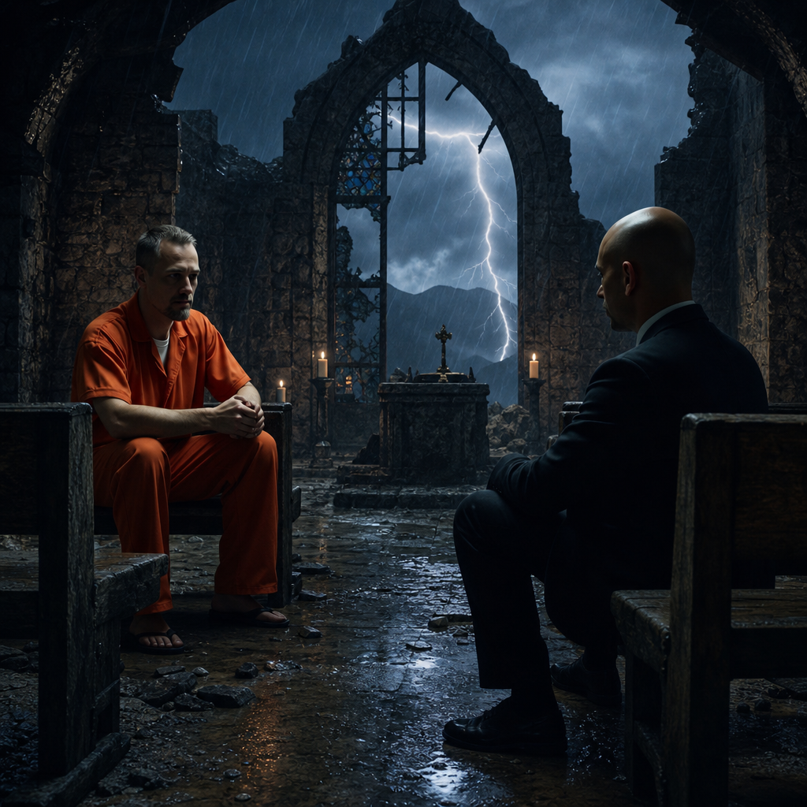

Rain swept across the highway in long silver sheets.
The windshield wipers fought steadily against the storm as Darrius guided the
unmarked sedan north through the darkness. No one spoke.
Rodney sat beside him reviewing the latest surveillance photographs.
Father Thomas occupied the rear seat, Michael Grealish's final letter resting quietly in
his lap.
The shepherd's staff ring lay inside an evidence pouch on the center console.
No one touched it. It no longer felt like evidence. It felt like history.
Miles passed beneath the tires.
The city lights slowly disappeared behind them.
Forests replaced concrete.
Dark hills rolled beneath a sky filled with heavy clouds.
Finally...
The familiar stone entrance appeared through the rain.
Saint Michael's Retreat
Rodney looked toward the weathered sign. "We're back."
Darrius nodded.
"No."
His voice was calm.
"I think this is where we've been heading since the first murder."
Silence settled over the car.
The retreat gates stood open. Neither broken nor forced.
Simply waiting.
Darrius parked beneath the old maple trees.
The rain had eased to a gentle drizzle.
Water dripped steadily from the branches overhead.
The building stood exactly as they had left it days earlier.
Silent. Dark. Patient.
Yet something had changed.
A single light burned inside the chapel.
Father Thomas saw it immediately. "He lit the sanctuary."
Rodney reached instinctively toward his sidearm.
Darrius gently stopped him. "Not yet."
Rodney looked puzzled. "He knows we're coming."
"I know."
"And?"
Darrius looked toward the warm light glowing through the stained-glass window.
"If Brendan wanted a fight..."
"...he wouldn't have turned on the lights."
The three men climbed the worn stone steps together.
The front doors stood closed.
Unlocked.
Darrius rested his hand against the weathered oak.
He paused.
Not from fear. From understanding.
Forty years earlier...

Michael Grealish had walked through these same doors carrying hope for one
frightened boy.
Now...
Another man crossed the same threshold carrying the same hope.
The heavy doors opened with a long, familiar groan.
Warm candlelight spilled into the entrance hall.
The retreat no longer felt abandoned.
Someone had brought it back to life.
Candles burned along the corridors.
Fresh flowers rested beneath the chapel crucifix.
Dust had been carefully wiped from the pews.
The air carried the faint scent of cedar and beeswax.
Rodney looked around slowly. "He cleaned it."
Father Thomas quietly nodded.
"Michael always said beauty helped wounded people breathe."
Darrius stepped deeper into the building.
Nothing had been disturbed. Nothing overturned. Nothing broken.
Every candle appeared intentionally placed.
Leading...
not randomly...
but toward the chapel.
The detectives followed the quiet trail of light.
Their footsteps echoed softly through the restored halls.
Passing the children's room...
Darrius paused.
The tiny wooden chairs remained where they had found them.
Except now...one additional chair had been placed at the circle.
Facing the others.
Waiting.
He understood immediately. Brendan wasn't recreating the past.
He was inviting it to continue.
Father Thomas touched the back of the empty chair.
His eyes filled. "He remembered."
Darrius nodded. "He remembered everything."
The trail of candles continued.
Each flame illuminating another familiar place.
The archive. The counseling room. The old meeting hall. The sanctuary.
Every room Michael had once filled with conversation now glowed quietly against the darkness.
The retreat felt less like a crime scene...and more like a farewell.
They reached the chapel.
The great wooden doors stood open.
Inside...
dozens of candles flickered beneath the restored stained-glass windows.
The altar had been carefully cleaned.
Fresh white lilies rested beside the cross.
No signs of violence. No struggle. Only stillness.
Brendan stood alone at the front of the sanctuary.
His back faced the entrance.
The black prayer rope hung once again around his wrist.
He did not turn. He had heard them enter.
He simply continued looking toward the altar.
Without speaking...
he said quietly,
"I wondered whether you'd come."
Darrius stepped into the chapel. "I said I would."
Another long silence.
Rain tapped softly against the stained glass.
The candles flickered gently.
Brendan finally turned.
His expression carried neither anger nor triumph.
Only exhaustion.
His eyes settled briefly on Father Thomas.
Then Rodney.
Finally...
Darrius.
"You brought Michael."
He nodded toward the folded letter.
Darrius answered quietly. "I brought his words."
Brendan smiled sadly. "That's enough."
He looked around the restored chapel. "I wanted you to see this."
Rodney glanced toward the candles.
"You did all this?"
Brendan nodded. "I wanted it to look..."
He searched for the right word.
"...alive."
Silence.
Father Thomas's voice trembled. "It does."
Brendan closed his eyes for just a moment.
"Good."
He looked back toward Darrius.
"Because after tonight..."
"...someone will finally have to decide what survives."
The words settled over the sanctuary. Not as a threat.
As a confession.
Darrius took one slow step forward.
Then another.
He stopped several pews away. Close enough to speak naturally.
Far enough to honor Brendan's space.
He looked around the chapel Michael Grealish had loved.
Every candle. Every flower. Every detail was carefully restored.
Then back at Brendan.
"You didn't bring us here to end something."
Brendan's expression softened.
"No."
He looked toward the cross above the altar.
"I brought you here..."
"...to finish what Michael couldn't."
The sanctuary fell completely silent.
Outside, the rain ceased.
For the first time all night...the retreat heard only voices.
❦
The sanctuary remained perfectly still.
No wind.
No rain.
Only the soft glow of candlelight dancing across polished wood and stained glass.
Darrius stood in the center aisle.
Brendan remained near the altar.
Neither hurried to close the distance between them.
Some conversations required space.
Father Thomas quietly motioned Rodney toward the rear pew.
Without a word, both men sat.
This conversation belonged to someone else.
Brendan looked around the chapel. "I used to hate this room."
His voice was calm.
"So many people came here pretending everything was fine."
He smiled faintly. "Michael never pretended."
Darrius nodded.
"No."
"He didn't."
Brendan's eyes drifted toward the cross.
"He always asked questions."
"He almost never gave answers."
Darrius smiled. "I've noticed."
A small laugh escaped Brendan.
The first genuine laugh anyone had heard from him.
"He used to say..."
Brendan paused, hearing the memory as though Michael were standing beside him.
'Answers end conversations. Questions begin healing.'
Silence settled gently between them.
Darrius spoke softly. "I've spent weeks trying to understand you."
Brendan looked back at him.
"And?"
"I've stopped asking why you killed."
A flicker crossed Brendan's face.
"What are you asking now?"
Darrius answered honestly.
"I'm asking what happened to the boy who asked Michael if everyone eventually
leaves."
For the first time...Brendan had no immediate response.
He lowered his eyes.
The sanctuary seemed to grow even quieter.
Finally...
he spoke.
"He waited."
"For a very long time."
"He watched promises disappear."
"People leave." "Churches close." "Cases die." "Witnesses forget."
His voice remained steady.
Almost conversational. "Michael was the only promise that stayed."
Darrius nodded. "I believe that."
Brendan looked up. "Do you?"
Darrius answered without hesitation.
"I've been reading his life for weeks."
"I think staying was the one promise he never broke."
The words hung in the air.
Brendan slowly wrapped the prayer rope once around his wrist.
"He died."
"Yes."
"He still left."
Darrius shook his head.
"No."
Brendan frowned.
"He wasn't at the cemetery."
"He wasn't at the retreat."
"He wasn't anywhere."
Darrius reached into his jacket.
He removed the folded note Henry had given him.
Without moving closer, he held it where Brendan could see.
Sit with him until he remembers he isn't alone.
Brendan stared at the familiar handwriting.
His jaw tightened. "He wrote that?"
"Yes."
Silence.
"He knew I'd come."
"He hoped."
Brendan looked away. "He wasn't there."
Darrius answered quietly.
"Henry was."
Another silence.
"The bench was." "The coffee." "The mug." "The room." "The journals."
"The letters."
"He kept leaving pieces of himself wherever he thought you might need them."
Brendan closed his eyes.
His breathing slowed.
"You make it sound easy."
"No."
Darrius said. "I think it cost him everything."
Those words struck home.
Brendan turned toward the altar.
For several moments...he simply stood there.
Then he asked the question that had followed him since childhood.
"What if mercy isn't enough?"
The words barely rose above a whisper.
"What if some people never change?"
"What if some wounds never heal?"
"What if justice keeps waiting..."
"...and no one ever comes?"
Darrius didn't answer immediately.
He looked toward the candles.
Toward the restored chapel.
Toward the room Brendan had spent hours bringing back to life.
Then...
he asked a question of his own.
"If you truly believed people never change..."
He looked directly at Brendan.
"...why did you restore Michael's retreat?"
Silence.
Absolute silence.
Brendan's eyes slowly swept across the sanctuary.
The polished pews. The fresh flowers. The lit candles. The children's chair.
Every act of care. Every act of hope.
He had done all of it.
Without realizing what it revealed.
Darrius spoke gently.
"Nothing in this building was repaired by a man who believed hope was dead."
Brendan's breathing became uneven.
"You don't understand."
"Then help me."
Another long silence.
Finally...
Brendan looked at the cross.
"I wanted..."
His voice caught.
"...I wanted him to come home."
The confession escaped before he could stop it.
Tears filled his eyes.
"I kept fixing the rooms..."
"...because I couldn't bear the thought of him seeing them abandoned."
The sanctuary remained utterly still.
Father Thomas quietly lowered his head.
Rodney looked away.
Darrius took one slow step forward.
Only one.
"You've been waiting for him."
Brendan laughed once.
A broken sound. "For forty years."
Darrius nodded. "I know."
Brendan looked at him through tear-filled eyes.
"No."
"You don't."
"He promised he'd stay."
The words broke apart. "And then he died."
Darrius stood silently for several seconds.
When he finally answered…
His voice was almost gentle enough to disappear into the candlelight.
"I don't think Brendan Dwight has been angry at Michael Grealish for forty years."
Brendan stared at him. "I think you've been heartbroken."
Silence.
The word landed with extraordinary force.
Not accused.
Named.
For the first time...Brendan's certainty cracked.
Not because Darrius had defeated his argument.
Because he had finally described his pain.
Brendan slowly lowered himself onto the front pew.
The prayer rope slipped through trembling fingers.
He looked smaller somehow.
Not weaker.
Younger.
Almost like the frightened boy from the retreat journals.
He whispered without looking up, "I didn't know the difference anymore."
Darrius quietly crossed the remaining distance.
He sat beside Brendan.
Not touching him. Not crowding him.
Simply...
staying.
Exactly as Michael had instructed.
For a long time...neither man spoke.
The silence itself became the conversation.
At last Brendan asked,
"Do you think Michael would still recognize me?"
Darrius looked toward the altar.
Then back at Brendan.
Without hesitation, he answered.
"I think he'd recognize you before you recognized yourself."
Brendan closed his eyes.
A single tear slipped down his face.
For the first time in forty years...he allowed himself to grieve instead of defend.
And in the quiet sanctuary where one priest had spent a lifetime teaching wounded
people to hope...another man finally understood that mercy had never asked him to
forget. It had only asked him to stop carrying his pain alone.
❦
The silence inside the chapel stretched for nearly a minute.
Brendan remained seated on the front pew.
His hands rested loosely in his lap.
The black prayer rope lay across his fingers.
Darrius sat beside him.
Neither man spoke.
Some wounds required silence before they could bear words.
Behind them...Father Thomas quietly bowed his head.

Rodney remained near the entrance, watching the doors without interrupting
the fragile peace settling over the sanctuary.
Then—
The heavy wooden doors opened.
No one rushed inside. No shouting. No drawn weapon.
Only slow footsteps. Measured. Deliberate.
Adrian Mercer entered the chapel.
Rain clung to the shoulders of his dark overcoat.
His cane tapped softly against the stone floor.
Brendan lifted his head.
For the first time in decades...the two men simply looked at one another.
No anger. No triumph.
Only the weight of forty years.
Mercer's eyes settled on the restored sanctuary.
The candles. The flowers. The polished pews.
He understood immediately. "You brought him home."
His voice trembled.
Brendan nodded once. "I wanted him to see it."
Mercer's gaze moved slowly across the room.
"He would have loved this."
Silence.
Brendan searched the older man's face. "I waited."
Mercer lowered his eyes. "I know."
"I kept asking the same question."
"I know."
"I kept believing you would finally tell me what Michael never could."
The old priest closed his eyes.
When he answered...his voice carried none of the certainty that had once defined him.
"I can't."
The words seemed to echo through the chapel.
Brendan frowned.
"What?"
Mercer looked directly at him. "I can't answer it."
The younger man's face tightened.
"For forty years..."
Mercer continued,
"...I believed I could."
He slowly removed his gloves.
Age had bent his hands.
The once-steady fingers now trembled visibly.
"I believed justice could heal what mercy could not."
He looked toward the cross above the altar. "I was wrong."
Silence.
Absolute silence.
Brendan stared at him.
As though he had misheard.
"You said evil had to be answered."
"It does."
Mercer replied quietly.
"You said waiting was weakness."
"I believed it."
"You said Michael was naïve."
Mercer's eyes filled with tears. "I said many things."
His voice broke.
"I never understood that Michael wasn't waiting because he lacked courage."
"He waited because he loved you."
The words landed like a physical blow.
Brendan slowly stood.
"No."
Mercer nodded through tears.
"Yes."
"I confused patience with surrender."
"I confused correction with healing."
"I confused being right..."
He looked at Darrius.
"...with bringing people home."
The chapel remained utterly still.
Father Thomas quietly covered his mouth.
Rodney looked away.
Mercer reached into the inside pocket of his coat.
He withdrew a folded sheet of paper.
Its edges were worn from repeated handling.
He handed it to Brendan. "I've carried this since the day Michael died."
Brendan unfolded it carefully.
It wasn't a letter. It was a photograph.
Three men stood beneath the great oak tree outside the retreat.
Michael Grealish. Young Brendan. Adrian Mercer.
All three smiling.
On the back...
Michael had written:
Never make him choose between us.
Brendan's hands began to shake.
He looked up slowly.
"You kept this?"
Mercer nodded.
"Because I failed him."
"No."
Brendan whispered. "You taught me."
Mercer's expression collapsed beneath the weight of regret.
"I taught you to fear becoming weak."
He took one slow step closer.
"And somewhere..."
"...you stopped believing love could be strong."
The words hung in the air.
Brendan stared at the photograph.
His breathing became uneven.
"I spent forty years trying to prove you right."
Mercer answered softly,
"I know."
"And now?"
Brendan asked.
The old priest looked toward Michael Grealish's cross.
Then toward Darrius.
Finally...
back to Brendan.
"Now..."
He smiled through tears.
"...I'm asking you not to."
Silence.
No arguments. No theology. No speeches.
Only one old man finally telling the truth.
Brendan looked down at the prayer rope wrapped around his wrist.
Then at the photograph.
Then toward Darrius.
His voice had become almost childlike. "What if I don't know how?"
Darrius answered before anyone else could.
"You don't have to know today."
Brendan looked at him.
"You only have to stop walking alone."
The words settled gently into the sanctuary.
Mercer slowly nodded.
"Michael said almost exactly that."
He laughed once through tears. "I should have listened better."
The laughter faded into quiet weeping.
Not dramatic. Not uncontrolled.
Simply the grief of a man who had finally stopped defending himself.
The rain outside ceased completely.
Sunlight filtered through the stained-glass windows.
The colors spread across the floor.
Blue.
Gold.
Crimson.
They reached all three men. No one stood in the shadows anymore.
For the first time since the retreat closed in 1985...
The conversation between Michael Grealish and Adrian Mercer had finally
reached its conclusion. Not because one man had won.
Because both surviving students had finally heard what Michael had been trying
to teach all along. Mercy was never the opposite of justice.
It was the only thing capable of completing it.

❦
The chapel remained bathed in stained-glass light.
No one moved.
Brendan still held the faded photograph.
Michael. Adrian. Himself.
Three smiling faces beneath the great oak tree.
His thumb slowly brushed across Michael's image.
"So much time..."
he whispered.
"...wasted."
Darrius shook his head gently.
"No."
Brendan looked toward him.
"It wasn't wasted?"
"No."
"It was lived."
Silence.
Brendan lowered his eyes again.
"I spent forty years trying to become someone neither of them wanted."
Mercer closed his eyes.
"I know."
"You don't."
Brendan's voice remained calm.
Almost tired. "I thought justice meant carrying every wound."
"I thought if I remembered enough..."
"...if I never stopped hurting..."
"...then the people who suffered would never be forgotten."
His fingers tightened around the photograph.
"I believed letting go meant betraying them."
Father Thomas quietly wiped his eyes.
Darrius remained seated.
Listening.
Not interrupting.
Brendan looked toward the restored sanctuary.
"The first time I came back here after Michael died..."
He smiled sadly.
"I couldn't even open the chapel doors."
"I sat outside for three hours."
"I kept waiting to hear his footsteps."
Silence.
"I knew he wasn't coming."
His voice cracked. "But I couldn't leave."
The confession hung in the air.
No one tried to fill the silence.
Finally Brendan spoke again.
"I kept thinking..."
"...if I stayed long enough..."
"...maybe I'd hear him say..."
He couldn't finish.
Darrius quietly completed the sentence.
'I'll be here.'
Brendan closed his eyes.
A tear slipped down his cheek.
"Yes."
The single word carried forty years of grief.
Mercer slowly sat on the opposite pew. The cane rested against the wood beside him.
For the first time since Darrius had met him...
the old priest looked every one of his years.
"I owe you something."
Brendan looked over.
"The truth."
Mercer drew a slow breath.
"The day Michael died..."
"...he wasn't talking about the Church."
Brendan frowned.
"He wasn't talking about theology."
"He wasn't talking about the retreat."
Mercer's voice trembled. "He was talking about you."
Silence.
"He told me..."
The old priest struggled to continue.
"...that one day..."
"...someone would have to convince Brendan he had never been abandoned."
Brendan stared at him.
"No."
Mercer nodded.
"I argued with him."
"I told him hope wasn't enough."
"I told him justice would protect you."
He lowered his head.
"Michael looked at me..."
"...and asked one question."
The chapel remained perfectly still.
Mercer's eyes met Brendan's.
"He asked..."
'Adrian...when did you stop believing people were worth waiting for?'
No one spoke.
The question seemed to echo through every corner of the sanctuary.
Mercer slowly shook his head. "I never answered him."
"I couldn't."
Another long silence.
Brendan looked toward Darrius.
Then Father Thomas.
Then back to Mercer.
His breathing had steadied.
The anger that had once defined him had disappeared.
Only grief remained. "I've spent my whole life asking the wrong question."
Darrius waited.
Brendan looked at the prayer rope wrapped around his wrist.
"I kept asking...why everyone leaves."
He slowly unwound the rope.
The worn knots slipped gently through his fingers.
"But that wasn't the question."
He looked toward Michael's cross.
"The question was...who stayed."
Silence.
Darrius felt a quiet smile form.
Not from victory.
From recognition.
Brendan looked around the restored chapel.
The flowers. The candles. The children's chair. The polished altar.
The photographs.
Every act of care suddenly looked different.
"I wasn't bringing Michael back."
He whispered.
"I was trying to become the person who would have welcomed him home."
No one interrupted.
The truth had finally arrived.
Not through evidence. Not through argument. Through confession.
Brendan stood slowly.
He walked toward the altar.
The prayer rope remained in his hands.
He looked up at the crucifix.
Then turned back toward the three men.
His voice was steady.
Clear.
Without fear. "I've confessed my sins before."
A faint smile crossed his face.
"I've confessed my anger." "My violence." "My failures."
He looked directly at Darrius.
"But I've never confessed the one thing that mattered."
Another long silence.
Finally...
he spoke.
"I stopped believing I was worth saving."
The words settled over the sanctuary like a prayer.
No one answered immediately.
Because nothing could improve upon the honesty of that confession.
Father Thomas quietly wept.
Mercer lowered his face into his hands.
Darrius stood.
He crossed the final few steps separating them.
Not hurried. Not cautious. Simply present.
He looked Brendan directly in the eyes.
Then, with complete certainty, he said,
"No."
Brendan frowned.
Darrius gently shook his head. "That's not your confession."
Silence.
"That's the lie."
Brendan stared at him.
Unable to speak.
Darrius continued.
"Your confession..."
He smiled softly.
"...is that you've believed it for forty years."
The sanctuary fell silent once more.
Then something remarkable happened.
Brendan laughed.
Not bitterly. Not desperately. Freely.
For the first time since childhood.
It was brief.
Quiet.
Almost surprised.
As though he had finally heard the difference between guilt...
and shame.
The prayer rope slipped from his hand.
It landed softly on the altar rail.
Brendan looked toward the cross one final time.
Then closed his eyes.
"I think..."
He whispered.
"...I'm finally ready to stop carrying him."
Darrius looked at the prayer rope.
Then back at Brendan.
"You don't have to stop carrying Michael."
He smiled.
"You only have to stop carrying him alone."
Brendan opened his eyes.
For the first time in forty years...
they held something no investigation could have uncovered.
Peace.
Not complete. Not perfect. But real.
Outside the chapel, the first rays of evening sunlight broke through the retreat windows.
The storm had passed. The light remained.
❦
No one spoke.
The prayer rope rested quietly upon the altar rail.
Its worn knots caught the late afternoon sunlight spilling through the stained-glass
windows.
For decades it had been Brendan's anchor.
His reminder.
His burden.
Now...
for the first time...his hands were empty.
He stared at them as though seeing them for the first time.
"I don't know what comes next."
His voice barely rose above a whisper. "I've always known what came next."
He looked toward Darrius.
"There was always another file."
"Another victim." "Another wrong." "Another reason to keep carrying it."
Silence.
Darrius nodded. "I know."
Brendan slowly shook his head.
"No."
"You know the investigation."
"I know the weight."
His eyes drifted toward the restored sanctuary.
"And now..."
"...it's gone."
The words held no triumph.
Only uncertainty.
Mercer slowly rose from the pew.
His cane echoed softly against the stone floor as he crossed the sanctuary.
He stopped beside Brendan.
Not in front of him.
Beside him.
The way Michael once had. "I owe you one final truth."
Brendan looked at the older man.
"When Michael and I argued..."
Mercer said quietly,
"...I kept believing I had to save the Church."
He smiled sadly. "Michael kept believing he had to save people."
Another silence.
"I thought institutions mattered most."
He lowered his head. "He never forgot names."
Brendan looked toward the children's room beyond the chapel doors.
"He remembered every child."
Mercer nodded. "Even after they forgot themselves."
The words settled gently between them.
Father Thomas stepped forward.
"There are children now..."
he said softly,
"...who have never heard Michael's story."
Brendan looked at him.
"There are detectives who have."
Thomas smiled.
"There are priests who need it." "There are parents who need it."
"There are broken people who need it."
He paused.
"They don't need another martyr."
"They need a witness."
The sanctuary became still.
Darrius said nothing.
He let the words breathe.
Brendan looked once more at the prayer rope. "So what am I supposed to do?"
Father Thomas smiled gently.
"What Michael always asked."
"Stay."
Brendan laughed quietly. "You all make it sound so simple."
Rodney spoke for the first time in several minutes.
"It isn't."
Everyone looked toward him.
"I've arrested people for twenty-five years."
"I've seen men deny everything."
"I've seen men blame everyone."
He met Brendan's eyes. "I've never seen someone tell the truth before anyone asked."
The words landed softly.
Without judgment. Without praise. Only respect.
Brendan lowered his eyes. "I still have blood on my hands."
Darrius answered immediately.
"Yes."
Silence.
"You'll answer for that."
"Yes."
Another silence.
"But answering for what you've done..."
Darrius continued,
"...isn't the same as believing you're beyond redemption."
Brendan looked at him. "I don't know how to live with both."
"No."
Darrius said.
"You learn."
The detective stepped toward the altar.
He gently picked up the prayer rope.
He looked at its worn knots for a long moment.
Then...
instead of handing it back...he placed it beside the open Bible resting on the altar.
Not discarded. Not reclaimed. Simply...
returned.
"It belongs here."
Brendan watched quietly.
A memory surfaced.
Michael standing in this very sanctuary.
Smiling.
Handing him the rope.
Not as armor. As a reminder.
Mercer followed Brendan's gaze.
"I used to think Michael gave you that because you needed strength."
He smiled sadly.
"I finally realized..."
"...he gave it to you because he believed you already had it."
The older priest slowly removed his Roman collar.
He placed it beside the prayer rope. "I carried this for forty-six years."
His voice trembled. "I forgot what it was for."
Father Thomas looked at him with tears in his eyes.
"You remembered."
Mercer nodded.
"Too late."
Thomas gently shook his head.
"No."
He glanced toward Brendan.
"Not too late."
The sanctuary fell silent again.
Outside, the clouds finally separated.
Golden evening light poured through the stained glass.
The colors spread across the altar.
Across the Bible. Across the prayer rope. Across Mercer's collar.
Across Brendan's hands.
He stared at them.
Then slowly lifted his eyes toward Darrius. "What happens now?"
Darrius smiled. "The same thing that should have happened forty years ago."
Brendan waited. "You stop carrying this by yourself."
Another long silence.
Then Brendan took a slow breath.
He looked once around the sanctuary Michael Grealish had loved.
The restored pews. The candles. The children's chair. The altar. The cross.
Finally...he nodded.
Not dramatically. Not ceremonially.
Simply...
as a man making the hardest decision of his life.
"I'll come with you."
The words were quiet.
Yet they echoed through the chapel with more power than any confession.
No one celebrated. No one rushed forward.
Darrius simply nodded.
"Thank you."
Brendan frowned slightly. "For what?"
Darrius smiled. "For choosing."
Brendan looked back toward the altar one final time.
For the first time in forty years...
his future no longer belonged to his past.
It belonged to the choice he had just made.
Outside, the chapel bell began to ring.
Not in mourning. Not in warning.
But in welcome.
❦
The chapel remained quiet.
No one moved for several moments after Brendan spoke.
"I'll come with you."
The words lingered beneath the vaulted ceiling.
Not as surrender. As freedom.
Darrius looked at Brendan for a long moment.
He had imagined this meeting countless times over the past weeks.
Every possibility had ended differently.
Violence. Flight. Desperation.
Never this.
Never a man laying down forty years of certainty with nothing more than a quiet
sentence.
Rodney stepped forward.
There was no urgency in his movement.
Only professionalism.
He removed a pair of handcuffs from his belt.
The faint click of the metal echoed softly through the sanctuary.
Brendan looked at them.
Then back at Rodney.
"I understand."
Rodney met his eyes. "So do I."
Silence.
Darrius spoke quietly.
"Brendan."
He waited until Brendan looked at him. "I'm going to ask you something."
"What?"
"If you'll walk out of here beside us..."
"...I don't want the last thing Michael's retreat ever sees to be chains."
The sanctuary became perfectly still.
Rodney looked toward Darrius.
Then slowly lowered the handcuffs.
Father Thomas closed his eyes.
Mercer looked toward the altar.
No one objected.
Rodney returned the cuffs to his belt.
"When we reach the car..."
he said calmly,
"...we'll do what the law requires."
Brendan nodded. "That's fair."
He looked once around the sanctuary.
Every candle still burned.
The flowers remained fresh.
The prayer rope rested beside the open Bible.
Mercer's Roman collar lay beside it.
Symbols of burdens finally surrendered.
Brendan slowly walked toward the altar.
He did not pick up the prayer rope.
He simply rested his fingertips lightly against the worn wood.
"Thank you."
The words were spoken so quietly that no one was certain to whom they were
addressed.
Michael.
God.
The room itself.
Perhaps all three.
He turned away.
Father Thomas stepped toward the altar.
Carefully lifting the prayer rope.
He folded it gently and placed it inside the open Bible.
Between its pages.
Not hidden. Protected.
Then he closed the cover.
He looked toward Darrius. "I'll keep it here."
Darrius smiled. "I think Michael would like that."
Mercer walked to the front pew.
His cane rested against the wood as he lowered himself into the seat.
He made no attempt to leave.
Darrius looked at him.
"You know what comes next."
Mercer nodded.
"I do."
"I'll give my statement."
"I'll answer every question."
He smiled sadly.
"For once..."
"...without trying to control the answer."
Father Thomas placed a gentle hand on his shoulder.
Neither man spoke.
Outside...the retreat grounds glowed beneath the fading light of evening.
The rain-washed trees shimmered in the breeze.
Water dripped from the old oak where children had once gathered around
Michael Grealish.
Brendan stopped beside the chapel doors.
He looked back one final time.
Not at the altar. Not at Mercer. At the children's chairs, arranged in a quiet circle.
One chair remained slightly apart from the others.
The one he had placed there.
Waiting.
He smiled softly.
"I think..."
he whispered,
"...someone else will need that chair."
Darrius followed his gaze. "I hope so."
Brendan opened the chapel doors.
Cool evening air filled the sanctuary.
The scent of wet leaves drifted inside.
Together...
The five men stepped onto the stone path.
Darrius.
Rodney.
Father Thomas.
Brendan.
Adrian Mercer.
No one walked ahead. No one walked behind.
For a brief stretch of quiet ground...they walked together.
The old retreat stood silently behind them.
No longer a place haunted by secrets.
Now...
a place where the truth had finally been spoken aloud.
As they reached the waiting vehicles, Brendan stopped once more.
He looked toward the hill where the great oak tree overlooked the retreat.
"I used to think that tree reminded me of everything I'd lost."
He smiled faintly.
"Now..."
"...it reminds me of someone who never stopped waiting."
Darrius looked toward the tree.
"He'll keep waiting."
Brendan frowned. "How?"
Darrius looked toward the retreat chapel.
"Every time someone chooses mercy instead of despair."
Brendan nodded slowly.
The answer seemed enough.
Rodney stepped beside him. "It’s time."
Brendan offered his wrists without hesitation.
Rodney secured the handcuffs with quiet dignity.
There was no struggle. No spectacle. Only accountability.
Brendan looked at the steel around his wrists.
Then toward Darrius. "I thought these would feel heavier."
Darrius answered gently. "They're lighter than what you've been carrying."
Brendan looked down.
A faint smile crossed his face. "I think you're right."
The patrol vehicle door closed softly behind him.
No sirens sounded. No lights flashed.
The convoy pulled slowly away from Saint Michael's Retreat.
The chapel remained visible through the rear window.
Candles still glowed inside.
One by one...they disappeared behind the trees.
The retreat did not feel abandoned. It felt entrusted.
Some places are remembered because terrible things happened there.
Others...because someone finally told the truth.
Saint Michael's Retreat had become the second kind.

Chapter Fifteen

The Good Shepherd

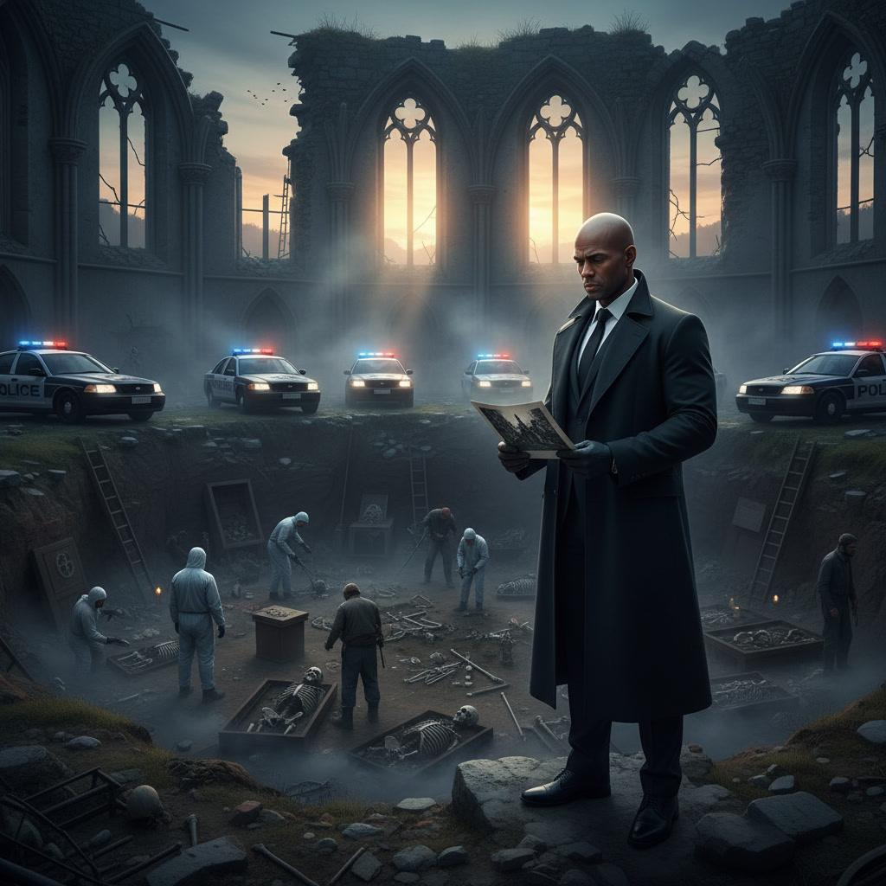

Spring arrived quietly. Winter loosened its grip one gentle morning at a time.
The bare branches surrounding Saint Michael's Retreat had begun to bloom again.
Fresh green leaves replaced the brittle remnants of autumn.
Wildflowers pushed through the earth beside the old stone walkways.
Life had returned. Not suddenly. Patiently.
The retreat looked different now. The broken windows had been repaired.
Fresh paint covered weathered walls.
The chapel bell once again rang every Sunday morning.
Children's laughter drifted across the grounds where silence had once lived.
The retreat had reopened. Not as it once was.
As something new.
Darrius Blue stood beneath the great oak tree.
Its branches stretched wide above him, casting soft shadows across the grass.
He looked toward the children's circle nearby.
Eight small chairs surrounded a low wooden table.
A ninth chair remained empty. Waiting.
He smiled.
Some traditions deserved to continue. Footsteps approached behind him.
Father Thomas. His Roman collar rested neatly beneath a dark jacket.
He carried two steaming paper cups. "Henry insists coffee tastes better outside."
Darrius accepted one gratefully. "He was right."
They stood together beneath the oak for several moments.
Watching. Listening.
Children chased one another across the retreat grounds.
Volunteers prepared supplies inside the restored counseling center.
Teachers laughed from the front porch.
The place breathed again.
Father Thomas looked toward the old chapel. "Michael would've loved today."
Darrius nodded. "I think he already did."
The priest smiled quietly. "You've started talking like him."
Darrius laughed. "I hope not."
"I could never fill those shoes."
Thomas looked toward the children. "I don't think he wanted anyone to."
Silence settled comfortably between them.
After a moment, Father Thomas reached into his coat pocket.
"I received this yesterday."
He handed Darrius a neatly folded letter.
The return address identified a state correctional facility.
Darrius recognized the handwriting immediately.
Brendan.
He unfolded the page carefully. The writing was slower than before.
Less precise.
More human.
Dear Father Thomas,
I planted tomatoes this week.
Darrius smiled.
The letter continued.
The prison chaplain says I'm terrible at gardening.
He's probably right.

But Michael would've laughed anyway.
Another smile.
Then—
Some mornings are still difficult.
Some memories still wake before I do.
But I'm beginning to understand something.
Darrius continued reading quietly.
Hope doesn't erase what happened.
It simply refuses to let yesterday become tomorrow.
He lowered the page for a moment.
The breeze stirred gently beneath the oak.
Then he finished the letter.
Tell Henry I finally understand the second cup of coffee.
Tell Father Thomas the prayer rope belongs exactly where it is.
And tell Detective Blue...
Darrius paused.
His eyes lingered on the final paragraph.
...thank you for staying long enough to let me remember who I was before I forgot.
Silence.
Father Thomas looked toward the retreat. "How is he?"
Darrius folded the letter carefully. "Still healing."
Thomas nodded. "So are we."
The words felt true.
Not only for Brendan.
For everyone.
A small girl wandered toward the empty chair beneath the oak.
She looked at it curiously.
Then looked up at Darrius.
"Is someone sitting there?"
Darrius smiled warmly. "Not yet."
She considered that answer seriously.
Then gently placed a wildflower on the empty seat before running back toward the others.
Neither man spoke.
The little flower rested quietly in the sunlight.
Waiting.
Just as the chair had always done.
Henry called from the chapel steps. "Coffee's getting cold!"
Father Thomas laughed. "Some things never change."
Darrius looked once more toward the empty chair.
Toward the flower. Toward the children.
Toward the retreat that no longer belonged to memory alone.
It belonged to the future.
For the first time since Nancy Calloway had walked into a confessional carrying a secret...
the story no longer felt defined by death.
It had become a story about those who remained.
Those who stayed. Those who waited.
Those who believed broken lives were never beyond repair.
Darrius lifted his coffee toward the oak tree almost unconsciously.
A quiet gesture. A thank you.
Then he turned toward the children. There was work to do. Good work.
The kind Michael Grealish had always believed mattered most.
And somewhere beyond the spring breeze...it almost felt as though an old shepherd smiled.
❦
The correctional facility stood beneath a clear spring sky.
Tall fences surrounded the aging brick buildings.
Steel gates opened and closed with practiced precision.
The routine never changed. Neither did accountability.
Darrius signed the visitor log.
The corrections officer recognized him immediately.
"Good afternoon, Detective."
Darrius smiled politely. "Good afternoon."
The officer glanced at the visitor request. "He's expecting you."
"I know."
"You've been coming every month."
Darrius nodded. "I said I would."
The officer smiled faintly.
"Not many people keep coming."
Darrius thought of Michael Grealish. "Someone taught me better."
The officer simply nodded.
He understood.
A few moments later, Darrius entered the visitation garden.
Unlike the main visitation room, this small courtyard had recently been renovated.
Raised flower beds bordered the walking paths.
A young maple tree offered shade over several benches.
Birds nested beneath the roofline.
It felt surprisingly peaceful.
Brendan was already there.
He knelt beside one of the garden beds wearing a denim work shirt with rolled sleeves.
Gardening gloves covered his hands.
A watering can rested nearby.
He looked up as Darrius approached.
A genuine smile appeared. "You came."
Darrius smiled back. "I said I would."
Brendan stood slowly.
He looked healthier.
Not untouched by sorrow.
But no longer consumed by it.
The hard edges had softened. The constant vigilance was gone.
He gestured toward the garden. "I've been assigned here."
Darrius looked around. "It suits you."
Brendan laughed.
"I would've argued with you six months ago."
"And now?"
"I've discovered tomatoes require more patience than people."
Both men laughed quietly.
The ease surprised them.
Not because the past had disappeared.
Because neither man needed to pretend it hadn't happened.
They sat together beneath the young maple tree.
For a few moments they simply watched other inmates working in silence.
Finally Brendan spoke. "I testified."
Darrius nodded. "I know."
"They asked about Mercer." "They asked about the murders."
"They asked about everything."
He looked toward the flower beds. "I told them the truth."
Silence.
"All of it."
Darrius looked at him. "I never doubted you would."
Brendan smiled faintly.
"I would've."
Another silence.
Then Brendan reached into his pocket.
He removed a folded photograph. It showed the restored retreat.
Children sitting beneath the great oak.
Father Thomas laughing beside Henry.
The ninth chair is still waiting in the circle. "I will keep this with me."
Darrius studied the picture.
"They sent copies to everyone who helped rebuild it."
Brendan nodded. "I know."
He looked at the empty chair.
"I still wonder who'll sit there."
Darrius smiled. "Probably someone who needs it."
Brendan quietly folded the photograph.
"Michael would've liked that answer."
The breeze stirred the leaves overhead.
A robin landed near the garden bed.
Brendan watched it hop through the fresh soil.
"I've been thinking about something."
"What?"
"The victims."
His expression became serious.
"I used to believe remembering them meant carrying guilt forever."
He looked down at his hands.
"Now I think remembering them means living differently because of them."
Darrius didn't interrupt.
Brendan continued. "I'll never undo what I did."
"No."
Darrius agreed gently.
"But maybe..."
Brendan looked toward the rows of growing vegetables.
"...I can still grow something that wasn't here before."
Silence.
The simple honesty of the statement carried more weight than any dramatic speech.
Darrius reached into his coat. "I brought you something."
Brendan looked surprised.
"What?"
Darrius handed him a small paperback notebook.
Its cover was blank. No title. No decoration.
Brendan opened the first page.
Only one sentence had been written inside.
In Darrius's handwriting.
Someone else will need your story someday.
Brendan stared at the words for a long time.
Finally he looked up. "You think anyone would want to hear it?"
Darrius answered without hesitation.
"I think someone who's about to believe the same lie you believed for forty years..."
"...might need to know how you found the truth."
Brendan closed the notebook carefully.
His eyes were filled with tears. "I don't know where to start."
Darrius smiled. "I know."
He pointed toward the first blank page.
"That's why there are so many."
Brendan laughed softly through the tears.
"You sound like Michael."
Darrius shook his head.
"No."
He looked toward the garden. "I just kept listening."
The prison bell rang in the distance.
Visiting hours were ending.
Neither man hurried to stand.
Brendan looked toward the young maple tree overhead.
"You know..."
He smiled quietly.
"I finally understand why Michael always planted trees."
Darrius looked up. "Why?"
"Because he knew someone else would someday sit beneath them."
Silence.
The breeze carried fresh leaves across the courtyard.
Brendan stood.
The corrections officer waited respectfully near the gate.
Before leaving, Brendan turned back toward Darrius.
"Thank you."
Darrius smiled. "You already said that."
Brendan nodded.
"I know."
"This one's different."
He looked toward the garden beds.
"Thank you...for believing the boy still existed."
Darrius rose slowly.
"He did."
Brendan smiled.
"He does."
Without another word, the corrections officer escorted Brendan back toward the housing unit.
He did not look defeated. He did not look triumphant.
He looked like a man finally learning how to tell the truth...
one ordinary day at a time.
Darrius remained beneath the maple tree for another few moments.
The seedlings swayed gently in the afternoon breeze.
Some would take months to mature.
Others years.
None of them hurried.
Healing rarely did.

❦
Summer arrived slowly at Saint Michael's Retreat.
The oak tree had become a canopy of deep green leaves.
Morning sunlight filtered through its branches, scattering shifting patterns across
the grass below. The retreat hummed with quiet life.
Children arrived carrying backpacks.
Parents lingered over coffee before work.
Counselors prepared activity rooms.
Laughter drifted through open windows.
The place no longer felt like it had survived tragedy.
It felt like it had found purpose again.
Father Thomas stood near the entrance greeting families as they arrived.
Henry sat nearby on the old wooden bench with a cup of coffee balanced carefully in
his weathered hands. He watched the children the way gardeners watched new growth.
Patiently. Gratefully.
Darrius walked across the courtyard carrying a small cardboard box.
"You found them?"
Father Thomas asked.
Darrius smiled. "In Michael's office."
He set the box on the picnic table beneath the oak.
Inside were dozens of worn children's books.
The Velveteen Rabbit. Charlotte's Web. The Little Prince.
Where the Red Fern Grows.
Each contained handwritten notes inside the front cover.
Simple messages. Encouragements. Questions. Reminders.
Michael had never simply given children books.
He had given them conversations.
Henry gently picked one up.
His rough fingers turned the pages carefully. "He read this one every spring."
Darrius opened the cover.
Michael's familiar handwriting greeted him.
Stories remind us we are never the first person to feel afraid.
Nothing more. Just that.
Father Thomas smiled.
"He believed books let children borrow hope until they could grow their own."
Nearby, several children gathered around the empty circle of chairs beneath the oak.
Eight chairs were already occupied.
Only the ninth remained empty.
A little boy carrying a baseball glove stopped beside it.
He looked uncertain.
One of the counselors smiled warmly. "That's your chair."
The boy hesitated. "I thought someone was sitting there."
The counselor shook her head.
"We always leave one open."
"Why?"
She looked toward Darrius.
Then back to the child.
"Because someone always needs to know there's still room."
The little boy considered the answer seriously.
Then quietly sat down.
Not in the empty chair.
Beside it.
Leaving it open.
Henry chuckled softly. "He understood."
Darrius watched the circle form beneath the oak.
For a moment...the years seemed to overlap.
Michael sitting with frightened children.
Edward laughing.
Young Brendan watching from the edge.
The empty chair waiting.
Different faces now.
The same invitation.
Father Thomas joined the group.
He sat among the children instead of standing before them.
One little girl immediately raised her hand.
"Father?"
He smiled.
"Yes?"
"Is this where the stories happen?"
Thomas looked toward the great oak. "They already are."
The children settled in.
He opened one of Michael's old books.
Not to read immediately.
To show them something first.
Inside the front cover another handwritten note appeared.
If you're reading this... someone believed you were worth waiting for.
The children couldn't fully understand the sentence.
Not yet.
That was all right.
Some truths needed years before they bloomed.
Darrius stepped quietly away from the gathering.
He preferred watching.
Always had.
Henry joined him after a moment. "They're good kids."
"They are."
Henry smiled toward the circle.
"You know..."
"I used to think Michael built this place."
Darrius looked over. "What do you think now?"
Henry's eyes remained on the children. "I think he built people."
Silence.
The words carried extraordinary simplicity.
And extraordinary truth.
The morning continued.
Games began. Conversations unfolded.
The smell of fresh bread drifted from the kitchen.
Parents volunteered beside retired police officers.
Teachers worked beside counselors.
Priests beside social workers.
No one seemed concerned with titles.
Only people. Helping people.
Darrius felt his phone vibrate.
A message from Brendan. Only a photograph. Nothing written.
He opened it.
Inside the prison chapel...
a small wooden chair sat beneath a young maple tree.
Beside it rested a handwritten notebook.
The first several pages had been filled.
At the bottom of the image Brendan had written only three words.
I stayed too.
Darrius smiled quietly.
He locked the phone.
Slipped it back into his pocket.
And looked once more toward the ninth chair beneath the oak.
It remained empty.
Not because no one belonged there. Because everyone did.
The breeze stirred the branches overhead.
Children laughed. Pages turned. Coffee cooled. Life continued.
Exactly the way Michael Grealish had always hoped it would.
❦
Late afternoon sunlight settled warmly across Saint Michael's Retreat.
The day had begun to slow.
Children carried handmade crafts toward waiting parents.
Volunteers stacked chairs beneath the pavilion.
The smell of fresh bread and tomato soup drifted from the kitchen windows.
Ordinary life.
Exactly the kind Michael Grealish had loved most.
Darrius wandered slowly through the grounds.
For the first time in months...he wasn't looking for evidence.
He wasn't searching for answers. He was simply paying attention.
Near the old counseling center, he noticed a young volunteer kneeling beside
a frightened little boy.
The child couldn't have been older than seven.
His backpack sat untouched beside him.
His shoulders were tight. His eyes fixed on the ground.
The volunteer never rushed him.
She didn't ask what was wrong.
She simply sat beside him.
After several quiet moments she smiled gently.
"We can stay here as long as you need."
Nothing more. No lecture. No pressure. Only presence.
Darrius stopped walking.
He had heard those words before.
Not the exact sentence.
The same heart.
The little boy slowly looked up. "You won't leave?"
The volunteer shook her head.
"No."
A pause.
"I'll be here."
Darrius closed his eyes for a moment.
Michael.
Without realizing it, the young woman had repeated the promise that had shaped
an entire generation. The boy nodded. His breathing slowed.
Several minutes later he reached for his backpack.
Together they walked toward the activity hall.
Neither seemed to notice Darrius watching.
He smiled quietly.
The echo had reached another life.
Behind him, Henry stepped onto the porch carrying two paper cups.
"I thought I'd find you wandering."
Darrius accepted one gratefully. "You usually do."
Henry followed his gaze toward the activity hall. "You saw it."
Darrius nodded. "She never met Michael."
Henry smiled. "She didn't have to."
Silence.
The old groundskeeper leaned comfortably against the porch railing.
"People think legacies are statues."
He shook his head. "They're habits."
Darrius looked toward him.
"Michael never taught programs."
"He taught people how to stay."
The simplicity of the statement made Darrius smile.
Inside the activity hall, children's laughter erupted.
Someone had started a game.
The sound spilled across the retreat grounds.
Henry chuckled.
"Music."
Darrius laughed. "I thought it was chaos."
"It's both."
The old man looked toward the oak tree.
"Michael used to say..."
"...if children are laughing..."
"...the Kingdom's doing just fine."
They stood together for several quiet moments.
A delivery truck pulled into the parking lot.
Several volunteers hurried over to unload donated books.
One teenage volunteer opened the first box. "Where do these go?"
Father Thomas answered from across the courtyard.
"Beneath the oak."
Another volunteer frowned. "Why there?"
Thomas smiled.
"Because that's where stories become conversations."
Without another question, the teenagers carried every box beneath the tree.
One by one. Carefully. Respectfully.
Darrius noticed something written across the side of the final box.
Community Library
Inside were books donated by dozens of families.
Some new. Some worn.
Many with handwritten notes tucked inside the covers.
The tradition had continued.
No one had announced it. No committee had organized it.
People had simply begun doing what Michael once did.
Henry opened one at random.
Inside, a child had written in uneven pencil:
If this book helps you smile, you can keep it.
The old groundskeeper laughed softly. "There it is."
Darrius looked over.
"What?"
"The echo."
Not imitation. Not memory. Continuation.
A little girl approached carrying a stack of books nearly as tall as she was.
One slipped from her arms.
Darrius bent quickly to pick it up.
She smiled shyly. "Thanks."
He handed it back.
She looked toward the empty ninth chair.
"My mom says that's for somebody who's scared."
Darrius nodded. "Sometimes."
She considered that answer.
"What if nobody's scared today?" He smiled.
"Then it reminds us to look."
The girl seemed satisfied.
She carefully placed the final book on the shelf beneath the oak.
Then she did something unexpected.
She walked over to the empty chair.
Straightened it.
Smoothed the cushion with her small hand.
And ran off to join the others.
No one had asked her.
No one had taught her.
She simply knew it mattered.
Henry watched her disappear into the crowd.
"Funny."
"What?"
"I don't think Michael ever believed he'd be remembered."
Darrius looked toward the children.
"I don't think he wanted to be."
Henry nodded.
"He only wanted people to remember each other."
The breeze lifted gently through the branches above them.
The ninth chair remained empty.
Ready. Waiting. Welcoming.
And somewhere beyond the sounds of children laughing...
beyond the turning pages...
beyond the quiet work of ordinary people choosing kindness...
Michael Grealish's voice continued to echo.
Not because anyone repeated his words.
Because they had begun living them.
❦
Autumn returned quietly.
Almost a full year had passed.
The oak tree stood once again dressed in gold and crimson.
Its leaves drifted gently across the retreat grounds.
The seasons had completed their circle.
So had the story.
The annual remembrance gathering had become a tradition.
Families. Former retreat children. Police officers. Teachers. Counselors.
Priests. Neighbors.
Some had known Michael Grealish personally.
Many had not.
Yet every chair beneath the oak was filled.
Except one.
The ninth chair remained empty. As always.
Waiting.
Darrius stood near the front holding a weathered envelope.
The paper had softened with age.
Its corners were worn.
Across the front, in Michael's familiar handwriting, appeared only four words.
To Whoever Stays
Father Thomas looked toward the gathering. "I found it inside Michael's Bible."
Henry smiled quietly. "He knew somebody eventually would."
Silence settled beneath the branches.
Children stopped playing. Parents drew closer.
Even the wind seemed to pause.
Darrius carefully unfolded the letter.
His voice remained calm.
Steady.
He began to read.
❦
If you are reading this...
...then life continued.
A gentle smile passed through the crowd.
Darrius continued.
That alone is reason to be grateful.
People often asked me why I believed broken lives could heal.
The answer was never complicated.
Because I watched it happen.
He paused briefly.
The words seemed to belong beneath this tree.
Not all at once.
Not dramatically.
Usually one conversation at a time.
Several people quietly nodded.
Henry lowered his eyes.
Darrius continued.
If someone trusts you enough to tell you the truth...
...treat that moment like holy ground.
Don't rush to solve them.
Stay long enough to understand them.
Silence.
The leaves stirred gently overhead.
You will discover that anger often protects grief.
That certainty often hides fear.
And that the people who insist they no longer need anyone...
...are usually the ones who have waited the longest.
Darrius glanced toward the empty ninth chair.
Then continued.
Never confuse fixing a person with loving them.
People are not projects.
They are stories still being written.
Father Thomas quietly smiled through tears.
The words sounded exactly like Michael.
Simple.
Patient.
True.
Darrius turned the page.
The final paragraphs had been written more slowly.
As though Michael had chosen each word with extraordinary care.
If one day you find yourself sitting beside someone who believes they are beyond redemption...
...please don't argue first.
Stay first.
Hope has always spoken more clearly through presence than persuasion.
No one moved.
Even the children remained unusually still.
The final lines followed.
And if you ever wonder whether your small acts of kindness matter...
Plant the tree.
Leave the chair empty.
Pour the second cup of coffee.
Someone you may never meet will someday need what you chose to leave behind.
Darrius felt emotion catch unexpectedly in his throat.
He read the final words almost reverently.
When my work is forgotten...
I hope those things remain.
Because that will mean love survived longer than I did.
Until we meet again...
Stay.
— Michael
Silence.
Long.
Comfortable.
Sacred.
No applause followed. None felt appropriate.
Instead...Henry quietly walked to the empty chair.
He placed a steaming paper cup beside it.
Then returned to his seat.
No explanation. None was needed.
A young boy sitting in the front row tugged gently on his mother's sleeve.
"Who's the coffee for?"
She smiled.
"For anyone who needs to know they're not alone."
The boy looked toward the empty chair.
Then carefully carried one of the wildflowers from the table.
He placed it beside the cup.
Just as another little girl had done the year before.
The traditions were continuing.
Without instructions. Without rules.
Simply because love had become a habit.
Darrius folded the letter carefully.
He looked around the gathering.
Some faces were wet with tears.
Others smiled quietly.
Several simply held one another's hands.
No one hurried to leave.
Some stories deserved lingering.
Father Thomas stepped beside Darrius.
"I think Michael would've been embarrassed."
Darrius laughed softly. "I think you're right."
Henry overheard them.
He smiled toward the oak tree.
"No."
He said quietly. "I think he'd just be glad nobody left early."
Laughter drifted gently through the gathering.
Warm.
Honest.
Healing.
Above them...the oak tree swayed gently in the autumn breeze.
Its branches stretched wide enough to shelter everyone beneath them.
Exactly as Michael always had.
❦
Evening settled gently over Saint Michael's Retreat.
The remembrance gathering had ended hours earlier.
Families had gone home.
Children's laughter had faded into the distance.
The pathways stood quiet beneath the first stars of autumn.
Only a soft breeze moved through the branches of the great oak.
The retreat had become still once more.
Not lonely. Peaceful.
Darrius remained beneath the tree long after everyone else had left.
The empty ninth chair still waited beside the circle.
Henry's second cup of coffee rested where he had placed it.
The wildflower lay beside it.
Its petals stirred gently in the evening wind.
Father Thomas walked slowly across the courtyard.
"You always stay last."
Darrius smiled. "I learned from someone."
Thomas laughed quietly.
"Yes."
"You did."
They stood together beneath the oak.
Neither man hurried to speak.
The silence had become familiar.
Comfortable.
Finally Father Thomas looked toward the retreat chapel.
"Do you ever wonder what Michael would think?"
Darrius followed his gaze. "I don't anymore."
Thomas looked surprised.
"No?"
Darrius slowly shook his head.
"I think he'd ask whether everyone made it home safely."
The priest smiled.
"That sounds exactly like him."
Another comfortable silence settled between them.
The chapel bell rang once.
Its single note drifted across the retreat grounds before fading into the evening sky.
Henry emerged from the chapel carrying a lantern.
He looked toward the empty chair.
Then toward the second cup of coffee.
"You leaving it?"
Darrius nodded. "As always."
Henry smiled.
"Good."
"You never know."
Without another word, the old groundskeeper walked slowly toward the library,
his lantern casting warm pools of light across the stone path.
Father Thomas eventually excused himself as well.
Morning Mass awaited.
Preparation never ended.
Soon...Darrius stood alone beneath the oak.
He walked quietly toward the empty chair.
He straightened it almost absentmindedly.
Then noticed something tucked beneath the seat.
A folded piece of paper.
He smiled before even opening it.
The handwriting was familiar.
Not Michael's.
Brendan's.
He unfolded the note.
Only one sentence had been written.
I finally understand why you left the chair empty.
Nothing more. No signature. No explanation.
Darrius folded the note carefully.
He slipped it into the same notebook that still held Michael Grealish's final letter.
Two voices. Two generations. One lesson.
He looked around the retreat one final time.
The restored chapel. The children's library. The garden. The pathways.
The old oak tree stretching toward the evening sky.
Life continued quietly here.
Exactly as Michael had hoped.
A car approached slowly along the gravel drive.
A young couple stepped out.
Between them walked a nervous little boy carrying a small duffel bag.
He stopped when he saw the circle of chairs.
His eyes settled immediately on the empty one.
He looked uncertain.
Darrius walked toward him.
The boy spoke first. "Is somebody sitting there?"
Darrius smiled. "Not yet."
The boy hesitated.
"What if I don't know anybody?"
Darrius knelt until they were eye level.
"You don't have to."
Another pause.
"What if I don't know what to say?"
Darrius smiled gently. "You don't have to know that either."
The little boy looked toward the empty chair again.
"Then why is it there?"
Darrius glanced toward the great oak. Toward the retreat.
Toward everything Michael Grealish had quietly left behind.
Then he answered.
"Because someone once believed there should always be room..."
"...for one more story."
The boy looked at the chair for a long moment.
Then...he smiled.
A small smile.
Hope beginning quietly.
He walked toward the circle.
Without hesitation...he sat in the ninth chair.
Darrius watched him for a moment.
Then looked upward through the branches of the great oak.
The leaves whispered softly in the evening breeze.
Almost like distant voices.
Not haunting.
Remembering.
He thought of Michael. Of Brendan. Of Adrian. Of Henry. Of Father Thomas.
Of every frightened child who had ever wondered whether someone would stay.
Then he smiled.
Not because every story ends well.
But because every story can begin again.
He turned off the lantern beside the pathway.
The retreat settled peacefully into the night.
The stars emerged one by one above the old oak.
The second cup of coffee continued to steam gently in the cool evening air.
Waiting.
Just in case.

"Greater love has no one than this: to lay down one's life for one's friends."
— John 15:13

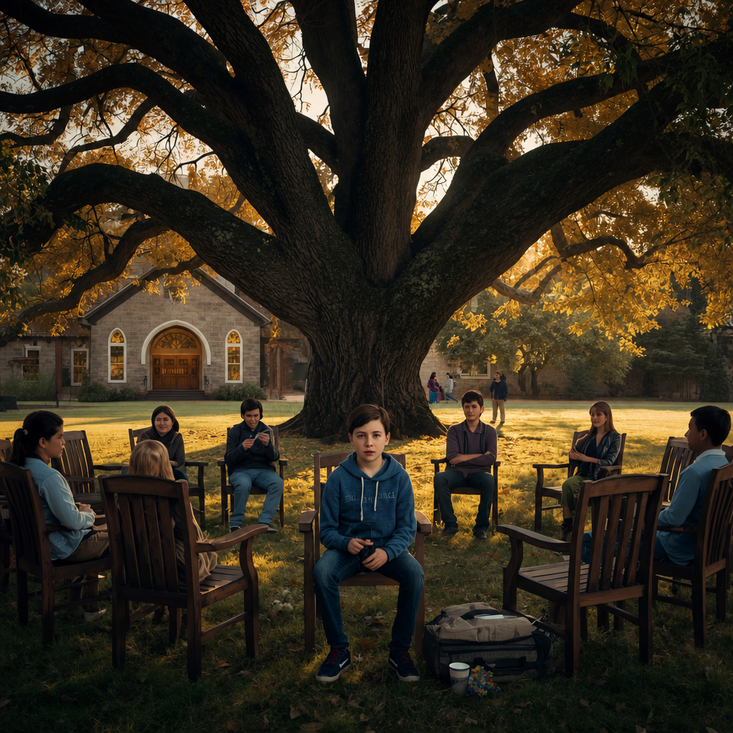

CASE CLOSED

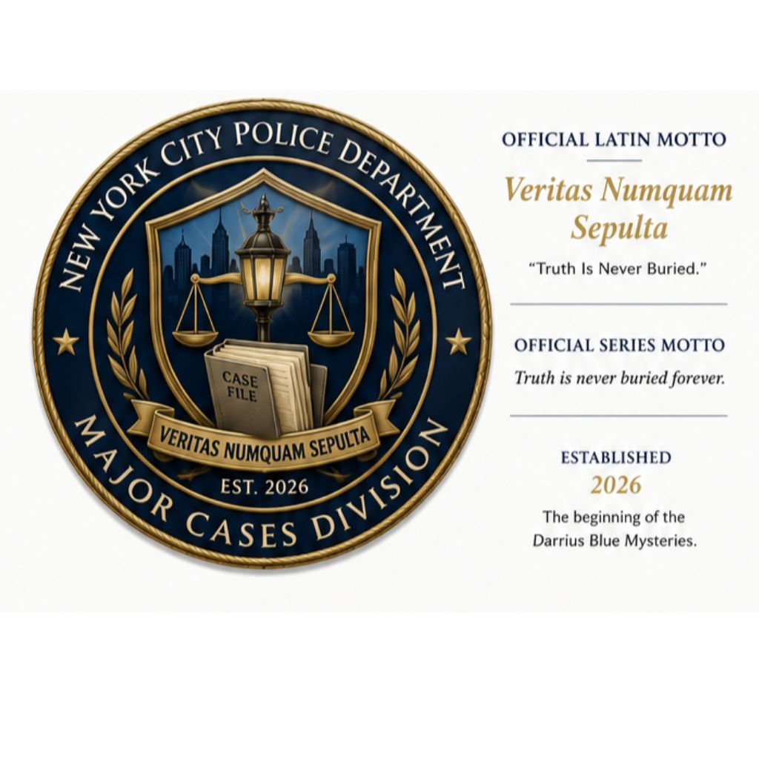

NEW YORK CITY POLICE DEPARTMENT

MAJOR CASES DIVISION

OFFICIAL CASE FILE SUMMARY

CASE FILE: DB-001-TCK
CASE TITLE: The Confessional Killer
LEAD DETECTIVE: Detective Darrius Blue
CASE CLASSIFICATION: Homicide / Historical Conspiracy
INVESTIGATION STATUS: CLOSED

CASE SUMMARY
The investigation known as The Confessional Killer has been concluded.
Evidence collected during the investigation established the existence of an organized conspiracy spanning decades. Through witness testimony, historical documentation, forensic evidence, and investigative persistence, the Major Cases Division successfully uncovered the truth behind a series of crimes long believed to be beyond resolution.
Although justice cannot erase the suffering endured by the victims, the investigation restored forgotten voices, exposed hidden wrongdoing, and ensured that the historical record would no longer remain silent.
The official investigative record has been completed and permanently archived.

EVIDENCE SECURED
✓ Witness Statements
✓ Grealish Journal
✓ Hidden Archive Records
✓ Prayer Rope
✓ Shepherd's Ring
✓ Historical Documents
✓ Forensic Evidence
✓ Final Testimony
✓ Official Case File

INVESTIGATIVE FINDINGS
Victims Identified: Complete
Historical Record Restored: Yes
Primary Conspiracy Exposed: Yes
Case Archive: Permanent

DETECTIVE'S NOTE
"Every investigation changes the investigator.
Some cases end with an arrest. Others end with the truth.
My responsibility has never been to decide which truth people are willing to accept.
My responsibility has always been to find it."
— Detective Darrius Blue

CASE DISPOSITION
FILE STATUS
CLOSED

ARCHIVED BY
Detective Darrius Blue
Major Cases Division
New York City Police Department

NEXT ACTIVE INVESTIGATION
Echoes in the Confessional
Case File DB-002
Truth is never buried forever.

BLUE PUBLISHING

Acknowledgments
Every book is the result of many influences, lessons, and moments of quiet encouragement. While The Confessional Killer is a work of fiction, it was shaped by a lifetime of service, observation, and a deep appreciation for those who dedicate themselves to seeking truth and serving others.
My sincere gratitude goes to the law enforcement professionals, investigators, first responders, military personnel, educators, clergy, and mentors whose commitment to integrity and justice inspired many of the themes explored in this novel. Their example has reinforced my belief that character is revealed not in moments of comfort, but in moments of responsibility.
I am especially grateful to my family for their unwavering love, patience, and encouragement throughout the writing process. Their support has made every page possible.
Finally, thank you to every reader who has chosen to spend time with Detective Darrius Blue. Your curiosity, imagination, and willingness to follow these investigations are the reason this series exists. I hope these stories entertain you, challenge you, and remind you that truth is always worth pursuing.
Thank you for taking this journey with me.
Sal Blue

About the Author
Sal Blue is a retired law enforcement lieutenant whose career spanned nearly three decades in policing, leadership, and professional training. Throughout his career, he served in a variety of operational and command roles, including academy instruction, tactical leadership, special operations, and organizational training, gaining firsthand experience in the realities of criminal investigations, leadership under pressure, and the pursuit of justice.
Drawing upon that experience, Sal Blue writes crime fiction that combines authentic investigative procedure with psychological suspense, historical mystery, and moral complexity. His novels explore not only who committed the crime, but why truth matters, how institutions shape lives, and what redemption can look like when justice and mercy collide.
He is also the author of several nonfiction works focused on leadership, discipline, personal growth, and intentional living.
When he is not writing, Sal enjoys continuing to mentor others, developing new stories, and building the Blue Publishing catalog.

ABOUT THE DARRIUS BLUE MYSTERIES

About the Series
Detective Darrius Blue investigates crimes where history refuses to stay buried.
Each investigation uncovers more than a criminal—it reveals forgotten victims, hidden institutions, long-held secrets, and the lasting consequences of choices made decades earlier.
Blending investigative realism with psychological suspense and historical mystery, the Darrius Blue Mysteries challenge readers to look beyond appearances and ask difficult questions about justice, memory, responsibility, and redemption.
Every novel stands on its own, while together they reveal the evolving journey of Detective Darrius Blue and the world he serves.
Truth is never buried forever.

ALSO BY SAL BLUE

Darrius Blue Mysteries
- The Confessional Killer (Book One)
- Echoes in the Confessional (Book Two — Coming Soon)
- The Reluctant Witness (Book Three)
- Devil in the Details (Book Four)

Personal Development
- Top 25 Mistakes in Route to the Good Life
- Own Your Life
- 7 Secrets to Daily Happiness
- 30-Day Discipline Challenge
- The Audit

PREVIEW

Continue the Investigation…
Echoes in the Confessional
A Darrius Blue Mystery
When new evidence surfaces connecting an unsolved disappearance to the events surrounding The Confessional Killer, Detective Darrius Blue discovers that the conspiracy he believed he had uncovered was only the beginning.
As forgotten confessions resurface and dangerous alliances emerge from the shadows, Blue is forced to confront a truth more unsettling than anything he has faced before: some secrets survive because powerful people have spent generations protecting them.
The next investigation has already begun.
CHAPTER ONE
The Newark Note
He sits in the low grass, silent, content to just watch the water. A far off thought reminds him that he should be working. On the cliff jagged edge, he watches the sun slowly slip behind the horizon like some shy maid. The man doesn't forget that a mere twenty metres below him was the entrance to the pocket cave hidden by the rugged bluff. The same cave where all the bodies had been.
And still, somehow, oranges and pinks burst from the peachy ball, and together with the twittering of birds somewhere above, he was lulled into sleep. The aura of death and decay forgotten. His eyelids lazily flutter open to witness a new discovery: the silver ball of light of that is the moon, floats on the lake’s still surface.
The water beckons invitingly. The thirst comes, hitting suddenly, and all his body wants is the water. In the moon’s light, it is liquid silver. Life saving. He stumbles on unsteady legs to the water., and the cliff when a rustling from behind raises the hair on the back of his neck.
Run! Blue, run!
The voice in the back of his head is loud. Panicked.
He spins around, The woods are dark all around him, and somewhere hidden in the shadows, there is a hunter on his tail. He knows it. The man runs but he can hear the hunter pushing through the brambles after him.
Without stopping, he madly tears through the brush.
No!
Hands hold him fast, and his resistance does little beside scraping the thorns and branches scratch against his face. He doesn't relent. To give up is to die.
When the knife sinks hilt-deep into his chest, it hits like a blow. And then the sharp pain comes, ushered by wet gurgles that drown out the rest of his scream. The last thing he sees before the darkness swallows all, is the stack of skeletal bodies piled as far as his eyes could follow, right in the middle of the clearing.
Darius Blue bolted awake, his heart pounding furiously against his ribcage. He could still feel the ache from his sternum where the blow had landed hardest. It clung to him, the pain, the fear. Even now, safe and sound in his bed, it still felt real, all of it.
Sofia snorted gently beside him before resuming her gentle snoring. The sound of it grounded it. Since the dredging - that dreadful incident which had unearthed so many bodies and unanswered questions - that noise had become his white noise. The only thing with the power to make him drift off into sleep.
The nightmares hadn't stopped coming. Not since he had discovered all those bodies. They were little more than stringy bits of flesh strung across bone for the most part, and yet they had fueled his nightmares for months on end. This night had proven that they would be harder to escape than he'd thought.

JOIN THE INVESTIGATION

Stay Connected
If you enjoyed The Confessional Killer, I invite you to continue the journey.
Join my reader community to receive:
- Updates on upcoming Darrius Blue novels
- Behind-the-scenes insights into the writing process
- Exclusive previews and bonus content
- Announcements about new releases from Blue Publishing
Visit: www.salblue.com/DarriusBlue
Or subscribe to the Blue Publishing newsletter to ensure you never miss the next investigation.

About Blue Publishing
Blue Publishing was founded on the belief that stories should endure.
We publish fiction and nonfiction that values truth, craftsmanship, and thoughtful storytelling. Every Blue Publishing title is created with a commitment to professional editorial standards, timeless design, and respect for readers.
Whether exploring crime fiction, leadership, or personal growth, our mission remains the same:
To produce books that inform, inspire, and invite meaningful reflection.
Blue Publishing
Truth is never buried forever.

Thank you for reading.
We look forward to welcoming you back for the next Darrius Blue investigation.
Blue Publishing

Blue Publishing Archive Copy No. 001

