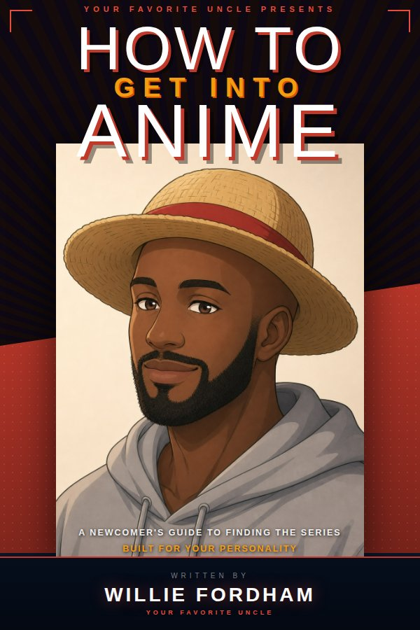

Find Your First — or Next — Anime Obsession
Your Complete Beginner's Guide to Finding the Shows You'll Love

Written by Willie Fordham
© 2026 Your Favorite Uncle
All rights reserved. No part of this publication may be reproduced, distributed, or transmitted
in any form or by any means, without the prior written permission of the publisher,
except in the case of brief quotations embodied in critical reviews and certain
noncommercial uses permitted by copyright law.
Permission requests: Hallelujah@williefordham.com
First Edition, 2026
ISBN: 979-8-950312-00-7

DISCLAIMER: This guide is not endorsed by, directly affiliated with, maintained, authorized,
or sponsored by any of the third-party brands mentioned. All product and company names
are the registered trademarks of their respective owners.

Contents

Introduction
Why Most People Fail to Get Into Anime

The 5 Steps
Step 1 — What Genres Do You Already Love?
Step 2 — Sub or Dub — How Do You Feel About Subtitles?
Step 3 — How Much Time Can You Commit?
Step 4 — What Emotional Experience Are You After?
Step 5 — What Is Your Tolerance for Weirdness?
Putting It All Together — Your Personal Anime Starter Pack

Bonus Guides
Bonus 1 — Your First Week Survival Guide
Bonus 2 — How to Talk About Anime Without Feeling Like an Outsider
Bonus 3 — How to Find Your Next Show Every Time

Appendix
Anime Fluent Cheat Sheet
The Hidden Gem Hunter's Toolkit

Introduction

Why Most People Fail
to Get Into Anime

Welcome. If you've ever tried to get into anime and given up, you're not alone. It happens to thousands of people every week — and the reason is almost never what they think it is.
Most people assume they just don't like anime. That it's not for them. That the fans who obsess over it are wired differently, or started young, or have some cultural context they'll never have.
That's not true. The real reason is simpler, and far more fixable: they watched the wrong show first.

The #1 Mistake Beginners Make
Most people search 'best anime to start with' and end up with a show that has 500+ episodes, references years of backstory, or is packed with cultural references they don't understand yet. They quit within 20 minutes and assume anime isn't for them.
That's not a 'you' problem. That's a matchmaking problem.
Anime is not a genre. It's a format — the same way 'live-action television' is a format. Within that format, you'll find psychological thrillers, heartbreaking romances, absurdist comedies, slow-burn mysteries, epic fantasy, and quiet slice-of-life stories about ordinary people living ordinary lives. There is something in there for everyone. The trick is finding the thing that's for you.

💡 Think of finding your first anime like finding a new favorite book genre. You wouldn't start with a 15-book fantasy series. You'd start with a standalone novel that feels familiar and delivers what you already know you love. That's exactly what this guide helps you do.

Your anime journey starts with the right match — not the most popular title.

How This Guide Works
This guide walks you through five targeted questions. Each one uncovers a specific dimension of your taste — your genre preferences, your relationship with subtitles, how much time you have, what emotional experience you're after, and your comfort level with storytelling conventions that differ from Western TV.
By the time you've answered all five, you'll have a personalized shortlist of three starter shows matched to who you actually are — not who Reddit thinks you should be.

How to Use This Guide
Each chapter has two parts. The first is the reading — the context, the reasoning, the recommendations. The second is the worksheet — prompts and exercises that help you apply what you've just read to your own taste.
Don't skip the reading to get to the worksheets. The reading is where the thinking happens. The worksheets are where you capture the output of that thinking.

→ Have a streaming app ready — Crunchyroll, Netflix, or Tubi
→ Set aside 30 minutes per chapter — there's no rush
→ Come in with an open mind — anime is a format, not a genre
→ Jot your answers as you go — you'll use them in the final chapter

💡 The show that's going to change the way you see this medium is already out there. You're a few questions away from finding it.

Step 1 of 5

What Genres Do
You Already Love?

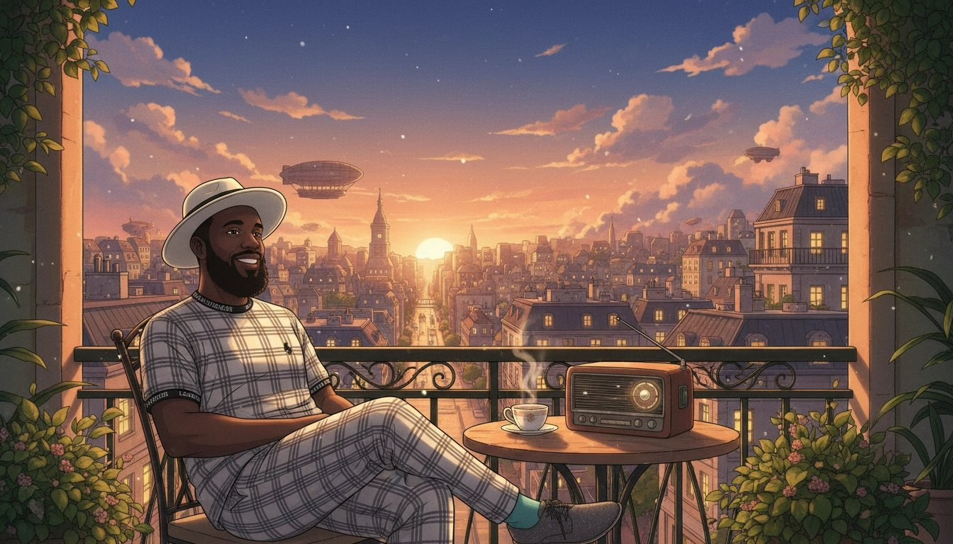
The fastest shortcut to finding anime you'll enjoy isn't reading recommendation lists. It's starting from what you already know you love.
Every genre that exists in Western TV and film exists in anime — and then some. The psychological thriller. The slow-burn romance. The ensemble workplace comedy. The sprawling fantasy epic. Anime has all of it, often at a level of craft and ambition that rivals anything produced anywhere in the world.
The problem is that anime's reputation is built around a narrow slice of what it actually contains. That's like saying Western TV is all procedural crime dramas and sitcoms. Technically not wrong. Wildly incomplete.
Your existing taste is your compass. Use it.

Your Genre Translation Guide
Below, we translate the genres you already love into the anime that delivers the same experience. Find your genre and start there.
If You Love Action (Marvel, John Wick, Mission Impossible)
My Hero Academia
Superheroes with genuine emotional stakes and some of the best character writing in the genre. An underdog story that earns every moment of triumph.
Demon Slayer
The animation quality is genuinely extraordinary. The emotional core — a brother trying to save his sister — is simple and devastating.
Attack on Titan
Structured more like a prestige war drama than a typical action series. Morally complex, relentlessly tense, and completely concluded.
If You Love Thrillers & Mystery (Breaking Bad, Gone Girl, Black Mirror)
Death Note
A psychological cat-and-mouse between two geniuses. A constant meditation on justice, power, and what happens when someone decides they should be God.
Erased
A man with the ability to travel back in time wakes up as his twelve-year-old self, weeks before a childhood murder.
Case Closed
A teenage detective is poisoned and shrunk into a child's body. 1,000+ episodes, but most cases are self-contained.
If You Love Romance & Drama (Normal People, Bridgerton, Grey's Anatomy)
Your Lie in April
A pianist who lost his ability to hear his own playing meets a violinist who plays like she's running out of time. Bring tissues.
Fruits Basket
A warm, healing story about chosen family, trauma, and the long work of learning to accept love.
Toradora
Sharp, funny, and emotionally honest teen romance that treats its audience as adults.
If You Love Fantasy & Adventure (Game of Thrones, Lord of the Rings, The Witcher)
Fullmetal Alchemist: Brotherhood
Widely considered one of the most complete fantasy stories ever told. Perfect pacing, an extraordinary cast, and a world with its own physical laws.
Made in Abyss
A gorgeously illustrated descent into a mysterious chasm. Starts as an adventure story and becomes something far darker and stranger.
Sword Art Online
Players trapped inside a virtual reality game must fight their way out or die. The premise is anime to its core, but it hooks you fast.
If You Love Comedy (The Office, Ted Lasso, Schitt's Creek)
Gintama
Absurdist samurai comedy — widely considered the funniest anime ever made. Parody, slapstick, and occasional devastating gut-punches.
Konosuba
A boy dies and is sent to a fantasy world with a goddess who turns out to be useless. Every character is a loveable disaster.
Barakamon
A calligrapher exiles himself to a rural island after punching an art critic. Wholesome, funny, and genuinely human.
If You Love Sci-Fi (Interstellar, Black Mirror, Westworld)
Steins;Gate
A self-proclaimed mad scientist discovers a method of sending messages to the past. Time travel done with genuine scientific engagement and real emotional weight.
Ghost in the Shell
The 1995 film that asked 'what makes a person a person' and inspired a generation of science fiction.
Neon Genesis Evangelion
Giant robots and existential crisis in equal measure. One of the most psychologically complex pieces of animated storytelling ever made.
If You Love Sports Stories (Moneyball, Whiplash, Rocky)
Haikyuu!!
A short kid who refuses to accept his limitations joins a volleyball team. The gold standard of sports anime — every match feels like a final.
Ping Pong the Animation
Two childhood friends chase greatness through table tennis. Quietly one of the most honest things ever made about genius.
Blue Lock
Three hundred strikers are locked in a facility and told only one will make Japan's national team. Brutal, high-concept, and addictive.

💡 Your taste will almost certainly cross multiple genres. Most great anime does too. Use this as a starting point, not a strict filter.

✏️ Step 1 Worksheet — Genre Translation
Part A — Your Top 3 Favorite Shows or Films
List your three favorite shows or films. Pick what you actually watch and rewatch.

Favorite #1 — Title
Why do I love it?
Favorite #2 — Title
Why do I love it?
Favorite #3 — Title
Why do I love it?

Part B — Genre Translation
Favorite #1 — Genre
Anime to try
Favorite #2 — Genre
Anime to try
Favorite #3 — Genre
Anime to try

Part C — Your Anime DNA
☐ Action / Adventure | ☐ Thriller / Mystery
☐ Romance / Drama | ☐ Fantasy / Isekai
☐ Comedy | ☐ Sci-Fi
☐ Slice of Life | ☐ Sports
☐ Psychological

My dominant genre(s)
Anime candidates from this step

Step 2 of 5

Sub or Dub — How Do You
Feel About Subtitles?

This is one of the most practical questions in this entire guide — and also, unfortunately, one of the most controversial in anime fandom. Let's deal with that upfront.
The anime community has strong, often loudly expressed opinions about whether you should watch subtitled (sub) or dubbed (dub) anime. Some fans treat watching dubbed anime as a moral failing. They're wrong, and you can safely ignore them. Your enjoyment matters far more than anyone's gatekeeping.
Here is the only truth that matters: the best format is the one that keeps you watching.

What "Sub" and "Dub" Actually Mean
Subbed anime means you're watching the original Japanese audio with English subtitles. You hear the original voice actors — called seiyuu in Japanese — performing the script as it was written.
Dubbed anime means the dialogue has been re-recorded in English. The quality of dubbing has improved dramatically over the last decade. There are now dubbed productions that are genuinely excellent — inspired casting, smart script adaptation, and emotionally true performances.
Both formats are legitimate ways to watch anime. The choice depends on you, not on some objective hierarchy.
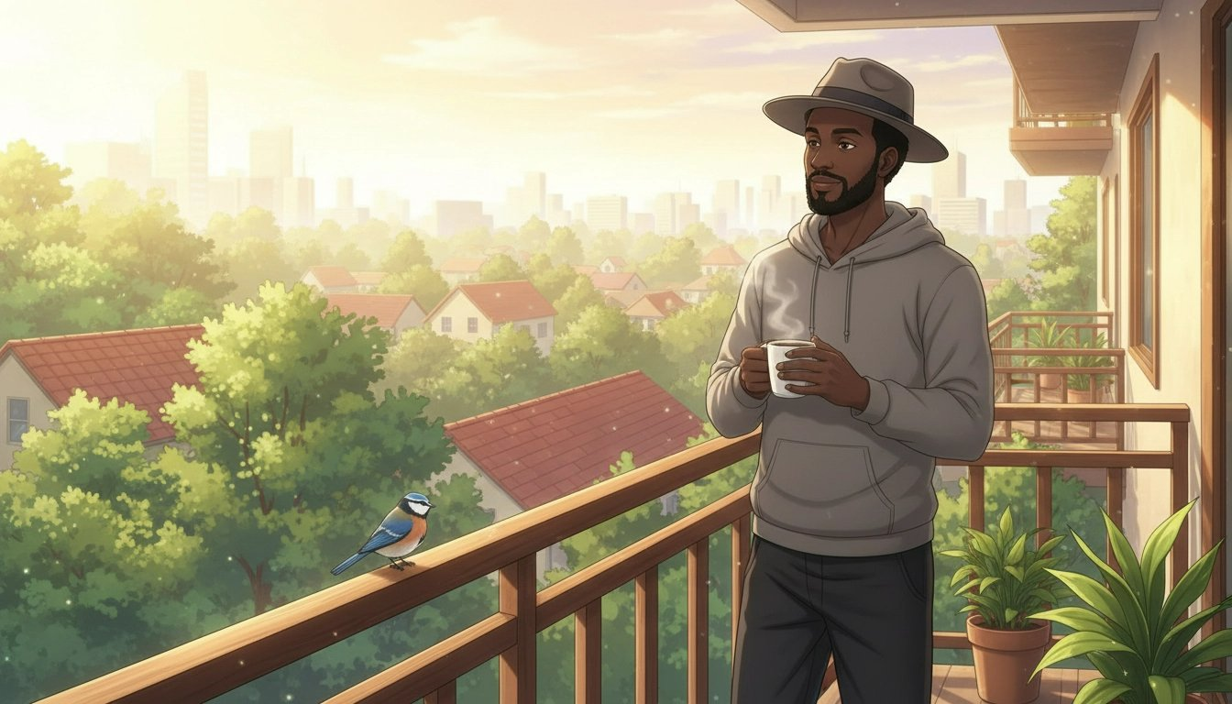

When Dubbed Works Best
If you're new to anime and watching something with a lot of visual information, dubbed lets you keep your eyes on the screen. These shows have exceptional English dubs:
▸ Fullmetal Alchemist: Brotherhood — Widely considered the gold standard of anime dubbing. The English cast is extraordinary.
▸ Cowboy Bebop — The English dub is so acclaimed the show's creator has held it in high regard.
▸ My Hero Academia — Energetic, well-cast, and consistently excellent across multiple seasons.
▸ Attack on Titan — The intensity of the performances matches the show's emotional weight.
▸ Demon Slayer — Recent, high-budget, and beautifully produced.
▸ Bleach — One of the longest-running dubs in anime history, with a cast that grew into their roles over hundreds of episodes.

When Subbed Works Best
▸ Death Note — The original voice of Light Yagami is one of the great performances in anime.
▸ Violet Evergarden — The emotional precision of the original Japanese vocal performances is central to the show's effect.
▸ Your Lie in April — A show about music and feeling, where the original performances carry layers the dub can't fully recreate.
▸ Steins;Gate — The main character's voice is doing real storytelling work that's harder to carry in translation.

The Practical Answer
Most streaming platforms — Crunchyroll, Netflix, and Tubi — let you switch between sub and dub at any point. There are no rules here.
A reasonable approach for a beginner: start with a dub on your first show to ease in without the cognitive overhead of subtitles. Once you're comfortable, try a subbed show and see which you prefer.

💡 If you're watching something with spectacular action sequences, dub lets you watch the screen. If you're watching something dialogue-heavy or emotionally intimate, sub keeps you closer to the original intent.

✏️ Step 2 Worksheet — Sub vs. Dub
Part A — Your Starting Preference
☐ I'd rather dub — I want to watch the screen without reading
☐ I'm open to subtitles — I'm comfortable reading while watching
☐ No strong preference — I'll try both and see

Part B — Honest Self-Assessment
When I watch foreign films, I usually:
☐ Watch with subtitles fine — I barely notice them
☐ Prefer dubbed versions when available
☐ Avoid them — the reading distracts me from the screen

Part C — My Decision
I'll start with (sub / dub)
Because

Part D — Shows to Try First
Show 1
Show 2
Show 3

Part E — After You've Tried It
Come back and fill this in after you've watched your first show.
Did your preference hold?

Step 3 of 5

How Much Time
Can You Commit?

This question saves more beginners from burnout than any other single piece of advice. The most common way to fail at getting into anime isn't finding a show you like. It's starting a show you like and then abandoning it because you accidentally began an 800-episode commitment when you were only looking for something to watch on a Sunday afternoon.
Good anime starts with good timing. Know how much you can commit before you hit play.

Understanding Anime Formats
Short Series — 10 to 13 Episodes
Called 'one-cour' series. They tell a complete, satisfying story in roughly four to five hours of viewing. For beginners, a short series is almost always the right starting point. You can finish it in a weekend.
Erased
12 episodes. A complete mystery thriller with genuine emotional stakes and a satisfying conclusion.
Violet Evergarden
13 episodes. A former soldier learns to understand human emotion by writing letters for others. Achingly beautiful.
A Silent Voice
A film (two hours). One of the most emotionally honest pieces of animation ever made.
Medium Series — 24 to 64 Episodes
The sweet spot for many fans once they've gotten comfortable. Long enough to develop a rich world. Short enough to finish in a few weeks.
Death Note
37 episodes. One of the most bingeable anime ever made. People regularly finish it in a week.
Fullmetal Alchemist: Brotherhood
64 episodes. Widely considered perfect. Not a single wasted episode.
Attack on Titan
Approximately 87 episodes across four seasons. Complete and concluded.
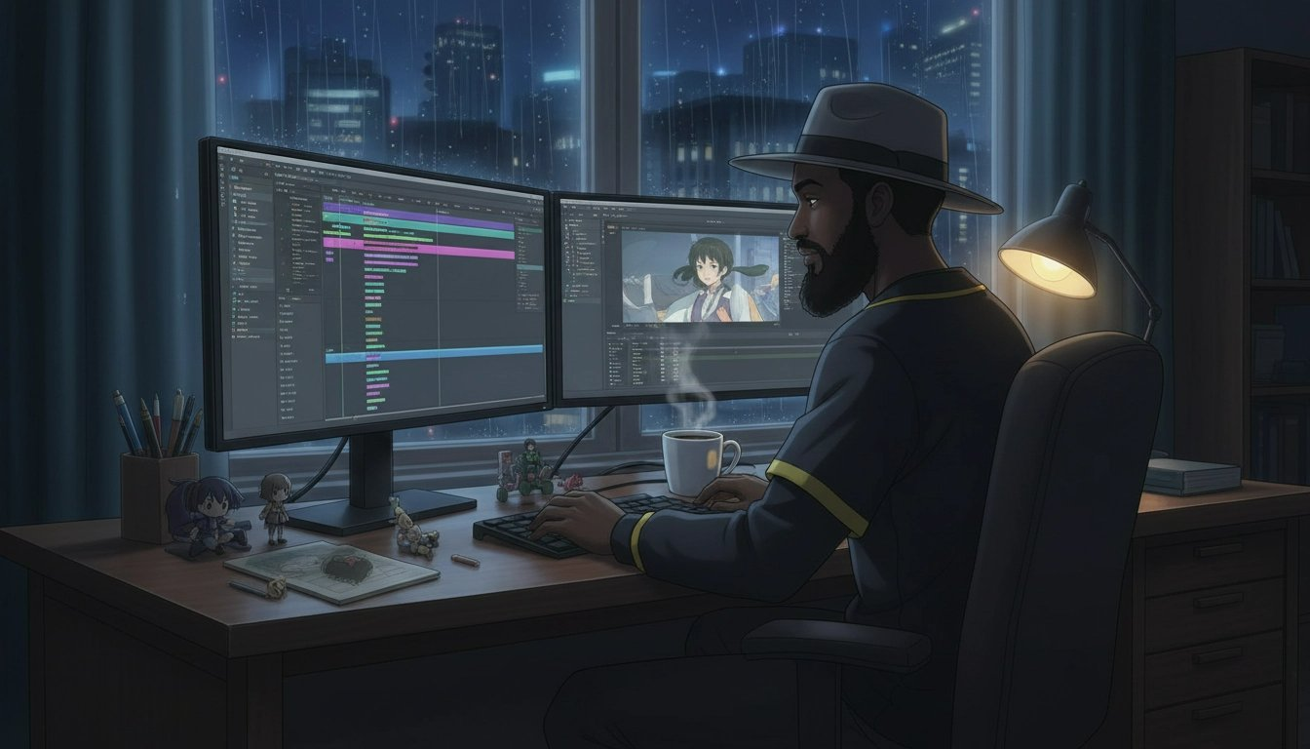
Films — 90 to 120 Minutes
Spirited Away
A Ghibli masterpiece. Universally beloved.
Your Name
A romantic fantasy about two teenagers who begin inexplicably switching bodies. A perfect entry point.
A Silent Voice
Guilt, redemption, and the courage it takes to keep living. Devastating in the best way.
Long-Running Series — 100 or More Episodes
One Piece. Naruto. Bleach. Dragon Ball. These shows are cultural institutions. They are also not where you start. Save them for after you've fallen in love with anime through something shorter.

💡 Starting with a 12-episode series is almost always the right call. Finishing something builds momentum. One completed show is worth ten abandoned ones.

✏️ Step 3 Worksheet — Time & Format
Part A — Your Weekly Reality Check
☐ Under 2 hours per week — Start with a film or 12-episode series
☐ 2–5 hours per week — A 12–13 episode series is your sweet spot
☐ 5–10 hours per week — Short or medium series both work
☐ 10+ hours per week — You can handle anything

When do I usually watch? (check all that apply)
☐ Weekday evenings
☐ Weekend afternoons
☐ Weekend evenings
☐ Lunch breaks or commuting

Part B — My Format Match
Format I chose
Approx. hours of content
Hours per week I'll watch
Approx. weeks to finish

Part C — My Shortlist for This Format
Show 1
Show 2
Show 3

Step 4 of 5

What Emotional Experience
Are You After?

This is the question that most recommendation lists miss entirely. Genre tells you the setting of a show. Emotion tells you how you want to feel while watching it — and when it's over.
They are completely different things. A fantasy series can make you feel hyped, or heartbroken, or intellectually stimulated, or warmly comforted. Genre is the map. Emotional experience is the destination.
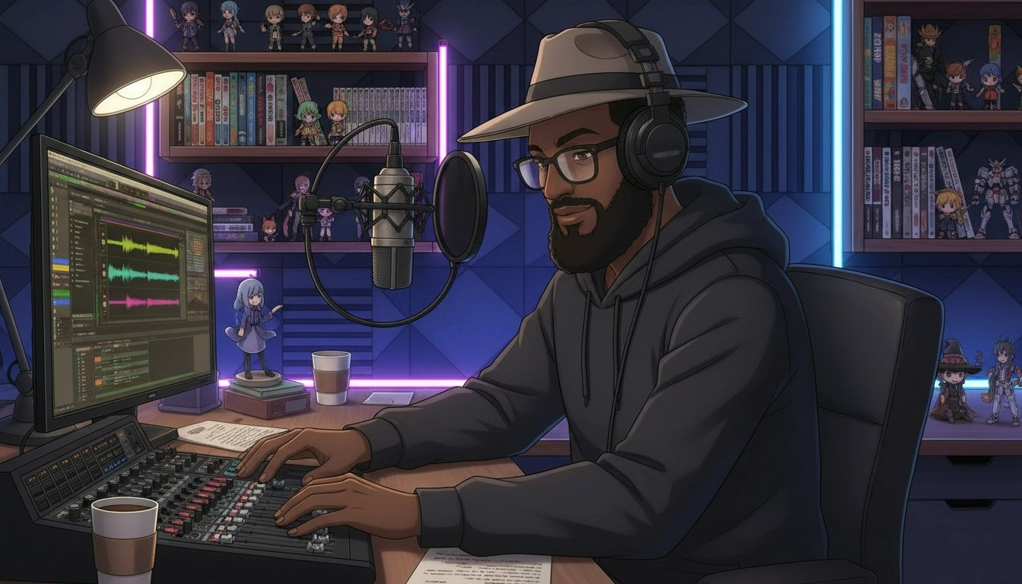

Matching Your Mood to the Right Show
I Want to Feel Hyped and Energized
Haikyuu!!
A volleyball anime that somehow makes sport feel like war, in the best possible way. Non-sports fans regularly call it life-changing.
My Hero Academia
A world where almost everyone has superpowers, and a boy born without them refuses to accept that as the final word.
Demon Slayer
The fight sequences will make your jaw drop. The emotional foundation — a brother who loves his sister — is devastatingly effective.
I Want to Think and Be Challenged
Death Note
A constant interrogation of justice, power, and what happens when someone gives themselves permission to play God.
Steins;Gate
Time travel explored with genuine intellectual rigour. The butterfly effect, the weight of choices.
Neon Genesis Evangelion
A show psychoanalysing its own protagonist in real time. Challenging, deliberately strange.
I Want to Cry — in a Good Way
A Silent Voice
Guilt, forgiveness, and the extraordinary courage it takes to keep living when you hate yourself.
Your Lie in April
A pianist who has lost the ability to hear his own playing, a violinist who is running out of time.
Clannad: After Story
The show that broke an entire generation of anime fans.
I Want to Laugh
Gintama
The funniest anime ever made, punctuated by moments of genuine emotional weight.
Konosuba
Every character is a loveable disaster. Every episode is a delight.
Nichijou
Surreal slice-of-life comedy. Impossible to watch without grinning.
I Want to Feel Warm and Safe
Barakamon
A stressed calligrapher finds peace and community on a remote rural island. Warm, funny, and deeply human.
Mushishi
Episodic stories about a traveller who encounters supernatural creatures. Quiet, contemplative, and extraordinarily beautiful.
Shirokuma Cafe
A polar bear runs a cafe. The most relaxing thing you will ever watch.
I Want to Be Transported to Another World
Made in Abyss
A terrifying, beautiful, and deeply strange world. The atmosphere is unlike anything else.
Fullmetal Alchemist: Brotherhood
A fully realised alternate world with its own history, geography, political structures, and physical laws.
Mushishi
Feudal Japan filtered through a supernatural lens. The world feels alive and endless.

💡 This isn't about what you always want from TV. It's about what you want right now. Be honest with yourself and your shortlist will be dramatically better for it.

✏️ Step 4 Worksheet — Emotional Experience
Part A — Your Mood Right Now
☐ Hyped & Energised — I want to feel fired up. Epic moments. Underdogs winning.
☐ Challenged & Engaged — I want to think. Complex questions. Ideas that linger.
☐ Moved & Emotional — I want to feel deeply. Beautiful sadness.
☐ Laughing Out Loud — I want to genuinely laugh. Absurdist, sharp comedic writing.
☐ Warm & Safe — I want comfort. Gentle stories. Kind worlds.
☐ Transported — I want world-building so rich I forget my own life.

Part B — Digging Deeper
Last show that made you feel something strongly?
What did it make you feel?
An emotion you want more of right now?
Anything you specifically want to avoid?

Part C — Matched Shows
Show 1
☐ Also on my Step 1 list
Show 2
☐ Also on my Step 1 list
Show 3
☐ Also on my Step 1 list

Step 5 of 5

What Is Your Tolerance
for Weirdness?

Anime emerged from Japanese culture. It was made by Japanese creators, for Japanese audiences, shaped by Japanese storytelling conventions, visual traditions, and cultural assumptions. When you come to it from a Western entertainment background, some of it will feel immediately familiar. And some of it will feel genuinely strange.
This is not a flaw. It's the medium being itself. But it's useful to know your starting point, because beginning at the wrong level of cultural density is one of the most common reasons people bounce off anime even after finding a show that should theoretically suit them.
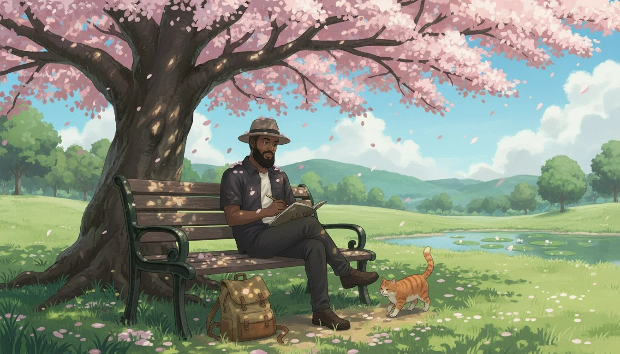

What Culture Shock in Anime Actually Looks Like
Pacing — Western TV cuts fast. Anime uses silence and stillness very differently. Long pauses. Reaction shots that hold. Internal monologue that replaces action. Your brain will recalibrate within two or three episodes.
Visual Grammar — Anime has developed its own visual shorthand over decades. Sweat drops to indicate embarrassment. Exaggerated expressions for comedic moments. Unusual hair colors that carry character meaning. You'll decode them faster than you expect.
Character Tropes — Anime has recurring character archetypes: the tsundere (cold on the outside, warm underneath), the kuudere (emotionally reserved), the reliable best friend. These are conventions the medium is often actively subverting.
High School Settings — An enormous number of anime is set in high school, regardless of whether the story has anything to do with being in high school. It's a cultural default. If this doesn't appeal to you, there are many shows that don't use this setting.
Power of Friendship — The idea that emotional bonds are a literal source of power is deeply embedded in certain genres. At its best, it's genuinely moving. Knowing it's coming helps you receive it on its own terms.

The Culture Shock Scale
Level 1 — Almost No Culture Shock
Attack on Titan
Structured and paced like a war drama.
Death Note
Feels like a psychological thriller. Very accessible.
Fullmetal Alchemist: Brotherhood
An adventure story with universal themes.
A Silent Voice / Your Name
Films with mainstream appeal worldwide.
Level 2 — Light Anime Flavor
Demon Slayer
Some comedic exaggeration, but easy to fall into.
My Hero Academia
Classic shonen tropes delivered with genuine self-awareness.
Haikyuu!!
Sports anime, grounded and human.
Level 3 — Embrace the Anime
Sword Art Online
Very anime premise and character dynamics.
Konosuba
Parody of anime tropes — funnier if you know what's being mocked.
Re:Zero
Dark twists on familiar fantasy tropes.
Level 4 — Deep End
FLCL
Pure disorientation. Best appreciated once you're fluent.
Serial Experiments Lain
Deliberately disorienting 1998 cyberpunk art.
Ping Pong the Animation
Unconventional visual style that alienates and then enchants.

💡 Even die-hard anime fans started at Level 1. Starting there and working up is smart, not cowardly.

✏️ Step 5 Worksheet — Culture Shock Self-Assessment
Part A — Rate Your Comfort Level (1 = very uncomfortable, 10 = very comfortable)
Reading subtitles while watching
Visual comedy (sweat drops, chibi moments)
Long internal monologue and slower pacing
High school settings in non-school stories
Power-of-friendship plot resolutions
Cultural references I might not understand
Different animation styles from Western cartoons

Part B — Your Level
☐ Level 1 — Almost No Culture Shock → Attack on Titan, Death Note, FMA:B
☐ Level 2 — Light Anime Flavor → Demon Slayer, My Hero Academia, Haikyuu!!
☐ Level 3 — Embrace the Anime → SAO, Konosuba, Re:Zero
☐ Level 4 — Deep End → Evangelion, Serial Experiments Lain

I chose Level
Because
One thing I'm willing to push past my comfort zone on
One thing I'm definitely not ready for yet

Putting It All Together

Your Personal
Anime Starter Pack

You've answered all five questions. You know your genres, your sub/dub preference, your format needs, your emotional target, and your comfort level with the medium. Now it's time to put it all together.
The purpose of this chapter is to cross-reference everything you've gathered into a shortlist of three shows — your Personal Anime Starter Pack. These are the shows you're going to watch, in order, starting tonight.

How to Build Your Shortlist
Go back through your worksheets from Steps 1 through 5. Make a note of every anime that appeared more than once across your answers. A show that appeared in your genre translation, your emotional experience matching, and your culture shock level is a significantly stronger candidate than one that appeared only once.

💡 If you love thrillers, want something in sub, are starting with a short series, want to feel challenged, and are at Level 1 culture shock, your shortlist almost certainly includes Death Note, Erased, and Monster. Trust the process.

Where to Watch
▸ Crunchyroll (free with ads) — The largest anime library available. Default choice for subbed anime with same-day access to new episodes.
▸ Netflix — A strong selection of both anime originals and licensed content, including the entire Studio Ghibli catalogue in many regions.
▸ Crunchyroll Premium / Funimation — The best platform for dubbed anime.
▸ Tubi — Rotating selection of anime, completely free. Great for older series.

The Three-Episode Commitment
Whatever show you pick, commit to watching three episodes before making any judgment. First episodes are doing setup work. The show doesn't reveal its true rhythm until episode three at the earliest.

✏️ Starter Pack Worksheet — My Personal Anime Starter Pack
Step 1 — Collect Your Answers
Step 1 — Genre(s) I love
Step 2 — Sub or Dub
Step 3 — Format preference
Step 4 — Emotional experience I want
Step 5 — My culture shock level

Step 2 — Cross-Reference Your Lists
List every show that appeared more than once across your step worksheets:
Show A
Show B
Show C
Show D

Step 3 — My Final Shortlist of 3
#1 — START HERE TONIGHT
Title
☐ Crunchyroll
☐ Netflix
☐ Funimation / Other
Why it fits me

#2 — Watch Second
Title
☐ Crunchyroll
☐ Netflix
☐ Funimation / Other
Why it fits me

#3 — Watch Third
Title
☐ Crunchyroll
☐ Netflix
☐ Funimation / Other
Why it fits me

Step 4 — My Commitment
I will start watching
On this date
After 3 episodes, my honest reaction

Bonus Guide 1

Your First Week
Survival Guide

You pressed play. You found your show. Now what?
This is the chapter nobody talks about — what actually happens in your first week watching anime, and how to handle all of it without quitting before it gets good.

💡 Most people who give up on anime quit in the first week. Not because the show is bad — because they didn't know what to expect. This chapter fixes that.

Why the First Episode Feels Weird
The Pacing Feels Slower Than You Expected
Western TV cuts fast. Anime uses silence and stillness very differently — long pauses, reaction shots that hold, internal monologue that replaces action. This isn't filler. Your brain will recalibrate within two or three episodes.
A Character Said or Did Something That Felt Strange
Anime is made in Japan for Japanese audiences. When something feels strange, get curious instead of critical. A quick search after the episode ends will usually explain what's happening.
The Art Style Threw You Off
Big eyes. Unusual hair color. Exaggerated expressions. These are conventions of the medium, not failures of artistry. Within a few episodes, the visual grammar will feel completely natural.
You Didn't Understand a Term
Anime has its own vocabulary. The Anime Fluent Cheat Sheet in the appendix covers every term you're likely to encounter. Don't pause mid-episode — note the term and look it up afterwards.

The 3-Episode Rule — And Why It Works
Episode 1 — World-building and setup. Often the most disorienting. This is normal.
Episode 2 — Characters start becoming real. You begin to care about them.
Episode 3 — The show's actual rhythm reveals itself. By the end, you know whether this is your show.

Handling Confusion Without Quitting
You missed something important: Rewind. Anime rewards attention.
A cultural reference went over your head: Note it and search after the episode ends.
You're not sure if you're enjoying it: Ask yourself one question — am I curious about what happens next? If yes, keep going.

💡 You don't have to love the first show you try. Finding your anime is sometimes a process. Every dropped show tells you something useful about what you actually want.

✏️ Bonus Guide 1 Worksheet — First Week Survival
Section 1 — After Episode 1: What Threw You Off?
☐ The pacing felt slow
What scene felt this way
☐ A character acted strangely
What happened
☐ The art style threw me off
What specifically
☐ I didn't understand a term
Write the term — look it up after

Section 2 — The 3-Episode Tracker
EPISODE 1
One thing that confused me
One thing I liked
☐ Am I curious what's next? ☐ Yes ☐ Not sure ☐ No

EPISODE 2
Character I'm most interested in
☐ Did I care more than Ep 1? ☐ Yes ☐ Same ☐ Less
One moment that stood out

EPISODE 3 — Verdict
The show's rhythm feels
My honest reaction
☐ My decision: ☐ Continue ☐ Move to my next shortlist pick

Section 3 — First Week Checklist
☐ Picked the first show from my shortlist
☐ Streaming app ready
☐ Decided sub or dub
☐ Watched Episode 1 without judgment
☐ Watched Episodes 2 and 3 before forming an opinion
☐ Kept my Anime Fluent Cheat Sheet nearby
☐ Made my decision after Episode 3

Section 4 — End of Week 1 Reflection
The show I watched
My overall reaction in 1–2 sentences
My favorite moment so far
Something that surprised me about anime
Curiosity level after 3 episodes (1 = not curious, 5 = very curious)

Bonus Guide 2

How to Talk About Anime
Without Feeling Like an Outsider

Knowing what to watch is one thing. Knowing how to talk about it is another entirely.
Anime fandom has its own language, its own etiquette, and its own unwritten rules. Fans throw around terms like isekai, seiyuu, sakuga, and cour as if everyone grew up knowing them. When you don't know the vocabulary, conversations feel like an exam you didn't study for.

💡 You don't need to have watched 100 shows to have great anime conversations. You just need the right vocabulary and the right approach.

The 10 Terms You'll Hear in Your First Week
1. Shonen
Anime aimed at younger male audiences. Stories built around action, friendship, and growth. My Hero Academia, Demon Slayer, Naruto, Dragon Ball Z — all shonen.
2. Isekai
A genre where the main character is transported to another world. Sword Art Online, Re:Zero, Konosuba. Once you know isekai, you'll start spotting it everywhere.
3. Slice of Life
Anime focused on everyday life with minimal dramatic conflict. Slow, warm, character-driven, and often deeply human.
4. Sub / Dub
You know this one already.
5. Filler
Episodes not adapted from the original manga. Long-running series — Naruto, Bleach, One Piece — are notorious for filler. There are guides online telling you exactly which episodes to skip.
6. Canon
Content officially part of the story as established in the original source material.
7. OVA
Original Video Animation. Bonus episodes or short films released outside the main series run.
8. Seiyuu
Japanese voice actor or actress. Seiyuu are celebrities in Japan.
9. Waifu / Husbando
Affectionate fan terms for a beloved fictional character. Used casually and warmly.
10. MAL / AniList
MyAnimeList and AniList are the two main websites fans use to track what they've watched and rate shows. Creating a free account on either is one of the best first moves you can make.

What to Say in the Most Common Situations
Someone asks if you've seen a show you haven't
Say: "Not yet — it's on my list. What's it like?"
Someone asks what your favorite anime is
Say: "I'm still early — I just finished [X] and I think it's going to be hard to beat."
The sub vs. dub debate starts
Say: "I prefer [sub/dub] for [reason], but I'll watch either."
Someone uses a term you don't know
Say: "I'm still learning the vocabulary — what does that mean?"

Where to Find Your People Online
▸ Reddit — r/anime — The largest English-language anime community. r/animerecommendations is specifically for finding new shows.
▸ MyAnimeList / AniList — Both platforms have community features beyond just tracking.
▸ YouTube — Finding a creator whose taste aligns with yours is one of the best ways to deepen your engagement with the medium.

💡 The anime community is mostly welcoming to newcomers. Lead with genuine curiosity and you'll find your people quickly.

✏️ Bonus Guide 2 Worksheet — Vocabulary & Community
Section 1 — Vocabulary Check
In your own words, define each term:
Shonen
Isekai
Slice of Life
Filler
Canon
OVA
Seiyuu
Waifu / Husbando
MAL / AniList

Section 2 — Conversation Scripts
Someone asks if you've seen a show you haven't. My response
Someone asks what your favorite anime is. My response
Someone uses a term I don't know. My response

Section 3 — Community Setup
☐ Created a MyAnimeList or AniList account
☐ Added my first show to my list
☐ Joined r/anime or found an anime community online
☐ Found one YouTube creator whose taste I want to follow

Bonus Guide 3

How to Find Your
Next Show Every Time

You finished your first show. You've crossed from curious to fan.
Now comes the question nobody prepares you for: what do I watch next?
💡 The best predictor of what you'll love next isn't genre or rating. It's understanding exactly what worked for you in what you just watched.

Step 1: The Post-Show Debrief
What did you love most?
Not 'I liked it' — that's not useful. What specifically worked? Was it the relationship between two characters? The way the plot constructed its mysteries? Be specific.
What would you change if you could?
These answers are specifications for your next show. Too slow? You want something with more momentum. Too action-heavy? You want something that prioritizes character.
How did it make you feel?
Energized? Emotional? Thoughtful? Comforted? These feelings are the emotional target for your next show.
More of the same, or something different?
Both are completely valid. Know which mode you're in before you start.

Step 2: The Match Framework
▸ You loved the characters above everything else → March Comes in Like a Lion, Natsume's Book of Friends, Fruits Basket
▸ The story and plot kept you watching → Death Note, Steins;Gate, Erased
▸ The animation quality blew you away → Demon Slayer, Jujutsu Kaisen, any Studio Ghibli film
▸ Emotional impact is what you're chasing → Your Lie in April, Anohana, A Silent Voice, Violet Evergarden
▸ You loved the world and wanted more of it → Fullmetal Alchemist: Brotherhood, Made in Abyss
▸ The humour made it special → Konosuba, Nichijou, Gintama

Step 3: Build Your Shortlist of 3
Filter by Length
Match the format to your current energy and available time. A 12-episode show is a weekend. A 64-episode show is a month. A film is an evening.
Filter by Completion Status
As a developing fan, strongly prefer shows that are fully finished. Check MAL or AniList — the completion status is listed on every show's page.
Read 3 User Reviews
On AniList or MAL, sort reviews by Most Helpful. Three reviews will tell you things the marketing doesn't.
Watch the First 3 Minutes
Open Episode 1. Watch the opening scene. Does the visual style interest you? Does the tone match what you're looking for right now?

💡 This whole process takes 15 minutes. It's the difference between an hour of scrolling and starting your next favorite show tonight.

✏️ Bonus Guide 3 Worksheet — What's Next
Post-Show Debrief
Show I just finished
Date finished
What did you love most?
What would you change?
How did it make you feel?
☐ More of the same
☐ Something different

Match Framework — My Candidates
Candidate 1
Candidate 2
Candidate 3
Candidate 4

Filter Checklist
☐ Filtered by length — matches my current energy and time
☐ Completion status checked — prefer Finished Airing
☐ Read 3 user reviews on MAL or AniList
☐ Watched first 3 minutes of top candidate

My Final Shortlist
#1 — Watch Tonight
Title
☐ Finished
☐ Ongoing
Why it fits what I'm looking for

#2
Title
☐ Finished
☐ Ongoing
Why it fits

#3
Title
☐ Finished
☐ Ongoing
Why it fits

My top pick to watch tonight

Appendix

Anime Fluent
Cheat Sheet

These are the terms you'll encounter in episode descriptions, online forums, reviews, and conversations with other fans. Keep this page bookmarked for your first few weeks.

Formats & Demographics
Term | Audience & Meaning — Example Series
Shonen | Teen boys — action, adventure, male protagonist. (Naruto, My Hero Academia, Demon Slayer)
Shojo | Teen girls — romance, drama, relationships. (Sailor Moon, Fruits Basket, Kimi ni Todoke)
Seinen | Adult men — mature, complex, darker themes. (Berserk, Monster, Vinland Saga)
Josei | Adult women — realistic romance, adult life. (Nana, Chihayafuru, Loveless)
Isekai | Protagonist transported to another world. (Sword Art Online, Re:Zero, Konosuba)
Slice of Life | Everyday mundane events, relaxing or comedic. (K-On!, Barakamon, Yuru Camp)
Mecha | Giant robots/machines piloted in combat. (Evangelion, Gundam, Darling in the FranXX)
Iyashikei | Healing anime — calm, gentle, deliberately comforting. (Mushishi, Shirokuma Cafe)

Must-Know Vocabulary
Term | Meaning
Manga | The original Japanese comic many anime are adapted from
Seiyuu | Japanese voice actor; often has a dedicated fanbase
Cour | A 13-episode broadcast season (one-cour = 13 eps, two-cour = 26 eps)
Filler | Non-canon episodes not from the manga, used to let the manga advance
OVA | Original Video Animation; bonus episodes outside the main run
OST | Original Soundtrack; anime music is often genuinely extraordinary
Chibi | Super-deformed, exaggeratedly cute art style used for comic effect
Kawaii | Japanese for 'cute' — widely used in fan communities
Tsundere | Character initially cold who gradually reveals a warm, affectionate side
Waifu/Husbando | Affectionate fan term for a beloved fictional character
Otaku | A person with passionate devotion to anime and manga
Fan Service | Content added to please fans, often unrelated to the main plot
Opening/Ending | The intro and outro songs; often beloved in their own right

Community Terms
Term | Meaning
Simulcast | New episodes released in your country on the same day as Japan
Crunchyroll / CR | The dominant anime streaming platform
MAL | MyAnimeList — the main site to track and rate what you've watched
AniList | MAL alternative with better design and social features
Dropped | Stopped watching a show before finishing it — happens to everyone
10/10 | A show so good it changes how you think about the medium
Sakuga | Exceptionally animated sequences; fans often clip and share these
PV | Promotional Video — a trailer or preview for an upcoming series

Appendix

The Hidden Gem
Hunter's Toolkit

With over 10,000 anime series available, streaming algorithms rarely surface the most creative and emotionally resonant titles. To find hidden gems, you have to step outside the algorithm.

The Discovery Method
Method 1 — Leverage Community Platforms
On MAL or AniList, use Advanced Search. Filter by your preferred genres, set minimum score to 7.5, and sort by Members (ascending). This reveals highly rated shows that very few people have watched. Reddit threads titled 'Hidden Gems' or 'Overlooked Masterpieces' are goldmines.
Method 2 — Follow the Creators
Many hidden gems come from visionary directors on passion projects. Masaaki Yuasa (The Tatami Galaxy, Kaiba) and Shinichiro Watanabe (Samurai Champloo, Space Dandy) consistently produce critically acclaimed but less commercially visible work. A director's full filmography is one of the most reliable discovery paths.
Method 3 — Explore Older Decades
The 90s produced gritty cyberpunk and space westerns. The 2000s were an era of experimental narratives and unique art styles. Don't limit yourself to what is currently airing.

5 Hidden Gems to Watch Now
Show | Why It Works
Astra Lost in Space | Sci-Fi/Mystery — 12 eps | Tightly plotted mystery with a satisfying conclusion and excellent character dynamics.
Kyousougiga | Fantasy/Action — 10 eps | Visually explosive and emotionally complex family story, consistently overshadowed by larger titles.
Barakamon | Slice of Life/Comedy — 12 eps | Heartwarming and hilarious — a calligrapher finds inspiration on a rural island.
Odd Taxi | Mystery/Thriller — 13 eps | Brilliantly written, dialogue-heavy mystery featuring anthropomorphic animals in a gritty urban setting.
Kaiba | Sci-Fi/Psychological — 12 eps | Directed by Masaaki Yuasa. Unique retro art style exploring memory and identity.

The Genre Mood Matrix
Mood | Recommended Show
I want to cry | Haibane Renmei
I want to laugh | Detroit Metal City
I want to think | The Tatami Galaxy
I want action | Gurren Lagann
I want to relax | Barakamon or Yuru Camp
I want mystery | Odd Taxi
I want adventure | Kino's Journey

The Tiered Watchlist System
Tier | Description
Tier 1 — Next Up | Your immediate priority. Maximum 3 shows. One short, one long, one film.
Tier 2 — On Deck | Shows you've actively researched. Maximum 10. Promote to Tier 1 when a slot opens.
Tier 3 — Someday | Your master backlog. Unlimited. Add anything without pressure.

🎉 You're Ready.

Bonus 1 gets you through your first week without quitting.
Bonus 2 makes you fluent in the language of anime fandom.
Bonus 3 means you never run out of great shows to watch.

The show that changes everything for you is already out there.
Now you know exactly how to find it.
— Willie Fordham
Your Favorite Uncle

© 2026 Your Favorite Uncle · All Rights Reserved
Hallelujah@williefordham.com

