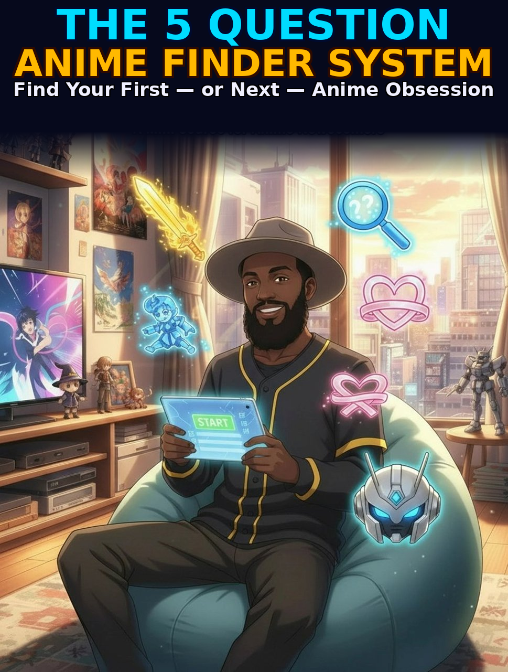

THE 5 QUESTION
ANIME FINDER SYSTEM

Find Your First — or Next — Anime Obsession
WILLIE FORDHAM
Your Favorite Uncle

The 5 Question Anime Finder System
Find Your First — or Next — Anime Obsession
Written by Willie Fordham

© 2026 Your Favorite Uncle
All rights reserved. No part of this publication may be reproduced, distributed, or transmitted in any form or by any means, including photocopying, recording, or other electronic or mechanical methods, without the prior written permission of the publisher, except in the case of brief quotations embodied in critical reviews and certain other noncommercial uses permitted by copyright law.
For permission requests, write to the publisher at:
Hallelujah@williefordham.com
First Edition, 2026
DISCLAIMER: This guide is not endorsed by, directly affiliated with, maintained, authorized, or sponsored by any of the third-party brands mentioned. All product and company names are the registered trademarks of their respective owners.

TABLE OF CONTENTS

Welcome: Why Most People Fail to Get Into Anime 1
The #1 Mistake Newcomers Make 1
How This System Works 1
How to Use This Guide 1
What Genres Do You Already Love? 1
Genre Translation Guide 1
If you love action (Marvel, John Wick, Mission Impossible) 1
If you love thrillers and mystery (Breaking Bad, Gone Girl, Black Mirror) 1
If you love romance and drama (Normal People, Bridgerton, Grey's Anatomy) 1
If you love fantasy and adventure (Game of Thrones, Lord of the Rings, The Witcher) 1
If you love comedy (The Office, Ted Lasso, Schitt's Creek) 1
If you love sci-fi (Interstellar, Black Mirror, Westworld) 1
Sub or Dub — How Do You Feel About Subtitles? 1
What Sub and Dub Actually Mean 1
When Dubbed Works Best 1
When Subbed Works Best 1
The Practical Answer 1
How Much Time Can You Commit? 1
Understanding Anime Formats 1
Short Series — 10 to 13 Episodes 1
Medium Series — 24 to 64 Episodes 1
Films — 90 to 120 Minutes 1
Long-Running Series — 100 or More Episodes 1
What Emotional Experience Are You After? 1
Matching Your Mood to the Right Show 1
I want to feel hyped and energised 1
I want to think and be challenged 1
I want to cry — in a good way 1
I want to laugh 1
I want to feel warm and safe 1
I want to be transported to another world 1
What Is Your Tolerance for Weirdness? 1
What Culture Shock in Anime Actually Looks Like 1
Pacing 1
Visual Grammar 1
Character Tropes 1
High School Settings 1
Power of Friendship 1
The Culture Shock Scale 1
Level 1 — Almost No Culture Shock 1
Level 2 — Light Anime Favor 1
Level 3 — Embrace the Anime 1
Level 4 — Deep End 1
Your Personal Anime Starter Pack 1
How to Build Your Shortlist 1
Where to Watch 1
The Three-Episode Commitment 1
The First Week Survival Guide 1
Why the First Episode Feels Weird 1
The pacing feels slower than you expected 1
A character said or did something that felt strange 1
The art style threw you off 1
You didn't understand a term 1
The 3-Episode Rule — And Why It Works 1
Handling Confusion Without Quitting 1
How to Talk About Anime Without Feeling Like an Outsider 1
The 10 Terms You'll Hear in Your First Week 1
1. Shonen 1
2. Isekai 1
3. Slice of Life 1
4. Sub / Dub 1
5. Filler 1
6. Canon 1
7. OVA 1
8. Seiyuu 1
9. Waifu / Husbando 1
10. MAL / AniList 1
What to Say in the Most Common Situations 1
Where to Find Your People Online 1
The What's Next Shortlist Builder 1
Step 1: The Post-Show Debrief 1
What did you love most? 1
What would you change if you could? 1
How did it make you feel? 1
More of the same, or something different? 1
Step 2: The Match Framework 1
Step 3: Build Your Shortlist of 3 1
Filter by length 1
Filter by completion status 1
Read 3 user reviews 1
Watch the first 3 minutes 1
Anime Fluent Cheat Sheet 1
Formats & Demographics 1
Must-Know Vocabulary 1
Community Terms 1
The Hidden Gem Hunter's Toolkit 1
The Discovery Method 1
5 Hidden Gems to Watch Now 1
The Genre Mood Matrix 1
The Tiered Watchlist System 1

INTRODUCTION

Welcome: Why Most People Fail to Get Into Anime
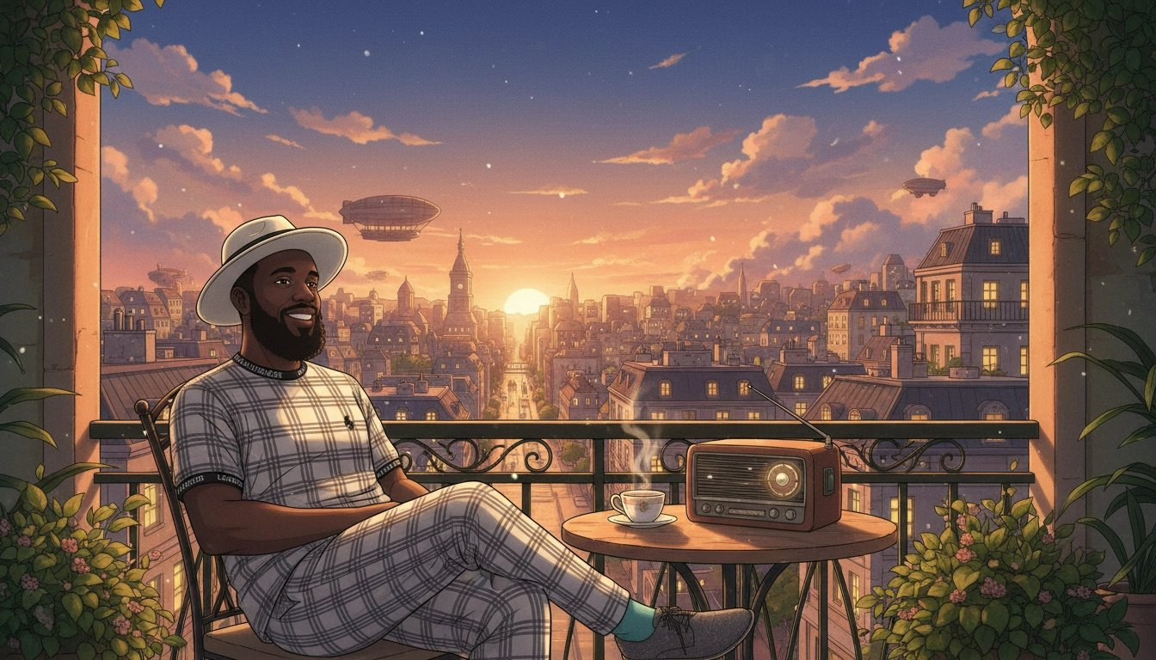

Welcome. If you've ever tried to get into anime and given up, you're not alone. It happens to thousands of people every week and the reason is almost never what they think it is.
Most people assume they just don't like anime. That it's not for them. That the fans who obsess over it are weird and wired differently, or started young, or have some cultural context they'll never have.
That's not true. The real reason is simpler, and far more fixable: they watched the wrong show first.

The #1 Mistake Newcomers Make
Most people search 'best anime to start with' and end up with a show that has 500+ episodes, references years of backstory, or is packed with cultural references they don't understand yet. They quit within 20 minutes and assume anime isn't for them.
That's not a ‘them’ problem. That's a matchmaking problem.
Anime is not a genre. It's a format. The same way 'live-action television' is a format. Within that format, you'll find psychological thrillers, heartbreaking romances, absurdist comedies, slow-burn mysteries, epic fantasy, and quiet slice-of-life stories about ordinary people living ordinary lives. There is something in there for everyone. The trick is finding the thing that's for you.
💡 Think of finding your first anime like finding a new favorite book genre. You wouldn't start with a 15-book fantasy series. You'd start with a standalone novel that feels familiar and delivers what you already know you love. That's exactly what this guide helps you do.

How This System Works
This guide guides you through five targeted questions. Each question is designed to uncover a specific dimension of your taste — your genre preferences, your relationship with subtitles, how much time you have, what emotional experience you're after, and your comfort with storytelling conventions that differ from Western TV.
By the time you've answered all five, you'll have a personalized shortlist of three starter shows that are matched to who you actually are, not who Reddit thinks you should be.
After the main chapters, three bonus chapters take you further: surviving your first week, talking about anime with confidence, and building a system for finding your next show every time you finish one.

How to Use This Guide
Each chapter has two parts. The first part is the reading — the context, the reasoning, the recommendations. The second part is the worksheet — prompts and exercises that help you apply what you've just read to your own taste.
Don't skip the reading to get to the worksheets. The reading is where the thinking happens. The worksheets are where you capture the output of that thinking.
- Have a streaming app ready — Crunchyroll, Netflix, or Tubi
- Set aside 30 minutes per chapter — there's no rush
- Come in with an open mind — anime is a format, not a genre
- Jot your answers as you go — you'll use them in the final chapter

💡 The show that's going to change the way you see this medium is already out there. You're a few questions away from finding it.

Chapter 1 · THE 5 Questions

What Genres Do You Already Love?

The fastest shortcut to finding anime you'll enjoy isn't reading recommendation lists. It's starting from what you already know you love.
Every genre that exists in Western TV and film exists in anime — and then some. The psychological thriller. The slow-burn romance. The ensemble workplace comedy. The sprawling fantasy epic with its own mythology and internal logic. Anime has all of it, often at a level of craft and ambition that rivals anything produced anywhere in the world.
The problem is that anime's reputation is built around a narrow slice of what it actually contains. That's a bit like saying Western TV is all procedural crime dramas and sitcoms. Technically not wrong. Wildly incomplete.
Your existing taste is your compass. Use it.

Genre Translation Guide

If you love action (Marvel, John Wick, Mission Impossible)
Action is one of anime's great strengths. The best action anime don't just choreograph fights — they build entire emotional architectures around them. A climactic battle crystallises everything a character has been through in a way that live-action rarely achieves.
My Hero Academia — Superheroes with genuine emotional stakes and some of the best character writing in the genre. An underdog story that earns every moment of triumph.
Demon Slayer — The animation quality is genuinely extraordinary. The emotional core — a brother trying to save his sister — is simple and devastating.
Attack on Titan — Structured more like a prestige war drama than a typical action series. Morally complex, relentlessly tense, with a plot that rewards attention over four complete seasons.

If you love thrillers and mystery (Breaking Bad, Gone Girl, Black Mirror)
Some of the most tightly plotted, intellectually satisfying storytelling in any medium is in anime. If you love stories where every scene is a chess move and you're always three steps behind, anime has what you're looking for.
Death Note — A psychological cat-and-mouse between two geniuses. A constant meditation on justice, power, and what happens when someone decides they should be God.
Erased — A man with the involuntary ability to travel back in time wakes up as his twelve-year-old self, weeks before a childhood murder. A mystery thriller that is also quietly one of the best things about growing up.
Case Closed — A teenage detective is poisoned by criminals and shrunk into a child's body, forced to solve murders while hiding his true identity. One of the longest-running and most beloved mystery series ever made — endlessly clever, with cases that range from locked-room puzzles to sprawling crime conspiracies.

If you love romance and drama (Normal People, Bridgerton, Grey's Anatomy)
Anime handles emotional intimacy with a directness that Western drama often sidesteps. The best romance and drama anime are genuinely human stories told with extraordinary emotional precision.
Your Lie in April — A pianist who lost his ability to hear his own playing meets a violinist who plays like she's running out of time. Music, grief, and first love. Bring tissues.
Fruits Basket — A warm, healing story about chosen family, trauma, and the long work of learning to accept love.
Toradora — Sharp, funny, and emotionally honest teen romance that treats its audience as adults.

If you love fantasy and adventure (Game of Thrones, Lord of the Rings, The Witcher)
World-building is a craft anime takes very seriously. Some of the most completely realised fictional worlds in any storytelling medium exist in anime. If you love getting lost in a world, anime will give you worlds you don't want to leave.
Fullmetal Alchemist: Brotherhood — Widely considered one of the most complete fantasy stories ever told. Perfect pacing, an extraordinary cast, and a world with its own physical laws.
Made in Abyss — A gorgeously illustrated descent into a mysterious chasm. Starts feeling like an adventure story and becomes something far darker and stranger.
Sword Art Online — Players trapped inside a virtual reality game must fight their way out or die. The premise is anime to its core, but it hooks you faster than almost anything.

If you love comedy (The Office, Ted Lasso, Schitt's Creek)
Anime comedy is its own genre with its own logic. At its best, it's inventive, absurdist, and faster than you expect. Committed, character-driven comedy that earns its laughs.
Gintama — Absurdist samurai comedy, widely considered the funniest anime ever made. Parody, slapstick, fourth-wall breaks, and occasional devastating emotional gut-punches.
Konosuba — A boy dies and is sent to a fantasy world with a goddess who turns out to be useless. Every character is a loveable disaster.
Barakamon — A calligrapher exiles himself to a rural island after punching an art critic. Wholesome, funny, and genuinely human.

If you love sci-fi (Interstellar, Black Mirror, Westworld)
Anime was thinking seriously about consciousness, identity, technology, and what it means to be human decades before most Western sci-fi caught up. The philosophical foundations of countless touchstones were built here first.
Steins;Gate — A self-proclaimed mad scientist discovers a method of sending messages to the past. Time travel done with genuine scientific engagement and emotional weight.
Ghost in the Shell — The 1995 film that asked 'what makes a person a person' and inspired a generation of science fiction.
Neon Genesis Evangelion — Giant robots and existential crisis in equal measure. One of the most psychologically complex pieces of animated storytelling ever made.

If you sports movies (Moneyball, Whiplash, Rocky)
Sports anime isn't really about the sport. It's about obsession, teamwork, and what it costs to become great at something. These are some of the best.
Haikyuu!! — A short kid who refuses to accept his limitations joins a volleyball team with a complicated history. The gold standard of sports anime — every match feels like a final, and you will care about characters you didn't expect to care about.
Ping Pong the Animation — Two childhood friends with completely different relationships, chase greatness in table tennis. Visually unlike anything else and quietly one of the most honest things ever made about what genius actually feels like.
Blue Lock — Three hundred strikers are locked in a facility and told only one will make Japan's national team. A brutal, high-concept competition anime that treats ego and selfishness as weapons rather than flaws.

💡 Your taste will almost certainly cross multiple genres. Most great anime does too. Use this guide as a starting point, not a strict filter.

✏️ Chapter 1 Worksheet — Genre Translation
Step 1 — Your Top 3 Favorite Shows or Films
List your three favorite shows or films. Be honest — pick what you actually watch and rewatch.

Favorite #1 Title:

Why do I love it? What specifically keeps me coming back?

Favorite #2 Title:

Why do I love it? What specifically keeps me coming back?

Favorite #3 Title:

Why do I love it? What specifically keeps me coming back?

Step 2 — Genre Translation
Using the Genre Translation Guide, match each show to an anime genre and note the recommended anime beside it.

Your Show | Closest Genre → Anime Match(es) to Try
Favorite #1: | Genre: _____________ Try: _____________________
Favorite #2: | Genre: _____________ Try: _____________________
Favorite #3: | Genre: _____________ Try: _____________________

Step 3 — Your Anime DNA
Circle or tick your dominant genres below.

☐ Action / Adventure ☐ Thriller / Mystery ☐ Romance / Drama ☐ Fantasy / Isekai ☐ Comedy ☐ Sci-Fi ☐ Slice of Life ☐ Sports ☐ Psychological

My dominant genre(s):

Anime candidates from this chapter:

Chapter 2 · THE 5 Questions

Sub or Dub — How Do You Feel About Subtitles?

This is one of the most practical questions in this entire guide — and also, unfortunately, one of the most controversial in anime fandom. Let's deal with that upfront.
The anime community has strong, often loudly expressed opinions about whether you should watch subtitled (sub) or dubbed (dub) anime. Some fans treat watching dubbed anime as a moral failing. They're wrong, and you can safely ignore them by walking away from the situation. Your enjoyment matters far more than anyone's gatekeeping.
Here is the only truth that matters: the best format is the one that keeps you watching.

What Sub and Dub Actually Mean
Subbed anime means you're watching the original Japanese audio with English subtitles. You hear the original voice actors — called seiyuu in Japanese — performing the script as it was written. Japanese voice acting is a prestigious profession with decades of craft behind it.
Dubbed anime means the dialogue has been re-recorded in English. The quality of dubbing has improved dramatically over the last decade. There are now dubbed productions that are genuinely excellent — where the casting is inspired, the script adaptation is smart, and the performances feel emotionally true.
Both formats are legitimate ways to watch anime. The choice depends on you, not on some objective hierarchy.

When Dubbed Works Best
If you're new to anime and watching something with a lot of visual information — fast-moving action, detailed environments, expressive animation — dubbed lets you keep your eyes on the screen. These shows have exceptional English dubs:
Fullmetal Alchemist: Brotherhood — Widely considered the gold standard of anime dubbing. The English cast is extraordinary.
Cowboy Bebop — The English dub is so acclaimed that the show's creator has held it in high regards.
My Hero Academia — Energetic, well-cast, and consistently excellent across multiple seasons.
Attack on Titan — The intensity of the performances matches the show's emotional weight.
Demon Slayer — Recent, high-budget, and beautifully produced.
Bleach - One of the longest-running dubs in anime history, with a cast that grew into their roles over hundreds of episodes

When Subbed Works Best
For some shows, the original voice performances are so central to the experience that watching a dub genuinely changes what the show is. If you're comfortable with subtitles, these shows are particularly worth watching in the original:
Death Note — The original voice of Light Yagami is one of the great performances in anime.
Violet Evergarden — The emotional precision of the original Japanese vocal performances is central to the show's effect.
Your Lie in April — A show about music and feeling, where the original performances carry layers the dub can't fully recreate.
Steins;Gate — The main character's voice is doing real storytelling work that's harder to carry in translation.

The Practical Answer
Most streaming platforms — Crunchyroll, Netflix, and Tubi, let you switch between sub and dub at any point. There are no rules here.
A reasonable approach for a newcomer: start with a dub on your first show to ease into anime without the cognitive overhead of subtitles. Once you're comfortable, try a subbed show and see which you prefer.
💡 If you're watching something with spectacular action sequences, dub lets you watch the screen. If you're watching something dialogue-heavy or emotionally intimate, sub keeps you closer to the original intent.

✏️ Chapter 2 Worksheet — Sub vs. Dub
Part A — Your Starting Preference
☐ I’d rather dub — I want to watch the screen without reading
☐ I’m open to subtitles — I'm comfortable reading while watching
☐ No strong preference — I'll try both and see

Part B — Honest Self-Assessment
When I watch foreign films, I usually:
☐ Watch with subtitles fine — I barely notice them
☐ Prefer dubbed versions when available
☐ Avoid them — the reading distracts me from the screen

I tend to watch TV while:
☐ Fully focused — screen only, nothing else happening
☐ Doing something else — eating, browsing, half-paying attention

My priority when watching anime:
☐ Immersion and the original performance — I want the real thing
☐ Following the story without the cognitive overhead of reading
☐ The animation and visuals — I want to watch, not read

Part C — My Decision
I'll start with (sub / dub):

Because:

Part D — Shows to Try First
Show 1:

Show 2:

Show 3:

Part E — After You've Tried It
Come back and fill this in after you've watched your first show. Did your preference hold?

Chapter 3 · THE 5 Questions

How Much Time Can You Commit?
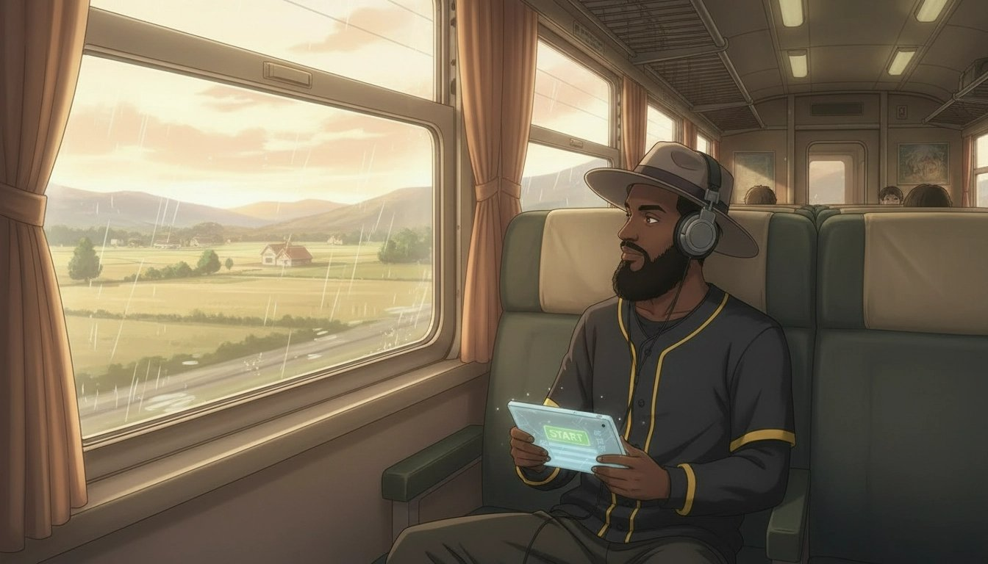

This question saves more newcomers from burnout than any other single piece of advice. The most common way to fail at getting into anime is not finding a show you like. It's starting a show you like and then abandoning it because you accidentally began an 800-episode commitment when you were only looking for something to watch on a Sunday afternoon.
Anime varies in length more wildly than almost any other storytelling format. Choosing wrong doesn't just waste your time — it can kill your enthusiasm for the medium entirely before you've given it a fair chance.

Understanding Anime Formats

Short Series — 10 to 13 Episodes
These are called 'one-cour' series. They tell a complete, satisfying story in roughly four to five hours of viewing. The storytelling is necessarily tight. Every episode is doing real work.
For newcomers, a short series is almost always the right starting point. You can finish it in a weekend. You get a complete story with a proper ending. Finishing something builds the momentum that turns casual curiosity into genuine enthusiasm.
Erased — 12 episodes. A complete mystery thriller with genuine emotional stakes and a satisfying conclusion.
Violet Evergarden — 13 episodes. A former soldier learns to understand human emotion by writing letters for others. Achingly beautiful.
A Silent Voice — A film (two hours). A boy who bullied a deaf girl in childhood seeks redemption years later. One of the most emotionally honest pieces of animation ever made.
FLCL – 6 episode fever dream about a boy hit in the head by a guitar-wielding alien woman, where nothing makes sense on purpose and that's exactly the point.

Medium Series — 24 to 64 Episodes
The sweet spot for many fans once they've gotten comfortable with the medium. Long enough to develop a rich world and genuinely complex characters. Short enough to finish in a few weeks without feeling like an open-ended commitment.
Death Note — 37 episodes. One of the most bingeable anime ever made. People regularly finish it in a week.
Fullmetal Alchemist: Brotherhood — 64 episodes. Widely considered perfect. Not a single wasted episode.
Attack on Titan — Approximately 87 episodes across four seasons. Complete and concluded. An extraordinary achievement.

Films — 90 to 120 Minutes
Anime films are one of the most underrated entry points into the medium. A complete story in under two hours, often with production quality that rivals any Hollywood blockbuster. If you're genuinely unsure whether anime is for you, a film is the lowest-stakes possible test.
Spirited Away — A Ghibli masterpiece. A girl gets trapped in a spirit world and has to work to free herself and her parents. Universally beloved.
Your Name — A romantic fantasy about two teenagers who begin inexplicably switching bodies. A perfect entry point.
A Silent Voice — Guilt, redemption, and the courage it takes to keep living. Devastating in the best way.

Long-Running Series — 100 or More Episodes
One Piece. Naruto. Bleach. Dragon Ball. These shows are cultural institutions that have shaped the entire medium. They are also not where you start.
Save them for after you've fallen in love with anime through something shorter. Starting a long-running series before you have a foundation in the medium means encountering its pacing conventions and slow-burn investment requirements before you have the context to appreciate what they're doing.
💡 Starting with a 12-episode series is almost always the right call. Finishing something builds momentum. One completed show is worth ten abandoned ones.

✏️ Chapter 3 Worksheet — Time & Format
Part A — Your Weekly Reality Check
☐ Under 2 hours per week — Start with a film or 12-episode series
☐ 2–5 hours per week — A 12–13 episode series is your sweet spot
☐ 5–10 hours per week — Short or medium series both work well
☐ 10+ hours per week — You can handle anything

When do I usually watch? (tick all that apply)
☐ Weekday evenings
☐ Weekend afternoons
☐ Weekend evenings
☐ Lunch breaks or commuting

Part B — Format Matching
If you... | Your Format → Examples
Want to finish something this weekend | Short series (12–13 eps) → Erased, Violet Evergarden
Watch a few eps a week and like closure | Medium series (24–37 eps) → Death Note, FMA:B
Have 2 hours right now and want a story | Film (90–120 min) → Your Name, A Silent Voice
Want to go deep over months | Long series (50–100 eps) → Attack on Titan, HxH
Want an epic that never ends | Ongoing (100+ eps) → One Piece, Naruto

Part C — Realistic Completion Estimate
Format I chose:

Hours of content:

Hours per week I'll watch:

Approx. weeks to finish:

Part D — My Shortlist for This Format
Show 1:

Show 2:

Show 3:

Chapter 4 · THE 5 Questions

What Emotional Experience Are You After?
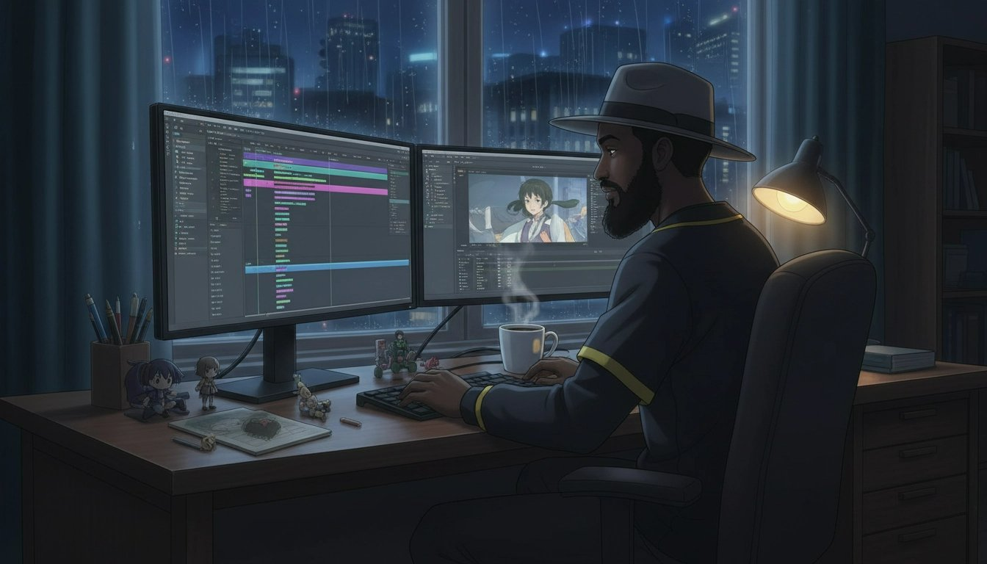

This is the question that most recommendation lists miss entirely. Genre tells you the setting of a show. Emotion tells you how you want to feel while watching it and when it's over.
They are completely different things. A fantasy series can make you feel hyped, or heartbroken, or intellectually stimulated, or warmly comforted. Genre is the map. Emotional experience is the destination.
Knowing what emotional experience you're after also helps you avoid a common newcomer mistake: picking a technically excellent show that simply doesn't match what you need right now. Neon Genesis Evangelion is a masterpiece. It's also psychologically dense and deliberately uncomfortable. If you want something energising, it's not the right show — no matter how many lists rank it among the greatest.

Matching Your Mood to the Right Show

I want to feel hyped and energized
You want anime that makes you want to get up. Stories about people who refuse to give up, who push through the impossible and earn their victories. The best shonen anime is built around exactly this emotional experience.
Haikyuu!! — A volleyball anime that somehow makes sport feel like war, in the best possible way. Non-sports fans regularly call it life-changing.
My Hero Academia — A world where almost everyone has superpowers, and a boy born without them refuses to accept that as the final word.
Demon Slayer — The fight sequences will make your jaw drop. The emotional foundation is simple — a brother who loves his sister — and devastatingly effective.

I want to think and be challenged
You want anime that stays with you. Shows that pose questions they don't fully answer, that present morally complex characters, that leave you arguing with yourself about what was right.
Death Note — A constant interrogation of justice, power, and what happens when someone with genuinely good intentions gives themselves permission to play God.
Steins;Gate — Time travel explored with genuine intellectual rigour. The butterfly effect, the weight of choices, and what happens when you can see the consequences of what you've done.
Neon Genesis Evangelion — A show psychoanalysing its own protagonist in real time. Challenging, deliberately strange, and one of the most discussed pieces of animation in history.

I want to cry — in a good way
Anime has a particular gift for devastating emotional experiences. The best examples don't manipulate you — they build genuine attachment and then put their characters through things that genuinely matter.
A Silent Voice — Guilt, forgiveness, and the extraordinary courage it takes to keep living when you hate yourself.
Your Lie in April — A pianist who has lost the ability to hear his own playing, a violinist who is running out of time, and music as the language between them.
Clannad: After Story — The show that broke an entire generation of anime fans. You need to watch the first series to get here, but After Story is the destination.

I want to laugh
Comedy is harder to make than tragedy. The best anime comedy is genuinely funny — not chuckle-worthy, but laugh-out-loud, pause-and-rewind funny. These shows have some of the sharpest comedic writing in any format.
Gintama — A samurai comedy set in an alternate-history Japan occupied by aliens. The funniest anime ever made, punctuated by moments of genuine emotional weight.
Konosuba — Every character is a loveable disaster. Every episode is a delight. The comedic timing is relentless.
Nichijou — Surreal slice-of-life comedy about nothing in particular. Impossible to watch without grinning.

I want to feel warm and safe
Not every watching experience needs to be emotionally demanding. Anime has an entire sub-genre — iyashikei, or 'healing' anime — dedicated to exactly this.
Barakamon — A stressed calligrapher finds peace, purpose, and community on a remote rural island. Warm, funny, and deeply human.
Mushishi — Episodic stories about a traveller who encounters supernatural creatures. Quiet, contemplative, and extraordinarily beautiful.
Shirokuma Cafe — A polar bear runs a cafe. The most relaxing thing you will ever watch.

I want to be transported to another world
You want world-building so rich that you forget your own life exists. Places you want to visit. A sense of genuine discovery, of being somewhere entirely new.
Made in Abyss — A terrifying, beautiful, and deeply strange world. The atmosphere is unlike anything else.
Fullmetal Alchemist: Brotherhood — A fully realised alternate world with its own history, geography, political structures, and physical laws.
Mushishi — Feudal Japan filtered through a supernatural lens. The world feels alive and endless.
💡 This isn't about what you always want from TV. It's about what you want right now, from this experience. Be honest with yourself and your shortlist will be dramatically better for it.

✏️ Chapter 4 Worksheet — Emotional Experience
Part A — Your Mood Right Now
☐ Hyped & Energised — I want to feel fired up. Epic moments. Underdogs winning.
☐ Challenged & Engaged — I want to think. Complex questions. Ideas that linger.
☐ Moved & Emotional — I want to feel deeply. Beautiful sadness. Characters I'll carry with me.
☐ Laughing Out Loud — I want to genuinely laugh. Absurdist, sharp comedic writing.
☐ Warm & Safe — I want comfort. Gentle stories. Kind worlds. No stress.
☐ Transported — I want world-building so rich I forget my own life.

Part B — Digging Deeper
What was the last show or film that made you feel something really strongly? What did it make you feel?

Is there an emotion you want more of in your life right now?

Is there anything you specifically want to avoid right now?

Part C — Matched Shows
From this chapter, write the shows recommended for your chosen mood. Note whether any also appeared in your Chapter 1 list — those are your strongest candidates.
Show Title | Also on my Chapter 1 list?
 | ☐ Yes ☐ No
 | ☐ Yes ☐ No
 | ☐ Yes ☐ No
 | ☐ Yes ☐ No

Chapter 5 · THE 5 Questions

What Is Your Tolerance for Weirdness?
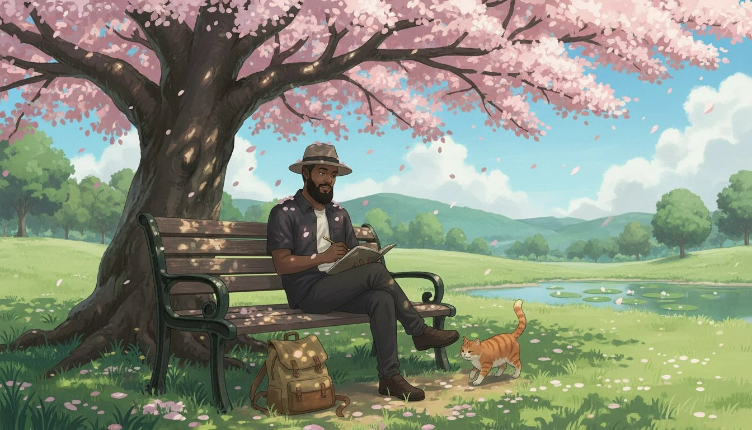

Anime emerged from Japanese culture. It was made by Japanese creators, for Japanese audiences, shaped by Japanese storytelling conventions, visual traditions, and cultural assumptions. When you come to it from a Western entertainment background, some of it will feel immediately familiar. And some of it will feel genuinely strange.
This is not a flaw. It's the medium being itself. But it's useful to know your starting point, because beginning at the wrong level of cultural density is one of the most common reasons people bounce off anime even after finding a show that should theoretically suit them.

What Culture Shock in Anime Actually Looks Like

Pacing
Western TV tends to cut quickly. Anime often sits in silence. A character stares out a window. A reaction shot holds for longer than you expect. This is intentional — the stillness is doing emotional work. Your brain will recalibrate to this rhythm within two or three episodes.

Visual Grammar
Anime has developed its own visual shorthand over decades. Sweat drops to indicate embarrassment. Exaggerated expressions (chibi style) for comedic moments. Unusual hair colors that carry character meaning. These are conventions, not failures of realism. You'll decode them faster than you expect.

Character Tropes
Anime has recurring character archetypes: the tsundere (cold on the outside, warm underneath), the kuudere (emotionally reserved), the reliable best friend. These are conventions the medium is aware of and often actively subverts.

High School Settings
An enormous number of anime is set in high school, regardless of whether the story has anything to do with being in high school. It's a cultural default in Japanese storytelling. If this doesn't appeal to you, there are many shows that don't use this setting.

Power of Friendship
The idea that emotional bonds between characters are a literal source of power is deeply embedded in certain genres. At its best, it's genuinely moving. Knowing it's coming helps you receive it on its own terms.

The Culture Shock Scale

Level 1 — Almost No Culture Shock
These shows feel like animated Western prestige TV. The storytelling structure, pacing, and emotional beats will feel immediately familiar. They are the best starting points for viewers who want to test the medium.
Attack on Titan — Structured and paced like a war drama.
Death Note — Feels like a psychological thriller. Very accessible.
Fullmetal Alchemist: Brotherhood — An adventure story with universal themes.
A Silent Voice / Your Name — Films with mainstream appeal worldwide.

Level 2 — Light Anime Favor
These shows have recognizable anime conventions — some visual exaggeration, some trope deployment — but nothing that breaks immersion for a newcomer approaching with an open mind.
Demon Slayer — Some comedic exaggeration, but easy to fall into.
My Hero Academia — Classic shonen tropes delivered with genuine self-awareness.
Haikyuu — Sports anime, grounded and human.

Level 3 — Embrace the Anime
These are unabashedly anime. They lean into tropes and are best enjoyed after you've warmed up to the medium.
Sword Art Online — Very anime premise and character dynamics.
Konosuba — Parody of anime tropes; funnier if you know what's being mocked.
Re:Zero — Dark twists on familiar fantasy tropes.

Level 4 — Deep End
For people who have already found their love for the medium and want to go further. Challenging, dense, or deliberately disorienting.
Fooly Cooly — fever dream about a boy hit in the head by a guitar-wielding alien woman, where nothing makes sense on purpose and that's exactly the point.
Serial Experiments Lain — Deliberately disorienting 1998 cyberpunk art.
Ping Pong the Animation — Unconventional visual style that alienates and then enchants.
💡 Even die-hard anime fans started at Level 1. Starting there and working up is smart, not cowardly.

✏️ Chapter 5 Worksheet — Culture Shock Self-Assessment
Part A — The Culture Shock Scale
Rate your comfort level with each element below, from 1 (very uncomfortable) to 10 (very comfortable).

Reading subtitles while watching: 1 – 2 – 3 – 4 – 5 – 6 – 7 – 8 – 9 – 10
Visual comedy (sweat drops, chibi moments): 1 – 2 – 3 – 4 – 5 – 6 – 7 – 8 – 9 – 10
Long internal monologue and slower pacing: 1 – 2 – 3 – 4 – 5 – 6 – 7 – 8 – 9 – 10
High school settings in non-school stories: 1 – 2 – 3 – 4 – 5 – 6 – 7 – 8 – 9 – 10
Power-of-friendship plot resolutions: 1 – 2 – 3 – 4 – 5 – 6 – 7 – 8 – 9 – 10
Cultural references I might not immediately understand: 1 – 2 – 3 – 4 – 5 – 6 – 7 – 8 – 9 – 10
Very different animation styles from Western animation: 1 – 2 – 3 – 4 – 5 – 6 – 7 – 8 – 9 – 10
Fan service and anime-specific character tropes: 1 – 2 – 3 – 4 – 5 – 6 – 7 – 8 – 9 – 10

Part B — Your Comfort Level Summary
☐ Level 1 — Almost No Culture Shock (most ratings 7–10) → Attack on Titan, Death Note, FMA:B
☐ Level 2 — Light Anime Favor (mixed ratings) → Demon Slayer, My Hero Academia, Haikyuu
☐ Level 3 — Embrace the Anime (broadly comfortable) → SAO, Konosuba, Re:Zero
☐ Level 4 — Deep End (8–10 across the board) → Evangelion, Serial Experiments Lain

Part C — My Level & Why
I chose Level:

Because:

One thing I'm willing to push past my comfort zone on:

One thing I'm definitely not ready for yet:

Chapter 6 · THE 5 Questions

Your Personal Anime Starter Pack

You've answered all five questions. You know your genres, your sub/dub preference, your format needs, your emotional target, and your comfort level with the cultural specificity of the medium. Now it's time to put it all together.
The purpose of this final chapter is to cross-reference everything you've gathered into a shortlist of three shows — your Personal Anime Starter Pack. These are the shows you're going to watch, in order, starting tonight.

How to Build Your Shortlist
Go back through your worksheets from Chapters 1 through 5. Make a note of every anime that appeared more than once across your answers. A show that appeared in your genre translation, your emotional experience matching, and your culture shock level is a significantly stronger candidate than one that appeared only once.
These overlapping recommendations are your strongest matches. They're shows that have passed five different filters based on your actual taste.
💡 If you love thrillers, want something in sub, are starting with a short series, want to feel challenged and engaged, and are at Level 1 culture shock, your shortlist almost certainly includes Death Note, Erased, and Monster. Trust the system.

Where to Watch
Crunchyroll (free with ads): The largest anime library available. If you want to watch subbed anime with same-day access to new episodes as they air in Japan, Crunchyroll is the default choice.
Netflix: A strong selection of both anime originals and licensed content, including the entire Studio Ghibli catalogue in many regions.
Funimation / Crunchyroll Premium: The best platform for dubbed anime. If you've decided to start with dubs, this is where you'll find the best selection.
Tubi: Rotating selection of anime, completely free. Useful for older series.

The Three-Episode Commitment
Whatever show you pick, commit to watching three episodes before making any judgment. First episodes are the worst representation of what a show actually is. They're doing setup work — establishing the world, introducing the cast, laying groundwork. The show doesn't reveal its true rhythm until episode three at the earliest.
After three episodes, if you're not feeling any pull toward the next one, it's okay to move to your second pick. But give it those three episodes. You might be surprised.

✏️ Chapter 6 Worksheet — My Personal Starter Pack
Step 1 — Collect Your Answers
Chapter 1 — Genre(s) I love:

Chapter 2 — Sub or Dub?:

Chapter 3 — Format preference:

Chapter 4 — Emotional experience I want:

Chapter 5 — My culture shock level:

Step 2 — Cross-Reference Your Lists
List every show that appeared more than once across your chapter worksheets.

Step 3 — My Final Shortlist of 3
#1 — START HERE TONIGHT
Title:

Where I'll watch: ☐ Crunchyroll ☐ Netflix ☐ Funimation ☐ Other: ___________
Why it fits me:

#2 — Watch Second
Title:

Where I'll watch: ☐ Crunchyroll ☐ Netflix ☐ Funimation ☐ Other: ___________
Why it fits me:

#3 — Watch Third
Title:

Where I'll watch: ☐ Crunchyroll ☐ Netflix ☐ Funimation ☐ Other: ___________
Why it fits me:

Step 4 — My Commitment
I will start watching:

On this date:

After watching 3 episodes, my honest reaction:

Bonus Chapter 1 · BONUS Chapters

The First Week Survival Guide

You pressed play. You found your show. Now what?
This is the chapter nobody talks about — what actually happens in the first week of watching anime, and how to handle all of it without quitting before it gets good. Because the most common reason people give up on anime isn't that they picked the wrong show. It's that the first week felt unfamiliar and they didn't have anyone to tell them that was completely normal.
💡 Most people who give up on anime quit in the first week. Not because the show is bad — because they didn't know what to expect. This chapter fixes that.

Why the First Episode Feels Weird
Anime has its own visual grammar, its own pacing conventions, and its own storytelling logic. If you grew up on Western TV, some of what you encounter in your first episodes will feel genuinely unfamiliar. This doesn't mean something is wrong. It means you're encountering a new medium and your brain is calibrating.

The pacing feels slower than you expected
Western TV cuts fast. Anime uses silence and stillness very differently. Long pauses. Reaction shots that hold. Internal monologue that replaces action. This isn't filler. It's where the emotional work happens. Anime trusts the audience to sit with a moment. Your brain will recalibrate within two or three episodes.

A character said or did something that felt strange
Anime is made in Japan for Japanese audiences. Cultural references, social customs, the unspoken rules that govern how characters treat each other — these emerge from a different cultural context. When something feels strange, get curious instead of critical. A quick search after the episode ends will usually explain what's happening.

The art style threw you off
Big eyes. Unusual hair color. Exaggerated expressions. Characters that briefly distort into a simplified, cartoonish form for comic effect. These are conventions of the medium, not failures of artistry. Within a few episodes, the visual grammar will feel natural.

You didn't understand a term
Anime has its own vocabulary. The Anime Fluent Cheat Sheet in the appendix covers every term you're likely to encounter. Keep it nearby for your first few episodes. Don't pause mid-episode — note it and look it up afterwards.

The 3-Episode Rule — And Why It Works
Never judge a show by its first episode alone. First episodes are doing an enormous amount of work simultaneously.
- Episode 1 — World-building and setup. Often the most disorienting. This is normal.
- Episode 2 — Characters start becoming real. You begin to care about them.
- Episode 3 — The show's actual rhythm reveals itself. By the end of episode three, you know whether this is your show.

If you're genuinely not feeling any pull toward the next episode after three, that's a legitimate signal. Drop it without guilt and move to your second shortlist pick.

Handling Confusion Without Quitting
You missed something important: Rewind. Anime rewards attention. A detail that seems minor in episode one often becomes significant later.
A cultural reference went over your head: Note it and search after the episode ends. Don't pause mid-episode for every unfamiliar thing — it breaks the flow.
You're not sure if you're enjoying it: Ask yourself one question: am I curious about what happens next? If yes — even a little — keep going.
💡 You don't have to love the first show you try. Finding your anime is sometimes a process. The system is working even when you're ruling things out — every dropped show tells you something useful about what you actually want.

✏️ Bonus Chapter 1 Worksheet — First Week Survival
Section 1 — After Episode 1: What Threw You Off?
☐ The pacing felt slow
What scene felt this way:

☐ A character acted strangely
What happened:

☐ The art style threw me off
What specifically:

☐ I didn't understand a term
Write the term — look it up after:

Section 2 — The 3-Episode Tracker
EPISODE 1
One thing that confused me:

One thing I liked:

Am I curious what's next? ☐ Yes ☐ Not sure ☐ No

EPISODE 2
Character I'm most interested in:

Did I care more than Ep 1? ☐ Yes ☐ Same ☐ Less
One moment that stood out:

EPISODE 3 — Verdict
The show's rhythm feels:

My honest reaction:

My decision: ☐ Continue ☐ Move to my next shortlist pick

Section 3 — First Week Checklist
☐ Picked the first show from my shortlist
☐ Streaming app ready — ☐ Crunchyroll ☐ Netflix ☐ Funimation
☐ Decided sub or dub
☐ Watched Episode 1 without judgment
☐ Watched Episodes 2 and 3 before forming an opinion
☐ Kept my Anime Fluent Cheat Sheet nearby
☐ Made my decision after Episode 3

Section 4 — End of Week 1 Reflection
The show I watched:

My overall reaction in 1–2 sentences:

My favorite moment so far:

Something that surprised me about anime:

Curiosity level after 3 episodes — circle one: Not curious 1 2 3 4 5 Very curious

Bonus Chapter 2 · BONUS Chapters

How to Talk About Anime Without Feeling Like an Outsider
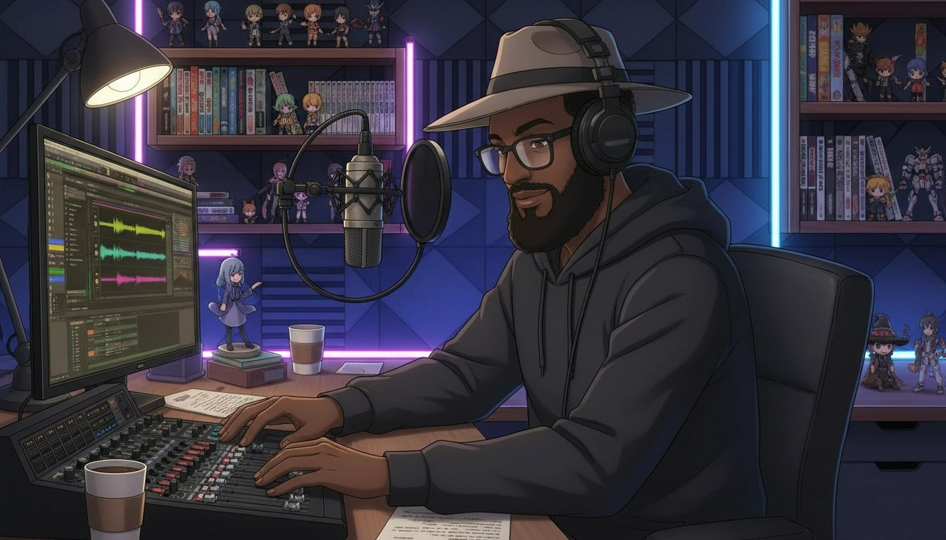

Knowing what to watch is one thing. Knowing how to talk about it is another entirely.
Anime fandom has its own language, its own etiquette, and its own unwritten rules. Fans throw around terms like isekai, seiyuu, sakuga, and cour as if everyone grew up knowing them. When you don't know the vocabulary, conversations feel like an exam you didn't study for.
This chapter gives you everything you need to show up in any anime conversation and feel like you belong — from week one.
💡 You don't need to have watched 100 shows to have great anime conversations. You just need the right vocabulary and the right approach.

The 10 Terms You'll Hear in Your First Week

1. Shonen
The category of anime aimed at younger male audiences. Stories built around action, friendship, growth, and what it means to become the person you want to be. My Hero Academia, Demon Slayer, Naruto, Dragon Ball Z — all shonen.

2. Isekai
A genre where the main character is transported to another world — usually a fantasy RPG setting. Sword Art Online, Re:Zero, Konosuba. Once you know what isekai is, you'll start spotting it everywhere.

3. Slice of Life
Anime focused on everyday life with minimal dramatic conflict. Slow, warm, character-driven, and often deeply human. The appeal is the quality of ordinary moments and the feeling of spending time with people you'd genuinely like to know.

4. Sub / Dub
You know this one already. Sub means original Japanese with subtitles. Dub means re-recorded in English. The right answer is whichever you enjoy more, full stop.

5. Filler
Episodes not adapted from the original manga, created to allow the manga to advance ahead of the anime adaptation. Long-running series — Naruto, Bleach, One Piece — are notorious for filler. There are guides online that tell you exactly which episodes to skip.

6. Canon
Content that is officially part of the story, as established in the original source material. Non-canon content (filler, alternate endings, some OVAs) exists outside the main story.

7. OVA
Original Video Animation. Bonus episodes or short films released outside the main series run. Worth watching if you love a show. Generally not where you start.

8. Seiyuu
Japanese voice actor or actress. Seiyuu are celebrities in Japan. Fans develop strong preferences for specific seiyuu the way Western fans follow actors.

9. Waifu / Husbando
Affectionate fan terms for a beloved fictional character. Used casually and warmly. Not to be taken too seriously.

10. MAL / AniList
MyAnimeList and AniList are the two main websites anime fans use to track what they've watched and rate shows. Creating a free account on either is one of the best things you can do as a newcomer.

What to Say in the Most Common Situations
Someone asks if you've seen a show you haven't: Say: 'Not yet — it's on my list. What's it like?' This keeps the conversation going and signals genuine interest.
Someone asks what your favorite anime is: Say: 'I'm still early — I just finished [X] and I think it's going to be hard to beat.' Honesty beats faking it every time.
The sub vs. dub debate starts: Say: 'I prefer [sub/dub] for [reason], but I'll watch either — it really depends on the show.' You don't need to have an opinion strong enough to argue about this.
Someone uses a term you don't know: Say: 'I'm still learning the vocabulary — what does that mean?' Curiosity is always the right response.

Where to Find Your People Online
Reddit — r/anime: The largest English-language anime community. r/animerecommendations is specifically for finding new shows based on what you've already watched.
MyAnimeList / AniList: Both platforms have community features beyond just tracking. You can follow other users and browse their lists for recommendations.
YouTube: Finding a creator whose taste aligns with yours is one of the best ways to deepen your engagement with the medium. Look for reviewers who do retrospectives and genre deep-dives.
💡 The anime community is mostly welcoming to newcomers. Lead with genuine curiosity, be honest about where you are, and you'll find your people quickly.

✏️ Bonus Chapter 2 Worksheet — Vocabulary & Community
Section 1 — Vocabulary Check
In your own words, define each term below.
Shonen:

Isekai:

Slice of Life:

Filler:

Canon:

OVA:

Seiyuu:

Waifu/Husbando:

MAL/AniList:

Section 2 — Conversation Scripts
Someone asks if you've seen a show you haven't. My response:

Someone asks what your favorite anime is. My response:

Someone uses a term I don't know. My response:

Section 3 — Community Setup
☐ Created a MyAnimeList or AniList account
☐ Added my first show to my list
☐ Joined r/anime or found an anime community online
☐ Found one YouTube creator whose taste I want to follow

Bonus Chapter 3 · BONUS Chapters

The What's Next Shortlist Builder

You finished your first show. You've crossed from curious to fan.
Now comes the question nobody prepares you for: what do I watch next?
Without a system, you're back to scrolling through thumbnails. Back to the paralysis that comes from 10,000 options and no clear way to distinguish between them. This chapter gives you a simple, reusable system for answering the 'what's next' question every time you finish a show.
💡 The best predictor of what you'll love next isn't genre or rating. It's understanding exactly what worked for you in what you just watched.

Step 1: The Post-Show Debrief
Before you open a streaming app or search for recommendations, spend ten minutes with these four questions. Write the answers down. The act of writing forces specificity, and specificity is what makes the system work.

What did you love most?
Not 'I liked it' — that's not useful. What specifically worked? Was it the relationship between two particular characters? The way the plot constructed its mysteries? The animation quality? The humor? The world-building? Be specific.

What would you change if you could?
These answers are specifications for your next show. Too slow? You want something with more momentum. Too action-heavy? You want something that prioritizes character. Every frustration is information.

How did it make you feel?
Energized? Emotional? Thoughtful? Comforted? These feelings are the emotional target for your next show. You might want to chase the same feeling — or you might need something different.

More of the same, or something different?
Both are completely valid. If you finished Death Note and want more of the same, you're looking for Steins;Gate or Code Geass. If you want something different, you might want Barakamon or Haikyuu. Know which mode you're in before you start.

Step 2: The Match Framework
- You loved the characters above everything else → March Comes in Like a Lion, Natsume's Book of Friends, Fruits Basket
- The story and plot kept you watching → Death Note, Steins;Gate, Erased
- The animation quality blew you away → Demon Slayer, Jujutsu Kaisen, any Studio Ghibli film
- Emotional impact is what you're chasing → Your Lie in April, Anohana, A Silent Voice, Violet Evergarden
- You loved the world and wanted more of it → Fullmetal Alchemist: Brotherhood, Made in Abyss
- The humour made it special → Konosuba, Nichijou, Gekkan Shoujo Nozaki-kun, Gintama

Step 3: Build Your Shortlist of 3

Filter by length
Match the format to your current energy and available time. A 12-episode show is a weekend. A 64-episode show is a month. A film is an evening. Know what you actually have before you commit.

Filter by completion status
As a developing fan, strongly prefer shows that are fully finished. You get a complete story with an actual ending. Check MAL or AniList — the completion status is listed on every show's page.

Read 3 user reviews
On AniList or MAL, sort reviews by Most Helpful. Real viewers tell you exactly what a show is like in practice. Three reviews will tell you things the marketing doesn't.

Watch the first 3 minutes
Open Episode 1. Watch the opening scene. Does the visual style interest you? Does the tone match what you're looking for right now? Trust your gut. This micro-commitment takes three minutes and saves you from starting something wrong for your current mood.
💡 This whole process takes 15 minutes. It's the difference between an hour of scrolling and starting your next favorite show tonight.

✏️ Bonus Chapter 3 Worksheet — What's Next
Post-Show Debrief
Show I just finished:

Date finished:

What did you love most?

What would you change if you could?

How did it make you feel?

More of the same — or something different?
☐ More of the same — I want to stay in this feeling
☐ Something different — I'm ready for a change

Match Framework — My Candidates
Apply the Match Framework from this chapter and list your 3–5 candidates:

Filter Checklist
☐ Filtered by length — matches my current energy and time
☐ Completion status checked — prefer Finished Airing
☐ Read 3 user reviews on MAL or AniList
☐ Watched first 3 minutes of top candidate — gut check passed

My Final Shortlist
Show #1 — Watch Tonight
Title:

Episodes: _______ Status: ☐ Finished ☐ Ongoing
Why it fits what I'm looking for:

Show #2
Title:

Episodes: _______ Status: ☐ Finished ☐ Ongoing
Why it fits:

Show #3
Title:

Episodes: _______ Status: ☐ Finished ☐ Ongoing
Why it fits:

🎬 My top pick to watch tonight: ___________________________________

Appendix

Anime Fluent Cheat Sheet

These are the terms you'll encounter in episode descriptions, online forums, reviews, and conversations with other fans. Keep this page bookmarked for your first few weeks.

Formats & Demographics
Term | Audience & Meaning — Example Series
Shonen | Teen boys — action, adventure, male protagonist. (Naruto, My Hero Academia, Demon Slayer)
Shojo | Teen girls — romance, drama, relationships. (Sailor Moon, Fruits Basket, Kimi ni Todoke)
Seinen | Adult men — mature, complex, darker themes. (Berserk, Monster, Vinland Saga)
Josei | Adult women — realistic romance, adult life. (Nana, Chihayafuru, Loveless)
Isekai | Protagonist transported to another world. (Sword Art Online, Re:Zero, Konosuba)
Slice of Life | Everyday mundane events, relaxing or comedic. (K-On!, Barakamon, Yuru Camp)
Mecha | Giant robots / machines piloted in combat. (Evangelion, Gundam, Darling in the FranXX)
Iyashikei | Healing anime — calm, gentle, deliberately comforting. (Mushishi, Shirokuma Cafe)

Must-Know Vocabulary
Term | Meaning
Manga | The original Japanese comic many anime are adapted from
Seiyuu | Japanese voice actor; often has a dedicated fanbase
Cour | A 13-episode broadcast season (one-cour = 13 eps, two-cour = 26 eps)
Filler | Non-canon episodes not from the manga, used to let the manga advance
OVA | Original Video Animation; bonus episodes outside the main run
OST | Original Soundtrack; anime music is often genuinely extraordinary
Chibi | Super-deformed, exaggeratedly cute art style used for comic effect
Kawaii | Japanese for 'cute' — widely used in fan communities
Tsundere | Character initially cold who gradually reveals a warm, affectionate side
Waifu/Husbando | Affectionate fan term for a beloved fictional character
Otaku | A person with passionate devotion to anime and manga
Fan Service | Content added to please fans, often unrelated to the main plot
Opening / Ending | The intro and outro songs; often beloved in their own right

Community Terms
Term | Meaning
Simulcast | New episodes released in your country on the same day as Japan
Crunchyroll / CR | The dominant anime streaming platform
MAL | MyAnimeList — the main site to track and rate what you've watched
AniList | MAL alternative with better design and social features
Dropped | Stopped watching a show before finishing it — happens to everyone
10/10 | A show so good it changes how you think about the medium
Sakuga | Exceptionally animated sequences; fans often clip and share these
PV | Promotional Video — a trailer or preview for an upcoming series

Appendix

The Hidden Gem Hunter's Toolkit

With over 10,000 anime series available, streaming algorithms rarely surface the most creative and emotionally resonant titles. Many of the most critically acclaimed anime have fewer than 10,000 ratings simply because they were never given algorithmic exposure.
To find hidden gems, you must step outside the algorithm and employ a proactive, community-driven discovery method.

The Discovery Method
Method 1 — Leverage Community Platforms: On MAL or AniList, use Advanced Search. Filter by your preferred genres, set minimum score to 7.5, and sort by Members (ascending). This reveals highly rated shows that very few people have watched. Reddit threads titled 'Hidden Gems' or 'Overlooked Masterpieces' are goldmines.
Method 2 — Follow the Creators: Many hidden gems come from visionary directors on passion projects. Masaaki Yuasa (The Tatami Galaxy, Kaiba) and Shinichiro Watanabe (Samurai Champloo, Space Dandy) consistently produce critically acclaimed but less commercially visible work. A director's full filmography is one of the most reliable discovery paths.
Method 3 — Explore Older Decades: The 90s produced gritty cyberpunk and space westerns. The 2000s were an era of experimental narratives and unique art styles. Don't limit yourself to what is currently airing. Haibane Renmei, Kino's Journey, and Trigun are all waiting for you.

5 Hidden Gems to Watch Now
Title — Genre — Episodes | Why It's Worth Your Time
Astra Lost in Space — Sci-Fi / Mystery — 12 eps | Tightly plotted mystery with a genuinely satisfying conclusion and excellent character dynamics.
Kyousougiga — Fantasy / Action — 10 eps | Visually explosive and emotionally complex family story, consistently overshadowed by larger titles.
Barakamon — Slice of Life / Comedy — 12 eps | Heartwarming and hilarious — a calligrapher finds inspiration on a rural island.
Odd Taxi — Mystery / Thriller — 13 eps | Brilliantly written, dialogue-heavy mystery featuring anthropomorphic animals in a gritty urban setting.
Kaiba — Sci-Fi / Psychological — 12 eps | Directed by Masaaki Yuasa. Unique retro art style exploring memory and identity.

The Genre Mood Matrix
Your Mood | Hidden Gem to Try
I want to cry | Haibane Renmei
I want to laugh | Detroit Metal City
I want to think | The Tatami Galaxy
I want action | Gurren Lagann
I want to relax | Barakamon or Yuru Camp
I want mystery | Odd Taxi
I want adventure | Kino's Journey

The Tiered Watchlist System
A disorganized list of 100+ shows is just as overwhelming as the algorithm. Use this system to keep your backlog manageable and actionable.
Tier | Purpose & Max Shows
Tier 1 — Next Up | Your immediate priority. Maximum 3 shows. One short, one long, one film.
Tier 2 — On Deck | Shows you've actively researched. Maximum 10. Promote to Tier 1 when a slot opens.
Tier 3 — Someday | Your master backlog. Unlimited. Add anything without pressure.

🎉 You're Ready.
Three bonus chapters. Three problems solved.
Bonus 1 gets you through your first week without quitting.
Bonus 2 makes you fluent in the language of anime fandom.
Bonus 3 means you never run out of great shows to watch.
The show that changes everything for you is already out there.
Now you know exactly how to find it.

— Willie Fordham
Your Favorite Uncle
© 2026 Your Favorite Uncle — All Rights Reserved
Hallelujah@williefordham.com

