The Lab Cook Book Vol. 2
“Success is built one choice at a time — starting with what’s on your plate.”
[Background image placeholder: Intro to Meal Prep]

Introduction

Welcome to

The Lab Kitchen
This isn’t just another cookbook—it’s a tool to help you transform the way you look at food, fuel your body, and stay consistent with your fitness goals. At The Lab Fitness, we believe nutrition doesn’t have to be complicated or bland. With the right approach, eating can be enjoyable, satisfying, and effective for building the body and lifestyle you want.
This book is designed to give you practical recipes that are easy to prep, delicious to eat, and aligned with your goals—whether that’s fat loss, muscle gain, or just building a healthier relationship with food. Each recipe has been created with balance, flavor, and convenience in mind, so you can spend less time stressing about what to eat and more time enjoying the process.

Why Meal Prep Matters
Meal prepping is about more than just cooking in advance—it’s about setting yourself up for success. When you plan your meals ahead, you:
- Stay consistent with your nutrition goals
- Save time and money during the week
- Reduce stress about what to eat daily
- Avoid quick, unhealthy choices that throw you off track
Whether you’re a busy professional, an athlete, or someone just starting their fitness journey, these recipes will fit seamlessly into your routine.

How to Use This Cookbook
- Pick your favorites: Each section offers a mix of breakfast, lunch, dinner, and snack options.
- Follow the plan: At the end, you’ll find a structured 2-week meal plan and grocery guide to make things even simpler.
- Track your progress: Each recipe includes calorie and macro breakdowns so you can match meals with your goals.
- Adjust as needed: These recipes are versatile—swap out proteins, grains, or veggies to fit your taste and lifestyle.

Final Note
This cookbook isn’t about perfection—it’s about building sustainable habits that last. Think of these meals as fuel for your lifestyle, not restrictions. Stay consistent, stay flexible, and remember: the results you want come from what you do daily.
Now, let’s get into the kitchen and make it happen. 💪
BONUS
CLICK THE LINK BELOW FOR A FREE 2 WEEK AT HOME SHRED PROGRAM
2 WEEK AT HOME SHRED

SECTION 1: Intro to Meal Prep
Meal prepping is the concept of preparing whole meals or dishes ahead of schedule. It's a time-saver, especially for busy individuals, and helps with portion control and reaching nutrition goals.
Types of Meal Prep:
- Full make-ahead meals: You cook an entire meal and store it in your fridge or freezer.
- Batch cooking: Make multiple meals, then portion and store them. This approach is useful for recipes you can easily cook in large amounts (like big pots of soup, quinoa or mashed sweet potatoes).
- Meals for one: Prepare food and portion it in single-serving containers. (Usually enough to last a few days.)
- Ingredient prep: For people who like to cook and serve food all at once, just prep parts of recipes. Chop veggies, mix spices or marinade meat in advance to save time when you’re ready to cook.
Benefits:
- Always have food ready: The most important benefit of meal prepping is always having something to eat. Even if you love to cook your meals from scratch every single day, sometimes you just can’t. Your busy life might get in the way and you won’t make it home in time. Or you will be too tired to cook. That’s why meal prepping is such a lifesaver.
- Save time & money: And, when these situations occur, having something delicious in the fridge you can heat up in 2 minutes is definitely better than ordering food.
- Reduce waste: It’s better to avoid buying food every day and have our food ready at home. This will save money on grocery shopping and restaurants. Plus, having a plan will make it so you waste less food because it didn’t get included in any of the meals.

How to meal prep
Make a plan and stick to it! • Pick one day per week to do all the work. Find a day you have a few hours to dedicate to preparing meals. After that, you will have most of the work done for the entire week!
• Choose 2 days per week for cooking healthy make-ahead meals if you don’t want to spend a lot of time in the kitchen at one time.
• Make meal prepping fun. If you don’t have time for complicated recipes, choose a simple meal prep. It’s better to choose what works for you.
• Make it delicious and not boring. Experiment with spices, herbs, and marinades. You’ll have countless easy meal prep ideas without too much effort.

Now that we have moved past the basics of Meal Prep let's get into what we have on the menu! In this issue, I have put together a full menu of delicious low calorie meals you can use for a one time cook or put aside for your meal of the week. Starting from the choices of a protein packed breakfast to a warm sweet and savory dessert, ALL UNDER 500 CALORIES EACH!

“How you start your day shapes how you end it — fuel with intention.”
[Background image placeholder: Breakfasts]

SECTION 2: “Morning Fuel” (Under 500 kcal)

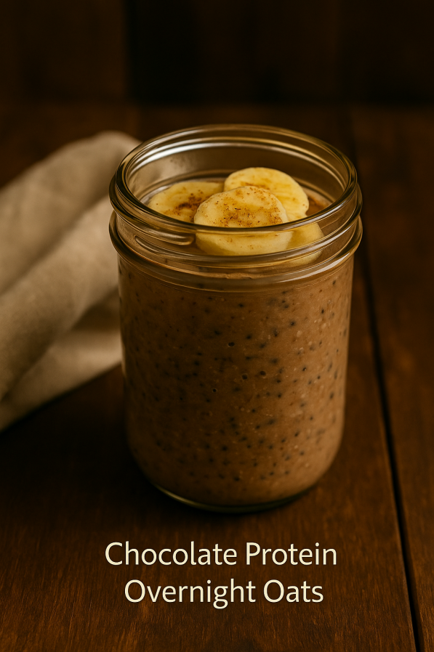

Chocolate Protein Overnight Oats

Prep Time: 10 minutes
Cook Time: 0 minutes
Marinating/Rest Time: 6–8 hours (overnight)
Total Time: 8 hours, 10 minutes
Difficulty: Easy
Calories per Serving: ~380
Ingredients:
- - 40g rolled oats.
- - 10g chia seeds
- - 20g chocolate protein powder
- - 150g almond milk
- - 50g banana, mashed
- - 1/4 tsp cinnamon
Instructions: Add all ingredients to a jar and stir until well combined. Cover and refrigerate overnight to allow the oats to soften and the flavors to blend. In the morning, stir again and enjoy chilled straight from the fridge or gently warmed for a cozy option

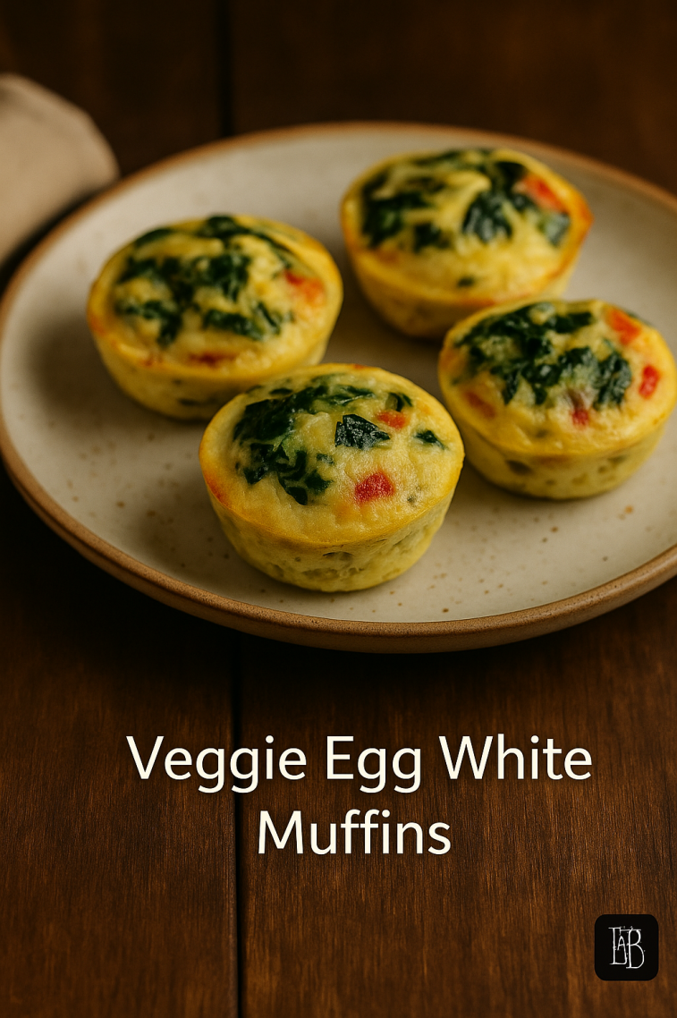

Veggie Egg White Muffins

Prep Time: 10 minutes
Cook Time: 20 minutes
Marinating/Rest Time: None
Total Time: 30 minutes
Difficulty: Easy
Calories per Serving: ~150 (per muffin)
Ingredients:
- - 250g egg whites
- - 40g chopped spinach
- - 40g bell peppers
- - 40g red onion
- - Salt and pepper to taste
Instructions: Preheat your oven to 350°F (175°C). Lightly grease a muffin tin. In a bowl, whisk together eggs, vegetables, and seasonings. Pour the mixture evenly into muffin cups and bake for 18–20 minutes, or until the muffins are set and golden. Let cool slightly before removing. Serve warm or store in the fridge for a quick grab-and-go option.

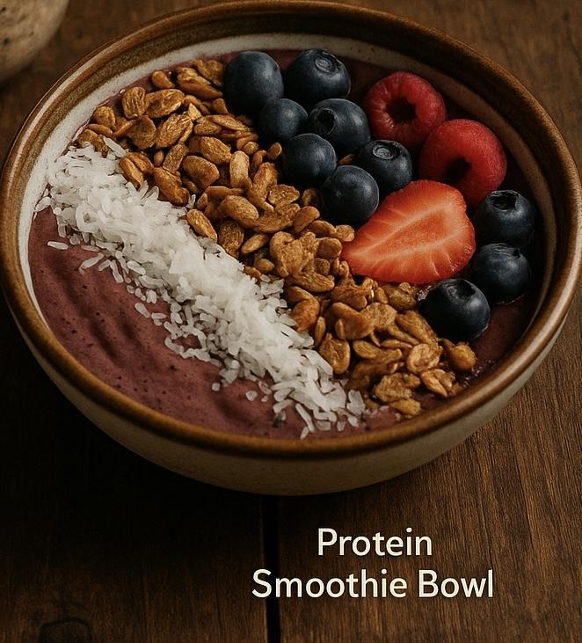

Protein Smoothie Bowl

Prep Time: 10 minutes
Cook Time: 0 minutes
Marinating/Rest Time: None
Total Time: 10 minutes
Difficulty: Easy
Calories per Serving: ~420

Ingredients:
- - 1 scoop vanilla protein powder
- - 100g frozen mixed berries
- - 50g banana
- - 100g almond milk
- - Toppings: 10g granola, 5g chia, 5g coconut
Instructions: Blend all ingredients until smooth and creamy. Pour into a bowl and add your favorite toppings for extra texture and flavor. Enjoy immediately as a refreshing, protein-packed breakfast.

“Strong bodies are built in the gym, but revealed in the kitchen.”
[Background image placeholder: Lunch & Dinner]

SECTION 3: Lunch & Dinner

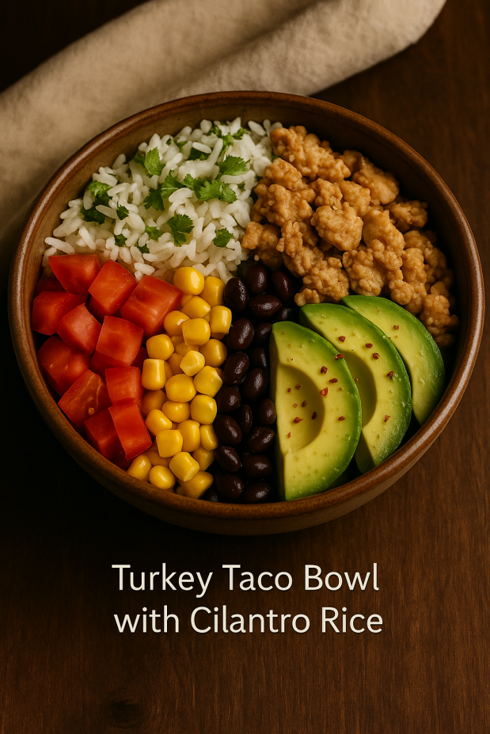

Turkey Taco Bowl with Cilantro Rice

Prep Time: 10 minutes
Cook Time: 20 minutes
Marinating/Rest Time: None
Total Time: 30 minutes
Difficulty: Easy
Calories per Serving: ~450
Ingredients:
- - 200g ground turkey
- - 100g cooked white rice
- - 30g diced tomatoes
- - 40g black beans
- - 10g chopped cilantro
- - 5g olive oil
- - Spices: cumin, paprika, garlic powder
Instructions: Cook ground turkey in a skillet with taco seasoning until browned and fully cooked. Fluff cooked rice with fresh cilantro and lime juice. Build your bowl with rice, seasoned turkey, black beans, corn, salsa, and a sprinkle of cheese. Top with avocado or Greek yogurt for a creamy finish. Serve warm.

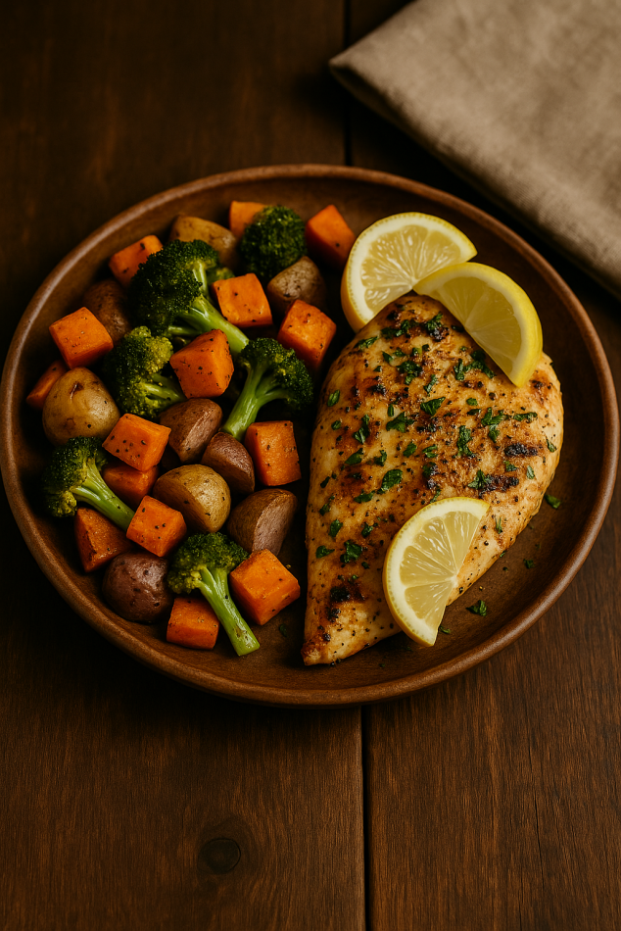

Grilled Lemon Herb Chicken with Roasted Veggies

Prep Time: 15 minutes
Cook Time: 25 minutes
Marinating/Rest Time: 30 minutes (optional, for deeper flavor)
Total Time: 1 hour 10 minutes
Difficulty: Moderate
Calories per Serving: ~420
Ingredients:
- - 180g chicken breast
- - 100g zucchini
- - 50g red bell pepper
- - 50g onion
- - Juice of 1 lemon
- - 10g olive oil
- - Herbs: thyme, rosemary
Instructions: Preheat oven to 400°F (200°C). Toss your favorite veggies with olive oil, salt, pepper, and Italian herbs, then spread them evenly on a baking sheet. Roast for 20–25 minutes until tender and golden. Meanwhile, grill chicken breasts seasoned with lemon juice, garlic, and herbs until cooked through. Plate with roasted veggies and serve with an extra squeeze of lemon.

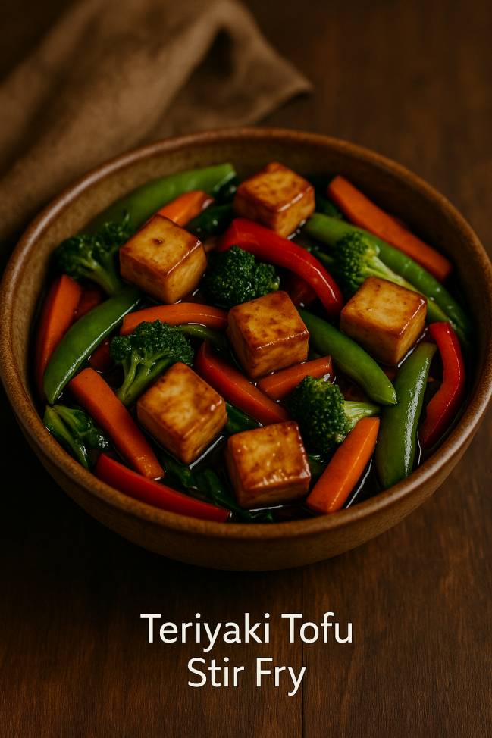

Teriyaki Tofu Stir Fry (Vegetarian Option)

Prep Time: 10 minutes
Cook Time: 15 minutes
Marinating/Rest Time: 15 minutes (for tofu)
Total Time: 40 minutes
Difficulty: Easy
Calories per Serving: ~400

Ingredients:
- - 150g firm tofu
- - 100g broccoli
- - 50g carrots
- - 50g red peppers
- - 30ml low sodium teriyaki sauce
- - 5g sesame oil
- - 5g sesame seeds
Instructions: Press and cube tofu, then sear in a hot pan until golden. Add mixed vegetables and stir-fry until crisp-tender. Pour in teriyaki sauce and toss until everything is coated and glossy. Serve hot over rice or noodles.

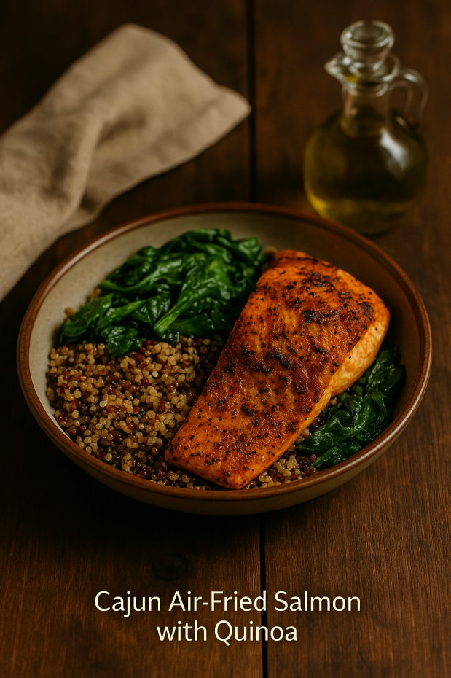

Cajun Air-Fried Salmon with Quinoa

Prep Time: 10 minutes
Cook Time: 12 minutes
Marinating/Rest Time: 15 minutes
Total Time: 40 minutes
Difficulty: Moderate
Calories per Serving: ~480
Ingredients:
- - 170g salmon fillet
- - 1 tsp cajun seasoning
- - 100g cooked quinoa
- - 50g spinach
- - 5g olive oil
Instructions: Preheat air fryer to 400°F (200°C). Rub salmon fillets with Cajun seasoning and a drizzle of olive oil. Air fry for 8–10 minutes, depending on thickness, until flaky and tender. Serve alongside fluffy quinoa and roasted veggies or a side salad for balance.

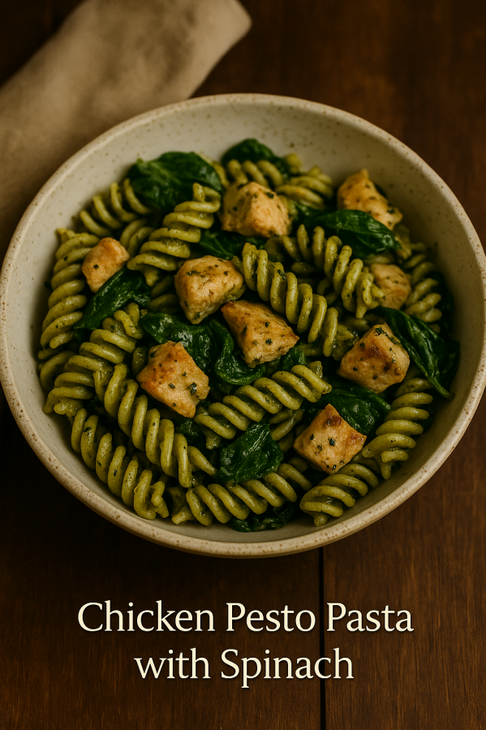

Chicken Pesto Pasta with Spinach

Prep Time: 10 minutes
Cook Time: 20 minutes
Marinating/Rest Time: None
Total Time: 30 minutes
Difficulty: Easy
Calories per Serving: ~460

Ingredients:
- - 160g grilled chicken
- - 75g whole wheat pasta
- - 30g pesto sauce
- - 40g baby spinach
- - 5g parmesan (optional)
Instructions: Cook pasta until al dente, reserving a splash of pasta water. In a skillet, sauté chicken pieces until golden and cooked through. Add pesto and spinach, stirring until the spinach wilts. Toss in the pasta, loosening with reserved pasta water if needed. Finish with a sprinkle of Parmesan. Serve warm.
“Treats don’t have to be cheats — make indulgence a part of your plan.”
[Background image placeholder: Snacks & Sweets]

SECTION 4: Snacks & Sweets

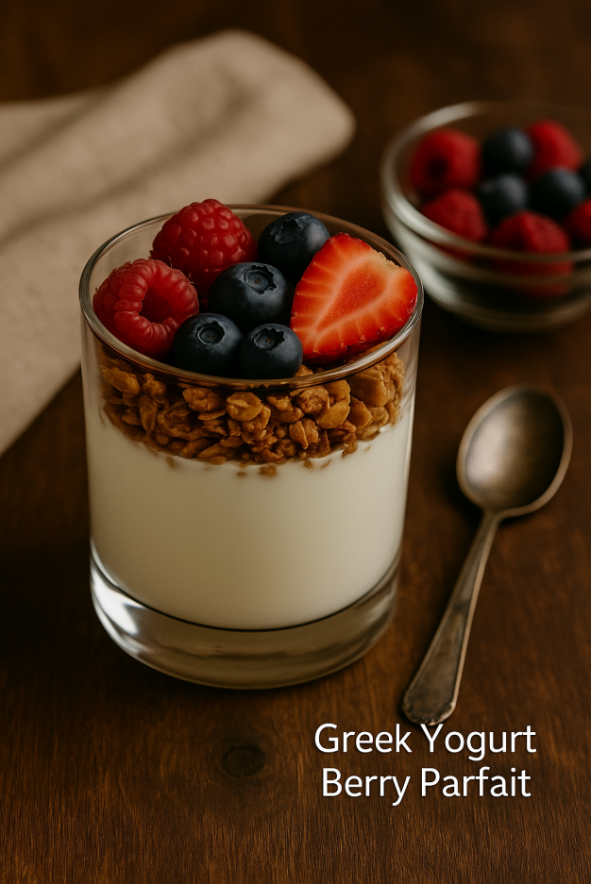

Greek Yogurt Berry Parfait

Prep Time: 5 minutes
Cook Time: None
Marinating/Rest Time: None
Total Time: 5 minutes
Difficulty: Very Easy
Calories per Serving: ~250

Ingredients:
- - 150g Greek yogurt (nonfat)
- - 50g strawberries
- - 30g blueberries
- - 10g granola
- - 1 tsp honey (optional)
Instructions: Layer Greek yogurt, fresh berries, and granola in a glass or bowl. Repeat the layers until full. Drizzle with honey or sprinkle with chia seeds for extra texture. Serve chilled and enjoy as a refreshing snack or light dessert.

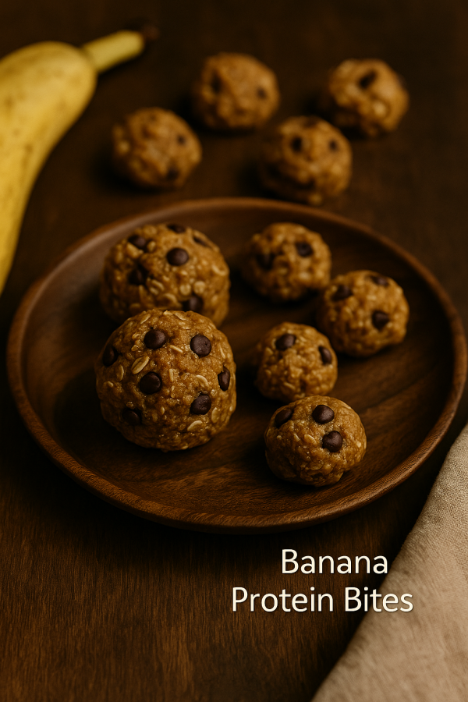

Banana Protein Bites

Prep Time: 10 minutes
Cook Time: None
Marinating/Rest Time: 30 minutes (to firm in fridge)
Total Time: 40 minutes
Difficulty: Easy
Calories per Serving: ~120 (per bite, depending on size)
Ingredients:
- - 100g mashed banana
- - 40g oats
- - 15g peanut butter
- - 10g chocolate chips
- - 10g vanilla protein powder
Instructions: Mash ripe bananas in a bowl, then stir in oats, protein powder, and a touch of nut butter. Roll the mixture into bite-sized balls and refrigerate until firm. Perfect for a grab-and-go snack.

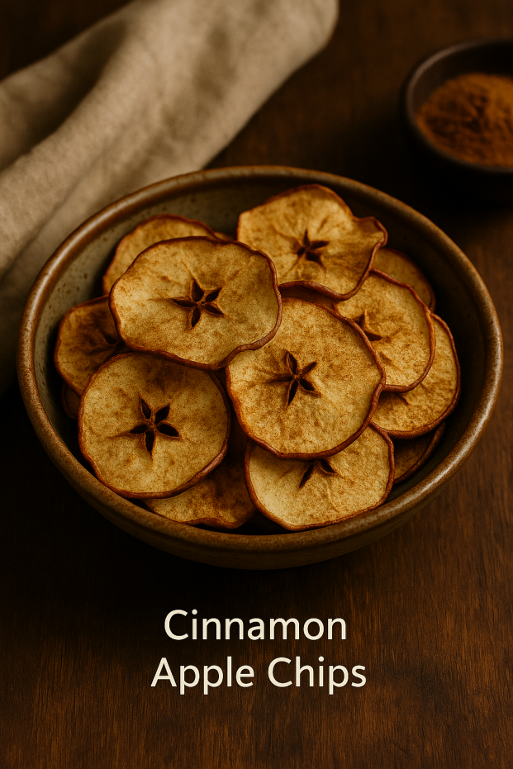

Cinnamon Apple Chips

Prep Time: 10 minutes
Cook Time: 2 hours (low oven or dehydrator)
Marinating/Rest Time: None
Total Time: 2 hours 10 minutes
Difficulty: Easy
Calories per Serving: ~100
Ingredients:
- - 2 medium apples, sliced thin
- - 1 tsp ground cinnamon
Instructions: Preheat oven to 225°F (110°C). Thinly slice apples and arrange on a parchment-lined baking sheet. Sprinkle with cinnamon. Bake for 1–2 hours, flipping halfway, until the slices are crisp. Cool before storing in an airtight container.
Josh’s Bonus Meals
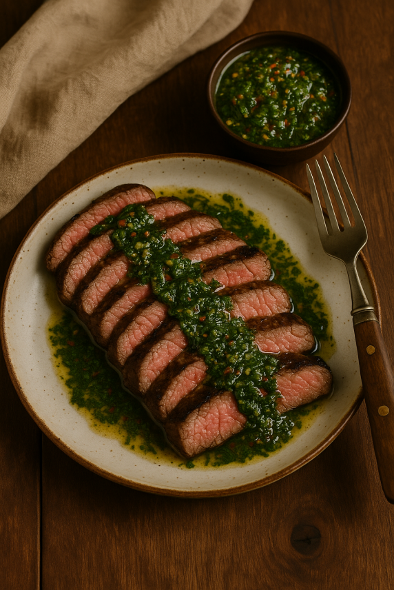
Steak & Chimmichuri
Prep Time: 15 minutes
Cook Time: 15 minutes
Marinating/Rest Time: 30 minutes (optional for max flavor)
Total Time: 1 hour
Difficulty: Moderate
Calories per Serving: ~480
Ingredients:
• -10+ oz Ribeye
• -½ cup Italian parsley (chopped)
• - 3-4 bulbs of garlic (minced)
• - ½ red bell pepper (diced)
• -tsp salt
• -tsp black pepper
• - ½ cup olive oil
• - ⅓ cup red wine vinegar
Instructions:
Season Steak w/ Salt & Pepper. Cook steak in saucepan at medium high temperature. Cook with oil and light butter, 2-3 mins per side. Add in Thyme and bast. Combine remaining ingredients together in a bowl, top steak.
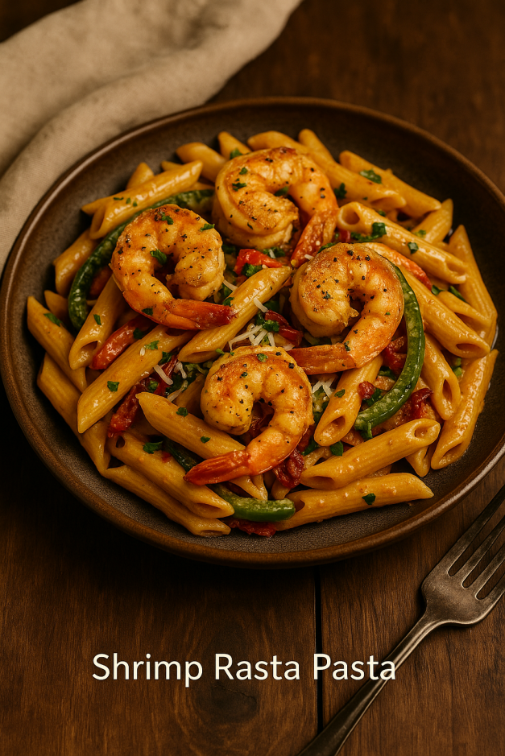
Shrimp Rasta Pasta
Prep Time: 15 minutes
Cook Time: 25 minutes
Marinating/Rest Time: 15 minutes (for shrimp seasoning)
Total Time: 55 minutes
Difficulty: Moderate
Calories per Serving: ~520
Ingredients:
• -6oz Peeled/Cleaned Shrimp
• -2cups Penne Noodles
• -Bell Peppers (red, yellow, orange)
• -tbsp Salt, Pepper, Garlic, Onion Powder, Adobo
• -No salt Cajun season
• -2tbsp Jerk Seasoning Sauce
• - Heavy Whipping Cream
• mozzarella, parmesan cheese
Instructions:
Boil Noodles for 10mins or until tender, season shrimp with all seasoning and jerk sauce, cook shrimp, remove shrimp, in same pan cook peppers. Remove peppers, in same pan, add in heavy whipping cream, seasonings & jerk sauce. Stir in noodles, then shrimp & peppers. Mix in parm & mozzarella cheese. Serve hot.

“A goal without a plan is just a wish — here’s your blueprint.”
[Background image placeholder: 2-Week Meal Plan]

SECTION 5: 2-Week Meal Plan
Below is a sample 2-week meal plan using the recipes from this cookbook. Each day includes 4 meals, balanced for fat loss and energy, averaging between 1300–1700 calories depending on recipe portion sizes.

Week 1

Monday
Meal 1: Chocolate Protein Overnight Oats
Meal 2: Turkey Taco Bowl with Cilantro Rice
Meal 3: Greek Yogurt Berry Parfait
Meal 4: Grilled Lemon Herb Chicken with Roasted Veggies

Tuesday
Meal 1: Protein Smoothie Bowl
Meal 2: Cajun Air-Fried Salmon with Quinoa
Meal 3: Banana Protein Bites
Meal 4: Teriyaki Tofu Stir Fry

Wednesday
Meal 1: Veggie Egg White Muffins
Meal 2: Chicken Pesto Pasta with Spinach
Meal 3: Cinnamon Apple Chips
Meal 4: Pan-Seared Salmon Green Beans and Garlic Rice

Thursday
Meal 1: Banana Nut Pancakes
Meal 2: Grilled Lemon Herb Chicken with Roasted Veggies
Meal 3: Greek Yogurt Berry Parfait
Meal 4: Honey Garlic Shrimp W/ Brown Rice and Snap Peas

Friday
Meal 1: Apple Raisin Instant Oatmeal Cup
Meal 2: Turkey Taco Bowl with Cilantro Rice
Meal 3: Banana Protein Bites
Meal 4: Chicken Fajitas w/ Black Beans

Saturday
Meal 1: Peanut Butter Chocolate Chip Instant Oatmeal Cup
Meal 2: Chicken Pesto Pasta with Spinach
Meal 3: Cinnamon Apple Chips
Meal 4: Teriyaki Tofu Stir Fry

Sunday
Meal 1: Orange Cranberry Instant Oatmeal Cup
Meal 2: Pan-Seared Salmon Green Beans and Garlic Rice
Meal 3: Greek Yogurt Berry Parfait
Meal 4: Grilled Lemon Herb Chicken with Roasted Veggies

Week 2

Monday
Meal 1: Pineapple Coconut Instant Oatmeal Cup
Meal 2: Honey Garlic Shrimp W/ Brown Rice and Snap Peas
Meal 3: Banana Protein Bites
Meal 4: Chicken Fajitas w/ Black Beans

Tuesday
Meal 1: Veggie Egg White Muffins
Meal 2: Cajun Air-Fried Salmon with Quinoa
Meal 3: Cinnamon Apple Chips
Meal 4: Grilled Lemon Herb Chicken with Roasted Veggies

Wednesday
Meal 1: Chocolate Protein Overnight Oats
Meal 2: Chicken Pesto Pasta with Spinach
Meal 3: Greek Yogurt Berry Parfait
Meal 4: Teriyaki Tofu Stir Fry

Thursday
Meal 1: Protein Smoothie Bowl
Meal 2: Turkey Taco Bowl with Cilantro Rice
Meal 3: Banana Protein Bites
Meal 4: Pan-Seared Salmon Green Beans and Garlic Rice

Friday
Meal 1: Apple Raisin Instant Oatmeal Cup
Meal 2: Grilled Lemon Herb Chicken with Roasted Veggies
Meal 3: Greek Yogurt Berry Parfait
Meal 4: Honey Garlic Shrimp W/ Brown Rice and Snap Peas

Saturday
Meal 1: Banana Nut Pancakes
Meal 2: Chicken Fajitas w/ Black Beans
Meal 3: Cinnamon Apple Chips
Meal 4: Teriyaki Tofu Stir Fry

Sunday
Meal 1: Orange Cranberry Instant Oatmeal Cup
Meal 2: Cajun Air-Fried Salmon with Quinoa
Meal 3: Greek Yogurt Berry Parfait
Meal 4: Grilled Lemon Herb Chicken with Roasted Veggies

“Discipline gives you freedom — the balance is where the magic happens.”
[Background image placeholder: 6 & 1 Eating Schedule]

SECTION 6: 6 & 1 Eating Schedule
The 6 & 1 Eating Schedule is a simple but highly effective strategy for building sustainable eating habits. This method balances structure with flexibility, making it easier to stick to clean eating long-term without feeling restricted.

How It Works:
✅ Eat clean for 6 days a week: Focus on whole foods, portion control, balanced meals, and consistent hydration. Use the recipes and meal plan in this cookbook as your foundation.
🍽️ On your 7th day: You’re allowed up to **2 cheat meals**. These can be foods you’ve been craving or meals out with family/friends. The key is to enjoy them mindfully and not let the entire day become a binge.
This approach gives your mind and body a break without reversing your progress. Over time, you’ll notice your cravings decrease and your consistency increase.

Why It Works:
- Builds consistency without burnout
- Encourages long-term lifestyle changes
- Reduces guilt around occasional indulgences
- Teaches balance and moderation
Use your cheat meals as a reward, not a setback. Plan them, enjoy them, and get right back on track the next day.

About The Lab Fitness
At The Lab Fitness, we believe health isn’t just about looking good — it’s about living strong, confident, and capable in every part of life. Our mission is to provide real-world fitness, nutrition, and lifestyle solutions that actually fit your life, so you can perform, feel, and look your best year-round.

A Note from Joshua Wilson
This cookbook is more than just recipes — it’s a tool to help you take control of your health without feeling restricted. I’ve put the same thought and care into these meals as I do into my training programs, so you have the fuel to match your goals. Remember, every choice counts. Every step matters. And you’re capable of more than you think. Let’s keep building.
Follow me on Instagram: @SeriouslyWillz_
The Lab Fitness: @TheLabFitness_
Email: FitnessTheLab@gmail.com
[QR Code: Book Your Training] [QR Code: Follow on Instagram]

