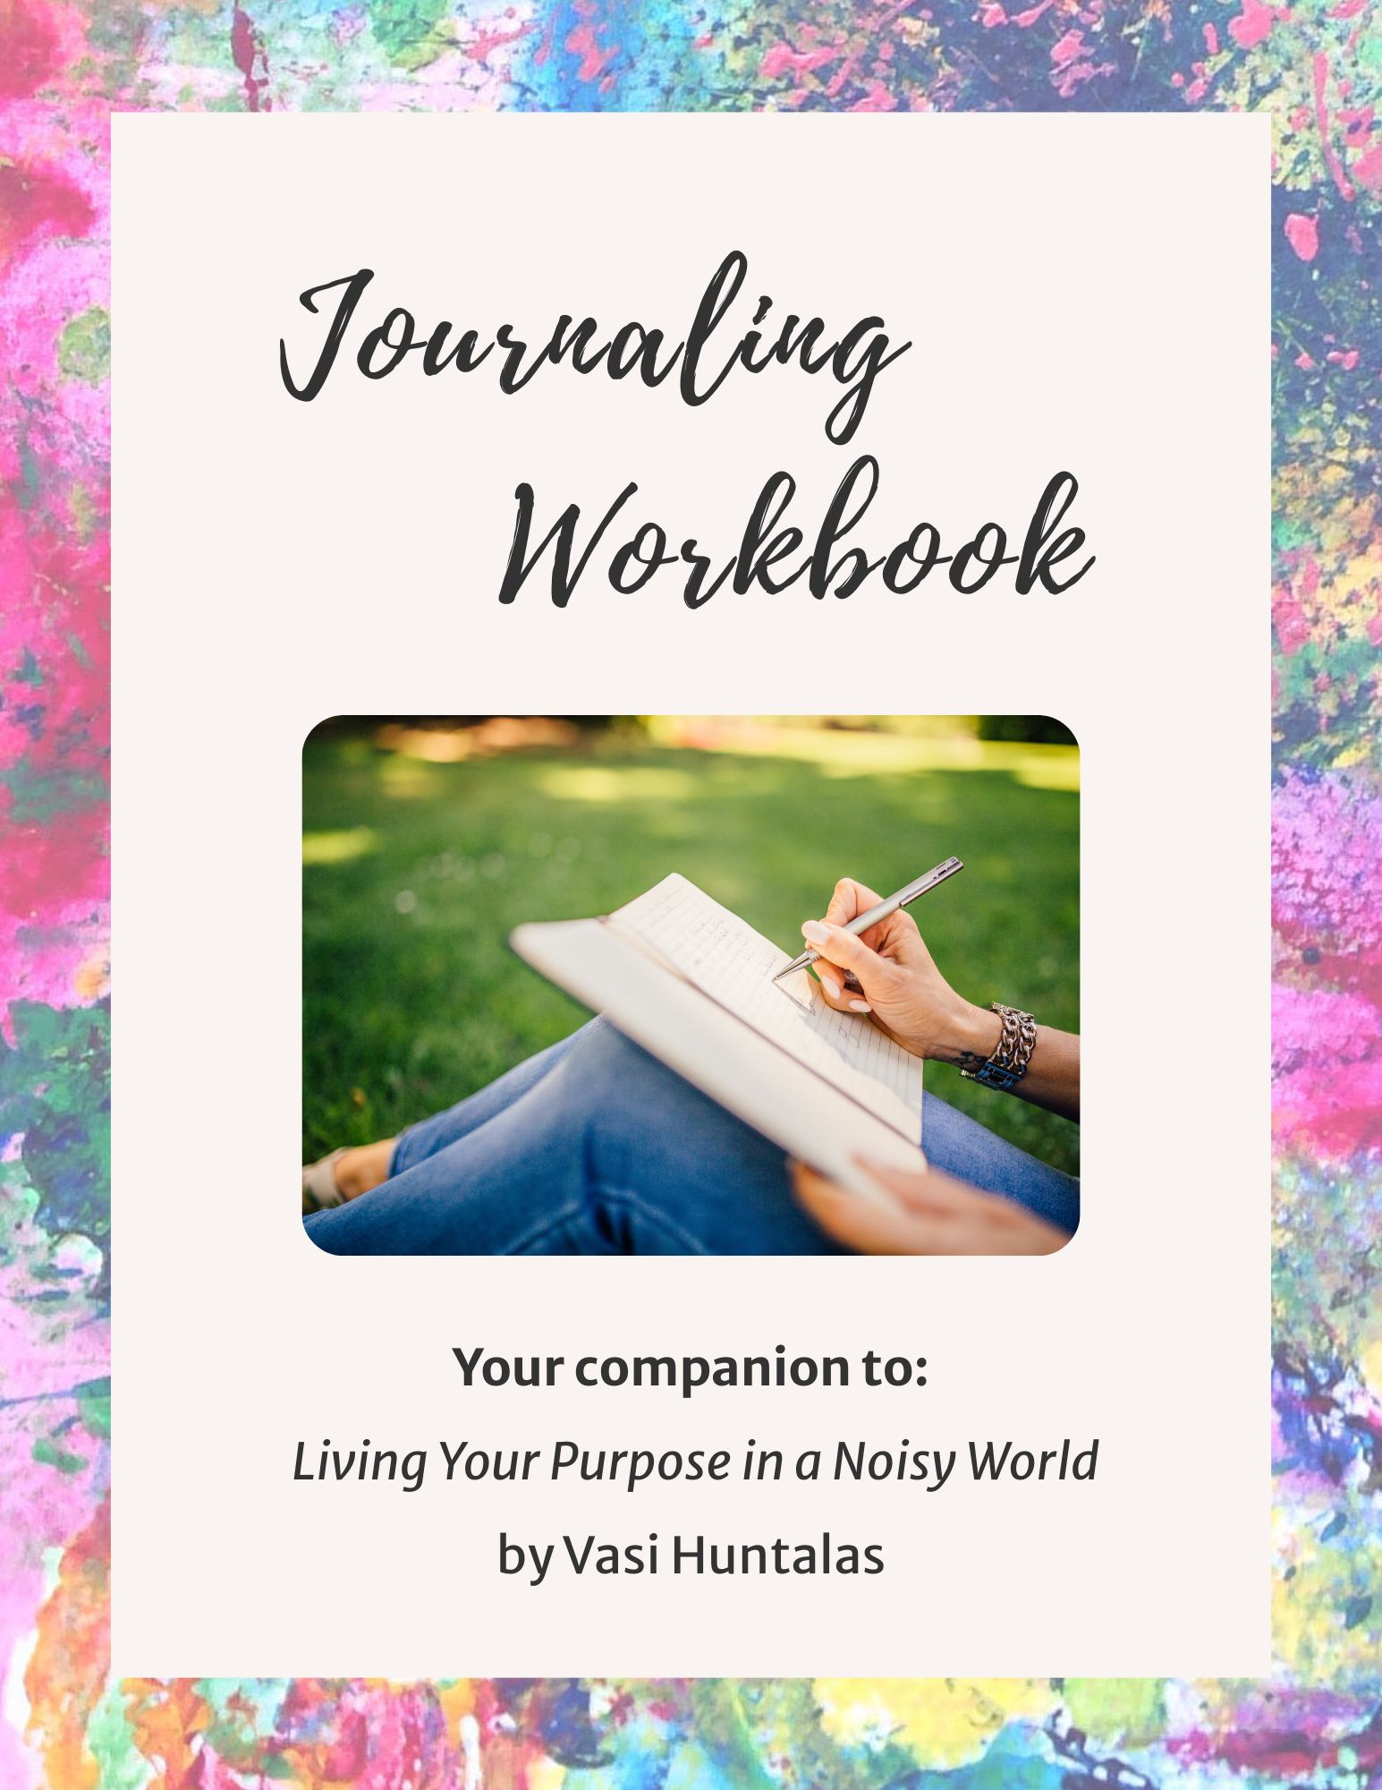
Journaling

Workbook

YOUR COMPANION TO:

Living Your Purpose
in a Noisy World

by

Vasi Huntalas

Welcome!

I’m so glad you’re here! This journaling workbook is your personal space to slow down, breathe, and reconnect with the wisdom that’s within you.

As a companion to the book “Living Your Purpose in a Noisy World”, this workbook helps you move from insight into integration, from awareness into aligned action.

There’s no right or wrong way to move through this workbook. Go at your own pace. Trust what you feel and sense. Let your intuition lead.

Each question is an invitation to come home to yourself—your truth, your clarity, your inner knowing.

May this be a sacred space where you feel supported, seen, and empowered as you step more fully into your purpose and your brilliance.

Enjoy!

Vasi Huntalas
IgniteYourSol.com

CHAPTER 1
Unraveling the Myths in a Noisy World

Circle the myth that resonates with you the most.
Myth 1: If I’m not always checking the news, something bad will happen or I’ll miss something important.
Myth 2: Success only comes from using my head, not from my heart.
Myth 3: The busier I am, the sooner I get ahead.

What do I notice about my body when I think about that myth?

How do I feel when I’m making choices from this myth?

What would I like to experience instead?

How would I show up if I trusted myself more than this myth?

If I no longer operated from this myth, what would my next aligned step be?

CHAPTER 2
Making Space for Stillness

What is Stillness? It is the space between your thoughts. It is like a pool of calm water that is clear and pure. It is freedom from the static in your mind.

When do I feel a deeper connection to my more expansive self?

What do I experience when I quiet my mind?

What are 1-3 practices that would bring me joy and help me connect deeper with my body and heart?

What belief and/or habit will I release to make space for these practices?

What am I committed to doing this week to make at least one practice I listed above a consistent part of my life?

CHAPTER 3
Discover Who You Are Not

Your life reflects your soul’s design and your life’s purpose. You being alive on Earth is a masterpiece of authentic expression. It’s a one-of-a-kind experience that only YOU can live! How you live is also a reflection of how you see yourself.

What roles do I take on in everyday life?

What do I believe I should do and shouldn’t do in those roles?

Where am I staying small to keep myself or others comfortable?

When do I feel most like my true self? What am I doing then?

What will allow me to do more of what lights me up?

CHAPTER 4
Keys to Unleash Your Creative Power
Your very nature is creative. Accessing your creative powers brings an abundant flow into living your purpose. While not everyone is an artist, EVERYONE is creative. Our creativity is the voice of our Big Self, expressing itself through us in countless ways that reflect our uniqueness.

What beliefs or stories have held me back from expressing my creativity?

What new materials, environments, or approaches am I curious to try?

What creative activity will bring me JOY to do this week?

How will I handle my inner critic so I stay inspired and feel free to be creative?

What tip will I use to make my creative practice a priority this month?

CHAPTER 5
Decoding Your Heart’s Wisdom and Passion

Your heart is like a vault filled with precious gems. You hold the keys to unlock the wisdom and passion in your heart. Our hearts speak to us in subtle ways. It’s the language of our soul, our Big Self, which is both tender and strong. Forgiveness, journaling to imagery, gratitude and spending time in nature are all ways to tap into your heart’s knowing.

When I place my hand on my heart, what does my heart have to say?

Where in my life is my heart calling me to be more honest about what I want?

What would following my heart look like today—in one small, loving action?

What passions would I like to devote time to starting... or to doing more?

What is one small, doable step I will take in the next 24 hours?

CHAPTER 6
Ignite Visibility On Your Path

What it means to be visible on your path is unique to you. When you listen to the wisdom within, you allow your True Self to guide you beyond doubt and toward greater impact with your purpose. If you don’t recognize or embrace these opportunities, subconscious blocks are likely in the way. These limiting beliefs often dim our light, but once we clear them, we’re free to shine our purpose more fully in the world!

When I think about sharing my purpose, what does that look like and feel like?

Which of the visibility blocks resonate most strongly with me?

What limiting beliefs am I ready to release?

What way of being visible energizes and inspires me?

What is my next step to being more visible with my purpose?

CHAPTER 7
Living Your Purpose One Day at a Time

By staying connected to your True Self daily, you infuse yourself with guidance and clarity to live your purpose. You live your purpose by embodying it, by BEING your True Self. Intuition is more than a deep knowing or instinct. It’s your bridge to communicating with your highest truth. It is the voice of your soul.

What does being intuitive look like for me?

Which of the myths did I recognize in myself?

Choose an issue or challenge that you’d like to get clarity and perspective.

Using the practice on page 68, what insight or solution did you receive?

What will help me trust my intuition in the days ahead?

How will I connect with my intuition daily?

CHAPTER 8
Connect With Your Community of Purpose

Your purpose and path are uniquely yours, by Divine Design. You may feel a longing to connect with others and to be part of something greater. Being held within a community of purpose helps us to grow and also amplifies our impact in the world. A community of purpose forms when people gather with a shared mission to expand what’s possible, both individually and collectively.

EXPLORE YOUR PURPOSE

What gives me energy to be and to do?

What do I feel drawn to learn, deepen, and/or experience that brings me joy?

What would I love the world to look like?

What about this ideal world energizes and inspires me?

What impact do I want to have on others… in the world?

What do people come to me for that feels natural to me and valuable to them?

DECIDE WHAT YOU’D LIKE TO GIVE & RECEIVE FROM A GROUP

What would I like to deepen, learn about and/or experience more — emotionally, intellectually, spiritually, creatively and/or socially?

What skills and abilities would I like to explore and/or grow?

What qualities and values do I want in the people I build community with?

What skills, expertise and/or qualities would I like to contribute to a group?

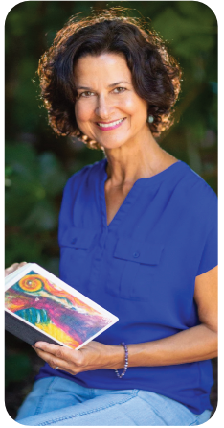
ABOUT THE AUTHOR

Vasi Huntalas

In a world filled with noise and distractions, Vasi Huntalas reminds visionary leaders that their deepest wisdom lives within their Big Self.

As a Mindset Mentor and Intuitive Business Strategist, she guides business owners and changemakers to bridge the space between soul and strategy — so their work becomes an authentic expression of who they are and the impact they desire to make.

For over two decades as a coach, speaker and trainer, Vasi has inspired people to align their lives with clarity, joy and purpose. Her unique approach blends deep subconscious clearing with practical action, empowering people to embody success with flow rather than force.

Whether you’re just discovering your purpose or ready to make your next level of impact, Vasi’s intuitive insights and expertise will guide you to bring your vision to fruition, with full abundance.

But Wait … There’s
More For You!
Your journey doesn’t end here. It’s just beginning. To keep connecting with the True, Abundant You and living your purpose with clarity and joy, use my free resources, guided practices, and inspiration to support you on your path. Go to:

IgniteYourSol.com/purpose-in-a-noisy-world



Contact me through my website:

IgniteYourSol.com/contact



