IELTS Task 1 Vocabulary

Introducing Graphs/Charts
Phrasing Options | Examples
illustrates…. | The pie chart illustrates the distribution of expenses.
gives information about/on ... | The chart gives information about the population growth.
provides information about/on ... | The table provides information on annual sales figures.
shows ... | The line graph shows the fluctuation in temperatures.
depicts... | The diagram depicts the stages of the manufacturing process.
compares … | The chart compares the performance of different companies.
contrasts... | The graph contrasts urban and rural population growth.
explains why ... | The report explains why certain trends occurred.
describes ... | The table describes the features of the products.
draws the conclusion of/concludes | The study draws the conclusion that customer satisfaction has improved.
The chart reveals information about | The chart reveals information about the changes in energy consumption.
The line graph presents | The line graph presents how internet usage has changed over a period of five years.
According to the pie chart… | According to the pie chart, 60% of respondents prefer online shopping.
As the chart indicates… | As the chart indicates, there was a significant increase in production.

Time Periods (use in the introduction)
Time Frames | Specific Periods
from 1990 to 1995 | in the 80s
from 1985 up until 1990 | in the summer of 1969
in 2019 (not: on 2019) | in the winter of 2010
in July | in the years 1985 to 1990
between 1990 and 1995 | over a three-month period (April to June)
between April and August | throughout the year
Duration of Time | Starting Points
for 5 years | since 2017
for 6 months | since February
During: | Over the Course Of:
Use ‘during’ to refer to a specific point or period within a larger time frame. | To describe change from the beginning to the end of a period (the entire period).
"During the first quarter, sales increased by 20%." | "The project was completed over the course of 5 years."
"The weather was particularly cold during the winter months." | "Over the course of 3 decades, the population significantly increased."

- Use an apostrophe of possession when referring to a particular category
Example: Canada's wheat exports → this sounds good (notice the apostrophe + s)
the wheat exports of Canada → This makes sense, but it does not sound great.

- Do not say ‘the’ before category names
Example: the Canada’s exports X the bread’s sales X
Correct: ‘Canada’s exports’ and ‘bread sales’

- The number of students decreased from 20000 in 2002 to 182000 in 2003 (i.e. decreased by 9%/decreased by 18000). – not: the amount of students (students is a countable noun)

Prepositions
Preposition | Explanation of Prepositions:
increased/decreased + By + how much (do the maths)  By + final year (end of the period of study) | Indicates the amount or degree of change  e.g., increased by 20% (so it went from 60% to 80%)  Exports increased to $1 million by 2006 (final year).
To + verb (increased/decreased) + number/% | Indicates the final level or target achieved (e.g., the temperature rose to 30 degrees/ sales increased to $6 billion/6 billion USD/6 billion US dollars
increased/decreased + until + time point (not # & %) | decreased until December/1999 - not: decreased to December
At + data point | Specifies a precise/exact number or percentage AT a certain point or moment in time (e.g., sales peaked at $150 in 2007).
With + data point | The highest percentage was seen in 2010, with 65% of participants choosing online shopping.
In + year/month/season | in 2007, in January, in winter
from __ until __ | buns sales decreased FROM August UNTIL December
for + duration (how long) | for 3 months
Verbs to describe ‘increase’
Past Simple | Example Phrase
increased | The sales increased dramatically, by 20% last quarter.
grew | Our customer base grew by 1,000 new clients.
varied | The results varied from one test to another.
climbed | The temperature climbed to 25 degrees this afternoon.
surpassed/exceeded | Sales surpassed/exceeded the target of $1 million last month.
exceeded | The profits exceeded expectations this quarter.
rose – not: rised | The temperature rose to 30 degrees yesterday.
surged | Profits surged to an all-time high this year.
peaked | The stock price peaked at $150 last week.
sky-rocketed | Exports skyrocketed to record levels last year.
soared | The demand for electric cars soared by 50%.
leapt | Revenue leapt to $2 million in Q2.
doubled | Internet usage doubled from 2018 to 2020 due to increased remote work.
tripled | Sales of organic foods tripled over the past decade as consumer preferences shifted."
quadrupled | Investment in renewable energy may quadruple within the next decade.
Verbs to describe ‘decrease’

Past Simple | Example Phrase
decreased | Unemployment decreased by 1% this month.
declined | Sales declined to their lowest point in years.
dipped | The stock dipped by $5 before recovering.
fell | The temperature fell to freezing overnight.
dove | The company's shares dove to $10 during the crisis.
plunged | The price plunged by 30% after the announcement.
plummeted | The market plummeted to a new low yesterday.
halved | Plastic waste could halve by 2030 with effective recycling programs.
Other Changes

Past Simple | Example Phrase
remained | The prices remained constant/stable at $50 for several months.
stabilised | The market stabilised after the initial drop.
fluctuated | Oil prices fluctuated between $70 and $80 last month.  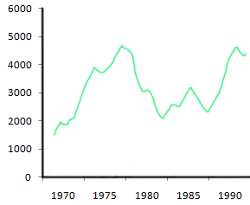
varied | The results varied from one test to another.
overtook/  surpassed | 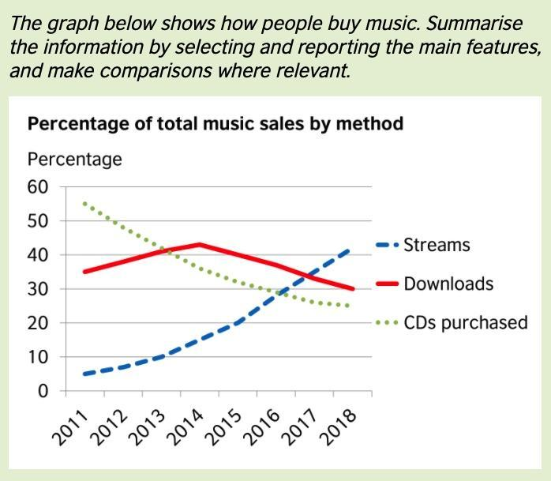  In mid-2013, music downloads overtook/surpassed CDs as the most popular method of music sales.
For future years:  is predicted to increase  is expected to  is projected to  Do not say ‘will’ for the future! | 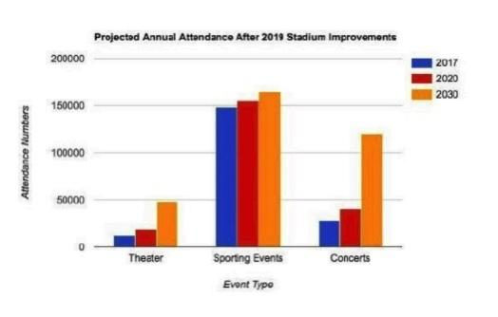

Adverbs to Describe the Intensity/Rate of Change
Adverb | Definition | Example Phrase
slightly | A small variation | The market fluctuated slightly throughout the week.
modestly | A small, moderate increase | Profits increased modestly this quarter compared to last.
gradually | A slow and steady change | The climate is changing gradually over the years.
slowly | A gradual decrease | The population has declined slowly over the past decade.
markedly | A noticeable improvement | Customer satisfaction improved markedly after the changes were made.
significantly | A notable or large increase (a lot) | Sales increased significantly after the new campaign launched.
dramatically/  drastically | A large and sudden decrease | Wheat exports decreased dramatically from 16 million tons to 11 million tons.
abruptly | A very quick drop | Stock prices fell abruptly after the announcement.
sharply | A quick or sudden rise | The temperature rose sharply in the afternoon.
suddenly | A quick and unexpected increase | Demand for the product rose suddenly during the holiday season.
rapidly | A quick decrease | The price dropped rapidly following the news.

Approximation Language (bar graphs)
Approximation Phrases | Meaning/Usage | Example
Just over | Slightly more than a given amount | Just over half of the population is female.
Just under | Slightly less than a given amount | Just under 20% of students failed the exam.
Nearly | Almost or close to a certain number or amount | Nearly 40% of people prefer coffee.
Approximately | An estimate, close to the exact number | Approximately 50,000 people attended.
Roughly | An estimate, not exact | Roughly 29 million tons were produced.
Around | An informal way to give an approximate figure | Around 75% of employees are satisfied.
A little over | Slightly more than | A little over 60% of respondents agreed.
A little under | Slightly less than | A little under a quarter of students passed.
Close to | Very near to a certain figure | Close to 80% of customers are satisfied.
About | Informal way to state an estimate | About 30% of the population smokes.
Nearly double | Close to being twice as much | The sales nearly doubled in two years.
Just above | Slightly higher than | The price was just above $50.
Just below | Slightly lower than | Attendance was just below the expected number.
About | Similar to "roughly"; indicates an estimate | The project will take about six months to complete.
Exactly | Precisely; no deviation from a specified amount | The budget was exactly $10,000.

Nouns for Describing the Type of Change
Type of Change | Change | Example Phrases
Increases | A rise (in) | - There was* a dramatic (adjective) rise (noun) in sales.  versus  Sales rose (verb) dramatically (adverb). → easier to use this combination
 | An increase (in) | - An increase in revenue  - There was an increase in user engagement  - There was a dramatic increase in India’s exports in recent years
 | Growth (in) | - Growth in profits  - There was growth in the customer base
 | Hit a peak | - Sales hit a peak  - The market hit a peak in August
 | A surge (in) | - A surge in stock prices  - There was a surge in website traffic  - There has been a surge in oil prices lately
Decreases | Change | Example Phrases
 | A fall (in) | - A fall in prices  - There was a fall in the number of subscribers
 | A decrease (in) | - A decrease in production  - There was a decrease in sales volume
 | A decline (in) | - A decline in attendance  - There was a decline in customer satisfaction
 | A dip (in) | - A dip in revenue  - There was a dip in stock value
Fluctuations | Change | Example Phrases
 | A fluctuation (of) | - A fluctuation in energy prices  - There was a fluctuation in sales across quarters
 | A variation (in) | - A variation in seasonal demand  - There was a variation in product quality

Adjectives to Describe Changes in Data

The most popular… The most common product
The least popular… The least common product
The highest sales… [highest /lowest + noun]
The lowest sales… — not: smallest X
Type of Change | Adjective | Definition | Usage Example
Small Changes | Marginal | Very small in amount or effect | "There was only a marginal dip in attendance."
 | Slight | Small in amount or degree | "There was a slight rise in prices over the month."
 | Modest | Limited or moderate in size or degree | "The firm saw a modest increase in revenue."
 | Gentle | Mild and gradual | "A gentle decline in profits continued over the year."
Big Changes | Considerable | Notable in amount or size | "A considerable growth in profits was observed."
 | Significant | Large or important enough to have an impact | "There was a significant increase in user engagement."
 | Substantial | Large in amount or degree | "Substantial growth was recorded in the final quarter."
 | Marked | Clear and noticeable | "There was a marked decrease in website traffic."
 | Dramatic | Striking, often large | "A dramatic surge in sales followed the new product launch."
Speed of Change | Adjective | Definition | Usage Example
Slow Changes | Gradual | Slow and steady | "The data showed a gradual increase in user activity."
 | Steady | Stable, sustained | "Steady growth was observed in the customer base."
 | Consistent | Regular and stable over time | "There was a consistent variation in seasonal demand."
Fast Changes | Sharp | Sudden and intense | "There was a sharp rise in demand last quarter."
 | Abrupt | Very sudden and unexpected | "There was an abrupt increase in market volatility."
 | Rapid | Happening at a fast pace | "The company saw a rapid growth in new subscriptions."
 | Steep | Very large or steep in gradient or degree | "The chart showed a steep rise in costs over time."

Tenses to Use
- For dates before 2026, use the simple past:
Sales + increased (no ‘have’/’has’) OR There was an increase in sales.
- If the graph/map has dates in the past & up until 2026, use the present perfect:
Sales have increased OR There has been an increase in sales.
- If the graph has dates in the future, do not use ‘will’.
Write: is expected to/is projected to/is predicted to increase

Maps
- If the map has dates up until 2026, use the present perfect passive:
Trees have been cut down, houses have been demolished, and a road has been built.
- If the maps have dates comparing two past dates e.g. 1950 & 2010, use the simple past passive:
Trees were cut down, houses were demolished, and a road was built.

Capitalization Rules: Compass Directions
In Task 1, unless referring to proper nouns or named regions, use lowercase:
- Shops were added to the north of the main road. (✔)
- The Southern entrance was replaced with a park. (❌ — should be southern entrance)

➤ Do NOT capitalize:
Use lowercase for general directions or movement.
- A stadium was built in the south.
- The factory is located to the west of the village.

When do we capitalise?
Use uppercase when the direction is part of a proper noun or refers to a specific region/group. This won’t be necessary in Task 1, but perhaps in Task 2 essays in a regional example.
- Economic growth was strongest in Western Europe.
- Trends are different in the East and West.
Use South when... | Use Southern when...
Referring to a specific point/direction | Referring to a part/area of something
✅ north of the building | ✅ southern section of the park
✅ located to the south of the school | ✅ The southern coastline was developed.

✔ IELTS Examples:
- The car park is to the north of the roundabout.
- A new road was constructed in the southern part of the town.
- Shops were relocated from the east to the west side.
⚠ Common IELTS Errors to Avoid
- ❌ The South area had more houses. → Should be southern area
- ❌ It is located on the Eastern side. → “eastern” is not a proper noun here → eastern side
- ✅ A playground was built in the north-east corner. (hyphen is correct for compound directions)

Comparison Language
When comparing how TWO things differ:

Use lower than when comparing two values.
Value A vs Value B
- The unemployment rate (50%) was lower than the previous year's (75%).
- The percentage of women was lower than that of men.
Here, you're comparing one value with another value.

Use ‘less than’ when you mean below a specific #number.
Below X
- Less than 20% of students failed.
- Less than 5,000 people attended.
- The project cost less than €1 million.
Here, you're not comparing two values—you are saying the figure is under a limit.
lower than = lower than something else
- 15% is lower than 20%.
- $50 is lower than $100.
less than = under a numerical limit
- Less than 20%
- Less than $100

  - as…as, e.g. In 2015, coffee production was as high as tea production.
  - not as…as, e.g. Sales in the final quarter were not as strong as those in the previous quarter.

Most & Least vs Highest & Lowest → used for comparing 3 or more things
- Use most and least before adjectives or nouns to describe categories – not values.
  - The most popular destination was France.
  - Coal made the least contribution to energy production.

- Use highest and lowest before nouns (e.g. number, percentage, rate, figure, amount) to describe values.
  - France had the highest number (noun) of visitors, at 1 million.
  - Japan recorded the lowest unemployment rate (noun) of 10%.

Less vs The Least
- Use less to compare two things.
- Use least to describe the smallest value in a group of three or more.
Examples
- Germany produced less electricity than France. [comparing 2 things]
- Solar power contributed the least to total energy production. [3 or more categories]

Common Errors
❌ Coal contributed less to total energy production. (Incorrect: less compares two items. Use least when identifying the smallest value in a group.)
✔️ Coal contributed the least to total energy production.
❌ France had the less visitors than Spain. (Incorrect: visitors is a countable noun. Use fewer with countable nouns.)
✔️ France had fewer visitors than Spain.
❌ Solar power was the less important energy source. (Incorrect: least is the superlative form used to describe the lowest-ranked item in a group.)
✔️ Solar power was the least important energy source.
- Use ‘respectively’ to mention TWO percentages in one sentence:
Boys enjoy computer games more than girls, at 34% and 16%, respectively.
= Boys like computer games (34%) more than girls (16%).
- Use ‘ranked as’ to list the position of categories relative to one another:
Computer games and basketball ranked as the top two activities done by boys.
In second place is playing basketball. Soccer ranks in third place.

Flow Charts
- Don’t try to use synonyms for machine parts/body parts/ingredients!
- In flow charts, we describe repetitive processes where the doer of the action is not known/not important, so use the present simple passive tense:
object | is + past participle | Example
a steel tank | is filled up to 75% capacity | A steel tank (object) is filled up to 75% capacity with compost and treated with water. [we don’t know who fills it]
The methane gas | is then pushed | The methane gas is then pushed through two larger pipes into a compressor. [we don’t know what pushes the gas]

Linking Structures
Don’t use these linking structures at the beginning of every sentence as that is too many – rather use them at the beginning of/in the middle of every 2nd sentence. Remember to add a comma after using these:
Category | Linking Structures | Category | Linking Structures
Listing / | Firstly, | Reinforcement | Additionally,
 | Secondly, |  | Moreover,
 | Thirdly, |  | Furthermore,
 | First, | Summarising | Overall,
 | Furthermore, |  | On the whole,
 | Finally, |  | To summarise,
Sequencing (for flow charts) | Next, | Highlighting | In particular,
 | After that, / Subsequently |  | Specifically,
 | …., after which ____ |  | Notably,
 | Then, | Similarity | Similarly,
Contrast | In contrast, / In comparison, |  | Likewise,
 | Conversely, | Expressing Alternatives | Alternatively,
 | However, |  | Conversely,
 | On the other hand, | Transition to New Points | Furthermore,
 | While ____X____, ____Y____ |  | In addition,
 | __X______ , whereas/while _____Y____

