THE WHEEL OF LIFE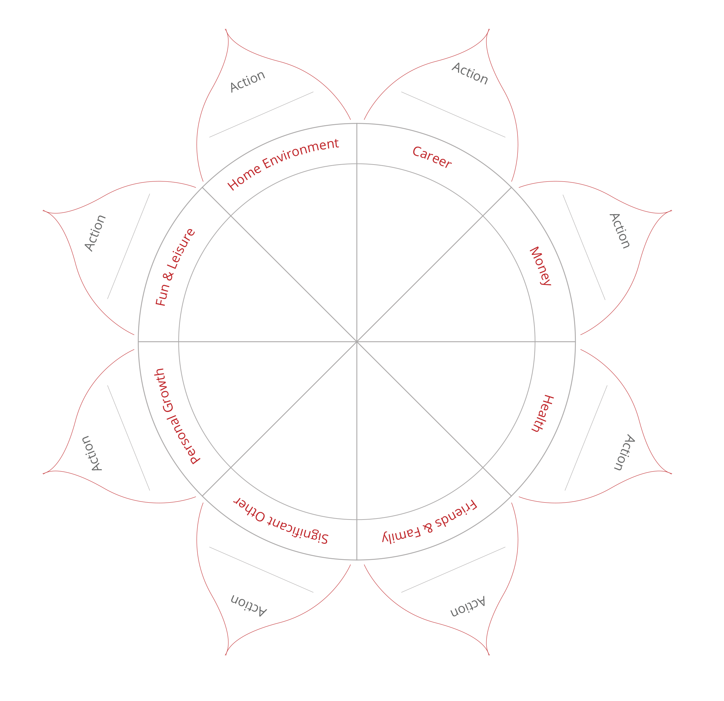
COMPLETE THE SUNFLOWER.
1a. Review the 8 categories in the sunflower thinking briefly about what a happy, satisfying life might look like for you in each area.
1b. Draw a line across each segment that represents your happiness score for each area.
• Imagine the centre of the wheel is 0 and the outer edge is 10.
• Choose a value between 1 (very unhappy) and 10 (couldn’t be happier).
• Now draw a line and write the score alongside (see example on page 1).
IMPORTANT: Use the FIRST number (score) that pops into your head, not the number you think it should be!
PART 2 - LOOK AT YOUR COMPLETED SUNFLOWER & ANSWER THESE REFLECTIVE QUESTIONS:
1. Where does your life need brightening up?
2. What surprises are there for you?
3. How do you feel about your life as you look at your Sunflower?

4. What is missing from your life right now?
5. Which of these areas would you most like to improve?
6. How could you make space for these changes?
7. What help and cooperation from others might you need to make changes and brighten up your life?

8. What is the key area you need to work on?

PART 3 - CHOOSE ACTIONS:
3a. Return to page 1 and write out one action you could take for each area in the petals.
Family & Friends
Partner
Career
Finances
Health
Environment
Fun/Recreation/Leisure
Personal Growth
3b. Finally, choose ONE Action you will take in the next week to brighten up your life. I WILL:
PS. OPTIONAL HOMEWORK:

Journal and make a list of 3-5 bullets or write a short paragraph that describes what a score of “10” would look like in each area.

