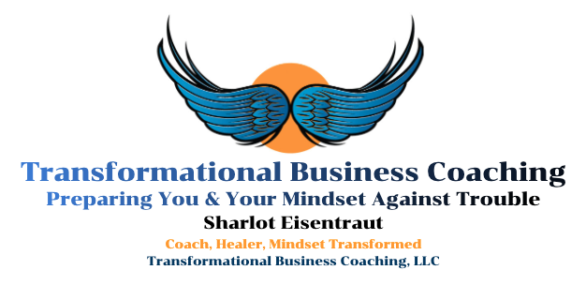
The Great I Am: Aligning Values, Vision & Action
Created by Sharlot Eisentraut

Embrace Who You Are and Value Yourself!

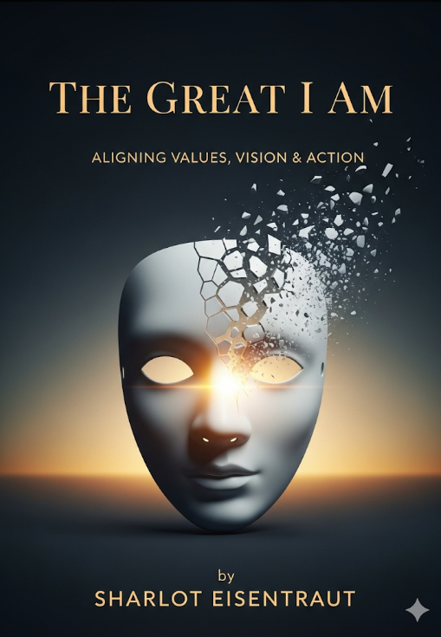

Tips to Keep In Mind Before We Begin:
- Be realistic with yourself; you are not a god nor should you force yourself to be. You are a perfectly imperfect, beautiful human being.
- As you fill out the worksheet, do your best to take away any “shoulds” or “should nots” coming from other people. You are you, this worksheet is about embracing who you are.
- There is no “right” or “wrong” answer, only what is right to you

The Great I AM! Identity, Mindset and Action Worksheet:
- When I am in a room full of people at work, how do I tend to act?
  - What do I tend to think when I am in a room full of people at work?
  - What do I tend to feel when I am in a room full of people at work?
- When I am in a room full of people at a party, how do I tend to act?
  - What do I tend to think when I am in a room full of people at a party?
  - What do I tend to feel when I am in a room full of people at a party?
- When I am with several close friends, how do I tend to act?
  - What do I tend to think when I am with several close friends?
  - What do I tend to feel when I am with several close friends?
- When I am by myself, alone, how do I tend to act?
  - What do I tend to think when I am by myself, alone?
  - What do I tend to feel when I am by myself, alone?
- If I take myself out of my own mind and my own perceptions and I were to look at myself as a close and loving friend sees me, how would I describe myself?
  - How would a close and loving friend describe what I like?
  - How would a close and loving friend describe what I do not like?
  - How would a close and loving friend describe my character?
  - How would a close and loving friend describe my temperament?
- If I take myself out of my own mind and my own perceptions and I were to look at myself as a very close and loving person sees me, how would I describe myself?
  - How would a very close and loving person describe me?
  - How would a very close and loving person describe my interests?
  - How would a very close and loving person describe my weaknesses?
  - How would a very close and loving person describe my strengths?
  - How would a very close and loving person describe when I am most awake?
  - How would a very close and loving person describe when I like to work?
  - How would a very close and loving person describe when I like to play?
- If I take myself out of my own mind and my own perceptions and I were to look at myself as my own loving and accepting creator, how would I describe myself?
  - How would my creator describe my life choices?
  - How would my creator describe my life path?
  - How would my creator describe where I am supposed to go?
  - How would my creator describe where I’ve been?
  - Would my creator want to change where I am going?
  - Am I asking my creator to watch over me and keep me _______? How often?
- If I were to take myself out of my own mind, my own head, my own body and think of myself as an Energetic Life Force attached to my body, mind and soul, how would I describe my Energetic Life Force, including color, brightness and transparency?
  - How would my Energetic Life Force feel about taking action?
  - How would my Energetic Life Force get me motivated to take action?
  - How would my Energetic Life Force feel about how I am treating my body?
  - How would my Energetic Life Force make sure I stay on my life path?
- If I were to focus my mind on what makes me unique and gives me life, my Soul, how would I describe my Soul?
  - As your Soul, what do you know you must do?
  - As your Soul, what do you know you must think?
  - As your Soul, who are you?
  - If a Higher Power were to be, what would Soul need to do to no longer be?
  - If a Higher Power were to be, what would Soul need to do to continue to be?
- If I were about to be born into the world and I am standing in front of my Great Creator, how would I describe my Great Creator (also known as God or Higher Power)?
  - What are some pieces of advice my Great Creator gave me before being born?
  - What are some things I was told by my Great Creator that I might not like?
  - What are some things I was told by my Great Creator that I will like?
  - What are some things I was told by my Great Creator that I must accept?
  - What are some things I was told I am allowed to explore by my Great Creator?
  - What are some things I was told I could change by my Great Creator?
  - What are some things I can change now with or without permission by my Great Creator?
- If I remember times where I felt, “I shouldn’t do that.” or “I feel I need to do this ______.” or “Watch out for _________!” How would I describe where that feeling of guidance or intuition comes from?
  - Does my guidance and intuition feel mostly negative or mostly positive?
  - Does my guidance and intuition seem to lead me to good things or bad things?
  - Is my guidance and intuition mostly looking out for me or mostly looking out for itself?
  - Where in my body do I feel guidance and intuition the most?
- As we grow, we develop a set of beliefs or views that influence how we think and interact with the world. As children, these beliefs help us survive. However, as we grow into adults, some or many of these beliefs become limiting, as certain beliefs limit how well or effectively we are able to take action in the world. What are two to three examples of beliefs that you can think of (EX: “I can…”, “I am…”, “There is…”)?
  - What are some beliefs you have currently that are annoying and get in the way of you taking action?
  - What are some beliefs you have currently that keep you from taking any action?
  - What are some beliefs you have currently that help enable you to take action?
  - What are some beliefs you have currently that are very helpful in taking action?
- Consider for a moment that you are at your funeral (but you can’t interact with anyone and no one can see you, hear you, smell you etc.) and you’ve lived your life the way you wanted and needed to, fully, who would you likely see at your funeral?
  - What would you want the people at your funeral to say about you?
  - What would you want your gravestone to say about you?
  - What would you want your friends and family to say about you?
  - What goals would you want to accomplish that would indicate to you that you’ve lived your life fully?
- Many great people who have come before us have said that “mindset creates” or “mindset manifests.” This means that what we hold in our minds, we create with our actions. Did you know that we have the power to create almost anything based on what we think we deserve when we are able to receive?
  - If you were someone who wanted to manifest something that you want, what characteristics would this person have?
  - If you were someone who wanted to manifest something that you need, what characteristics would this person have?
  - If you wanted to manifest something you want or need, would you be able and willing to take on and integrate some of these characteristics into yourself?
- Pride and ego will protect our identity and self-esteem, so much so that pride and ego will lead us off our life path of where we are meant to go. This means pride and ego will over protect us, to the point of offering false fickle treasures and instantaneous results as part of taking no immediate action or very little action. What are some sources of entertainment that you partake in that you consider “busy work” but are not the actions you know you need to be taking?
  - What are some actions that you can initiate that can prepare you to do life work you feel and know you need to do?
  - What are some actions that you can initiate that can prompt you to do life work you feel and know you need to do?
  - What are some actions that you can initiate that can clean up the life work you feel and know you need to do?
- Coaching, therapy, healing as well as many others are life-changing resources that many people participate in so that they can find themselves and take massive action towards their goals and dreams. What are some resources you would like to partake in so that you can follow your authentic life path?
  - What are some goals you would set with this resource?
  - What are some questions you would ask this resource?
  - What are some indications you’ve gained what you needed from this resource?
- Meditation is a tool that is used by many to gain insights, let go of past mistakes, radically accept the present, and be able to sleep peacefully as well as many others. What are some other benefits of mediation that you’ve heard of?
  - What is a form of meditation that you’ve tried?
  - If you were to meditate, what would you meditate on?
  - Research a form of meditation and try it. Write below what came up; what was interesting, what was difficult and what your intention was.
- Sleep is very important for our health, body and mind. Setting intentions, feelings and emotions during the day can be processed and resolved during sleep. However, sometimes sleep can be scary, meaning our general world can feel scary. What are some sleeping experiences (nightmares or good dreams) that you’ve had that changed the way you view the world?
  - What are some routines that you do to help you go to sleep?
  - Rooms that are set up to be dark, quiet and comfy tend to help us fall asleep and stay asleep. What are some changes you could make to your bedroom to help you fall and stay asleep?
  - The next time you go to sleep, set yourself one intention (EX: I will get a good rest) and write down the results below:
- Preparing for and doing work is an important aspect in all people’s lives, especially those who wish to do great work. Some people are “morning people” and like to get work done right away in the morning and then have downtime, entertain or relax themselves in the evening. And some people are “night people” who like to get work done during the evening and night and spend their relaxation, entertainment or downtime during the day, before working. And there are people who like to and feel most boosted to do work in the middle of the day where entertainment tends to happen before or after work. All are okay. All are good. And all are connected to our natural circadian rhythm. When do you feel you are at your highest to do great work, in the morning, afternoon, evening or something else?
  - Does your current working hours best reflect when you feel most motivated or boosted to do work?
  - Are you working at a business or doing a job that best takes advantage of when you are most motivated or boosted to do work?
  - If you want to make a change to your circadian rhythm, electrical light, food tendencies and other people can tend to make the most impact on when we wake up and when we go to bed. Are there any changes you would like to make to your sleeping arrangements so that you can go to bed and wake up energized and ready to work when you want and need to?
- Finding and doing purposeful work is incredibly satisfying, both to yourself and those you help. What are some results you want as a result of your work?
  - What kind of work would keep you going even when the going gets tough?
  - What activities in life give you the most meaning and urge to keep going?
  - What problems would you endeavor to solve even if other people say it is impossible?
  - How many people, animals or environments would you want to impact as a result of your work?
- Knowing when “enough” is is the same as attaining a goal and being okay with one’s position in life. To be enough means being able to stop the race of constantly chasing the symbolic “carrot” of success. To be enough or know you are enough can bring a great sense of peace and serenity. Being enough does not mean giving up. Being enough means you have reached a place of rest, celebration, reflection and of possibly creating a new goal to attain to. Describe below one to three aspects in your life where you feel you are enough:
  - What are some goals that other people have put upon you?
  - How many of the goals that other people have put upon you have been achieved?
  - What are some goals that you put upon yourself?
  - How many of the goals that you put upon yourself, have you achieved?
  - What are some ideas of success that other people have put upon you that you achieved?
  - What are some ideas of success that you have, that you have achieved?

