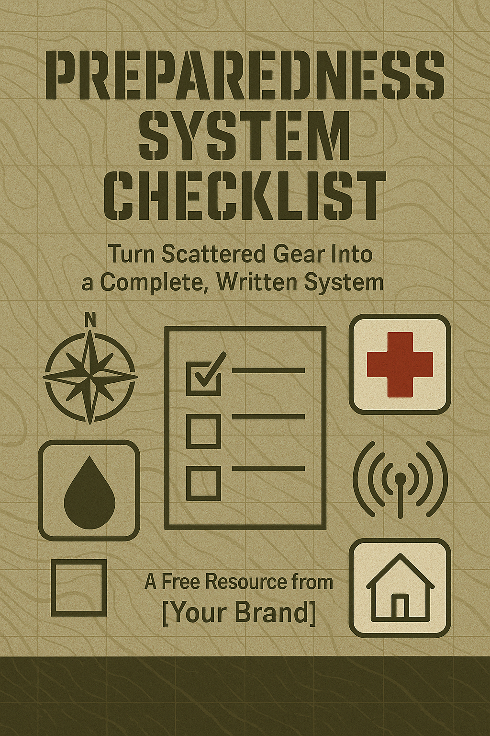
0. Snapshot Self-Assessment (Quick Overview)
Rate each area 1–5 (1 = nothing, 5 = confident & tested).
Today’s Date: __________
Area | Score (1–5)
Water | ☐
Food | ☐
Medical & Hygiene | ☐
Security & Home Safety | ☐
Comms (Communication) | ☐
Gear & Tools | ☐
Plans (Home/Evac) | ☐
Maintenance & Drills | ☐
Biggest gap right now (one sentence):

1. Household Profile
Household Members
- I have listed every household member, including ages and special needs.
- I have noted any medical conditions or medications required.
- I have included pets and their needs.
Household Summary
- Number of adults: ______
- Number of children: ______
- Pets (type & number): __________________________
- Special considerations (disabilities, chronic illness, pregnancy, etc.):

2. Gear & Supplies – Audit Snapshot
(This is the “dashboard” view; detailed inventory lives in your Gear Audit Sheet.)
2.1 Water
- I know how much water I currently have stored (gallons): ______
- I have at least 1 gallon per person per day for 3 days.
- I have a plan to reach at least 30 days of water (storage, source, or filtration).
- I have at least one water filter (e.g., Sawyer, Berkey, etc).
- I have backup purification (tabs, bleach, boiling method).
Top water gaps to address:

2.2 Food
- I have at least 3 days of no-cook/easy-prep food for my household.
- I have a minimum 2-week pantry of shelf-stable food we actually eat.
- I am working toward 30 days of food (pantry + long-term storage).
- I have a way to cook without grid power (stove, grill, rocket stove, etc).
- I have a basic rotation system (oldest food used first).
Top food gaps to address:

2.3 Medical & Hygiene
- I have a basic first aid kit (bandages, antiseptic, etc.).
- I have trauma supplies (tourniquet, pressure dressings, etc.) appropriate to my skills.
- I have a 30+ day supply of essential medications (where possible).
- I have over-the-counter meds (pain, fever, allergy, stomach, etc.).
- I have hygiene supplies for 30 days (soap, TP, feminine care, diapers, etc.).
Top medical/hygiene gaps to address:

2.4 Security & Home Safety
- Exterior doors are solid and have strong locks/strike plates.
- I have working flashlights/headlamps with spare batteries.
- I have a basic fire extinguisher accessible on each level.
- I have basic home defense appropriate to my situation and local laws.
- I have motion lights / deterrents / awareness measures (e.g., dog, cameras, neighbors).
Top security/safety gaps to address:

2.5 Communication (Comms)
- All family members’ phone numbers are written down, not just stored in phones.
- I have backup power for phones (power banks, car charger, solar, etc.).
- I have at least one radio option (FRS/GMRS/Ham) OR a clear plan to get one.
- I have local emergency numbers and an out-of-area contact written down.
- I have printed copies of key contacts and plans.
Top comms gaps to address:

2.6 Tools & General Gear
- I have basic tools: multi-tool/knife, duct tape, cordage, basic hand tools.
- I have lighting options: flashlights, lanterns, candles (used safely).
- I have basic shelter/warmth items: tarps, blankets, sleeping bags, etc.
- I have gloves, masks, and simple PPE appropriate to my environment.
- I know where all this gear is stored and can get to it quickly.
Top tool/gear gaps to address:

3. Home Base (Bug-In) Plan – Snapshot
3.1 Stay-or-Go Scenarios
- I have listed the top 3–5 scenarios where I would stay home (bug-in).
Examples: storms, grid failure, civil unrest, quarantine, etc.
Scenarios to bug-in for:

3.2 72-Hour Home Base Readiness
For 72 hours at home, I have:
- Water for every person and pet.
- Food that doesn’t require complex cooking.
- Light sources (flashlights/lanterns) and spare batteries.
- A way to stay warm/cool enough.
- Basic sanitation options (trash bags, wipes, TP, etc.).
- A way to receive information (radio, charged phone, etc.).

3.3 30-Day Home Base Readiness (Work-in-Progress OK)
For up to 30 days at home, I have or am building:
- A 30-day food plan for my household.
- A water plan (stored + resupply + filtration).
- A cooking plan off-grid (fuel, tools, safety).
- A meds & hygiene plan for 30 days.
- A basic home security plan (doors, windows, lighting, routines).
Biggest home base upgrade I need to make next:

3.4 Home Roles & Responsibilities
- I have assigned basic roles to household members (even if loosely).
Examples: water duty, cooking, comms, security checks, pet care.
- My household knows where key supplies are located.
- My household has had at least one “blackout night” drill or similar.

4. Evacuation / Bug-Out Plan – Snapshot
4.1 Triggers for Leaving
- I have written 3–5 specific triggers that would make us evacuate.
Examples:
- Mandatory wildfire or flood evacuation order
- Home is structurally unsafe
- Immediate threat from violence/industrial accident

4.2 Destinations
- I have a Primary destination (with address & contact).
- I have a Secondary destination (different direction/area).
- I have a Tertiary/"last resort" destination.
Primary: ______________________________________________
Secondary: ____________________________________________
Tertiary: _____________________________________________

4.3 Routes & Maps
- I have at least 2 routes to each destination (primary & alternate).
- I have printed maps with routes marked.
- Those maps are stored in my vehicle and/or bug-out bags.

4.4 Bug-Out Bags & Vehicle Prep
- Each adult has a bug-out bag with ~72 hours of essentials.
- Bags are packed, accessible, and reasonably carriable (I’ve test carried mine).
- Children have simplified packs or items staged.
- Pets have food, carrier/leash, and records considered.
- Vehicle has a basic emergency kit and is usually at ½ tank or more.
Biggest bug-out improvement I need to make next:

5. Communication Plan – Snapshot
5.1 Contact List
- I have a written Emergency Contact List with:
  - Immediate family
  - Close friends
  - Neighbors / local allies
  - Out-of-area contact
  - Key services (doctor, vet, school, etc.)
- Copies exist in:
  - My wallet/EDC
  - Home binder
  - Bug-out bag / vehicle

5.2 Devices & Backup Power
- I have at least one portable power bank (charged).
- I have car chargers for phones/devices.
- I have a radio (FRS/GMRS/Ham/NOAA) OR a plan to get one.
- I understand the basics of how to use my comms gear.

5.3 Rally Points & Check-Ins
- We have at least 2 physical rally points (nearby and out-of-area).
- Our family knows where to meet if separated.
- We have a simple check-in schedule (e.g., “try at 12:00 & 18:00”).
- We have a few simple code words/phrases everyone understands.

6. Logistics, Maintenance & Rotation – Snapshot
6.1 Rotation Systems
- I rotate food using a simple system (FIFO).
- I track expiration dates for key items (meds, batteries, etc.).
- I rotate or treat stored water as needed.
- I maintain fuel (where legal and safe) with stabilizer/rotation.

6.2 Seasonal Adjustments
- I review my preps 4 times per year (one per season).
- I adjust gear/bags for weather (cold-weather vs hot-weather).
- I check vehicle readiness each season (coolant, tires, etc.).

6.3 Drills & Practice
In the last 12 months, we have:
- Run at least one mock blackout (no grid power at home).
- Run at least one “no tap water” day/half-day.
- Conducted at least one bug-out drill (pack and load, even if we didn’t drive away).
- Tested comms gear and rally point plan at least once.
Next drill I will schedule:

Date I will run it: ____ / ____ / ______

7. Quarterly Review Summary
(Fill this out every 3 months when you review the checklist.)
Date of Review: ____ / ____ / ______
Snapshot Scores (from Section 0):
- Water: __
- Food: __
- Medical & Hygiene: __
- Security & Home Safety: __
- Comms: __
- Gear & Tools: __
- Plans: __
- Maintenance & Drills: __
Biggest improvements since last review:

Top 3 priorities for the next 90 days:

